Basic &amp; Clinical Pharmacology &amp; Toxicology

Fundamental Pharmacological Mechanisms

Free Access

Special Issue: Abstracts of the 17th World Congress of Basic and Clinical Pharmacology, 13–18 July 2014, Cape Town, South Africa
Volume 115, Issue s1Pages: 1-402
First published: 23 June 2014

https://doi.org/10.1111/bcpt.12259_8

Editor:
Kim Brøsen, Odense, Denmark
Associate Editors:
Jens Lykkesfeldt, Copenhagen, Denmark
Ulf Simonsen, Aarhus, Denmark

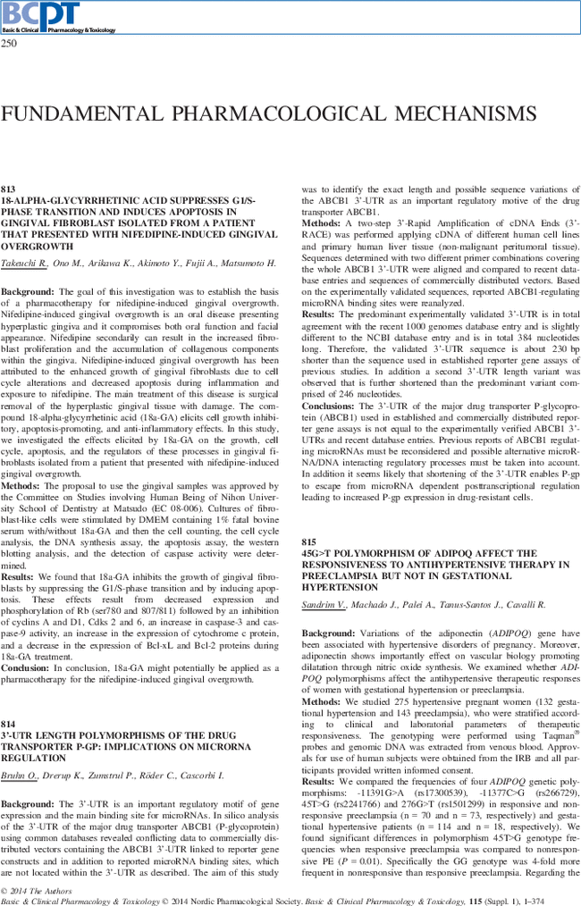
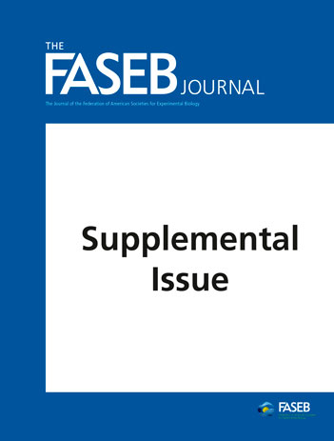

Volume 33, Issue 1_supplement
Pages lb1-872.4
April 2019

EB ABSTRACTS 2019
- Anatomy(694)
- Biochemistry and Molecular Biology(1688)
- Pathology(397)
- Pharmacology(899)
- Physiology(2296)

Editor-in-Chief (Bio)
Thoru Pederson, PhD
Editor-in-Chief
University of Massachusetts
Associate Editor (Bios)
Robert D. Goldman, PhD
Northwestern University

