CHAPTER 3
CHEMICAL ENGINEERING DISCIPLINE
O.A.A. Eletta, T.E. Odetoye, and E.O. Ajala
COURSE SYNOPSIS
Introduction to chemical engineering profession: Definition of chemical engineering. Specializations/ Options in chemical engineering. Use of various implements and equipment in chemical engineering for various operations/processes. Prospects and job opportunities in chemical engineering as a profession. Relevant regulatory bodies and societies in chemical engineering. The role of chemical engineers in advancement of humanity.
3.0 INTRODUCTION TO CHEMICAL ENGINEERING DISCIPLINE
3.1 DEFINITION
What is Chemical Engineering?
There are several ways of defining Chemical Engineering;
- American Institute of Chemical Engineers defined Chemical Engineering as a profession in which a knowledge of mathematics, chemistry and other natural science, gained by study, experience and practice is applied with judgement to develop economic ways of using materials and energy for the benefit of mankind.
- Chemical Engineering can also be defined as a broad discipline dealing with processes (industrial and natural) involving the transformation (chemical, biological, or physical) of matter or energy into forms useful for mankind, economically and without compromising environment, safety, or finite resources.
- Chemical Engineering is a branch of engineering that deals with the design of processes that convert raw materials from one form to a more useful products in an economical and safely way that is environmentally friendly.
- It can also be defined as an aspect of engineering that applies basic sciences (mathematics, chemistry, physics & biology) and engineering principles to the development, design, operation and maintenance of processes to convert raw materials to useful products (involving physical/ chemical changes) while ensuring that the environment is not compromised.
Who is a Chemical Engineer?
Chemical Engineer is a professional that create and develop the processes to produce, change or transport products and materials. He/She applied the principles of mathematics and science knowledge to investigate problems and design solutions based on safety, efficiency and sustainability. He/She becomes a Chartered Chemical Engineer by professional status and can earn competitive salary and wage. Figure 3.1. describes the relationship of chemical engineering profession with other disciplines. Chemical engineers understand the management of any substance by changing its chemical, biochemical or physical state, to create a desired product. There is a great number of products that are impacted by chemical engineers, ranging from manufacturing, pharmaceuticals, healthcare, design and construction, pulp and paper, petrochemicals, food processing, specialty chemicals, microelectronics, electronic and advanced materials, polymers, business services, biotechnology, and environmental health and safety industries, among others. Table 3.1 presents a list of Chemical Engineering applications and their products.

Figure 3.1: Relationship of Chemical Engineering Profession with other Disciplines

Table 3.1: Chemical Engineering Applications and their Products
S/N | Chemical Engineering Applications | Products
1 | Energy, Fuels and Power | Petroleum products, natural gas, battery, fuel cells.
2 | Polymer | Plastics, rubber, tyre.
3 | Biotechnology and Biochemical Engineering | Single cell protein, genetically modified agricultural product, organic acid.
4 | Household Chemicals | Adhesives, paints, inks, soaps, detergents, cosmetics, perfumes, disinfectants, pomade.
5 | Advanced Materials | Glass, ceramics, metals, polymers, catalyst.
6 | Pharmaceutical and Food | Drugs, beverages, brewing, pastries.
7 | Process Design and Control | Process and product development, efficient operation of the process plant, product quality and standard.
3.2 SPECIALIZATION / OPTIONS IN CHEMICAL ENGINEERING
Some of the main areas of Chemical Engineering include:

3.2.1 Process engineering
Process engineering is mainly the application of chemical engineering principles to the designing, operation, control and optimization of chemical processes. Process Engineer can be a Chemical Engineer or Mechanical Engineer as his/her schedule of duty involves equipment design and selection.
3.2.2 Biotechnology/Biochemical engineering
This is a growing sector of Chemical Engineering that involves exciting science discoveries in the area of genetic and tissue engineering, drugs development, medicine, renewable energy and waste management. Biochemical Engineer employs the principle of Chemical Engineering to the development of these useful products. He/She is scheduled to tackle many of present global challenges that affect human existence.
3.2.3 Petroleum engineering
Petroleum engineering concerned with the discovery, exploration, and processing of hydrocarbon. exploitation and activities related to the production of hydrocarbons, which can be either crude oil or natural gas. This field is very well patronized by students of Chemical Engineering because of the lucrative nature of the sector.
3.2.4 Environmental Engineering
This focuses on the assessment, management and design of sustainable environmental systems for the protection of man and ecological health. Systems designed include such as those used to treat and properly dispose waste, control water pollution etc.
3.2.5 Process Control and Modelling
This area employs the use of softwares to design, monitor and control processes. Control involves the purposeful influence on a controlled object (process) that ensures the fulfillment of the required objectives in order to satisfy the safety and optimal operation of the technology and to meet product specifications and mathematical models of processes. These models can be constructed from a physical and chemical nature of processes or can be abstract. The investigation of dynamical properties of processes as well as whole control systems give rise to a need to look for effective means of differential and difference equation solutions. Other areas include Biomedical Engineering, Nanotechnology, Chemical Reaction Engineering, Polymer Engineering, Plastics Engineering, Food Processing, Composite Materials, Corrosion and Protective Coatings, Pharmaceuticals, Manufacture of Microelectronic Components and Transport Phenomena. The traditional fields of chemical engineering include petrochemicals, petroleum and natural gas processing, plastics and polymers, pulp and paper, instrumentation and process control, energy conversion and utilization and environmental control.
3.2.6 Reaction Engineering
Reaction engineering is an important aspect of chemical engineering that distinguish chemical engineering from other field of engineering. Its knowledge help to determine efficient approach of converting feedstock into a more valuable product. This is achieved by influencing the reactor design or modify the way the feed is charge into the reactor or addition of additives or catalyst. Reaction engineering is concerned with the exploitation of chemical reaction on commercial scale by designing a reactor for specific conversion of raw material to product. Reactor Design uses information, knowledge and experience from a variety of areas - thermodynamics, chemical kinetics, fluid mechanics, heat and mass transfer and economics. Reaction Engineering is the combination of these subjects to properly develop an efficient chemical reactor.

3.2.7 Polymer Engineering
Polymer engineering is the combination of knowledge of chemical engineering and polymer science. It deals with the conversion of natural and synthetic raw materials into a number of products such as plastic, rubber, textile fabric and advanced materials. Polymer engineering is also a sub-field of materials engineering primarily focusing on the development of new polymer or polymer composite products.
3.2.8 Thermodynamics, energy and exergy analyses
Thermodynamics is aspect of chemical engineering that deals with the science of energy; energy has been defined as the ability to cause changes. Thermodynamics originated from the Greek words of therme (heat) and dynamis (power), which could be described as the efforts to convert heat into power. Nowadays, thermodynamics has been classified to include; energy and energy transformations (power generation, refrigeration, and relationships among the properties of matter); exergy and pinch technology (available work and maximum energy recovery). Exergy analysis methods can be applied to detect the processes inefficiencies.
3.3 USE OF VARIOUS EQUIPMENT IN CHEMICAL ENGINEERING FOR VARIOUS OPERATIONS AND PROCESSES
Unit Processes: ''unit process'' is one or more grouped operation in a manufacturing system that can be defined and separated from others. Chemical reaction engineering, chemical kinetics and chemical process modeling.
Chemical Process is a method used in manufacturing to change the composition of materials technology to a desired product. They can be illustrated as block flow diagrams which show each unit as blocks and the streams flowing between them as connecting lines with arrow heads to show direction of flow
Unit Operations: unit operation is a basic step in a process. It involves a physical change or chemical transformation. They include: separation, crystallization and evaporation. A process may require many unit operations to obtain the desired product from the raw materials. Chemical Engineering employs several unit operations. Unit operations of Chemical Engineering involve a coordinated series of separate operations. Examples of unit operations include extraction, evaporation, leaching and filtration. Table 3.2 shows various chemical engineering equipment and their uses.
There are other heat exchange equipment for maximum energy recovery which includes:
- Jacketted Vessel: the contents of a vessel are heated or cooled by condensing steam in a jacke surrounding the vessel.
- Double Pipe Heat Exchanger: consists of 2 concentric tubes with a fluid flowing in the central pipe and another flowing in the annular space either co or counter current.
- Shell and Tube Heat Exchangers: this is employed when the heat transfer surface required is large.

Table 3.2 Chemical Engineering Equipment and their Uses

S/N | Name of Equipment | Picture | Uses
1 | Fractionating column | 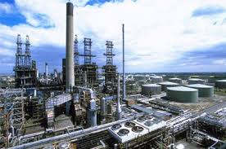 | For the separation of crude oil into various fractions
2 | Liquid – liquid extractor | 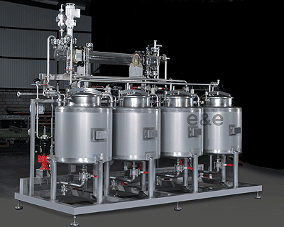 | For the separation of liquid-liquid mixture that are sensitive to heat treatment.
3 | Sedimentation tank | 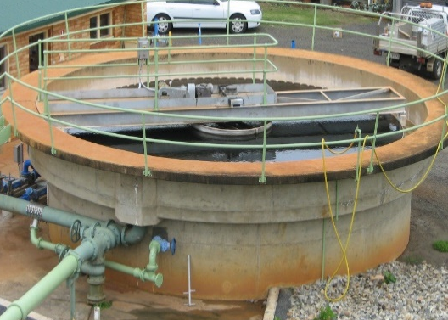 | For the separation of solid -liquid mixture under gravity. It is applicable in wastewater treatment.
4 | Bioreactor | 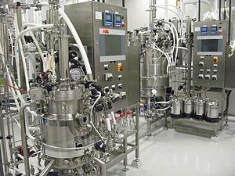 | This is a vessel where biological agent is used to produce the desired products.
5 | Polymer and starch dosing systems | 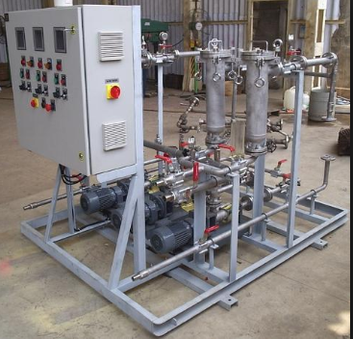 | It is use for paper chemical dosing and also suitable for all polymers.
6 | Batch reactor | 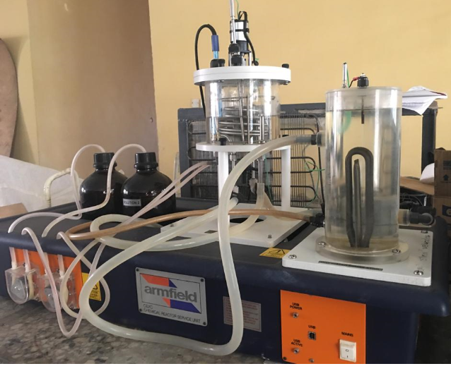 | Laboratory reactor for the reaction of two or more reactant to produce product(s) different in chemical properties to the reactants.
7 | U-Bundle heat exchanger | 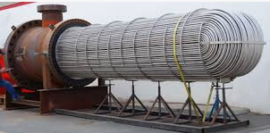 | It can be used to boil water recycled from a surface condenser into steam to drive a turbine to generate power. It can be used to recover heat energy in a process industry for economic benefit.

3.4 PROSPECTS AND JOB OPPORTUNITIES IN CHEMICAL ENGINEERING

What Are Some Specific Job Functions of Chemical Engineers?
- Chemical engineers develop and improve existing food processing and techniques. They also involve in the development of methods to produce fertilizers in order to increase the quantity and quality of available food.
- Chemical engineers also produce the synthetic fibers for making clothes; develop methods for mass production of drugs and vaccine at low cost.
- Chemical engineers are major stakeholder in petroleum discovery, exploration and refining. These they do in a safe, and more efficient way to make petroleum products, energy and chemical resources available for human socio-economic development.
- Chemical engineers also develop solutions to environmental problems, such as pollution control and remediation.

Therefore, there are a great number of job opportunities for Chemical Engineers in Chemical Process Industries (CPI) which made them to be referred to as “Universal Engineers”. As they are relevant and applicable in finding solutions to the essential needs of mankind. Below are other areas of job opportunities for Chemical Engineers;
Energy and Fuel: The petroleum and petrochemicals industry are involved in the production of petroleum products as well as nuclear and synthetic fuels. The Chemical Engineer are involved in diverse ways in this industry; they are involved in developing alternative energy sources, production, environmental monitoring, research and development and process safety. In the Petroleum Industry, a variety of opportunities abound for the Chemical Engineer in this industry. This ranges from plant design, to production of various products from crude (fuel, lubricants, liquefied Petroleum gas (LPG), Liquefied Natural Gas (LNG, petrochemicals, waxes etc).
Food and Beverage: Chemical engineers in the food and beverages industry, design process units for food production and packaging. They are also involved in quality control and process safety.
Environment, Safety and Health: Chemical engineers are employed to design processes that would reduce waste generation to the barest minimum in every process by introducing recycle streams, reusing supposed wastes. Treatment and disposal of final waste is also carried out putting in mind process safety and loss prevention.
Electronics: Chemical Engineers are employed in the electronics industry to handle development and production and process control equipment. They are also involved in the manufacturing of microchips and intricate circuitry by developing materials and processes that allow such circuits to be properly assembled.
Design and Construction: Chemical Engineers are involved with process design and project management. They work closely with other Engineers (Electrical, Mechanical and Civil).
Business, Finance and Insurance: Chemical engineers are employed to manage, analyze, and insure businesses in the chemical process industries. They carry out process design and act as consultants to finance houses.
Education: Teaching, research and development is carried out by Chemical Engineers to advance knowledge in the discipline.
Consultants and Government Agencies: Many Chemical Engineers also work in supplier, consulting and governmental agencies related to the Chemical Process Industries by engaging in equipment manufacture, plant design, consulting, analytical services and standards development.
Industry: Chemical Engineers hold lead positions in industrial firms and governmental agencies concerned with environmental protection since environmental problems are usually complex and require a thorough knowledge of the Social Sciences, Physics, Biology, Mathematics and Chemistry for their resolution. The majority of Chemical Engineers work in businesses known collectively as the Chemical Process Industries (CPI) such as pulp and paper, rubber and plastics, metal and mineral processing, textile, oil and gas, cosmetics/pharmaceuticals and agricultural chemicals industries.
3.5 RELEVANT PROFESSIONAL BODIES IN CHEMICAL ENGINEERING
A Professional Regulatory Body is a body established by a decree or an act of the legislative arm of Government and its primary function is to regulate the training of members of the profession and the professional practice.
Such regulatory body for the Chemical Engineering and other Engineering professions in Nigeria is the Council for the Regulation of Engineering in Nigeria (COREN). A practicing Chemical Engineer must be registered by the Council for the Regulation of Engineering in Nigeria (COREN). Other professional societies are Nigerian Society of Engineers (NSE); which is an umbrella association for all Engineering disciplines and the Association of Professional Women Engineers (APWEN). The Nigerian Society of Chemical Engineers is the recognized society under which all Chemical Engineers in Nigeria interact and collaborates. Its equivalent in the UK is The Institution of Chemical Engineers (IChemE) and in the US we have the American Institution of Chemical Engineers (AIChE).
3.6 THE ROLE OF CHEMICAL ENGINEERS IN ADVANCEMENT OF HUMANITY
Chemical Engineers face similar challenges with other fields of Engineering. However, their challenges are solved by applying their technical knowledge, communication and teamwork skills; the most up-to-date practices available; and hard work. Of course, in solving the challenges, there would be financial rewards, recognition and awards within industry and society, and the gratification that comes from working with the processes of nature to meet the needs of society. Chemical Engineers can contribute to the development of our nation through chemical process development in the following ways:
- Design of industrial processes: the design of the various units that make up a process is carried out by the chemical engineer.
- Development and installation of corrosion kits to protect corrosive industrial fluids from eroding units and leading to failure.
- Development of appropriate standards for processes.
- Research and development to improve existing processes: Constant upgrade to ensure better, and improved yielding processes.
- Development of processes to reduce waste generation in process industries: Waste treatment and proper disposal: Every chemical process in addition to product formulation generates wastes which could be in the 3 states of matter. The chemical engineers could be involved essentially in the treatment and disposal of such waste.
- Quality control in process industries.
- Feasibility studies to guide finance houses in granting facilities: It is only after going through a design and ascertaining the workability and economics that a chemical engineer would go ahead and approve a loan grant to establish a process.
- Production of cosmetics: Hair and body cream, make up, toothpaste etc are produce by chemical Engineers and they are used to enhance quality of skin and beauty.
- Development and production of appropriate agro-chemicals to improve yield in food.
- Production of textile and synthetic shelter material: Clothing and housing: new and better materials such as synthetic fibers, plastics and polymers, plywood and hardboards are used in place of the rapidly decreasing natural resources.
- Health: the chemical engineers have a lot of noteworthy contribution to health and population control in the industrial production of drugs and pharmaceuticals. The chemical engineer study complex chemical processes and materials to improve the quality of life through the creation of medical devices such as prostheses and biomaterials. Examples are artificial organs, contact lenses, artificial hips etc they are also involved in the chemical synthesis of and prolong life sustaining aids like the heart – lung machine, synthesis of drugs, genetic engineering and gene therapy.
- Food: they are involved with increasing the production and processing of food; in the production of fertilizers, insecticides and herbicides.
- Clothing and housing: new and better materials such as synthetic fibers, plastics and polymers, plywood and hardboards are used in place of the rapidly decreasing natural resources.
BIBLIOGRAPHY
- Crude fractionating column http://www.machineto.com/img/showcase/fushun-petroleum-catalytic-fractionating-column-10301297.jpg
- Felder R.M and Rousseau R.W. (2005). Elementary principles of Chemical Processes, 3rd edition
- Gas absorption column http://www. Separation processes.com/PlantPics/Plant_Pic08.jpg
- Gerben J Zylstraa and Jerome J Kukor, (2005). What is environmental biotechnology? Current Opinion in Biotechnology 16(3):243-245.
- Liquid – liquid extractor http://www.eunde-verfahrenstechnik.de/img/liquid-liquid-etraction-plant.png
- McCabe W.L and Smith J.C. (2007). Unit Operations of Chemical Engineering, 7th edition
- Sedimentation tank http://www.lgam.info/local--files/bruce-janke-s photos/Childers_WWTP_Secondary_Sedimentation_Tank2.JPG
- Gas absorption column http://www.separationprocesses.com/PlantPics/Plant_Pic08.jpg
- Liquid – liquid extractor http://www.eunde-verfahrenstechnik.de/img/liquid-liquid-extraction-plant.png
- http://upload.wikimedia.org/wikipedia/en/thumb/2/24/BTEC_Bioreactors.jpg/300px-BTEC_Bioreactors.jpg
- http://www.machineto.com/img/showcase/fushun-petroleum-catalytic-fractionating-column-10301297.jpg
- http://www.eunde-verfahrenstechnik.de/img/liquid-liquid-etraction-plant.png Gas Absorption
- http://www.separationprocesses.com/PlantPics/Plant_Pic08.jpg
- http://www.lgam.info/local--files/bruce- janke-s-photos/Childers_ WWTP_Secondary_ Sedimentation_ Tank2.JPG.
- Yaopeng, L., Ming, J., Yachao, C., Sage, L., Kokjohn, R.D., Reitz. (2016). Thermodynamic energy and exergy analysis of three different engine combustion regimes
Applied Energy 180; 849–858.

