Development and Characterization of Polyester Resin/Kenaf/Coconut Coir Reinforced Hybrid Composites
*¹James Obafemi ADEGBOLA, ² Opeyemi David ALLI, ³ Timothy Opeyemi AKINGBADE, ⁴ Musa Oluwajuwon ABDULMOJEED, ⁵ Ayofe Fatai BUHARI. and ⁶ Ibrahim Owolabi AMBALI, Oluwatoyin Peter JOSEPH
^{1,4,6} Department of Materials and Mechanical Engineering, University of Ilorin, Ilorin, Kwara state, Nigeria
²Department of Mechanical Engineering, Adeleke University, Ede, Osun State Nigeria
^{3,5}Department of Agricultural Engineering, Adeleke University, Ede, Osun State Nigeria
⁷Department of Civil Engineering, Faculty of Engineering Adeleke University, Ede, Osun State, Nigeria

Corresponding author: *adegbola.jo@unilorin.edu.ng

Abstract: The project begins with extracting and processing coconut coir and Kenaf fibers to obtain suitable reinforcement materials. These natural fibers are chosen for their desirable attributes, including low cost, lightweight nature, and environmental sustainability. The fibers are treated to enhance their compatibility with the polyester resin matrix, ensuring proper adhesion and minimizing moisture absorption The composites were developed using the Hand lay-up method involving the application of coconut coir and Kenaf fibers layer by layer onto a mold until the desired thickness of 5mm is attained using polyester resin as the matrix. A fixed load is applied to the top of the laminates and allowed to cure for 48 hours at room temperature. The resulting composite is assessed for mechanical and morphological examination. Preliminary results indicate the laminate Kenaf/coconut coir/Kenaf potential with the ultimate tensile stress of 22.667MPa, an impact strength of 74.7 J/m, and a water absorption rate of 5.98% as a lightweight yet eco-friendly material for automotive structural components, offering fuel efficiency benefits. Further research is needed to explore wider applications and commercialization prospects

Keywords: Kenaf; Materials, Hybridization, Synthesis, Reinforcement

1.0 INTRODUCTION
Composite materials are multiphase or multi-component materials that exhibit significant properties of both components such that a better overall property is obtained and it is based on the combined action in which better property combinations are designed from two or more distinct materials with property trade-offs. However, it is important to note that the composites must constitute phases that are chemically dissimilar and separated by a distinct interface (Parashar & Chawla, 2022). They are simply a combination of two or more constituent materials with different physical or chemical properties. Hence, the quest to develop composites with compositions or constituents from nature is an important area in material science since nature has a plethora of biomaterials that have reliable mechanical and chemical properties that need to be investigated for suitable applications (Dattatreya et al., 2023).

In the development of composites that are not biological such as metal matrix composite (MMC), a secondary material, typically in the form of particles, fibers, or whiskers, can be added to the metallic matrix or binder material to reinforce it. It was observed that metal, ceramic, or organic materials can be used as reinforcement. In addition to graphite, reinforcements for such MMC materials such as silicon carbide, and boron fibers are functional (Marichelvam et al., 2023).

Another composite that has been developed for use is the ceramic matrix composite (CMC). It has reinforcements of ceramic, metallic, or organic fibers. When making a comparison to available ceramics, It was observed that they can withstand large thermal loads, they withstand higher stresses hence they do not get damaged in a short time of service condition, and they have high toughness before fracture can set in (Müssig et al., 2024).

For composite materials classified as hybrids, they are known to consist of fibers in their matrix. This matrix is singular. However, they can consist of different types of fibers but two dissimilar fibers are known to give optimal service performances. It is also observed the disparity in hybrid composites falls in the mechanical properties of the materials and the chemical properties of the materials. However this is to be achieved, one salient fact there must be a valuable material in the composition as reinforcements (Dashtizadeh et al., 2020).

Polyester resins are synthetic resins that are byproducts of the chemical reaction by cross-linking substances such as styrene. Hence, they are used in aspects of production and as structural components in automobiles. For Kenaf, they are plants known as Hibiscus cannabinus native to Africa. However, Kenaf is useful as a candidate material in building some structural components for automobiles (Sreenivas et al., 2020).

For Coir, these substances are fibrous and can be found between the inner shell and outer surfaces of a coconut. is the fibrous material found between the hard, internal shell and the outer coat of a coconut (Chee et al., 2020).

In general, composite materials are made of the matrix, constituents with the largest quantity share other components and reinforce materials that are used to obtain projected properties hence, they can be termed as hybrids. This study aims to develop a reinforced composite with polyester resin, Kenaf, and coconut coir as its principal components. This developed composite has to be subjected to different characterization experiments to evaluate the material's physical and chemical properties.
2.0 MATERIALS AND METHODOLOGY

Materials
The primary materials used for the development of the material are the Coconut coir and Polyester resin. The coconut coir was obtained from a local market in Ilorin, Kwara state. The extraction of the fiber was achieved by using milling and grinding machines. The Polyester resin was acquired from Tony Nigeria Enterprises in Ojota, Lagos.
The chemicals used included Methyl Ethyl Ketone Peroxide (MEKP) as a catalyst, cobalt octanoate was used as an accelerator, sodium hydroxide for the chemical treatment of coconut coir, and coconut oil as a releasing agent.
A mold made of wood was, fabricated to obtain several samples. These molds were fabricated in a carpentry workshop to a good surface finish at the University of Ilorin. A smart electronic load cell was used to measure the masses of the samples; a sieve was used to obtain fine particle distributions, a mixing bowl was used for mixing the materials and the chemicals, with the timing of the product formation being monitored with a stopwatch. Gloves are necessary in handling the chemicals. For the characterization of the samples, a 50KN Universal testing machine (INSTRON 3369), and Scanning Electron Microscopy (SEM) were used.

2.2 Method

2.2.1 Chemical Preparation of Composites
The fibers used for this study are Kenaf and coir. The coir fibers were cut to lengths of 120-140 mm. The polyester resin with Methyl Ethyl Ketone Peroxide (MEKP) as a catalyst and Cobalt Octanoate was, used as an accelerator. The oil from the coconut was, used as a releasing agent. Surface impurities from the fiber; such as pectin and lignin were, removed by using NaOH. The NaOH solution was, prepared by dissolving NaOH pellets (by 10% of its weight) in distilled water (90% by its weight) and making it a uniform solution by effective mixing. The fibers are then soaked in NaOH for 12 hours. This is done to effectively remove the impurities and celluloses.
After 12 hours of soaking, the fibers, are removed and rinsed in distilled water and then exposed to sunlight for two days in order to dry. To ensure a uniformly blended polymer matrix, the fibers were, joined into 350 to 450mm lengths. This process is then, followed by drying at a temperature of 100⁰C for 48 hours. The moisture content of the fibers were also determined by comparing the oven-dried weight with the wet weight of the samples before treatment. The laminates formed during the making of the samples are shown in Figure 1.
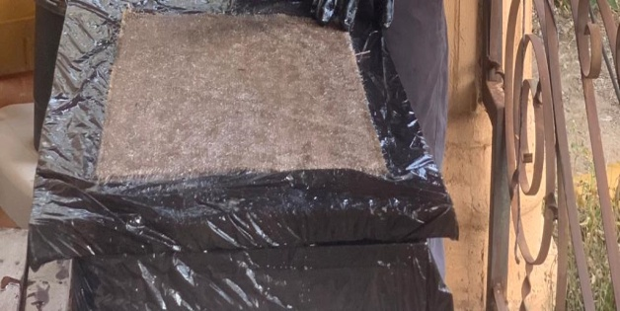
Figure 1: Laminates forming in the process

2.2.2 Mechanical Test

2.2.2.1 Tensile Test
This test was reproduced after the following ASTM D638 standards. It was carried out to measure the force required to cause the specimens to fracture as well as the extent of their elongation. The universal testing machine is shown in Figure 2.
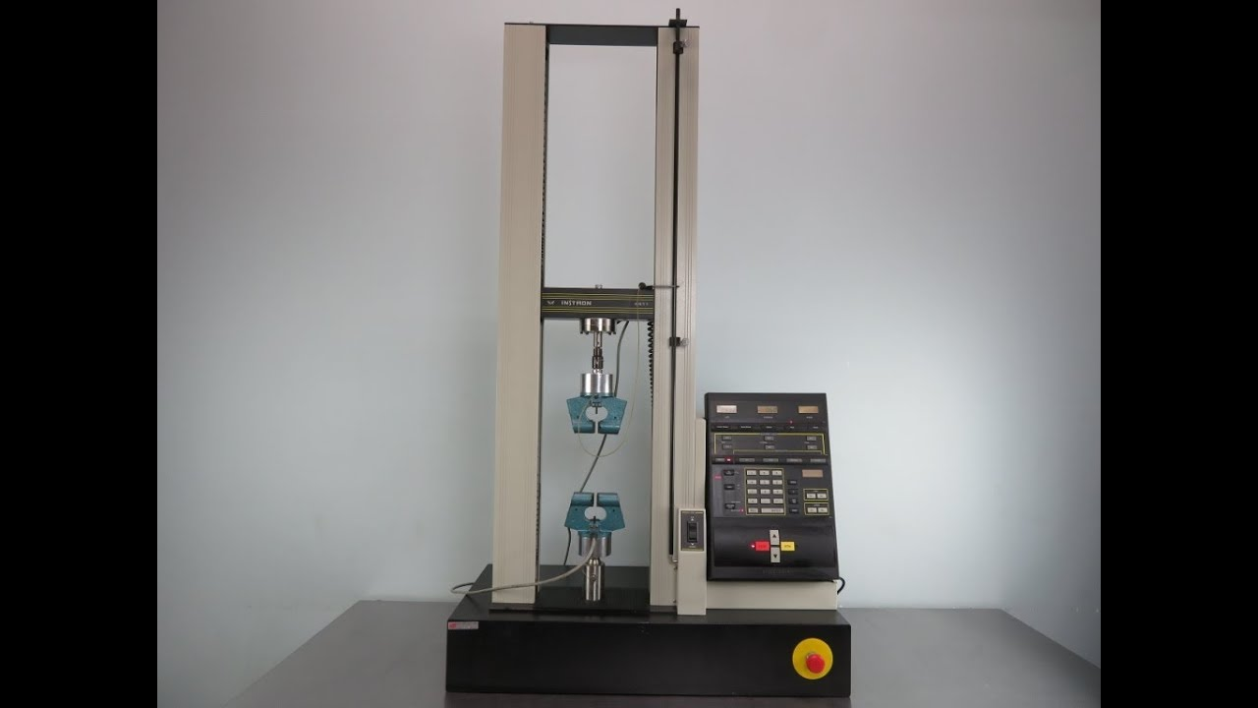
Figure 2: The Instron universal testing machine used for determining the tensile strength of the specimen

2.2.2.2 Impact Test
In order to determine the amount of energy that can be absorbed by the specimens, an Izod impact-testing machine was used to investigate their toughness as shown in Figure 3. This was effectively carried out by creating notches in the specimens according to the ASTM D256 standards.
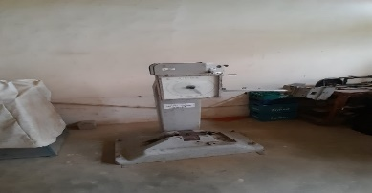
Figure 3: The Izod and Charpy impact testing machine

2.2.2.3Water Absorption Test
The test was, conducted according to the ASTM D570 standards. The samples were soaked in water for 7 days. The soaked samples were, weighed to determine their mass. The change in mass by comparing to the dry mass and taking it as a ratio with the dry mass was used to obtain the water absorption.

2.2.2.4 Microstructural Analysis
A test to investigate the microstructural compositions of the material samples was done with the aid of a scanning electron microscope (SEM) which is shown in Figure 4. Insights to the microstructural features of the composite was revealed. This includes the reinforcement materials and the polymers.
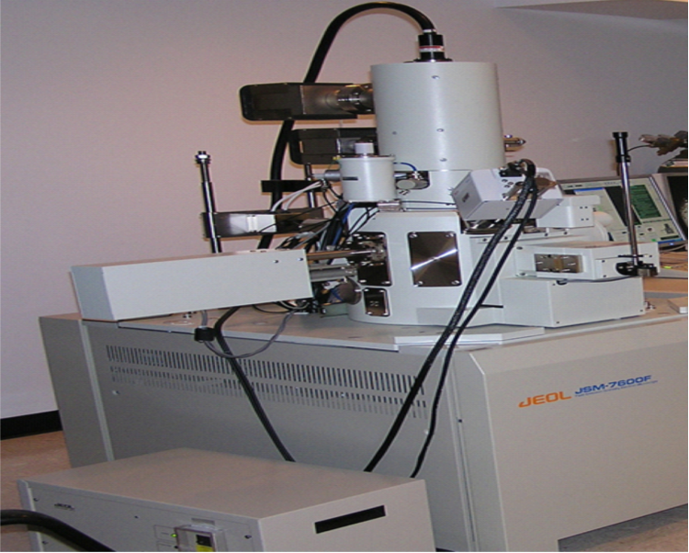
Figure 4:SEM equipment used for the microstructural analysis of the specimen EDX machine

3. RESULTS AND DISCUSSION

3.1 Morphological Examination
Three hybrid composites were developed. By using the SEM equipment, the surface topography of the polyester resin matrix and the developed three different types of hybrid composites; coconut fiber coir/Kenaf/coconut fiber coir (CKC), Kenaf/coconut fiber coir/Kenaf (KCK), and coconut fiber coir/coconut fiber coir/coconut fiber coir (CCC) were analyzed. The SEM analysis allowed for a comprehensive examination of the interfaces and fractured mechanical surfaces.
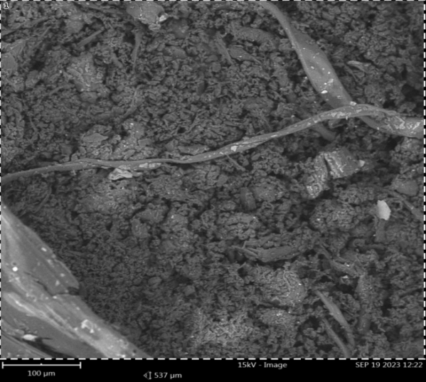 | 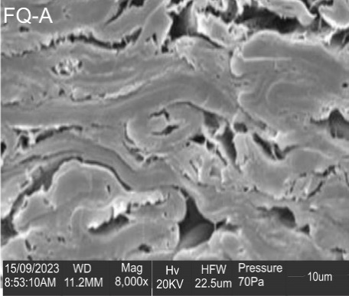 | 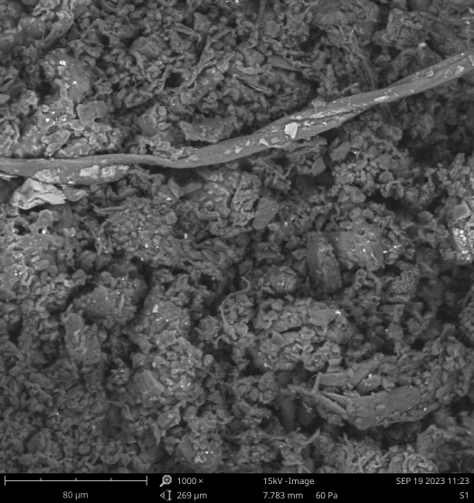
(a) | (b) | (c)
Figure 5: Shown in (a) is the topography of CKC at 15 kV , (b) is the topography of CCC at 20 kV and (c) is the topography of KCK at 15 kV

It is seen from Figure 5a and Figure 5b the boundaries of separation for the middle components in CKC and KCK respectively at fracture. The CCC material appears to be of haphazard contour distribution with no cleavages to show a distinct path for crack propagation at fracture.

From Figure 6, the Kenaf fiber-reinforced polyester can be seen to contain elements like silicon, carbon, aluminum, calcium, sodium, magnesium, iron, cadmium, potassium, and nitrogen in the synthesized composite nanostructure in the EDX spectrum. In the spectrum, carbon is seen to have the highest composition which is 85.84%, then Nitrogen at 10.41%, and silicon at 0.87% as seen in the table 1 below.

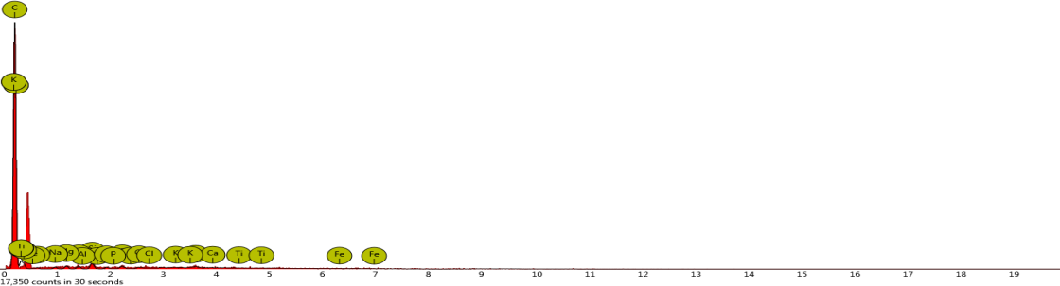
Figure 6: EDX measurement of Kenaf/Coconut coir/Kenaf fiber

Table 1: Compositions of the element make up for the developed polyester reinforced Kenaf-coir hybrid
Element  Number | Element  Symbol | Element  Name | Atomic  Conc. | Weight  Conc.
6 | C | Carbon | 89.11 | 85.84
7 | N | Nitrogen | 9.27 | 10.41
14 | Si | Silicon | 0.39 | 0.87
16 | S | Sulfur | 0.20 | 0.52
12 | Mg | Magnesium | 0.26 | 0.50
13 | Al | Aluminum | 0.22 | 0.47
11 | Na | Sodium | 0.22 | 0.41
20 | Ca | Calcium | 0.12 | 0.40
15 | P | Phosphorus | 0.11 | 0.27
17 | Cl | Chlorine | 0.08 | 0.22
19 | K | Potassium | 0.03 | 0.08
26 | Fe | Iron | 0.00 | 0.00
22 | Ti | Titanium | 0.00 | 0.00

3.2 Mechanical Characterization

3.2.1 Impact Strength Test (Impact Test ASTM D7256 Standard)
The impact test was conducted to evaluate the toughness of the different composite materials, each containing 1.5kg/2kg/1.5kg of polyester resin with Methyl Ethyl Ketone Peroxide (MEKP) 30g/40g/30g as a catalyst and Cobalt octanoate as an accelerator. The results, which is indicated in Figure 7 below, shows that the Kenaf/coconut coir/Kenaf fiber (KCK) hybrid composite exhibited excellent energy absorption capabilities before fracturing. This suggests a high level of impact resistance. This exceptional impact resistance in the KCK composite was attributed to strong adhesion and interfacial bonding between kenaf, coconut coir fibers, and the polyester matrix.
Figure 7: Impact strength of the test samples

3.2.2 Flexural Strength Test (ASTM D790 Standard)
A 3-point flexural bending test was conducted on specimens of varying thickness. The results is as shown in Figure 8. It indicates that the flexural strength initially increased with reduced fiber loading but declined with further decreases in fiber loading. The coconut fiber coir/coconut fiber coir/coconut fiber coir (CCC) hybrid composite demonstrated optimal flexural strength and was well-suited for applications such as safety helmets when compared to the other composite types (CKC and KCK). The CCC specimens displayed the highest flexural strength, followed by the KCK specimens, and then the CKC specimens.
Figure 8: Flexural test result of the developed hybrid specimen

3.2.3 Tensile Properties (ASTM D790 Standard)
The tensile testing results in Figure 9 indicates that the coconut fiber coir composite achieved a maximum ultimate tensile stress of 22.667 MPa compared to other composite types. The composite with a density of 400 grams combined with polyester resin exhibited strong resistance to tensile loading, suggesting effective bonding between the matrix and reinforcements, particularly in the coconut fiber coir/Kenaf/coconut fiber coir (CKC) fibers. This finding reflected the ductile nature of the materials (Biswas et al., 2019).

Figure 9: Tensile test result of the developed hybrid specimen

3.2.4 Water Absorption Test (ASTM D570 Standard)
The graph in Figure 10 reveals that Kenaf/coconut coir/Kenaf exhibited the lowest water absorption properties, attributed to the hydrophobic nature of Kenaf fibers. This property makes it suitable for applications where moisture resistance is crucial.
Figure 10: The water absorption test result of the developed hybrid specimen

4. CONCLUSION
In this study, composites containing kenaf and coconut coir fibers were developed. Findings from the study showed that laminates of polyester resins as the matrix components with coconut coir fiber and Kenaf as reinforcements can be effectively developed by a hand lay-up technique. It is important to note the major findings as
- The produced Kenaf/ coconut fiber /Kenaf (KCK) hybrid composite can absorb more energy with the value of 74.7J/m before fracturing according to the Impact test due to the strong adhesion and interfacial bonding between the kenaf, coconut coir fibers and the polyester matrix which is in agreement with literature (Biswas et al., 2019)
- Kenaf/coconut coir/kenaf composite has the lowest water absorption rate with a value of 5.98% in comparison to other samples, hence hydrophobic.
- Kenaf/coconut coir/kenaf composite possesses the highest tensile strength with the value of 68.17MPa when compared to others hence making it more suitable for applications where strength and durability are essential such as the car bonnets and bumper.
From the aforementioned facts, it is obvious that the hybrid compound kenaf/coconut coir/kenaf can serve as a replacement for fiber composites . Thus, further study is required to increase the flexural strength for more usefulness of the natural fibers as composition reinforcement in structural applications.

5. ACKNOWLEDGMENT
The authors wish to acknowledge the assistance and contributions of the laboratory staff of the Department of Materials and Metallurgy Engineering, University of Ilorin, Ilorin toward the success of this work.

REFERENCES
Biswas, B., Bandyopadhyay, N. R., & Sinha, A. (2019). Mechanical and Dynamic Mechanical Properties of Unsaturated Polyester Resin-Based Composites. In Unsaturated Polyester Resins (pp. 407–434). Elsevier. https://doi.org/10.1016/B978-0-12-816129-6.00016-8
Chee, S. S., Jawaid, M., Sultan, M. T. H., Alothman, O. Y., & Abdullah, L. C. (2020). Effects of nanoclay on physical and dimensional stability of Bamboo/Kenaf/nanoclay reinforced epoxy hybrid nanocomposites. Journal of Materials Research and Technology, 9(3), 5871–5880. https://doi.org/10.1016/j.jmrt.2020.03.114
Dashtizadeh, Z., Abdan, K., & Jawaid, M. (2020). Mechanical properties enhancement of cardanol by hybridization with kenaf/recycled carbon. Mechanics of Materials, 148, 103475. https://doi.org/10.1016/j.mechmat.2020.103475
Dattatreya, K., Sathees Kumar, S., Prasad, V. V. S. H., & Ranjan Pati, P. (2023). Mechanical properties of waste natural fibers/fillers reinforced epoxy hybrid composites for automotive applications. Materials Today: Proceedings. https://doi.org/10.1016/j.matpr.2023.02.001
Marichelvam, M. K., Kumar, C. L., Kandakodeeswaran, K., Thangagiri, B., Saxena, K. K., Kishore, K., Wagri, N. K., & Kumar, S. (2023). Investigation on mechanical properties of novel natural fiber-epoxy resin hybrid composites for engineering structural applications. Case Studies in Construction Materials, 19, e02356. https://doi.org/10.1016/j.cscm.2023.e02356
Müssig, J., Enke, S., Gusovius, H., Lühr, C., Uhrlaub, B., Dammer, L., & Carus, M. (2024). Mechanical separation of kenaf for composite applications – Evaluation of the total fibre line concept for field retted kenaf. Industrial Crops and Products, 208, 117870. https://doi.org/10.1016/j.indcrop.2023.117870
Parashar, S., & Chawla, V. K. (2022). Evaluation of fiber volume fraction of kenaf-coir-epoxy based green composite by finite element analysis. Materials Today: Proceedings, 50, 1265–1274. https://doi.org/10.1016/j.matpr.2021.08.147
Sreenivas, H. T., Krishnamurthy, N., & Arpitha, G. R. (2020). A comprehensive review on light weight kenaf fiber for automobiles. International Journal of Lightweight Materials and Manufacture, 3(4), 328–337. https://doi.org/10.1016/j.ijlmm.2020.05.003

