SOCIO-ECONOMIC IMPACT OF ILEYA FESTIVAL IN ILORIN, 1990-2020

BY
ADESHINA, LUKMAN
DEPARTMENT OF HISTORY AND INTERNATIONAL STUDIES,
FACULTY OF ARTS,
UNIVERSITY OF ILORIN,
ILORIN
adeshlukman@gmail.com
08039404799

Abstract
Ileya festival is one the Muslims festivals known as Eid-l-Adha or Eid-l-Kabir which involves slaughtering of ram(s) by every adult and capable Muslim. Ileya festival was annually celebrated with pomp and pageantry in Ilorin where many sons and daughters of the city usually come home from far and near to take part in the festival celebration. Thus, the city of Ilorin always witnessed high influx of people from few days to the day of the Ileya festival and there was a number of age long interesting socio-economic activities that sprang up in the course of the celebration of the festival. Most of these activities have become part of the cultural practices of the people. This paper examines the socio-economic impacts of Ileya festival in Ilorin. It analyses the social and economic activities of the festival as well as their impacts. The method of research and information gathering used were secondary and primary sources, mostly, oral interviews with old, young men and women in Ilorin as well as ram sellers, livestock feed sellers, petty traders, market brokers and Local Government revenue officials, amongst others.

Introduction
Festival, according Merriam-Webster dictionary is described as periodic celebration or programme of events or entertainment having a specific focus¹. Ileya festival is popularly celebrated in Ilorin with slaughtering of sacrificial rams as dictated by the Islamic injunction².The importance attached to Ileya festival by the entire indigenes of Ilorin led to the springing up of many socio-economic activities in the city such as Ileya ram grazing and fighting competitions, communal/joint ram slaughtering and butchering, family get-together and prayers as well as Durbar. Some economic activities during Ileya festival in Ilorin included ram selling and buying, brokerages, and involvement of people in other commercial activities in and around the various ram markets in Ilorin, amongst others.
Ileya festival in Ilorin had impacted people positively by the way of ensuring family re-union and unity. It also promoted inter or multi ethnic relations or interaction between Hausa/Fulani and Yoruba ram sellers and buyers respectively. It equally provided an avenue to showcase the rich culture of Ilorin through the organisation of annual Durbar a day after the festival. The festival provided employment opportunity for many indigenes of Ilorin and at the same time selling avenue for petty traders. Commercial transport owners and operators along with petrol sellers also benefited from the festival due to increment in movements of people within, into and outside of Ilorin during the period. The artisans like tailors, hairdressers, barbers and cap washers, amongst others equally recorded high patronages during the Ileya festival period in Ilorin.
Understanding Ileya Festival
The word ileya is a Yoruba language which means “it is time to go home”. It has been used to refer to the Muslim festival of Eid-l-Adha which involves slaughtering of sacrificial rams. There are different narrations as to the use of the word ileya for the festival by the Yoruba. The origin of the festival is connected with the history of Ibrahim (Abraham) and Ismail (Ismael), his son as narrated in the holy Quran, the Muslim holy book, when Ibrahim had a dream that he slaughtered his son, Ismail as sacrifice to Allah (God). It was in the actual course of slaughtering Ismail that God replaced him with a ram³. The word ileya i.e it is time to go home is believed by some Yoruba to have been uttered either by the father or the son upon the unsuccessful attempt of Ibrahim, the father to slaughter his son, Ismail for sacrifice following his replacement with a ram when he said “ileya”, it is time to go home since a ram had been substituted with human sacrifice⁴. This is the reason why Muslims all over the world commemorate the event as an act of worship and festival by sacrificing rams.
However, some Yoruba also believe that the word ileya is the bastardised Arabic word of Adha by the Yoruba which is the name of the festival and became ileya while some among them also believed that the festival is called ileya (it is time to go home) as a form of advice that wherever one is, when it is time for this festival,” go home”⁵. The reason for the choice of the name for the festival is hinged on a number of opportunities such as uniting members of same family that have lost contact in the past one year, amongst others that the festival offers⁶.
Social Activities of Ileya Festival
The first noticeable activity of preparation for Ileya festival was the movement of people from one ram market to another in search of cheap and desired rams. It began a few days or weeks before the day of the festival and this explained the reasons why the elder Muslims in Ilorin usually referred to the period as osu ragbo ragbo i.e the month of the ram purchasing⁷.
Ileya Ram Grazing Streams/Fields
Children and male youths in Ilorin usually urged their parents to buy rams some days before the Ileya festival with the aim of using the rams for show-off and at the same time for ram fighting. The rams were collected from different families and compounds in an area and then driven in flocks to various streams or fields that were located or closed to individuals’ areas In Ilorin.
The various Ileya ram grazing streams/fields in Ilorin and the areas or locations from which children/youths drove their parents’ animals to are tabulated below⁸.

Ram Grazing Streams/Fields | Areas or locations whose youths/children used the streams/fields
- Foma, Abata Subhan, and Ga’a Saka | Ita-Ogunbo, Ita-Egba, Ita-Kudimoh, Isale Aluko, Kuntu, Pakata, Oke’bo Alaso, amongst others
- Fooma Da’ada | Okelele, Adangba, Gaa-Osibi, Oke-Apomu, Alore, Abayawo and Ajikobi
- Amule/Ogba | Idi-Ape, Akodudu, Baruba and Ita’du
- Aluko or Olufadi | Emir’s Palace, Ago, Koro Gurumoh, Edun, Ikokoro, Fa’agba, Niger, Oke Aluko and Ita-Kure
- Ipata | Ipata, Opomalu, Isale-Maliki, Okesuna, Oja gboro, Akalambi and Amilegbe
- Sobi | Sobi, Ondoko and Akerebiata

Ileya Ram Fighting Competitions
One of the interesting social activities of Ileya festival among the youths/children of Ilorin was the ram fighting competitions. Many children wished and prayed that their parents bought rams that could fight very well. It was the responsibilities of the youths to take care of all the rams but they usually paid more attention and took good care of the rams that could fight more than the weak or coward ones. Using the rams to fight was one the reasons for taking the animals to the grazing streams/fields⁹. The competitors usually went extra mile in making preparations for their rams to have strength and boldness to confront any ram(s) to emerge as champion. These preparations, in line with their thinking and beliefs included feeding the rams with groundnut, groundnut cake, mixing rams’ food with aasa (snuff), rubbing rams’ horns with ori (shea butter), attaching fetish objects to the necks or tails of the rams and mixing igbo (marijuana) or ogogoro (spirits) with the animals’ food¹⁰.
The rams, usually large male horned sheep, would be brought out to the field where they would be unleashed for head-on collision with others. When the fight started, they walked away backward from each other, and when they reached certain meters apart, they ran towards each other and engaged in head to head butt until one surrendered to the other. The day that preceded the day of the festival was regarded as the last day of the competition where individual rams were brought out to the field and the fighting competition among the animals would begin until the overall champion emerged by either the fleeing of the defeated ram from the arena, not coming back for the head butt again or died¹¹.
The owner of the overall champion i.e the youth(s) that brought the animal for the competition would be praised and given gifts and so the animal too would be given captivating name of the reigning personalities in the town, state or nation like Mighty Ighor (unbeatable European wrestler in the 70s and 80s) or names of wild animals like lion. The second and the third winners too were not left out in the honour while rams that were weak or considered coward were given derogatory names like mumu (imbecile), gongosu (unintelligent) and Baba Sala (popular Nigerian comedian in the 1980s). It should be clearly stated that between 1980 and 1990s, youths in Ilorin did not use the ram fighting competition for betting rather they were interested in pride and ovation that they gained if their ram(s) emerged champion
Ilaya rams fighting competition is almost fading out due to lack of availability of enough grazing streams/fields and the persistent preaching against the practice by many Islamic clerics in Ilorin. What we now have is weekly Sunday rams fighting at the Kwara State Stadium, Ilorin by the Kwara State Ram Lovers Association¹².
Ileya Eid Prayer and Communal Animal Butchering and Sharing
Ileya festival is one of the Muslim festivals Known as Eid-l-Adha. On the day of the festival, usually every 10th day of Dul-Hija of the Islamic or Hijrah Calendar, Muslims in Ilorin trooped out in large number and gathered at the Ilorin Eid praying ground and other designated places in Ilorin for Eid prayer¹³.
Ilorin Eid praying ground usually played host to many dignitaries such as the Emir of Ilorin and his lieutenants, government officials and notable/successful sons of Ilorin. The praying ground always witnessed thousands of Muslim worshippers with a lot of side attractions such as the procession or arrival of dignitaries such as that of the Emir to the Eid praying ground amidst the hailing chants of “Sheeuu” to pay respect to the Emir. After the arrival of the Emir to the praying ground, the two (2) raka’at prayer led by the chief Imam of Ilorin would be observed. Immediately after the prayer, the Imam would slaughter his ram which has been brought to the Eid ground. It was after this that every other Muslim in Ilorin would then begin to slaughter their rams, this is in line with the Islamic injunction that a chief Imam of a community must first slaughter his sacrificial ram before any other person does, otherwise, the sacrifice would be invalid¹⁴.
After observing the Eid prayer, slaughtering and butchering of the animals at the individual home would begin. In the 1980 up to the late 1990s, every member of a family would bring his/her ram to the family house or compound for slaughtering and butchering. It was a tradition in Ilorin that a person was appointed to slaughter all the rams in a family compound, he was known as maidubu. Although, Islam encourages every Muslim to slaughter his/her ram but this was a tradition in Ilorin and such a slaughterer was usually rewarded with one-third of the complete neck of each of the animals that he killed, this was called orun maidubu¹⁵.
The butchering of the animals was a communal activity as those who knew how to butcher animal within the family would be working from one animal to another. All the able bodied members of the family would engage in one activity or the other in dressing the anima(s) that might not necessarily be the immediate members of their family. The animal would be shared among the family members first, this was done by collection of certain parts of the slaughtered animals like a portion of the ribs called iwanwa, neck (orun) and lower part of the back (igegeru). All the parts of the animal would be gathered and shared among the children, youths and those who did not have the means to buy ram for the festival within the family¹⁶.
The second and the third day of the festival were usually set aside for family gathering or meeting. Some families used to offer prayers at the meeting with recitation of the whole Quran and thereafter discussed major issues affecting the family members or the compounds.

Ileya Family Visit (Ikiri Odun)
Ileya festival was always wished for by all indigenous children of Ilorin, especially from the time of the establishment of the city as an Emirate up till the 1990s. This is because the festival period was the time when all the children would be allowed to go in group(s) and visit their parents’ extended families members and friends. The children were freed and allowed by their parents on the second and the third days of the festival to join their peer group(s) in visiting their parents’ relatives and friends, this visit was called ikiri odun¹⁷. They toured round the houses of individual parents’ families members and friends in their group and the person that received the children entertained them with foods and drinks in addition to the money that they were given. The money was generally referred to as owo odun which they gathered together and shared on their return home with the assistance of an elder¹⁸.
Impacts of the Social Activities
The movement of people from one ram market to another in search of rams to purchase has brought about market bargaining activities at the markets, which promoted inter or multi ethnic relations or interactions between the Hausa/Fulani ram sellers and other tribes especially Yoruba who were the major buyers.
The sharing of sacrificial muttons among family, friends and less privileged ones within the community during the festival as directed by the Islamic injunction has brought love, peace and tranquility within Ilorin community. Also, the family meeting/gathering that usually took place on the second and the third day after the festival in most family compounds in Ilorin has afforded the people of the same lineage and family that were scattered all over land the avenue of coming together at least once in a year, this was a family re-union which promoted unity¹⁹.
Every nook and corner of Ilorin was always in a festive mood with happiness and merriments during Ileya festival. This festivity was recently elevated with the re-awakening of Ilorin Grand Durbar where horse riding and adornment were displayed. The Durbar was also an opportunity to show case the rich culture of Ilorin.
+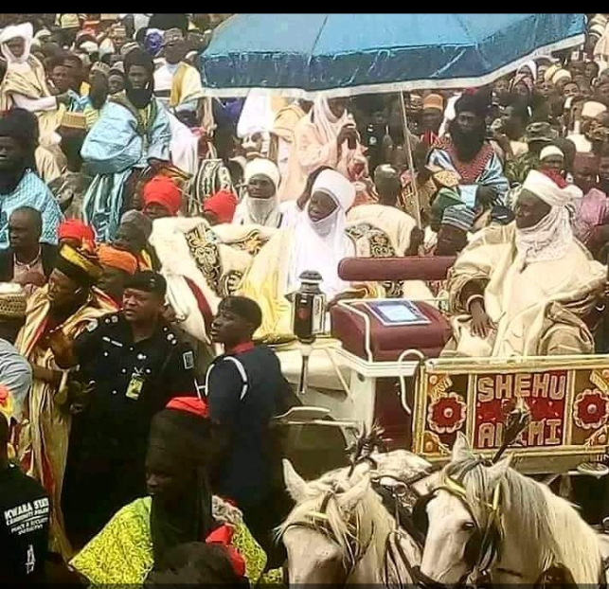
Emir of Ilorin’s Procession to Eid Praying Ground on the Day of the Festival
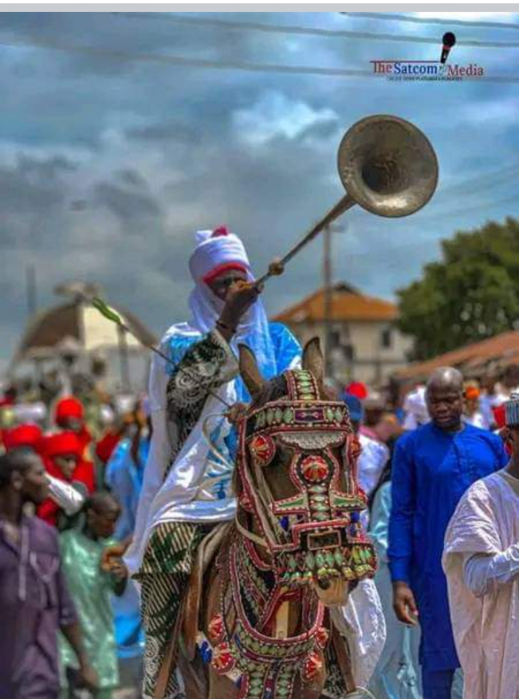
Ilorin Cultural Display at Durbar on the Second Day of Ileya Festival
Economic Activities of Ileya Festival
Ileya festival celebration in Ilorin has been noted for a number of economic activities that sprang up during the period. The notable among the economic activities included the following:
Ram Business
Ram selling was a prominent business during Ileya festival in Ilorin. It was a Fulani/Hausa dominated business up to 2010, even though there were few Ilorin indigenes that were involved in the business. The Hausa/Fualni ram sellers were situated at Sango Cattle/ram market of Ilorin where majority of the people used to buy rams for the festival until April 10, 2010 when the government relocated the market to Oke Ose, Ilorin East Local Government Area of Kwara State and renamed it Zulukarnani Cattle Market²⁰. After 2010, ram business has become major trade amongst some Ilorin youths. They sometimes went to the Northern part Nigeria to buy rams for onward sale in Ilorin while some of the youths bought rams few months before the festival and took good care of them for the purpose of selling them during the festival. The display of rams for sale in almost every available and conspicuous fields, spaces and roundabouts within Ilorin gave credence to the above claim²¹. 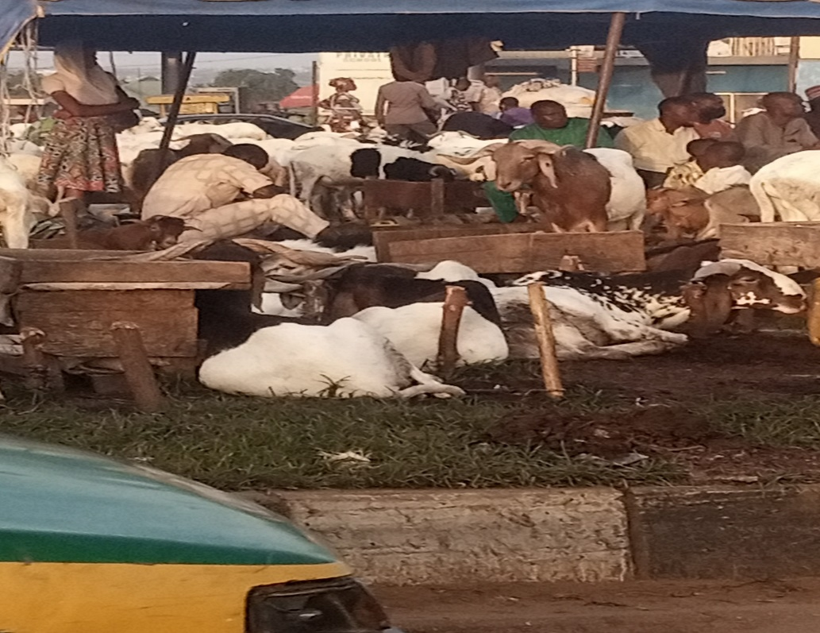
Rams Display for Sale at Adeta Roundabout, Ilorin with their Ilorin Youths Sellers

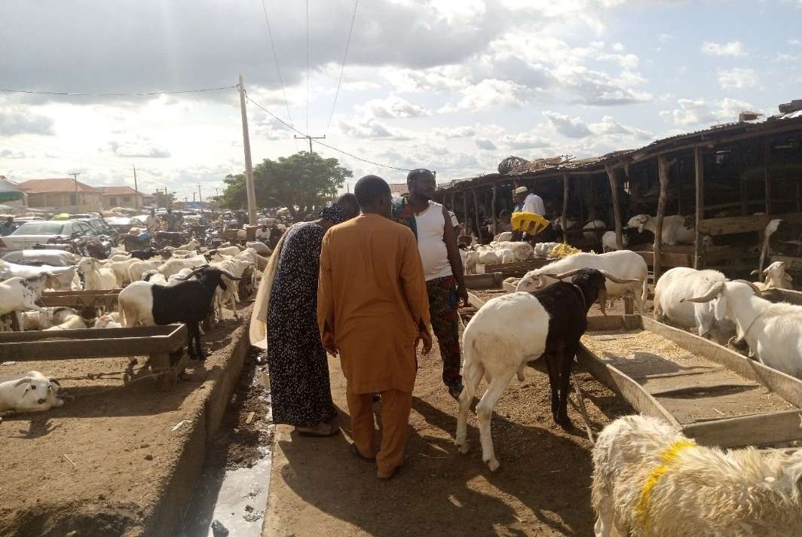
Market Bargaining at Mandate Ram Market, Ilorin

Brokerages
Many people who could speak Hausa/Fulani and Yoruba languages in Ilorin were in the various ram markets acting as brokers or intermediaries between Hausa/Fulani ram sellers and Yoruba buyers who did not understand Hausa language. They helped in negotiating on behalf of the buyers for the purpose of collecting monetary rewards called la’ada i.e broker’s fee for their services²². These intermediaries were known as Ba’ale (the hosts), they were the indigenes of Ilorin who played the role of hosting the ram sellers by preparing where they settled the ram sellers and their animals. The la’ada was the commission of a fixed amount of money, usually five hundred naira, on any ram bought at the market that the Ba’ale used to collect from the buyers. It should be stated here that, there were many people at the markets who were not the hosts but were only in the markets to help in negotiating on behalf of the buyers by speaking Hausa language to the Hausa ram sellers. The monetary reward given to those people were not la’ada but just a gift because such a monetary reward was on humanitarian ground and not by right²³.
Apart from the above, a number of commercial activities also sprang up in and around the major cattle/ram markets in Ilorin such as Oke Ose, Mandate, Oko Olowo and Ipata cattle/ram markets during the Ileya festival. These activities included selling of fodders and other animals’ food, rope, human consumables such as food, water, soft drinks and cigarettes, amongst others.
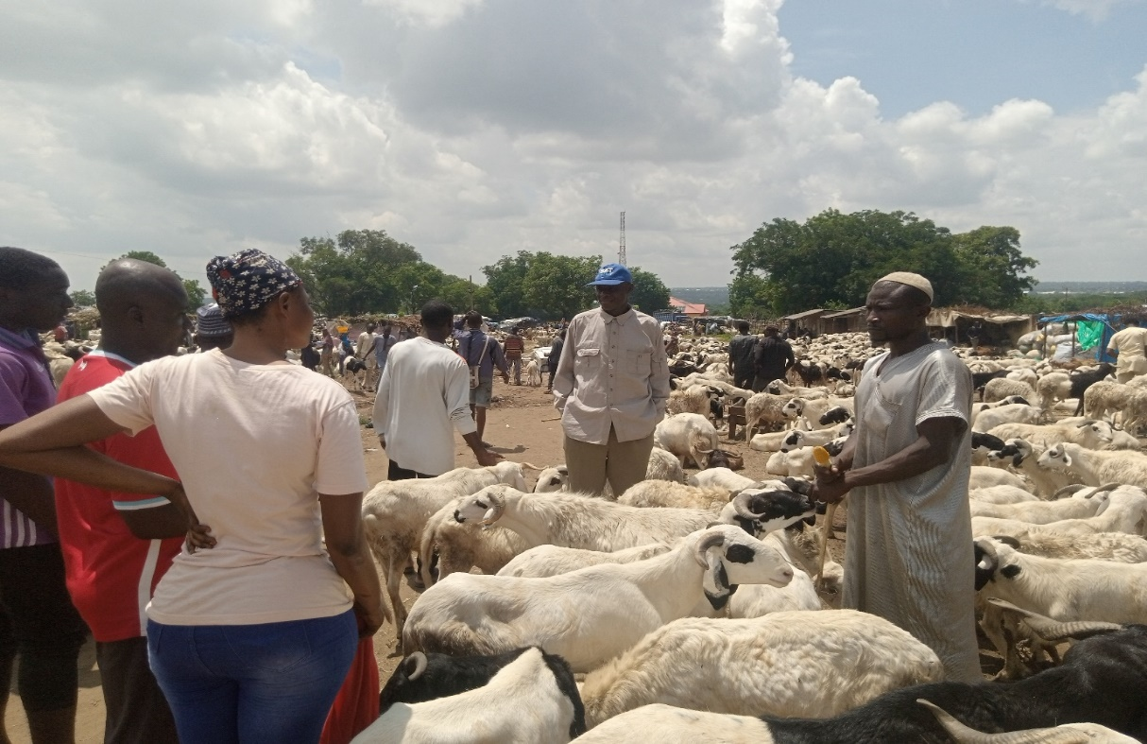
Ram Market Bargaining or Pricing at Cattle/Ram Market, Oke Ose, Ilorin
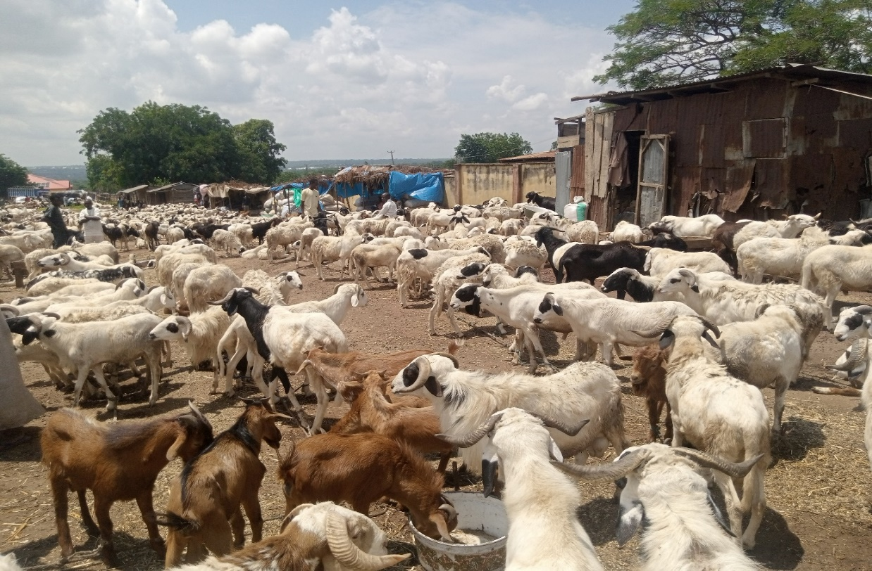
Rams Displayed For Sale at Oke Ose Cattle/Ram Market, Ilorin
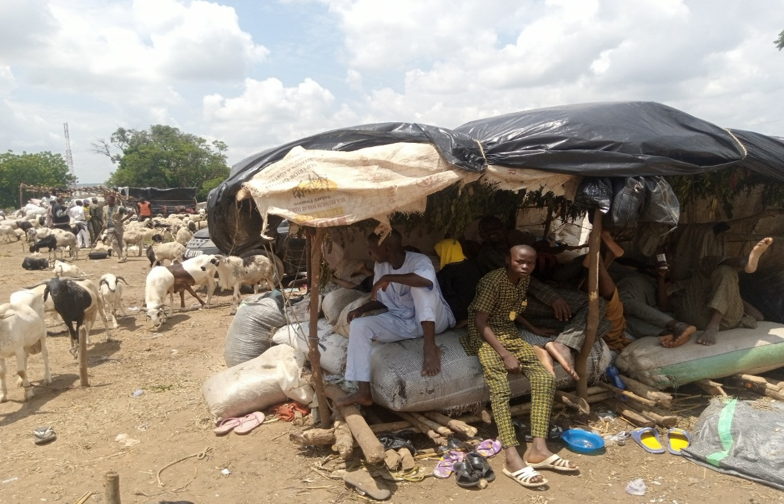
Hausa/Fulani Ram Sellers at Cattle/Ram Market, Oke Ose, Ilorin

Momentary Buying and Selling at the Eid Praying Ground and its Environs
A large number of petty traders and hawkers used to market their items in and around the Eid prayind ground on the day of the festival. Thus, buying and selling of different consumables such as foods, water, snacks, ice-cream and soft drinks, amongst others always took place in and around the Ilorin praying ground on the day of Ileya festival, this commercial activities only lasted for the period of the prayer which was not beyond four hours on the whole²⁴. Selling and buying of toy decorative or ornamental objects like eye glasses, wrist watches, earrings and toy guns, amongst others for children were also part of the brief businesses on the day of the festival and this has been regarded as annual business for some of the people that were involved²⁵.
Impact of the Economic Activities
Ram selling as an annual business by many Ilorin youths has provided employment opportunities for unemployed ones among them and those that needed to have more sources of income. Many of the indigenous ram sellers who did not have jobs before venturing into the business were meeting their end needs as result of their involvement while those that entered the business with the intention of more sources of income did not regret their involvement in the annual ram business²⁶.
The involvements of people in brokerages at ram markets by the ways of interpreters, intermediaries and hosts have afforded the people who could speak Hausa/Fulani and Yoruba languages the opportunity of financial gains during the period of Ileya festival in Ilorin²⁷.
The emergence of other commercial activities in and around the ram markets in Ilorin has provided avenue for petty traders such as sellers of rams’ food, recharge cards, human consumables such as food, cigarettes, water and soft drinks, amongst others to sell their goods/items and they made considerable profits during the festival²⁸. There was an upsurge of transportation of people and goods and services within, outside and into Ilorin during the period of the festival and this had greatly enriched the pockets of the commercial vehicle owners and operators. Petrol and kerosene sellers too were not left out of the Ileya gains as more people bought petrol for transportation, and kerosene for burning of the Ileya sacrificial rams’ furs²⁹. The artisans also benefited from the festival because tailors, barbers, hairdressers, cobblers and cap washers, amongst others experienced high patronages when the festival was approaching³⁰.
Government equally generated more revenue during the festival in Ilorin because Local Government revenue officials were stationed in the cattle/ram markets to collect charges of five hundred naira for the government on every animal bought in the markets and issued receipts for the charges³¹
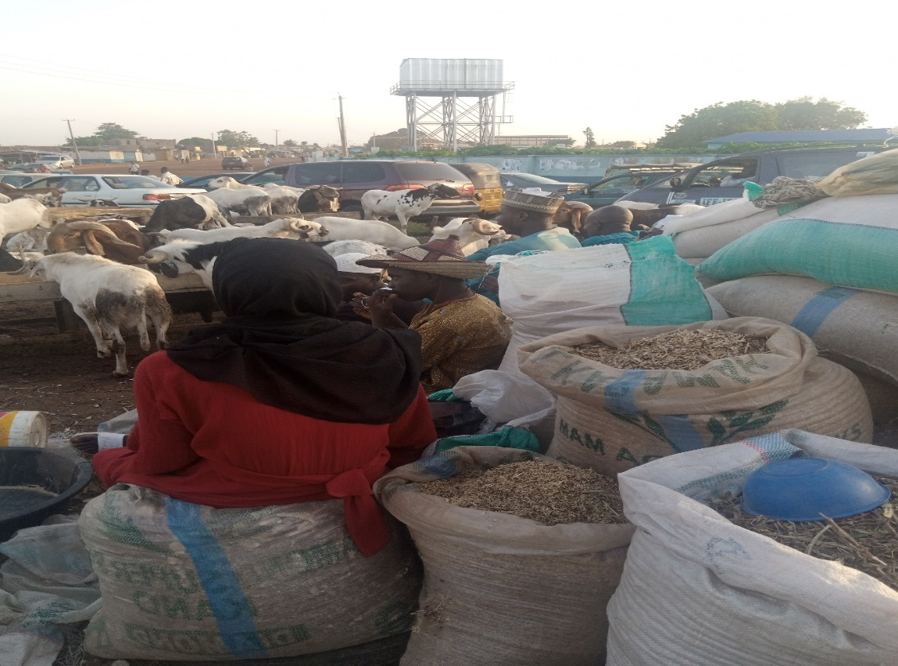
Ram Food Seller Displaying her Market at Adeta Roundabout Ram Selling Spot, Ilorin
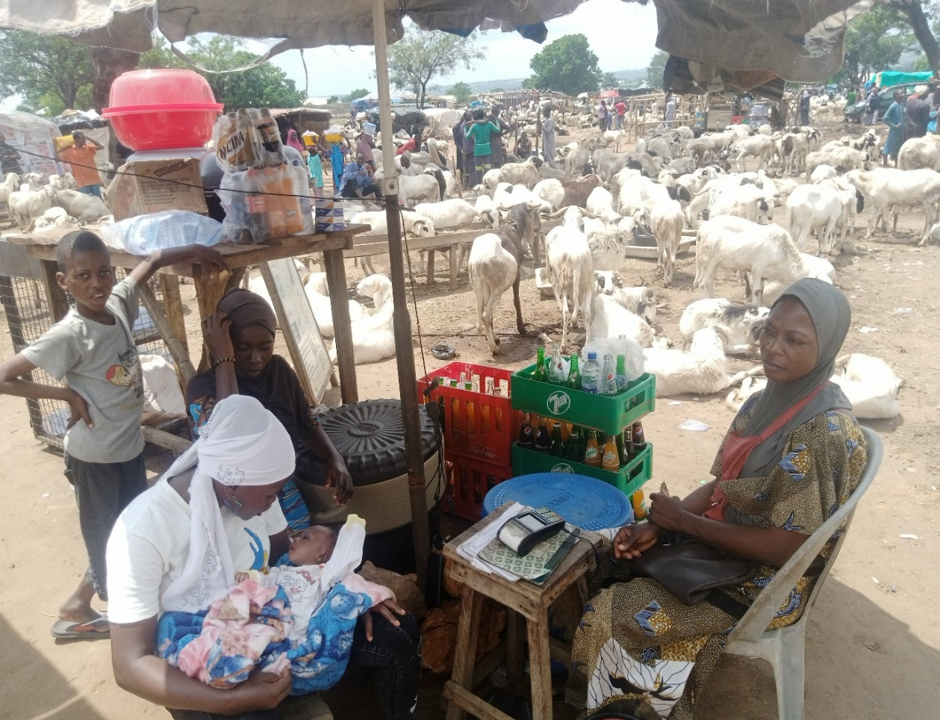 Traders Selling Soft Drinks, Water and Recharge Card, Amongst Others at Cattle/Ram Market, Oke Ose, Ilorin
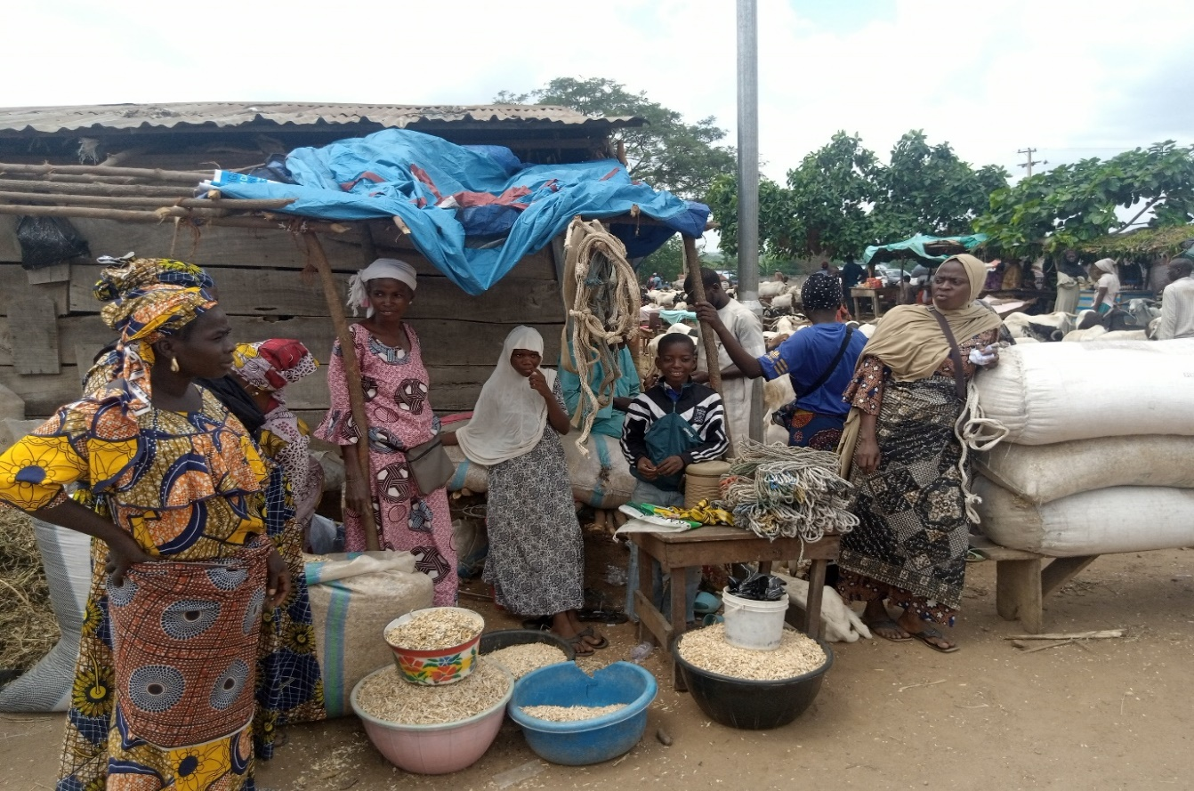Ram foods and Rope Sellers at Cattle/Ram Market, Oke Ose, Ilorin
Conclusion
Ileya festival is a Muslim festival called Eid-l-Adha which involves slaughtering of rams. It was celebrated in Ilorin with pump and pageantry as many sons and daughters usually came home from far and near to celebrate the festival. The festival stirred up many socio-economic activities, which had become part of the cultural practices of the people. The social activities such as Ileya ram grazing and fighting competition, Eid prayer, communal animal butchering and sharing have brought about some impacts like promotion of inter or multi-ethnic interactions or relations between the Hausa/Fulani ram sellers and the Yoruba buyers. The social activities have also led to unity and love due to the annual family gatherings in Ilorin during the festival
Economically, ram selling business, brokerages, and buying and selling in and around the ram markets as well as the Eid praying ground on the festival day have positively impacted the people by providing them employment opportunities and enrichment of their pockets. The artisans and government equally benefited from the festival because the artisans’ patronages increased during the period while Local Government collected charges as revenue on every ram bought at the markets.

References
- Merriam-Webster dictionary
- Quran Chapter 108 Verse 2
- Quran Chapter 37 Verses 102-107
- Suleiman, A. A. and Adeshina, L., “A Historical Appraisal of the Celebration of Ileya (‘Id Al-Adha) Festival in Ilorin Emirate in Contemporary Time”, Ilorin Journal of History and International Studies, University of Ilorin, Vol. 9 No. 1, 2019, PP.84
- Why Yoruba elders call Eid-ul-adha Ileya: https://iwitness.com.ng accessed on 17/06/2022
- Why Yoruba elders call Eid-ul-adha Ileya: https://... accessed on 17/06/2022
- Oral Interview: Alhaji Abdulrahman Baba Alabere, an elderly man, 18/06/2022 Alabere Compound, Ita Egba, Ilorin, age 78 years
- Suleiman, A. A. and Adeshina, L., “A Historical Appraisal of the Celebration of Ileya (‘Id Al-Adha) Festival in Ilorin Emirate in Contemporary Time”,…PP.85-87 and Oral Interview: Alhaji Abdulrahman Baba Alabere, an elderly man, as previously cited
- Oral Interview: Ismaila Akaje, Charman, Ode Alfanda/Ode Sarumi Ram Selling Ground, Ilorin, 01/07/2022, Ode Sarumi, Ilorin, age 60s years
- Oral Interview: Woli Onagun Yusuf (Baba), Civill Servant, 01/07/2022, Onagun Compound, Ilorin, age 50s
- Suleiman, A. A. and Adeshina, L., “A Historical Appraisal of the Celebration of Ileya (‘Id Al-Adha) Festival in Ilorin Emirate in Contemporary Time”…, PP.87-89
- Oral Interview: Rauf Garuba, Member of Ram Lovers Association, 26/06/2022, Kwara State, Kwara State Stadium Complex, Ilorin, age 49 years
- Hijrah Muslim or Islamic Calendar
- Hadith No.5242 of Bukhari Collection
- Oral Interview: Mallam Hidru Yusuf , Civil Servant and Onagun Compound Ram Slaughterer, 08/07/2022, Onagun Compound, Ilorin, age 46 years
- Oral Interview: Mallam Hidru Yusuf, Islamic Teacher and Onagun Compound Ram Slaughterer, as previously cited
- Oral Interview: Alhaja Ramata Ishola Akaje, an elderly woman, 12/06/2022, Akaje Compound, Ilorin, age 68 years
- Oral Interview: Alhaja Ramata Ishola Akaje, an elderly woman, as previously cited
- Why Yoruba elders call Eid-ul-adha Ileya: https://..., accessed on 17/06/2022
- Oral Interview: Alhaji Jimoh Muhammed Dan-Mairomu, Chairman, Zulukarnani Cattle/Ram Market, Oke Ose, Ilorin, 02/07/2022, Chairman’s Office, Zulukarnani Cattle/Ram Market, Oke Ose, Ilorin, age 60s
- Eye witness and observations of the researcher
- Oral Interview: Alhaji Jimoh Muhammed Dan-Mairomu, Chairman, Zulukarnani Cattle/Ram Market, as previously cited
- Oral Interview: Ismail Hassan, Ba’ale (host), Zulukarnani Cattle/Ram Market, Oke Ose, Ilorin, 01/07/2022, Oke Ose Cattle/Ram Marktet, Ilorin, age 45 years
- Eye witness and observations of the researcher
- Eye witness and observations of the researcher
- Oral Interview: Alhaji Abdulkadir Imam, Ram Seller, Ode Alfanda/Ode Sarumi Ram Selling Ground, Ilorin, 01/07/2022, Ode Sarumi, Ilorin, age 58 years
- Oral Interview: Alhaji Jimoh Muhammed Dan-Mairomu, Chairman, Zulukarnani Cattle/Ram Market, as previously cited
- Oral Interview: Alhaja Aishat Sulaiman, Ram Food Seller, Zulukarnani Cattle/Ram Market, Oke Ose, Ilorin, 01/07/2022, Oke Ose Cattle/Ram Marktet, Ilorin, age 42 years
- Oral Interview: Mr. Giwa Ibrahim, Manager M. M. Filling Station, Agbo-Oba, Ilorin, 03/07/2022, Agbo-Oba, Ilorin, age 36 and Oral Interview: Ahmed Kareem Ajetunmobi, Transporter, Ifesowapo NURTW 1, Ajase Park, Gambari, Ilorin, 06/07/2022, age 45 years
- Oral Interview: Alhaji Jimoh Ayinla Adeshina, Chairman, Kwara State Artisan Congress (KWACO), 22/07/2022, Kwara State Artisan Congress Office, Ga’a Akanbi, Ilorin, age 55 years
- Oral interview: Seriki Saheed Babatunde, Ilorin East Local Government Revenue Consultant, 02/07/2022, Zulukarnani Cattle/Ram Market, Oke Ose, Ilorin, age 43 years

