Perspective of Neighbourhood Preference: A study of Ilorin city, Nigeria.
Abdulraheem Maimuna O.
Department of Urban and Regional Planning, University of Ilorin, Nigeria
Olorunfemi Jacob F.
Department of Geography and Environmental Management, University of Ilorin, Ilorin, Nigeria.
Ajibade L. T.
Department of Geography and Environmental Management, University of Ilorin, Ilorin, Nigeria.
Agava Y. H.
Department of Estate Management, University of Ilorin, Ilorin, Nigeria.

CORRESPONDING AUTHOR
Dr. (Mrs.) Abdulraheem Maimuna Orire.
Department of Urban and Regional Planning,
University of Ilorin, Ilorin, Kwara State, Nigeria.
abdulraheem@unilorin.edu.ng
+2348033801012

ABSTRACT
Previous studies have long-established a strong relationship between the neighbourhood and the kind of environment to which an individual has been exposed and life chances available to him. Attributes of neighbourhoods and the experiences provided have been found to affect people’s capabilities in terms of their ideas, achievements in life, as well as their socio-economic development. This has made studies on neighbourhood preferences attractive. The present paper is an attempt to identify the category of and preference for neighbourhoods by residents in Ilorin, Kwara State, Nigeria. Data used were collected through a systematic random sampling of 334 households with the aid of structured questionnaire. Simple percentages, graphs and charts were used in data analysis and presentation. Findings of the study revealed that neighbourhood preference is not dependent on socio-economic status. Irrespective of background, the high income residential area (GRA) is the preferred place to live by the respondents.
KEYWORDS: Neighbourhood, Urban, Preference, Environment.

1.0 INTRODUCTION
The importance of neighbourhood to city dwellers cannot be overemphasized. Where people live affects their health, economic, social and mental well-being. Moreover, choice of a place of residence is an important marker of a person’s social status. There is an increasing concern about the quality of life in modern towns and cities around the world hence, the increasing interest among built environment professionals and policymakers on how to measure those factors that influence neighbourhood choice by residents. Individuals with a varied cultural background may live in a neighbourhood and yet share similar views regarding environmental features. Some urban researchers argued that residents’ preferences and evaluation of their neighbourhood vary as a result of the diversity in their senses of judgment as well as their individual lifestyles. Universally, improving the residential environment has become one of the fundamental goals of urban planners and policy makers, hence a motive for this research.
1.1 Statement of the Problem
Whereas residential mobility and neighbourhood preferences impact on urban growth and change, neighbourhoods do not share the same level of infrastructure and environmental quality as well as the residents who reside in them. Rapid urbanization coupled with the expansion of towns and cities in Nigeria has brought about continuing competition among people for the most desired locations. However, everyone cannot live where they would prefer to live due to several limiting factors. Nevertheless, availability of information on preference for neighbourhood and residential types has a lot of implication for planning and urban management. This study aims at examining neighbourhood characteristics and preference among the residents of Ilorin metropolis, Kwara state, Nigeria.
1.2 Objectives of the Study
The objectives of the study are to:
- evaluate the residential types and neighbourhood that are available; and
- identify the residential types and neighbourhoods that are preferred by households.
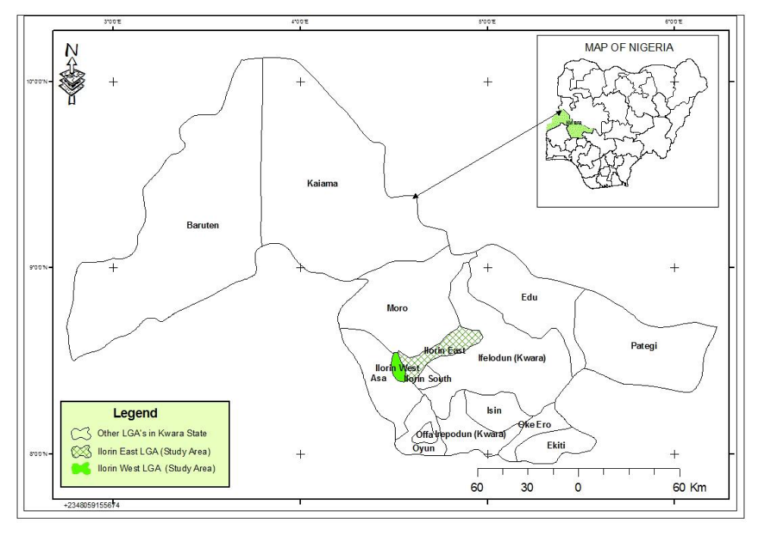Figure 1: Map of Kwara State Showing the Study Area (Ilorin).
Source: Ministry of Housing and Urban Development, KW/ST

1.3 The Study Area
The location of Ilorin, Kwara State capital is on the intercept of Latitudes 8⁰ 30’ and 8⁰ 50’ North of the Equator and Longitudes 4⁰ 20’ and 4⁰ 35’ East of the Greenwich Meridian. The city serves as the link between the Northern and Southern parts of Nigeria. Oyebanji (1994) described Ilorin as the socio-cultural, religious and political meeting point of Nigeria. Bounded by Niger State to the North and Ifelodun L.G.A to the West, Ilorin shares a boundary with Oyo State on the Southern end (Fig.1). Situated 500km from Abuja the city has an approximate land mass of about 100sq km and is populated by diverse people with different cultural backgrounds (Kwara State Gazette, 1991) e.g. Yorubas, Nupawas, Baribas, Hausas, Gwaris, Kemberis and Fulanis. However, the population of the Igbos and people from the Eastern part of Nigeria has increased drastically in recent times. Indeed, tribal heterogeneity and cultural diversity are well pronounced in the state, to an extent that Ilorin can aptly be referred to as a microcosm of Nigeria. The cultural plurality of Ilorin makes it easy for many Nigerians to find a niche within this dynamic city without much stress.
2.0 LITERATURE REVIEW
2.1 Defining Neighbourhood
Neighbourhood is a term often used to describe the sectors of urban or rural places such as cities, towns and villages. Berk (2004) defined a neighbourhood simply as the vicinity in which people live. The motives for communal living are usually for economic, sociological and psychological reasons. Neighbourhoods usually have some specific social or physical characteristics distinguishing them from the rest of the settlement, while they vary in population and density. Duany et al (2003) explained that size of a neighbourhood is limited, so that majority of the population is within walking distance of its centre where needs of daily life are easily satisfied.
Neighbourhoods offer facilities for transit stops, work places, police posts, retail community events and leisure activities in addition to providing places for primary and post primary education. The streets provide alternate routes to most destinations for both vehicles and pedestrians. Furthermore, the development of neighbourhood is often incremental in form or pattern and therefore one finds a mixture of large and small houses, shops, restaurants, offices, informal activities and so on. Civic buildings such as schools, multipurpose halls, museums, mosques, churches etc. are often placed at the open playground while parks are also provided for the residents’ use (Duany et al., 2003). In a study of the Gautreaux programme, James et al (2002) confirmed that places matter a lot on the life chances available to individuals and families. They further opined that the attributes of, and experiences provided by a neighbourhood, have profound effects on a person’s capability and his idea about what can be accomplished. Indeed, it has been stated that neighbourhoods where poor people concentrate isolate their residents from the resources and networks they require to attain their full potentials. This, by extension deprives the larger community of the human capital resource of such neighbourhoods. A good neighbourhood should create a better environment for safety, health, aesthetics, comfort and general welfare of the inhabitants.
2.2 Impact of Neighbourhood Environment on Residents
The quality of life of residents of any given neighbourhood depends on socio-economic, environmental and cultural factors, as well as physical conditions and spatial characteristics of such neighbourhood. This is why Okusipe (1999) opines that, city layout and aesthetics, land use patterns, population and building densities, transportation and ease of access of residents to basic goods, services and infrastructures impact on the liveability of settlements. Many households in any given city wish to live in good quality houses, in safe neighbourhoods that provide amenities which ameliorate the stress of urban living (Clark W.A., Deurloo M. C. & Dieleman F.M., 2004). Parks and green spaces are aspect of the environment that makes it attractive likewise the presence of peaceful, crime-free and clean surroundings. Ellen and Turner (1997), argue that the conditions of any given neighbourhood go a long way in shaping individual outcomes. The fact is that people want to live in decent neighbourhoods and to have their children growing up in a safe environment because growing up in an unhealthy neighbourhood could reduce the life chances of those children (Clark W.A. et al, 2004). Consequently, attention to the environmental quality of neighbourhoods and the impact it might have on the wellbeing and health of residents is increasing.
2.3 Factors that Influence Neighbourhood Desirability
The decision of a household on whether to move or not, the choice of a suitable destination within affordability and the ability to actually relocate are the primary issues that often govern residential location or relocation. Residing in a good residential neighbourhood has several advantages, but it is uncommon to have a neighbourhood that has all the good characteristics, and this explains why different people choose different kinds of neighbourhoods to live in. It has been argued that the choice of a particular neighbourhood is majorly the result of the desire to live in a specific type of dwelling, taking into account its tenure, size and price (Lina Bergstrom, Maarten Van Ham & David Manley, 2010). Nowadays most people are concerned with the safety of their home and family when choosing of where to live, because of the high crime rate in many cities. A good neighbourhood to such homes must have lower incidences of thefts, burglaries etc. Neighbourhoods that are characterized by improved accessibility, proximity to means of public transportation, shopping, places of worship, recreational areas and schools are often in demand. According to (Galster, 2003), the closer a resident is to an unwholesome neighbourhood; the more likely it is that he will be affected by it. Studies have established that there are push and pull factors that determine the reason why residents live in a certain neighbourhood. The choice of neighbourhood can also be a function of, but not limited to, availability of employment, business opportunities, access to education, cultural or recreational opportunities and microeconomic factors such as disposable income, and access to finance. People also prefer associating with natural and aesthetically appealing environment. Lina Bergstrom, Maarten Van Ham & David Manley, (2010) in their study observed that the choice of a particular neighbourhood is equally influenced by the desire to live in a specific type of dwelling. Neighbourhood characteristics such as reputation, status, population composition and location are also important factors that residents take into consideration in making neighbourhood choices.
3.0 METHODOLOGY
Census data and figures would have been the quickest and most reliable means of gathering information for a research work of this nature, but the dearth of a comprehensive census data in Nigeria has compelled the authors to employ the survey method using the questionnaire. The questionnaire was validated through a pilot survey. In order to determine the minimum sample size, the formula proposed by Snedecor and Cochran (1967), (Jimoh, 1988) was applied to results of the pilot survey. Many well-known formulae, using either the z-distribution (Snedecor and Cochran 1989) or the t-distribution (Sokal and Rohlf 1995) are available for calculating sample size at different levels of statistical power when testing differences in means with two independent samples. The Snedecor and Cochran (1967) formula was employed for the purpose of this research work. The formula goes thus:
L = 2 σ √n (n= size of preliminary survey)
n = (4σ²/L² at 95% level of probability).
n = (6.6σ²/L ² at 99% level of probability). Where;
n = minimum sample size.
σ= standard deviation.
L = limit of accuracy of estimated mean.
Source: Adapted from Jimoh, 1997.

3.1 Method of Data Collection
334 questionnaire forms were administered using the systematic random sampling technique.
According to Oshungade (2013), random sampling would not only allow for detailed planning and execution of sample surveys, but will also enable the parameters obtained with adequate sample size to represent the target population. Observations made during the during reconnaissance survey enable the entire study area to be sub-divided into the following four zones:
Zone H: High Income Earners Residential Area, comprising Adewole Estate, Mandate Estate, G.R.A, Fate, Agba-Dam New G.R.A.
Zone M: Medium Income Earners Residential Area, comprising Unity, Agbo-Oba, Post Office, Offa Garage, Harmony Estate.
Zone L: Low Income Earners Residential Area, comprising Okelele, Ode Alfa-Nda, Pakata, Kulende Estate.
Zone C: Combined (Mixed) Income Earners Residential Area, comprising Tanke, Oko-Erin, Sabo-Oke, Osere, Asa Dam.
A sample of one in fifteen dwellings recommended for urban centre of comparable size as Ilorin (Burton, 1970) was used along the main streets of Ilorin. Out of a total of 334 households that were selected for this study, 303 households provided useful data. Simple percentage distribution was adopted in the analysis relating to investigations of neighbourhood preferences in Ilorin.
(a) Zone H – Residential Zones:
The very highly educated civil servants, politicians and business men who are the high income earners reside in this zone. They are very rich and can afford most of the basic comforts and luxuries of life. These residential areas are clean and noise free. They have adequate green covers and are normally owner – occupier. There are lots of trees, shrubs and flowers in this area when compared with all the other zones in the city. The houses here are built on large and spacious compounds with tall fence cordoning them. The areas are well planned with adequate infrastructure and site and services. There is the absence of open gutters or refuse dumps and the architectural designs of buildings are very modern and can be compared to those found in other developed nations. The road network and refuse disposal methods are modern and good. This area includes the exclusive Government Reserved Area (G.R.A.),which initially housed the colonial masters but later converted to residence for the high class government workers and the wealthy families (See Plates 1.1 to 1.2).
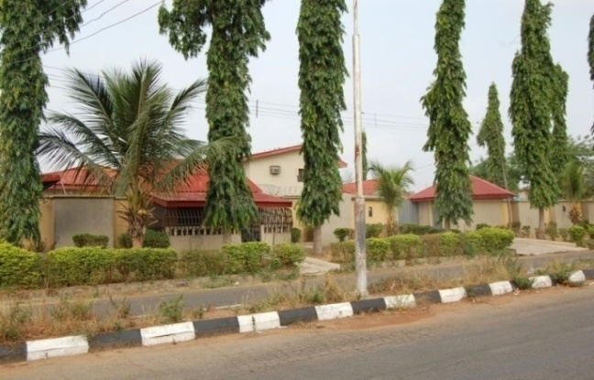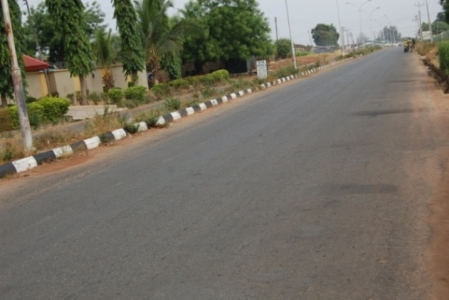
Plate 1.1: Wall Fence around Private Plate 1.2: Good Road Network in Zone H.
Residence H

(b) Zone M – Residential Zones:
Zone M is residence for the medium income earners, who could be classified as the educated middle class, civil servants, business men or traders. There is a concentration of the regular 2/3 bedroom bungalows while tenement storey buildings are also common in this area. The environment is generally well maintained, though not as clean (Plates 1.3 and 1.4) as Zone H, but with wider roads than those found in Zone L. The houses usually have in-built taps and water cistern toilets facilities though infrastructure exist for pipe-borne water, often times, water does not runs from these taps as residents can be seen moving around with carry jerry-cans and buckets to fetch water from nearby boreholes or hand-dug wells.
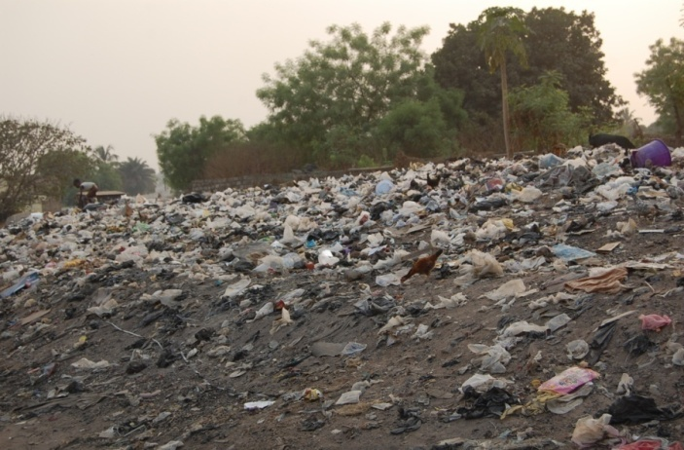
Plate 1.3: Open Refuse Dump Site in Zone M Plate 1.4: Blocked Drainage in Zone M.

c) Zone L – Residential Zones
This is the area where majority of the low income earners reside. The main features of this zone are high density buildings closely spaced, basically built with mud or plastered mud and of the old traditional architecture. Hand dug well is the commonest source of water except for a few bore holes sunk by the government. The layout is not planned but follows the old traditional pattern with narrow roads and foot paths. Pit latrine is the most common form of toilet facility available, while open gutters and large heaps of refuse are common. One prominent characteristic of this zone is the complete absence of walled fence around individual houses unlike in the high income residential zone. (Plate 1.5and 1.6)

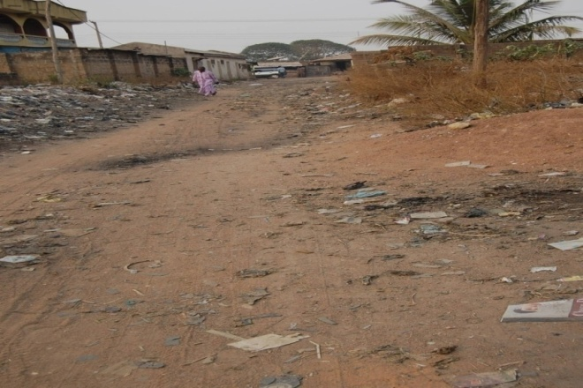
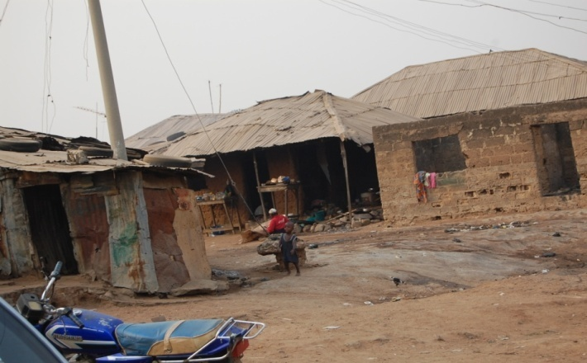 Plate 1.5: Road Network in Zone L. Plate 1.6: Houses in some parts of Zone L.

d) Zone C - Residential Zones:
This zone combines features of two or more of all the three zones earlier mentioned. Therefore it was labelled “Combined” Residential Zone. This particular neighbourhoods seems to have a relative mixture of all types of income groups (Low, medium and High). There isn’t any clear-cut demarcation between the different residential areas, housing the different income groups (Plates 1.7 and 1.8)
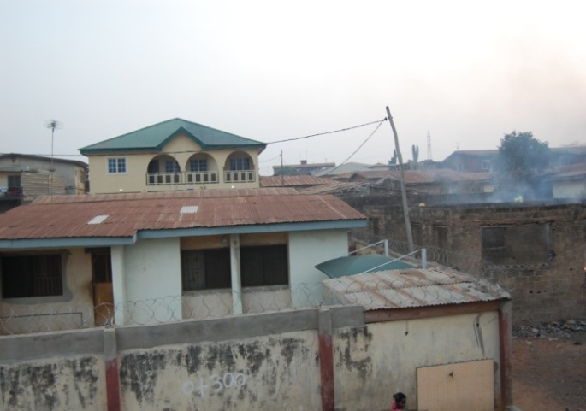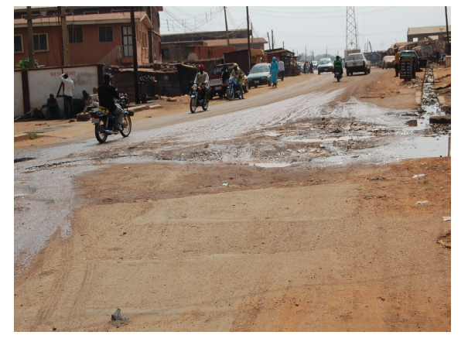
Plate 1.7: Residential Type in Zone C. Plate 1.8: Road Network in Zone C
4.0 RESULTS AND DISCUSSION
The residential type preferred by residents of Ilorin city is the two or three bedroom bungalow. It would be expected that the neighbourhood preferred by the inhabitants will follow suit, but this study revealed that it does not.
The results showed that out of 303 households, 116 of them (38%) had preference for the high income residential neighbourhoods (Table 1). The level of preference for the medium income zones and combined zone were almost the same. About 23% of the respondents had preference for medium income neighbourhoods while 22% had preference for the combined residential neighbourhoods (Table 1). Seventeen percent (17%) of respondents had strong preference for the low income residential neighbourhood (Table 1). In a rather strange development it was observed that 98% of residents of the low income neighbourhood had no intention of moving to any other neighbourhood other than the neighbourhood where they presently live. When probed further on if they were forced to change residence, they maintained that their preference would still be for other areas within the neighbourhoods accommodating the low income earners (Zone L). The reasons adduced for such a resolution by respondents, included responses such as “we understand our people”, “we are happy” or “we are comfortable”. This response is in contrast to that of the 68% of the residents living in either the medium or combined residential zones, who indicated future ambition to relocate to other residential zones other than where they presently live. Could this be a confirmation of the saying that the poor are usually happier and more contented than the rich members of the society? Or could it be the effect of the communal living pattern widespread in the low income neighbourhoods enhanced by absence of walled fenced cordoning individual residence? This could be left for future research.

Table 1: Most Preferred Neighbourhood in Ilorin Metropolis
 |  | Frequency | Percent %
 | Zone C (combined ) | 68 | 22.4
 | Zone H (high income) | 116 | 38.3
 | Zone L (low income) | 50 | 16.5
 | Zone M (medium income) | 69 | 22.8
 | Total | 303 | 100.0
Source: Author’s Survey Analysis, 2013.
5.0 CONCLUSION AND RECOMMENDATION
Findings of this study revealed that irrespective of ethnic background or level of income, the high income residential neighbourhood is the preferred place to live by majority of residents. In other words, environments close to nature, clean and beautiful. A home that is spacious surrounded with adequate green cover in the form of trees, shrubs, lawns, flowers and green areas. This is how neighbourhoods in zone H appear. More importantly, the study also revealed that neighbourhood preference is not dependent on socio-economic status.
The following actions are hereby recommended;
    - Concerted efforts should be made government and the inhabitants to re-create the kind of layouts existing in the high income residential zones in all other neighbourhoods within the city especially areas that are being newly developed.
- Urban renewal projects should be embarked upon by the government targeting the low income neighbourhoods mostly within the core traditional areas. However serious efforts should be made to preserve the traditional form and character of this area. The natural and cultural heritages of the traditional area are great features that must be preserved for the sustainability renewal projects.
- Massive campaign and sensitizations of the populace should be set in motion by government and non - governmental organizations. Citizen participation is vital in order to ensure that whatever projects government implements would be supported by the ultimate end users, without which the proposals might be put to wrong use or even ignored.
- Creation of green open spaces and enforcement of urban planning standards is needed to replicate the high income residential neighbourhood type in all parts of the city. This offers a means of peaceful getaway to residents from the bustle of city life. Probably it may reduce the incidences of violence, insecurity and youth unrest which has gradually infiltrated daily existence in the once peaceful traditional area of Ilorin.
REFERENCES
Abdulraheem M. O., Olorunfemi J. F. and Muhammad-Lawal A. (2014). ResidentialMobility Behaviour of Households in Developing Nations: A Case Study of Ilorin, Kwara State, Nigeria. Journal of Sustainable Development in Africa (Volume 16, No.8, 2014). Pennsylvania.
Berk, M. G. (2004). The Concept of Neighbourhood in Contemporary Residential Environment: An Investigation of Occupants’ Perception. Turkish Housing Survey.
Clark, W. A. V. Duerloo R.C. and Dieleman F. M. (2004). Residential Mobility and Neighborhood Careers. In :Goetgeluk R. and Musterd S.(eds.) Beyond Residential Mobility: Linking Residential Choice and Urban Change. Open House International. 30:3
Duany, Z. A., Duany, A., Zyberk – Plater, E. and Alminana, R. (2003). The New Civic Art: Elements Of Town Planning, New York, and Rizzoli.
Ellen I. G. and Turner M.A. (1997). “Does the Neighbourhood Matter? Assessing Recent
Evidence.” Housing Policy Debate 8(4): 833-66.
Galster, G. C. (2003). Neighbourhood Dynamics and Housing Markets. Housing Economics and Public Policy, 153-171. http://olabout.wiley.com/WileyCDA/Section/id-406090.html.
Gbakeji J. O. (2006). The Structure of Intra-Urban Residential Mobility and Neighbourhood Preferences in the Warri Metropolis Delta State, Nigeria. Ph.D. Thesis (Unpublished) Ekpoma: Ambrose Alli University.
James, E. R., Lisa, R. and Stafanie, D. (2002). How do Places Matter? The Geography of Opportunity, Self – Efficacy and a Look inside the Black Box of Residential Mobility. Housing Studies 17(1):71-82.
Jimoh, H. I. (1997). Individual Rainfall Events and Sediment Generation on Different Surfaces in Ilorin, Nigeria. Ph. D. Thesis University of Ilorin.
Julius O.G. and Ojeifo O.M. (2007). Aspects of Residential and Neighbourhood Preferences in the Warri Metropolis, Delta State, Nigeria. Research Gate. https://www.researchgate.net/publication
Kwara State of Nigeria (1985-1991). Official Gazette. Government Press.
Lina Bergström, Maarten van Ham, Manley David (2010). Neighbourhood Choice and Neighbourhood Reproduction, IDEAS http://ftp.iza.org/dp5238.pdf
Oshungade, I.O. (2013). The art of everyday sampling – 121st Inaugural Lecture of University of Ilorin, Library and Publication Committee, University of Ilorin Nigeria.
Oyebanji, J. O. (1994). “Kwara State”. In Udo, R. K and Mamman. A. B (eds.) Nigeria, Giant in the Tropics. State Surveys. 0012. Gabumo Publishing Co. Ltd. Lagos, 283-289.
Snedecor, G. W. and Cochran, W. G. (1967). Statistical Methods. The Iowa State College Press, Iowa.
Sokal, R. R. and Rohlf, F. J. (1995) Biometry: The Principles and Practice of Statistics in Biological Research. 3rd Edition, W.H. Freeman and Co., New York.
http://wwps.prenhall.com/ca_ph_eaton_microecon_6/22/5850/497719.cw/index.html.

