UNIVERSITY OF ILORIN
THE TWO HUNDRED AND THIRD (203RD) INAUGURAL LECTURE
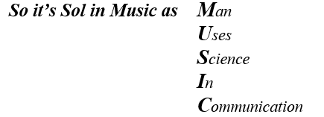
Courtesies
The Vice-Chancellor,
Deputy Vice-Chancellor (Academic),
Deputy Vice-Chancellor (Management Services),
Deputy Vice-Chancellor (Research & Technology Initiative),
Honourable Members of the Unilorin Governing Council present,
The University Registrar,
The University Bursar,
The University Librarian,
Other Principal Officers of the University of Ilorin,
The Provost of the College of Health Sciences,
Deans of Faculty, (especially my own Dean, the Dean of the Faculty of Arts),
Dean of the Postgraduate School,
Dean of Student Affairs,
Professors and other members of Senate here present,
Heads of Department,
Other Academic Staff (especially those of the Performing Arts Department),
Non-Academic Staff (especially those of the Performing Arts Department),
Members of my Family – Nuclear and Extended – especially my centenarian Father of 102yrs+,
My Lords Spiritual and Temporal,
Gentlemen of the Press (Print and Electronic),
Great UNILORITES (especially students of the Performing Arts Department – Great PASAITES),
Distinguished Ladies and Gentlemen.

All Glory be to God the Father, God the Son and God the Holy Ghost as I present this 203rd Unilorin Inaugural Lecture, for Great things the Almighty God has done in my life! Apostle Paul says in Romans 8:28 that “all things work together for good to them that love God”
Because, delivering a University Professorial Inaugural Lecture as a quinquagenarian is not a quintessential paradigm as very many had theirs at much younger age; but that it is done at all in one’s life time, is enough reason to glorify God’s name.
Preambles
A chronological review of inaugural lectures from the Performing Arts Department shows that Prof (Mrs.) ‘Zulu Sofola (1991) gave the first; Prof. Ayo Akinwale (2010), the second; Prof Akanji Nasiru (2013) the third; and Prof AbdulRasheed Adeoye (2019) presented the fourth. Thus, this 203rd University of Ilorin Inaugural Lecture is the fifth from the Performing Arts Department and the very first of its kind in the Music Unit. It is also the first to be delivered in any University within Northern Nigeria and also within the North-Central Geo-Political Zone also known as the Middle Belt of Nigeria.
It will interest you to know also that this 203rd Unilorin Inaugural Lecture is the twelfth of its kind nationwide by Professors in the field of Music. Prof Laz Ekwueme (1983) of the University of Lagos delivered the first Inaugural Lecture in Music in Nigeria. Others are: Prof ‘Tunji Vidal (2002) of Obafemi Awolowo University who delivered the second, Prof Richard Okafor (2005) of Enugu State University of Technology delivered the third, Prof Mosunmola Omibiyi-Obidike (2007) of University of Ibadan delivered the fourth, Prof Emurobome Idolor (2014) of Delta State University, Abraka delivered the fifth, Prof Anthony Mereni (2014) of the University of Lagos delivered the sixth, Prof Chris Onyeji (2016) of University of Nigeria, Nsukka, delivered the seventh, Prof Dan Agu (2017) of Nnamdi Azikiwe University, Awka delivered the eighth, Prof ‘Femi Adedeji (2018) of Obafemi Awolowo University, Ile-Ife, delivered the ninth. Prof Josephine Mokwuenye (2020) of the University of Benin delivered the tenth while Professor O. Idamoyibo (2021) of Delta State University, Abraka, delivered the eleventh Music Inaugural Lecture in Nigeria. All previous Inaugural Lectures in the field of music in Nigeria had been on “music theory, music practice, music education, music technology, musicology and the transformative role of music in man. Mokwuenye’s Inaugural Lecture was on the cordial relationship between Music and Theatre while Professor O. Idamoyibo’s inaugural Lecture is on how relevant music is to spirits, humans and national development.
This Inaugural Lecture focuses on the relationship between Music and the Sciences – “Man Uses Science In Communication”. It investigates the very close relationship between Music and the Sciences – Physics, Mathematics, Biology and Health Sciences. Incidentally, as I was preparing this lecture, one of our colleagues’ son who had been admitted and registered to study Physiotherapy willingly opted out to study Music with Physics, Mathematics and Biology at the UNILORIN JUPEB Program. Initially, I wondered what kind of subject combination that was, but on a second thought, I perceived that the boy made a very good choice as I pray that posterity will vindicate and reward him on this wonderful subjects’ combination. He wants to go into Music Technology.
Mr. Vice-Chancellor Sir, I have the imprimatur to do what I am doing now because I refused to be intimidated by whatever circumstances that surrounded me – human, natural and material. I therefore want to start this inaugural lecture by appreciating the Almighty God for helping me thus far in fighting for the course and cause of Music Education right from my days at the Federal College of Education, Okene in 1988 (when I was employed as an Education Officer, later rising through the ranks to a Senior Lecturer) until now. The landmarks had been tremendous. In 1999, I started the Association of Music Educators in Colleges of Education in Nigeria (AMECEN) which later became the Conference of Music Educators of Nigeria (COMEN) and now the Society of Music Educators of Nigeria (SOMEN). In 2001 when the ASUU crisis in Unilorin became very tough, many lecturers left the system. In a bid to prevent another Music Unit from being scraped from a Nigerian tertiary institution (as was done in Rivers state and in University of Lagos some years back) I had to pay the sacrifice of stepping out from FCE, Okene as a Senior Lecturer, to the Music Unit of the Performing Arts Department, University of Ilorin as Lecturer 1, losing about thirty thousand Naira monthly. (According to King Solomon of Old Testament fame, there is time for everything under the sun. In April 1987, Mr. A. K. Rufai had replied to my application that there was no vacancy for me in the Performing Arts Department of Unilorin and in April 2002, the same Mr. A. K. Rufai wrote to invite me for an interview for the regularization of my temporary appointment which had been given to me in November, 2001 as Mr Sunnie Ododo (now Professor) had come to plead with me to come and salvage a moribund Music Unit of the Performing Arts Department). By that act also, I separated from my family as I had to relocate to Ilorin, leaving my beloved wife and children behind. This good deed also made me to incur the wrath of Music lecturers, colleagues, friends, former classmates and mentors who insisted that I should resign my appointment at the University of Ilorin. My refusal to resign attracted sanctions and attacks – academic, physical and spiritual. At a time, I almost lost my life in a fatal motor accident which had been revealed to me in a dream but God delivered me. Thus, I cannot easily forget lawyer Yusuf Ali (SAN) whose chambers took over the case and I was summarily set free from man-slaughter in the case of that accident. All these are now part of history.
The Concept of Inaugural Lectures
Rutherford B. Hayes, the 19th president of the United States of America from 1877 to 1881 stated thus: “We have assembled to repeat the public ceremonial, begun by Washington, observed by all my predecessors, and now a time-honoured custom, which marks the commencement of a new term of the Presidential office”. So, George Washington started Presidential Inaugural Lectures in the United State of America to mark the commencement of his tenure as America’s first president. Thus, in the university parlance, an Inaugural Lecture is a public academic-ceremonial lecture which marks the commencement of a professorial position or chair. An inaugural lecture is, therefore, a key milestone in any academic's career, signifying his promotion to the rank of a “Professor”. It is an opportunity for a new professorial colleague to present his/her innovative research first-hand.
Similarly, we have assembled here to repeat the public (academic) ceremonial, begun by Prof. A. Awobuluyi, observed by all my predecessors, and now a time-honoured custom, which marks the commencement of a newly awarded professorial chair. To the politicians, this should be the time to proclaim all that they would want to achieve hereafter. But as an academic, it is a time to declare verily, not speciously, what one has achieved and also to prognosticate what one should do in the nearest future before exiting the academia. (Suffice it to mention that this Inaugural Lecture should have been held on Thursday, August 27, 2020 but for the COVID-19 and ASUU Strike which halted academic activities all over Nigeria).
My Odyssey into Musicology and Music Education
My call into musicological studies actually began in 1976 at Oleh Teachers’ College Oleh (now St. Michael’s College) where Mr. Aggrey Apena (now Archbishop Aggrey Apena in his 90s) introduced us to the rudiments of Music in Form 3. He taught us Music, using the play-way method shortly before he was transferred to St Joseph’s College in 1978 as Vice-Principal. Another Music teacher took over and, in a sandwich method, prepared us for the TCII Music paper in 1979. Around then, I took over the leadership of Isoko Central Choir, Oro-Oghene Choral and Orchestra Group of the God’s Kingdom Society (GKS) Isoko branch. The Choir had had successful choral performances at various programs of the church. The Choir became very popular in major activities of GKS. The Ekpokro-ile (wooden-slab xylophone in Isoko) was introduced to the orchestra of the choir and it made the performances more interesting and rhythmically melodic such that special invitations were always given to Oro-Oghene Choral and Orchestra Group which I directed then, to perform at every occasion of the God’s Kingdom Society, Isoko branch. So when I eventually got admission to study Music/Religious Studies at the then College of Education (now Delta State University), Abraka, it was not a surprise to my family members although some kicked against it. From there I proceeded to the University of Nigeria, Nsukka for a degree in Music. I thought of going straight for the MA immediately after the BA but that was not to be as the Music Department of the University of Lagos was closed down in 1987 and not until 2000 before I could obtain the MA degree in Music at Nigeria’s premier University of Ibadan.
I am aware that inside this hall to listen to me, are musicians, musicologists, non-musicians, non-musicologists, musicological musicians, non-musicological musicians, lovers of music and haters of music. Inside this hall, there could be people who do not like music and musicology for any reason – their presence here is just to hear what this music scholar has to say about his so-called musicological discipline. Mr. Vice-Chancellor, sir, having this knowledge of the fact that my audience is majorly a non-musicological one, l will limit my presentation to very rudimentary musicological examples for easy comprehension but pardon me if and when I go a bit high or deep.
Generally, religious adherents in Africa use music in worshipping God, whether they are African Religionists (AFREL), Christians or Muslims. Nketia (1974) and Agordoh (2004) attest that African gods are music-loving gods and as such worshippers in African traditional religion use music to worship God. The Christians’ Holy Bible makes mention of music, songs and musical instruments being used to worship or praise God right from the book of Genesis through to Revelation. In the same vein, Islam does not abhor music as some people are made to understand (see Adeola, 1999; 2016; Abiodun, 2000; and Ikibe, 2003; 2011). So, it is not true that Islamists do not like music. At the Federal College of Education, Okene, there was a Provost, Dr A.A. Imam, a Muslim, he actually employed me against all odds in 1988 as a Music Educator and later converted to Assistant Lecturer in Music. Although he studied Educational Psychology specializing in University Education, his love for music was so great that he bought virtually everything we needed for the Music Department then, equipping the Music Department with all types of musical instruments and gadgets. Among the instruments he bought was the saxophone. I was challenged to teach myself how to play the saxophone as there was no one to play it (Ikibe, 2006). Mr. Victor Nicholas Agbenu (of blessed memory), then my Head of Department, was good on the piano and guitar and never liked the wind instruments. Both of us became itinerant chamber duet instrumentalists playing at various occasions as we were invited. There were times Dr A.A. Imam attended our end-of-the-year performances and he danced with us as we played the music! The College Band which I headed, performed at various occasions – marriages, house warmings and Companies’ end-of-the-year parties, (Julius Berger, Fougerolle, Dumez, TEAM, and other construction companies in NIOMP, Itakpe and Nigeria’s Steel Company, Ajaokuta), retirement of highly placed officers, the French July 14 National Day celebration and many other occasions. Dr Imam encouraged the Music Department so much that he allowed us to travel all around the neighbouring towns – Lokoja, Kabba, Ajaokuta, Iyamoye, Igarra and Auchi in Edo State and many schools and colleges in Okene environ for performances. This was very rewarding as the Music Department began to be oversubscribed by candidates because many of those students who watched our performances then, both Muslims and Christians, wanted to study music.
Peter Amoyedo (aka PeterSax) is one of such boys I taught saxophone at FCE, Okene. Peter had withdrawn from the Music Department to a Polytechnic on his father’s instruction who never wanted him to read music. He obediently left and after the completion of the Diploma Certificate in Engineering for his father, he came back to complete his Music Education program at FCE Okene, and proceeded further to the University for a degree in music. Today, he is a leading saxophonist in Nigeria and a Music lecturer at the University of Portharcourt. One day as I was approaching the Band Studio in FCE Okene, I heard a piece of jazz music and I requested for the cassette. Peter said there was none and that he was the one playing the jazz music I heard, live. Just imagine how we could have lost such a virtuoso saxophonist to engineering!
My stay in FCE Okene from January 1988 to October 2001 was a very memorable one which I cannot easily and quickly wish away. As noted above, we toured virtually all the neighbouring towns with the sponsorship of the Provost providing logistics – the buses, etc. In fact he made Music department the envy of other departments in the College. Then, it was the only department with an air-conditioned studio in the College. We eventually honoured him by naming the biggest Music Classroom after him – Dr A.A. Imam Music Hall with his portrait still hanging there till now. Today, the Music Department, FCE Okene, has a complete Music Theatre for musical performances. The Music Department in FCE Okene, was to FCE Okene, what the Performing Arts Department is to the University of Ilorin, “the most visible public Department” using the words of Adeoye (2019, p.2) due to the several performances of the department within and outside the College as the Music Department was virtually at every official gathering of the College. An Islamist-Muslim-Provost made it possible for Music! Incidentally, there was also another Muslim, a former provost of the same FCE Okene, who was a hater of music. In his ignorance, he was quoted to have said at an academic seminar of a faculty that “music is the worst of all subjects”. I wondered what could have been the fate of the Music Department if this hater of music had been the provost when I was there.
Well, those are some of the paradoxes of the musician and musicologist in Nigeria. Yet, everybody needs music and should like music. Shakespeare is quoted to have written in The Merchant of Venice that
The man that has no music in himself,
Nor is moved with the concord of sweet sounds,
Is fit for treasons, stratagem and spoils.
The motions of his spirit are dull as night,
And his affections, dark as Erebus;
Let no such man be trusted. (Lott; 2000, p.213)

Shakespeare further states in his Twelfth Night that “if music be the food of love, play on, give me the excess of it, that, surfeiting, the appetite may sicken, so, die”. Thus, I submit that we should not hate music but keep on liking music, playing music, listening to music, and studying music no matter our religious or academic affiliation and career.
At 17 while a Primary School Teacher with my TCII, I began to organize concerts in the school where I attracted the admiration of both young boys and girls of the school and the envy of my age-mates and colleagues who thought I had come to dominate their influence in the community. The first and only Music concert I organized in Omo-Ode Primary School, Irri was in 1980. This propelled me to go further in Music Education at the NCE level. For my Bachelor of Arts degree in Music at the University of Nigeria, Nsukka, I traversed the length and breadth of the then Bendel State while undertaking “a Critical Study of Musical Activities in Bendel State Teachers’ Colleges”. I travelled from Evwreni Teachers’ College of the Southern Bendel to the Women Teachers’ College and Nana Teachers College, Warri of Central Bendel, to Auchi Teachers’ College of Northern Bendel State. Altogether, I made a study of musical activities in the existing ten (10) Teachers Training Colleges in the then Bendel State namely, Anglican Women Teachers’ College, Benin-City; Auchi Teachers’ College; Esan Teachers’ College, Ubiaja, Esenabe Teachers’ College, Bomadi, Esigie Teachers’ College, Abudu, Ewreni Teachers’ College, Ewreni, Isiokolo Teachers’ College, Isiokolo, Olona Teachers’ College, Onicha-Olona, St. Michael’s Teachers’ College, Oleh and St. Thomas’s Teachers’ College, Ibusa.
What does music teach? What does music educate? What advantages or gains does music give to humanity? Please permit me to indicate what Shola (2020) wrote:
WHAT DOES MUSIC TEACH?
Self-discipline
High standards
Teamwork
Creativity
Commitment
Task Orientation
Goal Setting
Achievement
Sense of Belonging
A Job Worth-Doing-Well

What do Universities and Employers Look for?
SEE ABOVE (Anon, 2020)

Entrance into Music Education, Ethnomusicology and Theatrical-Musicology
My MA degree in Music in the year 2000 paved the way for me to be preferred for the job at the Better-By-Far University in 2001 as I was specially invited in April of that year to come and salvage the moribund Music Unit of the Performing Arts Department amidst ASUU crises. From 2001 till now it has been battle all the way but I stood my ground never to yield to any intimidation from any angle. Theatrical Musicology, an aspect of the Performing Arts, became my special area of research instead of general musicology. Theories of musicological performances which have not been too well defined struck my mind. Moreover, Ethnomusicology, which is a foundational discipline and tool for getting into African Theatrical Musicology, became my focal point. Thus, the journey started. Having studied Ethnomusicology at the University of Ibadan with a research on the Ekuechi festival of the Ebira people of Kogi State, I became familiar with the terrain and also to lead others into more of such without necessarily getting initiated into any cult.
So far as an ethnomusicologist, I have conducted researches into the music in the culture of Ebira (Ikibȩ, 1997; 2000; Ikibȩ and Ikibȩ, 2007) and Kabba (Ikibȩ and Adamu, 2014) people of Kogi state, Etuno people of Edo state (Ikibȩ and Ikibȩ, 2020), Ilorin Muslim people of Kwara state (Ikibȩ, 2003; 2011; Ikibȩ and Ojakovo, 2014), oriki performance of the Yoruba people in southwestern Nigeria, (Ikibȩ and Bisiriyu, 2014; Ikibȩ, 2017) and the Isoko people of Delta State (Ikibȩ, 2007, 2011; 2012a; 2012f; 2012; 2014a; 2017).
As a theatrical musicologist, I have conducted researches in various aspects of musicological performances. See Ikibȩ, 2006; 2014a; 2014b; Ikibe and Ikibe 2018 among others. As a music educator, I have undertaken researches in various areas of music education such as Ikibe 2000; 2002; 2006; etc. As a growing composer and music arranger, I have composed and arranged very few musicals such as Ikibȩ 2010; 2011b; 2011d; 2012; 2017b; 2017c; 2017e; 2018; 2020; amongst others.

So it’s sol, not saw
Mr. Vice-Chancellor Sir, the first part of this inaugural lecture has to do with an age-long misdemeanour, a minor misdeed indeed, among choristers in Nigeria which has been of great concern to me. This is the issue of sol being wrongly enunciated as saw. The tonic sol-fa notes (d:r:m:f:s:l:t:d’) consisting of seven syllabic consonants (and a repetition of the first note with an apostrophe, to make it an octave higher) were devised by Sarah Ann Glover (1785 – 1867) a native of Norwich, England, in the 18th century but popularized by John Curwen (1816 – 1880) to simplify the sight-singing ability of choristers. The correct enunciation of the tonic sol-fa notes is doh, ray, me, fah, sol (soh), lah, te doh’. The fifth note, sol (soh), had always been wrongly sung as saw instead of sol. I have kept correcting this at various fora – conferences, workshops, classroom teaching and in publications. (See Ikibȩ, 2003, p. 120; 2012, p.1; 2013, p.34; and 2014, pp.4-5).
Mr. Vice-Chancellor Sir, in my researches over the years as indicated above, I discovered that this misdemeanour started when the missionaries who also brought western form of formal Music Education to us in the late nineteenth and early twentieth centuries were not actually musicologists but clergy men who had been trained as medical doctors, architects, historians, anthropologists and some other fields. Omibiyi-Obidike (N.D. p.29) has observed as quoted by Agordoh (2004, p.3) that
Contemporary African Art Music developed as a result of the introduction of Western Education brought by the Christian Missionaries. Thus, early education in music within the western school system was organized by the Christian Missionaries to promote their proselytizational (sic) activities. The aim was merely to produce catechists, priests and headmasters who could read music and play hymns and chants on the harmonium from staff notation. Given this aim, the content of the curriculum was confined to singing, rudiments of music and harmonium playing.

As part of the Christian tools for impacting the Nigerian converts, the Christian Missionaries needed to also teach the Christian hymns, songs, canticles and masses. While doing so, they did not take heed to teach the correct enunciation of the fifth degree and they did not bother to enforce its correct enunciation by the native converts. By the time our own eminent Nigerians such as T.K.E. Philips, William Wilberforce Echezona, Fela Sowande, Ayo Bankole (Snr), Sam Akpabot, Laz. Ekwueme, Adam Fiberisma, Achinivu Kanu Achinivu and others went abroad to study to be musicologists and came back, the deed had been done and to get it corrected has been a herculean task. Over the years, it became a norm and our people continued singing the wrong note. Of course, native catechists and choirmasters took over from the white missionaries and continued in their wrong enunciation of the note saw, instead of sol.
This is a correction I have been making over the years. Way back at the University of Nigeria, Nsukka, from 1984, we have had to be corrected severally by Dr Achinivu Kanu Achinivu of the University of Nigeria Choral and Orchestra Society (UNCOS) that, that note, the 5th degree of the diatonic scale is not enunciated saw but sol. It is however, appalling that after over three decades, the wrong enunciation is still what choristers do especially in Nigeria. I have had contact with some Ghanaian choristers and they seem to enunciate the note correctly. The modulator (a stepwise illustration of the tonic sol-fa) I created (Ikibe, 2000, p.48; 2013, p.34 and 2014, p.5) has helped a good number of choristers in singing the scale in both ascending and descending order but the problem still exists with many other choristers. 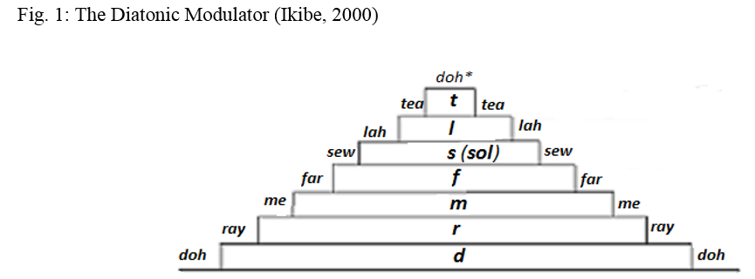 In my over thirty years of teaching music, first at the Federal College of Education, Okene, (13yrs, 10months), Kwara State College of Education, Ilorin and Kwara State University, Malete (as a visiting Associate Professor), and at the University of Ilorin (20yrs+), it had been my cry that the 5th degree of the tonic sol-fa note of the diatonic major scale is not saw but sol (soh). I have also taken this campaign to many church choirs as invited or on my own project to sensitize choristers but no sooner than I am done and I have left that the choristers go back to saw. In fact, many of my students have given me the nickname, “not saw but sol”.
I eventually took the battle for sol to an international conference of the Pan-African Society for Musical Arts and Education (PASMAE) in December 2012 (Ikibȩ, 2012; Ikibȩ, 2013 and Ikibȩ, 2014). I was vindicated by two professors of musicology who confessed that they had not thought of it as an issue because they had assumed that choristers (especially musicologically trained choristers) would normally sing and enunciate the right sound. One of the professors (Prof Nwamkpa) said “when you pronounce sol as saw, you are singing out of tune”. The second music professor (Prof Mokwuenye) said “if one is in doubt on how to pronounce a word, then do it the way the owners of the language do it”. So, our choristers should stop singing out of tune and pronounce it the way owners of the language do it.
Saw, is actually the lowered fifth (or flattened fifth) degree of the diatonic scale; or better still, it is the seventh note while descending the chromatic scale as shown below. 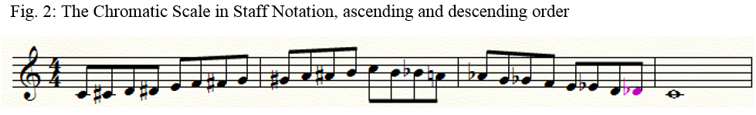
This can be observed when descending the chromatic scale – doh¹, te, taw, lah, law, sol, saw, fah, me, maw, ray, raw, doh as shown below.
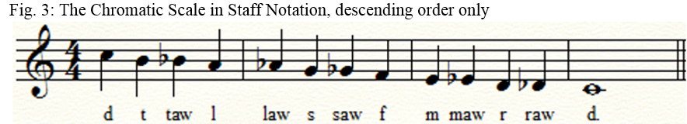
In Music harmony, this lowered 5th degree can be used as the Lowered Leading Note (taw = f) i.e. the 7th of the Dominant 7th Chord of the Submediant to modulate to the Supertonic Chord of the Home Key. On the other hand, it can be used as a mere chromaticism or a chromatic chord for ornamentation or coloration in the harmonic exercise. This chromaticism may eventually lead to atonality as applied by Peter Tchaikovsky, Rimsky-Korsakov, Arnold Schoenberg, Richard Wagner, Igor Stravinsky, Gyimah Labi, and many other 20th/21st century composers. See some examples below:

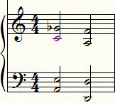
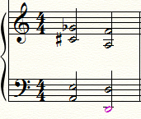
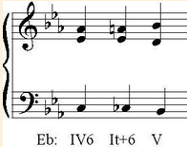

In another harmonic idiom, the lowered 5th degree, saw, can be used as a kind of Augmented 6th Chord – Italian, French, German or even a Nigerian Augmented 6th Chord.
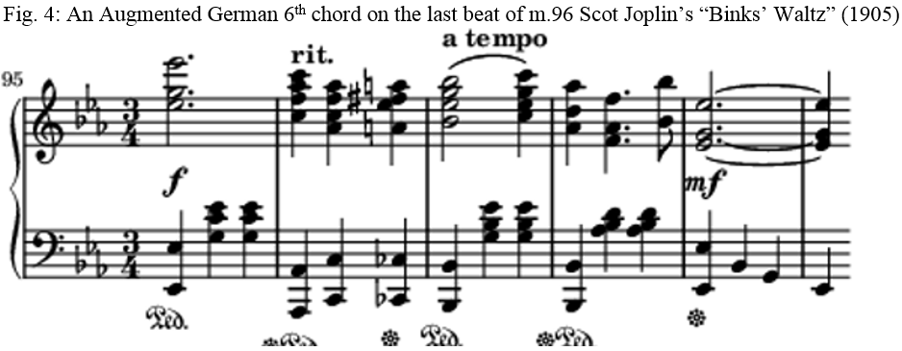
Participants at the PASMAE conference mentioned above, appreciated the effort I made. A female Music Director from Abuja confessed that she had been doing the wrong thing and that she would go back to correct her wrongs – I hope she did because old habits, they say, die hard. To further clarify this, we have the Modulator for the ascending and descending Chromatic scale in tonic sol-fa which I also developed shown here:
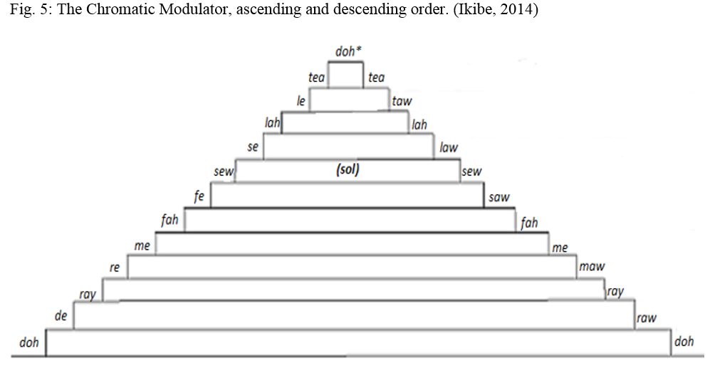
As if to attack my person, a musician turned musicologist after training who had been engulfed in saw and its advocate brought up the issue of the correct enunciation of bass being enunciated bazz. Of course it was unanimously corrected that the word is not bazz as in jazz but pronounced as in base. When bass is pronounced it means a kind of fish, not a musical term again. Thus we have basspart, bassguitar, basssinger and not bass (bazz) part, bass (bazz) guitar and not bass (bazz) singer.
I have also tried using the musical film, The Sound of Music directed by Robert Wise in 1965 to aid my fight for sol. In the film, Julie Andrews (acting as Maria, the governess and music mistress) taught the general’s children the correct enunciation when she sang thus:
Doe: a deer, a female deer;
Ray: a drop from golden sun;
Me: a name, I call myself;
Far: a long, long, way to run;
Sew: a needle-pulling-thread;
Lah a note to follow Sew;
Tea: I drink with jam my bread.
That will bring us back to Doe’, oh, oh, oh,
Doe, a dear, a female dear, Ray, a drop from golden sun, Me, a name, I call myself, Far, a long, long, way to run, Sew, a needle-pulling-thread, Lah, a note to follow Sew, Tea, I drink with jam my bread. That will bring us back to Doe’.

In this Sound of Music, the director uses Maria to teach the correct enunciation of the different notes of the tonic sol-fa of the diatonic scale by using different familiar items to illustrate the correct pronunciations of each of the notes. Specifically, she used an active verb, “sew” as an item for the sol in the sol-fa notation instead of saw as a carpenter’s tool or material for cutting wood.
In spite of all my efforts, some musicologists still go ahead to make wrong enunciation of singing saw instead of sol. “Old habits, they say, die hard”. Hence, at another academic forum, a University don, a music scholar, said that a renowned musicological Professor, though now retired, told him that whether saw or sol, it didn’t matter to him. In fact, he could decide to sing all the tonic sol-fa notes as: “daw, raw, maw, faw, saw, law, taw, daw” (instead of doh, ray, me, far, sol, lah, te, doh as stated above) in as much as he sings the song correctly. Of course, I retorted thus “that would be the highest level of disservice to musicological studies”. In all the places I have been to, it has been a tug of war, trying to correct choristers on the sol sound. Of a truth, change is not easy to be effected on humans, and to comply with. So, it’s Sol, in music and not saw.

Man Uses Science In Communication
Mr. Vice-Chancellor Sir, I proceed to the second aspect of this inaugural lecture, which is Man Uses Science In Communication. This is what I have acronymised into MUSIC.
The Holy Bible reveals that the Almighty God, before creating man, began to make sound right from the beginning as He said in Genesis 1:2. “And the Spirit of the Lord moved upon the face of the water”. When God created man, God spoke to him. Man heard God. In the Garden of Eden where Adam was domiciled, Adam began to use sound to communicate as he gave names to the animals that God had created. When God later made a woman for Adam, he called her Woman whom he later christened Eve. Since then had “Man Used Sound (an element of Science) In Communication” which is actually MUSIC. Thus, man has continued to use sound in communication till date. In the Bible book of Genesis Chapter 4 verse 21, harp and organ, which are musical instruments are written. Music(k) is mentioned 16 times, song is mentioned 61 times, sung is mentioned 5 times, sing is mentioned 97 times, singer(s) mentioned 38 times, musician once, musical instruments 3 times amidst specific mention of different musical instruments such as dulcimer, viol, organ, etc. Moreover, Hymn(s) is mentioned 4 times, Psalm(s) is mentioned 13 times and the Psalmist is mentioned once in the Bible. All these go to show that Christians and the people of the Book (according to Islam/Quran/Muslims) are very familiar with music and all that has to do with music. It may interest us to know that the first song, composed and performed in the Bible is the song of Moses as recorded in the Bible book of Exodus chapter 15 verse 1 to 18. It is within this song we have fantastic choruses such as:
“I will sing unto the Lord, the horse and his rider hath he thrown into the sea” (verse 1) and
“Who is like unto Thee, O LORD, who is like unto the, O Lord, among the gods who is like Thee; Glorious in Holiness and fearful in praises, doing wonders.” (verse11)
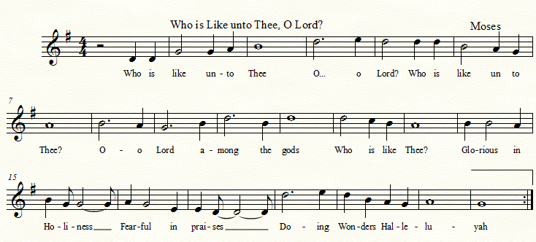
Mereni (2014, p. 57) avers that “music is both art and science”. Yes, Music is both art and science but I have focused on music as science (rather than art) in this discourse because a good number of us here perceive music to be in the arts. Mereni went further to state that Pythagoras (582 – 500 BC) actually studied African Musicology (Science of Music) in Egypt which he later took to Greece without changing the curriculum. So, what we have as Musicology currently actually started in Africa where Pythagoras studied and later turned it to be Ethnomusicology. Mereni states thus:
The meaning of musicology is the science or theory of music; it is a compound Greek word – mousike and logos (italics are mine). It is an old discipline whose origin traces back to the Egyptian Mystery System School where Pythagoras the father of that which is either mischievously or erroneously termed Greek Musicology, studied. The truth has come to light that what Pythagoras taught was purely African Musicology which he learnt in Egypt and poured out to his pupils/disciples in his home town, Greece without changing a word (sic) – not even changing the style of delivery and terminologies with which he learnt it from the Pharaonic priest-philosophers. (Mereni, 2014, p.37)
As stated earlier, in Genesis chapter 4, verse 21 of the Holy Bible, mention is made of Jubal, who was referred to as the father of those that handle the harp and organ. Of course, we all know that harps and organs are popular musical instruments. The word “handle” could mean play, make or repair. In whichever way, to play, to make or to repair, can be artistic, scientific, or technological. No wonder then that the first Department of Music in an African University, the University of Nigeria, Nsukka, popularly known as UNN from where I had my first degree, located her Music Department in the Faculty of Technology at its inception in 1960; although it was meant to be a College of Music. However, the Department of Music was later moved to the Faculty of Arts when the collegiate system was dropped for Faculties as advertised in UNN Newsletter of 1961 and the Nigeria Magazine of March, 1962, No.92. In some Universities, Colleges and Polytechnics, Music is actually domiciled in either the Faculty of Science or Faculty of Technology, depending on the philosophical background of its establishment. So, Music as a discipline can be in the Arts or any of the Sciences – Social, Physical or Technological. The only polytechnics in Nigeria with Music as a Department and course of discipline are The Polytechnic, Ibadan and the Federal Polytechnic, Ilaro. Both Polytechnics are in South-Western Nigeria; there is none in the Eastern and Northern parts of Nigeria. All polytechnics in the nation ought to have Music Technology Departments where the technological know-how (construction and repairs) of musical instruments should be well-handled. Unfortunately, we are where we are because for long, things have not been done the way they should have been done.

Elements of Music
Mr. Vice-Chancellor Sir, as I proceed on the second aspect of this inaugural lecture which is how man had always used science in communication, we are beginning with the elements of music. Music is a combination of two basic elements – sound and rhythm. Sound which is the object of Music, is a basic subject in Physics. According to Ewen, Schurter and Gundersen (2009, p.432) our very popular Physics authors, and as we had been taught in secondary school, “Sound is the vibration sensed by the ear; the vibrations through air, water or some other medium, especially those within the range of frequencies that can be perceived by the ear”. Although Nelkon (1951, 1976, 2009, pp. 370 – 371) did not give a definite definition of sound, he rather gave the characteristics of sound as pitch, intensity, timbre and velocity. All these are scientific components of musical elements. In his own definition of music, Mereni (2014, p.9) affirms that “MUSIC IS STRUCTURED SOUND” (sic). Thus, music being sound that is structured or organized, is basically an object and a subject of science. Furthermore, Music has generally been defined as “the organisation of sound which is made melodically or harmonically pleasant to the ears”. This is what Mereni has compressed in his definition as “structured sound”. In these definitions and many more which we could not accommodate here, we see sound and rhythm as common factors in music and in science.
Sound is calculative. Sound moves. The movement of sound could be retroactive, or straight. Sound in music is either calculated vertically or horizontally. Nelkon (2009, p.375) gives some of such mathematical calculations of musical intervals as calculated. In music, when we calculate vertically, it is harmonic and when we calculate horizontally, it is melodic. For instance the melodic excerpt in figure 6 below is horizontally written. 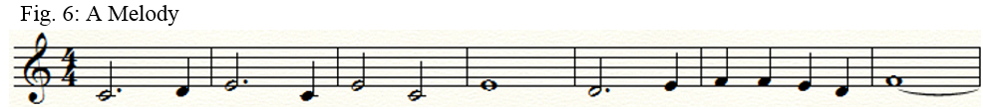
In this melodic excerpt, the first note is a dotted minim which moves in an interval of a major second or two semitones to the next note which is a crotchet. The melodic interval or distance between the dotted minim and the crotchet is equivalent to three crotchet beats.
Characteristics of Sound waves or movement of sound, which is basically what music operates with has been diagrammatically shown here on different musical instruments, depending on the timbre or quality of the instrument as shown below.
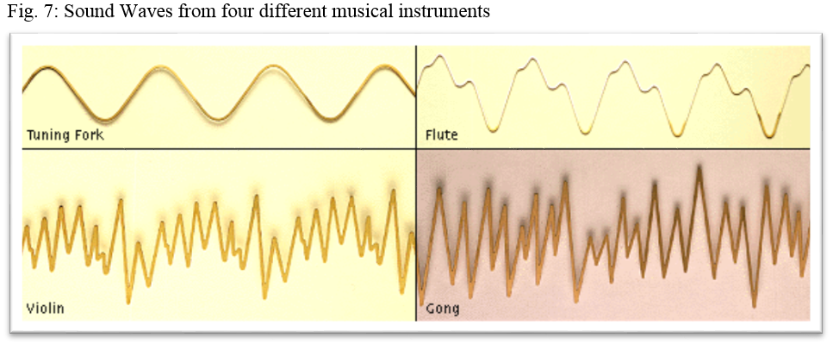
As shown above, we can see the wave formations of different sounds from different musical instruments: the Tuning Fork, Flute, Violin and the Gong. The features displayed herein are the movements of the sound waves when those instruments are struck or played.
Sound can be refractive, reflective and interfered with. All these depend on where the sound passes through and what it meets. For instance, when sound is made, it can be heard all around and in surrounds. This is unlike light that goes in a straight line. That is why, even when one backs where sound is made, the person can still hear it clearly but if a person backs the direction of light, he cannot see the light but darkness. Far be it from me to teach you Physics here; I am only trying to show you the very close relationship that exists between Music and Science. So, whenever musicians make music, they are actually using elements of science to communicate. The audience perceives the scientific communication with their ears which could make them to respond in various ways – emotionally, physically, or in a psychomotor way.
Horizontal sound: Rhythm
Music moves in horizontal intervallic space. When music moves and is measured horizontally, it is rhythm. A single line or voice of music is melody. Rhythm is a regular pattern of beat. It is also calculative. Rhythm is a basic feature of all the arts, particularly Music, Poetry, and Dance. Musical rhythm is the forward movement of music in time and space whereas in Dance, rhythm directs the way the human body moves. Dancers make use of the musical sound and rhythm they hear to make their dance movements. Rhythm, whether controlled or measured flow of movement, whether aural or visual, is usually produced by an ordered arrangement of differing elements of the medium concerned. Rhythm can also be detected in natural human phenomena. For instance, the flow of blood is rhythmically controlled by the heart – also known as heartbeat. Medical doctors would tell us that if the heartbeat is too fast it is a sign of hypertension and if it is too slow it is a sign of hypotension; in either situation it becomes problematic. So there is a regular heartbeat for every human being. Passamanai (2008) states that the human heartbeat sounds thus “lub-dup, lub-dup, lub-dup” which, when notated rhythmically, could be in ²₄ time thus: 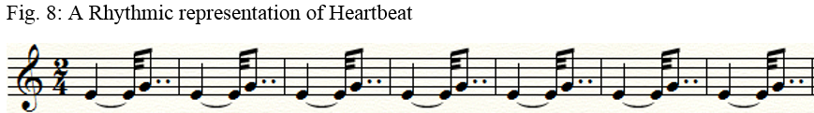 Passamani (2008) states that
a health-care professional uses an instrument known as a stethoscope to detect internal body sounds, including the sounds produced by the heart as it is beating. The characteristic heartbeat sounds are made by the valves in the heart, not by the contraction of the heart muscle itself. The sound comes from the leaflets of the valves slapping together. The closing of the atrioventricular valves, just before the ventricles contract, makes the first heart sound. The second heart sound is made when the semilunar valves snap closed.

The first heart sound is generally longer and lower than the second, producing a heartbeat that sounds like lub-dup, lub-dup, lub-dup as shown above.

The rhythmic notation of the heartbeat is in ²₄ beat (that is, two crotchet beats in a bar) as shown above. Normally, the first beat is the accent (or strong beat) while the second beat is weak. The first beat, 1.125 (1¹/₈) is longer than the second beat. The second beat is .775 (⁷/₈) long. Combining vertical (tonal/pitch) and horizontal (rhythmic) calculations to make good music is a serious task of the brain, eyes, mind, hands and sometimes the legs and voice. Music making is so calculative and complex that one cannot afford to miss either of the two elements (sound and rhythm) involved. If it so happens, the music made becomes cacophonic and disjunctive and so, unmusical, as it will be no longer pleasing to the human ear. Thus, some musicologists like me refer to this aspect of music-making as a kind of Applied Mathematical Music.

Vertical Sound: Harmony in Music
Vertical music is when music moves vertically. This occurs when more than one sound are made simultaneously. This brings about harmony in music. Pythagoras (582 – 500 B.C.) is quoted to have said that the harmony we have in music is like the harmony that governs the universe. Pythagoras also invented the two tetra-chords used in Music (Ikibe, 2001a, p.69; Encarta 2009). Should any of the planets in the universe shift or malfunction, the course of nature would automatically change. Thus, harmony is a very important aspect of music which must not be tampered with or handled carelessly. Harmony in music is mathematically calculative by the Musicologist and by the performers of the different harmonic parts. It is more serious with the vocalists who must pitch the correct notes and intervals otherwise they sing discordantly with other members of the group. As they sing, they also listen to other members of the group for concordance. Mistakes are not allowed both in the pitching and timing of the notes. Every performer must be exact in calculating vertically and horizontally to be sure they all agree and move together. Carpenter (2009) avows thus:
The astronomy of the Pythagoreans marked an important advance in ancient scientific thought, for they were the first to consider the earth as a globe revolving with the other planets around a central fire. They explained the harmonious arrangement of things as that of bodies in a single, all-inclusive sphere of reality, moving according to a numerical scheme. Because the Pythagoreans thought that the heavenly bodies are separated from one another by intervals corresponding to the harmonic lengths of strings, they held that the movement of the spheres gives rise to a musical sound—the “harmony of the spheres… The Pythagoreans, having discovered the mathematical laws of musical pitch, inferred that planetary motions produce a “music of the spheres,” and developed a “therapy through music” to bring humanity in harmony with the celestial spheres. They identified science with mathematics, maintaining that all things are made up of numbers and geometrical figures. They made important contributions to mathematics, musical theory, and astronomy. (Carpenter, Andrew N. 2009)
Music Directing and Conducting
The Music Director (and Conductor as the case may be) on the other side calculates and coordinates the entire ensemble as he listens to all the parts and instruments, looks at, and reads the music-score on the music stand before him and uses his hands and other gestures of his face or body generally to coordinate the music ensemble for a harmonious performance. In his coordination of the music ensemble, he brings in the parts as and when due especially when the structure or texture of the music is contrapuntal and fugal. The entire ensemble watches him for directives on when to apply various musical dynamics such as piano, forte, crescendo, decrescendo, diminuendo, poco-a-poco, dolce, accelerando, ritardando, etc. in the performance. Below is the picture of the virtuoso and quintessential American conductor, Leonard Bernstein in action. 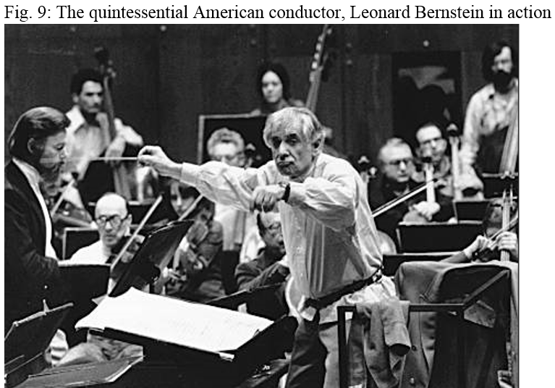
By virtue of the musicological profession, different types of music are harmonized for various occasions. I have been privileged to compose and harmonize musical pieces, anthems and marches for different institutions and events. For instance, some of the convocation marches Unilorin Brass Band plays were composed, arranged and harmonized by me. The Majestic Royal March is one of such marches.

Musical Acoustics
Musical acoustics is a branch of Music that deals with the treatment and effects of sound in an environment. We cannot discuss Music and Science without musical acoustics. The way sounds are emitted in various environments and especially in cities calls for attention as those making such loud sounds are not mindful of the effects of the sound they produce on the people around. Whether from Music shops on the streets, events’ centres during Wedding or Funeral receptions, church auditoria where people congregate for worships, or early morning calls for prayers by Muslim clerics, or even open-air crusades and similar programs, inside buses with big and heavy vibrating speakers, it is necessary that the organisers seek the help of sound engineers and acousticians for better control of their sound equipment.

When Music becomes Noise Pollution
Noise or sound pollution is a common but highly disregarded feature in our society. We encounter noise pollution from grinding/milling machines, factory engines, motor vehicles with their honks and sometimes blown exhaust-pipes, aeroplanes, untamed domestic animals, shops, church auditoria, mosques, events’ centres, to mention a few. As part of our research on sound pollution, we went into some church auditoria and halls where musical instruments’ acoustics/sounds cause noise pollution. We found that excessive musical instruments’ acoustics cause noise pollution in worship places and in halls (events centres) where excessive high volume of sound is released on congregants and audiences (Ikibȩ, S.O. and Adekogbe O.S., 2020, pp. 1 – 12). The World Health Organization (WHO) recommended sound output of 60dB is not usually adhered to by the operators/sound engineers of the music, therefore, worshippers, congregants, audiences and people living very close to such excessive voluminous sound output are in the danger of being half-deaf. Thus when the sound output is higher than the normal volume as prescribed by WHO, it becomes noise, no matter how appealing such music might be to the players/makers and hearers of such music. Harts (2009) records that “music, when played at very high volume, particularly through personal headphones, is as damaging to the ears as a roaring chain saw”. Arising from his therapeutic musical studies and presentations, Mereni (2014, p.59) states that “nervous diseases, high blood pressure, hot temper, etc. accrue to our citizens from uncontrolled environmental sounds, ear-rending/pounding of noisy music”. These statements corroborate our assertion above on the detriment of uncontrolled sound output on hearers/ receivers of such sound.
Resonance and Harmonics in Music
Resonance in music is the amplification of sound made originally on an instrument at a point and it goes further repeatedly for a period of time until it dies out gradually. The period within which the sound starts and ends results into echo. The overlaying sound heard can be calculated in various frequencies. For instance, the middle C when sounded on the upright piano instrument is 220 Htz. After this initial sound, it is repeatedly heard at 110, 55, 27.5, 13.75, 6.875, 3.937 and 1.968 as it fades far away into thin air. The harmonics of each sound has a way of harmonizing itself in concord with conventional harmony. In fact, conventional principles of harmony align themselves with natural harmonic effects. For instance, the fundamental harmonics of key C as tonic could be heard repeatedly as notated here: 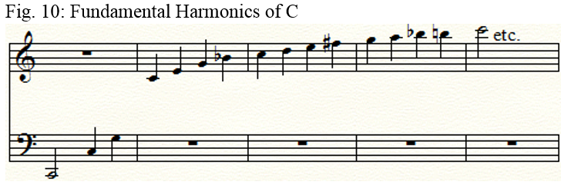

Biological science in music
The commonest and most highly rated musical instrument globally is the larynx. The sound from the human larynx, commonly known as human voice, has proved to be the most veritable musical instrument and the most portable. Anywhere, anytime, we go with our voices. Any human that is able to train the voice well or has the gift of good singing is an asset. Most musicians that abound today are vocalists. Many musicians do not play any other musical instrument apart from their voices. In fact, most vocalists who do not necessarily play other instruments see themselves as the performing musicians whereas the other instrumentalists are mere catalysts to their musicianship. To correct this impression holistically applying the gestalt theory, both the instrumentalists and the vocalists are all musicians.
Although I am not here to teach you Biology, let us see the structure and features of this very important musical instrument, also known as the larynx.

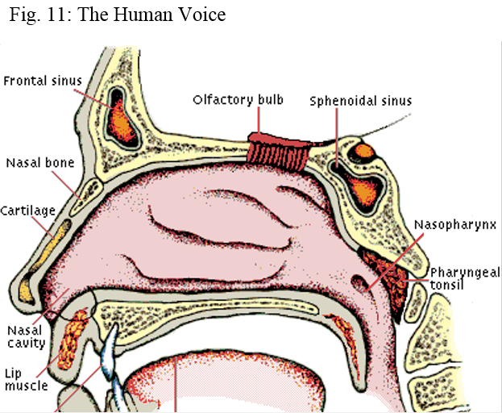
(Diagram of the throat from Encarta Suite, 2009)
Redmond in Encarta (2009) describes the larynx as being made up of three large cartilaginous structures, the epiglottis, thyroid cartilage, and cricoid cartilage, and of several pairs of small cartilages, the most important of which are known as arytenoid cartilages. The epiglottis is a broad cartilage attached in front to the top of the thyroid cartilage. The epiglottis swings over the opening from the pharynx into the voice box with which sound/music is made. The two organs responsible for singing in the human voice are the trachea (windpipe) and larynx.
Very close to the human voice is the human ear. While sound is made through the voice, it is received by the ear. Let us see an illustration of the human ear:
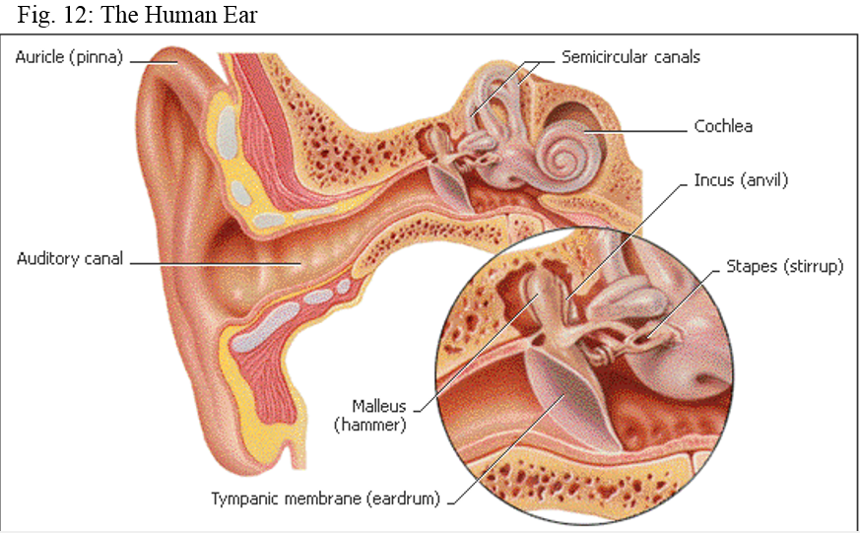
(Diagram of the Ear from Encarta Suite, 2009)

So, beyond our listening pleasure in music, Man Uses Science In Communication. Thus, sound is made through the human voice as a musical instrument and received by the ear. The voice and the ear are very close indeed. Without the ear, we cannot hear any kind of sound or music, thus making the sound/music being made to be useless.
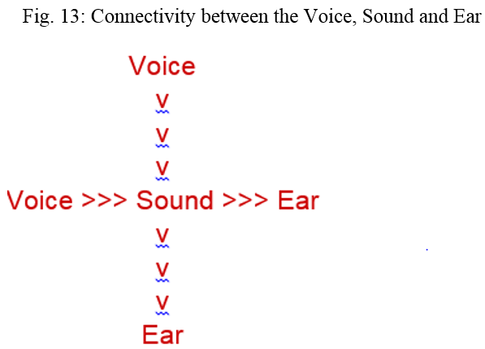
Some musicians we know around only make use of their voices in singing; they do not play any other musical instrument, yet, they are musicians. They are actually vocalists or singers. Can you imagine an auto-engineer mechanic being able to fix only one aspect of an engine, may be the carburettor, and he says he is an auto-engineer. Yet such vocalists are the popular celebrities in the society! A musician could be an instrumentalist, a vocalist or both.

Music and the Human Brain
The human brain is structured in such a way that all aspects of disciplines are situated either at the right or left hand side. The side of the brain where a particular discipline is situated determines what talents the individual manifests at birth and as he/she grows up. From the diagram by Toga (2009) below, we see that the brain is divided into two functional segments – the left Brain Functions and the Right Brain Functions. We can see a picture of a guitar at the bottom far Right Brain Functions indicating Music awareness among others. A gifted musician would normally have the dominance of this side of his brain more functional than the other, thereby, making him more a virtuoso musician or instrumentalist. This does not mean that musicians could not be found among people having the dominance of the Left Brain Functions, but they would have to study harder to acquire musical skills. Thus, most gifted musicians have the dominance of the Right Brain Functions. Similarly, Scientists, Lawyers, Medical Doctors who are supposedly in the Left Brain Functions could be trained to be musicians when they study and devote themselves to much musical studies and rehearsals.
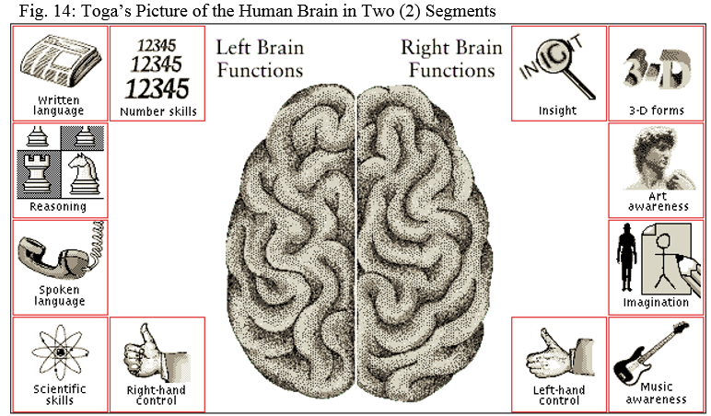

Music Simulates Reward by Releasing Dopamine in the Brain
What is dopamine? According to Encarta Suite dictionary (2009), dopamine is “a chemical compound occurring in the brain: a neurotransmitter that is also a precursor of epinephrine”. See an illustration of the brain on how listening to pleasurable music works as a catalyst to help people who are depressed when they listen to pleasurable music and the dopamine is released.
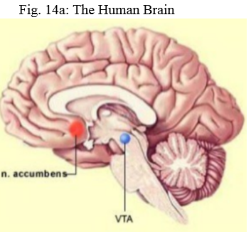
Generally when we enjoy positive times, such as eating, making love, getting lit and jumping off something, we get a rush of dopamine that provides the sense of pleasure. It has been found that music is a catalyst to all human activities. In fact, in 25 crazy science supported facts on the benefits of music, Jared (2020) records that “unborn babies hear and react to music… premature new-borns benefit from hearing lullabies… listening to music decreases anxiety and boosts immunity…” (https://ledgernote.com). So, listen to much music to boost your immunity especially in these days of COVID-19.

Applied Mathematics in Piano Performance
Of all the musical instruments commonly available, the pianoforte is the most difficult to learn and it is dreaded by students. The reason is not farfetched. Playing the piano and any other musical instrument is very mathematical but the piano is more complex and more difficult to learn especially when one does not come in contact with it at a very young age to learn and play it musicologically. This does not mean that one cannot learn it as a grown-up person. It only takes discipline on the part of the learner, devoting about four hours daily in practicing it. In fact, to be proficient as a concert pianist, one needs eight hours daily practice. (Ikibe, 2014c, p.) Most music students find it difficult and so, avoid attempting to learn playing the piano.
I refer to piano-playing as Applied Musical Mathematics but while gathering facts for this lecture, a mathematician told me it is more of Logic in piano playing. This is not the Calculous that is theoretical but calculatingly applied. Take for instance, when I was playing Beethoven’s Piano Sonata in E Major Opus 14, I had to play with my ten fingers, both hands playing different rhythms with crossed hands; the right hand crosses over to play at the bass side what the left hand should have played; I also had to apply my feet to control the pedals for dynamics. It gets more complicated and complex when one plays the multi-manual organ with pedals. As I looked at the various areas of Mathematics, I found it difficult situating the practical music calculation into any of the branches of Mathematics.
The organist playing the pedal-pipe-organ uses his legs to play the bass part, uses the left hand to play the lower part of the four manuals of the keyboard while the right hand plays the upper layers of the keyboard. There are times all ten fingers would play different rhythmic patterns and all must be in concord. I respect the organists in the house for their high sense in calculating the rhythms and at the same time listening to the choir or audience in case there are tonal shifts which are not written for him and he has to find his bearing tonally and still maintain his rhythm with his hands on the keyboards and feet on the pedals. See the picture of a Lady-Church-Organist on a three-manual organ with feet pedals. In my analysis from the picture, I imagine the lady organist has her body, soul and spirit on twelve (12) or more activities which she must coordinate.
- She reads from a notated music book;
- She has her eyes on the minister;
- Plays with one of her two hands for two different parts at the same time;
- Plays with the second hand on two different parts on a different manual at the same time;
- The music could be contrapuntal with different entry points and not a mere hymnody;
- Reads words from a book different from the notated Music book;
- Keeps an eye and ears on the congregation in case they are out of tune and shifts duely;
- Keeps an eye on the Music Conductor for the tempo;
- Her two legs are on the pedals to produce the bass notes of the Music;
- Remember to omit a particular verse of the hymn;
- Remember the B flat keys; and
- Might remind herself of a rehearsal with some choristers for an engagement next weekend.
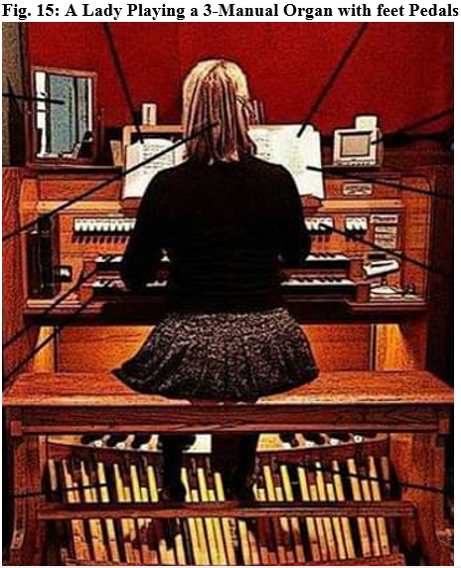
The source: SOMEN WHATSAPP Platform.
Only a very intelligent person can calculate and put all these activities simultaneously in place as this Lady-Church-Organist we see in the picture above. Can this be a kind of silmutaneous equation? A mathematician in the house should please help me.

Technological Science in Music
Most musical instruments are technologically inclined as they are designed and structured by music technologists. The technology could be modern or traditional. Modern technology has however, taken over the archaic, especially in the Western and developed worlds. In fact, beyond organology, western technology has made musicology and composition very easy especially with the introduction of such software as Cakewalk, Sibelius, Cubase, Finale etc. Eric von Hornbostel and Sachs’s (1934) musical instruments’ categorization of the early 1900s has undergone various amendments, including electronic, electrified, computerized and synthesized musical instruments. This is why we can have a synthesized keyboard with all sound effects of all musical instruments including the human voice. Akin Euba (1974) adapted to Hornbostel and Sachs’s musical instruments classification as he had his doctoral research on Yoruba people’s Dundun drums at the University of Ghana, Legon.

Organology and Ekpokrileism
The Music Dictionary (Online Wikipedia) defines organology as
The science of musical instruments including their classification and development throughout history and cultures as well as the technical study of how they produce sound. The Hornbostel-Sachs system of musical instrument classification is probably the best-known system in use today.
In music, Organology is the scientific study of musical instruments, including the make and its playing processes. In my research over the years I undertook the study of a musical instrument in my locality – the Isoko people’s xylophone – known as Ekpokroile. I found that the original Isoko people’s Ekpokroile is pentatonic; this means it is a 5-tone musical instrument. However, I was able to upgrade the instrument to a chromatic musical instrument. This upgrade makes it possible for the instrument to be placed and played alongside other western orchestral musical instruments without cacophonies. The term, ekpokrileism, is therefore used to denote the upgrade of the Isoko people’s xylophone from pentatonicism to chromaticism. It is hoped that this upgrade will be adopted and used by other African music organologists in making their instruments just as the gong has been made into diatonic form.

Also, MUSIC is “Making United Souls In Conflict”
In trying to unite a group of souls who have been in conflict – Christians and Muslims in Nigeria – we tried employing music whereby our students drawn from both Christian and Muslim religious affiliations participate in Christian music and Islamic music concerts. For years, we have been organizing Christmas concerts/cantata. This is quite common in schools all over the world. What is not common is the Islamic Sallah music concert which we did in 2003 as we organized the Islamic Sallah Music concert. We’ve had to research into Islamic music in order to find some solutions to some of our problems. Ikibȩ (2011, p. 30) arranged and composed some Islamic music (anthems for Islamic universities) and songs for concerts. In fact we organized the first and only Unilorin Islamic Sallah Cantata in 2003 while the Performing Arts Department was still in the Mini-Campus. With mixed feelings, we had a sizeable audience and the then Vice Chancellor, Prof S.O.O. Amali, the then Deputy Vice Chancellors – Prof. I.O. Oloyode and Prof. Edungbola – were in attendance. These Islamic music, to which I have been engaged in, do not make me anything less a heaven-bound Christian in as much as I keep on living to please God in holiness and acknowledge Christ as my Lord and Saviour. One of my former students, a Christian at the Master degree level is continuing his doctoral research into Islamic music in a Canadian university with particular focus on the music of the dreaded Boko Haram sect. Of course, he didn’t have to enter Sambisa forest to get the music of Boko Haram.
Music in Health Sciences
Music had always been a tool used to aid people in therapy. Therapeutic music is not new in human existence. Ikibȩ, (2007; 2010b; 2010d; 2011b) Adedeji (2018) and many others have alluded to many instances where music has been used as catalyst to healing. King Saul of Old Testament fame in the Bible got healed from his mental malady when David began to play his harp. Elisha began an ecstatic prophecy as the minstrels started a performance. Thus, even in our contemporary times, men of God had always been moved by God as they listen to inspiring music. Adedeji (2018) states an array of people who had been therapeutically helped with the aid of music. Ikibȩ (2010) reports on the Igbe religious group among the Isoko people of Delta State, using music to exorcise people under demonic possession such as the ogbanje and imeri. This is similar to the exorcists’ activities of the Bori cult music and dance among the Hausa people of northern Nigeria. According to Kofoworola and Yusef (1987, pp.3 – 10)
It is assumed that no communication or contact with the supernatural could be achieved in trance and healing (italics mine) without any form of spirit-possession by the bori. And that applying the bori instrumental music as a case example, it is possible to perceive the trance factor as characteristic nature of ritual in performance.
Although music might not have the chemical components to work in the chemistry of the body to effect healing in man, when people pass through different stages of medication, playing the appropriate music for them helps them to attain the needed recuperation with less feeling of the pain and time. Therefore, in the aspect of health sciences, music has been of immense benefit to mankind, acting as a catalyst to effectual medication.

Some Facts on Therapeutic Music on Lung Cancer and Parkinson Disease
Mr. Vice Chancellor Sir, let me add here what some Cardiff University music researchers did a few years ago. These Cardiff Researchers (have) uncovered evidence in 2012 that lung cancer patients who engaged in choral singing had greater expiratory capacity than people (cancer patients) who did not (get engaged in choral singing). Secondly, Music Professor Brenville Hancox established Skylarks, a choir aimed at people with Parkinson’s disease. One of the participants in the choir explained how his voice had been strengthened despite receiving a diagnosis of Parkinson’s five years earlier. Reasons for the improvement have been suggested as deep breathing and the extended use of the vocal chords. Physiotherapists should therefore, engage the services of vocal instructors to assist in remedying some of these ailments in people. Thus, in several ways music has been a catalyst in the health sciences to cure or at the least, assist in curing some human aliments.

Music as Therapy for the Mentally Derailed
It has also been proved that music can be used as therapy for mentally challenged and depressed people. It is common to see some mentally derailed people dance to music at the front of some music shops or speakers along the streets. This is because such music appeal to them and soothe their depressed souls. Therapeutic Mental Homes should therefore identify such music that could act as catalyst in administering healing on such mentally derailed people and apply same adequately.
Recently at the 2021 national conference of the Society of Music Educators of Nigeria (SOMEN) on “Music Education and Human Wellness”, Dr (Mrs.) Hannah Oziohu Abraham, Provost of Kogi State College of Nursing Obangede, while responding to an award given her by SOMEN, stated that medical personnel use Music to aid the treatment of patients in health facilities. Moreover, Professor Uzochukwuma while making comments at NTA Newsline on Sunday, 6th June, 2021, affirmed that “generally, singers don’t snore”. This statement also can be extended to trumpeters, flautists, saxophonists, trombonists, and other horn players do not snore because they exercise their lungs through the playing of the musical instruments and singing.

Music Influences Plant Growth and Productivity
While we do not doubt the place of good nutrients in soil for plants to grow, it has also been proved that playing pre-recorded soft instrumental music around plantations induce such plants to grow faster and yield more fruits. In Chicago, series of researches have been made comparing some particular crops which were planted the same time. While crops in specimen “A” were supported with soft music, crops in specimen “B” were without music or with very loud music. At the end of the experiment, it was observed that the crops in plantation Specimen “A” with soft music grew quicker and yielded more fruits than those in plantation Specimen “B”. Michelle (2018), affirms our assertion when she states:
Research has shown that any sound has the ability to stimulate plant growth. In one study, plants that were exposed to sounds for six hours a day showed more growth than plants in a soundless control group. However, that same research showed that while music helped plants grow, it wasn't more effective than non-musical sounds. In other words, plants don't distinguish between music and other sounds. However, music does help plants grow.

Intangible Contribution of Music to National and Human Development
More often than not, we attribute developments to tangible things, but the intangible developments which may not be seen materially or physically are not reckoned with. However, without the intangible, the tangible cannot stand. Therefore, the intangible contribution of music to the general development of mankind, leading to the significant tangible developments needed to be highlighted for us to appreciate the intangible (Kofoworola and Ikibȩ, 2013). Music has made so much impact on the steadiness of man in stabilizing his mental framework as man muses on various aspects of life. No meaningful development could have been achieved by anyone not in his right thoughts. Music has made it possible for man to be in his right mental frame before he brings about other developments. Amadi (1981) as reported by Ikibe (2001, p. 73) stated that “ABBA, a popular musical group, contributed the largest income revenue to the government of Sweden as tax in 1977, next only to Volvo Automobiles”. Similarly, the late Michael Jackson (an African-American musician) at a time, was the highest tax payer in America who brought much fame to USA. (Ikibe, 2001) As I checked through a list of the ten most expensive houses in Nigeria, I saw that of P-Square, a musician, as number four, and that of David ‘O’ right in Banana Island, Lagos. They are the only musicians/artistes whose houses are located in that man-made Island. No doubt, this is a lifetime significant achievement. However, it will interest you to know that all that was achieved through their investment in music. Xerophilously, P-Square and David ‘O’ have actually thrived and excelled when rated tangibly but intangibly, we cannot tell how much their music have imparted on others either positively or negatively.
Olu-Obafemi (2021, p. 3) laments the “relegation of the Humanities (including Music), in a national policy phenomenon”. He had argued in his inaugural lecture of 1997, that literature and the Humanities at large need to keep abreast the space – scientific age, the computer and telescopic revolution and from it unearth the essence of man of racist centric cannon and impositions.” He has asserted in several of his plays which are spiced with songs and instrumental music that
The Nigerian problem… cannot be resolved by science and technology….Humanities (including music) must come to the rescue…because the Humanities are more concerned with social ordering in terms of metaphysical and ineffable values as they are assumed to be the source of the material innovations. (Olu Obafemi, 2021, 12)
This is exactly what musical performances have been doing over the years. Sunny Okosun of blessed memory has used his music to contribute tangibly and intangibly to the development of mankind. While the xenophobic attacks lasted in South Africa, mention must be made of Nigeria’s contributions to the independence and deliverance of South Africa from apartheid. Stressing this point, reference must be made of Sunny Okosun’s music which was a weapon that was used to set South Africa and other Southern African nations free, not only from colonialism but also from the obnoxious apartheid policy that was prevalent in that region of Africa. Thus, the political emancipation of South Africa from the obnoxious political apartheid policy cannot be discussed without the input of the music of Sonny Okosun.
Emielu (2013, pp. 54 – 56) commenting on the socio-economic, cultural and political contributions of highlife music states thus “highlife music is an economic product involving a chain of economic activities” which can lead to various spheres of development – financial, political, physical, mental, tangible and intangible. He further avers that “the highlife label is more of a constructed mental template developed by social groups such as musicians, marketing companies and their audience”. He surmises finally that “the development of highlife music in Nigeria and Ghana represented, first and foremost, the attainment of cultural independence which ushered in the much desired political independence of Ghana in 1957 and Nigeria in 1960”. Can anybody quantify in monetary terms what music (through musicians) contributed to the political independence of African nations? No, capital NO!
Thus, the intangibility of the musician and musicologist go far beyond the physical and material status of man. Can you imagine how much the musical compositions of George Fredrick Handel, Johann Sebastian Bach, Wolfgang Amadeus Mozart, Peter Tchaikovsky, Ikoli Harcourt Whyte, Fela Sowande, Ayo Bankole, Kwabena Nketia, Laz Ekwueme, Fela Anikulapo Kuti, and many other great composers have influenced, inspired, motivated and even transformed the lives of people and the society? No. So, Music has helped and is still helping in developing mankind in very many tangible and intangible ways.
Let us take a look at some of such ways that music making has helped and is still helping mankind intangibly.
- Music improves memory, thus develops the mental and intellectual ability of man. Recently I read on the social media of the impact of music on Israelites and why they excel so much especially in sciences and inventions. The reason given is that their ladies are made to solve mathematics and listen to a lot of soft music during pregnancy. No wonder, while we studied about the Spartans in World History, we learnt that they made music a compulsory subject in the school curriculum right from the kindergarten stage up to higher grade school level.
- Focus – music performance makes one focused on what he does
- Improved grades – when one puts some items learnt in songs, it’s easier to recollect thus helping to get more points for higher and better grades.
- Encourages creativity – music performance helps one to create new ideas in form of extemporization in performance;
- Builds social skills – music performance popularizes the musician, as many people get to know him even more than he knows;
- Improves coordination – that one is able to do many things on stage accurately at the same time while singing, listening to others, playing musical instruments and singing at the same time, or conducting and doing some other things simultaneously;
- Listening to music helps to boost human immunity;
- Improves emotional resilience – even in the most adverse situations, when one begins to sing, there is a measure of emotional stability; and
- Confidence – regular musical performance makes one gain some measure of confidence and removes ochlophobia and anthropophobia (fear of crowd and people generally)
- Music making helps in the healing processes of mentally derailed people.

Music and Language
Music and language have many things in common. Music uses punctuation marks just as in language (Ikibȩ, S.O. and Ikibȩ, V.O. 2018; Ikibȩ, S.O. and Ikibȩ, V.O. 2021c). Music is vocalized just as language. Music uses signs/symbols just as language for enunciation. We read music just as we read language. Lehman (1976, p.4) as quoted by Ajiboye (2002, p.8) defines language as “a system for the communication of meaning through sounds” while music has been defined as “a combination of sounds made pleasant to the ears of man”. A common factor in these two definitions is sound which has been discussed in science above. So, both music and language use sound as their objects of communication. Interestingly, this object of music, sound, is a subject in the sciences, specifically, Physics. It is this object, sound as used in music, which is the core of this Inaugural Lecture. Let me highlight some areas where music and language share common interests and elements.
- Lyrics and poems: Texts of songs also known as lyrics are poetic. Whether written in stanzas or thorough-composed, song-texts have similar features. In fact, I term songs without the musical notations as poems. Have a look at this hymn text:
I dreamed that the great judgment morning
Had dawned and the trumpet had blown;
I dreamed that the nations had gathered
To judgement before the white throne;
From the throne came a bright shining angel,
And stood on the land and the sea,
And swore with his hand raised to heaven,
That time was no longer to be.
The text above would only be musical and known as song if a tune is given to it otherwise, it remains a poem.
- Punctuation marks: punctuation marks are used in language construction much as they are used in music. . , ; : - are all used to show duration of notes while writing the tonic sol-fa notation. For instance, the first phrase of the Nigerian national anthem when translated into tonic sol-fa uses the semi-colon, colon and the hyphen thus 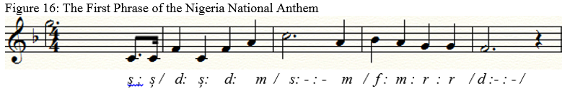
The colon (:) signifies a complete beat, the colon and a hyphen (:-) are two beats, the semi-colon (;) is a three quarter beat, a coma (,) is quarter beat, while a full-stop (.) is half a beat as shown above.
- Musical sentences and phrases are used to indicate complete musical thoughts and incomplete musical thoughts just as they are used in language. Of course, there are many other common tools shared between music and language.
Non-Musicals as Extra-Musicals
In the course of my researches, I observed that some non-musical instruments have performed the role of musical instruments (Ikibe, 2012, p.45). These I have termed extra-musicals. The sound of the broom used by Ekuechi masquerade performers was so fitting rhythmically to the on-going music of the performers that it became part of the ensemble. The rhythm is notated thus:
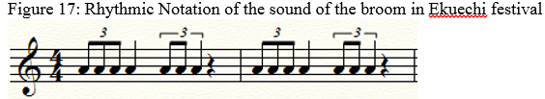
Another non-musical instrument that became musical is the hand-fan used by the Igbe religious group of Isoko and Urhobo people of Delta state.in some of their worship programs, especially during the end of the year festival. Every member holds a hand-fan used to ward-off evil spirits. A very common rhythm used to accompany their songs’ rendition is 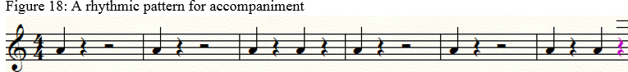

Scoring the rhythms of laughter
As time progressed, I began to research into notating people’s laughter, but first, what is laughter, why do people laugh? Is laughter of any benefit to humans? Laughter is a human expression of making sounds from the throat while breathing out in short bursts or gasps as a way of expressing amusement. I’ve tried recording some people laugh and I discovered that some of those laughters sound like the kicks of some good cars such as a new Toyota Sienna, Volkswagen Beetle, Mazda 323, etc. It will interest you to know that laughter is of high benefit to people who laugh. In fact, laughter is therapeutic as it helps to smoothen the face and relax the nerves which could lead to longevity according to Psychologists and medical personnel. So, laugh often in order to live longer.

Ikibe’s Singability Formulae: an adaptation of Flesch’s Readability Formulae
The ease with which language is meaningfully read is attributed to many factors, whether simplistic or complex. Although a research by Edward (2002) has it that by the year 2000, one thousand studies on readability formulae were published in professional journals authenticating their validity and strong research base, the following are the popular ones:
- The Dale-Chall Formula by Edgar Dale and Jeame S. Chall;
- The John Bornmuth Formula;
- The Gunning Fog formula by Robert Gunning in the 1940s;
- The Flesch formula by the Rudolf Flesch in 1943;
- Fry Readability Graph by Edward Fry in 1963;
- McLaughlin's SMOG (Simple Measure of Gobbledygook) formula by Harry McLaughlin in 1969;
- The FORCAST Formula in 1973; and
- Atos Reading Formula for Book in 2000

Among the many readability formulas, I chose Flesch’s because it aligns more with the features and elements of a music passage which are to be measured. Also, I decided to adapt Flesch’s Readability Formulae into music in order to make music reading less difficult to learners when the right music score is given to the right set of music learners. This is because I observed and discovered that many young choristers, either in the academe or church or secular groups find it difficult to read music at sight. Thus, applying the Singability Ease Formulae into music makes it possible for a music educator to give the correct music piece to the correct level of music students for sight singing. To measure the readability of textual compositions, Flesch (1948) came up with a Readability Formulae RE = 206.835 – (1.015 x ASL) – (84.6 x ASW). In Flesch’s Readability formulae, one is able to measure the level of difficulty in a passage. Similarly, one is able to measure the level of difficulty in a musical passage using the adapted variant of my developed Singability formula.
As I studied the readability in English language and as Vancura applied the Flesch Readability Formula to television programs, I therefore tried to apply a similar formulae with some amendments into Music, (using the Hutcheon’s Adaptation Theory) to make selecting music composed for different grades of music singers easier. We have had a measure of success after several attempts with individual singers and corporate groups of singers. However, we’ve had to adapt instead of adopting Flesch’s Readability Formulae (Ikibe and Ikibe, 2021; Ikibe and Ikibe, 2021), hence we christened ours the Ikibȩ Singability Ease Formulae. See the Ikibe Singability Ease Formula and how it works:

The Ikibȩ Singability Ease Formula
The specific music-matical formula is:
Singability Ease (SE) formulae = 500.835 – (1.015xAML) – (84.6 x ART)
Key
SE – Singability Ease
AML – Average Music Length i.e. the entire length of the musical passage in terms of tones and number of bars.
ART – Average number of Rhythmic Tones (i.e. the number of rhythmic notes divided by the number of tones)
The 500 is a figure I got from the five letters of the word “MUSIC”. Each letter is 100. Thus 100 x 5 = 500.
The output, SE, is a number ranging from 0 to 100. The higher the number, the easier the music is for a singer to sight-read in its performance.
Thus, scores between 71.0 and 100 are considered easily singable or sung at sight by an average Grade1 singer;
Scores between 51.0 and 70.0 are considered easily sung at sight at by Grade 2;
Scores between 31.0 and 50.0 are considered easily sung at sight by Grade 3; and
Scores between 0.0 and 30.0 are considered easily sung at sight by Grade 4 singers and above.
I used the few anthems I composed to test the Singability Ease Formulae among my students/choristers and some other choristers outside the University of Ilorin without letting them know that I was actually testing a formulae. It worked. I got the different results I needed to showcase the workability of the Singability Ease Formulae. For the anthem submitted for the Federal University, Dutse, I got a Singability ease of 38.029. This means, the proposed FUDUTSE Anthem has a Singability ease for a 3rd grade music singer seeing it at the first time. This is moderately alright for an institutional anthem as it is not just a street chorus for everybody. I also used it to test Crown-Hill University Anthem which I also composed. I had a score of 51. Similarly, for the Al-Hikmah University Anthem, Fountain University Anthem and Kwara Polytechnic Anthem, they have 51, 46 and 57 Singability Ease Formulae respectively. All fall within a good Singability range. For the WAUG Song, the Singability Ease is 72, which is good and easy enough for a common, non-music literate populace that can easily be learnt. Thus the Singabilty Ease Formulae can be adopted by composers, considering the audience or the learners of the music they want to compose for. Music educators and directors can also use it before selecting musical pieces for their target choristers.
The popular Old Black Joe song was also tested with the Singability Ease Formulae and I got 72.

“Composing” and “Performing” the music – which is more important?
Mr. Vice-Chancellor sir, the age-long debate between the composer of the music and director/performer of the music still rages on. Like the African adage among the Isoko people would say, “Where will a thief who steals a drum play it?” Music is meant to be performed for the enjoyment of people. If one is a composer and his compositions end on his table or in the library or even music conservatoire, such compositions are useless or at the best only useful as academic items. Similarly, if there are no musical compositions, what will the performers perform? So, the composer of the music and the performer of the music are both important. George Fredrick Handel composed the Messiah in the 18th century and he is long dead, yet the Messiah remains an evergreen musical piece whenever it is performed in its various and different arrangements. The sustainability and popularity that the Messiah enjoys today is as a result of the directors and performers of music. This is what Adeoye, (2019) in delivering the 186th inaugural lecture of this great University made reference to as “the poetics of legislation and de-legislation on play directing”. Hmm… can we say the poetics of legislation and de-legislation on Music Directing?
In first Corinthians chapter 3 verse 6 of the Holy Bible (King James Version), Apostle Paul said “I have planted, Apollos watered; but God gave the increase”. The composer plants (or composes) the music, the Music Director waters the music by bringing it out of the repertoire for performance; and God blesses the hearers of the music. Hallelujah Chorus, the most popular piece from the Messiah, has been transformed from an anthem in church gatherings into various media – complete instrumentals, full acapella, from the Christian anthem to popular and political protest song “We are Hungry” and many more. What some poets do is to change the lyrics of a tune and put in theirs just as we saw in Hallelujah Chorus above. Much as we appreciate the ingenuity and equity of the composer of the tune and the poet, the poet who changes a tune with another lyrics should take permission from the original composer of the tune before they embark on changing the lyrics otherwise, it is tantamount to plagiarism, in fact the Nigerian Copyright Law is against such imposition of lyrics on a composer’s original tune. Litigations are allowed but Nigerians are too afraid to stand by their rights.

Bi-Musicality
Adeogun (2013), portends that Bi-musicality is the ability to operate in two different musical terrains. I live and work among Christians and Muslims. My students and colleagues are either Christians or Muslims. Therefore, I have had the privilege of benefitting from their musical cultures. One way I have exhibited my bi-musicality is to organize musical concerts in the Christian tradition and Islamic tradition. The terrain of the musical culture I find myself also made me what I am as a bi-musicologist. Thus, I have had to be a little bit to the right and a little bit to the left musically. Moreover, I have been able to compose and arrange musical pieces to fit into the two musical cultures. More intricately, elements of bi-musicality are found in some of my musical pieces as I apply the principles of bi-musicality. For instance, composing the anthems for Al-Hikmah University and Fountain University made me to infuse some Islamic musical idioms of minor mode which Islamic/Arabic music culture is known for into them. On the other hand, composing for Christian programs makes it possible for me to be more conventional without necessarily using Arabic culture. As noted above, the first ever, and may be, the only Islamic cantata organised in this university was directed by me. We had to make some researches and source for Islamic songs, arrange them, teach our students and had the cantata. It is hoped that Muslims would have the privilege of organising similar music concerts during their festivals.

Institutional Anthems
I am not yet a versatile composer. However, I have only tried to compose and arrange a few institutional anthems. Mr. Vice-Chancellor Sir, let me make it crystal clear that I did not compose UNILORIN ANTHEM. Lavinia L. Odejimi and Adavi T.J. Abraham composed both the lyrics and melody of Unilorin anthem. However, my humble self and Taiye Adeola arranged and directed the anthem for studio recording as we have it played for us today. It was an assignment given to us by Prof. Is-haq Oloyede OFR, (then Vice Chancellor) in 2011 under a Committee superintended by Mrs. Olufolake Oyeyemi, (then Registrar) although without any act of appreciation. Other members of the Committee are Professor Ayo Akinwale, (then Head of the Performing Arts, and later, former Dean of Arts) of his blessed memory, Professor A.B.O. Omotosho (former Provost of the College of Medicine and Professor O.A. Adekunle of the Faculty of Agriculture. Mrs. M.B. Zakariya served as Secretary of the Committee. It was an assignment that took the two of us some three tough weeks of some sleepless nights in the recording studio (NUDREAM SOUNDSHOP along Unity Road, Ilorin) because of the perfection needed by the Chairperson and other members of the Committee. The voices you hear played in the anthem were some selected 400 level Music students of the 2011/2012 set, namely:
Elizabeth Onyia and Omowumi Adelabu (Soprano);
Ibidun Olabayo and Tosin Awoniyi (Alto);
Emmanuel Olabayo and Adebayo Adeleke (Tenor); and
Mark Akintayo and Moshood Fatai (Bass).
Therefore, what we hear played to us today and at other official engagements as UNILORIN Anthem is not just an omnium-gatherum of voices; they were selected and well trained musicologically. Before we did the recording of Unilorin anthem, some other people who might be musicians, musicologists and some laymen had been contacted to do their musical arrangements and recordings of some sort. Very many funny forms/styles were submitted such as country music, reggae, Ilorin traditional trumpet-intro and highlife. All these did not get the satisfaction of the musical essence of the anthem perceived by the management until we made and submitted this very one.
This segment of this inaugural is very vital because, of recent, some people have laid claims in the print, electronic and social media that they composed, performed and recorded this UNILORIN anthem. I say no, capital NO. Where I knew or heard of such false claims, I have responded immediately to correct them. This anthem as we hear it played today is the musicological directorship and musical craftsmanship of Solomon Ikibȩ and Taiye Adeola of the Performing Arts Department whom I believe is inside this Auditorium now. Congratulations to Prof. Is-haq Olarewaju Oloyede OFR (the Vice-Chancellor then but now the Registrar of the Joint Admissions and Matriculation Board – JAMB); Congratulations to Mrs. Olufolake Oyeyemi (then Registrar and Chairperson of the Committee) Congratulations to all members of the Committee; Congratulations to Dr Taiye Adeola, Congratulations to my music students (class of 2011/2012) and Congratulations to my humble self! This is to keep the records straight and give credit to whom credit is due and not for any personal aggrandizement. Mr. Vice-Chancellor Sir, may I crave your indulgence to allow the Committee members here present in this auditorium rise for special recognition on their contributions for the recording of UNILORIN ANTHEM as we have it played for us today.
I wish to suggest to the Vice-Chancellor that the University Anthem be registered with the Nigerian Copyright Commission immediately to avoid unnecessary court litigations. May I also request Mr. Vice-Chancellor Sir, that the names of Lavinia L. Odejimi and Adavi T.J. Abraham be inserted at the right top of the Anthem as composers of the melody and lyrics, while the names of Solomon Ikibȩ and Taiye Adeola be inserted below the Anthem as Directors of this recorded anthem? This is not strange because directors of plays would always write the names of the playwright and Director’s names on the Program Notes for every play directed. That is the right thing to do, anyway. Moreover, this is for posterity and to deter usurpers from claiming what they did not do in years to come. Till date, when the Messiah or any piece from it is performed, G.F. Handel is written as the composer while the Music Director’s name or arranger’s name, comes thereafter.
However, after that assignment, I composed Kwara Polytechnic Anthem (Ikibȩ, 2011). I composed, arranged and harmonized the Music (or tune) while the lyrics were written by Mr. Moses Salami (former Registrar of Kwara-Poly) and others. I also composed, arranged and harmonized Al-Hikmah University Anthem (Ikibȩ, 2012). The Lyrics were written by Popoola Olanrewaju who was a student of Al-Hikmah University; then our Vice Chancellor, Professor Abdukareem Age, was the Vice Chancellor. As I visited Al-Hikmah University recently, I was shocked to hear that someone else is laying claim to be the composer of Al-Hikmah Anthem. No. Once again, al-Hikmah University Anthem is composed by Solomon Ikibe.
The song for the thirteenth edition of the West African Universities Games (Ikibȩ, 2012) which was hosted by the University of Ilorin was also composed, harmonized, arranged and directed for recording by me. It was played on the Unilorin 89.3 FM (Better by Far) Radio Station for some weeks before and during WAUG on a daily basis. For our remembrance we have the lyrics here:
WEST AFRICAN UNIVERSITIES GAMES (WAUG) 13TH EDITION SONG
(Words and Music by Solomon Ikibe, 2012)
- We welcome you all to Nigeria
(WAUG, WAUG, WAUG)
The Super-Giant of Africa,
(WAUG, WAUG, WAUG)
To this thirteenth edition of WAUG
(WAUG, WAUG, WAUG)
O’ God help us now as we Celebrate.
(WAUG, WAUG, WAUG)

- We welcome you to UNILORIN
(WAUG, WAUG, WAUG)
The Better-By-Far University
(WAUG, WAUG, WAUG)
At this thirteenth edition of WAUG
(WAUG, WAUG, WAUG)
So let us Celebrate and Jubilate.
(WAUG, WAUG, WAUG)

- You will win laurels at this WAUG
(WAUG, WAUG, WAUG)
I will win laurels at this WAUG
(WAUG, WAUG, WAUG)
In tranquillity and hard-work we shall win
(WAUG, WAUG, WAUG)
So let us Celebrate and Jubilate.
(WAUG, WAUG, WAUG)

- You may lose laurels at this WAUG
(WAUG, WAUG, WAUG)
I may lose laurels at this WAUG
(WAUG, WAUG, WAUG)
But in the spirit of Sportsmanship
(WAUG, WAUG, WAUG)
So let us Celebrate and Jubilate.
(WAUG, WAUG, WAUG)

- You have won laurels at this WAUG
(WAUG, WAUG, WAUG)
I have won laurels at this WAUG
(WAUG, WAUG, WAUG)
In tranquillity and hard-work we did win
(WAUG, WAUG, WAUG)
So let us Celebrate and Jubilate.
(WAUG, WAUG, WAUG)

- You’ve lost some laurels at this WAUG
(WAUG, WAUG, WAUG)
I’ve lost some laurels at this WAUG
(WAUG, WAUG, WAUG)
But in the spirit of sportsmanship
(WAUG, WAUG, WAUG)
So let us Celebrate and Jubilate.
(WAUG, WAUG, WAUG)

- Goodbye to you from UNILORIN
(WAUG, WAUG, WAUG)
The Better-By-Far University
(WAUG, WAUG, WAUG)
At this thirteenth edition we celebrated
(WAUG, WAUG, WAUG)
So we did Celebrate and Jubilate
(WAUG, WAUG, WAUG)

- Goodbye to you all from Nigeria
(WAUG, WAUG, WAUG)
The Giant of Africa says Goodbye
(WAUG, WAUG, WAUG)
At this thirteenth edition of WAUG
(WAUG, WAUG, WAUG)
We thank you Lord for helping us.
(WAUG, WAUG, WAUG)

Moreover, I composed, arranged and harmonized Fountain University Anthem (Ikibȩ, 2012). I hope nobody is claiming to have composed it. The Lyrics of Fountain University Anthem were sent to me without the mention of the name of the poet. Furthermore, I composed, arranged, harmonized and recorded both lyrics and music of Crown-Hill University Anthem (Ikibȩ, 2017b). I also composed and submitted an entry for the Federal University, Dutse, Jigawa State (Ikibȩ, 2018), but because the Vice Chancellor wanted it for free which I refused to accept, I learnt it was dropped. I hope it is not being used without my consent. Moreover, I composed an anthem for Kwara State (Ikibȩ, 2017) while on Sabbatical leave in Kwara State University but for some unknown reasons not far from politics, it has not been presented or accepted. Finally, when the Kwara State Polytechnic was to host the Nigerian Polytechnics Games in 2018, I had the mandate to compose and produce a song for its opening and closing ceremonies which I did and titled NIPOGA Song (Ikibȩ, 2018).
Aside those mentioned here, other musical pieces for brass instruments and mixed voices include a simplified keyboard-harmony-arrangement of the melody of the Nigerian National Anthem (Ikibȩ, 2001) originally composed by Benedict Odiase. This my arrangement is to encourage our young pianists to learn how to patriotically play the Nigerian anthem on the pianoforte musicologically. And for those who might not know, the lyricists (poetic composers) of the Nigerian National Anthem are: John A. Ilechukwu, Eme Etim Akpan, B.A. Ogunnaike, Sotu Omoigui, and P.O. Aderibigbe (Joel, 2016, p. 68).
My style as reflected in all my musical compositions and arrangements are very simple like those of Franz Schubert and my harmonies are conventional. This is just to make it easy for whoever may want to sing them to easily do so. In my simplicity, I never delved into contrapuntal, fugal, complex and very long compositions. As mentioned earlier, I have used the Ikibe Singability Ease Formula on the anthems and they are good enough for all choristers.
*Some of the notations of the anthems are attached as appendix for further musicological studies and analysis by interested musicologists.

Music composition and inspiration
Music composition has been done by people as a form of creativity. However, beyond creativity, a good number of composers have claimed they received and realized the inspiration for their compositions as divine revelations from God. This divine revelation also known as inspiration as recorded in the Bible book of Job chapter 33 verses 15 to17 and chapter 35 verse 10 is a privilege to people in good standing with God. Moreover, Adedeji (2018) affirms that he has had such divine inspirational revelation of songs which he has penned down as musical compositions. Ikibȩ, (2018) has, amidst many songs received similar revelations from God in dreams and have notated some of such like this one which he got some months back and notated for further creativity and development.
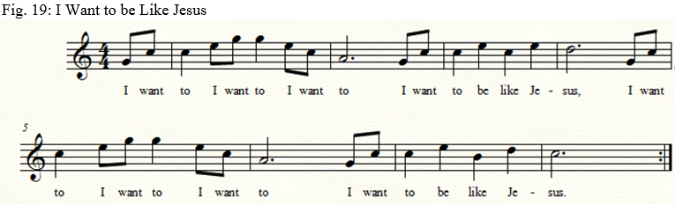

Unilorin Brass Band
When I got employed in UNILORIN in 2001, I was made to understand that Unilorin Convocation Marches were played by the Police Brass Band prior to my appointment in UNILORIN. However, on my assumption in the University in 2001, I made sure that the Performing Arts Department gets and directs her own Brass-Band which we have sustained till date. All the marches and other music played during convocation ceremonies are arranged and some compositions made by the directorate of Unilorin Brass Band and Unilorin Dance Band. One of such is the “Majestic Royal March” (Ikibȩ, 2002). The brigade drums bought by the University Management in 2002 are still being used till date. I think they need total replacement and not repairs as we have been doing for quite some time now. Moreover, students should be encouraged to buy and own their personal musical instruments as it is the practice in many other institutions. This makes it possible for them to rehearse on their instruments anywhere, anytime.

The Price before the Prize
Anything worth doing is worth doing well. Before obtaining any crown, one must bear the cross. Therefore, I paid the price before I got whatever prize I have received. It was not easy for me to leave my job as a Senior Lecturer at the Federal College of Education, Okene, earning some N65, 000:00 monthly to accept a job of N35, 000:00 in 2001. It was not also easy for me to leave my very lovely family and begin to live alone almost as a bachelor in a land where hostilities from perceived enemies abounded. It was not easy leaving my friends of over a decade and get to a place with no known friends and to begin afresh. It was not easy learning and doing new things from what I had been used to. I’ve had to start learning to be in a theatrical environment as against my musicological parlance. It was not easy travelling every weekend between Ilorin and Okene via Ekiti State, staying between 5 and 6 hours on Nigeria’s very risky and bad roads. It was not easy leaving an association I initiated and formed, and try to fix myself with others. Yes, I might not have made the kind of money others have made, but I stand high to say that I got my prize eventually, delivering a professorial Inaugural Lecture in a foremost Nigerian University, the Better by Far University of Ilorin. My former Music Lecturer at University of Nigeria Nsukka, Dr Achinivu K. Achinivu, sent a congratulatory message to me at my professorial elevation, and described Unilorin as “A No Mean University”. Yes, the Better by Far University is also A No Mean University.

The Paradox: much usage yet most hated of all disciplines
I have already mentioned a professor who made a derogatory remark on music being the worst of all subjects. I went round the town and community to investigate the attitude of parents, students and children in music with a very simple and short questionnaire. Guess what, they all confessed to like listening and dancing to music but never would they want to, nor allow their children to study music nor go into its academic pursuit.
Why the much hatred for the course, yet a phenomenon we must use? Can you imagine that this is the first inaugural lecture in music in UNILORIN out of 203 inaugural lectures? Yet at every inaugural lecture, we must sing the University Anthem, an act and an art of music. At every convocation, we must sing the Nigerian National Anthem twice and Unilorin Anthem twice. At every convocation, the Brass-Band must play to process in the academic processions of both students and staff. And at the convocation ceremonies, the Dance Band or recorded music must be played for the enjoyment of guests. Which other discipline is so friendly? Yes, the Faculty of Education, they say, is the Mother of all faculties but Music is the Friend of all Faculties, whether you like it or not. Even in the Performing Arts where music is domesticated as a Unit, Drama without Music will be too dull for the audience. Dance without Music will be like madness. So, why the hatred, yet it is the most used. Mr. Vice-Chancellor, Sir, permit me to request that Music be made a compulsory subject at all levels of the Nigeria’s educational system, not just as part of Creative Arts alone. In the university, it should be part of the General Studies unit, as it is done in Enugu State University of Technology and Mountain Top University, beyond its inclusion in GSE.
It is a fact that God, among the Christians, is music-loving, seeing that God inspires the adherents and worshippers with music. In the Holy Bible, right from the book of Genesis all through to Revelation, various references are made on Music and how God has done wonders in the lives of His people through Music. (see Ikibe, 2010a; 2010b; 2010d). But a good number of the Christians would rather want their children to study the sciences and be Doctors, Engineers, Pharmacists, etc. If they are in the Humanities or Arts, they would want them to be Lawyers; and if in Social Sciences they should be Accountants. I didn’t bother to go to mosques because they would say it is haram, even though we have a good number of Muslim musicians. In fact, in 2017, I tried carrying out a research on my Singabilty formula and sent a Music student who is a Muslim to a mosque in Malete with the As-Salam Alekun song. The boy was chased out of the mosque.
Training to become a musicologist, a musicological musician, a musician or an instrumentalist at the least is not an easy task. In some of my studies which are published, (Ikibe, 2000a; 2000c; 2001a; 2002; 2006; 2010; and 2012) over the years, I discovered that people love and would want to play some kind of music or a particular instrument especially when they see some exponents they admire performing on such instruments. However, no sooner than they start the study of such instruments that they fizzle out as they get frustrated for not achieving the needed results at their own given time. In support of my findings above, Leviton (2006) in his book This is Your Brain in Music attests thus:
The emerging picture of such status (of acquiring mastery in playing an instrument) is that 10,000 hours of practice is required to achieve the level of mastery associated with being a world-class expert in anything. In study after study of composers, basketball players, fiction writers, concert pianists, chess players, master criminals, and what have you, this number comes up again and again. 10,000 hours is equivalent to roughly 3hours a day or 20hours a week of practice over a period of ten years. (Leviton, 2006, p.197)
Three hours a day on a musical instrument? This looks too much to some people; but there was a boy, an undergraduate student in Geography Department in this University of Ilorin, who was spending as much as eight hours in practising the piano every day! When I challenged him on why he didn’t opt for the Performing Arts or Music in any other university, he said he was in Geography to satisfy his father’s desire. What a waste of time, talent and financial resources on that chap who could have been a concert/master pianist somewhere enjoying himself in music? Similarly, some years back, a spilling-student from Chemistry Department cried to me desiring to minor in Music. I asked why and he explained that it had been his desire to study Music but his father forced him to study Chemistry. We allowed him and he did excellently and marvellously well in all the Music courses he took that year. Parents, allow your children to study what God has destined and endowed them with!

Music Education with Humanity
My contributions to music education started way back in 1988 when I got employed as an Education Officer at the Federal College of Education, Okene. I did everything possible to lift the face of music education in Nigeria. One of my publications then was “making music education interesting to students”. This was why many years after I left Okene the students who heard of me longed just to see me. I met one in “He Reigns Music Studio” in Ilorin some years back. When the director of the studio introduced me, she felt like she had seen a spirit. She knelt down, and got a camera for a picture with me. She exclaimed that God had answered her prayers all through her life looking for a man she never knew but only had heard about on his musical education and exhilarating rapport with his students.
When I got my job at FCE, Okene and as a young lecturer in 1988, I needed to supervise a group of students on the Associate Certificate in Education (ACE) projects. Without any premonition of who was to be assigned to me because I didn’t actually take part in the course-content teaching of the students, I got my six supervisees which included a familiar face. He didn’t recognize me but I did. I refused to make myself known to him until he completed his ACE project for which I scored him 67%. When he came for the submission of the bound copies, he had actually submitted the bound copies and had stepped out of the office when I called him back for the introduction which I refused to make at the initial stage.
Listen to the drama that ensued:

Supervisor: Hello Mr. Olufemi, are you satisfied with your score?
Supervisee: Very well, thank you Sir.
Supervisor: Mr. Olufemi, did you attend St. Michael’s College Oleh?
Supervisee: Yes, I did sir.
Supervisor: In which house were you in St. Michael’s College?
Supervisee: Garrard House, Sir.
Supervisor: What post did you hold then before you left the College?
Supervisee: Assistant House Prefect.
Supervisor: Good, when did you graduate from St. Michael’s College, Olufemi?
Supervisee: 1977, sir.
Supervisor: Can you think back and recollect if you can recognize one very small boy in Garrard House then?
Supervisee: Aah, it’s quite a long time but let me think, Independence?
Supervisor: No, Independence was in Lasbrey House.
Supervisee: Okay, you are right, Independence was my classmate.
Supervisor: Still think, he was the smallest boy in the College then.
Supervisee: Aaah… don’t tell me you were that boy
Supervisor: Yes, I was that very small boy, Solomon Ikibe.
Supervisee: Aah… (At this stage, Olufemi bowed down his head as he couldn’t look at my face again and began to weep.
Supervisor: Stand up, don’t worry, it is a bygone issue and as you can see more than eleven years ago, I didn’t hold the past issue against you hence I made sure that I supervised you well and you got a good grade too. Congratulations on your ACE.
Supervisee: (at this stage, Mr. Olufemi could not say anything again but struggled to get up and he left my office with copies of his bound projects.)

The next time I saw Mr. Olufemi was in the Part-Time NCE class where I was to teach his class EDU115, (Educational Management I). When I entered the class and introduced myself as the Course Lecturer, Mr. Olufemi got up, packed his books and left the class. I never saw Mr. Olufemi again! Be humane to people always and beware of arrogance and pride!

This is a man I had known way back in 1974. His name is Olufemi. Olufemi was two years my senior in Oleh (St. Michael’s) Teachers College, Oleh and the Assistant House Prefect of Garrard House in the 1976/77 academic session. On one of those days, he maltreated me by asking me to kneel down in the rain because I was late for afternoon siesta at 2.30pm. It was our House Master, the late Rev. O.I. Eyeye who was watching the drama from his residential quarters just opposite our dormitory that came to bail me out, otherwise I might have suffered from pneumonia or severe cold that day. An Isoko proverb states that “if the person who defecated on the road forgot that he defecated on a wrong place, the person who packed the excreta would not forget”. Never maltreat anybody, whether or not the person is your subordinate today as you do not know when and where you may see yourselves later in life,

Change of Concept/Philosophy/Curriculum
Most of the programs we have in our educational programs today were conceived in the 1950s and in some cases even before then. For instance, in the case of Music at the University of Nigeria, Nsukka, it was conceived in the 1950s. Many other institutions merely copied it and began to operate. When reviews are made in most cases, they are not painstakingly and thoroughly done to change the philosophies and contents but mere course titles and course codes are changed. How relevant is that Program/Philosophy/Curriculum to our present musical needs? Over the years, we have kept doing the same things over and over again and we remain static. It is time for us to overhaul and change our music curricula right from the primary schools all through to the tertiary institutions. The so-call curriculum reviews we have had all this while were mere change of neumaclatures and recycling of contents. While it may be possible that there are some traditional aspects of the curriculum that may remain unchanged, it is very necessary that the contents of the academic programs are reviewed to accommodate modern and postcolonial ideas and technologies. We cannot afford to remain behind in the nineteenth and twentieth centuries while the world has gone ahead in the twenty-first century. Some of those traditional issues can be handled as archival academic materials in a currently reviewed program. Let them belong to “it was like that, but now, it is this”.

Conclusion
Mr. Vice-Chancellor Sir, so far so good, I have been able to tell my tales through my theatrico-musicological, music-education and ethnomusicological métier. Of a truth, it had always been sol not saw in music as Man Uses Science In Communication. Xerophilously as I see myself in the thespian world from a purely musicological background, I have prognosticated to make my omnium-gatherum musicological and ethnomusicological thoughts for excellence. The trajectory into achieving the little I have made, has not been an easy road. At last, I am what I am today in the theatrico-musicological world, by the special grace of the Almighty God.
Having fulfilled my desire and made my point on the very close relationship between Music and the Sciences, I want to sincerely end up to say that music is also an art. Yes, someone wrote somewhere:

Music is Science,
Music is Mathematical,
Music is a Foreign Language,
Music is History,
Music is Physical Education,
Music develops insight, and demands research,
Music is all these things but most of all, Music is Art.

And that is why we teach music:
Not because we expect you to enjoy Music…
Not because we expect you to play or sing all your life…
But so you will be human…
So you will recognize beauty…
So you will be closer to an Infinite beyond this world…
So you will have something to cling to…
So you will have more love, more compassion, more gentleness, and more good – in short, more LIFE.

Recommendations
Mr. Vice-Chancellor Sir, arising from my presentation in this Inaugural Lecture and seeing the close relationships between Music and the Sciences, I hereby make the following recommendations.
- The fifth degree of the diatonic tonic sol-fa is sol (soh) and not saw; Choristers, Music Directors and Music Educators should be aware of this and enunciate it correctly as anything outside it is wrong – singing out of tune.
Music students should be allowed to take some courses in the sciences, especially Physics, Mathematics and Biology. Similarly, science students should be encouraged to take some courses in music especially Tonal Harmony, Harmonics and Musical Acoustics.
2. Parents should never force their children against their personal interests as this could be counterproductive. Parents should allow their children to study what God has destined and endowed them with.
3. Physiotherapists should engage the services of vocal instructors to assist in remedying some of the ailments among some people as stated herein.
4. A study of the brain functions of children should be taken into consideration when counselling them to make career choices. It will be easier for children with dominance in Right Brain Functions to do better in Music and allow them as such instead of forcing them into the sciences where they have to suffer because they must please their parents.
5. Adequate financial provision should be made for Music Units and Music Departments in tertiary institutions across the nation. Music teachers need functional musical instruments to teach the music students the needed skills of musicological musicianship for them to graduate and be independent, and also be employers of labour as they put into practice what they learnt in music.
6. Music students should try to own their personal musical instruments, not depending on what their Music Units/Departments have procured.
7. Unbundling of the Performing Arts/Theatre Arts/Creative Arts Departments into Music, Drama, Dance, Technical Theatre, Fine and Applied Arts should be done in all Universities in order for the Music Units to function better and more properly as independent departments. The National Universities Commission is already on it in collaboration with the Society of Nigerian Theatre Artists (SONTA) which has submitted a comprehensive curriculum for the Faculty of Performing Arts/Theatre Arts/Creative Arts as the case may be; the Better by Far University of Ilorin can be a pacesetter in this unbundling exercise by establishing the Faculty of the Performing Arts with Dance, Choreography & Culture, Dramatic Arts, and Music & Music Production as foundational departments. Other departments that may be considered thereafter are: Technical Theatre, Fine Art, Photography, Film Studies and Media Arts.
8. Music Technology Departments, nay Faculties/Schools of Music Technology should be established in all Polytechnics and Universities of Technology respectively across the nation. The curriculum should contain the following departments: Departments of Musical Instruments Technology and Engineering, Computer Music Programming and Engineering, Basic Musical Technology and Engineering, Voice Technology, Music Compositional Technology, Music Performance Technology, Musical Sound Engineering, etc.
9. Training and re-training of Music Teachers/Lecturers in all institutions to acquaint them with current and affordable best global musical practices should be a regular feature. I have discovered that some music lecturers do not have the knowledge and usage of Computer Music programming especially in the use of software items such as Finale, Cakewalk, Sibelius, Cubase, etc.
10. Choristers and Music Directors should have regular re-training of their musical skills to acquire best global musical techniques.
11. Musicological Societies and Music Educators should work more on broadening the horizon of Music Education than to be satisfied being in their cocoons craving for personal aggrandizements and financial benefits.
12. Music teachers should be employed in all institutions right from the primary schools to secondary and tertiary institutions instead of using unqualified and untutored music instructors to teach music courses. It was found out as noted above (Ikibȩ, 2000; p. 2013, p.) that non-music graduates teach music courses in some Secondary Schools and even Universities, both private and government owned.
13. A national Sensor Board for Music Educators and Music Directors should be established to monitor the kind of music(s) and musical knowledge being given out to choristers, singers and the general public. Professor I. O. Oloyede (JAMB Registrar) has started to send subject experts from JAMB to some secondary schools around Abuja to assist in teaching the subjects as a way of making them to have first-hand knowledge of what the students who take JAMB examination have acquired. This can be replicated in other states.
14. Music composers and musicologists should adopt the Ikibȩ Singability Formula to enable them get the correct level of musical vocal pieces for their music candidates and singers.
15. A more comprehensive music readability formula can be developed from the Ikibȩ Singability Formula to possibly encompass music instrumentalists.
16. The names of the composers and directors of UNILORIN Anthem as played for us today should be placed on the anthem whenever and wherever it is played. This is the right thing to do; this will also forestall impostors, plagiarists and copyists from stealing the Better By Far anthem.
17. All institutions at whatever level (and in fact Departments/Faculties or Schools as the case may be) should have institutional anthems. Their anthems make them to imbibe the sense of comradeship, philosophical endearment, patriotism and loyalty of both students and staff of such institutions.
18. Laughter prolongs man’s life. Everybody should laugh often in order to live long. Laugh when things are good, laugh when things are not good. Laugh all the time and release tension.
19. Everybody should sing and make music every time.
20. More time should be dedicated to personal instrumental rehearsals by music students.
21. A “National Choral and Orchestral Music Commission” (NCOMC) should be established under the Ministry of Culture and Information to Coordinate, and control musical performances of various genres from the states and local government areas. Similarly, each State of the Federation should establish a Choral and Orchestral Music Directorate under her Ministry Culture and Tourism to harvest and bring together all musical creativities and performances within the state for national competitions, festivals and tourism within the states. Moreover, every Local Government Area should establish a Department of Choral and Orchestral Music in her headquarter to foster grassroots’ harness of choral and musical instruments which could be developed and promoted for local, national and global attraction.
22. Institutional Anthems should always have the names of composers written on them as it is done with hymns; and where there are arrangers or performance director(s), their names should be written to deter usurpers from taking undue credits for what they did not do.
23. Everybody should regularly listen to music in order to boost your immunity especially in these days of COVID-19.
24. Considering the enormous work that the performing musicological-musician does in the academia, I hereby recommend that his practical performances in form of musicianship and music directing/conducting be graded and rewarded for his promotion together with his publications as it is done in some other universities such as the Delta State University, Abraka and the University of Ghana, Legon. I have been privileged to be an External Assessor to the latter on promotion of a senior academic staff in Music.

Acknowledgements
At this juncture, Mr. Vice-Chancellor Sir, permit me to say a word of appreciation to people on whose shoulders I have climbed to get to where I am today and to those who might have contributed in some tangible or intangible ways to my status. I wish to pay glowing tributes to:
Chief Paul Omanudhowhoviodafe Ikibȩ – my father (102yrs+ now and still strong, he will be 103 years old in November 2021) who laid the educational foundation for me to build on; for, when I thought I was alright with a Grade II Teachers’ Certificate in 1979, he told me that I should not have dodo don don syndrome; and after my NCE in 1983 with a distinction in Music, he said: Solo, you have just started; thank God that you lived long to see me as a Professor. Also to Late Madam Odomovo Ikibȩ – my mother who helped to infuse in me the sense of self-contentment and kept warning me against the frivolities of life until she passed on at the ripe old age of 95years on December 14, 2014;
Pastor (Dr) William F. Kumuyi, General Superintendent of the Deeper Christian Life Ministry, Pastors Israel Akinsola (of blessed memory), David Adebiyi, M. Ogunlusi, Dr. Oladimeji my spiritual fathers, other Overseers; and Pastor (Dr) K. Alabi with other Group Coordinators in Deeper Life Bible Church, Ilorin Region for their prayers and spiritual impact in my life; District Pastor Isaac Oyebode and others, Workers and Members of the Deeper Life Bible Church, Agbooba Group and the entire Ilorin Region. Thank you for being a support to me spiritually with your prayers; they make the fulfilment of Mark 10:29 & 30 real in my life.
Late Chief Wilson Eboh (Prime Minister of Okumagba-Urhobo Kingdom of Warri of his blessed memory) – my classmate at Oleh Teachers’ College (formerly and now St. Michael’s College), Oleh (1974 – 1979) and at the College of Education, Abraka (1980 – 1983) who encouraged me to further my education beyond NCE by getting the Direct Entry JAMB form for me while undergoing the mandatory National Youths Service (NYSC) in 1983/84 session. He further advised that I chose UNN while he goes to UNILAG for us to crisscross the nation visiting ourselves as friends while in school. Unfortunately, we lost him to the cold hands of death on November 24, 2020 while ASUU strike lasted and could not live to attend this Inaugural Lecture as earlier planned.
Dr Achinivu Kanu Achinivu, my musicological mentor at the University of Nigeria, Nsukka who instilled in me the correct enunciation of the 5th degree of the diatonic major scale sol-fa to be sol and not saw that the 5th degree of the major diatonic tonic sol-fa notation is not saw but sol.
Dr A. A. Imam, (former provost of FCE, Okene and former Secretary to Kogi State Government) who encouraged me and the entire Music Department in the College by helping the Music Department to acquire all musical instruments needed and for supporting the cause of Music in the college;
Professor Sullyman Age AbdulKareem the pragmatic, amiable and focus-driven UNILORIN Vice-Chancellor and one time Vice-Chancellor of Al-Hikmah University under whose administration I composed Al-Hikmah University Anthem;
Professor Is-haq Olanrewaju Oloyede (OFR) (former UNILORIN Vice-Chancellor and currently the Registrar/CEO of JAMB) who saw the need and constituted the Committee to re-brand and re-arrange UNILORIN Anthem for better acceptance and appreciation; the Committee members already mentioned in the presentation above are well appreciated again;
Professor (Chief) Jeleel Ojuade, my classmate at the University of Ibadan during the MA program who encouraged me to continue and complete the program in spite of dispirited efforts aimed at stopping me midway; he also encouraged me to purchase the PhD form at the University of Ilorin in 2003 amidst frustrating circumstances around me;
Professor S.E. Ododo – who came to take me from the Federal College of Education, Okene to the University of Ilorin to salvage a moribund Performing Arts Department as all Music Lecturers were involved in the infamous and prolonged ASUU strike resulting to some of them being laid off – they have all been re-instated and Unilorin is NO LONGER ANTI-ASUU.
Professor AbdulRasheed A. Adeoye. my indefatigable Dean of Arts who was the Head of the Performing Arts Department when I got the professorial Chair and who defended me so much at the niche of time to qualify for this inauguration; because, without being a professor, one cannot give an Inaugural Lecture in a University. COVID-19 didn’t allow me to make this inaugural during your tenure as Dean of Arts that ended only on July 31, 2021.
Professor ‘Ronke Olademo, a very strong and quintessential academic, the first female Dean of Arts in UNILORIN under whose deanship I became a Professor.
Professor Ziky Kofoworola – who mentored me and supervised my PhD thesis in the Performing Arts; he encouraged me a lot and erased from my mind a purely musicological mentality and entanglement to accept a broad-based Performing Arts discipline where Music is also catered for.
Late Professor Ayo Akinwale – (of blessed memory) who was a father figure and Head of the Performing Arts for eight years; former Dean of Arts and SONTA President; he stood his ground for me to get the Professorial Chair I am inaugurating today when I faced some challenges;
Professor Olu Obafemi whose intellectual size is larger than all the detractors’ frames; his presence in the courtyard of the Performing Arts Department in Mini-Campus in 2001 dispersed the striking lecturers that came to accost me while on duty to salvage the Music Unit of the Performing Arts Department in 2001.
Late Professor ‘Bade Ajayi (may his gentle soul rest in peace) of the Linguistics and Nigerian Languages Department who was the Internal-External Examiner of my PhD Thesis: he taught me diplomatic ethics and ethos; he encouraged me so much when I was getting discouraged on some academic issues and forces against my progress.
Professor Emurobome Idolor – my classmate at the University of Nigeria, Nsukka during my Bachelor of Arts degree programme (1984 – 1986) and Institute of African Studies, University of Ibadan (1996 – 1999) who encouraged me to sacrifice my job at FCE Okene to get the MA degree at the University of Ibadan when frustrations set in on me. Had I not heeded to his advice, I might not have completed the MA course and eventually get the UNILORIN appointment as it were.
Professor Aliyu Abdullahi – my former Provost at FCE Okene who encouraged and released me to complete my MA program without necessarily losing my job and also encouraged me by releasing me to take up the appointment in UNILORIN in 2001.
Yusuf Ali (SAN) and Barr. Solagberu of Ghalib Chambers who helped me in my times of legal tussle as I got involved in a fatal car accident when I was returning to Okene after my Part-Time lectures with the final year Music students of the Performing Arts Department in August, 2001. God bless you sir.
Professor Olanrewaju the Founding Vice-Chancellor of Crown-Hill University under whose administration I composed Crown-Hill University Anthem.
Professor O.B. Oloyede a former Vice-Chancellor of Fountain University, Osogbo under whose administration I composed Fountain University Anthem.
Alhaji Mas’ud Elelu and Mr. Moses O. Salami, former Rector and former Registrar of Kwara State Polytechnic respectively, who gave me the mandate to compose the Music for Kwara State Polytechnic Anthem.
Mr. O.O. Idowu (LOC Chairman of Nigerian Polytechnic Games), Mrs. Rachael B. Akangbe (Kwara-Poly Librarian) and Mrs. F. Olaomi (then HOD, Food & Nutrition Dept. of Kwara Poly) who mandated me to compose NIPOGA Song.
I also appreciate Pastor Christopher Omotoso, Dr. Stephen ‘Segun Titus, Dr. Godwin E. Ogli, Dr Caroline Etim and Dr. Zacchaeus A. Adesokan and all my former colleagues and students at the Federal College of Education, Okene, Kogi State, who, up till now maintained their support to me in spite of negative remarks from their friends in SOMEN and ANIM.
I owe immense gratitude to all other colleagues in the Performing Arts Department for their various supports and cooperation – Dr. S.O. Oyewo, Dr. Sadiat O.O. Shuaib, Dr. T.S. Arinde, Dr. Oludolapo Ojediran, Dr. T.S. Adeola, Dr. A.A. Amali, Mr. F. Akinsipe, Mr. A.G. Adegbite, Mr. K. Olalusi, Mr. T. Olalusi, Mr. K. Rufai-Ahmad, and Mr. O. Atteh; Dr Gabriel Ojakovo of the Alberta University, Canada, and Dr Femi Abiodun of OAU, Ile-Ife. I also appreciate all the Non-Teaching Staff of the Performing Arts Department, (present, transferred and retired) especially Mr. ‘Tosho Awogbami, Mrs. Rahemo and my Postgraduate and Undergraduate students, past and present, especially the three graduated PhDs (Dr. Taiye Adeola (Unilorin), Dr. Damilola Babarinde (Redeemers’ University, Ede), and Dr. Olatubosun Adekogbe (OAU, Ile-Ife) and the six PhD candidates still in the pipeline.
I equally appreciate Professor Ahmed Yerimah (Redeemer’s University), Professor Duro Oni (University of Lagos) and Professor Bartholomew Oshioneboh (University of Abuja), Professor Chris Onyeji, University of Nigeria Nsukka, Professor Dan Agwu (Nnamdi Azikiwe University, Awka), Professor Agatha Onwuekwe (Nnamdi Azikiwe University, Awka), Professor Femi Adedeji, (Obafemi Awolowo University, Ile-Ife) and Professor Charles Aluede (Ambrose Alli University, Ekpoma), for impacting so much in my career progression.
Chief Emmanuel Freeborn Otete (my big cousin) of Paro Hotels Ltd. Sabon-Gari, Kano, who encouraged me so much financially and foresaw my professorial Chair long before I got it.
Pastor Isaac Oke (Chairman of Christ Apostolic Church, Abuja DCC) and Prof. (Mrs.) Bose Isaac-Oke (former Head of the Department of Educational Management, University of Abuja) – my wonderful in-laws who stood by me in my times of struggles and supported me spiritually to stand firm.
Society of Music Educators of Nigeria (SOMEN) {formerly Conference of Music Educators of Nigeria (COMEN)} former and present executive members for sustaining an association I started at FCE, Okene, but has really grown nationally – involving and accommodating University lecturers. I am aware that Professor Femi Adedeji of Music Department, Obafemi Awolowo University, and Dr. Oluranti Adeogun of the Music Department, University of Nigeria, Nsukka, had been presidents of the Association; thank you for not allowing the Association to die as I had to pay a sacrifice of being alienated from SOMEN for many years because I needed to be on a rescue musicological voyage to Unilorin and not to allow a Music Unit wiped out of existence as it was done in UNILAG and UNIPORT some years back. The result is that, while I was blacklisted and persecuted by some ANIM and COMEN (now SOMEN) members, I was actually developing and building some of our Music Educators from the Performing Arts parlance, many of whom have had their BAs, MAs and PhDs under my tutelage and supervision. Once again, I thank God for not bending and backing out then and now I’m with you again.
I am forever grateful to the Society of Nigeria Theatre Artists (SONTA) – fellows and senior members – for being there to mentor young thespians to maturity without prejudice and discrimination against sister associations. When the Musicological Society of Nigeria (MSN) as it was then known but now Association of Nigerian Musicologists (ANIM) rejected and cast me off for coming to take up a lecturing job in 2001 in order to salvage a moribund Music Unit in the Performing Arts Department, University of Ilorin, SONTA accepted me.
Mr. Vice-Chancellor Sir, permit me to specially appreciate my one and only love, my Prophetic and Prayerful wife, Bible-Victoria Omolere Ikibȩ – who saw me with a little light in my hand entering the thick-dark-forest of Ilorin and later coming out with a basket full of different fruits; your dream of 20years ago has come true today in answer to your prayers. My only regret for coming to UNILORIN is leaving you alone with the kids only 9years into our marriage. I sincerely empathize with you for the loneliness and other challenges you’ve had to cope with over the years of being away from our home in Okene, Kogi State, hoping that one day, our wish of ever-living together would come to pass but has not, till date. I also appreciate Statistician Jedidiah Ikibȩ and his adorable wife, Accountant Oluwatoyin Bolatito Ikibȩ, Architect Jeremiah Ikibȩ, Diplomat Jaazaniah Ikibȩ, Lawyer-to-be Victor Jotham-Tsidkenu Praise Ikibȩ, Jacinth-Favour Ikibȩ and my granddaughter Janaya-Jemima Oro-Oghene Ikibȩ – My children who believed so much in me and prayed very earnestly that I get to the top in spite of all odds of staying away in pursuit of higher degrees to get to where I am today – I really and sincerely love you all. I pray the Almighty God to lift all of you up to where He has destined you to get to in no distant time in Jesus’ Mighty Name.
I appreciate every other persons not mentioned herein especially my very wonderful audience here due to brevity of space. I really love you all and as the saying goes, all is well that ends well. THANKS AND GOD BLESS YOU ALL!

References
"Pythagoras." Microsoft® Encarta® 2009 [DVD]. Redmond, WA: Microsoft Corporation.
"The Sound of Music." Microsoft® Encarta® 2009 [DVD]. Redmond, WA: Microsoft Corporation.
Adedeji, S. O. (2018). A new song in my mouth: transforming our world through the music of the saints The 323rd Inaugural Lecture delivered at the Obafemi Awolowo University, Ile-Ife, Osun State, Nigeria.
Adeola T. S. (1999). “Style and structure in dadakuada music of the Yoruba” in: The Performer, Journal of the Performing Arts Department, University of Ilorin, Nigeria. Vol. 1 (2), Pp. 68 – 85.
Adeola T. S. (2016). “Towards a theory for the Nigerian gospel music” a PhD thesis submitted to the Performing Arts Department, University of Ilorin, Ilorin, Nigeria.
Adeoye, A. A. (2019). Poetics of legislation and de-legislation on play directing The 186th Inaugural Lecture of the University of Ilorin delivered on Thursday, December 12, 2019.
Agordoh, A. A. (2004). Evangelical Presbyterian Church, Ghana and her musical tradition Royal Gold Publishers Limited, P.O. Box 165, Madina, Accra, Ghana.
Agordoh, A. A. (2004). The music of Amu and Nayo Royal Gold Publishers Limited, P.O. Box 165, Madina, Accra, Ghana.
Agu, D. C. C. (2017). Utilizing the power of Music in contemporary Nigeria Nnamdi Azikiwe University Inaugural Lecture series, Nnamdi Azikiwe University, Awka, Nigeria.
Ajiboye, T. (2002). Nigeria and French: a paradox of closeness and distance the 52nd Inaugural Lecture of the University of Ilorin delivered on Thursday, January 24, 2002.
Akinwale, A. O. (2010). And the journey begins…: the travails of a theatre sociologist the 91st Inaugural Lecture of the University of Ilorin.
Biodun, F. (1999). “Performance norms of Baluu music and its musical practices” in: Ilorin Journal of arts and Social Sciences vol.2 No.1, Haytee Press and Publishing Company, Limited, Ilorin, Nigeria.
Carpenter, A.N. (2009). "Western Philosophy." Microsoft® Encarta® 2009 [DVD]. Redmond, WA: Microsoft Corporation.
Edward, F. (2002) Readability versus leveling. The reading 56 Retrieved from http://www.question.com/googlescholar.qstjjsessioned=952DDAA31F3(2E8f8F6EBF5109D38A9.inst2-added.5600673599
Ekwueme, L.E.N. (1983). To be or not to be culturally relevant: the importance of being creatively earnest University of Lagos Inaugural Lecture, University of Lagos Press, Nigeria.
Ewen, D., Schurter, N. and Gundersen P.E. (2009). Applied Physics (9th edition). Pearson Educational International Limited, London.
Hart, J. (2009). “Noise Pollution” Microsoft® Encarta® 2009 [DVD]. Redmond, WA: Microsoft Corporation.
https://en.wikipedia.org/wiki/Heart#Heart_rate Retrieved 27/11/2019
https://youtube/OxAjXtJf5AE Retrieved 31/08/2020
Idamoyibo, O. (2021). Music, how relevant is it to spirits, humans and national development? Delta State University 84th Inaugural Lecture, Delta State University, Abraka, Delta State.
Idolor, G. E. (2014). The traditions of Okpe disco and challenges of modernism Delta State University Inaugural Lecture Series. Delta State University, Abraka, Delta State.
Ikibȩ, S. O. (1997). “Ethnomusicology in Nigeria: the journey thus far” in UNE Abraka Music Journal 3 (1) pp.45 – 58. Department of music, Delta State University, Abraka, Nigeria.
Ikibȩ, S. O. (2001a). “Music: a vocational and economic potential in the development of a nation” in The Performer, Ilorin Journal of the Performing Arts, University of Ilorin, Nigeria, pp.69 – 76.
Ikibȩ, S. O. (2001b). “Music in contemporary Nigeria: an anthology of Nigerian theatrical art musicians” in SONTA national conference book of proceedings. Pp. 50 – 56.
Ikibȩ, S. O. (2002). “Music education through active musical experiences” in: Idolor (Ed.) Music in Africa: facts and illusions published by the Department of Music, Delta State University, Abraka. Pp. 99 – 104.
Ikibȩ, S. O. (2003). “Developing Islamic songs into theatrical entertainment: the Unilorin sallah experience” in: Awka journal of research in music (AJRMA) pp. 134 – 141.
Ikibȩ, S. O. (2006). “Learning to play the saxophone: a theoretical analysis” The Performer Ilorin Journal of the Performing Arts Department, University of Ilorin, Ilorin, Nigeria. Pp. 125 – 133.
Ikibȩ, S. O. (2009). “Majestic Royal March for UNILORIN Convocation.
Ikibȩ, S. O. (2010a). “An ethnomusicological insight into Ade P. Dopamu’s Esu: the invisible foe of man in: human views on God: variety not monotony (Chepkwony, A.K. and Hess, P.M. Eds.) Moi University Press, Eldoret, Kenya. Pp. 230 – 244.
Ikibȩ, S. O. (2010b). “Dynamic trends in Isoko religious music” in: R.A. Raji (Ed.) the relevance of religion in contemporary society published by the Nigerian Association for the Study of Religions (NASR) pp.13 – 24.
Ikibȩ, S. O. (2010c). “Notating the unnotated folk music of Idoma people of Nigeria” in: Culture, identity and leadership in Nigeria. Dandaura, E. and A.A. Adeoye (Eds.) Published by the Society of Nigeria Theatre Artists (SONTA). Pp. 230 – 244.
Ikibȩ, S. O. (2010d). “Prophecy and healing: music as catalyst” in: science in the perspective of African Religion, Islam and Christianity (S.O. Oyewole, Ade P. Dopamu, I.O. Umejesi, P.O. Amanze, V.A. Alabi and S.E. Ododo (Eds.) pp. 205 – 216.
Ikibȩ, S. O. (2010e). A Simplified Keyboard Harmony of the Nigerian Anthem
Ikibȩ, S. O. (2011a). “Arrangement of Muslim vocal music for concerts: a challenge to 21st century musicologists” in West African Theatre and Performing Arts Journal (WATPAJO) Vol. 1(1). Published by Cape Coast University, Ghana and University of Ilorin, Ilorin, Nigeria. Pp.28 – 36.
Ikibȩ, S. O. (2011b). Al-Hikmah University Anthem, Ilorin, Kwara State.
Ikibȩ, S. O. (2011c). Isoko Performing Arts and Culture: Music in Folktales as Paradigm” Published by Lambert Academic Publishing, (LAP), GmbH Germany. (168 pages)
Ikibȩ, S. O. (2011d). Kwara State Polytechnic Anthem, Ilorin, Kwara State.
Ikibȩ, S. O. (2012a). “Attaining cultural development in the MDGs” in: the dramaturgy of a theatre sociologist: festschrift in honour of Akinwale at 60 (A.A. Adeoye Ed.) Published by the Performing Arts Department, University of Ilorin, Nigeria. Pp. 18 – 25.
Ikibȩ, S. O. (2012b). “Non-musicals as extra musicals: Musical roles of broom and hand-fans in some African festivals” in: H.O. Ekwuazi, C.O. Aluede, and O.S. Omoera (Eds.) Contemporary discourses on media and theatre arts studies in Nigeria Kam-Raj Enterprises, Chawri Bazaar, Delhi, India. http://www.krepublishers.com
Ikibȩ, S. O. (2012c). “Techno-musicology of ekpokro-ile: theoretical paradigm for the standardization of African musical instruments” in: West African Theatre and Performing Arts Journal (WATPAJO) Vol. 1(2). Published by Cape Coast University, Ghana and University of Ilorin, Ilorin, Nigeria Pp. 67 – 75.
Ikibȩ, S. O. (2012d). “Theatrical musicality of Ayo Akinwale” in: the dramaturgy of a theatre sociologist: festschrift in honour of Akinwale at 60 (A.A. Adeoye Ed.) Published by the Performing Arts Department, University of Ilorin, Nigeria. Pp. 18 – 25.
Ikibȩ, S. O. (2012e). Fountain University Anthem, Osogbo, Osun State, Nigeria.
Ikibȩ, S. O. (2012f). Traditional Isoko folk music performance of Nigeria as catalytic to rural agriculture” in Nigeria Music Journal, Delta State University, Abraka, Nigeria.
Ikibȩ, S. O. (2012g). West African Universities Games (WAUG) 13th Edition Song, University of Ilorin, Kwara State.
Ikibȩ, S. O. (2013). “Not saw but sol (soh): enunciating the concept of the sol-fa notation” in: Makurdi Journal of Arts and Culture (MAJAC) Vol11:1 April, 2013. Journal of the Dept. of Theatre Arts, University of Makurdi. Pp.34 – 41.
Ikibȩ, S. O. (2014a). “Delta State: Cultural practices and belief systems” in: S.O. Aghalino (Ed.) Delta beyond Oil: A quest for sustainable development Vol 1. MINDEX Publishing Company Ltd. Pp 21 – 30. http://wwwmindexpublishing.com
Ikibȩ, S. O. (2014b). “The Impact of Slavery and colonialism on Nigerian music and dance” In: The Creative Writer: a Journal of Theatre and Media Studies, Vol 8 No. 2, October 2014. Nnamdi Azikiwe University, Awka, Nigeria. Pp.144 – 162.
Ikibȩ, S. O. (2014c). Musicological musicianship published by the Performing Arts Department, University of Ilorin, Nigeria.
Ikibȩ, S. O. (2015). “Shackled in love” in: Akinsipe, F. (Ed.) Dance discourse and scripts for the stage Published by the Performing Arts Department, University of Ilorin. Pp. 207 – 210.
Ikibȩ, S. O. (2017a). “Orientation and socialization of youths for sustainable agriculture: The role of folksongs” in: Annals of Child and Youth Studies Vol. 7 (2) A journal publication of the International Research & Development Network of Children and Youths in Agriculture Programme CYIAP-NETWORK, Dept. of Agricultural Extension & Rural Development, Obafemi Awolowo University, Ile-Ife, Nigeria. Pp. 143 – 153.
Ikibȩ, S. O. (2017b). Crown-Hill University Anthem
Ikibȩ, S. O. (2017c). Nigerian Polytechnics Games (NIPOGA) Song
Ikibȩ, S. O. (2018). Federal University Dutse Anthem (proposed)
Ikibȩ, S. O. and Adamu, O. (2014). “Musical aesthetics and dynamics in Kabba traditional music: A study of iworo are-oburin music” in: Omo-Okun Journal of Interdisciplinary Journal Published by the School of Languages and Communications Studies, University of Limpopo, Turfloop Campus, South Africa. Pp. 64 – 73.
Ikibȩ, S. O. and Babarinde, D. O. (2017). “Religious transformation: some critical issues in the secularization of gospel music in western Nigeria” in: Kola Abimbola, J. Ojuade and T. Harris (eds.) Culture, Healing and Development: the Ooni of Ife Oja II Symposium on Yoruba Culture Volume I (Orisaworld Publications: Washington DC) ISBN: 978-1-64136-940-7, USA.
Ikibȩ, S. O. and Bisiriyu, M. (2014a). “A textual analysis of some selected Asabioje Afenapa’s oriki performance” in: festschrift in honour of Prof. ‘Bade Ajayi. Department of Linguistics and Nigerian Languages, University of Ilorin. Pp. 162 – 173.
Ikibȩ, S. O. and Bisiriyu, M. (2014b). “Oriki (Praise singing in Yoruba culture” in: festschrift in honour of Prof ‘Bade Ajayi. Department of Linguistics and Nigerian Languages, University of Ilorin. Pp.174 – 185.
Ikibȩ, S. O. and Ikibȩ, V.O. (2007). “An ethnomusicological perspective of Ekuechi festival in Ebiraland” in The Performer Ilorin journal of the performing arts department, university of Ilorin, Ilorin, Nigeria. Pp. 88 – 96
Ikibȩ, S. O. and Ikibe, V.O. (2008). “Communicative potentials of music in African societies” in The Performer Ilorin Journal of the Performing Arts, Vol. 10 University of Ilorin, Ilorin, Nigeria. Pp.85 – 94.
Ikibȩ, S. O. and Ikibȩ, V.O. (2019). “a comparison of musicological and linguistic usage of punctuation marks” in The Performer Ilorin journal of the Performing Arts Department, University of Ilorin, Ilorin, Nigeria.
Ikibȩ, S. O. and Ikibȩ, V.O. (2020). “Ází: a communication of premiere-grandchild celebration by grandmothers in Igarra, Edo State, Nigeria” in: Akinsipe (Ed.) Dance discourse and scripts for the stage Published by the Performing Arts Department, University of Ilorin.
Ikibȩ, S. O. and Ikibȩ, V.O. (2021a). “Modern Education in the Service of Humanity: Adapting Flesch’s Readability Formula into Musicology” a paper presented at the 2nd National Conference of the Department of English Studies, Faculty of Arts, University of Ilorin, Ilorin, Nigeria.
Ikibȩ, S. O. and Ikibȩ, V.O. (2021b). “Musical Arts Education: Adapting Flesch’s Readability Formula into Musicology” a paper presented at the 16th National Conference of the Society of Music Educators in Nigeria (SOMEN) at the Federal College of Education, Okene, Kogi State, Nigeria.
Ikibȩ, S. O. and Ikibȩ, V.O. (2021c). “Language usage in transcribed songs of Olu Obafemi’s Scapegoats and Sacred-Cows as performed by English-Drama students, Unilorin” in: Larger than his Frame II (Duro Oni and Sunday Enessi Ododo (Eds.), Published by National Theatre, Iganmu, Lagos, Nigeria, in conjunction with Alpha Crownes Publishing Limited 107 Windmill Street, Rochester, United Kingdom and Department of English, University of Ilorin, Nigeria. pp. 312 – 320.
Ikibȩ, S. O. and Ojakovo (2014a). “Music and songs in Bakare Ojo Rasaki’s Rogbodiyan and Drums of war” in: U. Nwazuzu, A.A. Adeoye, S. Ejeke and E. Akwang (Eds.) Uncommon artistry: understanding Bakare Ojo Rasaki’s Dance, Drama and theatre (festschrift for Bakare Ojo at 50) a publication by SMP Woodfort, North South London, United Kingdom. Pp. 453 – 466.
Ikibȩ, S. O. and Ojakovo, G.O. (2014b). “Music and Africa’s contemporary challenges of alagbe performance in Ilorin metropolis, Kwara state, Nigeria” in: Abraka Humanities Review a Journal of the Faculty of Arts, Delta State University, Abraka. Pp. 242 – 257.
Ikibȩ, S. O. and Olalusi, T.A. (2014). “Operatic adaptation of drama scripts: Femi Osofisan’s a restless run of locusts at Unilorin 24th convocation play”. In: The Creative Writer: a Journal of Theatre and Media Studies, Vol 8 No. 1, May 2014. Nnamdi Azikiwe University, Awka, Nigeria. Pp.135 – 153.
Ikibȩ, S. O. and Omotoso, C.O. (2012). “Afro-culture-centred musicological golden applauses for the gazelle of the savannah at a golden age” in: a gazelle of the savannah (S.O. Osakue, S. Adeyemi, and B. Dinebai Eds.) Alpha Crownes Publishers, 107 Windmill St Rochester, ME2 3XL, United Kingdom. Pp. 566 – 575.
Ikibȩ, S. O., Ikibȩ, V.O. Ibitoye O. and Allitijesu, A. (2018). “Adeoye’s Neo-Alienation Directorial Theory Relived in Nigerian Legion Corps of Commissionaire Cadet Training and POP” in: Arinde T.S., Ojediran, O, and (Eds.)
Ikibȩ, Solomon (2016a). “Idolor: A music director and conductor of many colours” in Music scholarship, culture and performance challenges in 21st century Africa: a critical resource book in honour of Emurobome Idolor {Kenneth Eni, Benedict Binebai and Solomon Ikibȩ (Eds.)} published by Bahiti & Dalila Publishers, Lagos, Nigeria. Pp 75 – 82.
Ikibȩ, Solomon (2016b). “Music and technical theatre practice in Nigeria” in: Music scholarship, culture and performance challenges in 21st century Africa: a critical resource book in honour of Emurobome Idolor {Kenneth Eni, Benedict Binebai and Solomon Ikibȩ (Eds.)} published by Bahiti & Dalila Publishers, Lagos, Nigeria. Pp 489 – 500.
Ikibȩ, Solomon (2017e). Kwara State Anthem (Proposed)
Ikibȩ, Solomon (2018). I want to be like Jesus – a short musical composition
Ikibȩ, Solomon and Adekogbe O.S. (2020). “Exposure of excessive sound volume: challenge in the south-western Nigeria church auditoria” Article No. AIR 56309. Advances in Research Sciencedomain, U.K. ISSN: 2348-0394, NLM ID: 101666096. DOI: 9734/AIR/2020/56309. Pp. 1 – 12.
Ikibȩ, Solomon O. (2017f). “Music as a vital theory in the dramaturgy of a play production” in: African theatre: studies in theory and criticism (Kofoworola, Martin O. Owusu and A.A. Adeoye (Eds.) Published by Department of Theatre Arts Studies, Methodist University College, Ghana and the Performing Arts Department University of Ilorin, Nigeria. Pp.337 – 345.
Ikibȩ, Solomon O. (2020). “Nigerian Music Education in a Pandemic Era: Excelling Xerophytes in a New Normal” A paper presented at the Society of Music Educators of Nigeria (SOMEN) Webinar on 3rd December, 2020.
Ikibȩ, V. O. and Ikibȩ, S. O. (2017). “Secondary School English Language Curriculum as panacea to Veritable dramaturgy” in West African Theatre and Performing Arts Journal (WATPAJO). Published by Cape Coast University, Ghana and University of Ilorin, Ilorin, Nigeria. Pp. 54 – 71.
Ikibȩ, S. O. and Ikibȩ, V. O. (2021). “Umukoro’s The Performing Artist in Academia: Its Language and Capacity Building Refraction for Musicologists in Nigeria” In: MM Umukoro: The scholar and his métier in a glocal context (Mabel I. E. Evwierhoma, Taofiq O. Nasir and Sola Balogun Eds.) Pp. 108 – 117.
Jared, H. (2020). Jared and the LN Team https://ledgernote.com Retrieved 23/02/2020
Joel, S.A. (2016). “Demystifying the Nigerian National Anthem” unpublished M.A. Dissertation in the Performing Arts Department, University of Ilorin.
Kofoworola, E. and S. Ikibe (2013). “The contributions of African Music to human development: a folkloric approach” in: Makurdi Journal of Arts and Culture (MAJAC) Vol11:1; April, 2013. Journal of the Dept. of Theatre Arts, University of Makurdi. Pp.17 – 23.
Kofoworola, Z. O. and Lateef, Y. (1987). Hausa performing arts and music Published by the Department of Culture, Federal Ministry of Information and Culture, Lagos, Nigeria.
Leviton, Daniel J. (2006). This is your brain on music: the science of human obsession Penguin Group (USA) Inc.; 375, Hudson Street, New York, 10014, USA.
Mereni, A. V. E. (2014). Theorizing practice and practicing theory: a phenomenology of music in Nigeria University of Lagos Inaugural Lecture Series
Michelle, M. (2018). http://www/2020 Leaf Group Ltd./Leaf Group Media, All Rights Reserved. Retrieved on 15/04/2020.
Microsoft Encarta (2009). 1993-2008 Microsoft Corporation. All rights reserved.
Microsoft® Encarta® (2009). “Curwen, John” [DVD]. Redmond, WA: Microsoft Corporation.
Mokwuenye, J. N. (2020). Music and theatre: a quintessential marriage of convenience University of Benin Inaugural Lecture Series 233.
Moston, D. (1998). The Twelfth Night in: Mr. William Shakespeare’s comedies, histories, and tragedies. A facsimile of the first edition, 1623. Routledge, 29, West 35th Street, New York, NY 10001. Pp. 273 – 293.
Nasiru, A. (2013). The future has long arrived: New vistas of the role of theatre in a developing nation the 135th Inaugural Lecture of the University of Ilorin delivered on Thursday, May 23, 2013.
Nelkon, M. (1976, 2009). Principles of Physics England, Pearson Education Limited
Nigeria Magazine of March, 1962, No.92
Obafemi, Olu (2021). The Cristal Ball(ising) of a Scholar-Dramatist in the academia: the Humanities for national reconstruction the First Faculty of Arts Valedictory Lecture, University of Ilorin, Ilorin, Nigeria, delivered by Professor Olu Obafemi (NNOM, FNAL) on 3rd April, 2021.
Okafor, R. C. (2005). Music in a Technological University New Generation Books, Enugu, Nigeria.
Olademo O., R. W. Omotoye, S. O. Ikibȩ, L. O. Ibraheem, Y. O. Tijani S. O. Abubakre, A. A. Adebisi, A. J. Aboyeji, A. O. Fahm and R. A. Adimula (2021). “Internal mechanisms as tools for conflict resolution: A case study on Share-Tsaragi, Nigeria” In: Heliyon 7 (2021) e05974 Q1 Journal (http://creativecommons.org/licenses/by-nc-nd/4.0/ ).
Omibiyi-Obidike, M. A. (2007). Nigeria in the context of international musical world: Problems and prospects University of Ibadan Inaugural Lecture. University of Ibadan Press.
Omibiyi-Obidike, M. A. (N.D.). “The process of education and the search for identity in contemporary African music” in African Music in African Musicology: Current Trends vol. 2, p. 29.
Onyeji, C. (2016). Composing art music based on African indigenous musical paradigms University of Nigeria Inaugural Lecture Series 102. University of Nigeria Nsukka.
Passamani, E. (2008). “Herat” Microsoft® Encarta® 2009 [DVD]. Redmond, WA: Microsoft Corporation, 2008. Pp.144 – 161.
Sofola, O. (1991). The artist and the tragedy of a nation Inaugural Lecture of the University of Ilorin delivered on Thursday, March 28, 1991.
The Nigerian copyright Law, 1985.
Toga, Arthur W. (2009). "Brain." Microsoft® Encarta® 2009 [DVD]. Redmond, WA: Microsoft Corporation.
Vidal, O. A. (2002). The institutionalization of western music culture in Nigeria and the search for national identity Obafemi Awolowo University Inaugural Lecture Series, Obafemi Awolowo University Press, Ile-Ife, Osun State.
Wikipedia Glossary of Musical Terminology retrieved on 22/11/2019

Scoreography
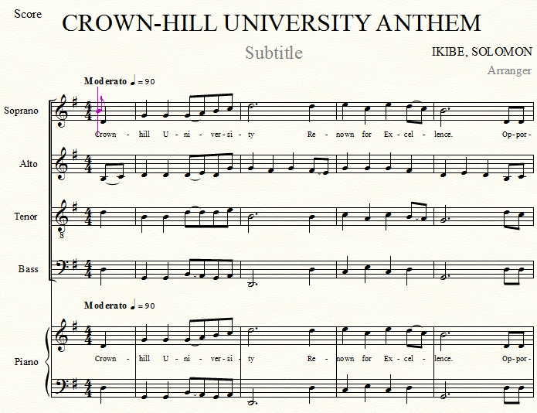

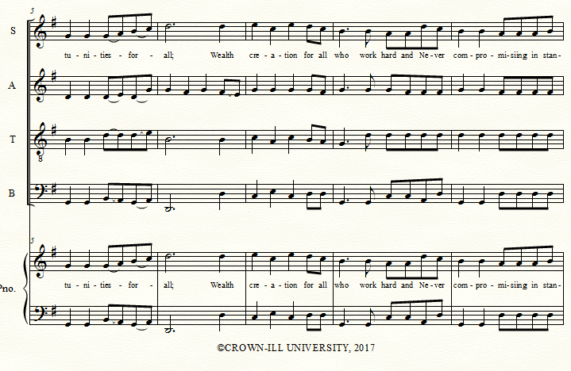

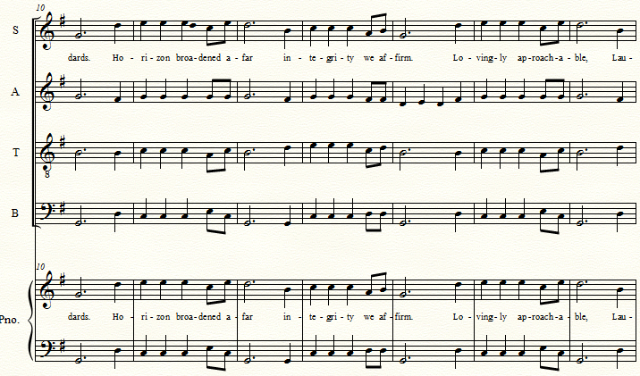

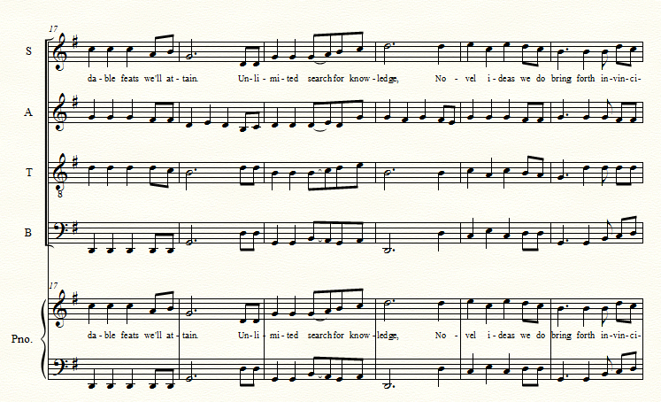

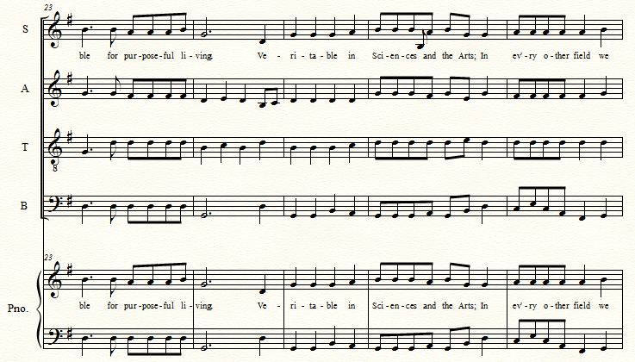
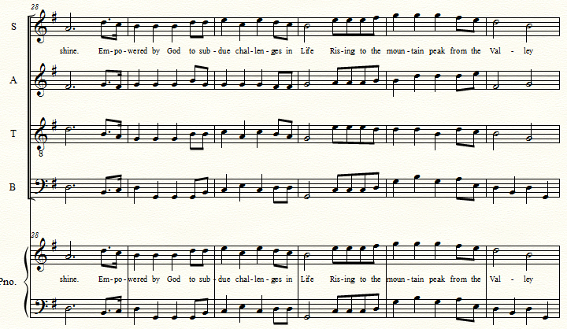
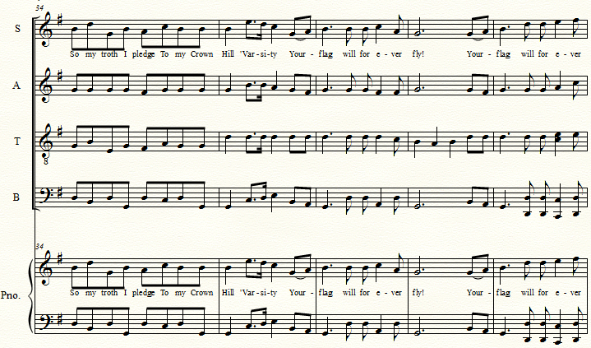

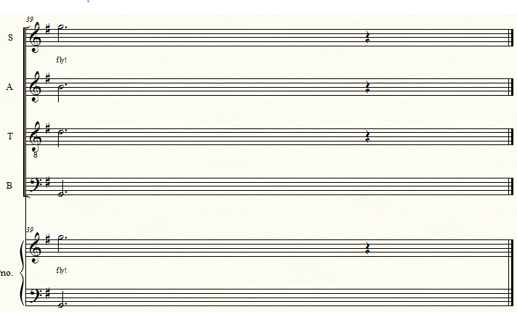
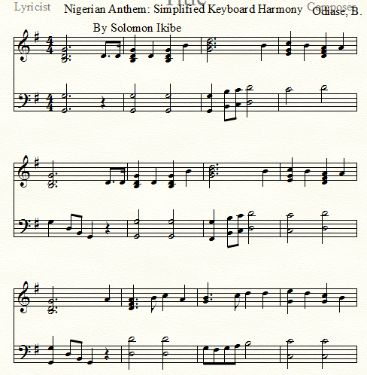
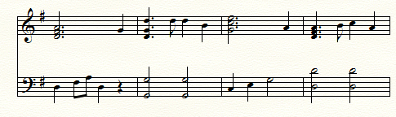
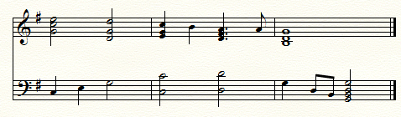

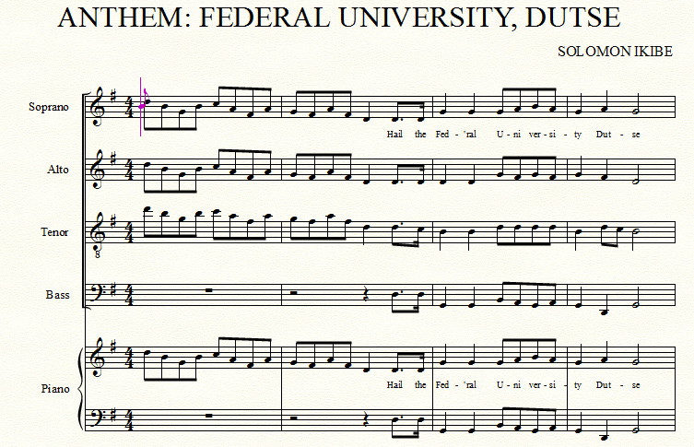
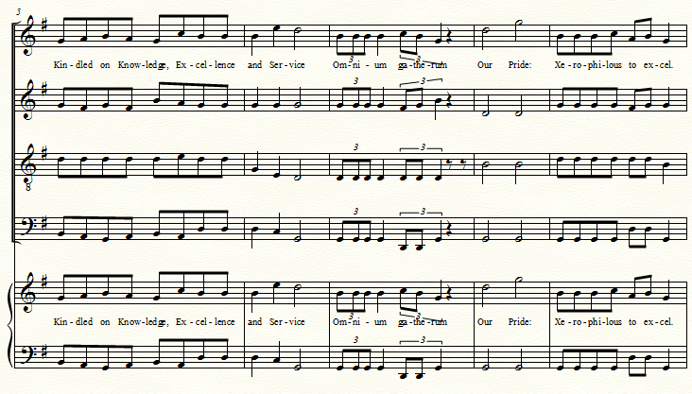

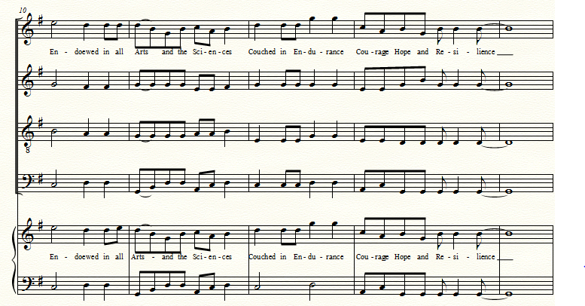
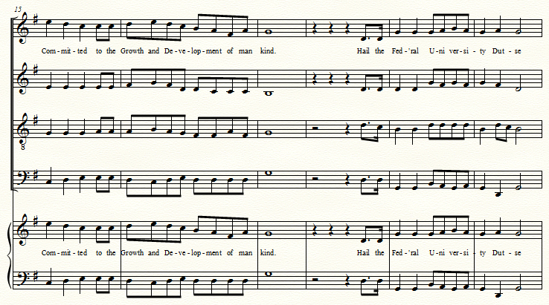

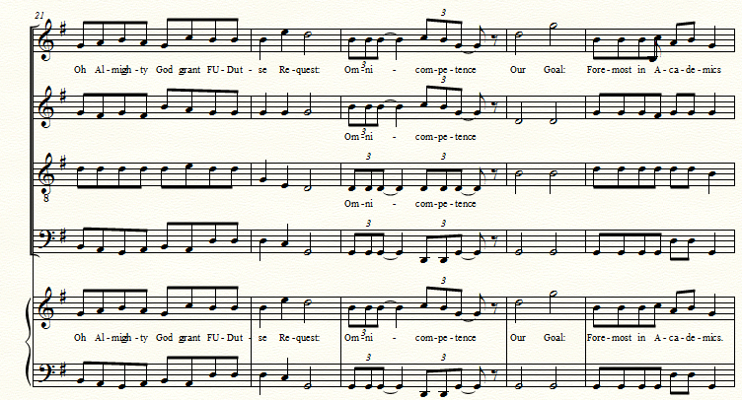
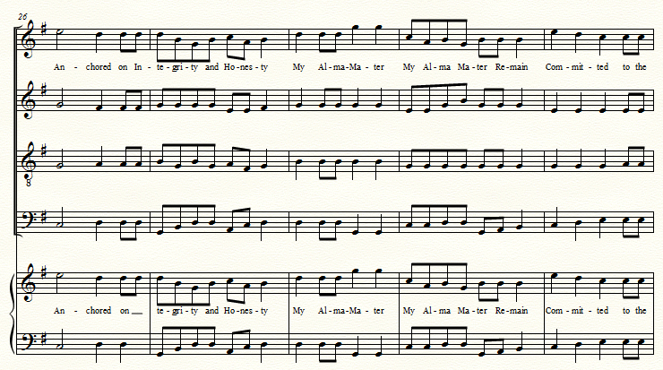

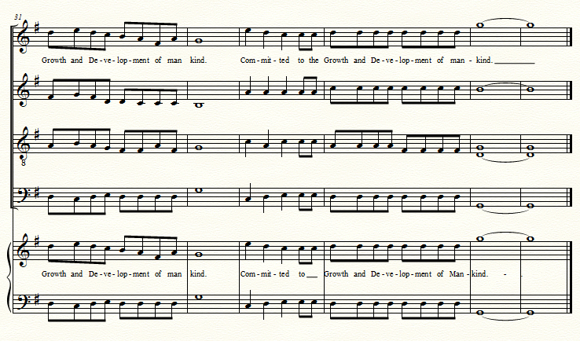
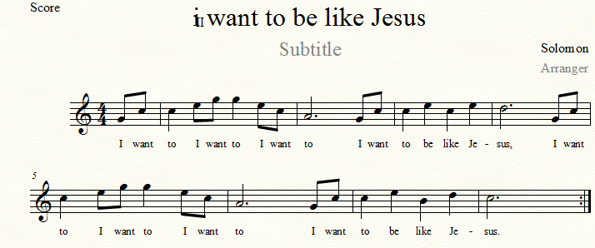

The Sound of Music (notated by S.O. Ikibe)
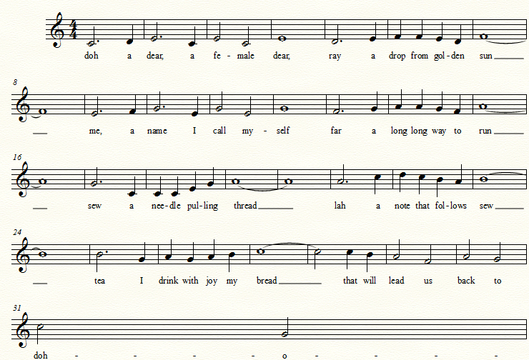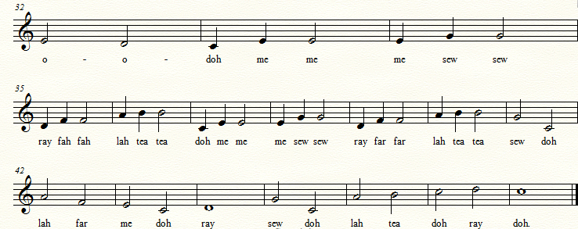

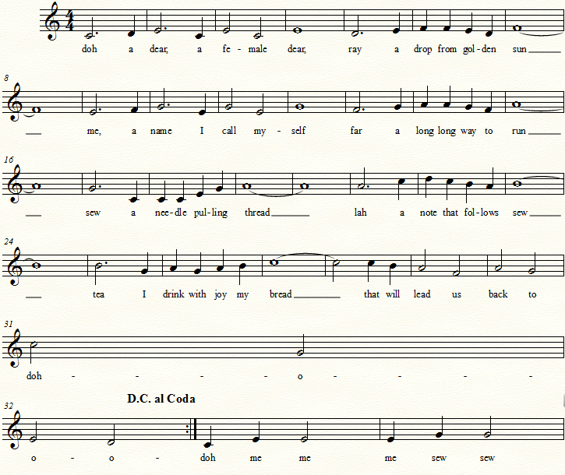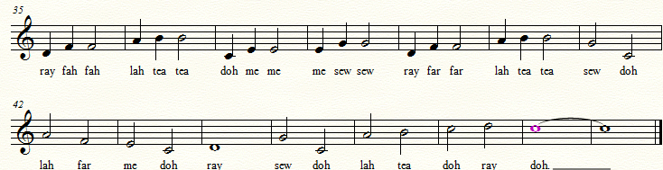

Anglican Women Teachers’ College, Benin-City;
Auchi Teachers’ College; Auchi
Esan Teachers’ College, Ubiaja,
Esenabe Teachers’ College, Bomadi,
Esigie Teachers’ College, Abudu,
Ewreni Teachers’ College, Ewreni,
Isiokolo Teachers’ College, Isiokolo,
Olona Teachers’ College, Onicha-Olona,
St. Michael’s Teachers’ College, Oleh, and
St. Thomas’s Teachers’ College, Ibusa.

