http//www.unilorin.edu.ng/centrepoint
Volume 23, No.1, pages 30-40 ©2017 University of Ilorin

Centrepoint Journal (Science Edition) 2141-3819/2016 $5.00 + 0.00

CPJ 2017003/23103

Axis Rotation of a Major F₁ Fold during a Retrograde F₂ Deformation in Southwestern Nigeria

¹Adedoyin, A.D., ²Ojo, O.J., ¹Alebiosu, M.T., ¹Adekeye, J.I.D. and
³Bamigboye, O.S.
¹Department of Geology and Mineral Sciences, University of Ilorin,Nigeria.
²Department of Geology, Federal University Oye Ekiti, Ekiti State, Nigeria.
³Department of Geology, Kwara State University, Malete, Nigeria.
*Corresponding author: deleadedoyin@yahoo.com

Abstract
North east of Ilorin, South-western Nigeria, a NE-SW trending (F₁) fold which was later refolded, was identified in part of the Basement Complex of the country. The area falls within the West African domain of the Pan African (600±150Ma) remobilized metamorphic terrain. Polyphase deformations, which involved at least three tectono-thermal episodes, were also identified. The area falls within the N-S trending Schist Belts where a large-scale sheeted S₁ penetrative metamorphic imprint was successively deformed into an overturned antiformal (F₁)fold and, later, to a broad synformal (F₂) fold whose axial traces are generally NE-SW and E-W, respectively. The first deformation episode was essentially metamorphic while the subsequent ones were tectonic. Petrological associations indicate that the rocks are mainly gneisses, psamites and psamitic to semi-pelitic schists, cut by Pan African granitoids. These rocks were deformed under high-temperature, low-pressure amphibolite facies conditions, but downgraded from high to medium grade metamorphic interface during a later tectonic event, under a high geothermal gradient within the upper crust. An occurrence of an overturned fold in the northern end of the axial trace of F₁ is attributed to irregular strain distribution that culminated in the open F₂ antiform during the third deformation episode. Of interest, within the context of the structural geology of Nigeria, is the E-W trend of the axis of the F₂ fold, which is apparently discordant to the observed general N-S structural trends in the Basement Complex of Nigeria. The origin of this latter structure is attributed to localized tangential deformation, culminating in fold axis rotation in the direction of the X axis, and subsequently overturning and tightening of the original F₁ fold during the late- to post- tectonic phases of the Pan African tectonism.

Keywords: Deformation, Folds, Axial trace, Overturned, Tangential, Tectonism.

Introduction
The Basement Complex terrain of south western Nigeria (Fig.1) lies within the convergence of the regional N-S structural trends which evolved as a result of tectono-thermal crustal remobilization during the evolution of the regional Pan African mobile belt. This terrain is part of the southern component of the Trans-Saharan Belt (Cahen et al, 1984); a Pan- African orogeny of the Late-Proterozoic age (Affaton et al, 1991) that post-dates three other major orogenic activities in Nigeria. The rocks of the Basement Complex of Nigeria are essentially Archean to Late Proterozoic but have been extensively remobilized by metamorphism, granitisation, deformation and magmatism during the various orogenies and more so by the Pan African event (Rahaman et al, 1983; Rahaman, 2004; Annor and Freeth, 1985; Umeji, 1988; Affaton et al 1991; Annor et al, 1996; Dada, 2006, 2008),the latest orogenesis, which is comparable and time-equivalent to the Cadomian and the Baikalian orogenies (Kroner and Stern, 2005).

The Basement Complex of Nigeria has been involved in multiphase deformations which are characteristic of the Himalayan-type orogenic belts (Dada, 2008) in which continental crustal thickening, aided by collision, reworked the rocks through combined actions of metamorphism, granitisation, shearing, folding and magmatism.

The Basement Complex of Nigeria is characterised by a generally N-S trending deformation fabrics like its counterpart domains in Niger, Mali and Algeria to the north within the Trans- Saharan Belt; and Benin, Togo and Ghana to the west (Boullier, 1991; Affaton et al, 1991) to which it has been correlated (Ajibade et al, 1987; Ajibade and Fitches, 1988; Bessoles and Trompette, 1980). Several works have been published on the structure of the Basement Complex of Nigeria (e.g. Boesse et al, 1989; Ajibade and Fitches, 1988; Annor 1986, 1998; Annor and Freeth, 1985; Annor et al, 1996, 1998; Caby and Boesse, 2001; Ajibade and Fitches, 1988; Dada 1999; Rahaman, 1988, 2004; Okonkwo, 1992, 1998, 2006; Adedoyin, 2013, 2015, 2016) and has been known to have witnessed polyphase deformations which have left an overriding N-S thermo-tectonic imprint on the rocks during the Pan African Orogeny.

The study area falls within Longitudes 04º45’– 04º55’ and Latitudes 08º45’ – 08º56’ but with no published petrological and structural data. However, Okonkwo (1992, 1998 and 2006) worked on the structures of the Basement Complex in Jebba area, some kilometres north of the area and identified features of similar typologies. Quartz- biotite- gneiss, semi- pelitic schists and psamites constitute the major rocks in the area. Small dykes of granite, pegmatites and quartz veins were also mapped.

In the north-eastern corner of the study area, the basement is overlain by the Cretaceous sediments of the Bida Basin. This paper therefore seeks to identify the reason for the tangential disposition of a major fold to the known N-S structural grains of the Basement Complex of Nigeria.

Methodology

Field exercise and laboratory works were carried out on the area. The field exercise included mapping on a 1:25,000 scale. Field data such as strike and dip, trend of lineation, axes and plunges of minor folds, attitudes of minor shear zones and faults were collected on the field during the mapping exercise. Sampling on the field was based on the methods of Paschier and Trouw (2005). In the laboratory, the various field data were resolved to produce the geological cum structural maps while the thin-sections, from the rock samples, were studied with conventional petrographic microscopes fitted with cameras (Amscope FMA050 Model).

Results
The geology of the study area comprises gneisses, psamites and granite. The gneiss varies in composition between quartz-biotite and granodioritic-tonalitic types which have been variably migmatized and banded. The varieties of gneiss grade into each other. The average assemblage is made up of quartz + biotite + microcline + plagioclase + hornblende ± muscovite. Tourmaline and other opaque minerals are the accessory minerals. The gneiss is the oldest rock type in the area. The psamite is comprised essentially of quartzite which is interleaved with quartz-schist and is considered to be likely of the same petrogenetic history. The quartzite is also often well exposed as high reliefs. The mineralogical assemblage of the quartzite comprises quartz which constitutes about 90% of the rock, sillimanite and sericite while zircon and opaque minerals constitute the accessory minerals.

The quartz-biotite schist is generally inter-banded with quartzite and contains quartz + biotite + muscovite + plagioclase + microcline while apatite and sphene are the accessory minerals. The overlying Cretaceous sediments are essentially sandstone of the Bida Basin, which is constrained to the north-eastern corner of the mapped area.

Members of the intrusive suite occur as small isolated bodies and possess discordant contacts with the background tectonites. The granite occurs as small oval or elongated bodies and contains quartz + biotite + plagioclase + microcline. Apatite, opaque, and myrmekite are the accessory minerals.

Field observations revealed a major (F₁) synformal fold which is tight in the south but becomes progressively tighter in the central area, and then overturned in the northern part (Fig. 2). The axis of the synform and the attitudes of the strike and dip around it indicate that it has also been refolded into a major open antiform with an E-W axis. Both the geological map and the geological cross-sections show the existence of the NE-SW trending F₁ synform which has been largely overturned, and the open fold with an E-W trending axis.

Discussion
The earliest structures in the study area are the large-scale sheeted metamorphic imprints, which conform to the structures within the Schist Belts (one of which the study area belongs to) in particular, and the Basement Complex of Nigeria in general. Like other parts of the complex, it has suffered polycyclic deformations with at least two folding phases. But the significant deflections of strikes in the area indicate a major E-W trending open fold with a moderately easterly plunge (Fig. 3), which has apparently refolded the earlier synformal structure (Fig. 4). The latter structure is a significant deviation from the known over-all structural pattern within the Basement Complex. The trend of foliations, high-grade metamorphism, polyphase deformation, and lack of primary structures suggest that the area probably belongs to the class of the Older Meta-sediments of Nigeria.

Field studies show that the schist and psamite are inter-banded, and overlie the gneisses and are all cross-cut by the granitic rocks. Petrographic studies, as summarised above, show that metamorphism is between low-pressure amphibolite facies and at the medium-high grade interface. Appearance of white mica, in an otherwise high-grade assemblage, is supportive of retrograde metamorphism during a succeeding tectono-thermal process. The constraint of the metamorphic conditions to the low-pressure amphibolite facies suggests that the metamorphism occurred under a high geothermal gradient within the upper levels of the crust. Remobilization under high geothermal conditions that was reported by Adedoyin et al (2013) in Koro-Egbe area may therefore be a common phenomenon within the Basement Complex of south-western Nigeria.

The dominant structural feature in the area (see Fig. 2) is a large-scale, broad, open antiform whose axis trends in an E-W direction and plunges easterly at moderate angles. The F₂ fold postdates the earlier F₁ synformal fold having been overprinted by the latter, and younger, F₂ fold. In the southern half of the mapped area, the axial trace of the F₁ fold is NE- SW with a westerly dip of about 40⁰. But in the northern half, it becomes NW-SE as a result of over-folding that affected it. The fold, therefore, is a synform which is open and symmetric in the south and tightened up and became essentially asymmetric as a result of differential strain distribution, northwards. This is possibly due to rotation of the fold axis, during the F₂ heterogeneous deformation episode. The latest and dominant axial disposition is E-W, suggesting a rotation towards the X axis.

The structural grain of the Basement Complex of Nigeria is N-S (Annor, 1986; Ajibade and Fitches, 1988; Affaton et al, 1991; Rahaman, 2004) and the Pan African folds are disposed along that trend. However, the trend of fabrics in the study area is an uncommon phenomenon which has not been widely reported in the Basement Complex of Nigeria. Although this may seem peculiar to this area, yet, the following discourse indicates that other areas within the Basement Complex of Nigeria have intruded this type of structural phenomena. A similar occurrence was reported by (Okonkwo, 2006) in Jebba area, north of this study area, where he identified recumbent folds as the dominant E-W structural features. It is considered that this feature in the present study area is only a local variation of the regional phenomenon that was either synchronous with the Pan African orogeny or related to a later localised tectonic event, which postdates the regional event. Okonkwo (2006) concluded that large-scale recumbent folding and ductile thrusting occurred during the early phase of the Pan African deformation event in Jebba area which was later truncated by west-ward back thrusting. If the phenomenon in the present study area was related to the Pan African orogeny, then it must have been a local variation that was probably due to anomalous strain distribution. Since older structural grains inherent in the Basement Complex during pre-Pan African events were either modified or obliterated during the Pan African episode, the dominant E-W trending F₂ antiform and the attitude of the earlier F₁ synform suggest that the later fold is post-Pan African. The localised deformation, which is tangentially disposed to the generally observed regional structural domain, occurred southwest of this area (Adedoyin, 2015).

Small-scale extensional features indicate that the area represents a regime of westerly movement coupled with N-S lateral compression that gave rise to the open antiform, during the latest phase of deformation, even as metamorphic retrogression set in. The first deformation episode occurred during the metamorphic processes that produced the large-scale, sheeted S₀/S₁ tectonites and was followed by the fold-forming event that produced the F₁ synform. The last deformation episode culminated in the E-W open F₂ fold during which period, a retrograde metamorphism occurred. The first event is non-tectonic, being essentially thermal, while the second and the third are essentially thermo-tectonic.

Conclusion
The geological and structural features of the study area show that the area belongs to the Older Metasediments of Nigeria. The general mineralogical assemblage in the study area typifies a high-grade, low-pressure, amphibolite facies metamorphism that was later downgraded to high-medium grade interface. The original axial trace of F₁ fold was in concordance with the N-S structural grain of the Basement Complex of Nigeria. The F₁ fold was refolded to another major F₂ fold with an E-W trending axis during a later deformation episode. The last deformation episode during which event the fold axis was rotated was also accompanied by retrograde metamorphism to the high grade/medium grade boundary. The trend of the axis of F₂ fold suggests that a localised condition of structural evolution, which is tangential to the widely accepted regional N-S trend within the Basement Complex of Nigeria, also occurred during the waning phase of the Pan African deformation, or that, locally, such episodes post-dated the Pan African tectonic event.
References
Adedoyin, A.D. and Ojo, O.J. (2016). Re-orientation of a NE-SW F₁ field during a retrograde F₂ deformation in South-Western Nigeria: further signature of Pan African tangentialdeformation.Abstract Proceedings of the 2016 Faculty of Science International Conference. Scientific Research for National Development, Federal University Oye Ekiti (www.fuoye.edu.ng).

Adedoyin, A.D. (2015). Geology and Structural Features of Parts of Sheets 203 (Lafiagi) SW and 224 (Osi) NW, Southwestern, Nigeria. Unpublished Ph.D. Thesis, University of Ilorin, Nigeria. 224.

Adedoyin, A.D., Bamigboye, O.S., Adekeye, J.I.D. and Ojo, O.J. (2013). Ductile shearing and remobilization of porphyritic granite in Koro-Egbe area, Southwestern Nigeria. Science Focus, 18(1): 73-77.

Affaton, P., Rahaman, M.A., Trompette, R. and Sougy, J. (1991). The Dahomeyide Orogeny: tectonothermal evolution and relationships with the Volta basin. In: Dallmeyer, R.D. and Lecorche, J.F. (eds,) The West African orogens and Circum Atlantic Correlatives. IUGS/UNESCO project 233. Springer Berlin, Heildelberg, New York. 107-122.

Ajibade, A.C., Woakes, M. and Rahaman, A.M. (1987). Proterozoic crustal developments in the Pan African regime of Nigeria.In; Kroner, A. (ed). Proterozoic lithosphere evolution. AGU Ser.17: 259-271.

Ajibade, A.C. and Fitches, W.R. (1988). The Nigerian Precambrian and the Pan African orogeny. In: Oluyide,P.O., Mbonu, W.C., Ogezi, A.E., Egbuniwe, I.G, Ajibade, A.C. and Umeji, A,C. (eds). Precambrian geology of Nigeria, Geological Survey of Nigeria Report. 1:45-53.

Annor, A.E. (1998). Structural and chronological relationships between the low grade Igarra Schist belt and its adjoining Okene Migmatite-Gneiss terrain in the Precambrian exposure of South-western Nigeria.Journal Mining Geology. 34(2):187-196.

Annor, A.E. (1986). A structural classification of the Precambrian Basement Complex of Nigeria. Journal of Applied Sciences. 21:84-89.

Annor, A.E. and Olobaniyi, S.B. (1998). A field appraisal of primary gold mineralization in the Okolom District of Isanlu area of the Precambrian schist Belts of Nigeria. In: Oni, E.A. (Ed.), Advances in Geodesy and Geophysics Research in Africa. 394-400

Annor, A.E. and Olobaniyi, S.B. and Mucke, A. (1996). A note on the geology of the Isanlu area in the Egbe-Isanlu Schist Belt, S.W. Nigeria. Journal of Mining and Geology. 32(1): 47-51.

Bessoles, B, and Trompette, R. (1980). Geologie de la’ Afrique La Chain Africain “zone mobile d’Afrique central (partiesud) et zone mobile soundanaise ”Mem. BRGM. 92:396.

Boesse, J.M., Ocan, O.O. and Rahaman, M.A. (1989). Lithology and the structure of Ife Ilesha area. Abstracts- 25th Annual International Conference of Nigerian Mining and Geosciences Society. 6-7.

Boher, M., Abouchami, W., Michard, A., Abarede, F. and Arndt, N.T. (1992). Crustal Growth inWest Africa at 2.1 Ga.J. Geophy.Res. 9:345-369.
Boullier, Anne-Marie (1991). The Pan-African Trans Saharan Beltin the Hoggar Shield (Algeria, Mali, Nigerin: Dallmeyer, R.D. and Lecorche, J.F. (eds,) The West African orogens and Circum Atlantic Correlatives. IUGS/UNESCO project 233. Springer Berlin, Heildelberg, New York. 107-122.

Caby, R. and Boesse, J.M. (2001). Pan-African Nappe system in South-western Nigeria: the Ife-Ilesha Schist Belt. Journal African Earth Sciences. 33:211-225.

Cahen, L., Snelling, N.J. and Vail, J.R. (1984). The chronology and evolution of Africa. Clarendon Press, Oxford. 512.

Dada, S.S. (2008). Proterozoic evolution of the Nigerian-Boborema province. Geological Society, London, Special publications. 294:121-136.

Dada, S.S. (2006). Proterozoic evolution of Nigeria. In: Oshi, O (ed). The Basement Complex of Nigeria and its Mineral Resources (A Tribute to Prof. M.A. Rahaman). Akin Jinad & Co. Ibadan. 29–44.
Dada, S.S. (1999). Geochemistry U-Pb, Rb-Sr and accessory mineralogical characteristics of the Sarkin Pawa Migmatitic Gneiss, North central Nigeria. Spectrum Journal 6 (1&2):126-136.

Kroner, A. and Stern, R.J. (2005). Pan African Orogeny. Elsevier Ltd. 1-12.

Okonkwo, C.T. (2006). Pan-African Faulting in Jebba area, Southwestern Nigeria. In: Oshin, O (ed). The Basement Complex of Nigeria and its Mineral Resources (A Tribute to Prof. M. A. Rahaman). Akin Jinad & Co. Ibadan. 71-86.

Okonkwo, C.T. (1998). Synsedimentary tectonics in the Proterozoic meta-sedimentary rocks of Bode Saadu area, Nigeria. Nigerian Journal of Pure and Applied Sciences. 11:455- 461

Okonkwo, C.T. (1992). Structural geology of basement rocks of Jebba area, Nigeria. Journal of Mining Geology. 28: 203-209.

Paschier, C.W. and Trouw, R.A.J. (2005). Microtectonics. 2nd Ed. Springer-Verlag, Berlin. 366.

Rahaman, M.A. (1988). Recent advances in the study of the Basement Complex of Nigeria. In: Oluyide,P.O., Mbonu, W.C., Ogezi, A.E., Egbuniwe, I.G, Ajibade, A.C. and Umeji, A,C. (eds). Precambrian geology of Nigeria, Geological Survey of Nigeria Report.

Rahaman, M.A. (2004). Nigeria’s Mineral Endowment and Sustainable development. 2nd Mosobalaje Oyawoye Faculty of Science Lecture in Geology. University of Ilorin, Nigeria.

Rahaman, M.A., Emofurieta, W.O., and Cean-Vachette, M. (1983). The potassic granite of the Igbeti area: Further evidence of the polycyclic evolution of the Pan-African Belt in Southwestern Nigeria. Nigerian Journal of Mining and Geology. 22 (1&2): 125-135.

Umeji, A.C. (1988). The Precambrian of part of SE Nigeria: a magmatic and tectonic study. In: Oluyide,P.O., Mbonu, W.C., Ogezi, A.E., Egbuniwe, I.G, Ajibade, A.C. and Umeji, A,C. (eds). Precambrian Geology of Nigeria, Geological Survey of Nigeria Report. 1:69-76.

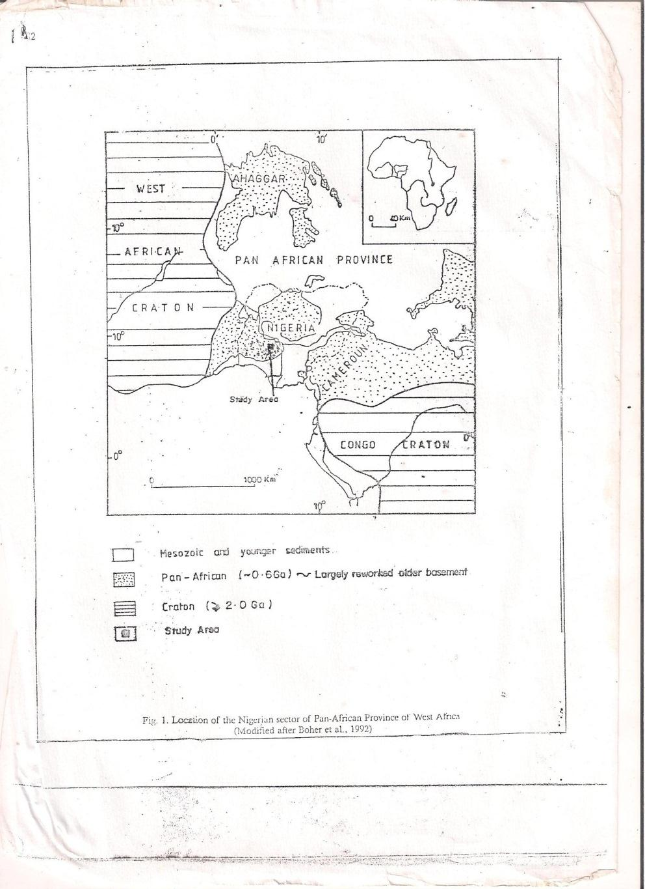
Fig. 1: Province of West Africa (Modified after Boher et al, 1992)
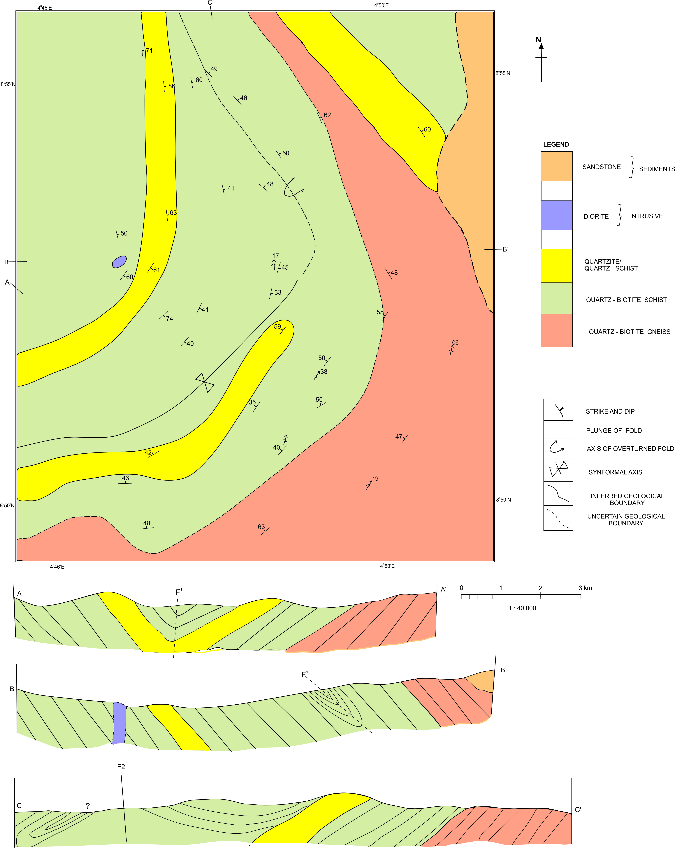
Centrepoint Journal Volume 23. No. 1 (2017)
Fig. 2: Geological map and Geological cross-sections of the study area showing the existence of F₁ folds.

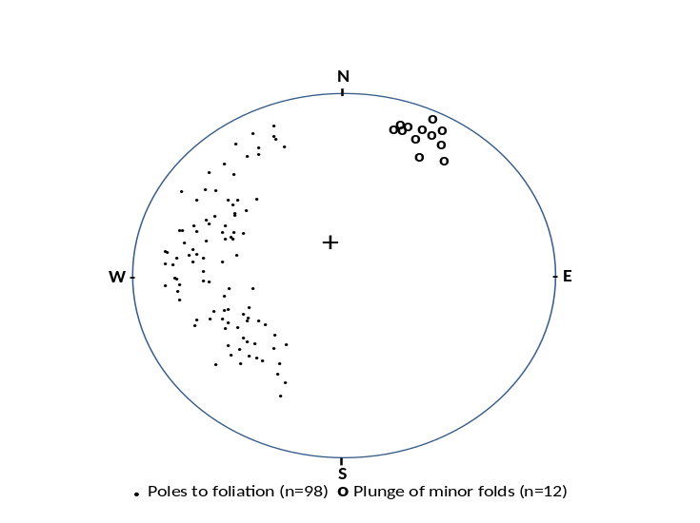
Fig. 3: Stereonet plot around the overturned fold
