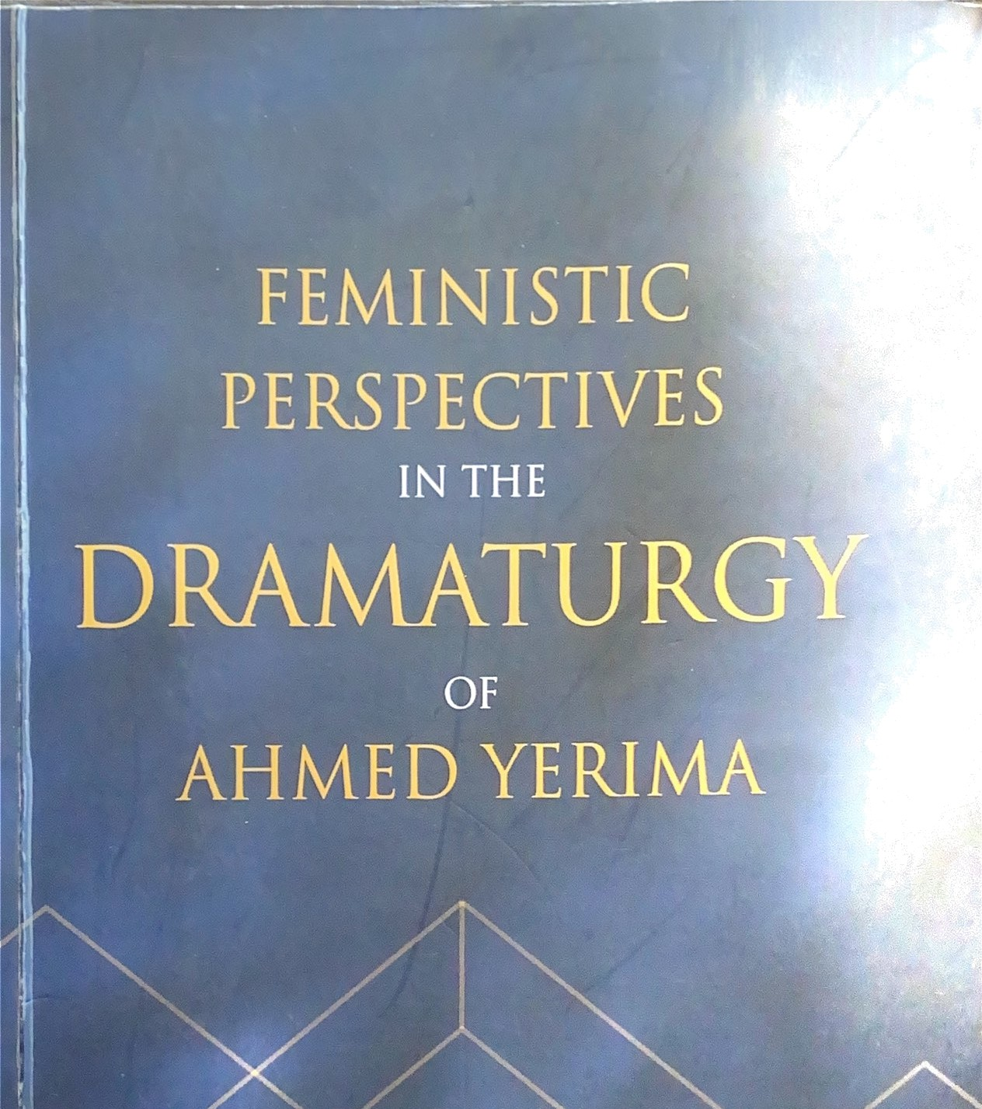

EDITED BY:





AHVED YI RIVA

O LUDOLAPO RJ E Dl RAN


Department of the Per forrning and Filme AI te

University of Ilorin

CONTENTS


Preface
Foreword

Notes on Contributors
Chapter One - The Female Gender and her Quest of Social 1
Reordering in Ahmed Yerima's Orisa Ibeji and Ikudeti -
Ojediran, Oludolapo th.D Bashiru A. yfptt,pz if

Chapter Two - Rape Culture and the Dehumanisation of 24

African Women in Ahmed Yerima's Selected Play-Texas -
Annexe, Adenikc

Chapter Three - Contextualising The Complexities and 52

Expectations of Womanhood in Ahmed Yerima's jakadiya
an6Aetu -FaUJode Abol0de

Chapter Four - Historicisation of Patriarchal Norms And 63

Representing Gender Roles in Ahmed Yerima's Selected Plays
-Atteh Semi Yist
Chapter Five - Objectifications Of Female Gender in Ahmed 92
Yerima'sAgéoJn -Atay k› OfamideSuliat
Chapter Six - Women For Power: A Discurse on Female 109
Discord and Question of PatriarchalOppression in Ahmed Yerima's Omjwj EHNa0 *!-*!* *** !• !* * * !
Mch' @ yode, Ayodeji’K**!*
iii



CJi ap rer Sèveri - des il i eri ce, Asserriveness in Ahmed Yeriina'

Chaprer Eigh t - Comparative Perceptions of Female
Cliaracters in Ahmed Yerima's Ak«abata and Pegvnrun


138

Chspzet Nine - Feminine Discourse in Ahmed Yerima 3 Selected Plays -Azfeo«A, f'oming

Chapter Ten - Religion Dynamics and the Nigerian Sociei:f in 173
Ahmed Yerima's Ore/ii’-Iyanda 'undayEl ah HDeni I

Chapter Eleven -Women, Polirics, ReJigion and Socio-ethical 187 Duplicity in Ahmed Yerima's Ae/iâo- ONJomi, f. Cargo/n
Chapter Twelve - Mae Subterfuge Against Women in Ahmed 205 Yerima's The liver- Oyedepo Omobola
Chapter Thirteen - Prey Arid Predator: A Study of Dual 213 Imaging Female Characters in Ahmed Yerima's Hard Graund andAerx-Hp«nmuñe, Hya6umi WJañnm, Lucky

Chapter fourteen - Religious And CuJtural Aesthetics of The Feminine Power in Ahmed Yerima's lien - tarief, Why Ta*’ye Ph.D., lyanda, Sunday El ah H At:teh, 'en
229

Chapter Fifteen - Feminine Morality and Virtue in Ahmed 242



Yerima's Selected PJay-Texts - OJedlrun, oIud«ïup•,
Psycho-analytÎCal Study of Ahmed
Oyedepo Omoboîa
267


Magbagbeola


CHAPTER FOURTćEN
gy!żíGíOUS A3ŃlČł CULTURW ÆsTaETş<s

OF THE FEVININE pçję¿yq jp
AHNfED YERmA's öscixi
DANIJ$L, Mary Taiye, IYANDA, Sunday Elij@ 8; AJÑ$ÏH, Femi Yinka

ęæoducčon
The African society represenY a socioreûğous lanAcape
characterised by diverse cultures and traditional pracÛces that iesthetic£ly, influence gender relaêonship. In Nigeôa, both Islam and Chrisüanity coexist £ongside inÂgenous ancient beliefs, which enphasise purity, spiritual cleansing, and Ğe utilisaöon of feminine power as instruments for regeneraüon. Therefore, Œis study explores the reûğous and cultural aesthetics of feminine power in Ahmed
ëńlna's Õsun. This study adopo the descripfive research design and C0fltent analysiswith Arnold Arnold Berleant's CulturA Aestheücs Geory (2005) to foreground the study. The descńpüve design is to 0flCëğlalise issues on the silent struggles of women, especially as



CO* *<m-alised in Yerima's Órun. Findings reveal that women have
* eloped a feminine force capable of intercepting and reğŃmä.IldìIlğ
* /nßuencesof patriarchA tendencies Withifl soclety's Culture and
°* lğons. It is observed that these spirituAly driven socio-religious
P'ãC><$$have resurfaced through various avenues. Characters lÅe
fi**å äHd fy_{e}moja should be emulated for S pp mfl$ jusüce for

223

tradition, and the mothers of the night'seffort at destroying lec tendencies like King Ogidan for plaguing women and society. Yerima's play, Clsun offers a compelling narrative that unders religious and cultural aesthetics of feminine power wit cosmology. To further explore the theme of feminine
African drama, it is recommended that scholars conduct co studies on similar portrayals in other playwrights' works. practitioners should also engage in productions that celeb
agency in African spirituality. ’
African culture and religions have always â feminine issues and challenges with a lot of sensitivity and paper addresses the issue of culture within the African African culture is being relegated to a lowly position to the
it is even despised by the very same people who are supp preserve it. To be an African in the traditional setting is to religious. Little wonder Mbiti (1969, p. 20) says °Afric notoriously religious”. He goes further by identifying religio aspects of culture which include beliefs, practices, cere festivals, and religious objects, and places values and m religious officials and leaders. In a nutshell, religion is £o aspects ofAfrican life.
Since the arrival of the Christian missionaries in most blacks have the belief that everything said and prac Christians is the best; this has affected and is still affecting culture negatively. In African traditional religions, Afri play significant roles in places like ritual ceremonies¡ an‘ leadership, therefore, contributing positively in various. Awolalu and Dopamu (2005, p. 6) emphasise the ‘lea women in traditional religion in areas of worship, medi and healers coupled with other special services which women are highly recognized and significant in religio their communities". Ahmed Yerima corroborated this

230


ucing the three elderly and
JyemojaintO his play; ó›xn.

° er WOmennamelyKori,

Aje



Plen: LÍke many academic dÍSciplines such as sociology,

òilosophy and psycholo yf “religion lant

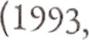
y ¡¡qjtion” (Eze, 2016, p. 13). Omoregbe
a universally accepted

P 3) asserts 4at,

reli
on is conceived and defined difFerently by difFerent people,

húng its subjective and variedinterpretations”. de absence of
tqsus reflects the complex and multifaceted nature of religion. It

¡, itated furtherthat “religion derives from tWO Latin words as ¡p

„ o: /‹g re(meaningto bind), relegere(meaning relationship),
the etyITlOlogy of the word “religion” shows tÍlàt It is essentially a
relatíorlship, a link established between two persona; the human
person, and the divine person believed to exist. (Omoregbe, 1593, p.
it).
Also, Momoh (2000, p. 16) opines that dCÍÏIlinga disciplina iubject is like controlling the executiva position in any viable organisation, say a state or an executive presidentOr an executive prime minister of a country calls the shots. He furtherviews that myone who controls the definitions and you have a pretty good clue
who controls everything else”; and the Chinese proverbs more or less igree with “he who defines the terms, wins the arguments”. Anyanwu (2004, p. 9) asserts that ‘religion is human interaction with the supernatural to cope with life's crises”. Okereke(1983, p. 7S) is of the opinion that ‘religion is a link between man and God”. He believes that religion is the sum total of man's relation with God and the transcendent.
Furthermore, Oxford dictionaries define religion as the belief Ad or worship of a super-human controllingpower, especidlya
!S0RÜ God or gods. Others such as Ekwunife (199 , p. 20) says

lgion iv a man's awareness and recognition of hís

231
dependent

rc1:itions1ii{ ‹an :i ti anscendeflt being, the wlac›lly other, nali«ble tin-n.true:ilale, personalised or iinpersonalizcd exPressible in u societ)’ tlit ougla bcliefs, worshi[ and ethical or moral vio Defining religion has been a controversial and Complicated iss religious studies with scholars failing to agree on any one defi ’ Religion is an effort by humans to search for meaning, to ande reality and to place themselves in a relationship with reality. R came as a result of man's quest to seek answers to the unkno
be concluded that religion is man's attempt at understan about phenomena through beliefs and practices.

Culture: Taylor (1920, p. 3); the first anthropologist, defines c as “the complex whole which includes knowledge, belief, art, morals, customs and any other capabilities acquired by man member of society”. He was the first to specify that culture is ie and acquired, as opposed to being a biological trait. Geertz (19 18) in his words, defines culture as “the fabric of meaning in te which human beings interpret their experience and guide actions”. This is another anthropological definition of culture.
Durkheim (1895, p. 6) gives a sociological definitio culture as the totality of social institutions, norms and values shape the behaviour and attitudes of individuals within a so Blumer (1969, p. 19) in his sociological definition of culture, o that “culture refers to the shared, learned and transmitted avi values and norms that characterises human group”. Adorno (19 4) defines culture philosophically that culture is the sum total o artefacts, values, and norms that are produced and reproduced
a society, and that shape the ways in which individuals perceive, and behave”. The various definitions given above show
multifaceted and complex nature of culture. They also highlight different disciplines and scholars approach the concept of C from unique or different perspectives.

232


Aesthetics is a broad field WÍth different categorisations in

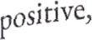
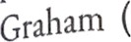
negative and neutral conceptions of art. For instance,
2005, p. 3) states, that the‘most familiar question
$§iJpsophicalaesthetics is this: what 1 Q Why is this question worth
 The answer has to be that art masters”. Interestingly, Berleant

(2012, p. §) expresses that ‘despite yagination, wide experience with
perceptu£ sensit¡vity, j_{Í}g_{e}jy

aestlietic masters that extend

Qyond one's native culture, and the educacionalbackground to focus md directthat experience, the influence ofcognitive prejudicemaybe more pervasive and poweifiil still”. The perception of an artwork is linked to in aesthetic value, which can be understoodthrough the Nsticstyles and cultures that shaped it.
Africa's cultural belief systems when examined alongside the influences of diverse foreign religions, manifest as culturdly rich environments distinguished by a vast arrxy of artistic expressions and inextraordinary degree ofcreativity. This interplay ofindigenous and external influences contributes to the dynamic cultural landscape which showcases Africa's intricate synthesis of tradition and innovation. From Berleant's (2005, p. 170) point of expression, ‘different cultural traditions in the arts have become increasingly Kiliar, ethnic tradition has emerged as a powerful force in cultural ÏdCRtity”. Ösun encompasses a diverse range of cultural identities
£CCOgnised by the Nigerian people. Osun State, the Òsun Osogbo
MtÍVJ and Ahmed Yerima's play, Õsun, are just a lew elements that contnb»i‹ to Nigeria's diverse identity. In Msm, Yerima portrays  4S botei a character and a cultural experience, reflecting tire nmcesofthesociety in which it isSet.

In addition, Yerima's conception of cultural aesthetics
RCOff p res three distinct analyt¡ ; ttt ds: the environment, the
°>ltura1 ethos, and artistic expression. ThiS framework is
t acterizedby a clarity of form and detail thãt rellects the intricate

233

ilà terplay of gender dynamics and the application of cultur aesthetics within the context of Nigerian theatre and drama. Th elements collectively contribute to a deeper understanding of socio-cultural landscape and its representation in the performing Johnson (2004, p. 35)submits that:
Clarity of form and detail...“ will ease the chanc appreciation of the performance by the audience; as " add to what is theatrical about the art. “Compl composition” can be linked to confiicu in the drama, which, the drama would lack suspense, tension and ia, while “balance and symmetry”, are indispensablü determining the aesthetic positions on the stage Òirectoriall
and in the placements offigures and props from a rather mis’
en-scene and tableau perspectives.
Johnson's perspective emphasises that the essence of the peopl culture and the art within it reflects the playwright's “complexity composition.” Yerima incorporates both the material and immat aspects of Yoruba culture, setting Ói«n background apart from o cultural environments. The aesthetic framework ofYerima's visio symmetrically balanced to align gender dynamics with cul representation.
Consequently, Ahmed Yerima's cultural aesthetic of feminine power in FSun essentially distorts the art of patriar tendencies within society. Berleant (2005, p. 170) opines that influence of culture on att, indeed the formative power of cu1 even more true of the environment”. However,
We cannot evade the realization that, despite the intent efforts of phenomenology and the psychology of percep there is no pure experience. And in the present context, we infer that there is no pure aesthetic experience. We look a world metaphorically, so to speak, through a multitud superimposed filters: the filters of language and, even

234

”

_{C}omprehensively, the ontology aRd metaphysics of our
nt

future.(Berlea , 2012, p. S).
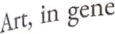
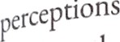
ral, relies on the phenomenologiCal and psychology of
which are rooted in its structuralCOIflpOsition—both

and content—allowing it to
„pptibility within the context of its

achieve a certain level of
Originality to society. This


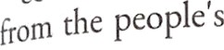
ed Yerima's aesthetic value Of art derives its uniqueness
cultural belief system. Each society generates art
tyit is unique to its cultural beliefs, serving as a means to convey its
p0 1dñ• and familiarise others with its beliefsystem.

@cRcladonshlp between Religion and Culture
Sociologists and Theologians agree that religion operates ytb¡n the context of culture and that religion is a prime influence o»‹ulture.Religion is influenced by culture and also triggers cultural charge. Though culture can be defined in vuious ways u discussed
ibor:, most simply, it is the behaviors and beliefs ofa group ofpcople. Rdigion is dso a set of behaviours and beliefs though it typically focuscsonthespiritudaspecu oflife.
Religion serves as a cornerstone of identity, shaping lnâividuxls, beliefs, behaviours, and communal interactions. inversely, culture provides the context within which religion otlops and is expressed, reflecting the values, norms and traditions
0/2J{irticu1usociety.




la opens with Kin O dv Arogun
$, the King of

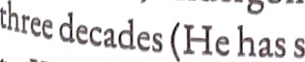


ljtin OdO,undergoing a ritual that Wlll prolonghli llf@grid relgn by
pent JUSt‹»•••r••t0{} iiiethrone),URknO 11
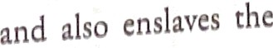
^{l0} Og m, he 1s under a curve plead on hint beccusc of his

23f
L

nieinbers of the maiden's family. The curse is that no descendant o
the king will reign for more than two years. This is the reason wh

King Ogidan decides to ward oíf the
curse through supernamr

forces that sanctioned the curse. Unfortunately, contrary to assurance given to the king by priest Ikusanri, the officiating p that the ritual was a success, it was indeed a failure. The affairs o town became awry, the reason why the annual festival of Orisa '
sun festival became a failure that year. For the town to
peaceful again, the help and intervention of the deities are to

then another royal secret is revealed, raped a maiden named Ósuntayo (the daughter of one of the chie6i
named Otun) to death or might have used the maiden for ritual for, tenure elongation. This provokes the anger of the already tense environment. So, the cleansing ritual items given to sun are rejected by the goddess and this significa danger. This is a sign that danger aheadin thetown.

Feminine Power Aesthetics lu Ahmed Yerlma's Ómn
After three years on the Throne, King Ogidan Arogunm the King of Ijekun Odo, uses ritualistic practices to prolong his and reign for three decades. Unknown to King Ogidan, he is und curse placed on him because of his father, the former king, violated a maiden while on the throne and enslaved members of maiden's family. The curse is that no descendant of the king will for more than two years. This is the reason why King Ogidari dec to ward oíf the curse through supernatural forces believed t capable of sanctioning the curse. Apena breaks the foreshado impending danger.
APENA: ... The air is stale...Three mothers of the night a cooking pot with rich sanyan and the cro ingredients in tlieir boíling pot.(Yerima, 2020, p. 20
The introduction of the influential mothers of the mg

236


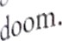
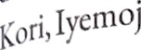
_{j}nCorporation of feinilline p_{O}pt, that reeks of iirlmine


The three elderly and powerful woiiien in the nt
a and Aje show their spiritualpow•rhere.
During the festival of Ori¡hã OdO Ósun Of Odun Yeye, the

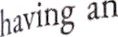

l‹ celebratethe Yeye Odo of the Imjekuniver, and they do this by
@rugba sun Carry calabash tO the river. Interestingly,
,« , Eiu priest also showed the Im Ortance of the power o/ boch gather of night, goddess and a woman's restless spirit.
SAURA: Did you give the mothers Of the night their gifts? Even your daughter's spirit is restless. Ósun heaves, her
anger festers. (Yerima 2020, p. 208).
Jt qgh Apena's reactions, it is expressed that with the machinations falegods, things begin to fall apart and Ijekun Odo is plunged into gtkness because “Orisa Odo Ósun and lyemoja were turningaround turning around until the once peaceful river became a turning
Girl ind” (Yerima 2020, p. 218). These feminine powers of the gods riused the water to rise, and“with arms outstretched from the river. lt yirt‹d San and dragged him down the river" (Yerirna 2020, p. 219).
Indy, ‘Igba Òsun which the Arugba had taken to the river the day
òefore. The calabash. was returned(Yerima 2020, p. 220).
Furthermore, the cultural and religious aesthetics of the people's tradition diminishes as the Arugba is expected to be pure so Mat the sacrificó is acceptable before the gods. After carrying the
*!*bash, ste is supposed to be happy but this is not so and this raised 9ttestions about her powers as Arugba.
ÍTÁ ODÓ: Kabiesi, the Arugba has fainted. the bleeds from
everywhere as if she has been defiled. (Yeflmít, 2020, p•
221).
°Ji also confirms that great consultations mUSt bfl before the
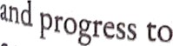
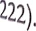
*g i is chosen because Ifa's choice is “a gifl pat Would bring peace the land, a virgin as pure as a dove” (Ó5tfR,2020, p.
° preparing her for the spiritual process,

237

 USÓ: ...We took her first to lyenloja asking f protection. We begged her to convince her sister Ós accept and bless our oíferings, then we went befor olóde, whom we fondly refer you as Kori, the mo abundant blessings,and finally Aje, the orisa of
and plenty...(Yerima2020, p. 22A)•
The feminine power is pronounced during the rites th Arugbahas to undergo before the processionmust start. The ordeal o the defiled Arugbawas shared and her reluctance to carry the calabas
also validated her defilement.
ÏYÄ ODÖ: “She was never possessed... I knew that the puri of the Arugba has been compfOlTlÏSCd” (Yerima 2020, 225)
At long last, the Arugba dres due to the power she lost, power linked to her virginity that could make her connect with goddess Ósun gone.
Aesthetics of feminine power is further expressed by mothers of the night. The trío thwart the fortification thxt Ogidan cmbarked on at the opening of the play. The trio unmu king as “a crooked man with the crown... an epitome of evil” ( 2020, p. US). For exposing the “Arugba” to defilement inst protecting her, he was eventually executed shamefully courtesy three elderlyand powerful women in Yerima's play; Ósun. Also intriguing is the fact that Esu also transformed into a woman sh solve the request brought by Otun. According to Saura, ‘my shapely shapeless. He takes the shape and turn the sides that o a matter to it” (Ósun, 2020, p. 229). To loosen the entanglc which Otun daughtcr's death could be revealed, more sacrifi to be mzdcto themothers.
Á • BOO lTlflR/ WOlT1Cf1 hRVg I¡hp{p Çjq pp3 }jq t3jjp
Scnd mora glfts to the mothers of the ntght o

238

time. There is a cloak they must pull from the face of the

killer of your daughter, and then (Yerima 2020, p. 230).
Creed Yerirria's conception of feminine power
WÎll be revealed.

Â tÎlàt tOo1 used to

¡pttr_{C}ept the lecherous tendencies of patriafchy in society while
t nsoling and restoring the importance of a wO '

ensuring national growth. lyemoja reacts ppprecedentedexperiences.
5 ptifity in

regardless of the Arugba's

Iemoa: Ösun weeps angry. lyemoja consoles her. Why did you send a broken spirit to Cdfty the sacred calabash to the riverside for Ösun?(Yerima2020, p. 231)
je three elderly women decide to use their feminine powers to mete jjt J2jjjjiS{imef2t tO b:llRflCe the scope of realiç and rtstore order in society. his is the reason why King Ogidan is rejected because of his approach to warding offthe curse from his father'sgeneration.

Conclusion
By portraying Osun ns a divine and influcntid figure, the play rcÆrms the signlficance of women In both spiritun) und soclctal leadership roles. Yerima's dramatisatlon utllised the chuactets of frit mothtrs of the night, Esu and the goddesses to chdlcnge paaluchd rit oints by llluminatlng the resilienct, wlsdom, and authorlty
8!ëtlt il rlcan tfaditÎons' Ùmlnint H e0 . 8 d

$ture studies probe into the intenection of gender, spirituality, and
ÿflÑ0flngnce in African drame to enhmce the understanding of
* gcnous feminist nurativ«i. Furthermore, theatre practitioners

' Id persist ln staging productions that honour feminine power
within cultural and religious contexte. Fostering continuons

"' °'nic discourse on African
"'trlbute to preservlng and promot n8 th°°' n‘rr'ti"« ln

0f1tBl}iporaryso ep.





References
A‹orilo, s:. (1'?r i). .1/‹’/‹fm.•n r«"•’’ ”""” ’”"”?’"'°›
Germany: Verso l’ublicatiC fl H Se
Akiintunde. D. O (2001). Afri'can culture and the qtiest for
ri§£r/. Ibadan: Seger.
Awolalu, J. 0. 8c Dopamu. P. A. (2005). f4"err Afn'can tradi
religion. Ibadan: Macmillian Nigeria Publishers.
Berleant, A. (200S). Aesthetics and envi'ronment: Theme an varcattoll5 OH driand culture. Aldershot: Ashgate Publishing.
Berleant, A. (2012). Aesthetics beyond the Arts: new and recent essay:
Aldershot: Ashgate Publishing.
Bluiner, H, (1969). Symb0lic interactionism: perspective and meth
Berkeley Los Angeles London: Universiy of CaliforniaPre!
Durkheim, E. (1895). The rules 0f soci0logic»il meth0d. Fran Librairie Felix Alcan.
Ekwunife. A.N. 0. (1990). Comecration in Igbo traditional reli,
Onitsha Publishers Ltd.
Eze, M, 0 (2016) The politi'cs ofl›istoy i'n contemporay AfNca. h
York: Palgrave Macmillan.
Graham, G.(2005), PhlfO5O 0 kh0 arts.21n introducti'on to
thi'rd edition. London: Routledge.
Geertz, C. (1973). The i’nte@retati0nOfCultures.New York City:
Books.
Johnsolx, E. (2004). Acstheti'cs thedi'alectics and theatri'csoftheatri
t’0MmtrniffIttOH. Lagos: Concept PublicationsLimited.
Mbitl. Jr S(1969) A[ri’Cax r0ligiOnsand philo5Dphy. New York:

Pulnlishcrs.
Mt›intila,C. S. (2000), 7âe su!›tattti «f AfNtan phllOsopl›y.

Christianperspective. In:
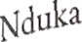
0. A and Ihuoma, E. 0. (eds) New peFspecti’ e in moral ed nation.Ibadan: Evans brothers.
O‹egbe, J. (j 993). A philosophical look at religion. Lagos: ]oga
0
@ucationalResearch and Publishers Ltd.

lor, . (1920) P"’’!!’*e «ultuTe:Re5e rchesi'nto th_{e} developmentof it0l• , philosophy, religi'on, language, Aflownand fft5tom.
London:John Murray.
A. (2020). 'efynrun Ikudeti KuteJu Msm (Four plays). R Chester: QhaCrownes Publishing Ltd.




Feministic Perspectives in the Dramaturgy of Ahmed YedDi8 1# 8 Compilation of articles by different authors who examlncd› m /«n md explored ftmale characters and theirchuacterisations,fcmlltlflllJ, Jm4)C aesthetics and female dynamism u portrayed in tire selected play-tcxu of Ahmed Yerima. The intellectudly crafted articles delved into how Yerima views women culturally, historically, socially, religiously, economically amongst others and how these women are presented to and navigated within the society at large. While women narratives come from different perspectives, the need to change the subjugation and ill-treatment of the women within the society isemphasised in most ofthe articles. However, the text with a compilation of over twenty analysed play-texts ofAhmed Yerima portrays the gendered culture of the African women who are mostly insearch ofidentityand societal value for the women folL

Oludolapo Ojediran is a Graduate of the Department of the Performing Arts, University ofIlorin, Eorin, where she holds her B.A(BachelorofArts)and MW (Master of Arts) Degrees. She obtained her Doctorate Degree from Queen Margaret University, Edinburgh, United Kingdom. She iscurrently a lecturer at the Department of the Performing Arts, University of Ilorin, Eorin, Kwara State, Nigeria.




