Spectrum Pricing for Cognitive Radio
By Abdulkarim Oloyede David Grace and Nasir Faruk

Introduction
Spectrum pricing and efficient allocation of spectrum should be some of the main concerns in implementation of cognitive radio because price indicates the value of the spectrum to both the buyer and the seller. Dynamic spectrum management brings about the need for a dynamic pricing mechanism. The concept of market theory needs to be introduced to spectrum management in order to effectively utilise the radio spectrum. According to [45] the estimated economic benefit arising from the use of the radio spectrum in the UK for 2005/6 was £42 billion compared to £28 billion in 2002. It also contributed about £37 billion to the UK Gross Domestic Product (GDP) in 2006. According to [46] the value the radio spectrum is contributing to the economy has grown in real terms by over 50% from 2006 to 2008 and the global telecom market is worth about 1.340 billion USD in 2008 and 1.348 billion USD in 2009. It is estimated that the radio spectrum could contribute more if spectrum trading is introduced to encourage spectrum efficiency by spectrum sharing [46]. Despite the increase in the contribution to the GDP the average revenue per user is reducing as a result of the cost of deployment and operation of the network [47, 48]. To operate a more profitable service, pricing needs to be studied with the aim of increasing capacity and performance, and coping with competition. In this research a centralised database system is advocated to reduce the cost of sensing and a centralised entity in from of broker to help build a general infrastructure.
Pricing is one of the foundations of any economic model. A proper pricing mechanism can help to reflect the value of the radio spectrum and how much the users are ready to pay for the usage. Modern economists argue that he who values the spectrum the most is the one likely to pay the most for it. Therefore, spectrum trading in a dynamic approach can help governments generate more revenue to fund other special projects without necessarily overburdening the subscribers [49].
The economics of wireless networks has brought about the need to understand the relationship between the primary and secondary users in a dynamic spectrum environment. There is a great need to understand the economic approach to spectrum trading as this would help in solving technical problems which might arise as a result of the interaction or exchange of information between different types of users. Managing the spectrum via the market might also help technology to grow faster.
Spectrum trading can be disadvantageous if the entire spectrum bands are traded such as the ones been used by the public services. It might result in the inability of the public services to maintain the expected standard as a result of insufficient spectrum. This can be solved by either not liberalising the frequency bands used by the public services or ensuring that the public services are given priority in accessing the spectrum.

Static Pricing Scheme
A static pricing scheme allows prices to be set without consideration for the network resources or amount of usage [50].

Flat Rate Pricing Scheme
This pricing scheme allows the WSP or regulators to fix price based on their assumed market price for the spectrum for an unlimited amount of access to the wireless network for a period of time [51]. This is the traditional approach to wireless pricing that does not take into consideration the Quality of Service (QOS). This does not allow for flexibility and cannot guarantee maximum profit for the WSP. This scheme does not provide incentives for QOS. Administrative Pricing (AP) is an example. AP was introduced by OFCOM in 1998 to reflect the opportunity cost of radio spectrum. This method was studied in [52]. According to [52] flat rate pricing schemes created a revenue gap for operators providing mobile broadband data service despite the increase in traffic. Another problem with this scheme is that it allows for excessive usage of the network during the period.
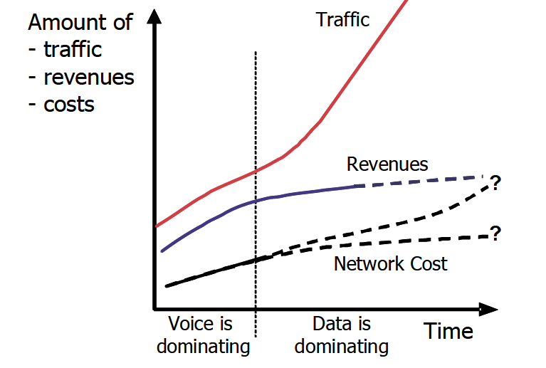
Figure 3.1 Traffic and revenue for increasing data (copied from [52])

Parameter Based Pricing Scheme
Pricing of the spectrum is based on certain parameters which are considered by the WSP or regulator as a measure of QOS. This parameter does not change over a period of time. It helps to improve their profit and helps in providing better QOS to the end users. This is a more fair and flexible method of charging for the use of the spectrum than flat rate pricing scheme [53].

Adaptation Pricing Scheme
This is a scheme that uses the previous data from the network in fixing the price of the spectrum. This static method allows for cooperation between WSP and it helps in predicting the future price of the spectrum. This scheme does not put into consideration the QOS and changes in traffic demand. Adaptation pricing scheme was proposed in [41].

Paris Metro Pricing
Paris metro pricing scheme was proposed in [54]. This pricing mechanism allows for different channels to have different values in terms of price and in terms of quality of services. The users would be charged based on their prefer channel. The prices of each channel usually stay constant over a long period of time as it is not based on availability of wireless resources.

Dynamic Pricing Schemes
This allows the WSP to adjust the price of the spectrum based on the QOS and the demand for the spectrum in a particular time and in an environment. This method can guarantee more profit when the demand is high and can help the end users obtain better QOS.

Priority Pricing Scheme
This is a pricing mechanism that allows the system to adjust the price based on changes noted by the system. It also allows an end user to prioritise the services but the priority can be modified based on the QOS. This type of price mechanism helps to manage the resources of the network by guarantying available bandwidth to end users [55].

Assignment Pricing Scheme
A method used by the WSP to assign price based on the base station the user is connected to. This is also known as hotspot based pricing. A user can be charged more when connected to a base station which is not the home base station. The home base satiation would be the user’s favourite location for making connection to the network [26].

Rate Adaptation Pricing Scheme
The price of the spectrum based on the impact the users have on other users. Congestion is used as an incentive for the end users. This can be used in regulating new users of handoff in order to provide better QOS [26].

Probabilistic Pricing Scheme
This method uses historical data and mathematical formulation and assumptions to determine the price of the spectrum. This formulation allows network to predict the network demand and series and would ultimately be used to determine the price of the spectrum [26]. This method is discussed and used in [56] for indifferent prices.

Auction Based Pricing Scheme
An auction is a process whereby bids are taken from different interested parties interested in the use of the spectrum and a winner(s) is determined based on certain criteria [57]. An auction usually involves a single seller and multiple buyers. This pricing scheme is quite interesting and can help to determine the appropriate market price of a commodity such as wireless radio spectrum which the price is based on the offered service. An auction requires little or no interaction between the seller and the buyer as a spectrum broker serves as the middle link.
The auction process is prone to sellers and buyers acting selfishly as they tend to maximise each other’s benefit. A broker is usually required as an intermediary between the seller and the buyer. Auction theory was discussed as a tool that can help to build a versatile and lightweight allocation mechanism in [58].
In any auction process there are three rules that must be made very clear before an auction begins. These are the bidding rules, the allocation rule and the payment rule. The bidding rules would inform all the potential buyers of how the bid would be carried out either an open or closed bid, or if it is open it can be in increasing or decreasing auction. The allocation rules would state what each bidder would get if they emerge victorious and the payment rule would state the amount that would be paid. An example is the Vickrey auction model in which the winning bid pays the amount of the second highest bidder. The rules determine the auction schemes. There are various auction formats; each has its own uniqueness type of auction does not fit all situations however; an important feature of a good auction process is to guide against collusion and be attractive to potential bidders, some of which are discussed below.

First Price Seal Bid Auction
This is a simple and quick bid where the highest bidder wins and pays the value that he last bid. It is ideal for small bands of the spectrum or when just one licence is required. This format has the disadvantage of users assigned in a similar band paying a discrepant amount. This method was used in allocation of the GSM band in the UK leading to different companies paying different amount for spectrum used for same purpose.

Vickrey Auction
This is a kind of seal bid auction where the highest bidder pays the price offered by the second highest bidder. This encourages bidders to put forward bid which would show the true valuation of the spectrum. This method is disadvantageous if more than one winner would emerge. Vickery auction model was adopted in [59] to capture the interaction between end users and brokers and services provider in a multi-provider setting.
Simultaneous Ascending Auction (Dutch auction)
This method involved bidding round by round in which the auctioneer specifying the minimum bid increment. This method can be time consuming and can lead to tactical collusion among buyers. The collusion might be predominant in a situation where multiple similar commodity like the radio spectrum is been auctioned. Buyers might resolve to “live and let live”. This is a situation where in the early stages of the auction process, when prices are low, buyers would collide to allow everyone win a band and tactically agree to stop pushing prices up.

Reserve Price Auction
This is a type of auction that guarantees that the seller would only sell above a minimum price. If a buyer bids below this price the seller would refuse to sell. Usually the reserve price is not always announced but must be realistic. This method increases the revenue of the seller above the cost price. If a realistic reserve price is not set it could impact negatively on the auction. This method was adopted in this research because it guarantees that the costs of using the spectrum would be met. There are many pricing mechanisms but the proposed pricing mechanism in this work is unique because it reflects the variation in demand which would occur daily and in different locations. Also it prevents a loss in a situation of few bidders.

Hybrid Auction
This auction process would usually take place after a prequalification round has been carried out. The prequalification would be used to screen out some in eligible bidders and would help reduce the overall time of the bidding process and allowing only serious and genuine bidder to bid. One major disadvantage of this method is that the screening agency can influence those who are allowed to bid thereby, eventually influencing the winning bid. This process was used in the bidding process for Hong Kong’s 3G licensing [60].

Homogeneous Seal Bid Auction
This type of auction is a multiple bid auction in which the buyers (N) would submit their bid in a vector format (b1, b2, and b3….bn) where each bid stands for the amount the buyer is willing to pay for a particular commodity. The total amount the bidder is willing to pay for all the commodities is the sum of (b1-bn).

Uniform Pricing Scheme
Uniform pricing scheme is a type of pricing scheme where all winning bids pay the same amount. This scheme is popular for a multi-unit auction. In this scheme the auctioneer can determine the clearing price which would maximise the auctioneer’s revenue [61] or the winners would pay an amount which is the lowest offered price for the winning bid. An example is if there are 3 channels available and 5 users offered a price of £1, £2, £3, £4, £5 the three highest bidders would either pay a value set by auctioneer which might be any value between £1 and £5 or all 3 winning bids pay £3, which is the lower value of the winning bid. This type of pricing scheme prone to collusion among bidders and it is less fair creating an unsettle market [26].

Game Theoretic Pricing Scheme
A game theoretic pricing scheme uses a mathematical tool used in analysing the problem encountered in spectrum pricing usually for systems with multiple entities. It helps to provide optimal solution for different entity as they interact with each other. The actions of the users (players) in the game must be inter-dependent.
The three major components of game theory are the model, the player and the payoffs. The users make rational decisions and they try to maximise their profit by interacting with each other and adjusting their strategy to optimise their utility. Optimising user’s utility would help to predict the behaviour of the users [62]. The utility function also known as the payoff represents the player’s interest for every strategy and it can be the communication rate/data rate, power, energy, or even price. It can also be a combination of any of the factors needed in a communication network. The possible outcome is then represented in the form of a game. The utility of an end user is not only determined by the end users but also by the strategy adopted by other users. The timing, payoffs and feasible moves are all common knowledge [63].
A game theoretic pricing scheme was used in [64, 65]. From the literature review [64-67] carried out it was noticed that lots of the proposed research scenarios are not very realistic in the real world. One of the reasons for this is lots of information exchange between the users and the central entity which would further contribute to the overhead, requiring a reliable and dedicated channel. The proposed model here is designed to provide a connection with low exchange of information between users and a base station.

Conclusion

This chapter examines the importance of pricing in spectrum management and presents different approaches to implementing pricing in a dynamic spectrum scenario. Pricing policy should be such that the wireless service provider would be able to recover the investment and provide good QOS to the customers. It should be less complex and be able to reflect the demand and supply for the radio spectrum. This chapter compares different pricing mechanisms under static and dynamic pricing mechanisms. The static pricing mechanisms are fixed for a long period of time and do not depend on the network resources while the dynamic pricing mechanisms change depending on the required wireless network resources. The performance of each pricing scheme depends on the prevailing scenario and this report only presents a discussion of the available pricing scheme and some improved methods. This research is proposing an auction based dynamic pricing mechanism which allows users to choose when and how to pay when using a wireless network while discouraging the use during peak period to allow better QOS for genuine users. It also allows the network service provider to charge according to availably of network resource.

