PERFORMANCE ANALYSIS OF EMPIRICAL PROPAGATION MODELS FOR FIXED WIRELESS APPLICATION
Quadri R. Adebowale¹, Caroline T. Adeniran¹, Olugbenga A. Sowande¹, Yusuf O. Imam-Fulani¹, Samuel O. Onidare¹ Ismael A. Sikiru²
¹Department of Telecommunication Science, University of Ilorin. P.M.B 1515,
Ilorin, Kwara State, Nigeria ²Department of Information and communication Science, University of Ilorin. P.M.B 1515,
Ilorin, Kwara State, Nigeria
Email: adebowaleq, imamyusuph, idhikrullah{@gmail.com} temitayo.ayodele@myport.ac.uk, serialomg@hotmail.com, onidaresam@yahoo.com
ABSTRACT
In this study, an efficacy assessment was carried out on 5 most widely used empirical propagation models by using MATLAB simulator to compare these models for FWA in both urban and suburban environment. Simulations were carried out at two different frequencies of 2.5 GHz and 3.5 GHz with a transmitter height of 30 m and varying distance from 250 m to 10 km. Three different receiver antenna heights of 3 m, 6 m, & 10 m were considered. The results indicated that, Ericsson model has the least prediction of 145 dB to 147 dB at 10 m and 6 m receivers’ antenna height respectively, operating on 2.5 GHz frequency in urban environment. Apparently, COST 231 Hata indicated the highest predicted path loss at 10 m and 6 m with predictions of 160 dB and 162 dB respectively in urban environment while the SUI model revealed the least variation of propagation loss of 136 dB to 138 dB. Similarly, the study revealed that Ericsson model has the lowest predicted path loss (150 dB to 153 dB) in an urban environment at 3.5 GHz. The study concluded that no specific model predicted the least path loss for both urban and suburban environment with the varying receiver antenna heights.
Keywords: Path loss; fixed wireless application; empirical models; signal propagation; simulation

- INTRODUCTION
Communication involves the transmission of signals from a source to a destination. Wired transmission of signal can only be employed when the sources and destinations are not extremely far apart, making it almost impractical to achieve long-range communication with wired infrastructure. In the 18th century, wireless transmission of signals was introduced to bridge this gap, ever since then, the usage of this means of information transfer had experienced incessant proliferation [1]. To conquer the great need for the mobile accessibility of internet by users, irrespective of place and time with impeccable Quality of Service (QoS) and Quality of Experience (QoE), WiMAX was trolled into the market as a Wireless Application that is fixed (FWA) by the working group of IEEE 802.16 [2]. The use of radio waves as wireless medium of propagating radio signals encounter technical challenges as it propagates through the wireless channel. Initial phase of network planning requires the feasibility study of the environment which plays a major role in successful implementation of wireless system. During the design phase of how practical implementation of the transmitting antenna communicates with the receiving antenna, important parameters such as the received signal power, the coverage area and possible interferences occurrence are carefully optimized. The prediction of the attenuation of received power signal and interference analysis lead to a sophisticated plan of a network and also construct futuristic networks that can perform better in different environment. Radio propagation models are used at the initial planning phase to predict the behavior of how the radio waves behave during propagation of signals in disparate environment [3]. The focus of this paper is to identify suitable empirical propagation path loss model in urban and suburban area with the application of appropriate transmitter and receiver antenna heights in planning, designing and implementing an effective WiMAX wireless systems. In this paper, five empirical propagation models which were proposed for radio frequency band up to 3.5GHz in urban and suburban environments in diverse transmitter and receiver antenna at 2. 5 & 3.5 GHz using WiMAX technology were compared. Section II gives an overview of previous related literature. In section III, the study briefly discussed about the simulation software used and the models for the study. Section IV is devoted to compare the result and analysis of the propagation models. Section V comprises the summaries and conclusion of this study.
In [4], efficacy assessments of propagation models were conducted in Kano City with the aim of identifying a suitable model for Kano, Nigeria. A drive test was conducted in Kano and the data obtained was used for graphical representation for the purpose of comparison. The results showed that the mean path loss values 137.7 dB and 138.7 dB for HATA and COST 231 respectively. It was concluded that COST 231 model would be more suitable for use in urban environment. The study in [5] presented the comparison between three basic propagation models for mobile communication in urban, suburban, and rural environment in Rivers State. Its aim was to investigate the effectiveness of commonly used existing models (COST 231 Hata, SUI, and ECC-33) for cellular transmission simulated on Matlab. The measurement data was obtained from the drive-test taken with a test mobile phone capturing the received signal power at 2100 MHz with a specific distance from Globacom NodeBs available in the State. The result obtained from the analysis reported by Standard Deviation (SD) and (MSE) Mean Square Error indicated COST 231 Hata model having accurate predicted values and was suggested for path loss predictions in River State. In [6], the performance of Okumura, Hata, and Lee Models were compared on a large scale prediction. The paper methods include the use of MS antenna height, T-R distance and Base Transceivers Station (BTS) antenna height with 900 MHz frequency band through MATLAB simulation software. The result indicated that Okumura model shows better performance amongst compared large-scale propagation models.
Comparative study of different path loss models on 4th generation LTE networks was conducted in [7]. The comparative assessment was made using disparate environment e.g. rural, suburban and urban simulated on MATLAB software. The result revealed that the lowest predicted path loss in all terrain was reported by the SUI model while the highest predicted path loss reported was COST 231 HATA Model in urban environment, suburban and rural terrain reported COST Walfisch-Ikegami model as the highest predicted path loss. In [8], the performance of eight empirical path loss models and a localized model along a predefined routes in Osun States, Nigeria was presented. It was concluded that localized (ILORIN) model demonstrated the best path loss prediction with significant accuracy over the compared models. In [9], a study on how empirical models were used for prediction of path loss of TV signals for secondary use in which measurement campaign of field strength in the VHF and UHF band along six different routes that covers rural, suburban and urban environment of Kwara State was also presented. The results indicated that there is no record of a single model revealing a good fit consistently.

- METHODOLOGY
In this paper, five different empirical models were assessed for the investigation on WiMAX technology that can operate both in 2.5GHz and 3.5GHz [10-13]. The best fitted parameters were chosen suitable for Nigerian terrain in terms frequency and average heights of the building. The propagation models ECC-33 Model, SUI Model, Hata COST 231 Model, COST 231 Walfish-Ikegami and Ericsson Model were compared. MATLAB (2010a) simulator was used for the graph of comparison.
Table 1: Simulation parameters
PARAMETERS | VALUE
Tx Power of the base station | 43 dBm
Mobile Tx power | 30 dBm
Height of antenna Transmitter | 30 m in urban and suburban
Tx-MS Distance | 10 m
Operating Frequency | 2.5 GHz and 3.5 GHz
Height of the receiving | 3 m, 6 m and 10m
Distance of Building to Building | 50 m
Height of Average Building | 15 m
Width of the street | 25 m
Street Orientation Angle | 30⁰ (urban) & 40⁰ suburban)
Correction for Shadowing | 8.2 dB (suburban) and 10.6 dB (urban environment)

- SIMULATION RESULTS AND DISCUSSION
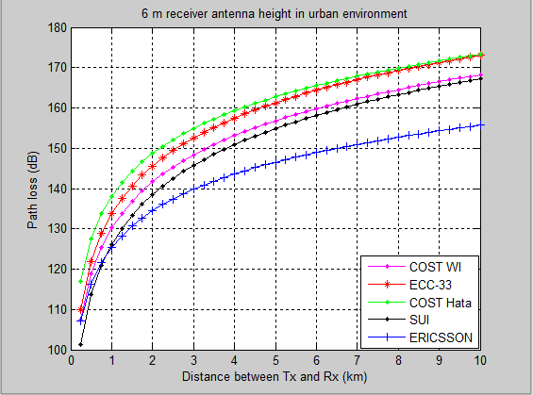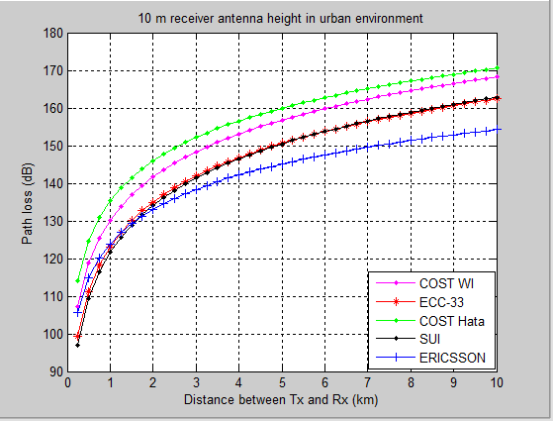
(a) (b)
Figure1: Graph of predicted losses in urban environment at 2.5GHz with (a) 6m and (b) 10m antenna receiver height.

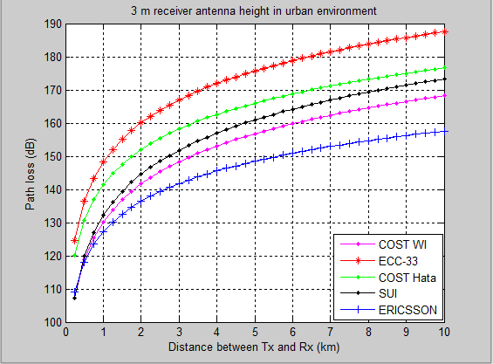

Figure 2: Graph of predicted losses in urban environment at 2.5GHz with 3m antenna receiver height.

Figure 3: Graphical breakdown of the results for urban area at 2.5GHz with different antenna receiver heights at distance 5km

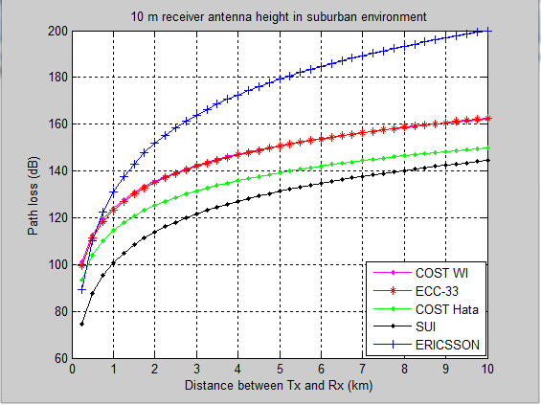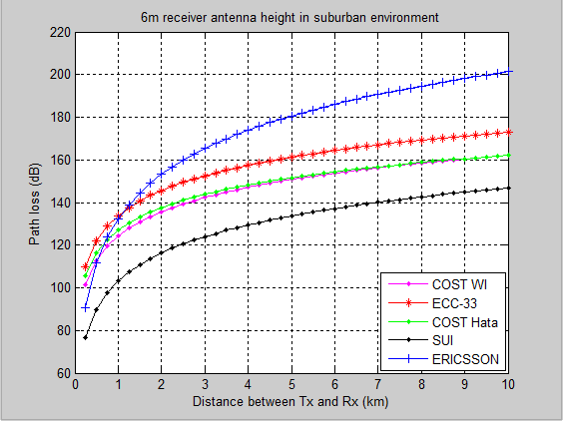
(a) (b)
Figure 4: Graph of predicted losses in suburban environment at 2.5GHz with (a) 6m and (b) 10m antenna receiver height.

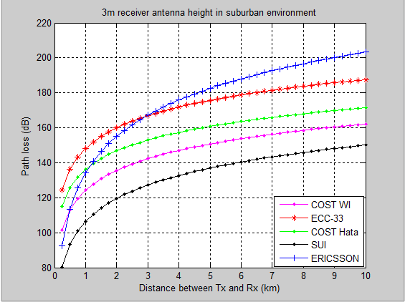

Figure5: Graph of predicted losses in suburban environment at 2.5GHz with 3m antenna receiver height

Figure 6: Graphical breakdown of the results for urban area at 2.5GHz with different antenna receiver heights at distance 5km.

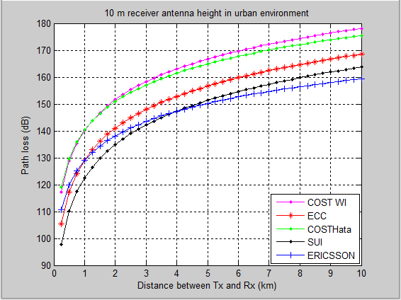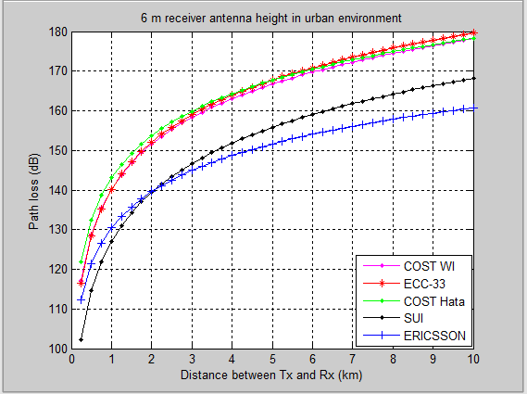 (a) (b)

Figure 7: Graph of predicted losses in urban environment at 3.5GHz with (a) 6m and (b) 10m antenna receiver height.

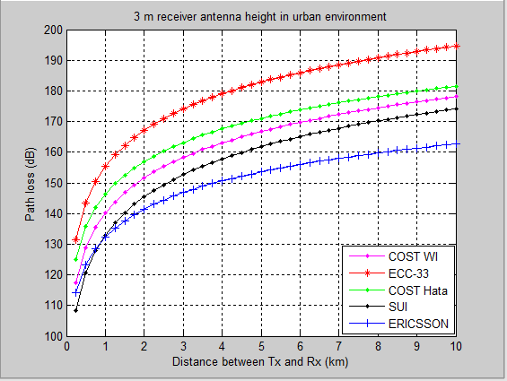

Figure 8: Graph of predicted losses in urban environment at 3.5GHz with 3m antenna receiver height

Figure 9: Graphical breakdown of the results for urban area at 3.5GHz with different antenna receiver heights at distance 5km
Predicted path loss in suburban environment at 3.5GHz
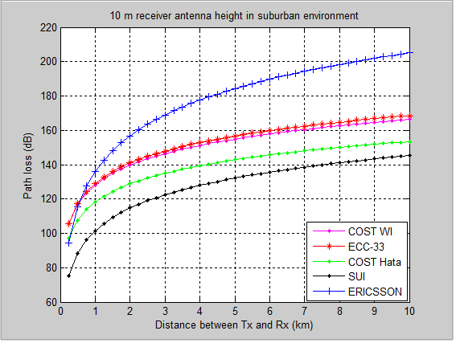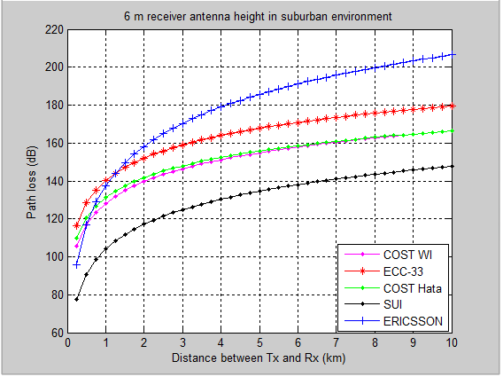
(a) (b)

Figure 10: Graph of predicted losses in suburban environment at 3.5GHz with (a) 6m and (b) 10m antenna receiver height.

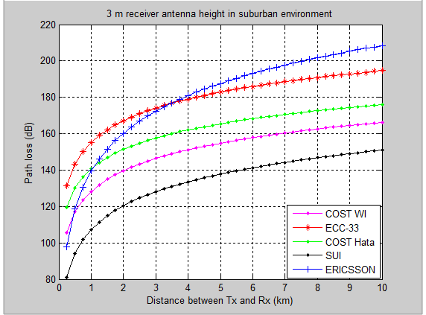

Figure 11: Graph of predicted losses in suburban area at 3.5GHz with 3m antenna receiver height

Figure 12: Graphical breakdown of the results for suburban area at 3.5GHz with different antenna receiver height at distance 5km.

- RESULTS and DISCUSSIONS
In fig 1 and 2, the variation of the predicted path loss with distance shows that the Ericsson model revealed the least predicted value (i.e., between 145 dB to 147 dB) at 10 m and 6 m receivers’ height of antenna operating on 2.5 GHz frequency within the urban environment. The Ericsson model demonstrated the minimum fluctuations paralleled to other models as a result of change in the receivers antenna height. Apparently, COST 231 Hata indicated the highest predicted path loss at 10 m and 6 m with the predictions 160 dB and 162 dB respectively. In the same case, ECC-33 revealed the highest prediction of 176 dB at 3m with same 5km distance and 2.5GHz frequency. In contrast, the Ericsson model as shown in figs. 4 and 5 presented the highest predicted propagation loss of 178 to 184 dB at suburban environment that showed the maximum compared to other models at disparate receivers antenna height. SUI model revealed the least variation of propagation loss of 136 to 138 dB. COST 231 Walfish-Ikegami showed a constant path loss value of 150 dB at each receiver antenna height.
Figs. 7 and 8 illustrated the predicted path loss value in an urban environment at frequency of 3.5 GHz and 30 m transmitter antenna height to 10m, 6m and 3m receivers’ height of an antenna, with Ericsson model showing the least predicted path loss of 150 dB to 153 dB. It showed the lowest predicted value of path loss amongst compared propagation model each time the receiver antenna height was changed. The ECC-33 model revealed the peak propagation loss value using 6 m and 3 m receiver antenna heights of 168 dB and 182 dB respectively. However, the COST 231 Walfish-Ikegami showed the highest predicted value of 166 dB at 10 m receiver antenna height. In figs. 10 and 11, the suburban terrain indicated a constant path loss value by COST 231 Walfish-Ikegami at 155 dB at each time the antenna receiver height is changed. Ericsson model revealed the highest fluctuation due to the change in receiver antenna heights. The predicted values in all figures discussed, denotes that, an increment in the receiver antenna height will increase the probability of the receiver to detect a better transmit signal from the servicing transmitter.

CONCLUSIONS
The suburban environment showed a lower predicted value compared to urban environment. It revealed that, the more the reduction in the receiver antenna heights, the lesser the possibility of the device to receive a better quality of signal transmitted by the transmitter which can result to low received signal power and vice versa. Deployment of a full coverage area can be achieve when there is an increase in transmission power, which will possibly increase the level of interference between two frequencies adjacent to each other. Alternatively, a lesser transmit power can also be used for the deployment, but this might not serve the intended users in that coverage plan. It may cause some users out of signal reach in the serving cell particularly when congestion arises. In this case, trade-off is needed between both methods. However, the Ericsson and SUI model are best suitable for the deployment of FWA operating at both 2.5 GHz and 3.5 GHz and in an urban and suburban environment respectively.
REFERENCES
[1] X. Wang, and H. V. Poor “Wireless Communication Systems” Advanced Techniques for Signal Reception, 2003.
[2] M. Shahajahan and A. Q. M. A. Hes-Shafi, Analysis of Propagation Models for WiMAX at 3.5 GHz, Department of Electrical Engineering Blekinge Institute of Technology, 2009.
[3] N. T.Surajudeen-Bakinde, N. Faruk., A. A. Ayeni, M. Y. Muhammad, M.I Gumel, “Comparison of Propagation Models for GSM 1800 and WCDMA Systems in Some Selected Urban Area of Nigeria”, International Journal of Applied Information Systems (IJAIS), Foundation of Computer Science FCS, New York, USA, – ISSN : 2249-0868. Vol. 2, No.7, pp 6-13, May 2012.
[4] A. Ayeni, N. Faruk, L. Olawoyin, M. Y. Muhammad and M. I. Gumel “Comparative Assessments of Some Selected Existing Radio Propagation Models: A Study Of Kano City, Nigeria” European Journal of Scientific Research, Vol.70 No.1, pp. 120-127, 2012.
[5] B.O.H. Akinwole and J.J. Biebuma “Comparative Analysis of Empirical Path Loss Model for Cellular Transmission in Rivers State” American Journal of Engineering Research (AJER) Volume-02, Issue-08, pp-24-31, 2013.
[6] M. A. Alim, M. M. Rahman, M. M. Hossain, and A. Al-Nahid “Analysis of Large-Scale Propagation Models for Mobile Communications in Urban Area” (IJCSIS) International Journal of Computer Science and Information Security, Vol. 7, No. 1, 2010.
[7] N. Shabbir, M. T. Sadiq, H. Kashif and R. Ullah “Comparison of Radio Propagation Models For Long Term Evolution (LTE) Network”, International Journal of Next-Generation Networks (IJNGN) , Vol.3 No.3, September 2011.
[8] Jimoh A.A, Surajudeen-Bakinde Nasir Faruk, Bello O.W. and Ayeni “Clutter Height Variation Effects on Frequency DependenPath Loss Models at UHF Bands in Build-Up Areas” Science Technology and Arts Research Journal, Oct-Dec 2015, 4(4): 138-147.
[9] Nasir Faruk, Adeseko A. Ayeni and Yunusa A. Adediran “On The Study of Empirical Path Loss Models For Accurate Prediction Of Tv Signal For Secondary Users” Progress in Electromagnetics Research B, Vol. 49, 155{176, 2013.

[10] V.S. Abhayawardhana, I.J. Wassel, D. Crosby, M.P. Sellers, M.G. Brown, “Comparison of empirical propagation path loss models for fixed wireless access systems,” 61th IEEE Technology Conference, Stockholm, pp. 73-77, 2005.
[11] Josip Milanovic, Rimac-Drlje S, Bejuk K, “Comparison of propagation model accuracy for WiMAX on 3.5GHz,” 14th IEEE International conference on electronic circuits and systems, Morocco, pp. 111-114. 2007.
[12] Joseph Wout, Martens Luc, “Performance evaluation of broadband fixed wireless system based on IEEE 802.16,” IEEE wireless communications and networking Conference, Las Vegas, NV, v2, pp.978-983, April 2006.
[13] V. Erceg, K.V. S. Hari, M.S. Smith, D.S. Baum, K.P. Sheikh, C. Tappenden, J.M. Costa, C. Bushue, A. Sarajedini, R. Schwartz, D. Branlund, T. Kaitz, D. Trinkwon, "Channel Models for Fixed Wireless Applications," IEEE 802.16 Broadband Wireless Access Working Group, 2001.

