SPATIO-TEMPORAL ANALYSIS OF RESIDENTIAL CONDITIONS IN ILORIN WEST LOCAL GOVERNMENT AREA: A CASE STUDY OF OKELELE-ADANGBA COMMUNITIES.

- I. Bako¹*, W. M. Raheem¹ and O. T. Aduloju¹.
¹Department of Urban and Regional Planning, Faculty of Environmental Science, University of Ilorin. P.M.B. 1515, Ilorin, Nigeria.
*Corresponding Author’s E-mail: alibbako@yahoo.com

Abstract
Poverty and unemployment are concentrating in the cities due to the urbanization trend. Slums, illegal dwellings and indecent shelters are proliferating as city planners and city managers are overwhelmed by the urbanization trend.Housing in developing nations and poor parts of developed countries continues to be of insufficient quality and quantity to meet increasing demand. It is against this backdrop that the research was perceived with the aim of assessing the residential conditions of Okelele – Adangba community by assessing the infrastructural facilities, housing conditions, sanitary facilities, socio-economic characteristics, environmental conditions and prevalent diseases as well as associated disasters. The methodology employed was systematic random sampling of interval of 5 buildings, amounting into one hundred and nineteen (119) buildings being sampled.
The findings invariably show that the study area, indubitably exhibit evidence of slum that has undeniable impact on the socio-economic activities. However, the regression analysis performed shows that the calculated F value of (22.259) is by far, greater than the F table value of (2.31) at significant level of 0.05 and degrees of freedom (5,94). which shows the dependency of housing satisfaction on some principle factors. The research concluded the findings with few recommendations like slum upgrading and economic rejuvenation, provision of infrastructure master plan, as well as joint environmental management plan as the way forward.

Introduction
The problem of adequate and habitable housing has long been a concern, not only of individuals but of governments as well. Thus, the history of housing is inseparable from the social, economic, and political development of humankind (Listokin and Burchell, 2008). Close and Crabbe (2016) clearly label housing as one of the traditional areas of concern for public health, that has been relatively neglected over recent decades. Housing as a unit of the environment has profound influence on the health, efficiency, social behaviour, satisfaction and general welfare of the community. As Omole (2010) observes that residential environment reflects the cultural, social and economic values of a society, as it is the best physical and historical evidence of the civilization of a country.
Housing in developing nations and poor parts of developed countries continues to be of insufficient quality and quantity to meet increasing demand(Encarta Interactive World Atlas, 2008). However, Slums, illegal dwellings and indecent shelters are proliferating as city planners and city managers are overwhelmed by the unprecedented urbanization trend. The problems are especially acute in Asia and Africa, where the population growth rate far outpaces the global rate(Rizvi, 2016). Indubitably, the challenge of providing affordable housing for low-income city-dwellers is universal,as the intensifying and record-breaking urban congestion is drastically becoming inconceivable. Housing and built environments have profound impacts on human health. WHO (2010) observes in developed countries that 80 – 90% of the day spent in built environments and most of this is in the home. The home is important for psychosocial reasons as well as its protection against the elements, but it can also be the source of a wide range of hazards (physical, chemical, biological). It is the environment in which most people spend the majority of their time (Close and Crabbe, 2016).
Apart from the intrinsic value of housing, housing conditions affect a wide range of outcomes, as housing costs make up a large share of the household budget (OECD, 2007b), people particularly those of low incomes, are often constrained by the level of resources left for other essential expenditures, such as food, healthcare and education. Kennedy (1987) further ascertains housing for the poor suffers in quantity and quality as tenement landlords milk tenants and allow their buildings to deteriorate and becomes uninhabitable at the rate that outstrips construction of new house. High housing may threaten household material wellbeing and economic security and may generate housing stress that may hamper relations between households’ members and impair the development of children(OECD, Housing Condition, 2011).
Agbola (2010) believes three major housing policy streams or strands that were identified by Nigerian government over the past 40 years have failed because they could no longer meet with the demand of time and space.Olawale, Lawal and Alabi (2015) believe to this effect, the low-income group in the country is still bedevilled with myriad of housing problems notable among which include quantitative deficiency and their inaccessibility to decent housing. One of the ways by which human beings organize in space around themselves is through the organized spatial expansion.Omole (2010) argues the importance of providing adequate and quality housing in any country cannot be overstated nor disputed in time or space. But what is being witnessed in Ilorin today is heralded by haphazard development resulting into amoebic pattern of development which shows some deficiency in road and street plans from the past. This however, has brought about irregularity instead of orderliness into the Ilorin residential neighbourhoods and its immediate satellite settlements.
The residential environment of Okelele - Adangba has been an area of neglect, as no new housing, or very little, is currently built for the poor people of Okelele – Adangbacommunities in Ilorin West local government area. The trickle-down effect of residential environment in these communities is at its peak and Okelele-Adangba residential environment which is already facing a massive housing backlog, will soon be facing an even bigger housing challenge – compounded by the deterioration of the existing housing stock, infrastructure and the continuing shrinkage of household size in space and time. It is against the prospect of ever-worsening urban housing conditions in Okelele-Adangba that this research tends to haveaSpatio-temporal analysis of residential conditions of Okelele- Adangba communities in Ilorin west local government area, Kwara State and with a view of obviating such problems.
Study Area
Ilorin West happens to be a local government area in Kwara State, Nigeria with its headquarters in the town of Oja Oba. Ilorin West Local Government Area of Kwara State is in the transitional zone between Northern and Southern parts of Nigeria. The Area lies within latitude 8°30′00″N and longitude 4°35′00″E. Ilorin West Local Government Area occupies a land area of 105 km² and according to National Population Census (NPC), this local government has a population of 364,666 at the 2006 census, making densest of all the local government in Ilorin (Figure 1). The Local Government is divided into Twelve (12) electoral wards (Adewole, Ajikobi, Alanamu, Badari, Baboko, Magaji-Nngeri, Ogidi, Oko-erin, Oloje, Ojuekun/Sarumi, Ubandawaki and wara/Osin/Egbejila)(Oloko-Oba, et al., 2015).
The residential housing conditions and densities are characterised by various types of houses present all over the city. The study area is amongst the traditional centre of the city (Okelele, Pakata, Adangba, Omoda, Ajikobi, Oloje, Gegele, Sanni-Okin, Eruda, Balogun Fulani, Alanamu, Ita – Adu, etc) comprises mainly old compound and tenement houses interspersed with block of flats all of high-density category(Akogun & Ojo, 2013).The Okelele, Adangba, Gambari, Ipata Oloje, Oko Erin e.tc communities are significantly the slum areas of Ilorin West Local Government Area pigeon-holed with tenement and contiguous buildings. The Medium density housing estates are found at Oloje, Kulende, Adewole, Irewolede and the Mandate estates(Akogun & Ojo, 2013). Low density areas are found in the GRA, Taiwo and parts of Adewole areas where the houses are mainly detached bungalows of two to five bedrooms, duplex and maisonettes.
The residential conditions of the study area bread violence, and vis a vis have a nexuswith liveability. The core areas as labelled above, best described as socially disadvantaged neighbourhoods, are dominated by the locals(Abdullahi, Seedat-Khan, and Abdulrahman, 2016).
The inhabitants of Ilorin Okelele and Adangba communities are industrious and entre pricing in nature. Current commercial could be classified as large scale, medium scale and small-scale types (Fakomogbon, 2015). The Local Government Area has Crownhill and Al-Hikmah University as the only two private universities in the local government.
Research Methodology
The necessary data for this study werechannelled through primary and secondary sources.Questionnaire administration constitutes the major instrument used in information collection. Map upgrading, building and facility surveys supplemented this research. Semi-secondary data fromrelevant ministries and government departments, particularly Town Planning Authority in Ilorin, Kwara State and Department of Urban and Regional Planning, University of Ilorin were sufficiently used.
Accordingly, there were 993 existing buildings in the study area of Okelele and Adangba communitiescovering about 1.18 square kilometres of land. As observed and pointed out by Fasakin (2000) that average of seven (7) persons make up a household and average of four (4) households make up a building. Which approximately amounts into 27, 804 persons in both Okelele and Adangba communities. To this effect, a 12% sample size was taken out of the 993 buildings as the target population, which results into one hundred and nineteen (119) buildings carefully and reasonably considered for the study due to the homogenic characteristics of these areas of study.
Using systematic random sampling approach to select respondents in the area, every 5th house in each of the five districts involved was taken for the interview.Meanwhile, only one household was interviewed in each of the buildings selected. Each questionnaire contains 51 variables, which were thoroughly investigated to obtain information on gender, marital status and age of respondents. However, the residences’ socio-economic characteristics, structural condition of buildings, the psychological wellbeing, the level of infrastructure facilities as well as residents’ perception of their environment were investigated.
Findings and Discussions
Housing has been described by OECD (2011), as a major element of people’s material living standards.However, the findings took into cognisance a ‘user’s reaction’ technique of measuring habitability, which according to Omole (2000) encompasses four major components (Man, shelter dwellings, environment and institutional management). Overall, housing conditions were evidently lamentable in terms of living space and the level of satisfaction derived from household composition, when taken into consideration. To that effect, the findings of this research empirically focus on the socio-economic characteristics, the level of liveability of individual households, conditions of the buildings, housing facilities, level of infrastructure, wellness of the residents in Okelele-Adangba, the level of decay and the actual and potential disasters. However, nineteen (19) out of the one hundred and nineteen (119) questionnaires distributed could not be retrieved leaving one hundred (100) which were used for the analysis. This represents 84% of the total expected responses. It was still considered reasonable when taking into consideration the overlapping features ofOkelele-Adangba High density areas.
Socio-Demographic Characteristics
The ‘beck and call ‘of the questionnaire administration focused mainly on the adults as table 1 evidently shows that 85% considerably number of respondents fell above 18 years of age while the remaining 15% fell below 18 years. While all the ages sampled in the study area were 100%Muslims and Yoruba speaking tribe respectively. This is so because Okelele-Adangba communities are one of the traditional cores of the city of Ilorin however, one of the origins of the formation of Ilorin Metropolis. Nevertheless, there was a close call between male and female distribution, as the rule of gender equality was observed. This amounted into 60% males and remaining 40% respondents were females. Table 1 clearly puts the marital status on a scale, as 70% of the respondents were married, while 6% were divorced, 4% widowed and 20% were single respectively. Taking their educational background into equation, 65% respondents never had education or only had primary school certificate, while 10% and 25% respondents only had secondary school leaving certificate and tertiary certificates respectively. As pointed out by SGCAS (2010), there exist complex links between housing and educational level, as Okelele – Adangbacommunities are aesthetical displeasing and unpleasant due to lack of proper education being the signature of slum areas like Okelele – Adangbacommunity.
Furthermore, this research shows that 5%, 5% and 35% respondents were currently unemployed, students and self-employed respectively, while the remaining 55% respondents were involved in trading (Figure 1). This further consolidates the findings of (Fakomogbon, 2015), who labelled Ilorin west residents as a very enterprising area of Ilorin metropolis and AsoOke being the most creative hand work in Okelele – Adangba communities.
The income distribution of the study area is lamentable and evidently one of the major cause of poor residential condition as this research observed in figure 1, that 35% respondents earned below N5000, 30% between N5000 - N10,000, while the remaining 25% and10% to be earning between N10,000-N 20,000 and above N20,000 respectively. The level of income of individuals is believed to have a direct correlation with their wellbeing (Bako, Adulojuand Abubakar-Kamar, 2017).However, poverty remains a feature of contemporary Okelele-Adangba community today, as Johnstone and McWilliams (2005) perceive it to be an urban phenomenon in terms of extent and intensity. The standard of living of Okelele-Adangba is nothing to write home about and residents finds it difficult to live in a decent housing. A discussant was quoted saying “I have accepted my faith, my income cannot afford decent housing, I have to stick to my fore father’s house I inherited”.
Table 1:Socio-Demographic Characteristics of Respondents
Character | Percentage (%)
Gender Distribution
Male | 60
Female | 40
Total | 100
Age Distribution
Below 18 Years | 15
18-40 Years | 45
41-60 Years | 40
Total | 100
Religion
Christianity | 0
Islam | 100
Traditional | 0
Total | 100
Ethnic Group
Yoruba | 100
Others | 0
Total | 100
Single | 20
Married | 70
Divorced | 6
Widowed | 4
Total | 100
Source: Field Survey, 2017

Figure 1: Occupational and Income Status
Source: Field Survey, 2017

Level of Housing Condition and Sanitary Facilities
This section focuses on the level of housing condition and the general sanitary facilities. From observation alone, inference can be drawn on the state of quagmire the housing conditions and general sanitary facilities of Okelele and Adangba communities were during the field survey. Table 2 evocatively shows what was gathered from respondents of Okelele and Adangba communities on the housing and sanitary conditions, as 92% of the houses in the study area were owned due to inheritance, while the remaining 8% were self-owned. This clearly affirms what that Okelele and Adangba communities remain one of the traditional core areas of contemporary Ilorin Metropolis. Nevertheless, the occupancy ratio of the study area was put on the scale, as 20% respondents observed fell between 1 – 2 persons per room, while the remaining 50%, 20% and 10% fell between 3 – 4 persons per room, 5 – 6 persons per room and above 7 persons per rooms respectively. This reaffirms the given that overcrowding is the signature of areas labelled as slum, just as Okelele and Adangba communities. Furthermore, taking the age of buildings in the area into consideration, it was observed that 10% of the buildings were below 20years of age, while the remaining 90% buildings were over 20 years of age. These findings were further consolidated with a discussant of over 50years of age saying “this house, I inherited from my fore fathers is older than me, cannot give a specific date this house was built”.This shows that majority of the houses in the study area are expired, as Omole (2000) opines the life expectancy of a building to be sixty (60) years.However, 70% of the buildings were observed to be leaking, while the remaining 30% were observed to be patched.accordingly, 90% of the buildings were mud blocks and the remaining 10% were constructed with cement blocks. Hence, figure 2, shows the structure of the buildings examined as 70% of the buildings need major repairs and the remaining 30% need to be pulled down. From observation, one finds it inconceivable that average of 3 – 4 persons still live in a room beyond repairs in Okelele – Adangba communities. Thus, the situation in Okelele and Adangba communities is getting complex for urban planners for viable and doable solutions.
Figure 2 shows the type of residential dwellings in the study area, as 90% respondents owned up to live in a tenement (Brazilian) form of dwellings while the remaining 6% and 4% respondents claimed to be living in a Flat and Duplex respectively. However, taking the sanitary facilities into reckoning, table 2 shows that 80% respondent claimed to have toilet facilities while the remaining 20% were rigid with truth enough to claim not to have any toilet facility whatsoever, contributing to the open defecation in the study area. Subsequently, out of the 80% respondents who claimed to have toilet facilities, only had 25% who uses water closet while the remaining 45% and 30% use Pit latrine and Water-assisted Pit latrine respectively. This regrettably shows the level of access sanitation in Okelele and Adangba communities, as UNICEF (2008) opines access to sanitation to be a sine qua non in preventing diseases spread by unsanitary conditions and by water contaminated with human waste. It is a minimum requirement for human health and well-being. Assessing the buildings with cracks, 72.4% buildings examined had cracks while the remaining 27.6% were without evident cracks (Plate I). This clearly expounds how dangerous people can endanger their lives.
Figure 2: condition of Building Structure, Toilet Facility and forms of Dwelling Structure
Source: Field Survey, 2017

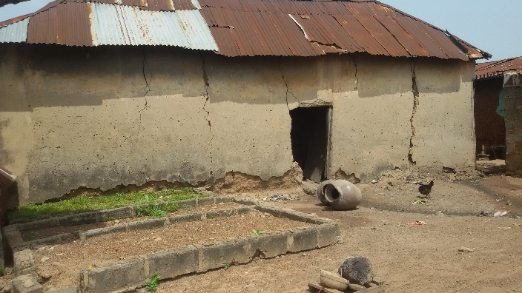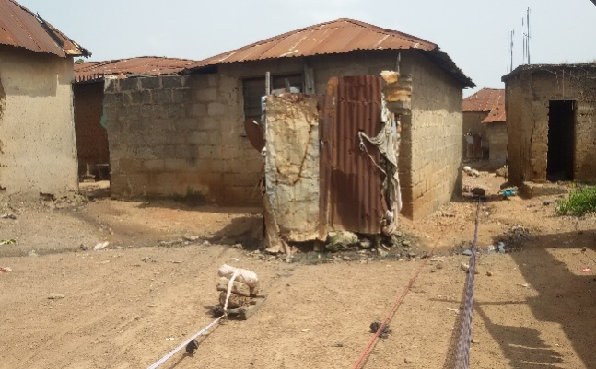
Plate I: Cracked Mud House, Ile Baale, Okelele Plate II: Retarded Bathroom in the Study Area
Source: Field Survey, 2017

Accordingly, it was observed that most of the bathroom and kitchen were far below standard, as large proportion of the buildings examined have these facilities, only that they are substandard, grossly inadequate or inconveniently located (Plate III). Many of the bathrooms are just small enclosures, some of which are made of non-durable materials like bamboo, rusted iron sheets, or planks at the backyard (Plate II). Furthermore, the intertwined flow of sewage from different bathrooms and kitchens is unspeakable and very haphazard in nature, however, due to the clear absence of septic tanks in the study area, the stench of smell in these areas cannot be underscored. The use of firewood and charcoal for cooking is prevalent, hence many of the buildings have their kitchens located at the backyard or sometimes as the focal point of the local compound called ‘Agbole’, except for the few ones that used kerosene stoves as supplement to cook at the passage or right inside their rooms.

Table 2:Housing Condition in Okelele and Adangba Communities
Character | Percentage (%)
Housing Ownership
Self-Owned | 8
Inheritance | 92
Total | 100
Occupancy Ratio
1-2 | 20
3-4 | 50
5-6 | 20
7-8 | 10
Total | 100
Age of Residential Buildings
15 - 20 Years | 10
Above 20 Years | 90
Total | 100
Roofing Condition
Leaking | 70
Patched | 30
Total | 100
Toilet Facilities
Yes | 80
No | 20
Evidence of Cracks
Yes | 72.4
No | 27.6
Total | 100
Type of Wall
Mud Blocks | 90
Cement Blocks | 10
Total | 100
Source: Field Survey, 2017

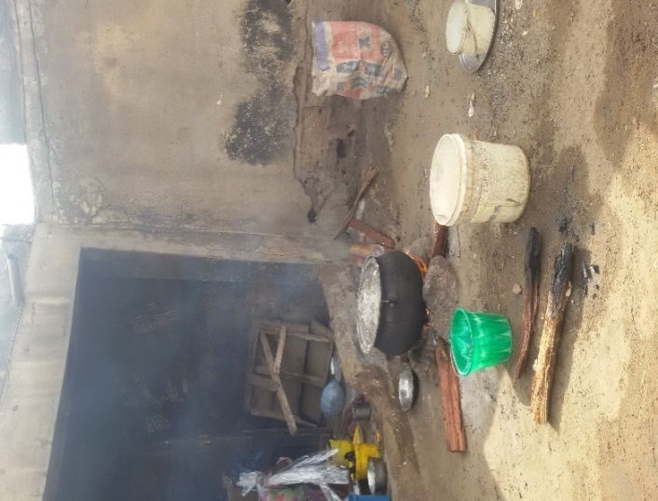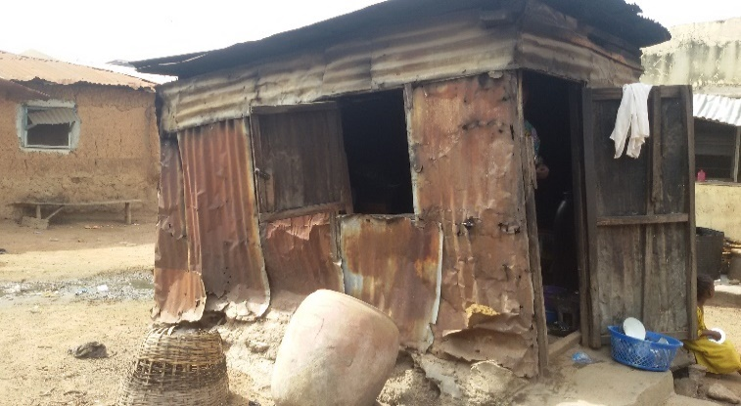
Plate III: Unpleasant and Unorganized Kitchens in Isale-Baale, and Tanka-Tu Streets, Okelele
Source: Field Survey, 2017
Regression Analysis of Principle Factors
Determining the determinants of housing satisfaction and comfortability (dependent variable) in Okelele – Adangba communities, multiple regression analysis was conducted using ‘entre method’ with five (5) principal factors (Violence, Infrastructure, hazards & Disasters, Pollution and appearance of the environment) known as the independent variables. The model summary in Table 3 specifies the coefficient of determination (R²) value of 0.542 indicating 54% variance in housing Satisfaction was explained by the model and subsequently, Adjusted R² value of 0.518 representing 52% of the housing satisfaction. Albeit, this result shows that R² is high showing that most of the variation in housing satisfaction were adequately explained by the predictor variables. However, this value is reliable and considered reasonably well above an acceptable range of 15% as postulated by Mitchell and Carson (1989) and further ascertained by Akinyode (2017) this is acceptable in social sciences when cross-sectional data are taken into consideration. This research further rejects the null hypothesis as it was observed that the calculated F value of 22.259 is by far greater than the table F value of (2.31) at 0.05 significance level and degrees of freedom (5,94) (table 4). As ascertained by Panneerselvam (2014); Bako, Aduloju and Abubakar-Kamar (2017), this simply implies that the regression is highly significant. However, three predictors(pollution level, appearance of the environment and infrastructure) were all significant with their p values = 0, which is less than 0.05 significance level (Table 5).this clearly shows that the predictors have a huge effect on the level of satisfaction and liveability of residents of Okelele and Adangba communities. Furthermore, the result of ANOVA from table 4 shows the P value is 0 which is less than 0.05, which also proves the above fact.

Table 3: Model Summary^{b}
Model | R | R Square | Adjusted R Square | Std. Error of the Estimate | Durbin-Watson
1 | .736ª | .542 | .518 | .522 | 2.058
a. Predictors: (Constant), Violence, Infrastructure, hazards & Disasters, Pollution and appearance of the environment
b. Dependent Variable: Level of Satisfaction

Table 4: ANOVA^{b}
Model |  | Sum of Squares | df | Mean Square | F | Sig.
1 | Regression | 30.359 | 5 | 6.072 | 22.259 | .000ª
1 | Residual | 25.641 | 94 | .273
1 | Total | 56.000 | 99
a. Predictors: (Constant), Violence, Infrastructure, hazards & Disasters, Pollution and appearance of the environment
b. Dependent Variable: Level of Satisfaction

Table 5: Coefficientsª
Model |  | Unstandardized Coefficients |  | Standardized Coefficients | t | Sig.
 |  | B | Std. Error | Beta | t | Sig.
1 | (Constant) | .872 | .627 |  | 1.391 | .168
1 | Environmental Appearance | .795 | .142 | .425 | 5.581 | .000
1 | Pollution Level | -.423 | .078 | -.452 | -5.408 | .000
1 | Infrastructure | .359 | .084 | .432 | 4.292 | .000
1 | Hazards & Disasters | .128 | .142 | .084 | .900 | .370
1 | Violence | -.231 | .109 | -.151 | -2.116 | .037
a. Dependent Variable: Level of Satisfaction
Assessment of Infrastructure Facilities and Environmental Conditions
Infrastructure can be labelled as the economic and social underpinnings of a community or nation (Bako, Aduloju, and Abubakar-Kamar, 2017). However, elements of infrastructure include systems of transportation, power generation, sewage and solid waste disposal, communications, open space, education, and health.The infrastructural distribution in Okelele – Adangba communities relative to space and time is grossly inadequate, as Figure 3 shows that 20% respondents believed that access to potable water was the infrastructure purely missing in the study area, while 40%, 30% and 10% voted for effective solid waste collection and disposal system, power supply and others (all infrastructure), to be missing in the study area respectively. Infrastructure remains the backbone of any liveable community as a discussant clearly shares his views, ‘my family have to trek over 40 minutes to get a drinkable water’, this is by far very compromising to the definition of World Health Organization, which sees reasonable access to potable water in urban areas, as access to piped water or a public standpipe within 200 meters (219 yards) of a dwelling or housing unit (UNICEF, 2008).
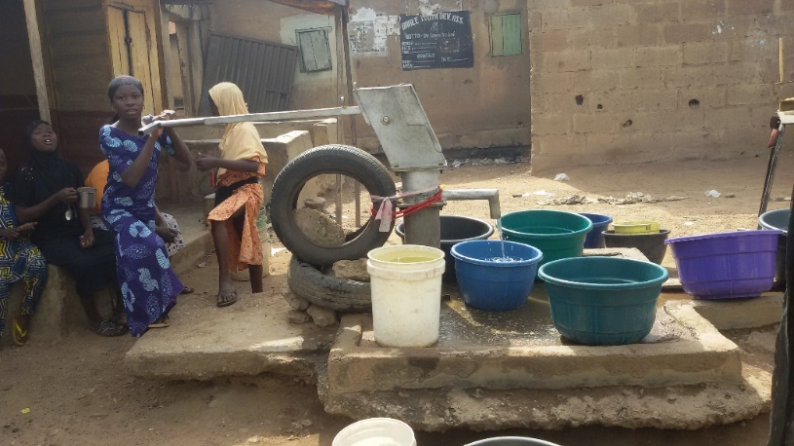
Plate VI: A Show of Water Stress and Shortages in Adangba Community
Source: Field Survey, 2017
From the environment alone, one can deduce that effective solid waste collection and disposal system was unambiguously absent (Plate IV). All these lead to poor housing quality as studies have found that poor quality housing can cause psychological stress (Dunn, 2002) and can negatively impact self-esteem.Moreover, the prevalent disease was also sampled amounting to 90% of respondents ticking Malaria fever as the most prevalent disease in the area while the remaining 10% ticked Typhoid fever to be the prevalent disease in the study area as no case of cholera or diarrhoea was recorded. This shows that Okelele and Adangba will forever be plagued with malaria fever as the filthy environment, houses the causative agent (Mosquitoes) of malaria fever due to the stagnant, storm water and inappropriately channelled sewage (Figure 3).

Figure 3: Missing Infrastructure, Prevalent Disease and Prevalent Hazards
Source: Field Survey, 2017

Nevertheless, actual and potential hazards in the residential environment was taken into consideration, as hazard has been defined as the potential for natural or human caused events to occur with negative consequences. 60%respondents believed the prevalent hazard in the study area to be flooding, while the remaining 40% voted the prevalent hazard to be storm, with fire and hazardous waste having no occurrence whatsoever. From observation, it could be deduced that the flooding that occurs in Okelele and Adangba communities was due to blockages and or absence of drainages. This type of flooding has been classified by Nwilo(2014) as fluvial flooding, however, in the recent studies of Bako, Aduloju and Abubakar-Kamar (2017), it was pointed out that if the drainages are not properly channelled and cleaned specifically in the above-named communities in Okelele and Adangba communities, fluvial flooding will forever be a friendly disaster(PlateV).
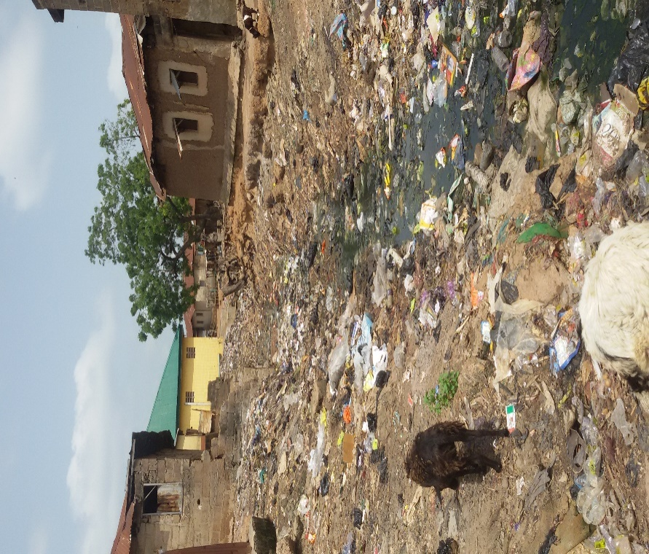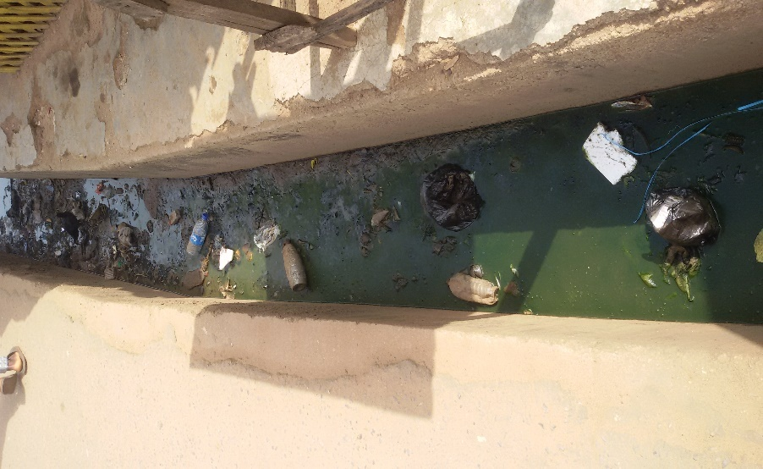
Plate IV: Haphazard Refuse Dumpsite, Tanka-Tu, Plate V: Blocked and Stench Drainage,
Okelele Adangba
Source: Field Survey, 2017

Assessing the most prevalent form of pollution in the study area, it was observed incontrovertibly that, there exist pollution in Okelele. Air and land/soil pollution as shown by table 6 were the most prevalent forms of pollution having respondent views of 20% and 80% respectively. This implies that, there exist an intertwined relationship between the stench of smell and filthy environment and both strikes a balance at Okelele, with exhaust from vehicle contributing to the air pollution in the study area.
Accessing the source of power supply, 90% of respondents agreed to be using IBEDC (Ibadan electricity distribution company) power supply while the remaining 10% agreed to be using self-generating plant. However, many of the respondents lamented vehemently on the power situation in the community to be nothing to write home about. Furthermore, accessing the road condition of the study area, 82% of the houses sampled were only accessible by footpath and this is due to the contiguous nature of the buildings in this area, while the remaining 9% each could only be accessed by tarred and untarred roads respectively. From analysis, it was deduced that total area of road measured in the study area was 0.059 km²(5.9%) out of 1.18km² land mass of Okelele and Adangba communities, this clearly compromised the circulation standard of (15% - 25%) planning cities.
Table 6:Assessment of Infrastructure Facilities and Environmental Conditions
Character | Percentage (%)
Electricity (Source)
Government (IBEDC) | 90
Self-Generating Plant | 10
Total | 100
Prevalent Pollution
Land/Soil | 80
Air | 20
Total | 100
Accessibility (Road Condition)
Foot Path | 82
Tarred Road | 9
Untarred | 9
Total | 100
Availability of Open Space
Yes (Available) | 88.7
No (Not Available) | 11.3
Total | 100
Assessment of the Environment
Rowdy | 21.1
Dirty | 78.9
Total | 100
Source: Field Survey, 2017

However, assessing the open space facilities in the area, 88.7% agreed not to have open space site, while the remaining 11.3% agrees to use open Agoole compound as open space.In the assessment of the general environment, not less than 21.1% of the sampled respondents agreed that their environment is rowdy, probably because of its closeness to the CBD, particularly the Emir market. While this was followed by the 78.9% who affirmed that the environment is dirty. but from observation theOkelele and Adangba communities have their neighbourhoods extremely filthy and raucous. This was further buttressed by a discussant who anonymously confirmed the cleanliness of neighbourhood to be nothing to write home about during the rainy season, he said “residents with no toilet has seen it as a routine to roll out stashed faeces, just to stuff it into drainages whenever it is raining, for running water to wash away”. The environment of Okelele and Adangba have spoken for itself already, as environmental resilience is fighting to gain its ground due to the persistent damages being done to the environment.
Recommendations and Conclusions
Housing is a numbers game,the more people in any city or town, the greater the need to improve housingenvironment(Rizvi, 2016). To this effect, the following recommendations are put forward as policy guidelines.
Slum Upgrading and Economic Rejuvenation
Slum upgrading should be appropriately instituted in Okelele-Adangba communities. This approach should be combinations of rehabilitation/Renovation and Economic rejuvenation, as this will help in relieving overcrowded buildings invariably labelling this area as slum. Findings evidently show that 70% of the buildings in the residential environment need repairs. However, more roads should be introduced to increase circulation from 6% in the study area and to further reduce the blighted houses in the area. Furthermore, economic rejuvenation should be institutionalized in order to compliment the rehabilitation and renovation, as this will invariably help in solving the cause of decay, rather than just treating symptoms alone.
Public Awareness
The findings through regression analysis further shows that the satisfaction of residents of Okelele – Adangba community depends significantly on three (3) principal factors (pollution level, infrastructure and appearance of the urban scenes of Okelele – Adangba community). In defeating the pollution and appearance of the environment, Bako, Aduloju and Abubakar-Kamar(2017) believe public understanding of science is a necessity and a veritable tool in stimulating the consciousness of individuals. As stakeholders like government and non-governmental organizations can organize programmes on the need to take care of one’s environment and further emphasize the slogan ‘health is wealth’. Jingles on radio and T.V sets help in connecting to the micro and macro level and invariably changing the mindset and mentality of people as regards how our precious environment can be saved from degradation due to carelessness in use. In achieving this feat, awareness through government organs, Corp members of National Youth Service Corps (NYSC) as vanguards,could all be used to propagate the gospel of environmental sustainability.
Reintroduction of Old Sanitary Inspectors
The case of fluvial flooding and poor sanitation gradually becoming a friendly disaster, can be a thing of the past, if the old sanitary inspectors Wolewole are reintroduced to check the attitude of dumping wastes in drains, houses without toilet facilities and inappropriate flushing of faeces in drainages under the umbrella of rainy season.

Joint Environmental Management Plan
This research is also recommending a collaboration between state government and private companies in form of Public-Private Partnership (PPP) with a solid Memorandum of Understanding (MOU) as a way out of improper solid waste and collection system. Private sector in the municipal solid waste sector in developing countries are partly driven by more stringent environmental standards and the recognition that the private sector can play a significant role in improving environmental and hygiene issues around solid waste collection and disposal. So therefore, Public-Private Partnership (PPP) in many other states like Ondo State could be effective as regards solid wastes collection, disposal and administration of the laws surrounding the failure of the public especially in Okelele – Adangba community to comply. If this is instituted in Kwara State, land/soil pollution and indiscriminate dumping will be a thing of the past.
Provision of Infrastructure Master Plan (IMP)
Infrastructure is the backbone of any liveable city, as it encompasses all indicators of liveability. Therefore, this research is suggesting an infrastructure masterplan of 10 – 15 years for Okelele -Adangba community of study as this will help in complementing the existing land use masterplan. From the findings of this research most of the valuable infrastructure like good roads, potable water supply, sewage collection system,solid waste collection and management. Etc. are clearly missing. The IMP will support and ensure there is enough infrastructure capacity in the right areas of the Okelele -Adangba community at the right service levels at the right time to accommodate development and redevelopment until 2032.
Conclusion
Global environmental collapse is not inevitable.Thus, housing is very important for many aspects of healthy living and well-being, as number of people living on the planet is rising every second, as the World Population Clock shows, the cultural characteristics of cities reflect both historical and contemporary ways of living. In assessing the residential conditions of Okelele – Adangba communities relative to space and time however, is lamentable, as this research as pointed out that all infrastructures are clearly missing, occupancy ratio well above minimum standard and income level cannot cater for the residential environment
The massive housing backlog in Okelele – Adangba communities is made worse by the absence of adequate, habitable housing environment and the apathy of stakeholders in addressing housing-related issues. However, the heartrending and quagmire situation of Okelele – Adangba communities require an assertion of political leadership that goes far beyond political sloganeering.It is imperative that political leadership comes forward, in a determined manner to take on this challenge, by mobilizing urban planners, academic scholars, local governments and regulatory authorities. Equally important is the need for knowledge-sharing in order to apply best practices.
The era of strategic negligence and patience is over. This paper due to the deplorable sight of Okelele – Adangba community, therefore throws a clarion call and challenge to the Kwara State government both at the State and Local levels, all NGOS and Stakeholders, professionals, and individuals to rise up and see to the situation of Okelele – Adangba community.

References
Abdullahi, A. A., Seedat-Khan, M., & Abdulrahman, S. O. (2016). A Review of Youth Violence Theories: Developing Interventions to Promote Sustainable Peace in Ilorin, Nigeria. AFRICAN SOCIOLOGICAL REVIEW, 20(2), 40-60. Retrieved from https://www.ajol.info/index.php/asr/article/viewFile/153938/143520
Akinbode, T. (2015). Housing Policy and Programmes. Akure.
Akinyode, B. F. (2017). Determining Factors for Housing Affordability in Ibadan, Nigeria. (K. Singh, Ed.) Ethopian Journal of Environmental Studies and Management, 10(5), 642-653.
Akogun, I. T., & Ojo, O. (2013). Tenant Eviction in Property Management Practice in Ilorin Metropolis, Nigeria. Journal of Economics and International Finance, 139-145. Retrieved from https://www.researchgate.net/profile/Tajudeen_Akogun/publication/273761565_Aspects_of_tenant_eviction_in_property_management_practice_in_Ilorin_metrpolis_Nigeria/links/57ed2ca008ae26b51b395b40/Aspects-of-tenant-eviction-in-property-management-practice-in-
Bako, A. I., Aduloju, O. T., & Abubakar-Kamar, A. T. (2017). Liveability and Wellness of Residence of Oloje Community in Ilorin West Local Government Area, Ilorin Nigeria. Journal of Social Sciences, 2(3).
Close, R., & Crabbe, H. (2016). The health problems Associated with Poor Housing and Home Conditions, Flooding, Poor Sanitation and Water Pollution. United Kingdom. Retrieved from https://www.healthknowledge.org.uk/public-health-textbook/disease-causation-diagnostic/2f-environment/health-problems-poor-housing
Dunn, J. R. (2002). Housing and Inequalities in Health: A Study of Socioeconomic Dimensions of Housing and Self Reported Health from a Survey of Vancouver Residents. Journal of Epidemiol Community Health, 671 - 681.
Encarta Interactive World Atlas . (2008). Human Habitation. Microsoft Encarta Premium.
Fakomogbon, O. E. (2015). Facilitating Employment Generation through Small and Medium Scale Industries in Iloin West Local Government Area, Kwara State. Ilorin.
Fasakin, J. O. (2000). A Landuse Analysis of the Operational Characteristics of Commercial Motorcycle in Akure. Ph.D Thesis, Federal University of Technology, Akure, Department of Urban and Rgional Planning, Akure.
Johnstone, C., & McWilliams, C. (2005). Urban Policy in thr 'New' Scotland in Exploring Social Policy in the 'New' Scotland. Scotland: Policy Press.
Kennedy, D. (1987). The EEffects of the Warranty of Habitability on Low Income housing: "Milking" and Class Violence. Florida State University Law Review, 15, 484-519.
Listokin, D., and Burchell, R. W. "Housing (shelter)." Microsoft® Encarta® 2009 [DVD]. Redmond, WA: Microsoft Corporation, 2008.
Mitchell, R. C., & Carson, R. T. (1989). Usinng Surveys to Value Goods: The contigent Valuation Method.
National Ocean and Atmospheric Administration. (2016, July 22). "Ilorin Climate Normals 1961–1990". Ilorin, Nigeria.
Nwilo, P. C. (2014). Environmental and Management Issues in Nigeria Coastal and Inland Waters. Akure: FUTA BDC.
OECD. (2007). Society at a Glance. In OECD, Social Indicators. Paris: OECD Publishing.
OECD. (2011). Housing Condition. In OECD, How's Life?: Measuring Well-Being. OECD Publishing. Retrieved from http://dx.doi.org/10.1787/9789264121164-6-en
Olawale, S. B., Lawal, A. A., & Alabi, J. O. (2015). Nigeria Housing Policy: Any Hope for the Poor? American Research Journal of Humanities and Social Sciences, I(4), 29-35. Retrieved from https://www.arjonline.org/papers/arjhss/v1-i4/5.pdf
Oloko-Oba, M. O., Ogunyemi, A. S., Alaga, A. T., Olatunji, S. B., Ibrahim, S. I., Isa, I., . . . Kolawole, M. H. (2015). A Geospatial Approach to Evaluation of Accessibility to Government Primary Schools in Ilorin West Local Government Area, Kwara State, Nigeria. European International Journal of Science and Technology, IV(8), 96-107.
Omole, F. K. (2010, December). An Assessment of Housing Condition and Socio-Economic Life Styles of Slum Dwellers in Akure, Nigeria. Contemporary Management Research, 6(4), 273-290.
Panneerselvam, R. (2014). Research Methodology (2nd ed.). Delhi: PHI Learning Private Limited.
Rizvi, Z. M. (2016, August 09). The Challenge of Affordable Housing for Low-Income City-Dwellers. Retrieved October 04, 2017, from http://blogs.worldbank.org/psd/challenge-affordable-housing-low-income-city-dwellers
Services, S. G., & (SGCAS). (2010). A Thematic Review of Literature on the Relationship Between Housing, Neighbourhoods and Schools.
United Nations Children’s Fund (UNICEF). (2008). Access to Sanitation, Total Population. Microsoft Encarta Premium.
World Health Organization. (2010). Developing Guidance for Health Protection in the Built Environment Mitigation and Adaptation Responses. International Workshop on Housing, Health and Climate Change: . Geneva: World Health Organization.

