MANUAL FOR THE MAINTENANCE OF
THE SUSPENDED WALKWAY
AT THE UNIVERSITY OF ILORIN
ZOOLOGICAL GARDEN
First Edition

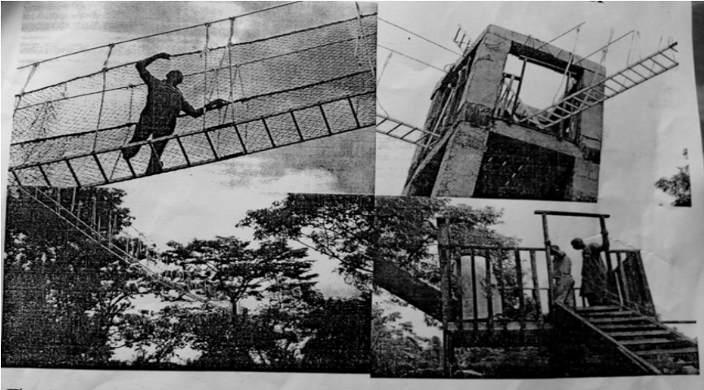
Prepared by:

ABDULLAHI A. JIMOH
MOBOLAJI S. SANNI
ADESOJI M. ABISOYE
AMUDALAT M. ABIDOYE
TUNDE M. SAHEED

2018
- PREFACE
The aim of preparing this manual, Manual for the Maintenance of the Suspended Walkway at the University of Ilorin Zoological Garden, is to produce a working paper for those responsible in the day to day running of the Suspended Walkway and to keep the life of the Walkway system long and safe for the tourists and users (the climbers). The manual is therefore very relevant to the Works Department, University of Ilorin, being the Unit that is responsible for the maintenance of the infrastructures in the University.
This manual is divided into 25 parts. Parts 1 to 3 give the introductory information and importance of the Walkway; parts 4 to 6 explain the various components of the Walkway; and parts 7 to 20 provide information about the maintenance of various components of the Walkway. Part 21 provide information on the Walkway operation and the remaining parts (22 to 25) also give relevant information.

The authors felt that being the team that was responsible for the Walkway construction, they should also try and prepare this manual for its maintenance, and hope to continue to update the manual in future. Therefore, they would welcome any constructive criticism, which would be added to the future edition.


Dr. A.A. Jimoh Engr. A.M. Abisoye
(Civil Engineering Department) (Director of Works)

TABLE OF CONTENT
PAGE
- PREFACE ii
- INTRODUCTION 1
- PRELIMINARY ACTIVITIES 4
- VIEW OF PART OF THE COMPLETED UNILORIN SUSPENDED WALKWAY 9
- POSITIONS OF THE TOWERS AND PATH OF
THE UNILORIN SUSPENDED WALKWAY 10
- SCHEMATIC REPRESENTATION OF ELEVATION OF THE WALKWAY 12

- CONCRETE TOWER MAINTENANCE 14

- TREE TOWER MAINTENANCE 15
- STAY WIRE MAINTENANCE 16
- STAIRCASE MAINTENANCE 17

- SUSPENSION CABLE MAINTENANCE 18

- HANGER-POLYESTER ROPE MAINTENANCE 19

- SIDE NET MAINTENANCE 20

- GALVANISED CLIPS MAINTENANCE 21

- ALUMINIUM LADDER MAINTENANCE 22

- WALKWAY TIMBER DECK MAINTENACE 23

- TIMBER PLATFORM MAINTENANCE 24

- CONTACT FACES MAINTENANCE 25
- TERRAIN MAINTENANCE 26
- GENERAL INFORMATION ON
MAINTENANCE 27

- OPERATION OF THE WALKWAY 28
- AKNOWLEDGEMENT 29
- ABOUT THE AUTHORS 30
- BIBLIOGRAPHY 32
- APPENDIX 35

- INTRODUCTION

Suspended Walkway is a universally applied structural system because it is found in many nations of the world: USA, Switzerland, Spain, China, Argentina, Brazil, Russia, France, Ghana and so on. It could be a recreation project and could also serve as a route built over obstacles (river, valley or deep gorge), for ease of movement of pedestrians. Therefore, it would function as a system that encourages social interaction and relaxation in a society. It is also similar to the suspension bridge and therefore could be a source of educational information for engineering students and lecturers.

The Suspended Walkway at University of Ilorin is located in the Zoological Garden of the university and it is the first of its kind and the only one in Kwara State and in the North Central part of Nigeria. The Unilorin Suspended Walkway consists of three suspended bridges supported by four towers. The Walkway is a blend of nature and innovations aimed at providing comfort and satisfaction to the prospective visitors to the Garden. It is hoped to boost the tourism potential and of course, the image of the University. Since tourism has been identified as a major global source of revenue generation, this project equally seeks to boost the IGR of the University. All these benefits are elements that could satisfy some components of Vision of this University, which is, “To be an International Centre of Excellence in Learning, Research, Probity and Service to humanity”.

The construction team for this project was constituted in 2012. The team members names and positions (as at 2012) were: Dr. (Engr.) A.A. Jimoh (Head, Civil Engineering Department), Engr. M.S. Sanni (Director of works), Engr. A.M. Abisoye (Deputy Director), Engr. (Mrs.) A.M. Abidoye (Works Department), Engr. T.M. Saheed (Works Department) and Mr. A. Kenneth (From Ghana). Dr. A.A. Jimoh was the Technical Chairman while Prof. A.B. Olayemi, the then Vice Chancellor Management Services, was the overall Chairman, to oversee the construction activities and the management of funds allocated for the construction. This project was completed in 2012 through direct labour and commissioned in October of that year (2012), by the then Honourable Minister for Education, Mrs. Rukayat Rufai, on behalf of the President of the Federal Republic of Nigeria.

The Walkway is made up of various materials: metallic and non-metallic, which, due to severe exposure and with passage of time, can undergo various stages of rot, rust, decay, and disintegration. Therefore, some of its parts will require polishing, protection and even replacement. Thus, in order to sustain its use for a long time, the authors decided to prepare this manual for its maintenance, more so that there is no handbook at present for this purpose.

- PRELIMINARY ACTIVITIES

3.1 Visit to the Suspended Walkway in Ghana: Before the commencement of construction of the Suspended Walkway in the Zoological Garden, University of Ilorin, a visit was made to the Federal Republic of Ghana to understudy the Suspended Walkway at the Kakum National Park, Cape Coast, Ghana. Two members of the team, Engr. A.M. Abisoye and Engr. T.M. Saheed, were selected for the visit. The visit to the park in Ghana was essentially to inspect and assess the Canopy/Suspended Walkway and other recreational facilities there with a view to constructing same at Unilorin Resort Centre and Zoological Garden, respectively.

The Canopy/Suspended Walkway in Ghana was the Africa’s first and only Rain Forest Walkway. It is made up of 350m long (7-suspended) bridges and six tree towers that reached the height of 30m above the forest floor.

From this visit, useful information on the construction, management and maintenance of the Walkway was gathered through interaction with the maintenance officer in- charge, Mr. Kenneth Asare. Areas of possibilities/opportunities of assistance for the construction of Unilorin’s Suspended Walkway were explored.

The maintenance officer in-charge of the Walkway (in Ghana) hinted that:
(a) Two Canadians and six Ghanaians, including himself, were directly involved in the construction of the Kakum National Park Walkway. Besides, he had been in charge of its management and maintenance since completion in 1994; and,
(b) Having understudied the Canadians for the six month construction period of the Kakum National Park Canopy/Walkway, he had successfully constructed a 250 feet (76.2m) long similar Walkway across a river in Accra, Ghana, with construction period of three months, and also another Walkway in Ankasa Forest, a village between Ghana and Ivory Coast border.

For the Walkway discussed above, the material and the construction processes were observed as follow:
Construction: Each of the suspended bridges was hanged by ropes tied to the suspension cables and spaced at one metre centre to centre. The sides of the bridges were covered with polyester nets as a protective device for the tourists. The timber platforms could be supported under either by galvanised ladder or galvanised cable.

Materials for the construction: Materials for the Kakum National Park Walkway in Ghana were:
- 12 mm & 14 mm galvanised cable/ladder;
- Galvanised clips;
- Galvanised hold-down bolt & nuts;
- Polyester ropes (14mm & 12mm);
- Polyester net (50mm x 50mm) ;
- Seasoned & treated timber/ planks (assorted);
- Concrete/tree support platforms ; and,
- Roof covering (thatched roof or long-span roofing sheet).

All the materials listed above should not be compromised as they are the materials that could withstand the applied loads in the Walkway system. These materials also possessed high resistance to all forms of climatic weather conditions. Further interaction with Mr. Kenneth revealed that the Galvanised ladder was suitable for the walkway platform and the galvanised cable would provide an efficient strength and low maintenance cost. For provision of towers, concrete or steel towers would be required where the tree supports were not available. Finally, a dedicated personnel was recommended, that should be trained and retained for the management and maintenance purposes of the proposed Walkway at University of Ilorin.

Having understudied the Ghana Walkway, the information gathered was next applied to replicate same in University of Ilorin. Also, the maintenance officer for that in Ghana, Mr. Kenneth Asare, was brought into Unilorin, as part of the Unilorin construction team.
3.2 Location, Reconnaissance Survey and Costing of the Unilorin Walkway:
For the Unilorin Walkway, survey of the location was carried out. This location is near the university main gate. The place was marked and the trees including oil palm trees, stumps and grasses were cut and removed from the site. Cost estimate of the material required for the project was also carried out, which included the cost of the aluminium ladders, iron cables, ropes, nets, timber, etc. These materials are similar to those used in Ghana as highlighted in section 3.1. Some of the materials were purchased in Nigeria and some from Ghana.
Having done the items in sections 3.1 and 3.2, the construction activities started in earnest and the project was completed in less than six months, through hard work and dedication of members.

- VIEW OF PART OF THE COMPLETED UNILORIN SUSPENDED WALKWAY

In order to aid understanding of the maintenance activities described in later sections, a pictorial view of part of the completed Unilorin Suspended Walkway is presented, as shown in Figure 1. It shows the staircase, the tree tower (Iroko – Milicia excelsa), the wooden platform placed on the tree and the Walkway deck. More views are presented in Appendix.
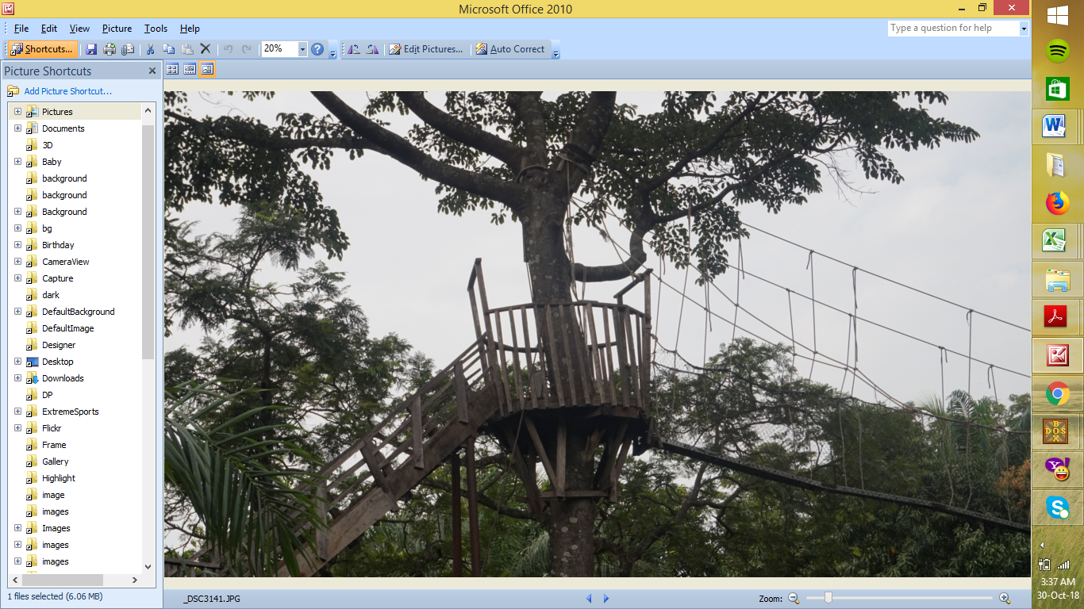
Wooden platform
Tree tower
Walkway deck
staircase
Figure 1: A Portion of the Suspended Walkway at the Zoological Garden

- POSITIONS OF TOWERS AND PATH OF UNILORIN SUSPENDED WALKWAY:

Information on tower positions and spacing are important in the maintenance activities. These positions and spacing are presented schematically in Figure 2. Towers are placed at points A, B, C and D. Point A is the nearest to the gate and marked as the entry point into the Walkway. Point B and C are in between and point D is the furthest and marked as the exit point. The distances between the tower positions are indicated. The entire length of the Walkway from the beginning (point A) to the end (point D) is 132m.

It was proposed that in future, this particular range (A to D) would be expanded or extended, and also, that another Suspended Walkway would be constructed across the University Dam Site.

These points (A, B, C and D), apart from hosting the towers, also contain other components of the Walkway, which are discussed in the next sections.

50 m
40 m
(A) An Iroko tree tower (close to the gate)
(B) R.Conrete Tower (two columns)
(C) R. concrete Tower –(four columns)
( D) An Iya tree tower

42 m
A stream

Figure 2. A schematic diagram for positions of towers and path of the Suspended Walkway

6.0 SCHEMATIC REPRESENTATION OF ELEVATION OF THE WALKWAY
While section 5 contains the plan view of tower positions, this section contains the elevation view of tower positions, to show the components that are attached to the tower and those that are not. This view is shown schematically in Figure 3.
Components at the tower positions are: the towers, platform, the stay wire and the stair case. Components that are not attached but in between the towers (suspended) are: the rope hangers, the suspension cables, the Walkway timber deck, the aluminium ladder and the side net.
Maintenance information on these components, including their descriptions and functions are presented in the subsequent sections. Also, other important areas like the clips, contact faces and terrain, are discussed.

Hanger rope
Side net
Suspension cable
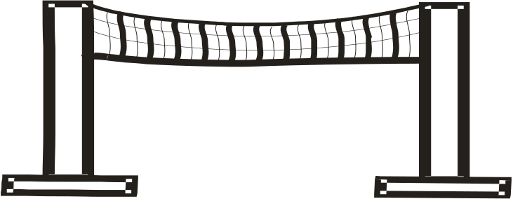
towers
(tree or concrete)
Walkway deck
Mass concrete stay wire
Figure 3 Schematic diagram for elevation of a span of the Suspended Walkway

7.0 CONCRETE TOWER MAINTENANCE
Concrete towers resist the pull from the suspension cables. They are placed at points B and C, shown in Figure 2. The concrete tower at B has two columns with cross section of 50cm by 50cm and spacing of 2.15m centre to centre while the second concrete tower at C has four columns and of the same cross section as that in B but of different spacing of 160cm centre to centre. The heights of the concrete towers vary between 12 and 15 metres.
The Concrete towers are made up of steel reinforcement and concrete and were further protected with porcelain tiles laid over their surface. It is recommended that the tiles should be kept intact and any fall off tile should be replaced. Also, fencing is required to prevent human and vehicular damage. At any point where concrete peels off from the tower surface, this should be mended. At the base of each tower, soil backfill is required if the soil there has been eroded. The stay wire provided for the tower should be maintained and kept tight.

8.0 TREE TOWER MAINTENANCE
Tree towers, just like the concrete towers, also resist the pull from the suspension cables. They are placed at points A and D. That at point A is an Iroko tree (Milicia excelsa) with a girth of 2.25m while the other at D, had a higher girth of 3.25m and it is an Iya tree (Daniella oliveri).
The enemies of trees are fire, chemicals, borers, rotting , erosion which can expose the roots, strong wind, excess pull from the cable and human factors. These problems must be avoided and the tree towers must be fenced and stay wire provided to prevent excessive forces from uprooting the tree. Backfill is required at the tree base if the soil there has been eroded.

9.0 STAY WIRE MAINTENANCE: Stay wire stabilises the towers against excess pull from the suspension cable. It is a cable with one end tied to the top of the tower and the other end down is tied to a mass concrete, buried in the ground as shown in Figure 3. Stay wires, apart from acting as equilibrant devices against the excessive force on a tower, it also acts as a damper of the vibration on the Walkway. The stay wire is an offcut from the suspension cable and therefore has the same cross section as the suspension cable.

It must always be cleaned and oiled or greased to prevent rusting while the exposure of the buried concrete should be avoided. Vehicles should not be allowed over the concrete buried in order not to crush it. The stay wire cables should be checked regularly for its tightness to the tower and also checked for any break in its fibrils.

10.0 STAIRCASE MAINTENANCE: Staircase is a devise for users to move up from the ground into the platform placed on the tower. There are three types along the Walkway. One staircase is placed against the tower at point A, one is at B and one is placed at D. They are of different spans and their risers are each 80 mm while their treads are each 280mm. Their plan-shapes varied with one being L-shaped and the other two U-shaped, with three landings. One landing is placed on the ground, one in between the two landings and the topmost landing is incorporated into the platform placed on the tower.

They (staircase) are constructed with Ayin (Anogeissus leiocarpus) timber and some with mahogany (Khaya senegalensis) timber. The timber stair case was to be replaced with steel type in future.

Since the staircase is made up of wooden material and because of severe exposure, it can rot, decay and can be attacked by termites and borers. Therefore, it should be sprayed with appropriate chemicals to prevent the attack. Frequent inspection is required and damaged portion should be repaired or replaced.
11.0 SUSPENSION CABLE MAINTENANCE: Two cables are used to suspend the Walkway deck. Each cable’s two ends are tied to the towers on either side and in this way it sags with its shape being parabolic in view. The cable is 16 mm in diameter, consisting of three sub strands, each having 18 to 20 units.

The cable is a metal and because of exposure, it can rust or rot. Therefore regular cleaning and greasing is required to avoid rusting. Its fibrils should be checked regularly for any break and replacement. Its ends tied to the towers should always be checked to avoid drops in the Walkway deck.

12.0 HANGER-POLYESTER ROPE MAINTENANCE: It is a twisted rope with shining silver colour and 20mm in diameter. It has three sub strands also twisted with each fibril being 8mm in diameter. This rope has varying lengths and connects the Walkway deck to the suspension cable, that is, one of its ends up, is tied to the suspension cable and the other end down, is tied to the Walkway deck. They are spaced at 1m interval and because the entire Walkway length is 132 m long, there will be at least 270 units of this hanger ropes.

Since the rope is not a metal, and also, because it is within hand reach during walking on the bridge, it can be easily cut or damaged and can rot. Therefore, necessary check is required for correction of any defect and damage.

13.0 SIDE NET MAINTENANCE: Side net is a protective devise, held in position between the Walkway deck and the suspension cables, respectively, covering both sides of the Walkway. It is also made up of polyester material like the rope but black and not shining. It has a rhombic geometry with side dimension of 50mm by 50mm and 3mm thick.

The net, just like the rope, is not a metal and also it is within hand reach. Therefore, it can rot and be damaged. Frequent check is therefore required and replacement implemented where necessary.

14.0 GALVANISED CLIPS MAINTENANCE: A clip has a pair of U shaped steel rods and slots for bolts and nuts that are used to connect cables together.

Being a metal and because of exposure, it can rust and therefore, it should be polished regularly. The bolts and nuts of this clip should be checked regularly and tightened back if loosened, so that the cables being held together do not slip off.

15.0 ALUMINIUM LADDER MAINTENANCE: Ladders are devices laid under the Walkway deck and act as supports for it (for the deck). A ladder weighed 6kg and 4.5m long and all ladders are connected together to form a continuous unit between two towers.

They can deform or crack due to fatigue and can press-in under the weight of the climber because its section is hollow. Damage can be prevented if it is well placed under the timber deck. Cracked portion should be replaced.

16.0 WALKWAY TIMBER DECK MAINTENANCE: Timber deck forms the Walk way floor and are placed over and bolted to the aluminium ladders. The timber used for the deck had the usual market dimension of 25mm thick, 350mm wide and 3000mm long and weighed 7kg/m; but after purchase, the thickness was tinned down from 25mm to 15-18mm thick to reduce the dead weight. They (the timber) are joined together like the ladders to form a continuous unit over the ladder. The species of timber used for the board is locally called Apadan (Apa of savanna origin) (Afzelia bipindensis).

Because they formed the floor of the Walkway, they must always be checked and maintained. Any defective timber must be replaced with seasoned one. The joint between the timber and the ladder should be checked regularly for any damage and repair should be carried out regularly.

17.0 TIMBER PLATFORM MAINTENANCE: Platform is a small compartment made of wooden material constructed on each tower. It is a temporary resting cubicle for the climbers. Its floor resists the weight of the user and the wall resists the push (leaning) from the climber.
It is essential that the various joints of the platform are checked for firmness and the floor should always be in good condition and stable. Because it is a wooden material, it is prone to decay and insect attack. Therefore it must be treated and replaced if defect is noticed.

18.0 CONTACT FACES MAINTENANCE: The Walkway deck and the suspension cables have some contact with the towers and may cause some damage at the contact points, as explained below.

Where the suspension cable ends are wound round the tree towers, this could hinder the growth of the tree girth at the points of contact. To avoid damage and death of the tree, the cable positions should be changed annually. Where the ends of cables are wound round the concrete tower, they can break concrete off the surfaces at the contact points and reduce its (tower’s) cross section. Therefore, at the contact points, if defect is noticed, the maintenance required is re-plastering and flat objects sandwiched and fixed in position between the two faces.

19.0 TERRAIN MAINTENANCE

Terrain is the area occupied by the Suspended Walkway. Factors that can affect the terrain are flooding and allowing vehicles to cross the area without any defined road. This should be avoided and there should be provision for drainage channel for runoff and lawn should be kept low.

20.0 GENERAL INFORMATION ON MAINTENANCE

Apart from the routine activities outlined above, it is recommended that the polyester rope hangers and the side net (also of polyester material) be changed after every two years. The reason for this is that by fifth year of use, they disintegrate, rot, or get weakened and can easily break with little force when pulled apart. In addition, bush burning should be avoided near the Walkway in order not to cause any damage to these materials.
For replacement of timber material, it is important that the durable and seasoned timber is used. Categories of durability of timber are available in NCP 2 (1973) as follow: very durable, durable, moderately durable, non-durable and perishable. The names of timber belonging to each of these categories are also given and can be used as a guide to select an appropriate timber for a particular maintenance.
In addition, pecking of birds on the Walkway components should be prevented as they can cause damage in the process. Also, bee or other dangerous animals should be prevented from settling on the Walkway, to ensure safety for the users.
21.0 OPERATION OF THE WALKWAY

Presently, the Walkway is being operated under the supervision of the Works Department of the University, through a personnel appointed at the site. It is recommended that frequent check is kept to ensure that the operator carries out the minor maintenance regularly while the major maintenance is carried out by qualified personnel. It is also recommended that not more than four adults should be allowed at a time on the bridge.

22.0 AKNOWLEDGEMENT

The authors wish to appreciate the kind gesture of the Vice Chancellor in 2012, when the Walkway was under construction, Professor I.O. Oloyede, for choosing us as the team responsible for the construction. This has provided us an avenue to showcase our potentials and the project no doubt is an additional exposure and an experience for us. The authors also wish to acknowledge the dedication of Professor Albert B. Olayemi who was the overall Chairman of the Construction Committee. Our appreciation goes to Engr. Ademola A. Adesiyun, former Director of Physical Planning Unit of this University, who used to attend some of the initial meetings on the project and offered useful suggestions. The reviewers of this manual: Dr. B.F. Ibrahim and Mr. M.O. Durosinmi of English Department of this university are well appreciated for carrying out this responsibility. Finally, the current Vice Chancellor, Professor Suleiman Age Abdulkareem, is appreciated for sustaining the operation of the Suspended Walkway.

23.0 ABOUT THE AUTHORS

Dr. A.A. Jimoh is an Associate Professor in the Department of Civil Engineering University of Ilorin. His area of specialization is Structure and Material Engineering and he has published articles in these areas.

Engr. M.S. Sanni was a former Director of Works and has retired from the services of the University. Engineer A.M. Abisoye is the current Director of Works while Mrs. (Engr) A.M. Abidoye is the Deputy Director, Civil/Building and Engr. T.M. Saheed is a Principal Engineer in the same Department.

All the authors have had various experiences in the design and construction of diverse engineering infrastructures. The roles of these personnel as at 2012, when the Walkway was being constructed, are shown in the table below.

The authors / the construction team member roles and Departments as at 2012

Member Name | Roles During Construction (2012) | Department
Dr. (Engr.) A.A. Jimoh | Designer and the Technical Chairman of the Construction Committee | Head, Civil Engineering  Department
Engr. Mobolaji S. Sanni (Director of Works) | Director of Works then and the Representative of the University and a Member of the Committee | Works Department
Engr. A.M. Abisoye | Deputy Director of Works and a Member | Works Department
Engr. Mrs. Amudalat M. Abidoye | Clerk of work for the construction and also a Member | Works Department
Engr. T.M. Saheed | Clerk of work for the construction and also a Member | Works Department
Mr. Kenneth Asare | Technician for the construction | From the Federal Republic of Ghana

24.0 BIBLIOGRAPHY

- Adefemi, J. B. and Jimoh A.A. (2011); Experimental
determination of buckling loads at varying heights of full-size mahogany (Khaya senegalensis) timber columns or struts, Conference Proceedings, 3rd Annual Conference of Civil Engineering, 6th -8th July 2011, Department of Civil Engineering, University of Ilorin, Ilorin, Nigeria, 20-23.
- BS EN 12390-5 (2009) ; Testing Hardened Concrete:
Flexural Strength of Test Specimens, British Standards Institution, London .
- BS 8110-1: (1997); Structural use of Concrete, Code of
Practice for Design and Construction, Part 1, British Standards Institution, London.

- Clough, R.W. and Penzien J.; (2015) ; Dynamics of
Structures, Second Edition, CBS Publishers, Delhi

- Deschi H.E. and Dinwoodie J.M. (1991); Timber Proper
ties, 6th Edition, Macmillan Education LTD, London.

- EN 1992-1-1 (2004); Eurocode 2: Design of concrete
structures - Part 1-1 : General rules and rules for buildings, European Union

- Jimoh, A.A. and Chabi, A.B. (2017) ; Some Physical and
Mechanical Properties of Daniellia Ogea Harms green timber species. Journal of Applied Sciences & Environmental Management (JASEM). 21(6); 1101-1104. Published by the World Bank Assisted National Agricultural Research Programme (NARP)- Faculty of Science, University of Port Harcourt, Port Harcourt, Nigeria.

- Jimoh A.A., Yahya, I.A. and Adefemi J.B. (2016); Strength
Characteristics of Apa (Afzelia bipindensis) Timber for structural use (A case study of species grown in Kwara State, Nigeria. WebsJournal of Science and Engineering Application, WESEA. 5(1); 467-474.

- Jimoh, A. A. (2007); A continuous column design formula
at ultimate strength for axially loaded Iroko (Milicia excelsa) timber column. The Nigerian Journal of Pure and Applied Sciences. 22; 2129-2135, Faculty of Science , University of Ilorin, Ilorin, Nigeria.

- Jimoh, A.A. (2005); Ultimate Strength Design of Axially
Loaded Ayin (Anogeissus leiocarpus) Timber Columns. Journal of Applied Science and Technology (JAST) , Published by International Centre for Materials Science & Technology (ICMST), Accra, Ghana. 10( 1 & 2); 29-34.

- NCP 2 (1973); Nigerian Standard Code of Practice, The Use
of Timber for Construction, Nigerian Standard Organisations, Federal Ministry of Industries, Lagos, Nigeria
- Roy, S.K. and Chakrabarty, S. (2011); Fundamentals of
Structural Analysis with Computer Analysis and Applications, S Chand & Company LTD (Publisher), New Delhi.

25.0 APPENDIX
Preamble: This project has been completed and in the process has undergone some important stages: design, construction and commissioning; and now undergoing operation and maintenance stages. The previous three (commissioning, operation and maintenance) have been discussed in the previous sections. The first two (Design and Construction) will now be discussed casually. Although these two are not directly related to maintenance, but they will contain some details which will aid knowing the type of maintenance methods to apply.

Appendix I
Design Information

A1.1 Material stresses: The structural material component for the Walkway can be divided into three: the natural structural material, the factory made structural material and the site made structural material.

The only natural structural material is the tree tower. Its green stress values are more important than the conventional dry stresses. In the analysis for its resistance against loads or pull by the suspension cable, the tree green stress values are applicable. The green stress is obtained from test specimen cut from a similar tree, freshly felled.

Specific recommendation: Timber green stress data are not as common as the air dry stress data. Green stress is defined in NCP 2 (1973) as the one obtained with moisture content exceeding 18 %. The stress data at 18 % though are available for some timber in NCP 2 (1973), but are not applicable for the tree towers. This is because the moisture content of a freshly felled tree is far above the 18%. Thus, researchers are encouraged to carry out studies on green timber stresses especially for living trees.

The factory made materials are six: the hanger (polyester) rope, the suspension cable, the stay wire, the aluminum ladder, the steel poles and the timber. In the Walkway system, the first three are subjected to pure tension while the rest three are subjected to flexural and compression forces. They have fixed dimension and their design stress is obtained from experimental test carried out on small piece cut from each of them.

The only site made structural material was the reinforced concrete, cast for the towers. Pieces of steel rods were cut from the reinforcement for test and the concrete cubes were prepared and tested accordingly, to obtain design stresses.

A1.2 Dead and imposed load: The dead weights are the self-weight of the structural components like the rope, the cable and the timber. The imposed load is the self weight of the user or the climber and design imposed load values are available in BS 6399-1 (1996).The minimum imposed load is 2.5 kN/m² for a uniformly distributed load and 1.8 kN for a concentrated load. Dead weights are obtained from literatures or by weighing a particular material.

A1.3 Algorithm for flow of load/force in the system: The loads (dead or imposed load) follow a path. The flow path is from the climber through many components down to the foundation. The load path flow is shown below.
- weight of the climber (imposed load)
- Weight of timber deck (dead)
- Weight of the aluminium ladder (dead)
- Weight of the hanger rope (dead)
- Weight of the suspension cable (dead)
- Weight of the tower (dead)
- Foundations (dead)
At a level, total load is the load at that level plus the level loads above it. For example, at 2nd level, the total load is the weight of the timber deck plus the weight of the climber. Others follow similarly. This step was followed in determining the total design load during the design process.

A1.4 Algorithm for design stages: The design stages also followed the flow of load. First element to design was the timber deck, second was the aluminium ladder and the last was the foundation etc. The design position is shown thus:
- timber deck
- aluminium ladder
- hanger rope
- the suspension cable
- tower
- the foundation.

A1.5 Assessment of tree tower for applied loads: The tree is acting in form of vertical cantilever beam. They were checked for resistance against the applied loads and the root was checked for firmness against overturning before tying cables on them.

A1.6 Assessment of factory made material against load: For this set of materials, quality was checked and adequacy of section to carry loads was determined. This resulted to using appropriate number and spacing for the timber, the suspension cable and the hanger ropes, respectively.

A1.7 Assessment of timber staircase for load: The span of staircase step is sideways, that is, the steps rest on the side planks which span from one landing to another. The side timber piece was made thick by doubling them, in order to make them carry high loads. Also, steel poles were constructed on both sides of the staircase to guide against sway.

A1.8 Fatigue: This is a repeated stress (tension and compression), set up in the Walkway components as they swing. It can result to creation of micro-cracks in the towers, the suspension cables and the stay wire, respectively. This effect is however reduced in the various components due to some factors.

In the concrete tower, heavy weight is a factor that will reduce the amplitude and the frequency of vibration while the ductility of the reinforcement (in the concrete tower) is a factor that will increase its resistance against the formation of cracks and crack propagation. In the suspension cables and the stay wire, the safe factor was the low working stress that is occurring in them. These stresses are less than the material ultimate stresses, which is a condition that will make the cables safe with respect to fatigue.

A1.9 Exposure of concrete tower: Apart from the design consideration for the applied loads, there is also consideration for exposure condition to rain and temperature. For the towers, the exposure condition is a severe type especially to rain and the requirements for prevention of defects are given in BS8110 part 1, 1997, as follows:
Concrete cover to reinforcement due to the exposure is 40 mm;
Lowest grade of concrete 40 N/mm²;
Minimum cement content=40 kg/m³;
Minimum cover against fire=20 mm; and,
For fully exposure to fire for 4 hours, the minimum width of concrete required is 450 mm for columns.

The above requirements have been satisfied because the concrete tower section for this Walkway is 500 x 500 with appropriate reinforcement percentage and cover is 40 mm. The mix ratio used was 1:1:2 with water cement ratio of 0.5. This mix has satisfied both the requirement for the cement content and the concrete grade.

Appendix II
Construction Information

A2.1 Construction process: The construction stage is the opposite of design stage and it is shown below. The first element to construct was the foundation followed by the tower and the last was the timber deck etc. `These steps are indicated by positions shown below.
- Foundation
- The tower
- suspension cable
- the hanger rope
- the aluminium ladder
- the timber deck

A2.2 Ancillary Construction: This type is the side net connection. During the construction, the side net was used as a safe working cage inside which other activities went on.

A2.3 Precautions: One of the precautions taken during the construction was for the safety of the work man, who belted himself up to the suspension cable and with helmet on, did the various connections, gliding along the cable. Another precaution taken was on avoiding the formwork problems. For this, steel form work was used throughout. Also, problem of straightness vertically of the towers was taken as an important item during the construction. This also was solved by using dropping weight method.

A2.4 Foundation construction: There are two places where foundations were prepared: at point B and at point C. The soil for the foundation at B was soft, swampy and involving dewatering problem. At this point, pile foundation with reinforced concrete pile cap was used for the two-column concrete tower. The soil at C was rocky and hard generally, with problem of breaking through the rocky layer to the required depth. At this point, combined foundation was used for the four-column concrete tower. The foundation construction is shown pictorially in the Appendix.

A2.5 Some pictorial presentation of the Construction

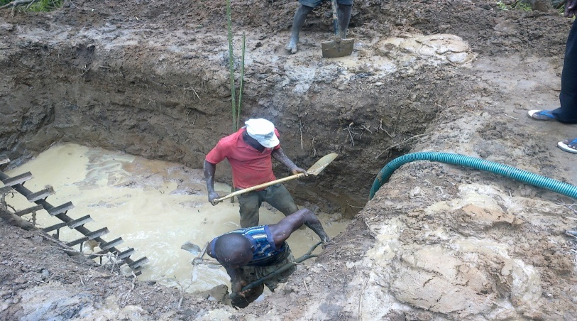
Figure A1: Foundation preparation at point B for the two leg tower involving dewatering using pump
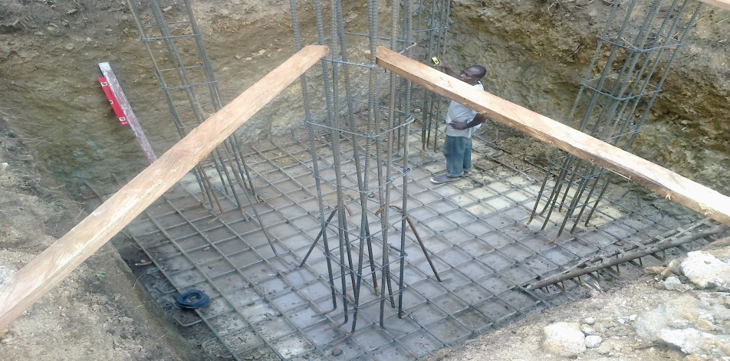
Figure A2: Combined foundation preparation at point C for the four leg concrete tower showing reinforcement arrangement

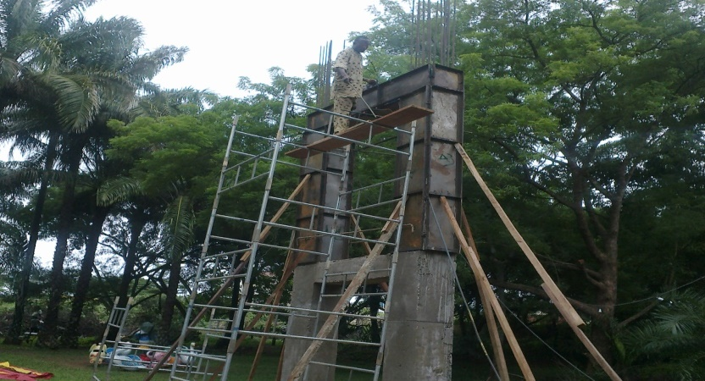
Figure A3: The two leg concrete tower at point B during casting

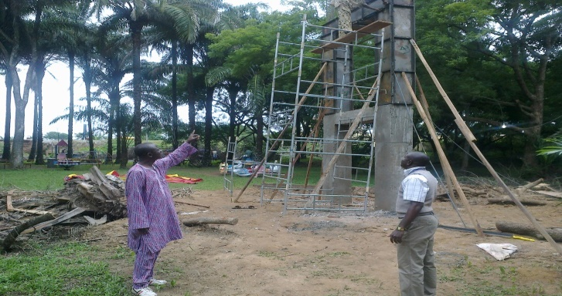

Figure A4: Dr.A.A. Jimoh and Engr. T.M. Saheed discussing on the two leg tower construction
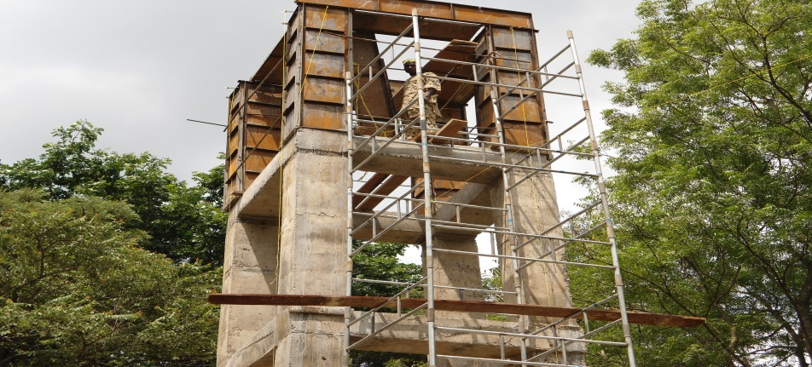
Figure A5: The four leg concrete tower after casting at point C
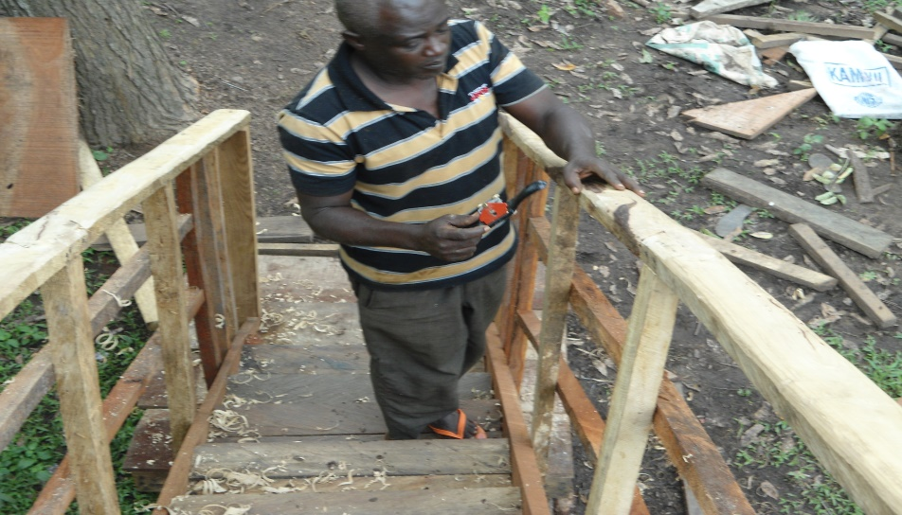
Figure A6: Staircase hand rail construction
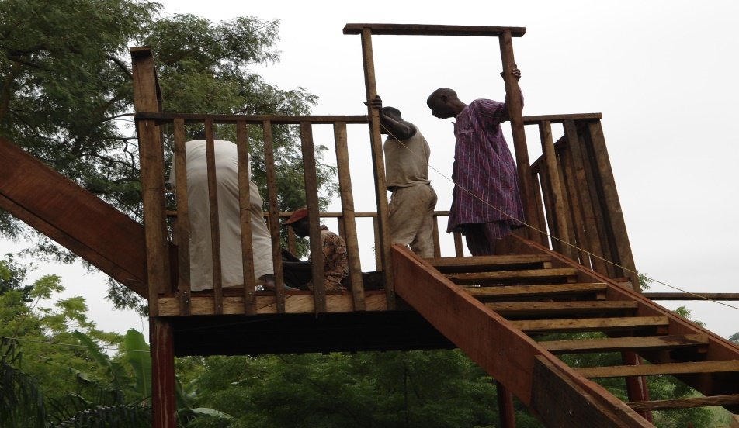
Figure A7: Staircase midway landing under construction
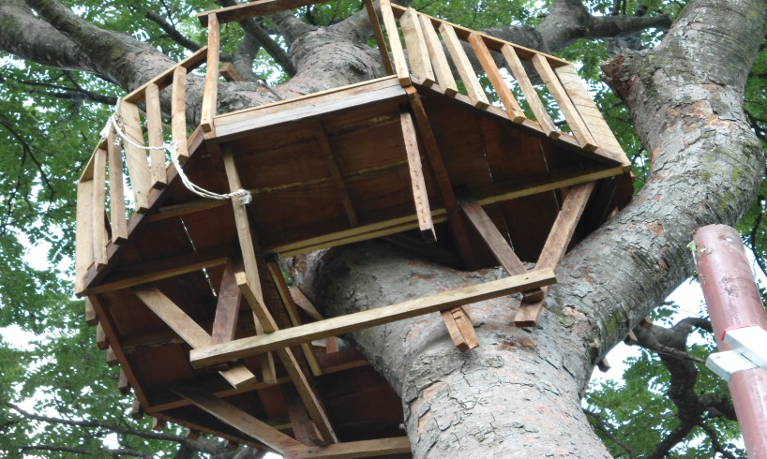
Figure A8: A platform constructed on Iya ( Daniella oliveri) tree at point D

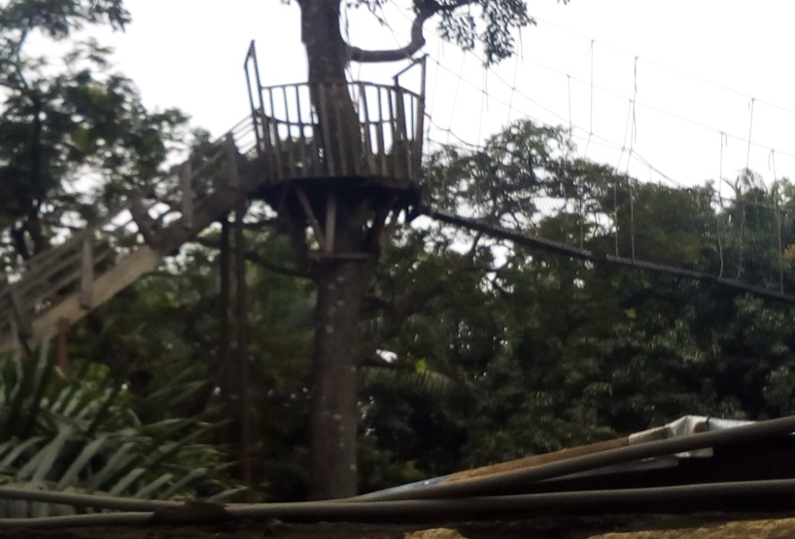
Figure A9: A platform constructed on Iroko (Milicia excelsa) tree at point A.

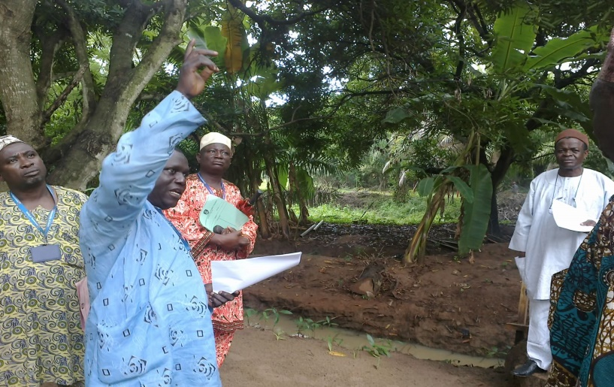
Figure A10: Engr. Abisoye discussing with Prof. A.B. Olayemi on the construction activities.
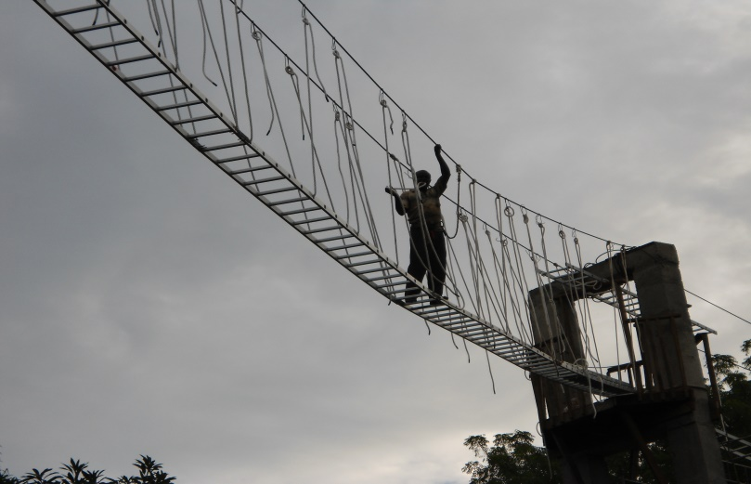
Mr. Kenneth ladder rope steel cable tower
Figure A11: View to show the connection of components: aluminium ladder, the polyester rope, the suspension cable and the 2-column tower

