Production and characterization of biodiesel using palm kernel oil; fresh and recovered from spent bleaching earth

Aladetuyi, A. Olatunji, G.A. Ogunniyi, D.S., Odetoye, T.E., Oguntoye, S.O.

Abstract
Palm kernel oil (PKO) was recovered from spent bleaching earth with a yield of 16 %, using n-hexane while the fresh oil was extracted from palm kernel with n-hexane and a yield of 40.23% was obtained. These oils were trans-esterified with methanol under the same reaction conditions: 100 oC, 2 h reaction time, and oil-methanol ratio of 5:1 (w/v). The cocoa pod ash (CPA) was compared with potassium hydroxide (KOH) as catalyst. The percentage yields of biodiesel obtained from PKO catalysed by CPA and KOH were 94 and 90%, respectively. While the yields achieved using the recovered oil catalysed by CPA and KOH were measured at 86 and 81.20 %. The physico-chemical properties of the biodiesel produced showed that the flash point, viscosity, density, ash content, percentage carbon content, specific gravity and the acid value fell within American Society for Testing and Materials (ASTM) specifications for biodiesel. The findings of this study suggest that agricultural residues such as CPA used in this study could be explored as alternatives for KOH catalyst for biodiesel production.

Keywords
Palm kernel oil; Spent bleaching earth; Agricultural residues; Cocoa pod ash ; Novel basic catalyst; Biodiesel

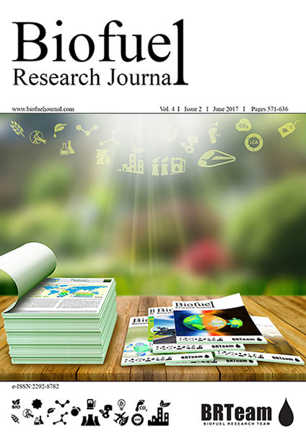

Volume 1, Issue 4
Autumn 2014

Pages 134-138

Files
- XML
- PDF 414.89 K

Share

How to cite

Statistics
- Article View: 4,573
- PDF Download: 7,382

Aladetuyi, A. Olatunji, G.A. Ogunniyi, D.S., Odetoye, T.E. & Oguntoye, S.O. (2014): Production and characterization of biodiesel using palm kernel oil, fresh and recovered from spent bleaching earth, Biofuel Research Journal, 1(4):134-138.

