POTENTIAL IMPACT OF ENVIRONMENTAL LAWS FOR SUSTAINABLE DEVELOPMENT IN NIGERIA: A CASE STUDY OF ILORIN METROPOLIS
- I. Bako^{1*}, W. M. Raheem¹ and O. T. Aduloju¹.
¹Department of Urban and Regional Planning, Faculty of Environmental Science, University of Ilorin. P.M.B. 1515, Ilorin, Nigeria.
*Corresponding Author’s E-mail: alibbako@yahoo.com

ABSTRACT
There are many problems, challenges and opportunities associated with the living environment today. The earth and its treasure base is experiencing a siege from all aspects of human endeavours. Environmental management requires not just planning but the basis upon which objective evaluation can be made and the degree of success or failure of management performance. There have been cases of air pollution emanating from Automobiles, water pollution, gas flaring, hazardous wastes. Etc. However, the scope of environmental laws is concerned with those areas of laws, national, regional or international which focus on planning and protecting the environment. This research takes a look at potential impact of environmental laws for sustainable environment in Nigeria using Ilorin as a case study, with the view to ensure proper assessment of environmental laws in Nigeria with particular reference to Kwara State. In order for this vision to materialize, existing environmental law(s) in Kwara State were identified and assessed, the need of the environmental law(s) and the agencies in charge of the enforcement of this law(s) were all assessed accordingly. The general objective of the study is to show how laws can be used to promote environmental sustainability. A case study of Ilorin-South Local Government Area was the research design employed, with total number of respondents sampled standing at Eighty – Five (85) which includes residents in and out of Ilorin South, government officials both at Kwara State Environmental Protection Agency (KWEPA) and Ministry of Environment and Forestry. To this effect, analyses of various data based on the objectives of this research were descriptively analysed with the use of Statistical Package for Social Science (SPSS). It can be recalled that the summary of the findings revealed that the rate of degradation of Ilorin South Area of study has exceeded the capability of the existing laws to respond, environmental laws on environmental sustainability has little impact and lack of public awareness about most of the existing laws. However, the KWEPA laws are outdated and have long been reviewed since 2006. Introduction of Public-Private Partnership along with Citizen Science Education were among the few recommendations made to sharpen the environmental law(s) of the land, in order to give hope to environmental sustainability and the research conclusively leaves a trail of further research.
Keywords: Impact, Environment, Sustainable Development, Environmental Law.

1. Introduction
Over the last two centuries, human activity has transformed the chemistry of Earth’s water, land and air, altered the face of Earth itself, and re-woven the web of life. This period, more than any other has brought widespread environmental change (Mcneil, 2007). The world of research agrees that if pollution and other environmental deterrents continue at their present rates, the result will be an irreversible damage to the ecological cycles and balances in nature upon which all life depends (Zimmerman, 2008; Toriola, 2016). Numerous activities of development in which man engages have impact on his environment. These activities in most cases are projects conceived with good intention from the onset by individuals, groups or governments to achieve a specific physical, economic or social objective (Basorun, 2006).
Given the global impact of industrialization, it is increasingly important to understand its nature and its consequences. Whereas the impact of industrialization is easy to understand on a personal level, as it affects where and how people work or live their lives—it is more difficult to understand its nature on a global level, particularly when its global pattern is so complex. However, industrialization effects and how it has made environmental laws ineffective over the decades differ from place to place, the global pattern of environmental problems (Stearns, 2008). Industrialization has brought about severe consequences on our environment and our eco system as a whole, inform of pollution of the environment. There have been cases of air pollution emanating from gas flaring, severe water pollution emanating from discharge of petroleum wastes into the rivers, earth pollution and land degradation emanating from oil spillage with terrible consequences on human lives animals, aquatic lives, farm land and crops, with all these being dividends of urbanization (Ganiyu, 2015).
Environmental law has been shaped by a variety of global and regional institutions, international organizations, and non- governmental bodies (Fry and Amesheva, 2016). One of the distinctive features of the environmental law framework is that it largely was the result of a reactive approach to dealing with specific environmental concerns (Moira and Gold, 1992). As opposed to recognizing these concerns as being valid and trying to come up with ways to prevent them from becoming more serious, such as by adopting the precautionary principle. Moira and Gold (1992) further argue that environmental challenges have historically assumed a secondary role in the international legal discourse.
The chief beneficiary of environmental law is mankind since the law is designed to "improve mankind's living conditions and hinged on the control of all kinds of pollution and generation and disposal of waste, an intrinsic consequence of life (Ikharaile, 2007). According to Toriola (2016), the scope of environmental law is concerned with those areas of law, national, regional or international which focusses on protecting the environment. However, environmental law has been explained to comprise the set of laws, conventions and legislations which are made for regulating and protecting the environment (Olugbenga, 1992). However, it is as a result of the need to combat various aforementioned problems of environmental pollution and the quest to protect the environment from further degradation, that the international community came up with laws and conventions to control pollution of environment.
Kwara State Government has been trying to own up to their slogan as “state of harmony” as regards the protection of their environment by confidently exuding sense of responsibilities and enforcement of duties on her own global community and environment through environmental laws which sees prevention and control of environmental pollution in many spheres. However, it can be said that the many enforcement agencies along with the efforts of Kwara State Waste Management Company (KWWMC), are presently responsible for erratic day to day collection and disposal of solid wastes and cleaning of streets in Ilorin the State capital, efforts of these agency are yet to be felt in the areas of water and air pollution i.e. preventing erosion, flood, Greenhouse gas emission and climate change (Ganiyu, 2015). This research focuses on the appraisal of environmental laws in Nigeria Urban centre using Ilorin, Kwara State as a case study and further discuss ways of improving the laws.

2. Literature Review

2.1 Understanding Pollution
Pollution is the introduction of contaminants into a natural environment that causes instability, disorder, harm or discomfort to the ecosystem i.e. physical systems or living organisms (Baker and Elaine, 2004). Pollution, contamination of Earth’s environment with materials that interfere with human health, the quality of life. Although some environmental pollution is a result of natural causes such as volcanic eruptions, most is caused by human activities (Engelking, 2008). Pollution can take the form of chemical substances or energy, such as noise, heat, or light. Pollutants, the elements of pollution, can be foreign substances or energies, or naturally occurring; when naturally occurring, they are considered contaminants when they exceed natural levels.
Section 38 of the Federal Environmental Protection Agency Act 34 defines ‘pollution’ as “manmade or man-aided alteration of chemical, physical or biological quality of the environment to the extent that is detrimental to that environment or beyond acceptable limits.” Pollution is often classed as point source or nonpoint source pollution (Ayawei, Kalama, and Abila, 2015). The Blacksmith Institute issues annually a list of the world's worst polluted places. In the 2007 issues the ten top nominees are located in Azerbaijan, China, India, Peru, Russia, Ukraine, and Zambia. To this effect, it can be clearly understood that environmental laws are structured on pollution as one of the drivers of environmental degradation.

2.2 Overview of the Environmental Laws
The basis of environmental policy in Nigeria is contained in the 1999 Constitution of the Federal Republic of Nigeria (Ogbodo, 2009). Pursuant to section 20 of the Constitution, the State is empowered to protect and improve the environment and safeguard the water, air and land, forest and wildlife of Nigeria. In addition to this, section 2 of the Environmental Impact Assessment Act of 1992 (EIA Act) provides that the public or private sector of the economy shall not undertake or embark on or authorise projects or activities without prior consideration of the effect on the environment (Makinde and Adeyoke, 2007). In furtherance to this research all existing and repealed environmental laws would be discussed.

2.2.1 Harmful Waste (Special Criminal Provision) Act, (Decree No. 42 of 1988).
Promulgation of harmful waste (Special Criminal Provision Act) Decree took place in 1988, sequel to dumping of 3888 tons of assorted toxic wastes at Koko port in old Bendel State.34 The dumping of the harmful wastes made the populace aware of the dangers posed by waste product in whatever form. The harmful waste Act prohibited the purchase, sale, importation, transmit, transportation, deposit and storage of harmful waste in Nigerians. It also made it an offence for anybody to collect and keep or dump harmful waste anywhere within the territorial water, the contiguous zone or the exclusive economic zone of Nigeria or the inland water ways. A section of the Act also provided that apart from criminal liability, anyone responsible for dealing in harmful wastes will also suffer civil liability (Ganiyu, 2015).
2.2.2 Federal Environmental Protection Agency Act (Decree No. 58 1988)
The Federal Environmental Protection Agency Act (FEPA Act) came into existence in1988, with a view to establishing the basic institutional machinery for environmental management in Nigeria. Although preceded by an earlier environmental protection statute prohibiting activities on harmful wastes, The FEPA Act was established for two purposes; the establishment of Federal environmental protection Agency and provision of legal foundation for the national policy on environment (Gbuonu, 2009). Decree 58 of 1988 was amended by FEPA (Amendment) Decree no. 59 of 1992. This legislation vests in FEPA overall responsibility for the protection and development of the environment bio-diversity conservation and sustainable development of Nigeria's natural resources in general and environmental technology, including initiation of policy related to environmental research and technology among other functions. Section 37 of the decree also charged FEPA with responsibility of making regulations generally for its purpose and in particular, prescribed standard for; (a) Noise control (b) control of hazardous substances and removal control methods (c) Atmospheric protection (d) influent limitations, (f) water quality and (g) Air quality (Olorunfemi, 2010).

2.2.3 National Environmental Standards and Regulation Enforcement Agency (establishment) Act 2007
This act which replaced the Federal Environmental Protection Agency (F.E.PA) Act, is the embodiment of laws and regulations that focused on protection and sustainable development of the environment and its natural resources. The creation of NESREA by section 1 of the NESREA Act, is the core of the Federal Government's determination to combat the problem of increased environmental degradation in Nigeria (Ehusani and Etudaiye, 2010). The NESREA Act is divided into six parts; Part I established National Environmental Standards regulation and Enforcement Agency, states the objectives of the Agency and establishes the governing Council of the Agency, its tenure and emolument. Part II provides for the power of the Agency, functions of the agency and functions of the council. Part III establishes the Directorates of the Agency (Ehusani and Etudaiye, 2010). Part IV provides for the appointment of the Director General and staff of the Agency. Part V deals with finances of the agency and provides for environmental standards in the country. Part VI relates to miscellaneous matters and the repeal of the FEPA Act Cap FIO LFN 2004. The Agency is the integral part of the presidency with operative organs like, the Governing Council and the Director General.
2.2.4 Environmental Impact Assessment Act No. 86, 1992
The creation of impact assessment act above brought about the establishment of a formal legislative- frame work for environmental impact assessment in Nigeria. This seeks to ensure that all activities by all persons at the commencement of the project's identification and planning in order to inculcate an environmental ethic in all citizens, persons and institutions in the country. It also aims at encouraging free dissemination of information relating to the Environmental impact activities to relevant interested parties and public generally (Ehusani and Etudaiye, 2010). The Act established a frame work that would make a rigorous environmental impact assessment. It specifies that, assessment minimum content of EIA and stipulates that assessment should be as detail as the severity of the impact requires. The act vests on the NESREA, the duty to consider Environmental Impact Assessment. Impartially, to state clearly reasons for its decisions and to ensure transparency in its decision making. Section 4 of the Act requires mandatory Evaluation Assessment Report whenever the extent, nature or location of a proposed project or activity is such that it is likely to significantly affect the environment (Ganiyu, 2015). By the provision of section 14, an EIA is mandatory.
- When any of the government in the federation is itself the proponent of a project and does any or thing to commit government to carry out the project wholly or in part.
- Where any of the governments in the federation by virtue of specific legal authority issues a permit or license or grants an approval or takes any other action for enabling the project to be carried out wholly or in part.
2.2.5 Kwara State Environmental Protection Agency Law.
The Kwara State environmental protection agency is the body created by Kwara State government and empowered by the laws of the state to see to prevention and control of environmental pollution in many spheres. The body is also saddled with responsibility of hazardous waste disposal and maintaining clean environment in the state. The KWEPA task force is also empowered to apprehend and prosecute offenders for violating the state sanitation laws (Adeniran, 2005). Although it can be said that the agency through the efforts of another company, Kwara State Waste Management Company (KWWMC), is presently responsible for day to day collection and disposal of solid wastes and cleaning of streets in Ilorin the State capital, efforts of the agency is yet to be felt in the areas of water and air pollution i.e. preventing erosion, flood, Greenhouse gas emission and climate change.
2.3 Concept of Sustainable Development
The world today is living beyond our means and the satisfaction of human needs and aspirations is the major objective of development (Zimmerman, 2008). As a people, we have developed a life-style that is draining the earth of its priceless and irreplaceable resources without regard for the future of our children and people all around the world (Mead, 1978; Aduloju, 2016). The concept of sustainability was coined in 1972 at the United Nations Conference on the Human Environment in Stockholm. Sustainability can have different meanings to different people in the context of corporate social responsibility. One of the best definitions was outlined at the 2005 World Summit on Social Development, which presented sustainability as an integration of social, economic, and environmental factors.
According to Brundtland Report (2015), Sustainable development is briefyly defined as the ability to make development sustainable, in order to ensure that it meets the needs of the present without compromising the ability of future generations to meet their own needs (WCED, 2008; Aduloju, 2016). According to united nations, sustainable development has been regarded as the environmental conscience of the earth and as one gathers from this assertion that sustainable development simply means getting the best out of the environment with the minimum environmental cost. The lesser it costs to derive quality utility from the environment, the more sustainable the means of getting such utility; this satisfies both human development and environmental protection (Onifade , 2014).
The term ‘environmental sustainability’ was a term coined to be the ability of the environment to carry life (Onifade, 2014). This was as a result of the need to protect the environment in view of deleterious changes that caught global attention in the decades following the Second World War. The human environment will always change, development will continue. There will be growth. This cannot and should not be avoided. The decisive question is in which direction we will develop, by what means we will grow, which qualities we want to achieve, and what values we wish to guide our future (Palmes, 1972).
3. Research Methodology
3.1 Geographical Location and General Characteristics
Ilorin is the state capital of Kwara in Western Nigeria (The World Gazetteer, 2013). As of 2006 census, it had a population of 777,667, and a projected population of 1.1 million in 2017 making it the 6th largest city in Nigeria by population (The Federal Republic of Nigeria, 2016) Ilorin is located on latitudes 8º 30`N and 8º 32`N and longitudes 4º 35` and 4º 37`E and the state capital of Kwara State and stands at an elevation of 293m (961ft) above sea level using elevation data from NASA's 90m resolution Shuttle Radar Topography Mission (SRTM) data Ilorin has a land area of 36,825 km2 (14,218 sq. mi) .The weather is tropical wet and dry climate of average maximum temperature, average minimum temperature and average relative humidity in a year standing at 32.5⁰C (90.5⁰F) of 21.2⁰C (70.2⁰F) and 51.1% respectively (National Ocean and Atmospheric Administration, 2016). Ilorin city has four different local government areas (Figure 1.1).
Agriculture is the main source of the economy and the principal cash crops are: cotton, cocoa, coffee, Kolanut, tobacco, beniseed and palm produce. Mineral resources in the state are Gold, limestone, marble, feldspar, clay, kaolin, quartz and granite rocks. Industries in the state include Dangote Flour Mill, Lubcon Lubricant Company, Kam Industries Nigeria Ltd, Tuyil Pharmacy Nig Ltd, Padson Industries NiG Ltd Kwara Breweries, Ijagbo Global Soap and Detergent Industry. The state has federal university, the University of Ilorin (http://www.unilorin.edu.ng), Kwara State University, Malete, Landmark University, Omu-Aran, and Al-Hikmah University, a private university.
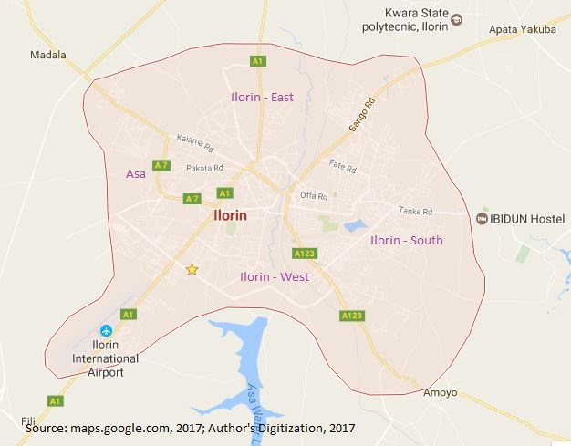
Figure 1.1: Map of Ilorin Showing Four Different Local Government Areas

3.2 Data Capture:
This chapter describes the methodological framework used in attaining the stated aim and objectives of the study. This chapter expounded how the research hypotheses postulated were empirically determined and examined relevant methodological approaches adopted in the study. A case study approach was selected for this research because it offered the ability to connect the micro-level experience of different opinions of respondents as regards their thoughts and feelings about effectiveness of environmental laws with a macro-level understanding of environmental sustainability, protection and pollution control throughout the study area. The case study of Ilorin is instrumental in nature, as it is used in order to provide insights into the broader issue of environmental planning and development in the study area.
The Research Population considered in this study area was 648,720 people, by the National Population Commission (NPC) in 2006 and later projected to 2016. The population, comprising of both gender, male and female, aged men and women, adults, youths, young ones and infants who were the main users and dwellers of the environment all over the world. It also comprises of field of Urban and Regional Planning in University of Ilorin, who are the custodian of the environment. This population formed the basis on which generalizations of the research findings was based on.
In taking the sampling frame, the study area was subdivided into four (4) districts (Figure 1.1). These districts formed the focal points for selection of appraisal of environmental laws for questionnaire administration. However, the Ilorin South district formed the “beck and call” of this study in which the questionnaire administration captured. Ilorin South District which covers areas like Tanke, Basin, Government Reserved Areas, Challenge, Fate, Maraba, Ahamadu Bello way, Flower Garden. Etc. The summed population of these areas is clearly adumbrated in the table below.
Table 1: Sampling Frame
S/N | District | Zones Under Observation | Population
1. | Ilorin-South | Tanke, Basin, Government Reserved Areas, Challenge, Fate, Maraba, Ahamadu Bello way, Flower Garden, Oke Ogun, Pipeline. Etc. | 208,691
Source: Source: Author’s computation, 2017
The Sampling Technique employed during the collection of data required Simple Random Sampling. This technique required a process whereby some respondents were selected in designated places such as respondents of different neighbourhoods across all areas in Ilorin South (Table 1). Department of Urban and Regional Planning in University of Ilorin, Kwara State Environmental Protection Agency Ministry, Kwara State Ministry of Environment and Forestry. Etc. was given equal chances for being selected in the study area.
Quota Sampling was also chosen alongside Simple Random Sampling, government officials in various agencies and ministries and Department of Urban and Regional Planning in University of Ilorin. All data collected through the use of questionnaire, interview and were analysed using S P S S (Statistical Programme for Social Sciences) software. In order to display tables, graphs, charts and diagrams as it applies, all analyses were carried out through the use of descriptive analyses, through the use of this SPSS.
4.0 Research Findings and Discussion
Awareness of Environmental Laws
Before any meaningful analyses can be done, there is need to know whether the general public of Ilorin South study area are aware of any environmental laws. Figure 2 clearly shows the binomial view of respondents on the scale of ‘yes’ or ‘no’ in which 68% of the respondents believes there exist an environmental law and 32% believes no environmental law whatsoever.
This clearly affirms that the residents of Ilorin South of study have knowledge about their environment and believes solely that environment does not take care of itself alone.

Figure 2: Awareness of Environmental Laws
Source: Field Survey, 2017

Impact of Change in Government on Environmental Laws
Figure 3 illustrates the impact of change in government on environmental laws in Kwara State, as 75% of the respondents in the study area ticked yes while the remaining 25% ticked no. this clearly shows that change in government is becoming Nigerian’s problem, as every government come with different dispensation and focus.

Figure 3: Impact of Change in Government on Environmental Laws
Source: Field Survey, 2017

Penalty of Environmental Laws
Table 2 expressly shows the opinions of respondents on the penalty given to those who contravene environmental laws based on the above analysis, 47% of the respondents who had one time or the other being a victim of environmental laws were only allowed to pay a fine, 27% left with a warning, 0% incarcerated and 27% were left without the options of fine, warning or imprisonment. This clearly shows the feebleness of the environmental laws in the study area.
Table 2: Penalty of Environmental Laws
Penalty of Environmental Laws | Percentage (%)
Pay a Fine | 46
Warning | 27
Imprisonment | 0
Left Alone Without Options a,b,c | 27
Total | 100
Source: Field Survey, 2017

Residents’ Concerns About Environmental Pollution
Figure 4 clearly shows the concerns of the respondents about environmental pollution in the study area with 53% of respondents extremely concerned about environmental pollution, while the reaming 27% and 20% are very concerned and moderately concerned respectively. This implies that the pollution from different damages done to the environment is becoming heartrending and instinctively giving the dwellers of Ilorin South area a study a great concern. Plate I clearly shows where land/soil, water and air pollution struck a balance in Maraba. However, with this site there is no how residents and non-residents won’t be extremely concerned about pollution

Figure 4: Residents’ Concerns About Environmental Pollution
Source: Field Survey, 2017
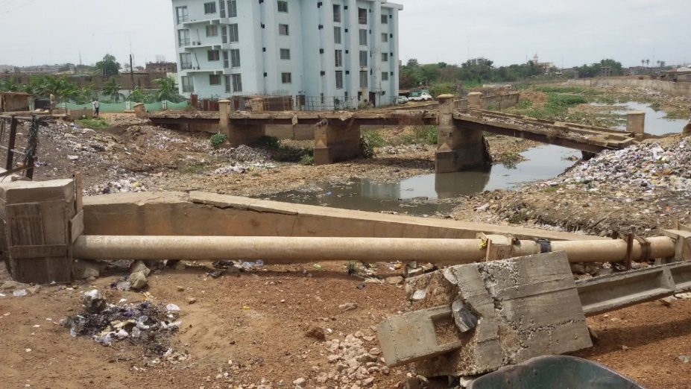
Plate I: A Degraded Unity River Traversing Maraba
Source: Field Survey, 2017

Global Warming
Respondents opinions were collected on their takes on global warming, Figure 5 shows that 15% each gave their own opinions to be good and extremely bad respectively, 5% voted it to be extremely good, while there was a close call between 32% and 33% respondents who were of the opinions that global is neither good nor bad and bad respectively. This clearly shows that many residents of Ilorin South which happens to be the citadel of government administrative functions and activities are oblivious of the impact of the term global warming to the environment they degrade day by day. Zimmerman (2008) believes if the concentration of gases like methane, carbon dioxide, nitrous oxide rises, they trap more heat within the atmosphere, causing worldwide temperatures to rise. He further predicted that unless dramatic action is taken, global temperature will continue to rise by 1.4 to 5.8 Celsius degrees (2.5 to 10.4 Fahrenheit degrees) over the next century compared to the previous century (Plate II).

Figure 5: Global Warming
Source: Field Survey, 2017
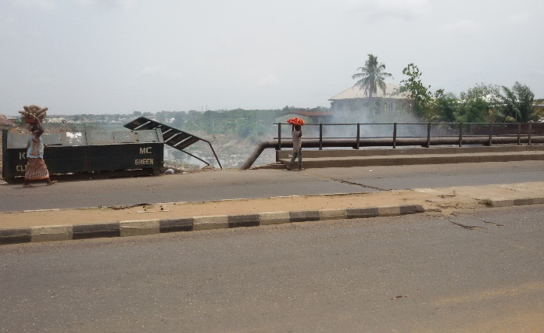
Plate II: Air Pollution; Emission of Gaseous Substances
Source: Field Survey, 2017

Most Prevalent Pollution
Engelking (2008) clearly defines pollution as the contamination of Earth’s environment with materials that interfere with human health, the quality of life, or the natural functioning of ecosystems. However, figure 6 shows the respondents views in the study area as regards the most prevalent form of pollution in Ilorin South area of study. 15% each opined that noise and water is the most prevalent form of pollution, while the majority unequivocally believed it to be land/soil, while 25% and 7% were of the opinions that air and other forms of pollution are the most prevalent forms of pollution. Plates III clearly justifies that land/soil and Air which carry majority of the respondent views of 38% about the most prevalent pollution in the study area as many the stench of smell in the study area further consolidate the assertion that the Agency in charge has failed her people in maintaining and sustaining the environment.

Figure 6: Most Prevalent Pollution
Source: Field Survey, 2017

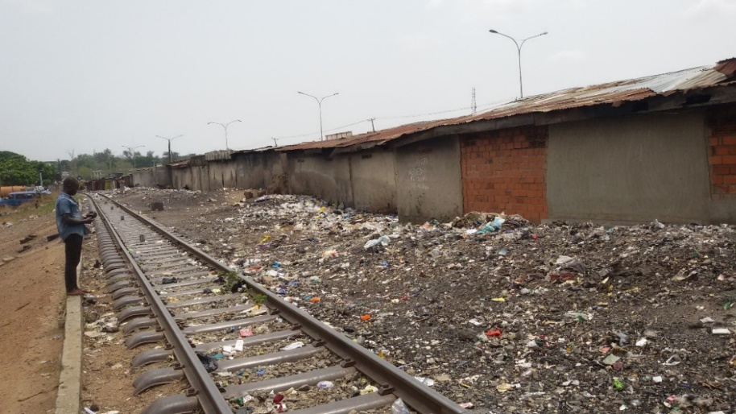
Plate III: A District Dunghill Along a Rail Way Track, Maraba
Source: Field Survey, 2017

Wastes Disposal Method
Figure 7 shows the type of waste collection system adopted in the study area, where 23% respondents dispose waste through government agency (KWEPA), 17% through neighbourhood dunghill. 52% of respondents with no regards for law or any environmental consequences burn their refuse and even Kwara State Environmental protection agency and Pake Local Government in Maraba have a dunghill and invariably burn every refuse within the establishment while the remaining 8% use other means like disposing in drainages during rainfall which according to Nwilo (2014) causes fluvial flooding. This indubitably explains the failure of the agency in charge of the environment and invariably has not done much for the people of the state to be asking from them, what they can do for their state. If the Agency too in charge of the environmental protection is degrading the environment they had faithfully sworn to protect, perhaps this leaves a trail for further research.

Figure 7: Wastes Disposal Method
Source: Field Survey, 2017

4.1 Implications of the Findings
The fact that the use of environmental laws in Kwara state has failed cannot be discounted. However, the present state of the environment of Ilorin area of study is lamentable. This section tends to pour more icing on the cake in summary and concisely expound in thoroughness the extent at which this laws, agencies and government have failed.
From the analyses, it can be deduced that the rate at which damages is being done to the environment has surpassed the capability of the only existing law however, which is KWEPA law to respond. Evidently, the filthy environment of Maraba spreading across the railway track in Maraba is an Iconic model depicting the undesirable and appalling way in which residents of Maraba live and carry out their day to day socio-economic activities. The deficiency of Town Planning laws was intertwined with that of Environmental laws and struck a balance in Maraba. The linear form of temporary shopping areas was found on the setback to the rail track and however, use the rear of these shopping complexes to cover bulk of wastes generated by all the commercial land uses and consequently, using the setbacks of Maraba rail track and unity river as their dunghill. Nevertheless, the unity river has instinctively lost her potentials with an unguided, uncontrolled and unplanned way of refuse dumping by individuals, government agents and unrecognized and unregistered merchant cart pullers all leading to all forms of pollution. The exhaust from all forms of vehicles is bewildering, which however, increases the daily hot temperature of Kwara State as a whole and consequently contributing to effects of climate change and making sustainability a mirage. with all these environmental concerns invariably asking a complex and pesky question on ‘how the KWEPA law was designed, on the basics it was designed and who the law was designed for’.
There is no need for a genius to further assess the existing KWEPA law that has been in place since the year 2006 and has not been reviewed. The Director of Ministry of Environment lamented vehemently that they do write for review and attributed failure in response to such request to bureaucracy, evidence that government has failed her people environmentally. The existing laws has failed the people of Ilorin not only in Maraba but all across the study area with the presence of fluvial flooding due to blockages of drainages in Tanke, land/soil pollution in GRA by turning a dunghill into a major land use in these areas and most annoyingly is most of the residents are oblivious of any environmental law.
Regrettably, the designated dunghill site at Eye Konrin for the whole state is not scientific and every form of solid waste collected and disposed there is left to take its fate. Research has it that the highest concentration of methane, which happens to be one of the greenhouse gases is gotten from landfill site uncontrolled and frowzy. Obviously, we live in a nonchalant world. The Assistant General Manager of KWEPA expressly blamed the unkempt and unplanned dunghill site at Eye Konrin to bureaucracy and misplaced priorities of the government as the sum quoted to turn this site into a sanitary landfill was 40 million as at that time and government responsively closed chapter on it.
In closing, the previous section descriptively showed the deficiency of the existing KWEPA law, the apostle of sustainability and Kwara State is living in a time of disaster, not sudden, but slow which gradually develop into an emergency that requires the immediate attention of all stakeholders. The failure of environmental laws in Kwara State has undoubtedly created and left a trail of further research as any law that cannot fulfil its purpose is worthless more than the piece of paper upon which its being written.
5. Recommendations
The need for environmental law has gone beyond debate, it is now a necessity. Environment however, is no longer asking what she can do for the people again, but what the people can realistically do for her to achieve sustainability. With the problems facing the implementation of environmental laws clearly identified, the strength of this research strongly lies on the recommendation provided by this technical research.

5.1 Proper Implementation of Environmental Laws and Act
In Kwara. Therefore, in order to have effective laws that will curb environmental degradation and pollution and as well guarantee effective protection of environment in Kwara State and Nigeria as a whole, it is suggested that the existing environmental KWEPA law governing Ilorin South area of study should be effectively reviewed for the very first time since enacted in 2006 and implemented while some of the laws and their penalties should be reviewed compulsorily as victims of environmental laws only pay token fee, while some are left alone without a fine, warning or incarceration. However, This KWEPA law must be reviewed in order to be in line with the demand of time.

5.2 Citizen Science Education: A Transformational Approach to Environmental Protection
Citizen science represents a huge opportunity to advance Environmental Protection’s mission to protect human health and the environment and also a bail out from ineffectiveness of environmental law. People affected by climate change or pollution in air, water and land need to be included in the solutions. The importance of community citizen science (many times driven by community groups and civil-sector intermediary organizations) and the power of this type of methodological process are in providing people with the tools to ask their own questions, collect their own data, and advocate for themselves about the issues they are oblivious of like how resilient the environment can be, the issues on global warming. etc. Citizen science is more than the participation of volunteers in research. It is a model for the democratization of research and policy making. In addition, it is an environmental movement that is changing the way the government and institutions interact with public. Citizen science and other crowdsourcing approaches that promote open collaboration, offer the opportunity to educate, engage and empower members of the public to apply their curiosity and contribute their talents to advancement in science and technology in achieving sustainability. Active volunteers, community researchers and environmental advocates can provide broad geographic observations and information that could not otherwise be obtained by agencies because of time, geographic and/or resource.

5.3 Joint Strategic Plan in Remediation of Hazardous Waste Sites and Reduction of Water Pollution
The state of degradation in some parts of the study area has clearly outstripped the capability of existing laws to respond, however, in order for KWEPA law to regain its potential, there is need to clear out the mess the ineffectiveness of the law caused. This research then recommends a joint strategic plan to conquer existing water pollution evident in unity river traversing Maraba. There is need for government to have a coping strategy to clear the cause of water pollution in this study area before KWEPA law can be administered. A collaboration with international bodies like World Bank will go a long way in solving some environmental issues threatening sustainable development goals, which is a stimulant for the international bodies to react. In China, the Bank helped clean up the Pearl River system in fast growing Guangdong province by expanding waste water treatment capacities of Foshan and Jiangmen to reduce pollution. In Morocco, the World Bank has supported the modernization of waste management. The above forms of strategies could be employed in Unity River traversing Maraba and a non-scientific dunghill site at Eye Konrin respectively.

5.4 Joint Environmental Management Plan
The state of environmental degradation due to the ineffectiveness of the agency in charge of this laws, as pointed out by the general public has raised a public health concern about whether this government agency can continue to be the drivers of environmental laws. To this effect this research is recommending a collaboration between state government and private companies in form of Public-Private Partnership (PPP) with a solid Memorandum of Understanding (MOU) as a way out of this problem. Private sector in the municipal solid waste sector in developing countries are partly driven by more stringent environmental standards and the recognition that the private sector can play a significant role in improving environmental and hygiene issues around solid waste collection and disposal. So therefore, Public-Private Partnership (PPP) in many other states like Ondo State could be effective as regards solid wastes collection, disposal and administration of the laws surrounding the failure of the public to comply. If this is instituted in Kwara State, land/soil pollution and indiscriminate dumping will be a thing of the past.

6. Conclusion
Global environmental collapse is not inevitable. But the developed world must work with the developing world to ensure that new industrialized economies do not add to the world’s environmental problems. In short, with the technology that currently exists, the years of global environmental mistreatment can begin to be reversed. Politicians must think of sustainable development rather than economic expansion. Conservation strategies have to become more widely accepted, and people must learn that the term environmental resilience will soon seize to exist and passionately believe that protecting the environment is the most sustainable thing the environment can ask for. However, environmental laws will gain ground if ignorance of it by the public is extirpated and government making sure these laws are properly implemented in heavy doses. Environmental issues are becoming a global disaster exceeding the capabilities of existing environmental laws to respond. These laws have been out fashioned by the increasing pollution in our environment and there is need to adopt some strategies that will disjointedly save our planet from ever degrading environment.
Due to the failure of environmental laws in Kwara State, therefore this paper throws a clarion call and challenge to the Kwara State government both at the State and Local levels, all NGOS and Stakeholders, professionals, and individuals to rise up and save our precious environment from further destruction.

References
Adeniran. (2005). Solid Waste Management in Kwara State. Environmental Protection Enforcement in Ilorin, 2.
Aduloju, O. T. (2016). Sustainable Development Goals; the Relevance and Roles of Town Planners in Achieving These Goals. Akure.
Ayawei, P., Kalama, S. T., & Abila, S. (2015, August 25). Second Colloquium on EnvironmentaL Law and Land Use. Environmental Law and Land Use in Nigeria.
Basorun, J. O. (2006). Basic Elements of Urban and Regional Planning. Akure: Shalom Publishers.
Blacksmith Insititute. (2016). 2016 World's Worst Pollution Problems; the Toxics Beneath the Feet. Green Cross.
Brundtland Report. (2015). Chapter 2. Towards Sustainable Development. United Nations World Commission on Environment and Development. Retrieved July 28, 2017, from https://en.wikisource.org/wiki/Brundtland_Report/Chapter_2._Towards_Sustainable_Development
Ehusani, J. A., and Etudaiye, E. M. (2010). A Critical Analysis of the Existing Legal Regime for Environmental Protection;. National Workshop on Climate Change University of Ilorin, (p. 28). Ilorin.
Engelking, P, (2008). "Pollution." Microsoft® Encarta® 2009 [DVD]. Redmond, WA: Microsoft Corporation.
Fry, J. D., , & Amesheva, I. (2016). Oil Pollution and the Dynamic Relationship between International Environmental Law and the Law of the sea. George Town Journal OF International Law, 1003 - 1004.
Ganiyu, M. M. (2015). An Appraisal of the Laws on Protection of Environment in Nigeria. Retrieved from http://works.bepress.com/murtala_ganiyu/1/
Gbuonu, U. (2009). Examination of the Enforcement of Environmental Laws in Nigeria, LLM thesis Unilorin.
Hogan, M. C., and Latshaw, G. L. (1973). The relationship between highway planning and urision specialty conference,. Chicago;Illinois: American Society of Civil Engineers. Retrieved from http://www.worldcat.org/wcpa/top3mset/2930880
Huang, Y.C. (2008). "Solid Waste Disposal." Microsoft® Encarta® 2009 [DVD]. Redmond, WA: Microsoft Corporation.
Ikharaile, M. (2007). A Constitutional Imperative on the Environment: A Programme of Action for Nigeria.
Makinde, O., and Adeyoke, T. (2007, November 20). The International Comparative Guide to PFI / PPP Projects. Nigeria: Environment Law in Nigeria. Retrieved March 16, 2017, from http://www.mondaq.com/Nigeria/x/53804/Energy+Law/Environment+Law+In+Nigeria
Mcneil, J. (2007). Environmental Effects of the Fossil Fuel Age. Washington.
Moira, and Gold. (1992). Rio Declaration on Environment and Development. United Nations Conference on Environment and Development. Rio: Princ. U.N. Doc. A/CONF.151/26/Rev.1(vol.I).
National Ocean and Atmospheric Administration. (2016, July 22). "Ilorin Climate Normals 1961–1990". Ilorin, Nigeria.
Nepf, H. (2008). "Seashore." Microsoft® Encarta® 2009 [DVD]. Redmond, WA: Microsoft Corporation, 2008.
Nwilo, P. C. (2014). Environmental and Management Issues in Nigeria Coastal and Inland Waters. Akure: FUTA BDC.
Office of Emergency and Remedial Response;USEPA. (n.d.). Risk Assessment Guidance for Superfund, Human Health Evaluation Manual. Washington D.C.
Ogbodo, G. S. (2009). Environmental Protection in Nigeria: Two Decades After the Koko Incident. Annual Survey of international and Comparative Law, 15(1). Retrieved from http://digitalcommons.law.ggu.edu/annlsurvey/vol15/iss1/2
Olugbenga, O. S. (1992). Appraissing the Sources of Environmental Law in Nigeria,in Nigerian Environmental Law. Kingdom Age publication.
Onifade , T. T. (2014). Legal and Institutional Framework for Promoting Environmental Sustainability in Nigeria through Renewable Energy: Possible Lessons from Brazil, China and India. University of Ibadan, Faculty of Law, Ibadan.
Palmes, O. (1972). UN Conference on Human Environment. [Recorded by S. Delegates]. Stockholm, Sweeden.
Senate Public Works Committee,. (n.d.). Noise Pollution and Abatement Act of 1972, S. Rep. No. 1160, 92nd Cong.
Stearns, P. N. (2008). Global Consequences of Industrial Revolution. Pennsylvania.
The World Gazetteer. (2013, February 09). Ilorin , Nigeria.
Toriola, E. G. (2016). Appraisal of Environmental law in Environmental Protection and Pollution Control. Lagos.
(WECD), W. C. (1987). Our Common Future.
Zimmerman, M. (2008). "Environment." Microsoft® Encarta® 2009 [DVD]. Redmond, WA: Microsoft Corporation.

