UNIVERSITY OF ILORIN



GENERAL STUDIES DIVISION

GNS 312
DIGITAL SKILL ACQUISITION TEXTBOOK
EDITED BY:
PROF. W. O. EGBEWOLE
DR R. G. JIMOH

CHAPTER ONE
COMPUTER FUNDAMENTALS
A. O. Ameen, A. O. Bajeh, A. O. Babatunde and F. E. Hamza-Usman
Department of Computer Science,
Faculty of Information and Communication Sciences,
University of Ilorin, Ilorin, Nigeria
Corresponding Author E-mail: aminamed@unilorin.edu.ng

  - Computer and Its Classification
    - What is Computer?
Generally, a computer can be defined as an electronic device that accepts data as input, processes the data and generates results as output. The data given to the computer as input are processed using a set of instructions called program. The instruction in the program directs the computer on how to arrive at the result and thus, generate the expected output called information. Figure 1.1 depicts the architecture of a typical computer.

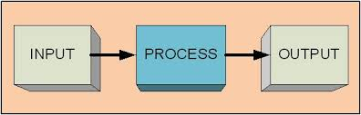
Figure 1.1: Basic Architecture of Computer

    - Computer Classification
Computers are classified using several criteria namely by: nature of data, size, generation and purpose. The following sections discuss these classifications.

      - Classification by Nature of Data
There are two types of data the computer can process. They are Digital and Analogue. Computer types can be classified into three. These are Analogue, Digital and Hybrid computers.
- Analogue Computer: This type of computer deals with quantities that are continuously varying. It measures changes in current, temperature or pressure and translates these data into electrical pulses for processing. Examples are speedometer, electric meter, water meter, thermometer etc. Figure 1.2 shows a typical analogue computer.
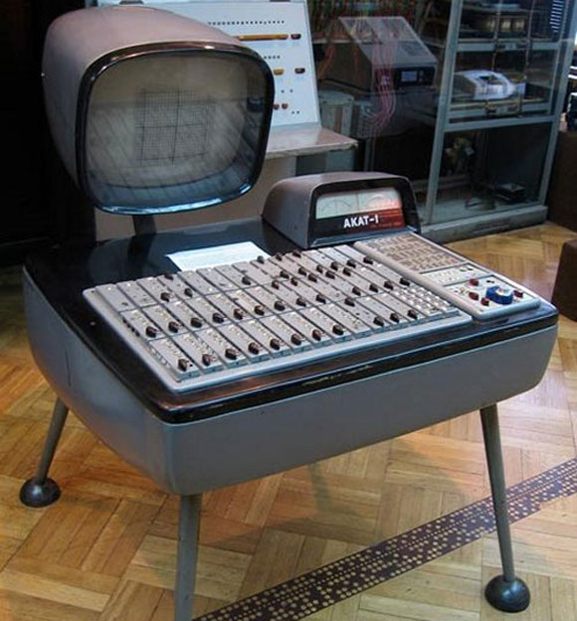
Figure 1.2: An Analogue Computer

- Digital Computer: This operates on data representation in form of discrete values or digits (e.g 0,1,2,3,X,Y,Z,…). They handle numbers discretely and precisely rather than approximately. These types of computers are very common in use both at home and offices. Figure 1.3 presents a digital computer used nowadays.

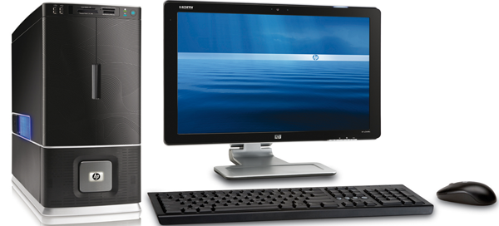
Figure 1.3: A Digital Computer
- Hybrid Computer: This type of computers combines the features of both analogue and digital computers. They handle data in both discrete quantity and variable quantities. They are mostly found in industrial processes for data acquisition and data processing purposes. In most cases, analogue signal generated from the analogue computer needs to be converted to digital signal which has to be processed by the digital computer, hence, the need for Analogue-to-Digital Converter and Digital-to-Analogue Converter modulator/demodulator (Modem).

      - Classification by Size
Computer classifications based on sizes are as follows:
- Super Computers: The super computers are extraordinarily powerful computers and they are the largest and fastest computer systems. They provide high level of accuracy, precision and speed for mathematical computations, meteorological, astronomical and oil exploration applications. In most of the Hollywood’s movies, it is used for animation purposes. It is also helpful for forecasting weather reports worldwide. Examples are Cray-1, Cyber series, Fujistu, ETA-10 system. Most of these machines are not available for commercial use. Figure 1.4 depicts a typical super computer. It occupies a whole hall or theater.
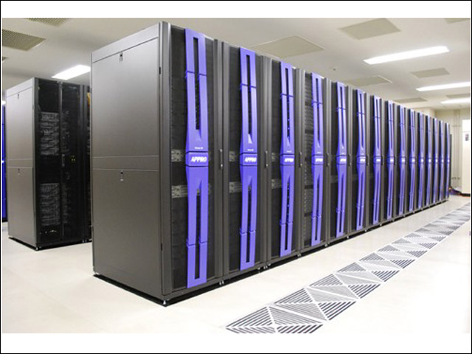
Figure 1.4: Super Computer

- Mainframe Computer: This is a system that has a very powerful Central Processing Unit (CPU) linked by cable to hundreds or thousands of terminals. This system is cable of accepting data simultaneously from all the terminals at the same time. This type of computers are very big and very expensive general-purpose computers with memory capacity more than 100 million bytes and processing power of well above 10 Million Instructions Per Second (MIPS). Mainframe computers are used in large organizations such as banks, oil companies, big hospitals, airline reservations companies, examination bodies such as WAEC, NECO, JAMB etc. that have very large volumes of data to process which also need to be adequately secured. Examples include ICL 1900 and IBM 360/370 series, IBM 704 etc. figure 1.5 shows a mainframe. It typically occupies a room or large space.
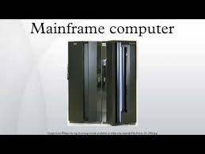
Figure 1.5: A Mainframe Computer
- Minicomputer: This type of computer share similar features with mainframe computers but it is smaller in physical size; generates lower heat, has less instruction set and is less expensive. It requires the same conditions for its operation like mainframe computers. Such conditions are very cool environment because of the enormous heat being generated, raised or false floor, dust free environment, high-secured office accommodation. Examples of minicomputers are IBM AS/400, NCR Tower 32, DEC System, PDP 7 etc. This is the type of computer beign used at the Computer Services and Information Technology (COMSIT) in the University of Ilorin. Figure 1.6 depicts a typical minicomputer.
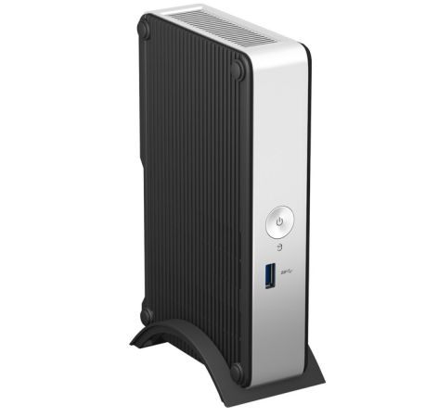
Figure 1.6: A Minicomputer
- Microcomputer: This type of computers is much smaller in size compared to mini and mainframe computers. They are ridiculously cheaper in terms of naira value compared to either mainframe or minicomputer. On these systems, various integrated circuits and elements of computer are replaced by a single integrated circuit called “chip”. Microcomputer was first developed by companies like Apple Computers and later by IBM PC in 1981. It is also called Personal Computer (PC). A microcomputer is shown in Figure 1.7.
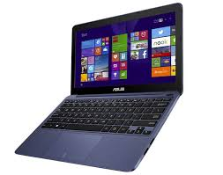
Figure 1.7: Microcomputers
Other types of computers based on size are palmtop and PDA (Personal Digital Assistant).

      - Classification by Generation
The industrial revolution during and after the 2nd World War was fully annexed by the stakeholders in information technology to fully actualize their dreams of having a very reliable computer, hence, the classification of computers into generations. There are five basic generations to which computer can be classified.
- First Generation Computer: These were the early computers that were manufactured in 1940’s and last till 1950’s. The first generation computers were characterized with the use of vacuum tubes as its major components. These vacuum tubes generate enormous heat and consume much electricity. The first generation computers introduce the concept of stored programs. Exclusively, computer experts can program the computer only in machine language, which makes it programmable. Examples are UNIVAC (UNIversal Automatic Computer), ENIAC (Electronic Numerical Integrator and Calculator) etc.
- Second Generation Computer: These were the set of computers that succeeded the first generation computers. Their advent was in early 1950’s and lasted until late 1950’s. The components of the second generation of computer were built around transistors which replaces the vacuum tube in the first generation. The resultant effect of the transistors in place of vacuum tube is reduction in size compared with first generation computers, less power consumption, generation of less heat and improved storage facility due to introduction of magnetic devices for storage medium. The overall effects are the improved reliability and introduction of symbolic languages for programming. Examples are ATLAS, IBM 1400 series (International business Machine), PDP I & II (Programmed Data Processor I & II) etc.
- Third Generation Computer: This generation of computer succeeded the second generation computers. The advent of this generation was between early 1960’s to late 1960’s. Due to the technological advancement that had taken place in the industrial sector which makes many transistors to be coupled into a single unit component. Hence, the major component that characterized the third generation computer is the Integrated Circuitry (IC), which is a resultant effect of thousands of transistors combined into a single unit component. The integration of transistors into one component makes the computer smaller in size compare with first and second generation computers, faster machine, consume less power and generate less heat. The concept of multi-programming was introduced in this generation of computers. Programming was made easier by the use of high level languages. Examples include: IBM 360/370 series, ICL 1900 series (International Computers Limited) etc.
- Fourth Generation Computer: The emphasis in the first three generations of computers has been on the development of a computer system that is less expensive, more portable and highly reliable. The fourth generation computers were also developed having in mind the above assertions. These generations of computers were built around Very Large-Scale Integrated Circuitry (VLSI) in which over ten thousand flip-flops were placed in a single silicon chip i.e. thousands of ICs were combined into a single chip. This period witnessed the era of microcomputer with the introduction of microprocessors as its major component. The system came into being in the early 1970’s and still in existence till date. Examples include: IBM, COMPAQ 2000 series, Dell series, Toshiba etc.
- Fifth Generation Computer: The development of the fifth generation computers started in the 1980’s and classical researches are still going on in this generation of computers. Although, some of these machines are already in use, but a lot of work still need to be done to actualize the reasons for this generation of computer. The objective of this computer system is to build a computer system that mimic the intelligence of human expert in a knowledge domain such as medicine, law, education, criminal investigation, etc. This objective is achieved through the implementation of Artificial Intelligence and Expert Systems development.

      - Classification by Purpose
There are two classifications to which computers are grouped, according to their usage or function. These are special purpose and general purpose computers.
- Special Purpose Computer: This type of computer is specially developed to perform only one task. The system is highly efficient and economical but lacks flexibility. The program for the machine is built into the machine permanently. Some areas of usage include air traffic control system; military weapons control system, ship navigation system and industrial process controls.
- General Purpose Computer: These computers have the ability to handle a wide variety of programs and to solve many problems such as payroll, numerical analysis, software development for accounting, inventory system etc. It makes use of stored program for switching from one application to another.

    - Elements of a Computer
A computer system can be divided into three main components: hardware, software and humanware.

        - The Hardware
The hardware refers to the physical components and the devices which make up the visible computer. It can be divided into two: Central Processing Unit (CPU) and the Peripherals. The CPU is responsible for all processing that the computer does while the peripherals are responsible for feeding data into the system and for collecting information from the system.
The CPU consists of Main storage, Arithmetic and Logic Unit (ALU) and Control Unit. The main storage is used for storing data to be processed as well as the instructions for processing them. The ALU is the unit for arithmetic and logical operations. The control unit ensures the smooth operation of the other hardware units. It fetches instruction, decode (interprets) the instruction and issues commands to the units responsible for executing the instructions.
The peripherals are in three categories: Input devices, Output devices and auxiliary storage devices.
The input device is used for supplying data and instructions to the computer. Examples are terminal Keyboard, Mouse, Joystick, Microphone, Scanner, Webcam, and so on.
Output device is used for obtaining result (information) from the computer. Examples are Printers, Video Display Unit (VDU), loudspeaker, projector, and so on.
Auxiliary Storage Devices are used for storing information on a long-term basis. Examples are hard disk, flash disk, magnetic tape, memory card, and so on.
A simple model of the hardware part of a computer system is shown in Figure 1.8. This model was proposed by John Von Neumann.

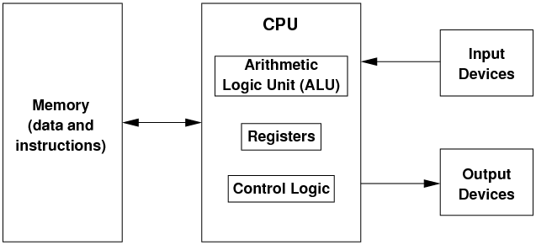

Figure 1.8: Computer Structural Diagram

        - The Software
Software is basically a computer program. A program consists of sequence of instructions required to accomplish a well-defined task such as computing the average score of students in a course and preparation of the employee payroll. It is the software that drives the hardware to accomplish a given task. There are two main categories of software; they are System software and Application software.

        - System Software
System software are programs commonly written by computer manufacturers, which have direct effect on the control, performance and ease of usage of the computer system. Examples are Operating System, Language Translators, Utilities and Service Programs, Device drivers, etc.

        - Application Software
These are programs written by a user to solve specific task(s) not directly tied to the system hardware. They do not have any effect on the efficiency of the computer system. An example is a program to calculate the grade point average of all the 100L students. Application software can be User application program or Application package. User’s Application Program is a program written by the user to solve specific problem which is not generalized in nature. Examples include writing a program to find the roots of quadratic equation, payroll application program, and program to compute students’ results. Application programs can also be written such that they can be adopted by a number of different organizations or persons to solve similar problem. This type of applications is referred to as Application Package. They include word processors (such as MS-Word, WordPerfect, WordStar); Database packages (such as Oracle, MS Access, Sybase, SQL Server, and Informix); Spreadsheet packages (such as Lotus 1-2-3 and MS-Excel); Graphic packages (such as CorelDraw, Fireworks, Photoshop etc.), and Statistical packages (such as SPSS).

1.1.3.3 The Humanware
Although, the computer system is automatic in the sense that once initiated, it can, without human intervention, continue to work on its own under the control of programs. However, it is not automatic in the sense that it has to be initiated by a human user, and the instructions specifying the operations to be performed on the input data are given by human users. Therefore, apart from the hardware and software, the third element that can be identified in a computer system is the humanware. The components of the humanware in a computer system include the system analyst, the programmer, data entry operator, end users etc.

    - Characteristics of a Computer
A typical electronic computer has the following characteristics:
- Electronic in nature: Data are represented in form of electrical pulses. The basic component and the operation of computers are electronic, using integrated circuits (ICs).
- Speed: Computers can perform millions of calculations in a few seconds as compared to man who will spend months for doing the same task.
- High degree of accuracy: computers perform tasks with 100% accuracy provided that correct input has been given. It is garbage in garbage out (GIGO); i.e., given accurate input, it generates accurate output, and given a wrong input it gives a wrong output.
- Consistency – that is given the same set of input data, the same result will always be produced.
- Iterative: ability to perform repetitive operations without getting bored or fatigued.
- Storage: could store data/information on a long term basis. Variety of data/information such as text, images, audio and video.
- Automatic control: once initiated, it could operate on its own, without human intervention, under the control of stored sequences of instructions called program.

  - Computer Memory
A computer memory is the store in which data/information and computer instructions can be temporarily or permanently kept for processing or future use. The computer memory is made up of elements that can be in a state of on or off, magnetized or non-magnetized states. Each element is referred to as a bit. Bit stands for BInarydigiT. Bits are organized into 8-bit addressable units called bytes. A character is encoded and represented as a byte in the computer.
The storage capacity of computer memories is most often measured in unit of byte. The following shows the various memory sizes and their equivalent in number of byte:
- 1 Kilobyte (KB) = 1,024 bytes
- 1 Megabyte (MB) = 1,048,576 bytes = 1024 KB
- 1 Gigabyte (GB) = 1,073,741,824 bytes = 1024 MB
- 1 Terabyte(TB) = 1,099,511,627,776 bytes = 1024 GB
- 1 Petabyte(PB) = 1,125,899,906,842,624 bytes = 1024 TB
The following sections discuss the various types of computer memories:
    - Primary or Main Memory
The primary memory is the memory that resides inside the computer’s central processing unit (CPU) and it holds the data and instructions undergoing processing by the CPU. This memory is often referred to as RAM (Random Access Memory). It is volatile i.e., data stored in it is lost when the power is switched off or during power failure. RAM is also a read and write memory which implies that data can be read and also written into the memory. Figure 1.9 depicts a typical main memory or RAM
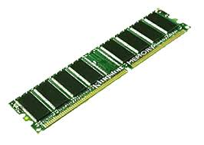
Figure 1.9: Main Memory

    - Secondary or Auxiliary Memory
The secondary memory is an external memory used to store data/information permanently for future use. This type of memory is non-volatile i.e., data/information is not lost when power is off unlike the RAM that loses its content when power is off. This memory is also slower than the main memory. Examples of Secondary memories are:
- Hard Disk (Local Disk and External Disk)
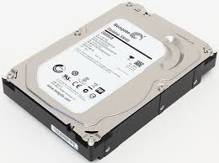
Local HD
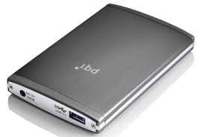
External HD
Figure 1.10: Hard Disk

- Optical Disks (CD-R, CD-RW, DVD-R, DVD-RW)
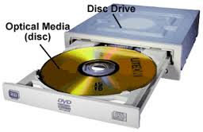
Figure 1.11: Optical Disk

- Pen Drive (Flash drive)
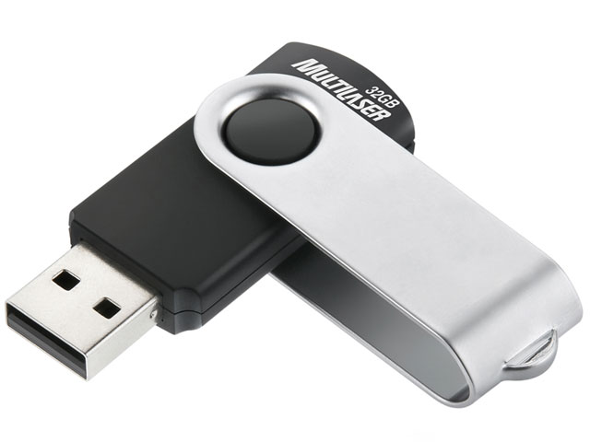
Figure 1.12: Pen Drive

- Zip Drive
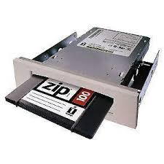
Figure 1.13: Zip Drive

- Floppy Disk
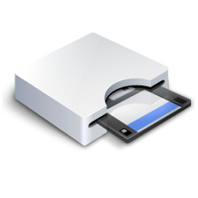
Figure 1.14: Floppy Disk

- Memory Cards
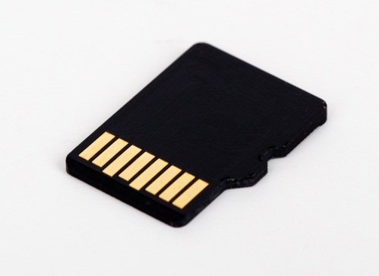
Figure 1.15: Memory Card

    - Cache Memory
Cache (pronounced as Kash) is the memory that serves as a buffer between the primary memory between the CPU and main memory. Data/information and instruction frequently used in the CPU are kept in the cache for faster access.

  - Input and Output Devices
Data and instructions are fed into the computer through input devices. The input device translates data and instruction into the form the computer can process, and information are received from the computer through the output devices. The output device translates information into the form users can understand. The following are examples of input and output devices:

    - Input Devices
- Keyboard
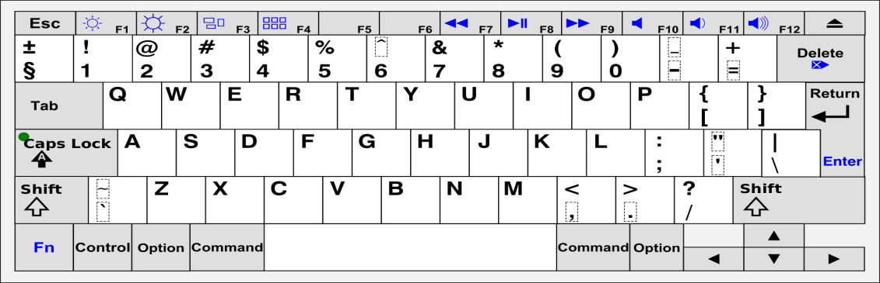
Figure 1.16: QWERTY Keyboard
- Mouse
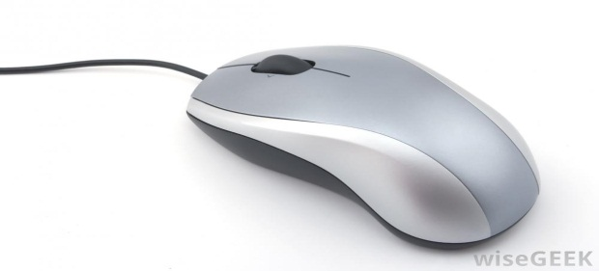
Figure 1.17: Mouse
- Scanner

Figure 1.18: Scanner
- Digital Camera
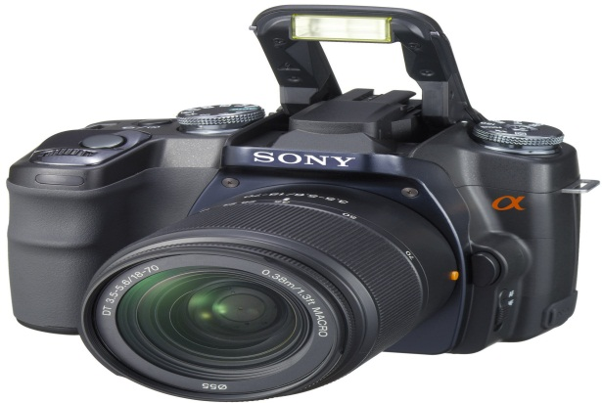
Figure 1.19: Digital Camera
- Web Camera

Figure 1.20: WebCam

- Joy Stick
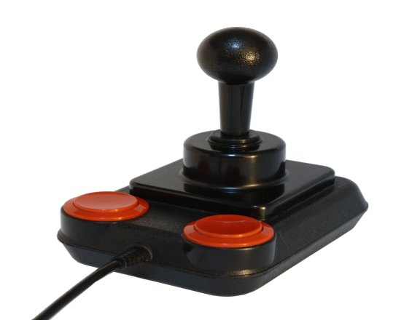
Figure 1.21: Joy Stick
- Track Ball
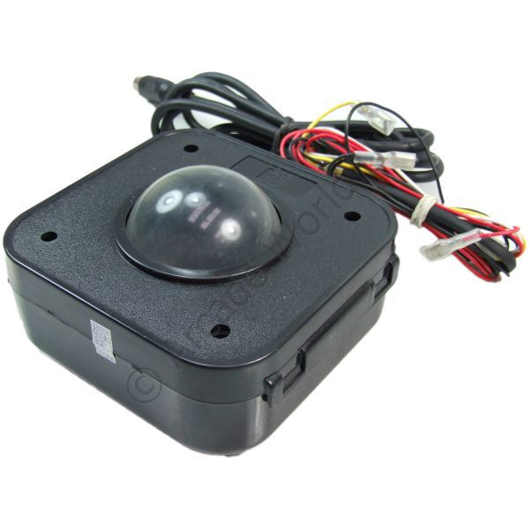
Figure 1.22: Track Ball

- Touch Pad/Screen
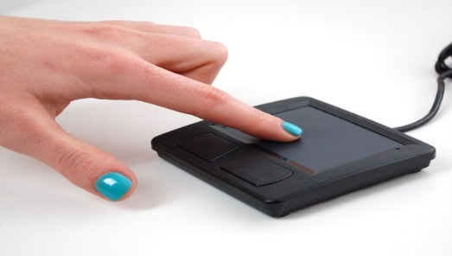
Figure 1.23: Touch Pad/Screen
- Light Pen
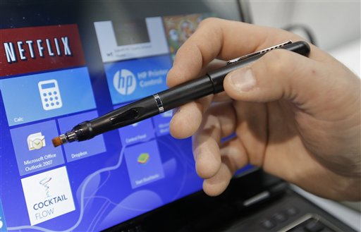
Figure 1.24: Light Pen

- Bar Code Reader

Figure 1.25: Bar Code Reader

- Microphone
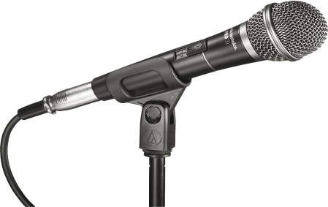
Figure 1.26: Microphone

- Graphics Tablets
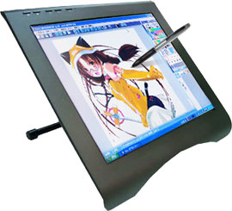
Figure 1.27: Graphics Tablet

- Magnetic Ink Character Reader (used in Banks)
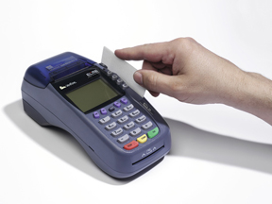
Figure 1.28: MICR
- Optical Card Reader
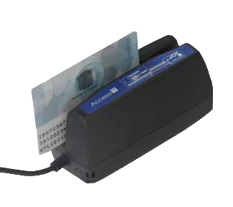
Figure 1.29: OCR

- Magnetic Card Reader (used in shops, colleges, stations ect.)
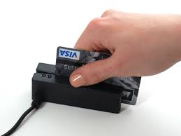
Figure 1.39: MCR

- Biometric Device
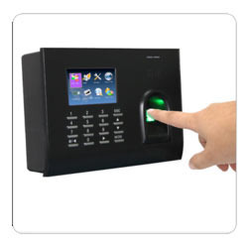
Figure 1.40: Biometric Device

- Bluetooth
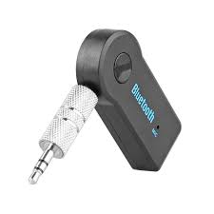
Figure 1.41: Bluetooth

    - Output Devices
- Visual Display Unit (VDU) also known as Monitor for softcopy output
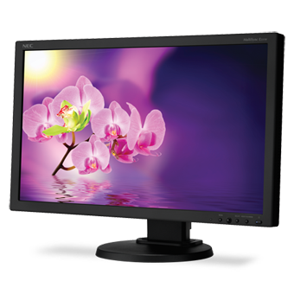
Figure 1.42: Monitor

- Printer (Dot Matrix, InkJet and Laser) for hardcopy output
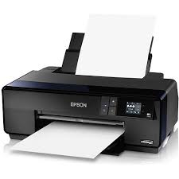
Figure 1.43: Printer

- Projector

Figure 1.44: Projector
- Plotter
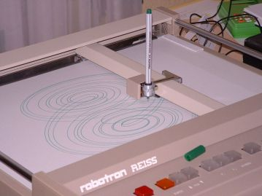
Figure 1.45: Plotter

- Speaker
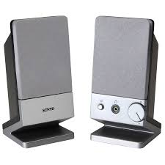
Figure 1.46: Speaker

  - Computer Networks and Information Sharing
A computer network is a system of computers interconnected to share data and resources with each other. Figure 1.47 depicts a simple computer network.
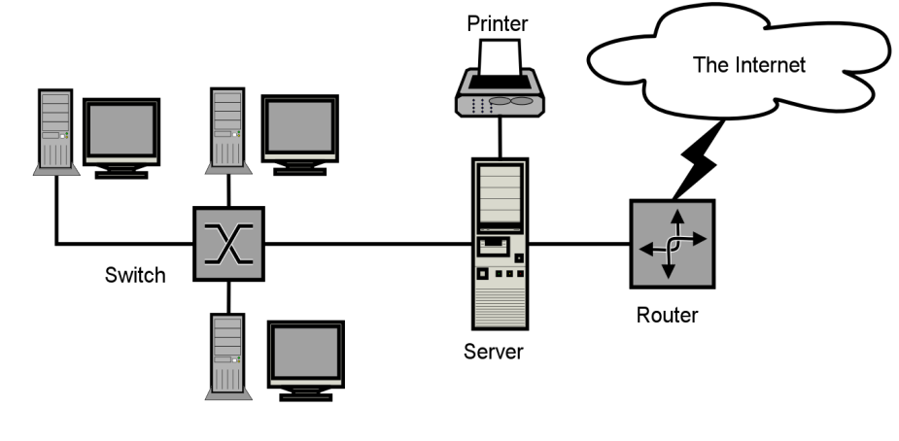
Figure 1.47: A Computer Network

1.4.1 Types of Computer Networks
A network can be small or large, depending on the number of computers and the user requirements. Generally, the following are the types of computer networks available:
- Local Area Network (LAN): is a computer network that interconnects computers within a limited area and has its network equipment locally managed. The limited area covered by a LAN could be a residence, school, laboratory, university campus or office building.

- Metropolitan Area Network (MAN): is a computer network that connects computers in a geographic area larger than that covered by LAN but smaller than the area covered by a Wide Area Network (WAN).

- Wide Area Network (WAN): is a computer network that extends over a large geographical distance. The area covered is wider than that of MAN.

1.4.2. Benefits of Computer Networks
There are many benefits of being on a network, the main one is being able to share information or equipment.
- Share files stored in one location (network) by multiple users.
- Share devices such as printers or access the internet.
- Company information organized in one central area for storage, maintenance and backup
1.4.3. Hardware Components of a Computer Network
The following is the list of hardware's required to setup a computer network.
- Network Cables

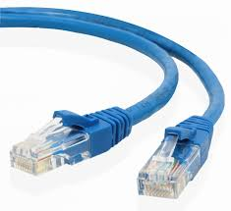
Figure 1.48: Network Cable

- Distributors
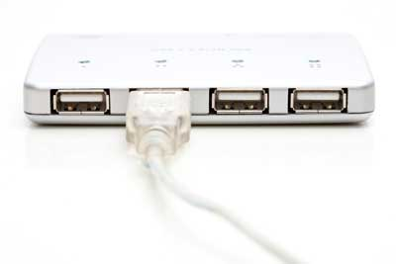
Figure 1.49: Network Distributor

- Routers
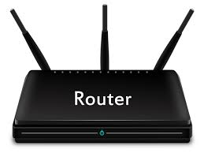
Figure 1.50: Router
- Internal Network Cards
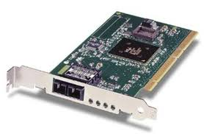
Figure 1.51: Internal Network Card
- External Network Cards
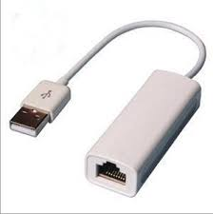
Figure 1.52: External Network Card

  - Troubleshooting Techniques
Computer troubleshooting is the act of identifying and correcting faults in a computer system. It involves a logical and systematic search for the source of faults or problems in order to fix it and make the computer work properly as expected. A set of steps is followed by a computer technician in identifying the source of a fault and fixing the fault.
The steps taken for troubleshooting is determined by the type of problem or fault in the computer. The following are some common problems and the troubleshooting steps for fixing them

1.5.1 Problem: Power button will not start computer
Solution 1: If your computer does not start, begin by checking the power cord to confirm that it is plugged securely into the back of the computer case and the power outlet.
Solution 2: If it is plugged into an outlet, make sure it is a working outlet. To check your outlet, you can plug in another electrical device, such as a lamp.
Solution 3: If the computer is plugged in to a surge protector, verify that it is turned on. You may have to reset the surge protector by turning it off and then back on. You can also plug a lamp or other device into the surge protector to verify that it's working correctly.

1.5.2. Problem: The computer is frozen
Sometimes the computer may become completely unresponsive, or frozen. When this happens, clicking anywhere on the screen, opening or closing applications, or accessing shut-down options becomes almost impossible.
Solution 1 (Windows only): Restart Windows Explorer. To do this, press and hold Ctrl+Alt+Delete on your keyboard to open the Task Manager. Next, locate and select Windows Explorer from the Processes tab and click Restart. You may need to click More Details at the bottom of the window to see the Processes tab.
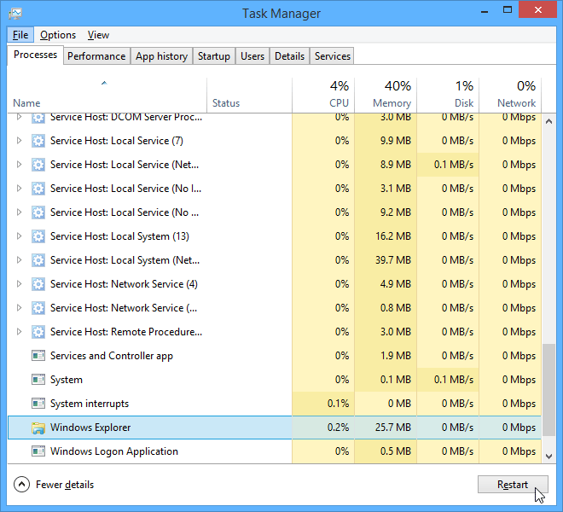
Figure 1.53: Task Manager Interface
Solution 2 (Mac only): Restart Finder. To do this, press and hold Command+Option+Escon your keyboard to open the Force Quit Applications dialog box. Next, locate and select Finder, then click Relaunch.
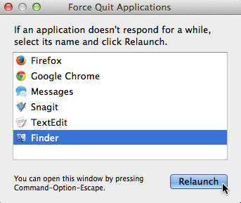
Figure 1.54: Force Quit Interface
Solution 3: Press and hold the Power button. The Power button is usually located on the front or side of the computer, typically indicated by the power symbol. Press and hold the Power button for 5 to 10 seconds to force the computer to shut down.
Solution 4: If the computer still won't shut down, you can unplug the power cable from the electrical outlet. If you're using a laptop, you may be able to remove the battery to force the computer to turn off. Note: This solution should be your last resort after trying the other suggestions above.
Bibliography
French, C.S. (2007). Computer Science, 5th Edition, Cengage Learning, ISBN: 0826458068, 9780826458063

CHAPTER TWO
OPERATING SYSTEM

¹B. A. Oluwade, ¹M. A. Mabayoje, ²A. R. Tomori, ²M. AbdulRaheem, ¹A. G. Akintola & ¹S. A. Salihu
¹Department of Computer Science
Faculty of Communication and Information Sciences,
University of Ilorin, Ilorin.
²Computer Service and Information Technology (COMSIT Unit)
University of Ilorin, Ilorin.

2.1 Operating System Software
An Operating System (OS) is a system software that manages computer hardware and software resources and provides common services for computer programs. OS is the program that is first loaded when power button is on. After successful upload of OS into the computer by a boot program, OS allocates memory, prioritizes the processing of instructions, controls input and output devices, facilitates networking, manages files and schedules the execution of other programs in a computer. There are various OS available which includes: DOS, windows, Linux, Unix, Ubuntu, Mac OS X,
2.1.1 DOS acronym for Microsoft Disk Operating System was developed by Microsoft for IBM-compatible personal computers. The term DOS refers to any operating system, but it is most often used as a shorthand for MS-DOS (Microsoft Disk Operating System).
To use DOS you follow the following steps:
Step 1: Click on window start button
Step 2: Type command
Step 3: Press the enter key
Figure 2.1 shows the DOS interface
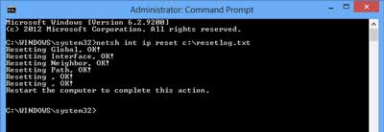
Figure 2.1: DOS Command prompt

Table 2.1 lists some DOS commands
Command | Description
Cd | The cd command is the shorthand version of the chdir command.
Chdir | The chdir command is used to display the drive letter and folder that you are currently in. Chdir can also be used to change the drive and/or directory that you want to work in.
Chkdsk | The chkdsk command, often referred to as check disk, is used to identify and correct certain hard drive errors.
Cls | The cls command clears the screen of all previously entered commands and other text.
Command | The command starts a new instance of the command interpreter.
Copy | The copy command does simply that - it copies one or more files from one location to another.
Date | The date command is used to show or change the current date.
Del | The del command is used to delete one or more files. The del command is the same as the erase command.
Deltree | The deltree command is used to delete a directory and all the files and subdirectories within it.
Diskcomp | The diskcomp command is used to compare the contents of two floppy disks.
Diskcopy | The diskcopy command is used to copy the entire contents of one floppy disk to another.
Doskey | The doskey command is used to edit command lines, create macros, and recall previously entered commands.
Erase | The erase command is used to delete one or more files. The erase command is the same as the del command.
Fdisk | The fdisk command is used to create, manage, and delete hard drive partitions.
Format | The format command is used to format a drive in the file system that you specify.
Md | The md command is the shorthand version of the mkdir command.
Mkdir | The mkdir command is used to create a new folder.
Rd | The rd command is the shorthand version of the rmdir command.
Rem | The rem command is used to record comments or remarks in a batch or script file.
Ren | The ren command is the shorthand version of the rename command.
Rename | The rename command is used to change the name of the individual file that you specify.
Replace | The replace command is used to replace one or more files with one or more other files.
Restore | The restore command is used to restore files that were backed up using the backup command. The backup command was only available up to MS-DOS 5.00 but the restore command was included by default with later versions of MS-DOS to provide a way to restore files that were backed up in previous versions of MS-DOS.
Rmdir | The rmdir command is used to delete an existing or completely empty folder.
Scandisk | The scandisk command is used to start Microsoft ScanDisk, a disk repair program.
Undelete | The undelete command is used to undo a deletion performed with the MS-DOS delete command.
Xcopy | The xcopy command can copy one or more files or directory trees from one location to another. The xcopy command is generally considered a more "powerful" version of the copy command though the robocopy command trumps even xcopy.

2.1.2 Windows
Microsoft Windows (or simply Windows) is a family of graphical based operating systems developed by Microsoft in 1995. It consists of several versions, each of which make available to a certain sector of the computing industry.
Various versions of windows OS is as listed in Table 2.2:

Table 2.2: windows OS and the Year
Windows OS | Year
Windows 1.0 | 1985
Windows 2.0-2.11 | 1987
Windows 3.0 | 1990
Windows NT | 1993
Windows 95 | 1995
Windows 98 | 1998
Windows ME | 2000
Windows XP | 2001
Windows Vista | 2006
Windows 7 | 2009
Windows 8 | 2012
Windows 10 | 2015

Windows OS interface
Windows 7
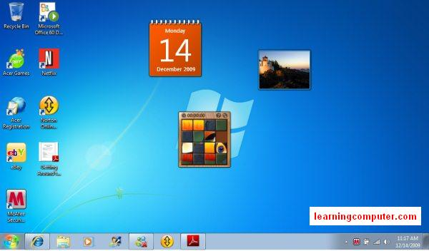
Figure 2.2: Windows 7 Interface
Windows 8
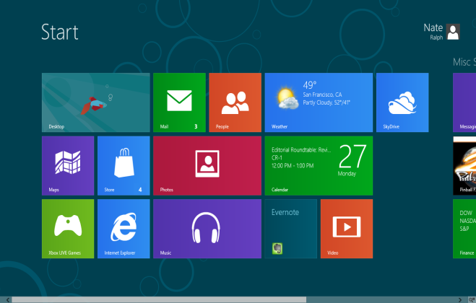
Figure 2.3: Windows 8 Interface

Windows 10
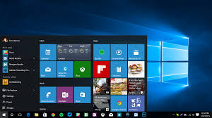
Figure 2.4: Windows 10 Interface

2.1.3 Windows Fundamentals
While there are many different versions of Windows, the fundamentals are the same. Some of the basics of windows are Desktop, Start Menu, Icons, Taskbar, Title bar etc.

2.1.3.1 Desktop
The “Desktop” is the general work area of your computer. It gives you access to programs, folders and documents that you use frequently. The figure below is a desktop of a computer.
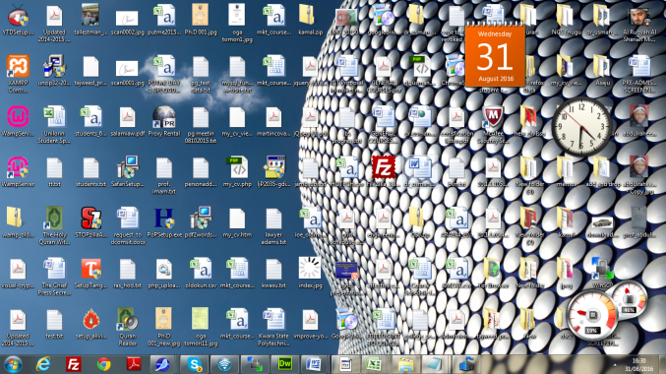
Figure 2.5: Windows 7 Desktop

2.1.3.2 Start Menu 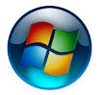 
Start Menu is located at the lower left hand corner of the screen. It is indicated by window icon with or without the word start. Clicking on the “Start” button will give you access to settings, help, other programs and documents and many other features.
Figure 2.6: Start Menu

2.1.3.3 Icon
An icon is a symbol/picture in a windows environment which acts as a button in order to open up application, document, folder or other object. To open a folder, double clicked the icon representing the folder. Samples of icons are given below
Figure 2.7: Windows Icons
2.1.3.4 Icons vs. Programs
You double click on the icon to execute the program. However, when a program is already opened, use single click on the commands or icons for such program. Examples of such program are MS Office, Internet Explorer, Firefox, Windows Media Player, etc.

2.1.3.5 Different Types of Icons
There are three types of icons. These are Application Icons, Folder Icons and Document Icon.
Application Icons open up a program like Internet Explorer, Microsoft Word, etc. The figure below represents application icons
Folder Icons store and organize documents and applications for easy access. Often you will find folders within folders.
Figure 2.8: Folder Icons

Document icons represent a specific file, like a word document, picture, etc. These files typically have an association with the program that is used to open them.
Figure 2.9: Document Icons

2.1.3.6 The Taskbar
The taskbar is what you see at the very bottom of your screen. It contains the “Start” button, which allows access to other Windows programs and features that are not on the desktop. System tray shows programs running in the background, the clock, volume control, etc.
Figure 2.10: Windows Taskbar

2.1.3.7 System Tray
The system tray or simply "systray" is at the lower right corner of the desktop on the taskbar which is used to display the clock and the icons of certain programs running so that a user is continually reminded that they are there and can easily click one of them
Figure 2.10: Windows System Tray

2.1.3.8 Title Bar is at the top of the window containing the following items such as Minimize, Maximize, Restore and Close.
Figure 2.11: Windows Title Bar
Minimize is use to minimize an open window if the window is maximized.
Maximize is use to maximize a window if the window is minimized.
Restore is use to switch between minimize and maximize mode
Close is use to close an opened window.

Types of Windows
Program Windows – Program windows are used to open applications like Word, Internet Explorer, etc.
Document Windows – Document Windows open a specific document within the applicable program window.
Folder Windows – open folders that contain other folders, documents, programs, etc.
Menu bar: On a window, menu bar allows access to feature within the particular program. Office 2010 programs have a menu bar configured in a different way called “the ribbon”.
Figure 2.12: Windows Menu bar

Scroll Bars: When there is more content than a window can contain, the scroll bars appear at the bottom and even more often on the right hand side of a window. Scroll bars are disabled when the content displayed is limited enough to fit within the dimensions of the window.
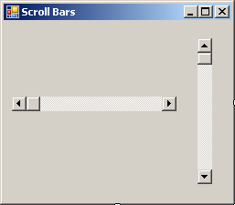
Figure 2.13: Windows Scroll Bars

2.1.4 Cut/Copy/Paste
Cut, copy, and paste commands in windows can be used to move text, graphics and other items from one application to the other such as Internet Explorer to Microsoft Word. Copied or cut items are placed in temporary storage called the Clipboard and can be retrieved as long as the computer is on or if the item has not been replaced by another selected item. An item on the Clipboard can be pasted multiple times.

2.1.4.1 Cut/Copy/Paste Steps
- Select the item (text or graphic) to be copied by either highlighting the text or right clicking on the graphic.
- Once you have made your selection, in the case of text, notice that it remains highlighted
- You can now right click on your selection and select Copy OR Press [Ctrl]+ [C]
- Now you have copied the material and you can use it to paste into another application.
2.1.4.2 Cut/Copy/Paste
- Once you have copied the item, go to the application where you would like to paste it.
- Place your cursor where you want to paste the item in the document (a word file, email, etc.)
- Right Click and then select Paste OR Press [Ctrl+[V]

CHAPTER THREE
OFFICE APPLICATIONS

²M. I. Ahmed, ¹R. G. Jimoh, ¹M. A. Mabayoje, ²M. AbdulRaheem & ¹S. A. Salihu
¹Department of Computer Science
Faculty of Communication and Information Sciences,
University of Ilorin, Ilorin.
²Computer Service and Information Technology (COMSIT Unit)
University of Ilorin, Ilorin.
  - Introduction
This chapter introduces the students to some basic and commonly used computer application programs used majorly for office/organization document preparation. Microsoft (MS) office applications are used as the example applications since they are the most commonly used applications. The MS office application discussed are: MS Word for word processing, MS Excel for spreadsheet preparation and MS PowerPoint for preparation of presentation slides.

  - Word Processing
Microsoft Word is one of the most popular word processing software supported by both Mac and PC platforms used to create documents, brochure, leaflets outlines, resumes, lists, and simple web pages.
    - Getting Started
Opening Microsoft Word On A Pc
To launch Microsoft Word, go to Start > All Programs > Microsoft Office > Microsoft OfficeWord 2010 (Figure 4.14) - A blank Word document will open.
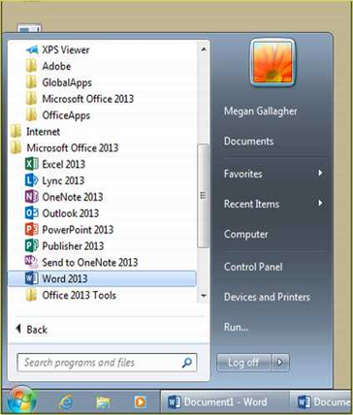
Figure 3.1: Start Tab

    - Saving Documents
Computers crash and documents are lost all the time, so it is best to save often.
Saving Initially
Before you begin to type, you should save your document. To do this, go to File Tab (Figure 4.15) > Save As. Microsoft Word will ask you to choose a location and then browse to a folder to save it in. After selection a dialogue box (figure 3) will open and you can name the file. Once you have specified a name and a place for your new file, press the Save button.
Note: If you want to save your document on a Mac and then open it on a PC, you must specify a file extension (i.e. .doc). Usually your computer will do this for you, but if it does not you must do this process while in Save As. Once you have titled your document, you can give it a file extension by clicking on the Format box. Click Microsoft Word Document for the correct file extension and make sure Append File Extension is checked.

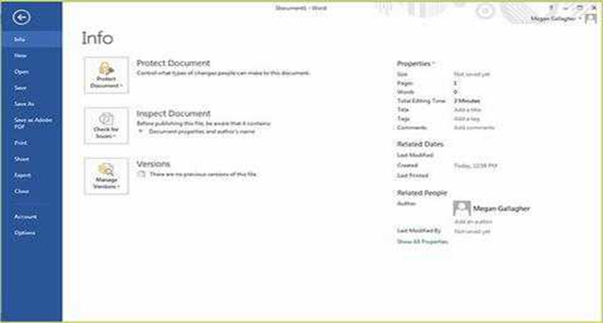
Figure 3.2: File Tab
Saving Later
After you have initially saved your blank document under a new name, you can begin writing your paper. However, you will still want to periodically save your work as insurance against a computer freeze or a power outage. To save, click File tab > Save

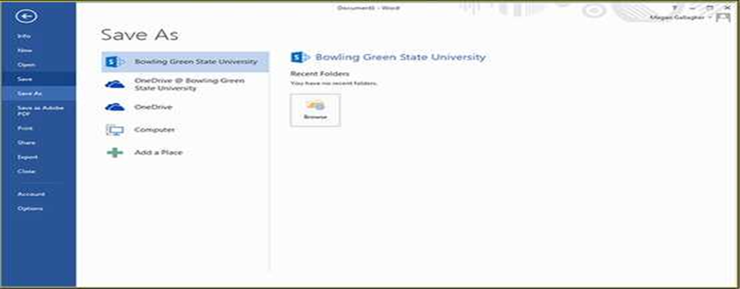
Figure 3.3: Save As Dialogue Box
    - Toolbar and Tabs
The new Microsoft Word uses one main toolbar to allow you to modify your document. Within this toolbar, you can switch between tabs to determine what you would like to do.
The Main Toolbar contains all the options available to you in Microsoft Word. The File Tab (see Figure 3.2) allows you to Save, Save As, Save as Adobe PDF, Open, Close, Print, Export, and Share. Other Tabs are discussed as follows.

The Home Tab (Figure 3.4) is Microsoft Words standard view. This is the view most widely used and allows you to format text by Font Style, Font Size, Bold, Italic, Underline, Alignment, Numbered List, Bulleted List, Indentation, Spacing, and Font Color

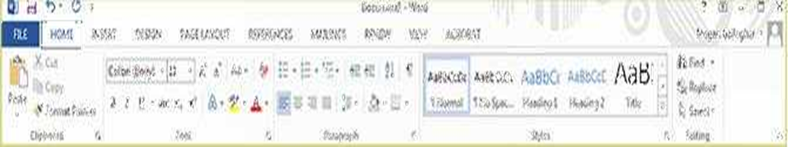
Figure 3.4: The Home Tab

The Insert Tab (Figure 3.5) contains any additives you want to place in your document, including but not limited to: Tables, Online Picture/Clip Art searches, Headers, and Footers. These icons are convenient and will bring up a dialogue box to give you further options when clicked.

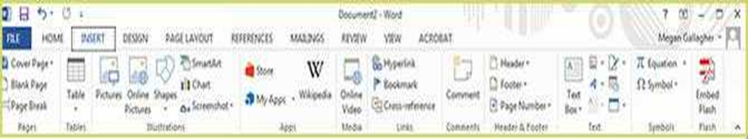
Figure 3.5: Insert Tab

The Design tab (Figure 3.6) contains different styles of page formatting. When you type, your layout will automatically match the format selected. It also allows you to change the color scheme, watermark, and paragraph spacing of the document.

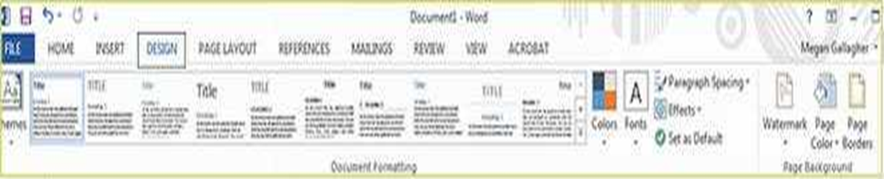
Figure 3.6: Design Tab

The Page Layout Tab (Figure 3.7) contains icons for page set up and paragraph actions, such as Margin, Orientation, Size and Columns

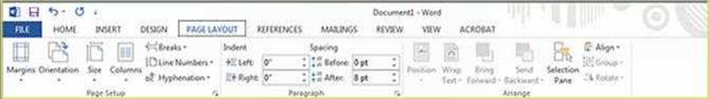
Figure 3.7: Page Layout Tab
The References Tab (Figure 3.8) makes it especially simple to add Table of Contents, Footnotes, Bibliographic Information, Indexes and Citations.

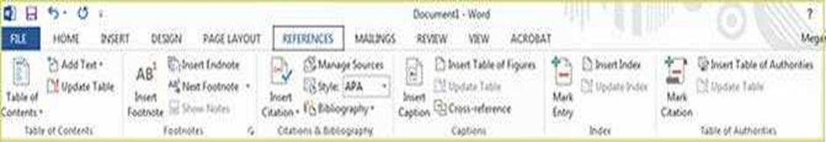
Figure 3.8: Reference Tab

The Mailings Tab (Figure 3.9) is for post-office elated uses. If you wanted to create custom Envelopes or Labels, this is where you would find such action.

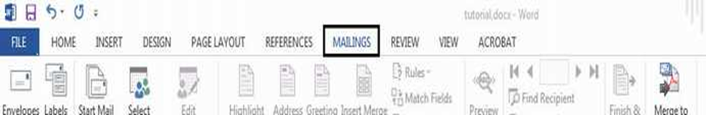
Figure 3.9: Mailing Tab

The Review Tab (Figure 3.10) is where one can find Spelling & Grammar, the built in Thesaurus and Dictionary, you can Track Changes, Check Word Count, and Show/Add Comments.

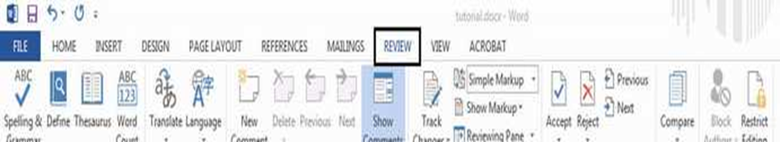
Figure 3.10: Review Tab

The View tab (Figure 3.11) allows you to change the views of your document.
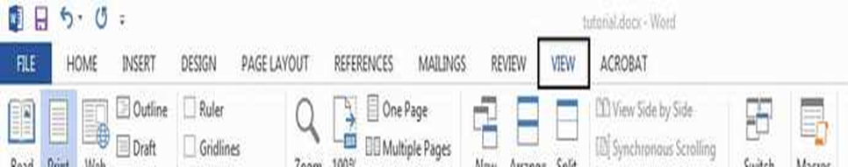
Figure 3.11: View Tab

The Acrobat Tab (Figure 3.12) is the final tab. It allows users to format their word documents to Adobe PDFs. Documents can be created and attached to email, become embedded Flash Player videos, and run actions such as optimization and web publication.

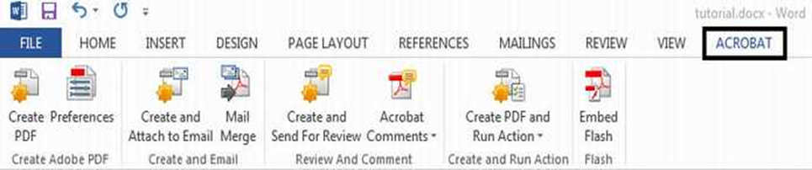
Figure 3.12: Acrobat Tab

    - Formatting Document
The default page margins for Microsoft Word documents are 1 inch, but you may want to change them for a project. To change the page margins on a PC, go to Page Layout Tab > Page Setup box> Margins button. On a PC, a dropdown will appear to give a set of standard options, but by clicking “Custom Margins,” a menu will appear where you can type irregular margins (Figure 3.13). From the same menu (Figure 3.13), click Portrait if you want your document to be 8.5 x 11 inches (most common). Click Landscape if you want your document to be 11 x 8.5 inches. Landscape simply flips the page 90 degrees.

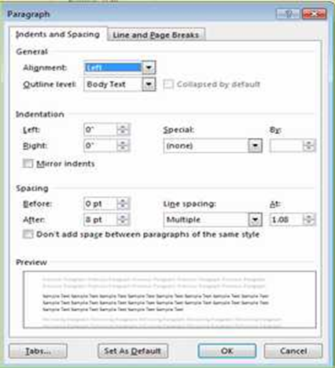
Figure 3.13: Formatting Document

Formatting Paragraphs: To format your paragraph, first highlight the paragraph you wish to format. To highlight more than one paragraph, click at the beginning of the paragraph and drag the mouse over the text. To apply changes to the entire document, select all by hitting Ctrl + A. To specify Alignment, Line Spacing, Indentation, and Page Break expand the Paragraph section of the Home Tab. This will open up the Paragraph menu (Figure 3.14). The Alignment option allows you to choose how you want your paragraph to look (i.e. justified right, center, or left). The Line Spacing option allows you to set the desired spacing, such as single or double. The Indentation option allows you to tab/push the line(s) in your paragraph either left or right. The Page Break option is found in Paragraph menu, but you must first select the Line and Page Breaks tab. Page Break allows you to split a paragraph or a page up into sections. You can also bring up this menu by right clicking (or by hitting Ctrl + Click on a one button mouse) within the document and selecting Paragraph.

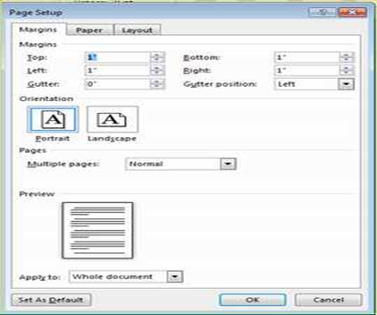
Figure 3.14: Changing Paragraph attributes using Paragraph Menu

Cut, Copy, and Paste You can use the Cut, Copy and Paste features of Word to change the order of sections within your document, to move sections from other documents into new documents, and to save yourself the time of retyping repetitive sections in a document. Cut will actually remove the selection from the original location and allow it to be placed somewhere else. Copy allows you to leave the original selection where it is and insert a copy elsewhere. Paste is used to insert whatever has been cut or copied.
To Cut or Copy: Highlight the text by clicking and dragging over the text to be cut or copied. Go to Home Tab > Clipboard box > Copy or Home Tab > Clipboard box > Cut. Click the location where the information should be placed. Go to Home Tab > Clipboard box > Paste.
Formatting Text
Before you type, you should select your font style, size, color and attributes (such as bold, italic and underline) in the Home Tab. You can expand the Font Menu box to get more options by clicking the down-arrow (Figure 15). However, if you wish to change text that has already been typed, click and drag over the text to be changed to highlight it (or go to Edit > Select All to select the entire document) and change it as before.
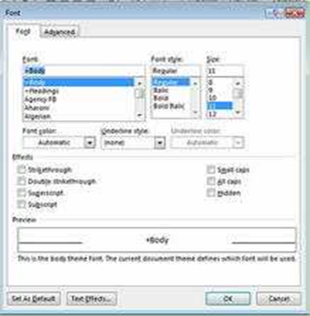
Figure 3.15: Changing Font attribute using the Font Menu

Numbered and Bulleted Lists
To create a simple numbered or bulleted list, click on the Numbering or Bullet button on the Paragraph toolbar in the Home Tab. To have more control over the format of your list, click the down arrows beside each style of list. Type the first item in the list and press Return to move to the next number or bullet. Press Return twice to exit the list.

Adding Columns
Columns can be used for a variety of document types, such as a tri-fold brochure. To do this, go to Page Layout Tab > Page Setup box > Columns. From the Columns menu, you can choose the number of columns, or for more options, click More Columns (Figure 3.16) where you can set column width and spacing. Once you select your preferred design, it will show up in the Preview box. This is a nice feature because it allows you to see what you are selecting before applying it to your word document. When you are happy with how your document looks, click Ok.

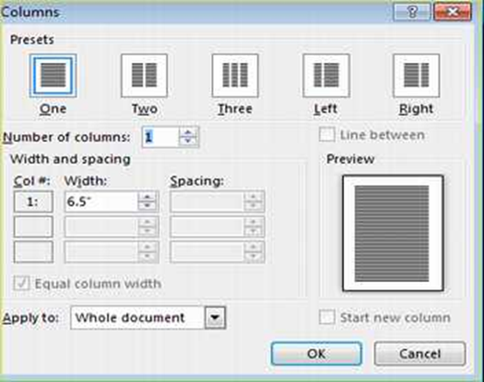
Figure 3.16: Selecting the number of column from Column Menu

Headers and Footers
Headers and Footers can be used to give a uniform look to the pages of your document. To create one, go to Insert Tab > Header and Footer. Use this toolbar to insert and format words and objects in the header. When editing the header, a new Top View will appear that is specific to headers and footers.

INSERTING AND ADDING OBJECTS
Clip Art
When trying to enhance your word document you may want to include Clip Art and/or Word Art. Microsoft Word comes with an Online Pictures button (Figure 3.19) that contains a large variety of images including pictures, borders, and backgrounds. To find a desired image, you can either search through the Clip Art gallery or search the Internet with the Bing Image Search engine.

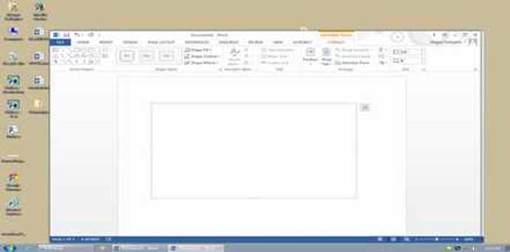
Figure 3.17: Clip Art and Picture Gallery

To insert Clip Art or Pictures: Go to Insert Tab > Illustrations box > Online Pictures. A dialogue box with the Clip Art gallery and the Bing Image Search engine will appear. If you wish to have a Clip Art photo, search the image’s description in the Clip Art Gallery. If you wish to have an image from the Internet, search the image’s description in the Bing Image Search engine. The picture will be inserted at the location of your cursor within your document. If you need to modify you Clip Art, click on it once to select it, and small boxes will appear around the corners (See WordArt, Figure 3.20). Once your Clip Art is selected, you can resize your picture by clicking and dragging on the boxes. Holding Shift while clicking and dragging will resize the Clip art appropriately. You can use the Drawing toolbar to further modify your Clip Art (Figure 3.18). To delete Clip Art, select it by clicking on it until the black boxes appear and then hit Delete.

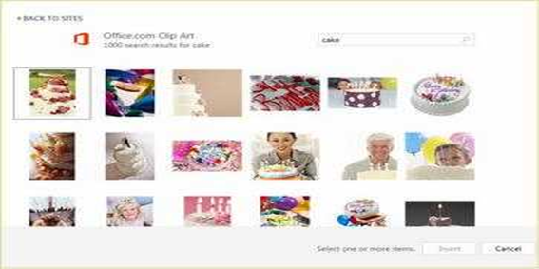
Figure 3.18:Clip Gallery

Drawing
To draw in Word, go to the Insert Tab > Illustrations box > Shapes and click the New Drawing Canvas. A new toolbar will appear that is specific to drawing tools
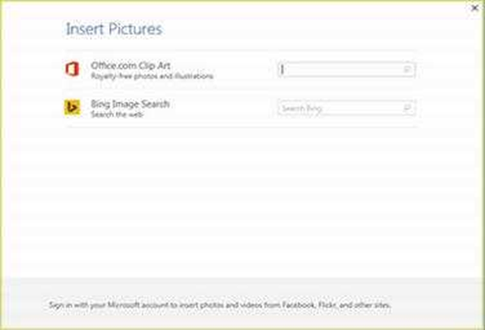
Figure 3.19: Drawing Toolbar

WordArt
To insert WordArt, go to Insert Tab > Text box > WordArt button. Select the desired style and click OK. Type the desired text and click Ok. You can further modify your text by using the Drawing toolbar. To select your WordArt, click on it, and small boxes will appear in the corners (figure 20). Moving the circle arrow anchor on the top of the WordArt allows the user to change the slant of the WordArt. WordArt can be resized and deleted similarly to ClipArt

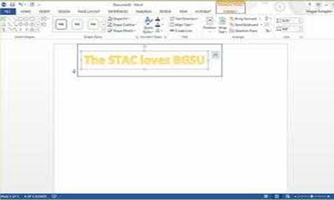
Figure 3.20: Word Art

Word Wrap
Word Wrap is part of formatting pictures. To use Word Wrap, select your inserted image, and go to the Format Tab > Arrange box. Here users can choose the type of text wrapping style desired. For more options. Select More Layout Options (Figure 3.21).

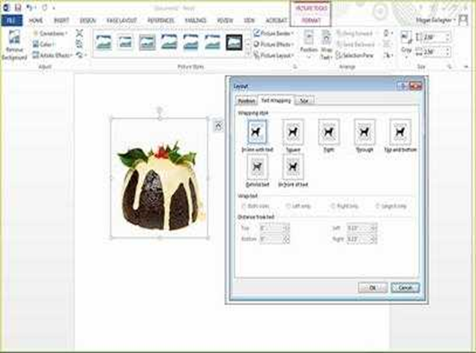
Figure 3.21: Wrapping Styles

Inserting From a Previously Created File
To insert a picture or object that is not in the Clip Gallery, go to Insert Tab > Illustrations box > Picture button and select the directory or disk where the file is located The easiest way to insert a Microsoft Excel file or graph is to open Microsoft Excel, copy your information, and switch back to Word to paste.

Creating a Table
To create a table within your document, go to Insert Tab > Tables box > Table button. Choose the desired table size and format by hovering over the boxes, and press Enter on the keyboard. The table will be inserted at the cursor’s location within your document. To navigate within your table, use the arrow keys. To modify your table, when your table is selected, a Design Tab and Layout Tab will appear in the Toolbar (Figure 3.22). From here, you can add cells, columns or rows, merge or split cells, and further modify your table. To exit the table, click outside of it.
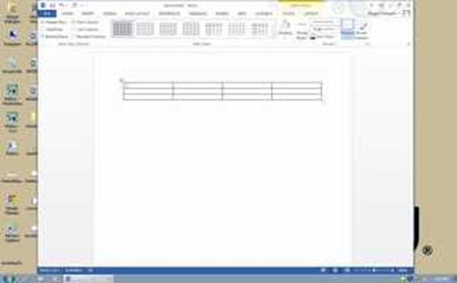
Figure 3.22: Tab option for the Toolbar

Flowcharts
Flowcharts are used to create diagrams in Microsoft Word. If you want to create a custom flowchart, you can use the Drawing capabilities discussed earlier. To insert Smart Art, go to Insert Tab > Illustrations box > Smart Art. A dialogue box will open (Figure 3.23) with basic choices.

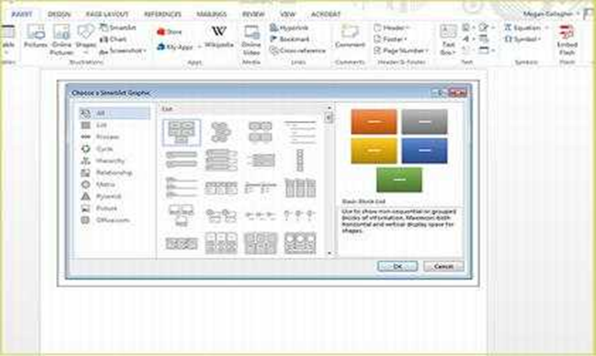
Figure 3.23: Smart Art Graphics

PRINTING
It is important to always save your document before you print! Print Preview Before you print your document, you may want to preview it to make sure you are happy with the page layout and appearance of your document. To do this, go to File Tab > Print. This should open up a preview of your document (Figure 3.24). To zoom in on the page, find the scale in the bottom right corner of the screen. You can move it back and forth to adjust the magnification If you are satisfied with the appearance of your document, you can click on the Print icon in the toolbar. If you need to make changes to the document or are not ready to print, select Close on the toolbar.

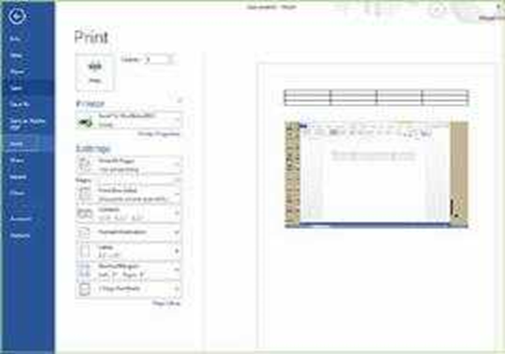
Figure 3.24: Print Preview

To print your document, go to File Tab > Print > Print, select your desired settings, and then click Print again. It is also possible to print by clicking the drop down arrow in the top left corner. You can either quick print which will not preview or print preview and print which will show your document.

Saving as A Pdf
Go to File Tab > Save As Adobe PDF. or Go to Mailings Tab > Acrobat box > Merge to Adobe PDF button.

Other Helpful functions
Undo and Redo
The easiest way to undo an action is with the key commands Ctrl + Z and to redo an action with Ctrl + Y. It is important to note that not all actions are undoable, thus it is important to save before you make any major changes in your document so you can revert back to your saved document. There are also two icons (Figure 3.25) above the Main Toolbar near the Save Icon. The left icon is Undo and the right icon is Redo.

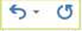
Figure 3.25: Undo and Redo

Word Count
To get an accurate word count of your document, go to Review Tab > Proofing Box > Word Count. This will give you the total number of words in your document (Figure 3.26). If you need to word-count a specific section highlight that section first click and drag over it and then to go Review Tab > Proofing Box > Word Count as before.

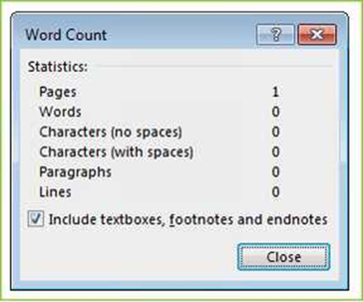
Figure 3.26: Word count

Quitting
Before you quit, it’s a good idea to save your document one final time. Go to File Tab > Exit Word. This is better than just closing the window, as it insures your document quits correctly.

SHORTCUT KEYS FOR MICROSOFT OFFICE
The shortcut keys listed below can be a great help when using Microsoft Office products. Not only are they quick and easy, they are also amazing time savers.

CTRL+K Create a hyperlink CTRL+/ Display HTML tags CTRL+T Create an Auto Thumbnail of the selected picture CTRL+SHIFT+B Preview a page in a Web browser SHIFT+ALT+F11 Display the Microsoft Script Editor CTRL+N Create a new page CTRL+B Bold CTRL+I Italic CTRL+U Underline CTRL+C Copy CTRL+V Paste CTRL+Z Undo CTRL+S Save CTRL+P Print CTRL+O Open.

  - Spreadsheet
Spreadsheet is a type of application program which manipulates numerical and string data in rows and columns of cells. The value in a cell can be calculated from a formula which can involve other cells. A value is recalculated automatically whenever a value on which it depends changes. Different cells may be displayed with different formats. Spreadsheet can also be defined as a computer software program that is used for storing, organizing and manipulating data. It is such an interactive computer application for organization, analysis and storage of data in tabular form. The best known spreadsheets are MS Excel and Lotus.
3.2.1 Getting Started
Microsoft Excel is one of the most popular spreadsheet applications that helps you manage data, create visually persuasive charts, and thought-provoking graphs. Excel is supported by both Mac and PC platforms. Microsoft Excel can also be used to balance a checkbook, create an expense report, build formulas, and edit them.
Opening Microsoft Excel on a PC
Step 1: Begin by opening Microsoft Excel. On a PC click
Start > All Programs > Microsoft Office> Microsoft Excel 2013. (Figure 3.27)
Step 2: A new spreadsheet will pop up on the screen. If this does not happen click on the
File tab > New.
From here a dialog box with various different templates will appear on the screen that you can choose from. Once a template is chosen, click Create. (Figure 3.28)
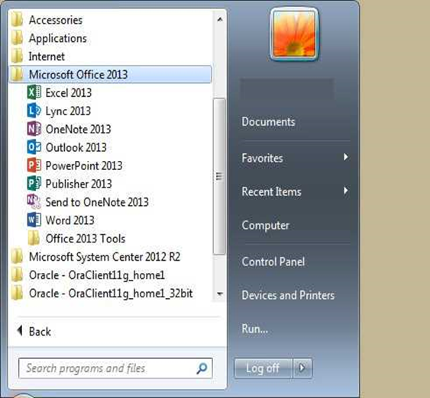
Figure 3.27: Launching MS Excel
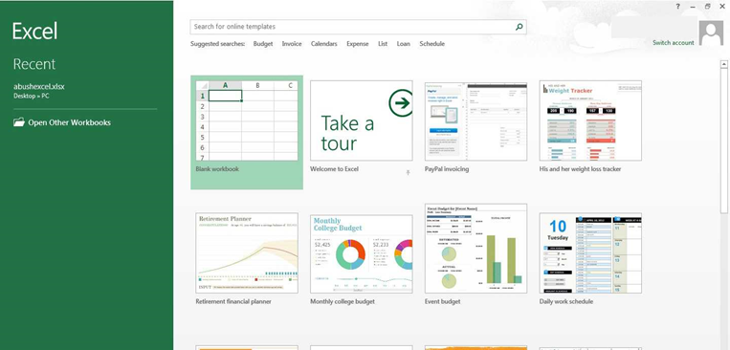
Figure 3.28: Opening New Workbook
3.2.2 Saving Document
Saving Initially
Computers crash and documents are lost all the time, so it is best to save often. It is also recommended that you save your document before you begin working on it. The following steps can be followed to save MS Excel document:
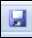
Step 1: Click on the File tab > Save.
Step 2: Microsoft Excel will open a dialog box where you will be prompted to select a save location for your file. If your desired location is not apparent in this box, press the Browse icon and a new window will appear allowing you to input the name of your document, where you want it saved, as well as the format of the document. (Figure 3)
Step 3: Once you have specified a name, place, and format for your new file, press the save button.

Note: Specifying your file format will allow you to open your document on a PC. To do this, you use the drop down menu next to the Format option. Also, when you are specifying a file extension (i.e. .doc) make sure you know what you need to use.

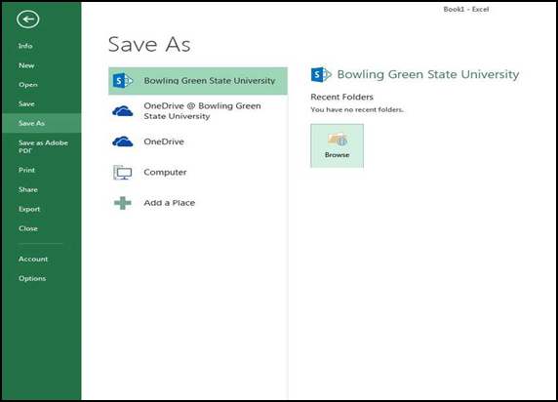
Figure 3.29: Save Dialogue Box

Saving Later
After you have initially saved your blank document under a new name, you can begin your project. However, you will still want to periodically save your work as insurance against a computer freeze or a power outage. To save, just click on the floppy disk, or for a shortcut press CTRL + S.

3.2.3 Toolbar
In Microsoft Excel 2013 for a PC, the toolbars are automatically placed as tabs at the top of the screen. Within these tabs you will find all of our options to change text, data, page layout, and more. To be able access all of the certain toolbars you need to click on a certain tab that is located towards the top of the screen.
Three Commonly Used Toolbars
The Home Tab: This is one of the most common tabs used in Excel. You are able to format the text in your document, cut, copy, and paste information. Change the alignment of your data, insert, delete, and format cells. The Home Tab also allows you to change the number of your data (i.e. currency, time, date). (Figure 3.30)

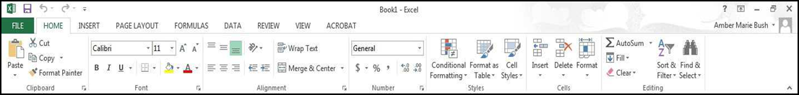
Figure 3.30: Home Tab

The Insert Tab: This tab is mainly used for inserting visuals and graphics into your document. There are various different things that can be inserted from this tab such as pictures, clip art, charts, links, headers and footers, and word art. (Figure 3.31)
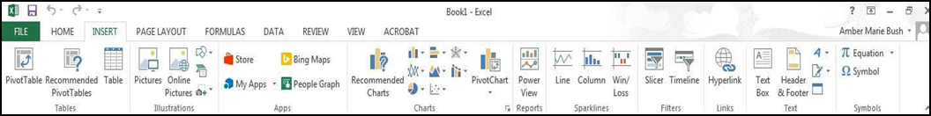
Figure 3.31: Insert Tab.

The Page Layout Tab: Here you are able to add margins, themes to your document, change the orientation, page breaks, and titles. The scale fit of our document is also included as a feature within this tab, if needed. (Figure 3.32)

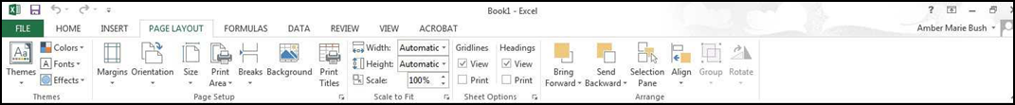
Figure 3.32: Page Layout Tab

3.2.4 FORMATTING

Working with Cells
Cells are an important part of any project being used in Microsoft Excel. Cells hold all of the data that is being used to create the spreadsheet or workbook. To enter data into a cell, you simply click once inside of the desired cell, a green border will appear around the cell. (Figure 3.33) This border indicates that it is a selected cell. You may then begin typing in the data for that cell.
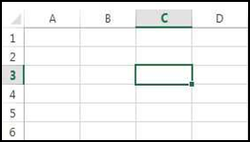
Figure 3.33: Entering Data.

Changing an Entry within a Cell
You may change an entry within a cell in two different ways:
1. Click the cell one time and begin typing. The new information will replace any information that was previously entered.
2. Double click the cell and a cursor will appear inside. This allows you to edit certain pieces of information within the cells instead of replacing all of the data.

Cut, Copy, and Paste You can use the Cut, Copy and Paste features of Excel to change the data within your spreadsheet, to move data from other spreadsheets into new spreadsheets, and to save yourself the time of re-entering information in a spreadsheet. Cut will actually remove the selection from the original location and allow it to be placed somewhere else. Copy allows you to leave the original selection where it is and insert a copy elsewhere. Paste is used to insert data that has been cut or copied. The following steps can be taken to cut, copy and paste:
Step 1: Highlight the data or text by selecting the cells that they are held within.
Step 2: Go to the Home Tab > Copy (CTRL + C) or Home Tab > Cut (CTRL + X).
Step 3: Click the location where the information should be placed.
Step 4: Go to Home Tab > Paste (CTRL + V) to be able to paste your information.

Formatting Cells
There are various options that can be changed to format the spreadsheets cells. When changing the format within cells, you must select the cells that you wish to format.
1. Drag and select the cells you wish to change.
2. Click Home Tab > Format > Format Cells. A box will appear on the screen with six different tab options. (Figure 3.34).
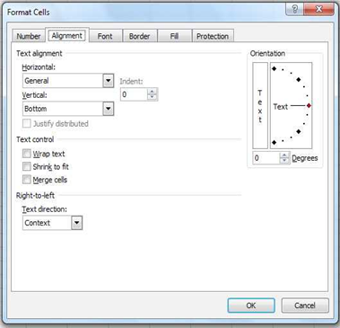
Figure 3.34: Formatting Cells

Number: Allows you to change the measurement in which your data is used. (If your data is concerned with money the number that you would use is currency)
Alignment: This allows you to change the horizontal and vertical alignment of your text within each cell. You can also change the orientation of the text within the cells and the control of the text within the cells as well.
Font: Gives the option to change the size, style, color, and effects.
Border: Gives the option to change the design of the border around or through the cells.

Formatting Rows and Columns
When formatting rows and columns, you can change the height, choose for your information to autofit to the cells, hide information within a row or column, un-hide the information. To format a row or column, proceed with the following steps:
Step 1: Select the cells which will be altered.
Step 2: Go to Home Tab > Row Height (or Column Height).
Step 3: Choose which height you are going to use. (Figure 3.34)

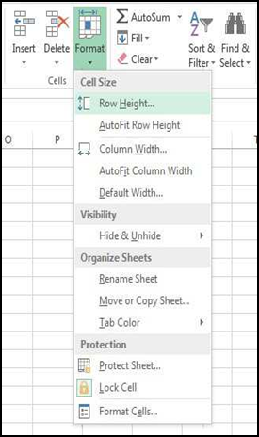
Figure 3.34: Formatting Rows and Columns Height

Adding Rows and Columns
Rows are cells that run horizontally across the document. You can insert an extra row of cells like this:
Step 1: Drag select along the row of cells where you want your new row to appear.
Step 2: Click Home Tab > Insert > Insert Sheet Rows (Figure 3.35).
The row will automatically be placed on the spreadsheet and any data that was selected in the original row will be moved down below the new row.
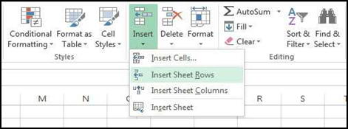
Figure 3.35: Inserting Rows

Columns are cells that run vertically down the document. You can insert an extra column of cells as follows:
Step 1: Drag select along the column of cells where you want your new column to appear.
Step 2: Go to Home Tab > Insert > Insert Sheet Column.
The column will automatically be placed on the spreadsheet and any data to the right of the new column will be moved more to the right. (Figure 3.36)

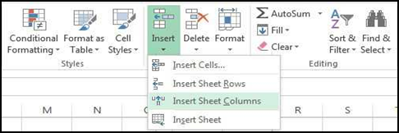
Figure 3.36: Inserting Columns

Working with Charts
Charts are an important part to being able to create a visual for spreadsheet data.
Step 1: In order to create a chart within Excel, the data that is going to be used for it needs to be entered already into the spreadsheet document. Once the data is entered, the cells that are going to be used for the chart need to be highlighted so that the software knows what to include. Next, click on the Insert Tab that is located at the top of the screen. (Figure 3.37)
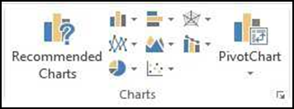
Figure 3.37: Charts Tab

Step 2: You may choose the chart that is desired by clicking the category of the chart you will use. Once the category is chosen the charts will appear as small graphics within a drop down menu. To choose a particular chart just click on its icon and it will be placed within the spreadsheet you are working on.

Step 3: To move the chart to a page of its own, select the border of the chart and Right Click. This will bring up a drop down menu, navigate to the option that says Move Chart. This will bring up a dialog box that says Chart Location. From here you will need to select the circle next to As A New Sheet and name the sheet that will hold your chart. The chart will pop up larger in a separate sheet but in the same workbook as your entered data. (Figure 3.38)

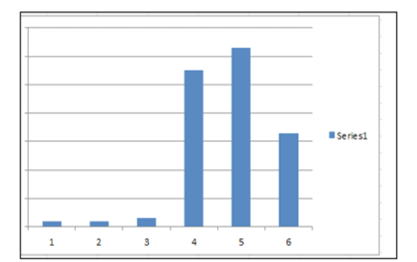
Figure 3.38: Chart in new sheet

Chart Design
There are features that you can change to make your chart more appealing. To be able to make these changes you will need to have the chart selected or be viewing the chart page that is within your workbook. Once you have done that the Design Tab will appear highlighted with various different options to format your graphic. (Figure 3.39)
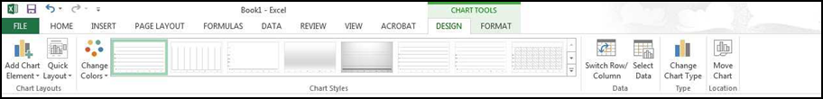
Figure 3.39: Chart Tool
Chart Options
Titles: Within the new chart Design tab, click the Add Chart Element icon. Here, you will see the option to title the chart as well as various components of the chart.

Change Chart Type: You can change your chart easily by selecting this icon and navigating to a more desirable chart. This feature is very convenient for someone who chose the wrong chart and doesn’t wish to reselect all their data and go through the process a second time.

Format Chart Area: This allows for changes to be made to the chards border, style, fill shadows, and more. To get this option you will need to right click on the charts border and navigate to the Format
Chart Area option. Once this is clicked, a dialog box will appear.

3.2.4 Inserting Smart Art Graphics
Pictures
To insert Pictures: Go to the Insert Tab> Picture, a dialog box will appear and then you can select the desired picture from the location that is it stored. The picture will be inserted directly onto your document, where you can change the size of it as desired

Inserting Clipart: To insert Clip Art you will need to go to the Insert Tab > Online Pictures. A window will appear giving you the options to either pull clip art from the Microsoft Office website or search for more options using a Bing image search engine. (Figure 3.40)
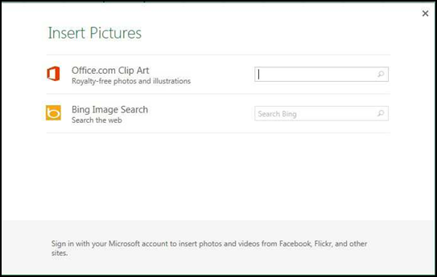
Figure 3.40: Inserting Clip Art

Creating Functions
When creating a function in Excel, you must first select the data on which you wish to perform the function.
Step 1: Select the cell that you wish for the calculation to be entered in (i.e.: if I want to know the sum of B1:B5 I will highlight cell B6 for my sum to be entered into). (Figure 3.41)
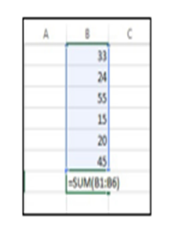
Figure 3.41: Choosing calculation cell

Step 2: Once you have done this, you will need to select the Formulas Tab located at the top of the screen.
Step 3: A list of Most Recently Used, Financial, Logical, Text, Date and Time, Math and Trig formulas will appear. To choose one of the formulas click the icon that holds the formula you are looking for.
Step 4: Once you have clicked your formula this will display a dialog box on your screen (Figure 3.42).
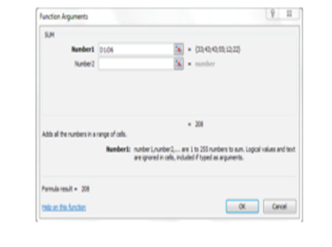
Figure 3.42: Formula dialogue Box

In this screen it lists the cells that are being calculated, the values within the cells, and the end result.
Step 5: To accept that calculation you can press OK and the result will show up in the selected cell.

3.2.5 Printing
To print your document, go to File Tab > Print, select your desired settings, and then click OK. You can also do this by using the shortcut CTRL + P
To be able to change the orientation of your page for printing, you can click on the Portrait Orientation button under the option under Print then click the change the layout (Figure 3.43).

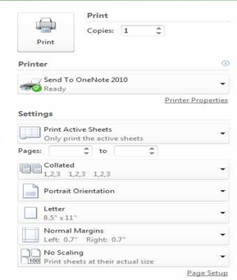
Figure 3.43: Printing Document

3.2.6 Other Helpful Functions
Undo and Redo
In order to undo an action, you can click on the blue arrow icon that is pointing to the left at the top of the screen. To redo an action, you can click on the blue arrow icon pointing to the right. It is important to note that not all actions are undoable, thus it is important to save before you make any.
  - PowerPoint Presentation
This section presents the use of MS PowerPoint, specifically MS PowerPoint 2013, for preparing electronic presentations. Figure 3.44 depicts a typical interface of MS PowerPoint when it is initially launched.
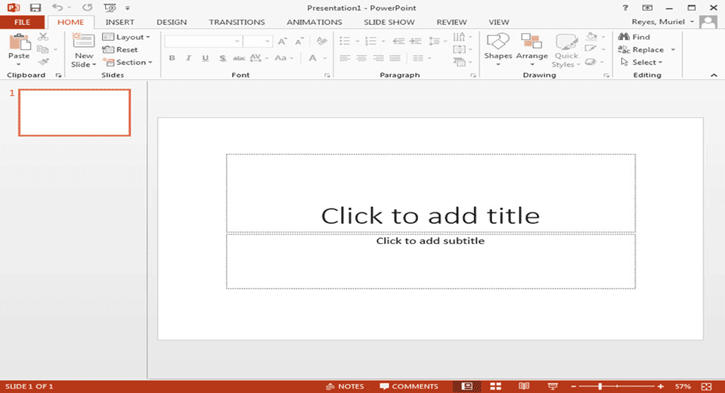
Figure 3.44: MS PowerPoint Interface

3.3.1 Presentations
A presentation is a collection of data and information that is to be delivered to a specific audience. A PowerPoint presentation is a collection of electronic slides that can have text, pictures, graphics, tables, sound and video. This collection can run automatically or can be controlled by a presenter.
There are three features that you should remember as you work within PowerPoint 2013: the File menu tab, the Quick Access Toolbar, and the Ribbon. The function of these features are presented in the following subsections.
3.3.2 File Menu Tab
The File menu tab allows you to create a new presentation, Open an existing presentation, save and save as, print, send, set options, and close presentations. Figure 3.45 depict how to get to the File menu tab.
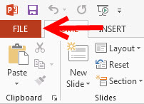
Figure 3.45: MS PowerPoint Tab

3.3.3 Ribbon
The Ribbon is the panel at the top portion of the document. It has eight tabs besides the File Menu Tab: Home, Insert, Design, Transitions, Animations, Slide Show, Review and View. Each tab is divided into groups. The groups are logical collections of features designed to perform function that you will utilize in developing or editing your PowerPoint slides.
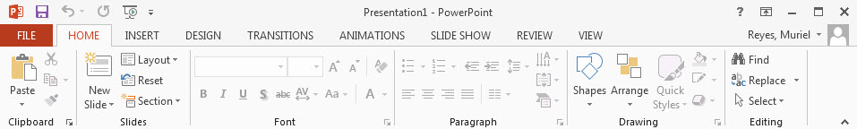
Figure 3.46: The Ribbon of MS PowerPoint
Commonly utilized features are displayed on the Ribbon. To view additional features within each group, click the arrow at the bottom right corner of each group as depicted in Figure 3.47.
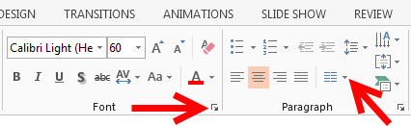
Figure 3.47: Accessing additional features
The following enumerates the commonly used functions of the ribbons:
HOME: Clipboard, Slides, Font, Paragraph, Drawing, and Editing
INSERT: Tables, Illustrations, Links, Text, and Media Clips
DESIGN: Page Setup, Themes, Background
ANIMATIONS: Preview, Animations, Transition to this Slide
SLIDE SHOW: Start Slide Show, Set Up, Monitors
REVIEW: Proofing, Comments, Protect
VIEW: Presentation Views, Show/Hide, Zoom, Window, Macros

3.3.4 Quick Access Toolbar
The Quick Access Toolbar is a customizable toolbar that contains commands that you may want to use. You can place the quick access toolbar above or below the ribbon. To change the location of the quick access toolbar, click on the arrow at the end of the toolbar and click Show Below the Ribbon as depicted in Figure 3.48.
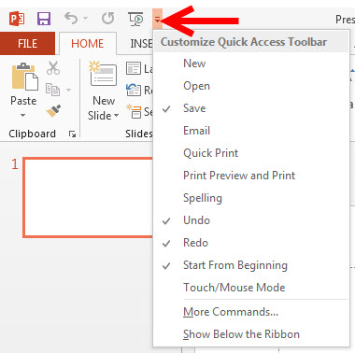
Figure 3.48: Activating the Quick Access Toolbar
You can also add items to the Quick Access Toolbar. Right click on any item in the Ribbon and click Add to Quick Access Toolbar and a shortcut will be added. Figure 3.49 depicts the menu for this feature.
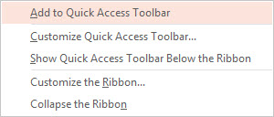
Figure 3.49: Adding more items to the Quick Access Toolbar

3.3.5 Mini Toolbar
This is a floating toolbar that is displayed when you select text or right-click text. It displays common text formatting tools, such as Bold, Italics, Fonts, Font Size and Font Color. Figure 3.50 shows the menu for the mini toolbar. This toolbar is also referred to as context menu.
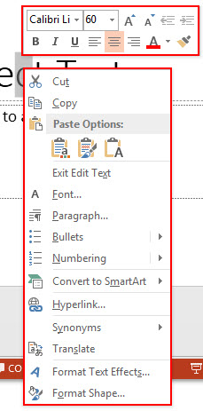
Figure 3.50: Mini Toolbar

3.3.6 Navigation
Navigating through the slides can be accomplished through the Slide Navigation menu on the left side of the screen. The Navigation menu displays an outline of the entire slides in the presentation. To access the outline, click the outline tab. Each of the slides in the presentation can be accessed by clicking on it in the outline as depicted in Figure 3.51.
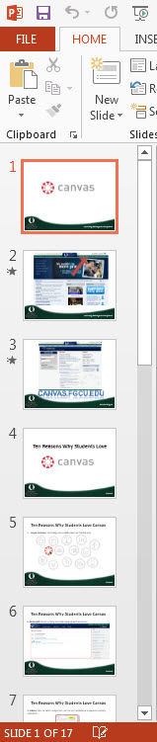
Figure 3.51: Navigation Menu

3.3.7 Slide Views
Presentations can be viewed in a variety of manners. On the View tab, the Presentation Views group allows you to view the slides as Normal, Outline View, Slide Sorter, Notes Page, and Reading View. The Master Views group allows you to view the Slide Master, Handout Master, and Notes Master for the current presentation. Figure 3.52 depicts these views and other functions in the View Tab
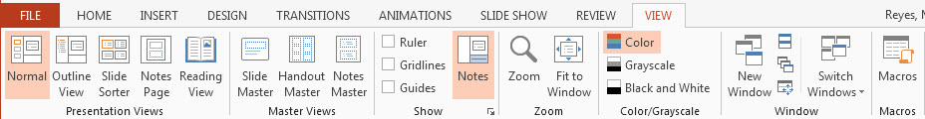
Figure 3.52: Slide Views

3.3.8 Creating Presentation
New Presentation
You can start a new presentation from a blank slide, a template, existing presentations, or a Word outline. To create a new presentation from a blank slide, take the following steps:
Step 1: Click the File menu tab.
Step 2: Click New.
Step 3: Click Blank Presentation.

Save a Presentation
When you save a presentation, you have two choices: Save or Save As.
To save a document:
Step 1: Click the File menu tab.
Step 2: Click Save.
Figure 3.53 depicts the Save/Save As interface of MS PowerPoint
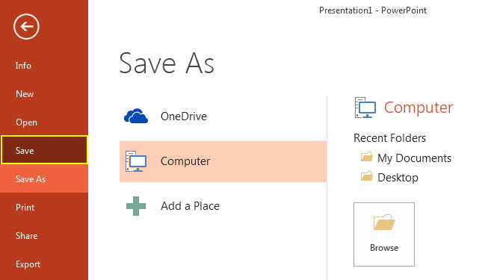
Figure 3.53: The File Menu showing Save functions
You may need to use the Save As feature when you need to save a presentation under a different name or to save it for earlier versions of PowerPoint. Remember that older versions of PowerPoint will not be able to open a PowerPoint 2013 presentation unless you save it as in an older format. Figure 3.53 shows the Save As interface.
To use the Save As feature:
Step 1: Click the File menu tab.
Step 2: Click Save As.
Step 3: Type in the name for the presentation.
Step 4: In the Save as type box, choose a format.
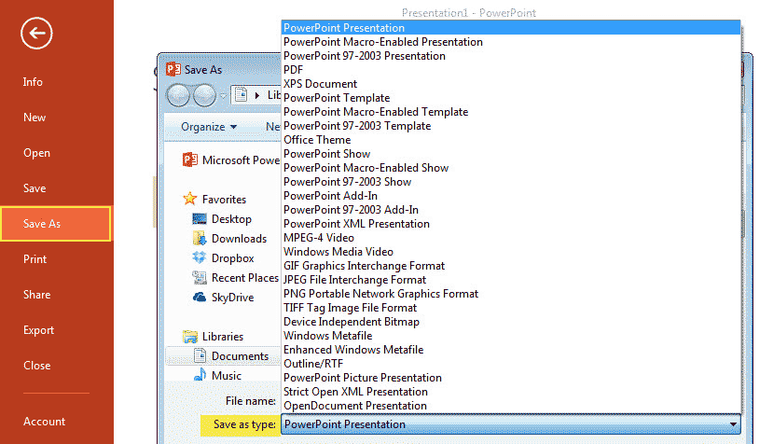
Figure 3.54: The File Menu showing Save As functions

Add Slides
There are several choices when you want to add a new slide to the presentation: Office Themes, Duplicate Selected Slide, or Reuse Slides.
To create a new slide from Office Themes:
Step 1: Select the slide immediately BEFORE where you want the new slide
Step 2: Click the New Slide button on the Home tab.
Step 3: Click the slide choice (depicted in Figure 3.55) that fits your material

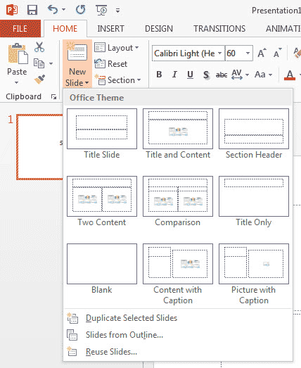
Figure 3.55: Slide Templates
To create a slide as a duplicate of a slide in the presentation:
Step 1: Select the slide to duplicate.
Step 2: Click the New Slide button on the Home tab.
Step 3: Click Duplicate Selected Slides (depicted in Figure 3.56).
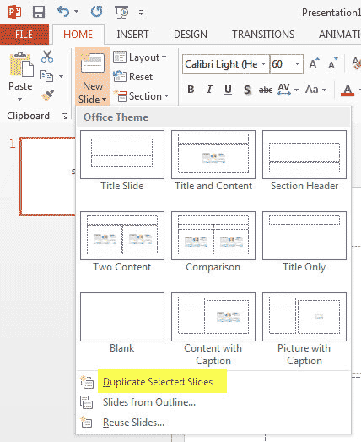
Figure 3.56: Slide Duplication
To create a new slide from another presentation:
Step 1: Select the slide immediately BEFORE where you want the new slide
Step 2: Click the New Slide button on the Home tab.
Step 3: Click Reuse Slides (depicted in Figure 3.57).
Step 4: Click Browse.
Step 5: Click Browse File.
Step 6: Locate the slide show and click on the slide to import.
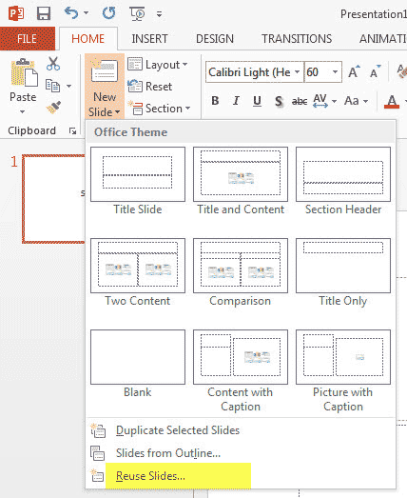
3.57: Slide Reuse

Themes
Themes are design templates that can be applied to an entire presentation that allows for consistency throughout the presentation. To add a theme to a presentation:
Step 1: Click the Design tab
Step 2: Choose one of the displayed Themes or click the Galleries button (depicted in Figure 3.58).
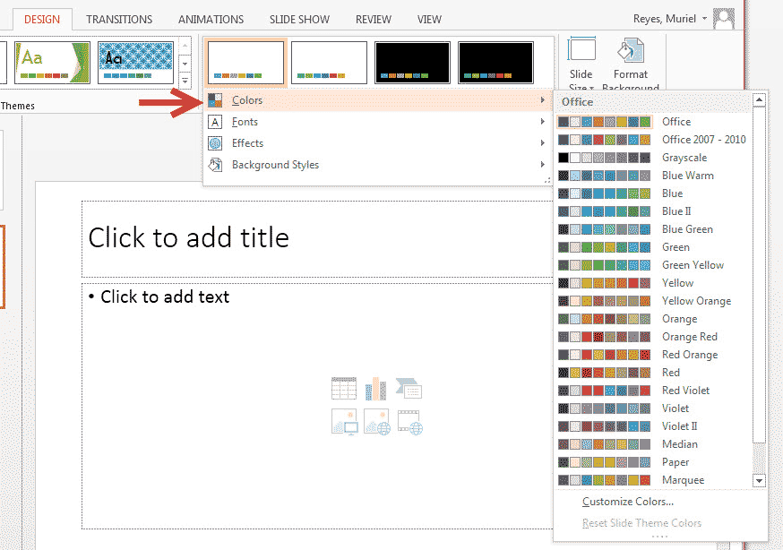
Figure 3.58: Theme selection
To change the background style of a theme
- Click the Background Styles button on the Design tab (Figure 3.59).
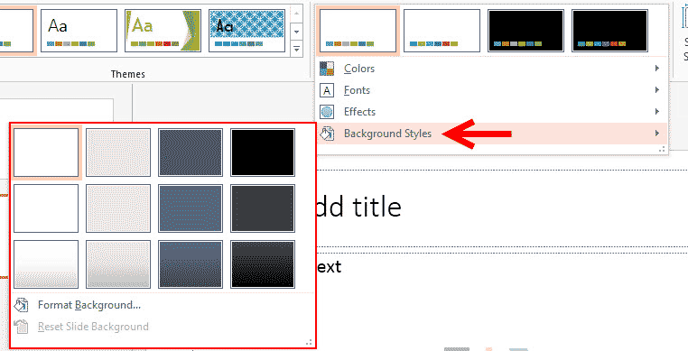
Figure 3.59: Background Styles

3.3.9 Working with Content.
Entering Text
To enter text:
Step 1: Select the slide where you want the text.
Step 2: Click in a Textbox to add text as depicted in Figure 3.60.
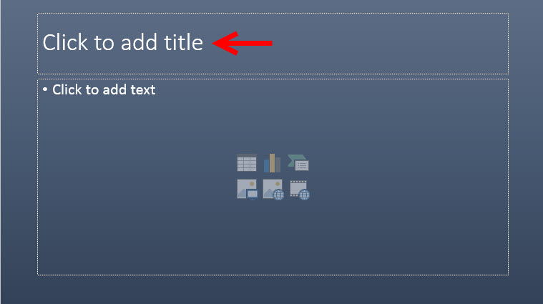
Figure 3.60: Entering Text
To add a text box:
Step 1: Select the slide where you want to place the text box.
Step 2: On the INSERT tab, click Text Box.
Step 3: Click on the slide and drag the cursor to expand the text box.
Step 4: Type in the text.
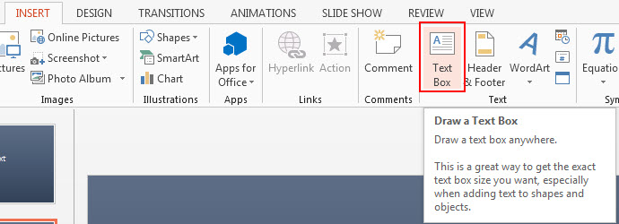
Figure 3.61: Adding Text Box

Select Text
To select the text:
- Highlight the text by pressing the left button of the mouse and dragging it over the text as depicted in Figure 3.62.
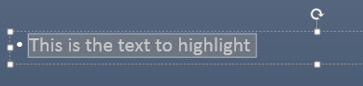
Figure 3.62: Text highlighting

Copy and Paste
To cut and paste data:
Step1: Select the item(s) that you wish to copy.
Step 2: On the Clipboard group of the HOME Tab, click Cut (Figure 3.63).
Step 3: Select the items(s) where you would like to copy the data.
Step 4: On the Clipboard group of the HOME Tab, click Paste.
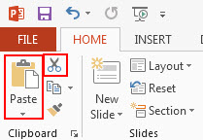
Figure 3.63: Copy and Paste

Undo and Redo
To undo or redo most recent actions:
Step 1: On the Quick Access Toolbar (Figure 3.64).
Step 2: Click Undo or Redo.
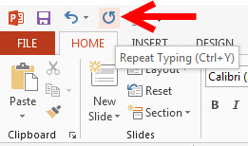
Figure 3.64: Undo and Redo button

Spell Check
To check the spelling in a presentation:
Step 1: Click the REVIEW tab.
Step 2: Click the Spelling button (Figure 3.65).
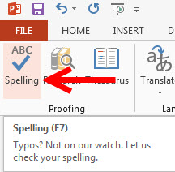
Figure 3.65: Spell Checking

Change Font Typeface and Size
To change the font typeface:
Step 1: Click the arrow next to the font name and choose a font (Figure 3.66).
Step 2: Remember that you can preview how the new font will look by highlighting the text, and hovering over the new font typeface.
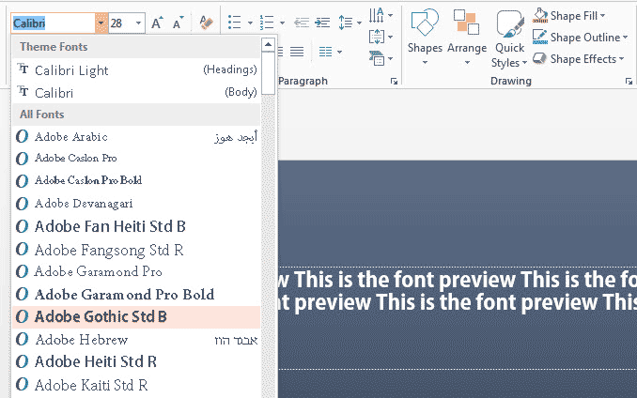
Figure 3.66: Selecting Font
To change the font size:
Step 1: Click the arrow next to the font size and choose the appropriate size, or
Step 2: Click the increase or decrease font size buttons.
Figure 3.67 depicts the Home Tab section for this function.
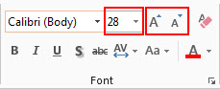
Figure 3.67: Font size

Font Styles and Effects
Font styles are predefined formatting options that are used to emphasize text. They include: Bold, Italic, and Underline. To apply these to text, use the font group of the Home Ribbon depicted in Figure 3.68 following these steps:
Step 1: Select the text and click the Font Styles included on the Font group of the Home tab or
Step 2: Select the text and right click to display the font tools
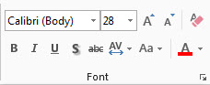
Figure 3.68: Font styling

Change Text Color
To change the text color:
Step 1: Select the text and click the Colors button included on the Font Group of the Ribbon (Figure 3.69), or
Step 2: Highlight the text and right-click and choose the Colors tool.
Step 3: Select the color by clicking the down arrow next to the font color button.
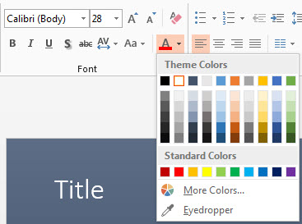
Figure 3.69: Text Color

WordArt
WordArt are styles that can be applied to text to create a visual effect. To apply WordArt:
Step 1: Select the text.
Step 2: Click the Insert tab.
Step 3: Click the WordArt button (Figure 3.70).
Step 4: Choose the WordArt.
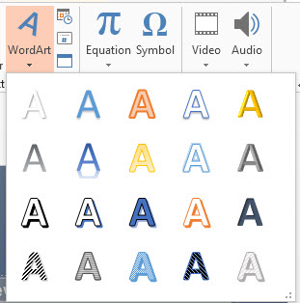
Figure 3.70: Word Art
To modify the styles of WordArt
Step 1: Select the WordArt.
Step 2: Click the Format tab for the Drawing Tools (Figure 3.71).
Step 3: Click the WordArt Fill button, the WordArt Outline button, or the Text Effects button.
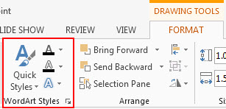
Figure 3.71: Formatting WordArt

Change Paragraph Alignment
The paragraph alignment allows you to set how you want text to flow relative to other content. To change the alignment:
Step 1: Click the Home Tab.
Step 2: Choose the appropriate alignment button on the Paragraph Group (Figure 3.72).
  - Align Left: the text is aligned with your left margin.
  - Center: The text is centered within your margins.
  - Align Right: Aligns text with the right margin.
  - Justify: Aligns text to both the left and right margins.
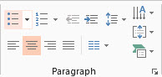
Figure 3.72: Alignment setting

Indent Paragraphs
To indent entire paragraphs, you can do the following:
Step 1: Click the Indent buttons on the Home ribbon (Figure 3.73) to control the indent,
Step 2: Click an Indent button repeated times to increase or decrease the amount of indentation.
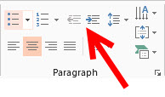
Figure 3.73: Indentation

Text Direction
To change the text direction:
Step 1: Select the text.
Step 2: Click the Text Direction button on the Home tab (Figure 3.74).
Step 3: Click the selection.

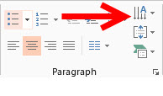
Figure 3.74: Changing text direction

Graphics

Adding Picture
To add a picture:
Step 1: Click the Insert Tab.
Step 2: Click the Picture Button (Figure 3.75).
Step 3: Browse to the desired picture within your files.
Step 4: Click the name of the picture.
Step 5: Click the Insert button.
Step 6: To move the graphic, click it and drag it to where you want it.
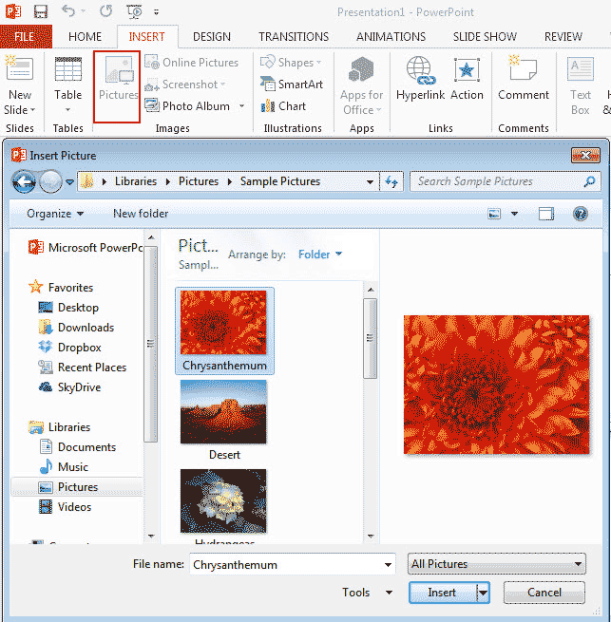
Figure 3.75: Inserting Picture

Adding Clip Art
To add Clip Art:
Step 1: Click the Insert Tab.
Step 2: Click the Online Photos Button (Figure 3.76).
Step 3: Search for the clip art using the search Clip Art dialog box.
Step 4: Click the clip art.
Step 5: Click the Insert button.
Step 6: To move the graphic, click it and drag it to where you want it.
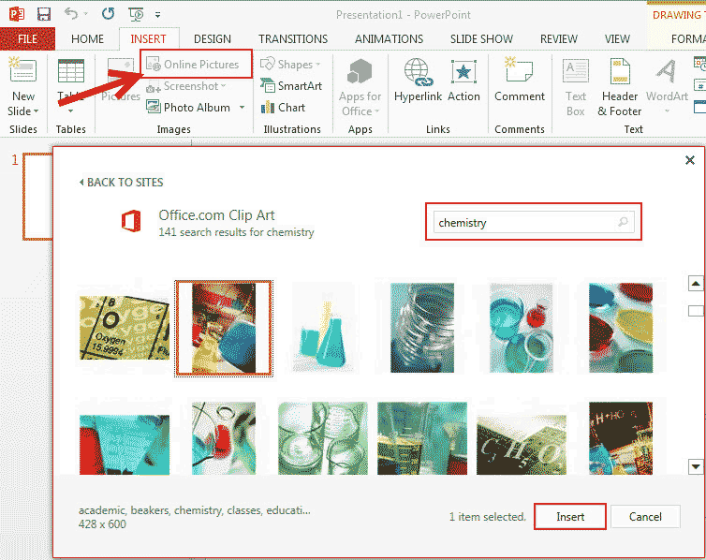
Figure 3.76: Online Picture

Adding a Shape
To add shapes:
Step 1: Click the Insert Tab.
Step 2: Click the Shapes Button (Figure 3.77).
Step 3: Click the desired shape.
Step 4: Click the Slide.
Step 5: Drag the cursor to expand the shape.
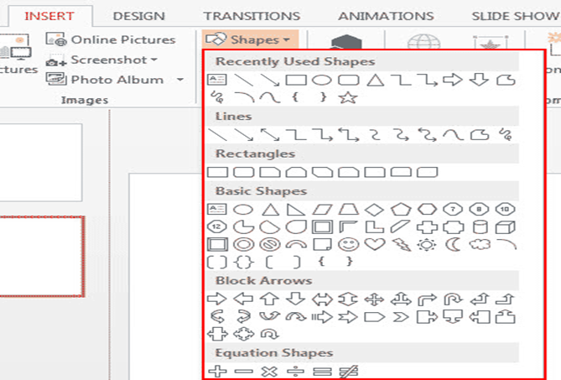
Figure 3.77: Shapes

To format shapes:
Step 1: Click the Shape.
Step 2: Click the Format tab (Figure 3.78).
Step 3: Change format settings as desired.
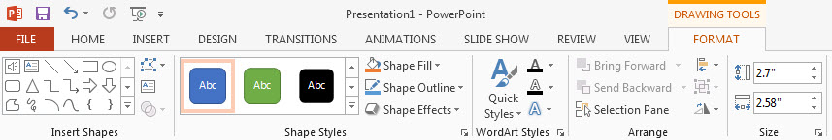
Figure 3.78: Formatting shapes

Adding SmartArt
SmartArt is a feature that allows you to choose from a variety of graphics, including flow charts, list, cycles, and process. To add SmartArt:
Step 1: Click the Insert Tab.
Step 2: Click the SmartArt Button (Figure 3.79).
Step 3: Click the SmartArt you choose.
Step 4: Click OK.
Step 5: Drag it to the desired location in the slide.

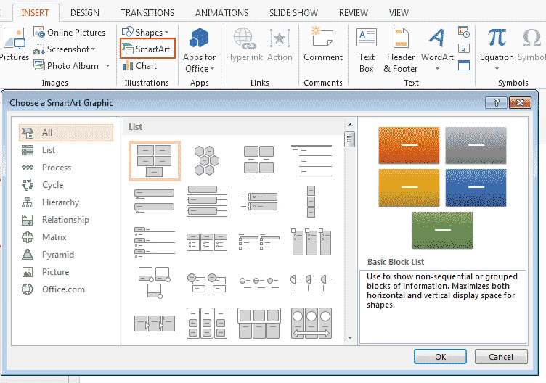
Figure 3.79: SmartArt

To format the SmartArt:
Step 1: Click the SmartArt.
Step 2: Click either the Design or the Format tab (Figure 3.80).
Step 3: Click the SmartArt to add text and pictures.
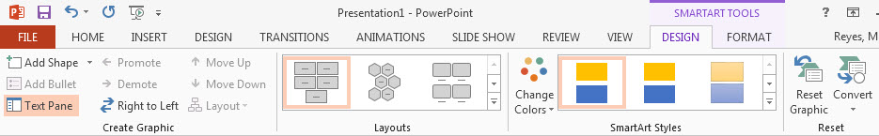
Figure 3.80: Formatting SmartArt

Adding Tables
To create a table:
Step 1: Place the cursor on the page where you want the new table.
Step 2: Click the INSERT Tab of the Ribbon.
Step 3: Click the Table Button on the Tables group (Figure 3.81). You can create a table in one of four ways:
  - Highlight the number of row and columns.
  - Click Insert Table and enter the number of rows and columns.
  - Click the Draw Table, create your table by clicking and entering the rows and columns.
  - Click Excel Spreadsheet and enter data.
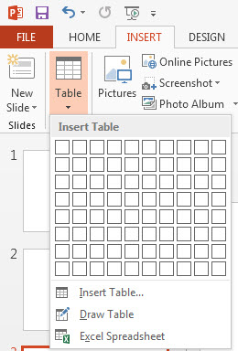
Figure 3.81: Inserting Table

Insert a Table from Word or Excel
Step 1: Open the Word document or Excel worksheet.
Step 2: Select the chart.
Step 3: Click Copy on the HOME tab (Figure 3.82).
Step 4: Go to the PowerPoint document where you want the chart located.
Step 5: Click Paste on the HOME tab (Figure 3.82).
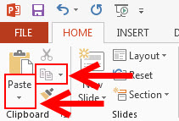
Figure 3.82: Inserting Table from MS Word/Excel

Adding Charts
Charts allow you to present information contained in the worksheet in a graphic format. PowerPoint offers many types of charts including: Column, Line, Pie, Bar, Area, Scatter and more. To view the charts available click the Insert tab on the Ribbon (Figure 3.83).
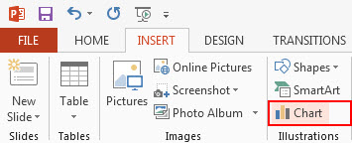
Figure 3.83: Inserting charts

Create a Chart
To create a chart:
Step 1: On the Insert tab, click the Chart ribbon (Figure 3.84).
Step 2: Click the type of Chart you want to create.
Step 3: Insert the Data and Labels.
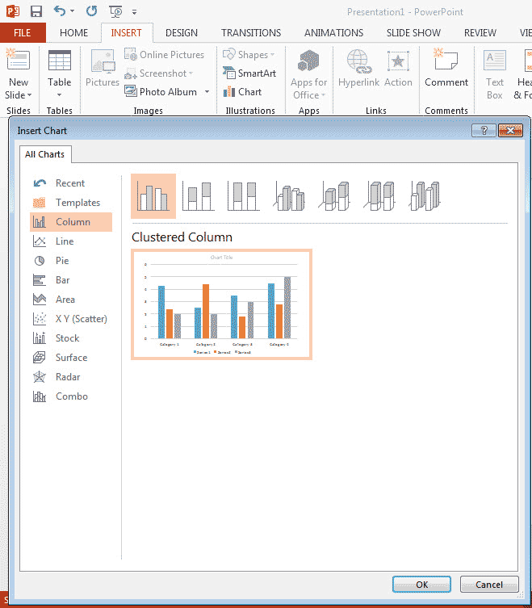
Figure 3.84: Adding Charts
Slide Effects
Slide Transition
Transitions are effects that appear when you switch from one slide to the next during the presentation of your slide show. To add slide transitions:
Step 1: Select the slide that needs transition
Step 2: Click the TRANSITIONS tab (Figure 3.85).
Step 3: Choose the appropriate animation or click the Transition dialog box.
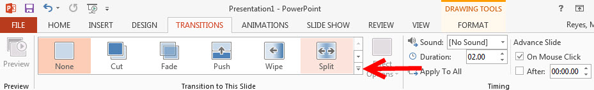
Figure 3.85: Slide Transition effects

To add more effects to slide transitions:
- Add sound by clicking the arrow next to Transition Sound and select your desired sound as shown in Figure 3.86.
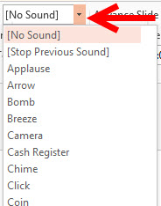
Figure 3.86: Adding sound to transition

- Modify the transition speed by clicking the arrows next to Duration box and adjust the speed to a desired value as shown in Figure 3.87.
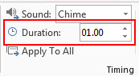
Figure 3.87: Transition speed

To apply the transition to all slides:
- Click the Apply to All button depicted in Figure 3.88.
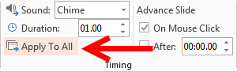
Figure 3.88: Applying transition effect to all slides

To select how to advance a slide, from the Advance Slide options:
Step 1: Choose On Mouse Click, or
Step 2: Choose After and enter a time to have a slide transition automatically after your set time.
This is depicted in Figure 3.89.
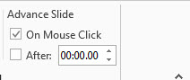
Figure 3.89: Trigger for slide transition

Slide Animation
Slide animation effects are predefined special effects that you can add to objects on a slide. To apply an animation effect:
Step 1: Select the object.
Step 2: Click the ANIMATIONS tab on the Ribbon (Figure 3.90).
Step 3: Click the Animation dialog box.
Step 4: Choose the desired effect.
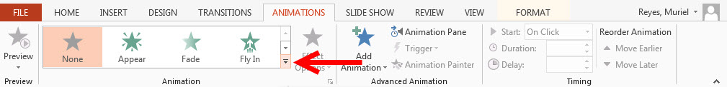
Figure 3.90: Animating slides

Animation Preview
To preview the animation on a slide:
- Click the Preview button on the ANIMATIONS tab as depicted in Figure 3.91.
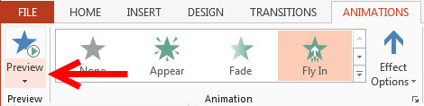
Figure 3.91: Animation preview

Slide Setup and Slide Show
This option allows you to set preferences for how the slide show will be presented. The options include:
- Whether the show will run automatically or will be presented by a speaker
- The looping options
- Narration options
- Monitor resolutions
Figure 3.92 depicts the interface for setting up of these options
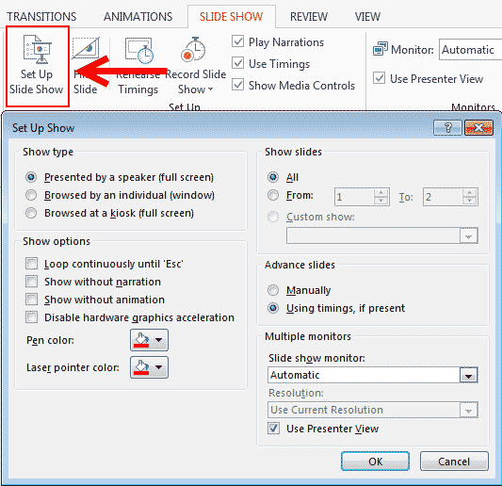
Figure 3.92: slide show setup

Record Slide Show
When you are ready to record narration for the slides:
Step 1: Click the SLIDE SHOW tab (Figure 3.93)
Step 2: Click the Record Slide Show button
Step 3: Choose Start Recording from Beginning OR Start Recording from Current Slide.
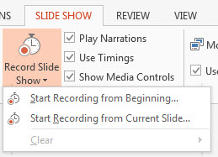
Figure 3.93: Recording slide show

Rehearse Timings
Use Rehearsed Timings to rehearse the timings of slide with audio.
- Click the SLIDE SHOW tab.
- Click the Rehearse Timings button.
- Practice speaking and advance the slides as you would in the presentation.
- When you have completed this, click through to the end of the slide.
- Choose whether or not to keep this timing or to retry.
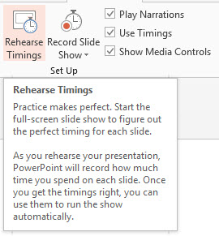
Figure 3.94: Rehearse Timing

PowerPoint 2013 – Printing

Create Speaker Notes
Speaker Notes allow you to create notes for each slide in a presentation. To add speaker notes:
Step 1: Select the slide.
Step 2: Click View tab.
Step 3: Click Note Pages.
Step 5: Click inside the notes text box labeled Click to add text.
Step 6: Type in the Notes for that slide.
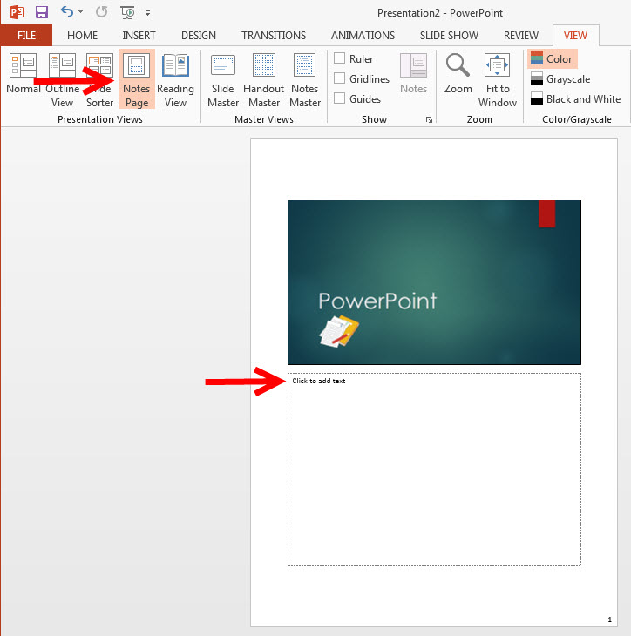
Figure 3.95: Creating Notes

Print a Presentation
There are many options for printing a presentation. They are:
- Slides: These are slides that you would see if you were showing the presentation one slide per page.
- Handouts: 1, 2, 3, 4, 6 or 9 per page, this option allows for more slides per page.
- Notes Page: This includes the slides and the speaker’s notes.
- Outline View: This will print the outline of the presentation..
To access the print options:
Step 1: Click the File menu tab.
Step 2: Click Print (Figure 3.96).
Step 3: In the Print Dialog Box, click the Full Page Slides option.
Step 4: Choose the format and click OK to print.
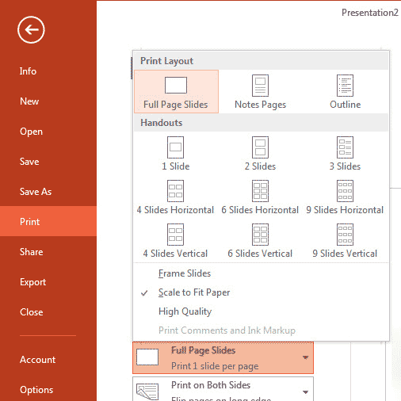
Figure 3.96: Printing Slides
To print preview:
Step 1: Click the File menu tab.
Step 2: Click Print.
Step 3: The preview displays to the right of the screen.
Step 4: Click the arrows below the preview image, to navigate to other slides.
Step 5: Click the Full Pages Slides under Settings to view or change print options.
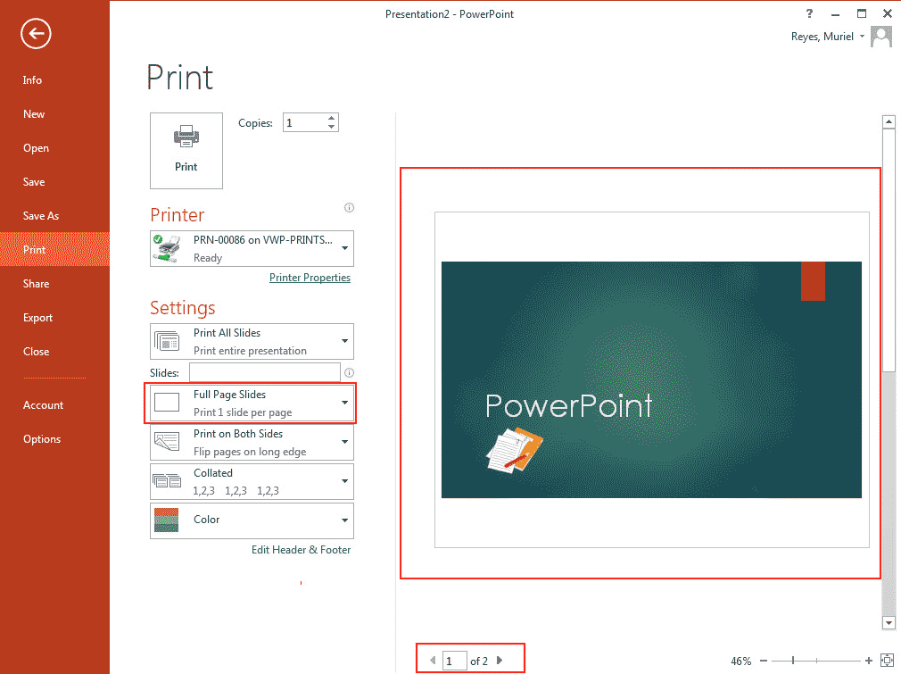
Figure 3.98: Print preview
To Exit Print Preview:
Click the back arrow from the menu to exit print preview.

Figure 3.99: Exiting Preview

Package a Presentation
There are times when you may want to package a presentation with all of the additional files attached. To package a presentation:
Step 1: Click the File menu tab.
Step 2: Click Share.
Step 3: Click Publish Slides from the Share options (Figure 3.100).
Step 4: Click the Publish Slides button.
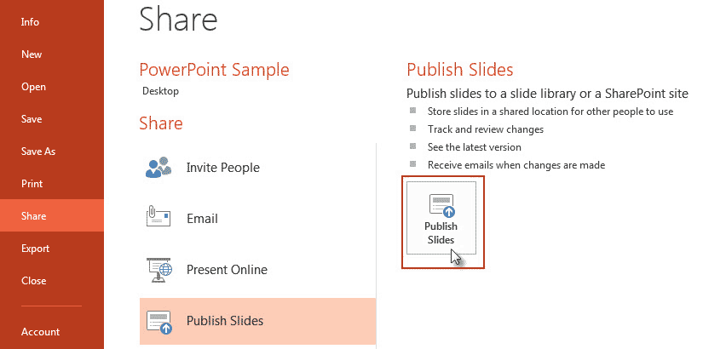
Figure 3.100: Publishing Slides Menu
Step 5: Select the slide(s) you want to publish.
Step 6: Click Browse to choose a location.
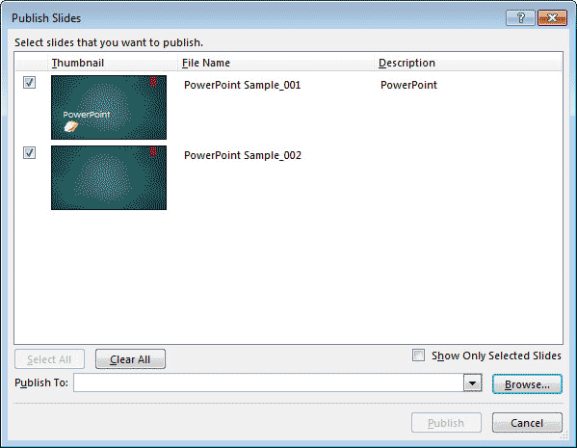
Figure 3.101: Publishing Slides options
Step 7: Select a Slide Library.
Step 8: Choose a folder and click the Select button.
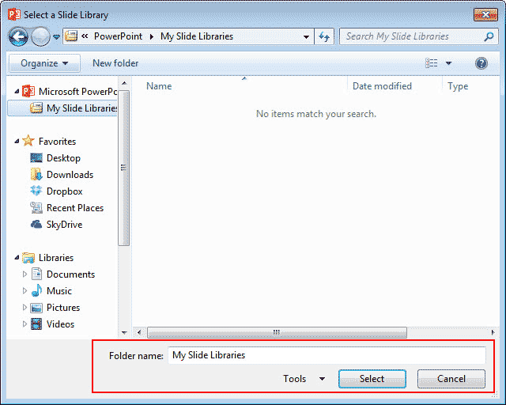
Figure 3.102: Selecting Destination for Publishing Slides
Step 9: Click the Publish button (Figure 3.103).
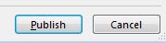
Figure 3.103: Publishing Slides
REFERENCES
- https://www.prattlibrary.org/uploadedFiles/www/locations/central/public_computer_center/Introduction%20to%20Windows.pdf
- http://searchenterprisedesktop.techtarget.com/definition/system-tray
- http://searchenterprisedesktop.techtarget.com/definition/MS-DOS
- http://www.tutorialspoint.com/operating_system/os_services.htm
- https://www.prattlibrary.org/uploadedFiles/www/locations/central/public_computer_center/Introduction%20to%20Windows.pdf
6. https://training.health.ufl.edu/handouts/Access/2010/Access2010Basics-Notes.pdf
7. https://training.health.ufl.edu/handouts/access/2007/Access2007.ppt

8. https://training.health.ufl.edu/handouts/Access/2010/Access2010Basics-Ppnt.pdf

9. http://www.gcflearnfree.org/access2010
CHAPTER FOUR
INTRODUCTION TO DATABASE
¹A. O. BAJEH, ¹A. O. BALOGUN, & ²A. R. Tomori

¹Department of Computer Science
Faculty of Communication and Information Sciences
University of Ilorin

²Computer Service and Information Technology (COMSIT Unit)
University of Ilorin, Ilorin.
Corresponding Author E-mail: bajeh_amos@yahoo.com ; bajehamos@unilorin.edu.ng

4.0 Introduction

The goal of this chapter is to introduce how to design a database using Microsoft Access (MS Access) which is a relational database management system (DBMS) developed by Microsoft. A database is a structured collection of related data. The data could be that of an organization such as the records of all employees in an establishment. A database (DB) is most often electronic which can be saved on computer memory, retrieved and sorted or processed electronically.
A relational database management system comprise of data organized into tables. The tables are made of tuples called records which represent (semi) complete information about an entity. The records are made up of fields which are the attributes of an entity represented as a record. Figure 4.1 depicts a typical Table in a relational DB. The table contains 12 records with 5 fields each: ID, Name, CountryCode, District and Population.
A record
Fields
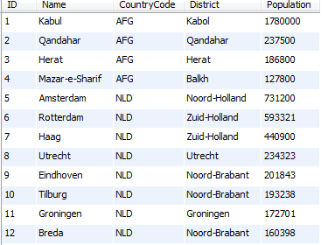
Figure 4.1: Relation DB Table
As shown in the table, collection of fields make up a record and collection of records make up a table. A collection of tables make up a database.
Figure 4.2 depict the interface of MS Access for the creation and management of a relational database. Similar to other Microsoft office applications, MS Access can be launched by selecting the start menu -> All Programs -> Microsoft Office [X] -> Microoft Access [X]. where [X] is the version of office package installed on the computer. For instance to launch Microsoft Access 2010:
start menu -> All Programs -> Microsoft Office 2010 -> Microoft Access 2010
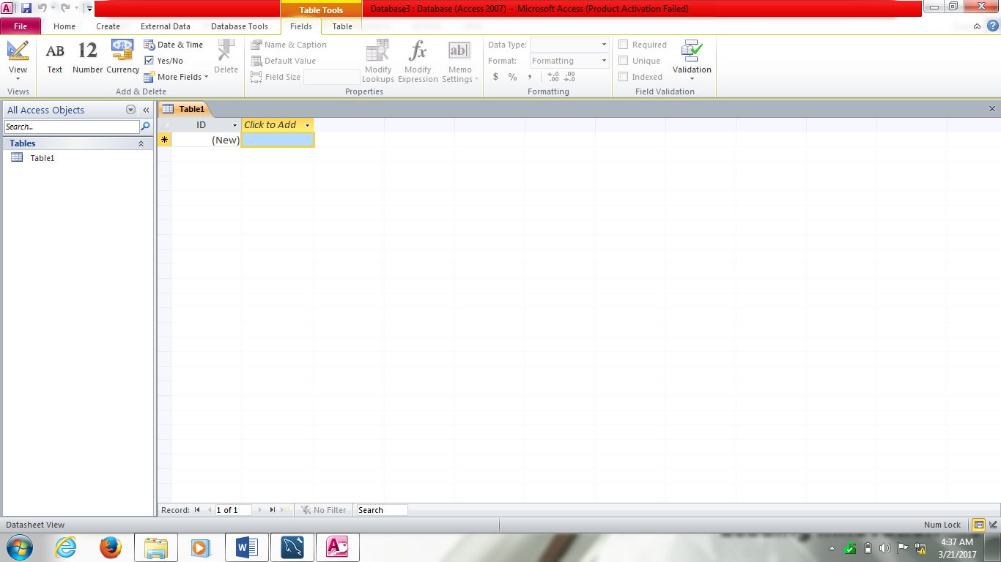
Figure 4.2: MS Access Interface
The interface is very similar to that of other Microsoft office application such as MS Word and MS Excel. The menus are organized into ribbons: File, Home, Create, External Data and Database Tools ribbons. Some of the menu on the ribbons will be used in the course of designing a database.

4.2 Database component
A typical relational database management system such as MS Access contains four components:
- Tables
- Queries
- Forms
- Report

    - Tables
Tables are the store in which data are kept in a database. Accessing data requires direct access to the tables in a database. All Queries, Forms and Reports pull from the data saved in the tables. In MS Access, there are two views for Tables (and other components as well): the Data View and the Design View. The Design view can be used to build the structure of a table by specifying the fields, their data types, size and other information. The Data View can be used for record manipulations: entry, sorting, filtering, editing, and deleting. Figure 4.3 depicts a Customer table in the data view. New records can be entered by clicking on the (New) line with * and typing the values for the various fields of the table.
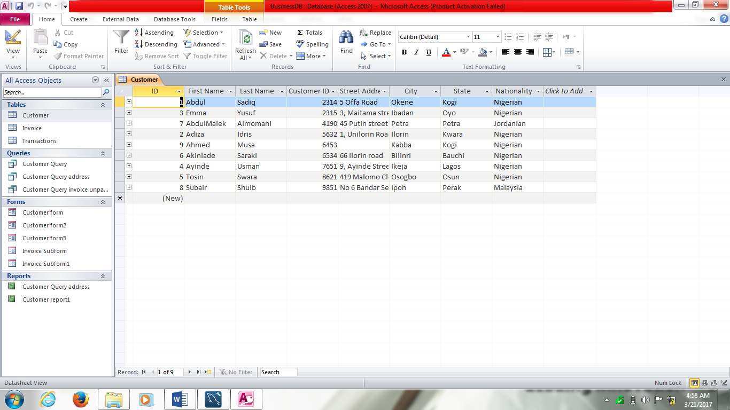
Figure 4.3: An MS Access Table
    - Queries
Queries are commands or instructions designed to retrieve data from one or more tables in the database. They can be designed to fetch data that satisfy certain criteria from the tables and also to perform some computation on data retrieved from some fields in the tables. Queries can also be accessed both in Design view and the data view. The design view provides the features for creating queries while the data view executes and display the results of queries. Figure 4.4 depicts a query in the data view. It shows a result that consist of two records with a calculated field labelled Total.
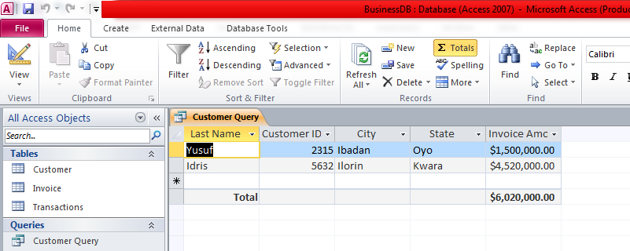
Figure 4.4: a query result in data view
    - Forms
Forms are well-organized medium for entering data into a database. Similar to the conventional form filled by humans, database forms arranges database fields with corresponding text boxes for entering data for the fields. It main purpose is for users to enter data into the database without accidentally altering the structure or design of the database tables. It is also used to view the records in the tables of a database. Figure 4.5 shows a simple form designed for viewing and entering data into Customer table in Figure 4.3. The form consist of the fields in the customer table and thus can be used to view old records and enter new records in the customer table.
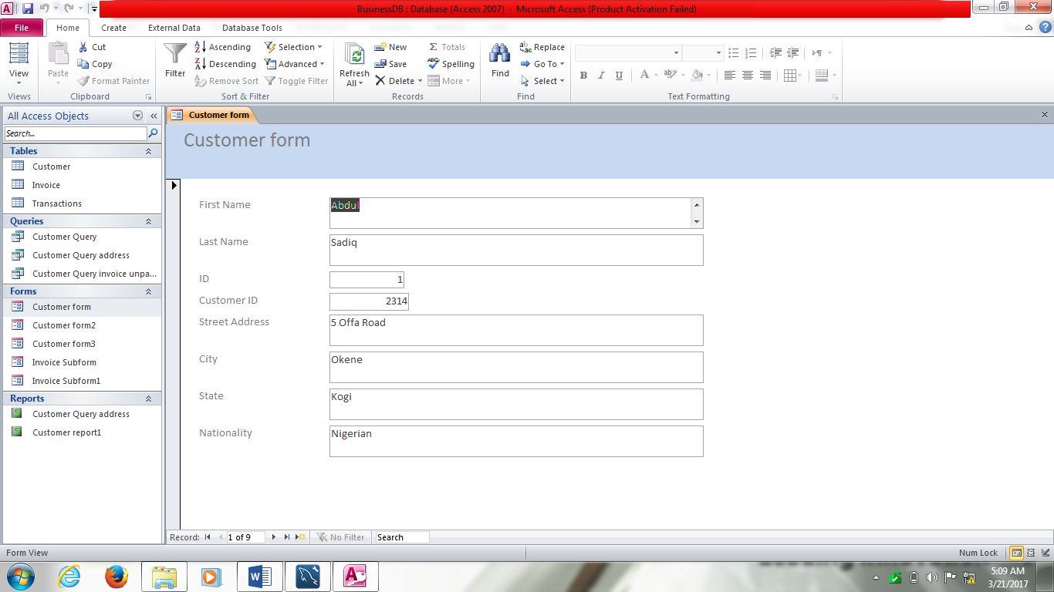
Figure 4.5: A Database Form

    - Reports
Reports are the output of data in an organized form for human consumption. It is simply the print out of data in one or more tables or the results of queries. Figure 4.6 shows a simple report generated from Customer table. The report consist of the eight fields of the Customer table. Reports can also be created from query result.
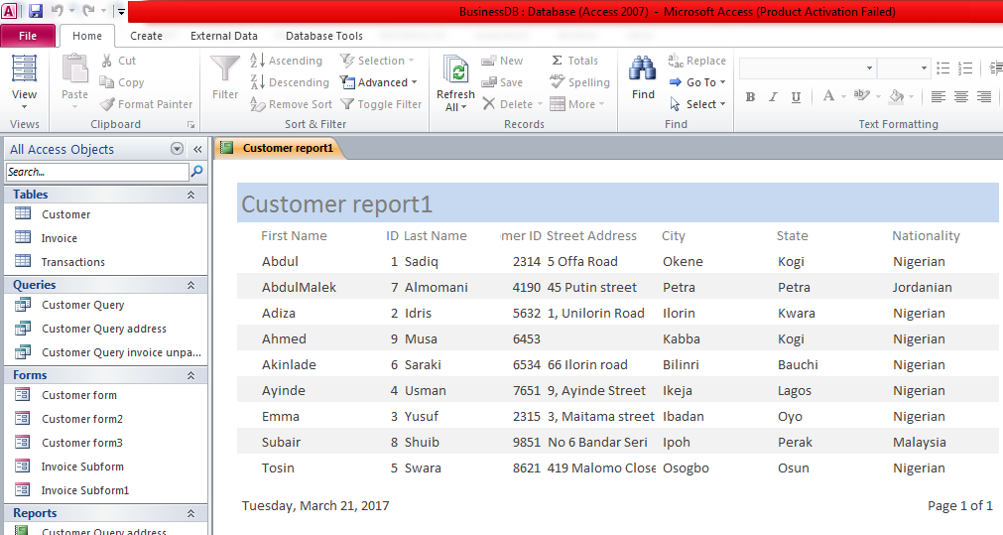
Figure 4.6: A simple database report

4.3 Creating MS Access Database
This section will present the steps for the creation of a MS Access DB by designing DB tables, queries, forms and reports. To demonstrate these concepts, a MS Access database will be designed for a shop where varieties of goods are sold. The database will be named BusinessDB.
4.3.1 Creating the DB
The following steps can be taken to create a database
Step 1: Open Microsoft Access by selecting
Start -> All Programs -> Microsoft Office -> Microsoft Access 2010.
The interface in Figure 4.7 will be displayed.

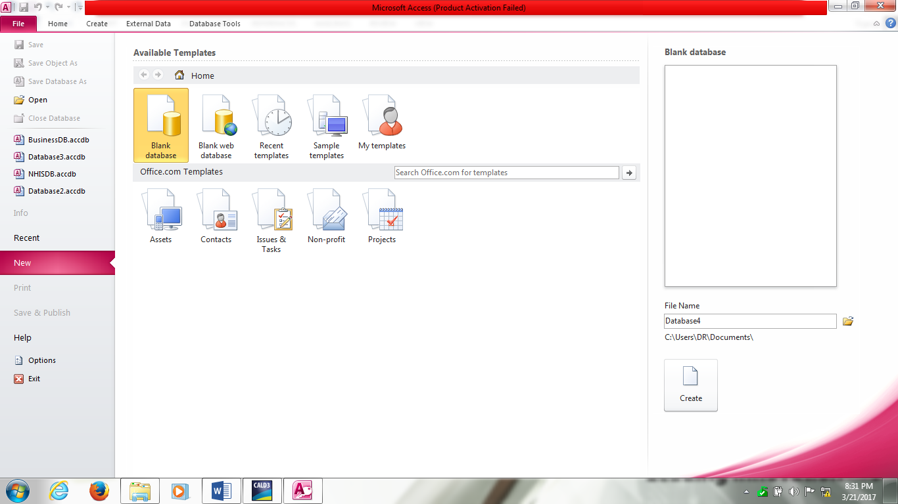
Figure 4.7: MS Access Interface creation

Step 2: Click on Blank Database button on the top center panel.
Step 3: Enter the name of the database, BusinessDB in the File Name text box and select the directory where the database should be saved after it has been created.
Step 4: Click the Create button to create the database using the name entered.
A new blank table will be automatically created as depicted in Figure 4.8. Notice that the table has a default field name ID which uniquely identifies each record that will be entered into the table.
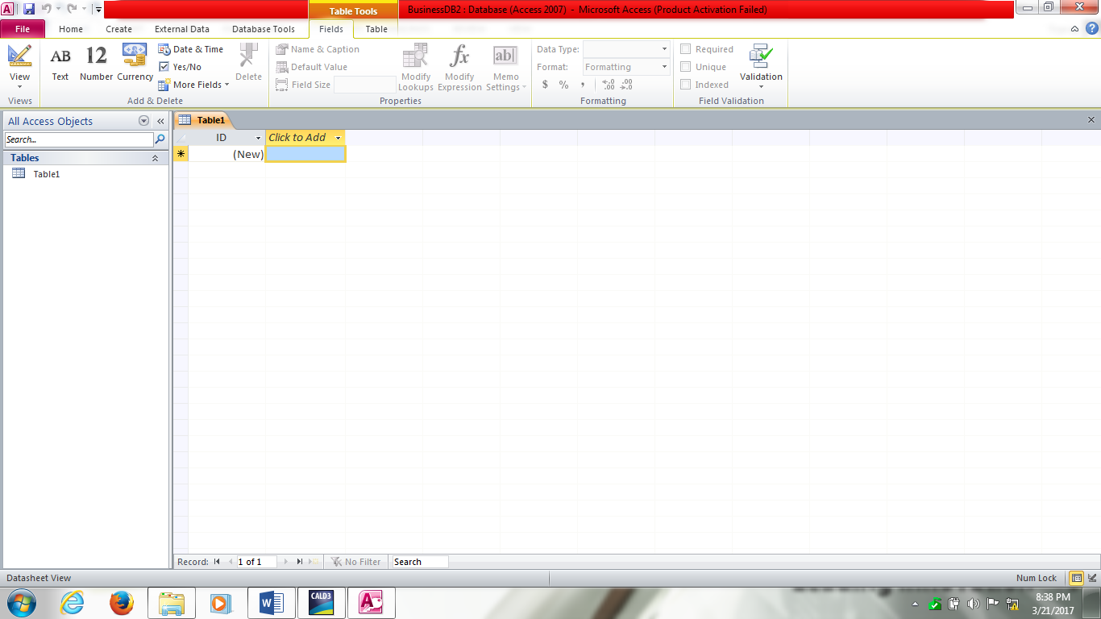
Figure 4.8: A Table automatically created

The table can be discarded or edited into a table for the BusinessDB database. The step for designing table is discussed in the following section.

4.3.2 Designing Table
Step 1: Select Table on the Create ribbon on the MS Access interface depicted in Figure 4.8
Step 2: Click on “click to Add” combo box on the Table interface to select the data type of the field of the Table, as depicted in Figure 4.9.
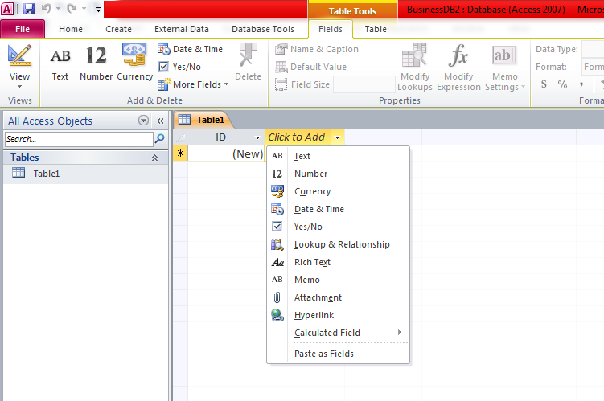
Figure 4.9: Selecting the field data type

Step 3: Enter the name of the field in the highlighted text as depicted in Figure 4.10.
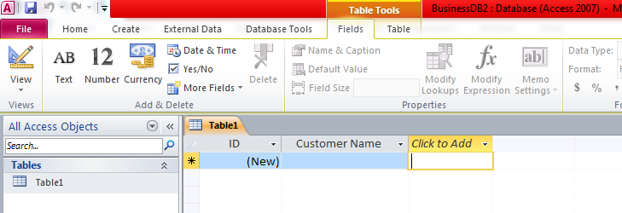
Figure 4.10: Entering Table fields
Step 4: Repeat step 3 for all the fields of the Table.
Step 5: Enter records into the table by clicking on New and typing values for each of the fields of the table. Figure 4.11 depicts the full design view of the Table.
Note that the default ID field is automatically entered and incremented whenever a new record is entered.
Step 6: the designed table can be named by right clicking on the table name at the left hand pane and select rename from the context menu. Type the name of the table and press enter. The designed table is named Customer.

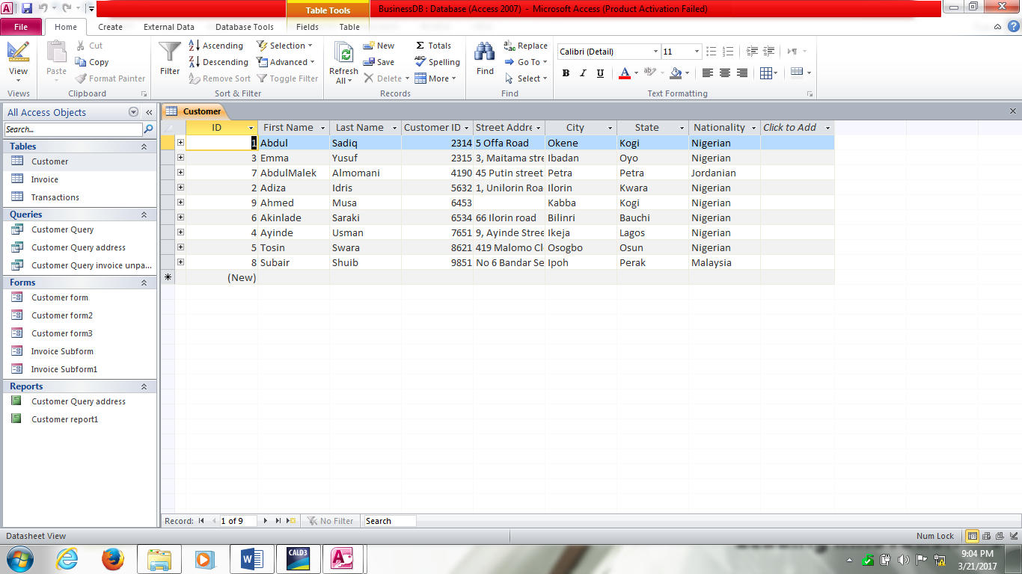
Figure 4.11: fully designed table with records

In the design of Tables in a relational database such as MS Access, two principal components needs to be specified to facilitate the accessing of data from one or more tables in the database. These components are the Primary Key and the Foreign Key.

4.3.2.1 Primary Key
The primary key is the field in a Table that is unique in value for each of the records in the Table. It is used to identify each record from among others. Fields such as Employee ID and Student Matric Number are good primary for Employee and Students Tables respectively.

In MS Access, to set a field as the primary key, the following steps can be taken:

Step 1: Open the Table in the design view mode.
Step 2: Select the field to be made the primary key of the Table (Figure 4.12).
Step 3: Click on the Primary key under the design ribbon. The field will be set as the primary key of the table.

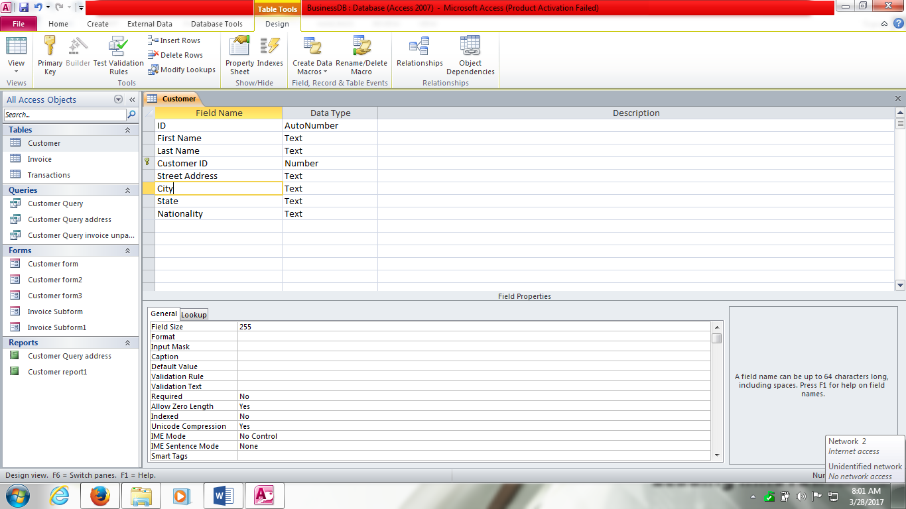
Figure 4.12: Setting the Primary key of a Table

4.3.2.2 Foreign Key
A foreign key is simply one or more fields in a given Table that are primary key in another Table. Foreign key helps in uniquely identifying a related record from the other Table in which the field (Foreign key) is a primary key. For instance the Customer ID field in the Invoice Table in Figure 4.13 is a foreign key in the Table because Customer ID is a Primary key in Customer Table in Figure 4.12.

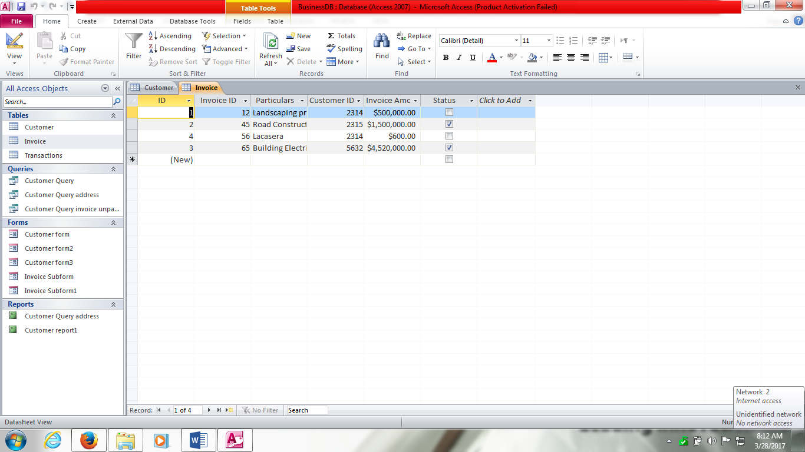
Figure 4.13: Foreign Key
The difference between the primary and foreign keys is that primary key uniquely identifies records in the Table but foreign key may not necessarily identify records uniquely in a Table. Foreign key simply establish a relationship between its Table and the other Table where it is a primary key.

4.3.3 Designing Forms
Forms are the interface through which data can be entered into database Tables. This section presents the basic steps for designing a simple form for entering data into a Table. As an example, a form will be designed for entering data into the Customer Table of the BusinessDB.

Step 1: Select Form Design menu on the Create ribbon. Figure 4.14 depicts the interface for form design. It consist of grid lines for proper alignment of fields and boxes for entering data, and also for adding other contents such as headings, graphs and images.

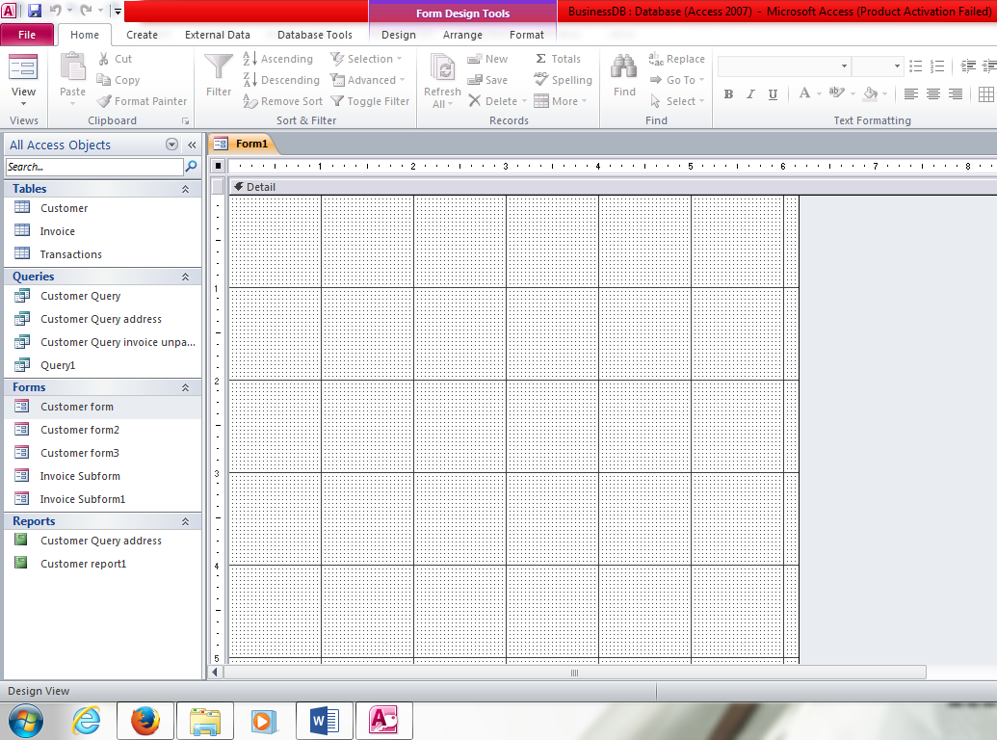
Figure 4.14: Form design interface

To add the fields and the text boxes for entering data, take the following steps:

Step 2: On the Design ribbon, select the Add Existing fields menu. A Field List pane is displayed by the right hand side of the interface. The pane contains the list of the Tables and their fields in the database.
Step 3: Expand the Customer Table to display the fields in the Table.
Step 4: Drag and Drop each of the Fields on the grid layout of the form in the position desired
Alternatively, all the fields can be selected, dragged and dropped them at once. Select all the fields by holding on the CTRL key (control key) on the keyboard while clicking on the fields.
The form can be edited as desired by changing the theme, color, font; adding logo, title date and time, etc. Figure 4.15 depicts a complete form for entering data into the Customer Table.

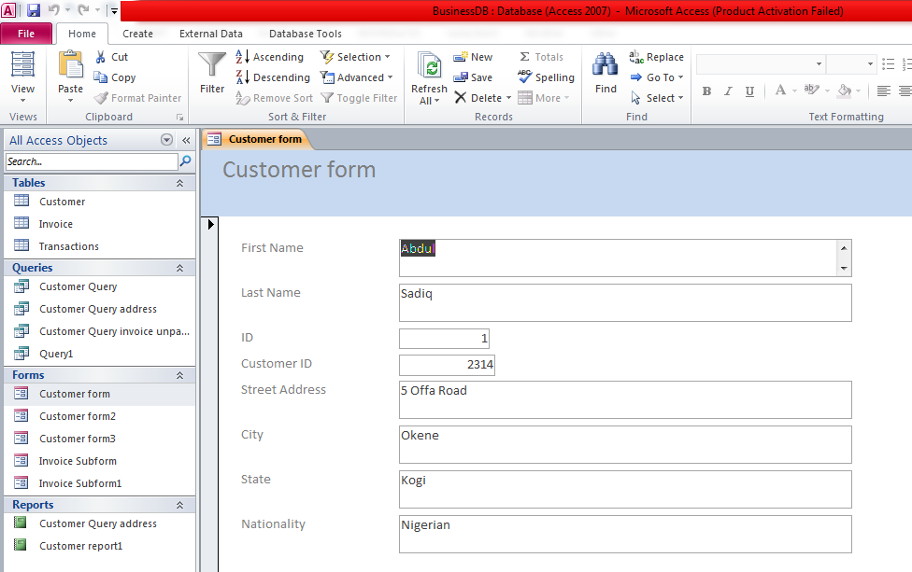
Figure 4.15: Form design

Step 5: To save the form, click on Save on the File menu and enter a name for the form.

A form can also be designed for entering and viewing data into and from more than one tables. This kind of Forms are called compound or complex forms.

4.3.4 Creating Query
As earlier discussed, a query pulls required data from one or more Tables in a database. This section gives the steps for creating a simple query in MS Access. A query that pulls data from the Customer and Invoice Tables of the BusinessDB will be used as an example.

Step 1: Select the Create ribbon.
Step 2: Click Query design under the queries group – this is one of the two approach to creating a query under the Queries group (i.e. query can be created using the query wizard or query design).
The interface in Figure 4.16 is displayed. It consist of a blank query pane, a pane for setting the properties of the query and the Show Table dialogue box that displays all the Tables and queries in the database.

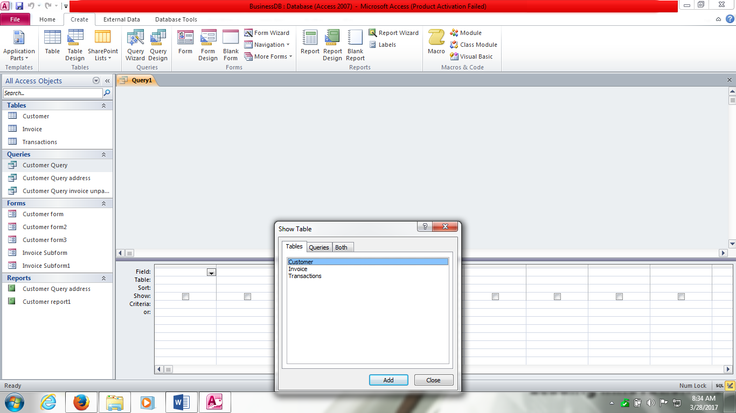
Figure 4.16: Query design interface

Step 3: from the Show Table dialogue box, add the Table(s) from which data is to be pulled for the query by selecting the Table name and clicking on the Add button. Since the query example is to pull data from the Customer and Invoice Tables, add them to the query. When done, close the Show Table dialogue box. Figure 4.17 depicts the resultant interface after adding the two Tables.

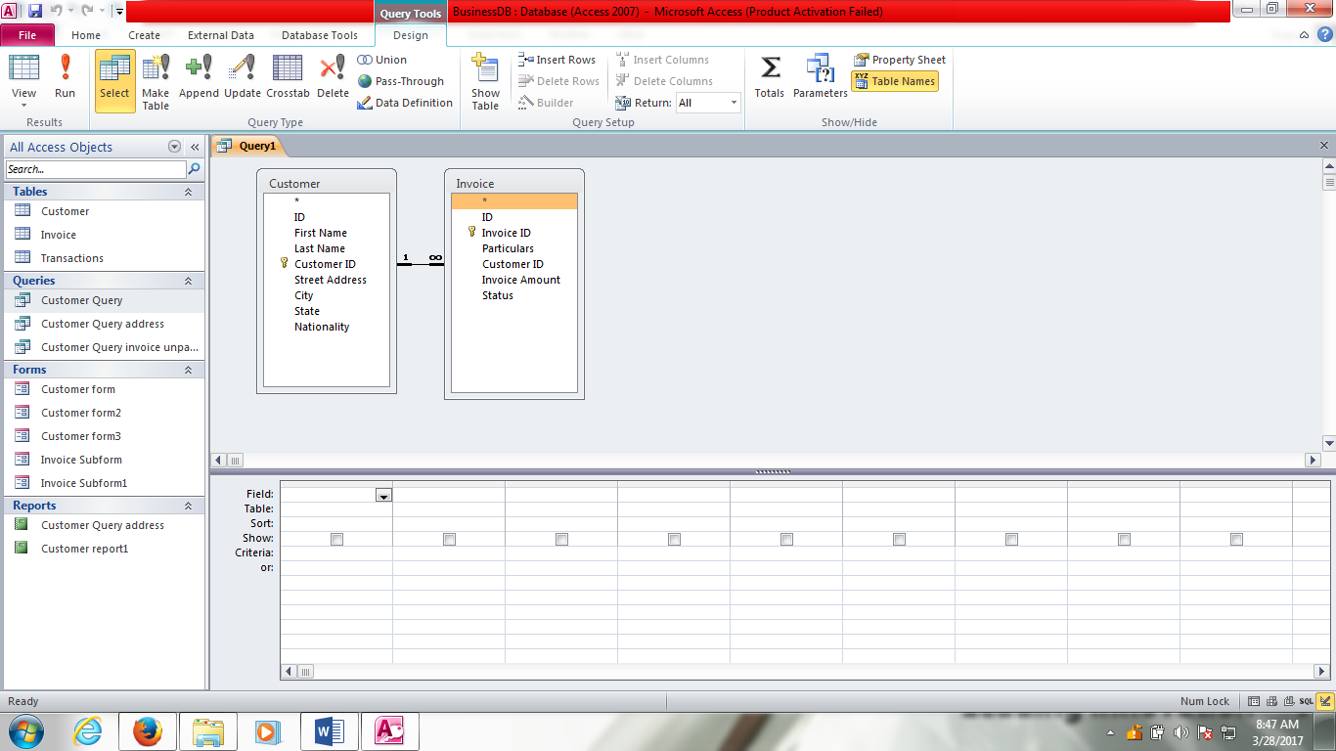
Figure 4.17: Adding Tables to Query

The next steps are to design the query by adding the required fields from the Tables using the pane at the bottom of the query interface.

Step 4: Select the fields by clicking on the arrow in the filed row. The Table row is automatically populated by the Table which the selected field belongs.

Step 5: (Optional) Select the sort row to sort the result of the query either in ascending or descending order of the field.

Step 6: Check or uncheck the show row if the field is to be explicitly shown in the result of the query.

Step 7: (Optional) Set the criteria row to select certain records from the Table that meets the criterion. For instance to pull all records that have ID greater than certain value (10), the criterion “> 10” will be entered.

Step 8: Repeat steps 4 -7 for all the required fields for the query.

Step 9: To save the query, click on Save on the File menu and enter a name for the query.

Figure 4.18 depicts the complete design of a simple query pulling data from the Customer and Invoice Tables.

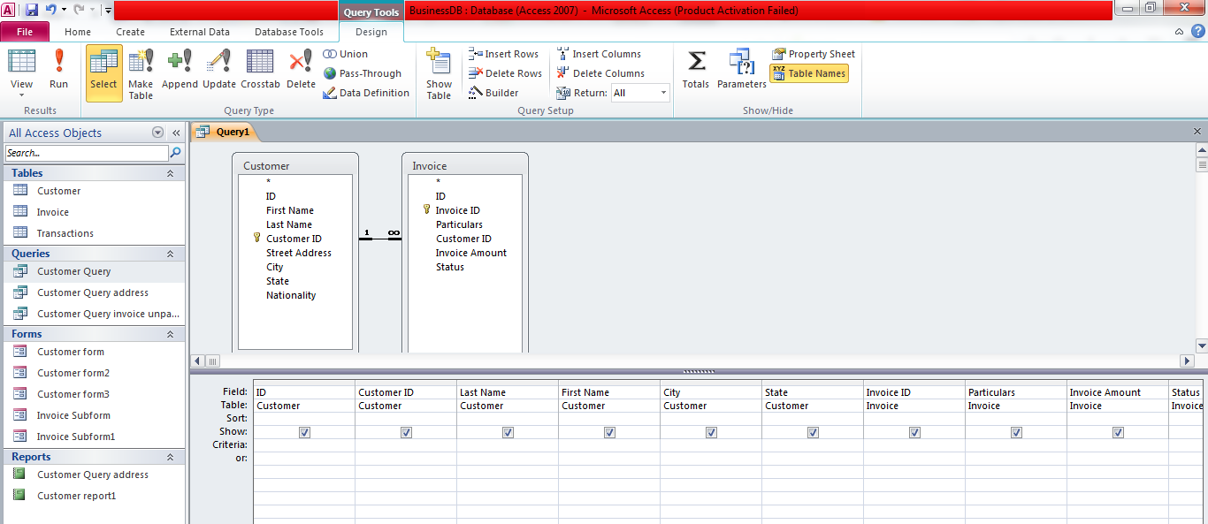
Figure 4.18: Simple query for retrieving data from Customer and Invoice Tables

Having created the query, it can be executed to generate the required results. This is done by clicking on Run on the Design ribbon menu. It will generate the output depicted in Figure 4.19. The result consist of only the 10 fields selected during the design of the query in the order of the fields were selected. The query returns 4 records in the database.

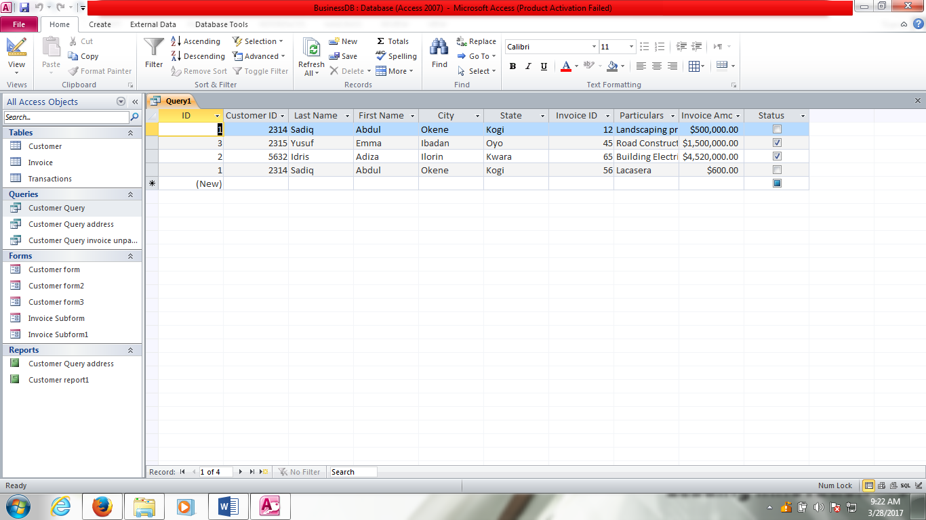
Figure 4.19: Simple query result

4.3.5 Creating Report

Relatively, the creation of report is similar to the creation of query. The interface are almost the same except that the report interface has designated header and footer sections as shown in Figure 4.20. The page header is often used for displaying the fields that will be in the report; that is, the Table fields that will be pulled from the database to make the report. The detailed section is where the records that are part of the report will be displayed. A report header can be added by clicking on the Title menu in the Header and Footer group of the Design ribbon.

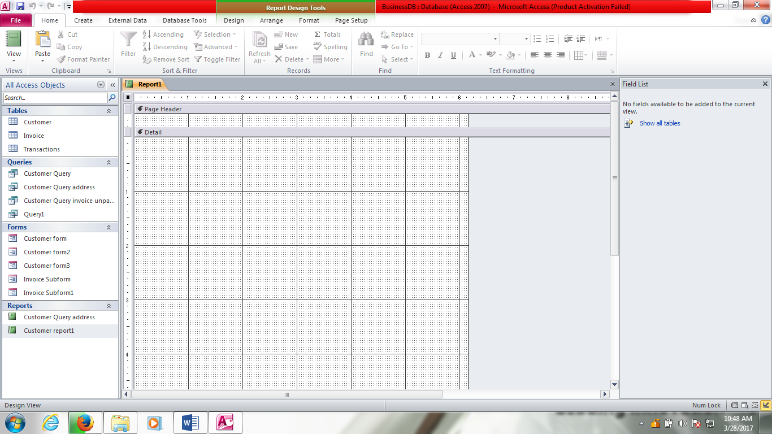
Figure 4.20: Creating report

The following steps can be followed to design a simple report from a MS Access database. As an example, a report that gives the customers the transactions they do will be designed.

Step 1: Select the Report design menu on the Reports group of the Create ribbon. Figure 4.20 will be displayed.
Step 2: Each of the required fields for the report can be dragged and dropped into the report grid area just as it was done in the creation of query. All the fields can also be selected at once by holding down the CTRL key while clicking on the fields. Figure 4.21 depicts the report for the example been demonstrated after performing this step.

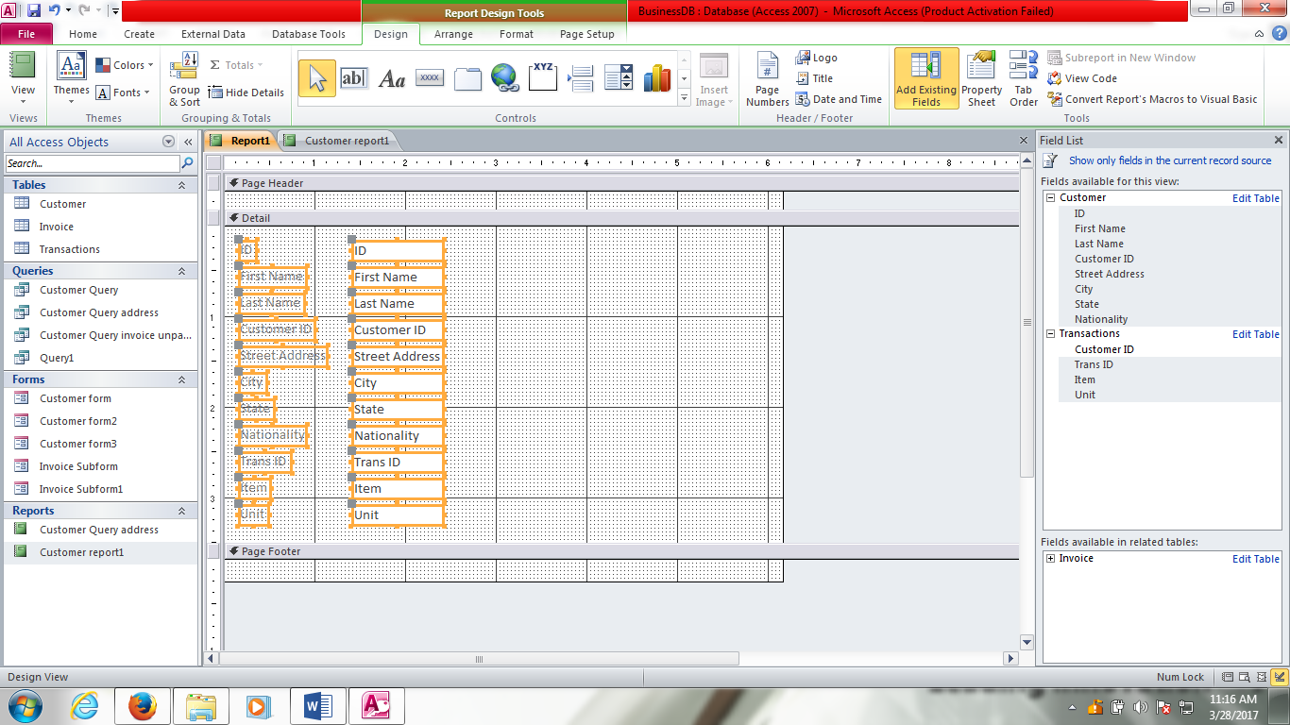
Figure 4.21: Report creation, step 2

Step 3: To organize the report in a tabular form so that there will be a header of the fields and the detail containing the record, highlight all the fields added to the report as depicted in Figure 4.21, right-click on one of the fields and select Layout and then Tabular from the context menu. This will re-arrange the labels and boxes of the fields, putting the labels on the Page Header section and the boxes on the Detail section as depicted in Figure 4.22.
This step can also be accomplished by clicking on the Tabular menu in the Table group of the Arrange ribbon as shown in Figure 4.23.
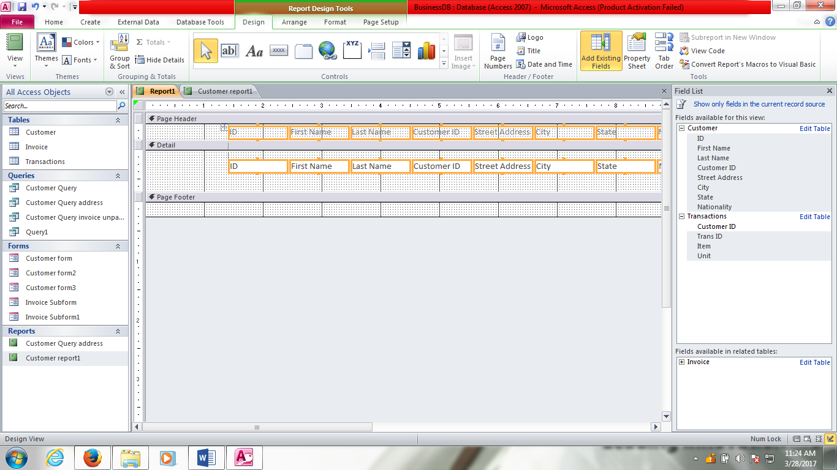
Figure 4.22: Report creation, step 3

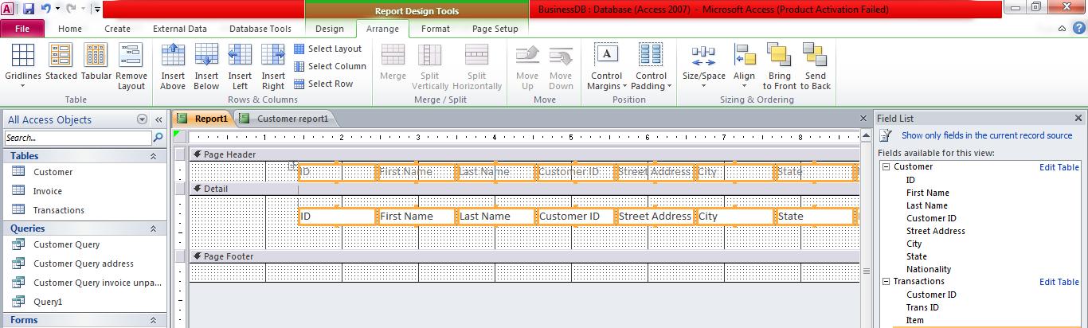
Figure 4.23: arranging the fields in Tabular form

Note that the Page Footer section has been dragged up to close the empty space in the Detail section.

An example of a report generated from the BusinessDB database is depicted in Figure 4.24.

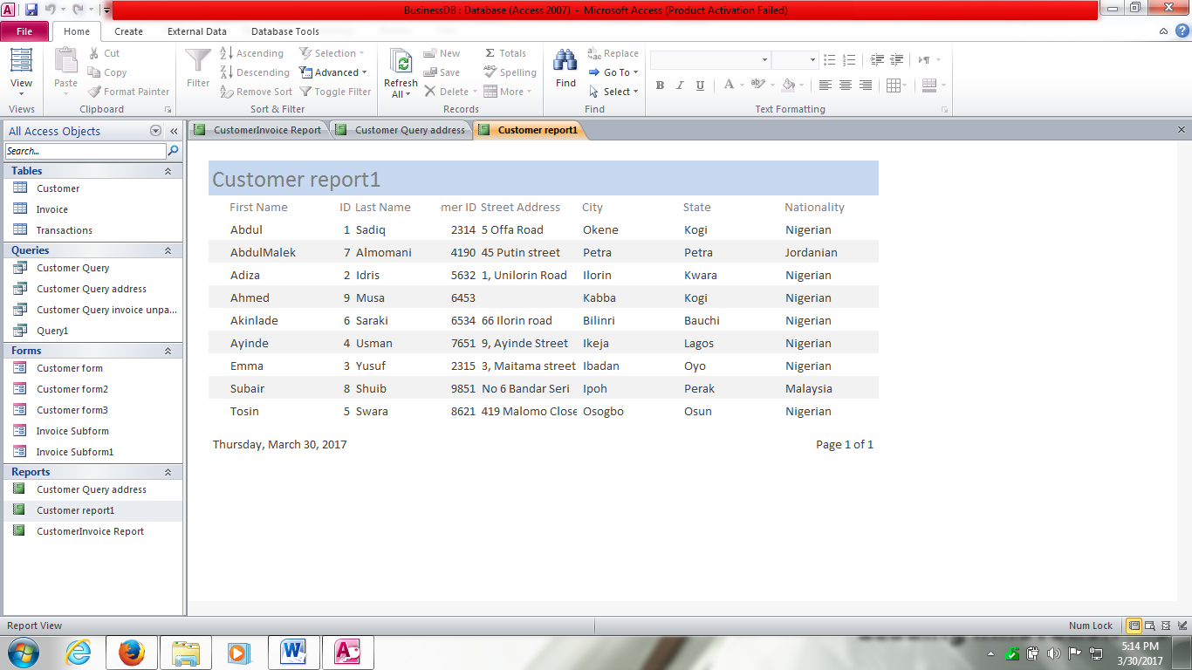
Figure 4.24: Database Report output
A report header has been added to the report. It can be printed by selecting Print from the File menu.

CHAPTER FIVE

INTERNET AND THE WEB

O.C. Abikoye, A.G. Akintola & H. A. Mojeed

Department of Computer Science

Faculty of Communication and Information Sciences

Corresponding Author e-mail address: kemi_adeoye@yahoo.com, abikoye.o@unilorin.edu.ng

5.1 INTERNET AND THE WEB

5.1.1 What is the Internet?

The Internet is also often referred to as the Net. This is the means of connecting a computer to any other computer anywhere in the world via dedicated routers and servers. i.e a worldwide system of computer networks - a network of networks (interconnection of networks) in which users at any one computer can, if they have permission, get information from any other computer (and sometimes talk directly to users at other computers). It connects millions of computers together globally, forming a network in which any computer can communicate with any other computer as long as they are both connected to the Internet. Information that travels over the Internet does so via a variety of languages known as protocols. When two computers are connected over the Internet, they can send and receive all kinds of information such as text, graphics, voice, video, and computer programs. Any computer on the internet is identified by an Internet Protocol (IP) address.


Figure 5.1: A Diagram depicting computers connected together on the Internet.

5.1.2 What is The Web (World Wide Web)?
The World Wide Web, or simply Web, is a way of accessing information over the medium of the Internet. It is a collection of interconnected documents and other resources, linked by hyperlinks and Uniform Resource Locators (URLs). It is also an information-sharing model that is built on top of the Internet. The Web uses the Hyper Text Transfer Protocol (HTTP) to transmit data. The Web also utilizes browsers, such as Internet Explorer, Firefox, Opera Mini, Google Chrome etc to access Web pages. Web documents also contain graphics, sounds, text and video.

5.1.3 The Web is a Portion of the Internet
The Web is just one of the ways that information can be disseminated over the Internet. The Internet, not the Web, is also used for email, which relies on Simple Mail Transfer Protocol (SMTP), Usenet news groups, instant messaging and File Transfer Protocol (FTP). It is one of the services communicated via the internet.


Figure 5.2: A diagram depicting WWW

5.1.4 Internet Providers
An Internet Service Provider (ISP) is an organization that provides services for accessing, using, or participating in the Internet. Internet service providers may be organized in various forms, such as commercial, community-owned, non-profit, or otherwise privately owned. Internet services typically provided by ISPs include Internet access, Internet transit, domain name registration, web hosting, Usenet service, and collocation.

Internet service providers are connected to the Internet. The most widely used ISPs are national and wireless. Connection technologies include dial-up, Digital Subscriber Line (DSL), cable, and wireless modems. Internet Service provider can be categorized into the following
1. Access providers ISP
2. Edge providers
3. Mailbox providers
4. Hosting ISPs
5. Transit ISPs
6. Virtual ISPs
7. Free ISPs

8. Wireless ISP
Internet Service Providers (ISP) serves as the main entry or gateway access to the world largest network of computers, the internet. ISP companies are charged with the sole responsibilities of providing, distributing and regulating internet access to individuals, organizations and government establishment. Below is the list of some ISP companies in Nigeria.
1. NETCOM Africa
2. SWIFT
3. IPNX Nigeria
4. ETISALAT
5. SPECTRANET
6. SMILES
7. GLOBACOM
8. VDT Communications
9: MTN Nigeria
10. VISAFONE
5.2 CONNECTIONS AND PROTOCOLS
5.2.1 Connections
In telecommunication and computing in general, a connection is the successful completion of necessary arrangements so that two or more parties (for example, people or programs) can communicate at a long distance. In this usage, the term has a strong physical (hardware) connotation although logical (software) elements are usually involved as well.

5.2.2 Protocol

The communications between the computers are possible because of a set of protocols, which is a set of rules about exactly how information will be transferred between the computers on the Internet. Protocols specify interactions between the communicating entities. The two most important protocols that allow networks to cooperate with one another and exchange information are called TCP (Transmission Control Protocol) and IP (Internet Protocol). Collectively, these two protocols are known as TCP/IP.
…
FTP
HTTP
RTP
TFTP
TCP
UDP
IP
Ethernet
802.11
PPP
CAT-5
Single-Mode
Fiber
RS-232

Figure 5.3: TCP/IP Protocol Stack

FTP: File Transfer Protocol

HTTP: Hypertext Transfer Protocol

RTP: Real Time Transport Protocol

TFTP: Trivial File Transfer Protocol

UDP: User Datagram Protocol

PPP: Point to Point Protocol
Purpose of the Internet Protocol
- The IP protocol defines the basic unit of data transfer.
- IP software performs the routing function.
- IP includes a set of rules that embody the idea of unreliable packet delivery:
- How hosts and routers should process packets ƒ.
- How and when error messages should be generated ƒ .
- Conditions under which packets can be discarded.

5.3 MAILING SYSTEM
At the sender, data is broken into packets and sent to the nearest node (router). At each router, it sends the packet to another router that is closer to the final destination and at the receiver; packets are reassembled to get the original data. Examples include e-mail.

Figure 5.4: A diagram depicting a mailing system

5.3.1 E-mail
Electronic mail, most commonly called email or e-mail since around 1993, is a method of exchanging digital messages from an author to one or more recipients. Email operates across the Internet or other computer networks.
Email is an information and communications technology. It uses technology to communicate a digital message over the Internet. There are many software platforms available to send and receive. Popular email platforms include Gmail, Hotmail, Yahoo Mail, Outlook, and many others. A typical e-mail address consists of four basic components which include the user name, the "@" symbol, the mail server and the top-level domain. Example of an e-mail address is abikoye.o@unilorin.edu.ng. In this context

User name – abikoye.o , a user name can be a position at a company such as "CEO" or a user name can be part of a name such as "kemi_adeoye."
@ - "at" symbol which separates the user name from the second part of the email address, which begins with the mail server.
Mail server – unilorin , which identifies the institution or company that owns the email server.
Top level domain- .edu.ng, this is the last part of the email which breaks down various websites into hierarchies. Several top-level domains include ".com" used for commercial businesses, ".org" used for non-profit agencies and groups, ".edu" for educational institutions and ".gov" for government agencies.

5.4 INTERNET SERVICES
- Electronic mail: E-mail provides a mechanism for group of people who have common interests to establish and maintain contact.
- Remote terminal: This service allows you to log-on to a remote machine, on which you have your account.
- File transfer: This is achieved by FTP. FTP is an abbreviation for File Transfer Protocol. FTP is used to send a copy of a file from one computer to another. The files can be sent across using FTP which includes spreadsheets, digitized pictures, sound files, programs, word – processed files, etc.
- Newsgroups: There are many ways to meet people and share information – using Internet. One of such ways is Usenet newsgroups. These are special groups set up by people who want to share common interests ranging from current topics to cultural heritage. There are currently thousands of newsgroups.
- File sharing
- Resource distribution
- World Wide Web
- Video conferencing
- Games
5.5 E-commerce
E-commerce (electronic commerce or EC) is the buying and selling of goods and services, or the transmitting of funds or data, over an electronic network, primarily the Internet. i.e the buying and selling of goods over the Internet. The terms e-commerce and e-business are often used interchangeably. The term e-tail is also sometimes used in reference to transactional processes around online retail.
Electronic commerce draws on technologies such as mobile commerce, electronic funds transfer, supply chain management, Internet marketing, online transaction processing, electronic data interchange (EDI), inventory management systems, and automated data collection systems.
Three basic types of e-commerce are business-to-consumer, business-to-business, and consumer- to-consumer.
1. Business-to-Consumer E-Commerce (B2C)
This is the e-commerce between companies and consumers. Most widely used business-to-consumer (B2C) applications are online banking, online stock trading, and online shopping.
2. Business-to-Business E- commerce (B2B)
B2B e-commerce is simply defined as e-commerce between companies. This is the type of e-commerce that deals with relationships between and among businesses. About 80% of e-commerce are of this type.
3. Consumer-to-Consumer E-Commerce (C2C)
C2C is simply commerce between private individuals or consumers. This type of e-commerce is characterized by the growth of electronic marketplaces and online auctions, particularly in vertical industries where firms/businesses can bid for what they want from among multiple suppliers. Web auctions are growing consumer-to-consumer (C2C) application. Two basic types are auction house sites and person-to-person auction sites.
This type of e-commerce comes in at least three forms:
- auctions facilitated at a portal, such as eBay, which allows online real-time bidding on items being sold in the Web;
- peer-to-peer systems, such as the Napster model (a protocol for sharing files between users used by chat forums similar to IRC) and other file exchange and later money exchange models; and
- classified ads at portal sites such as Excite Classifieds and eWanted , Pakwheels.com (an interactive, online marketplace where buyers and sellers can negotiate and which features “Buyer Leads & Want Ads”).
Other types of E-commerce include Business-to-government e-commerce or B2G, M-commerce (mobile commerce), Consumer-to-Business (C2B), Business-to-Administration (B2A) & Consumer-to-Administration (C2A)

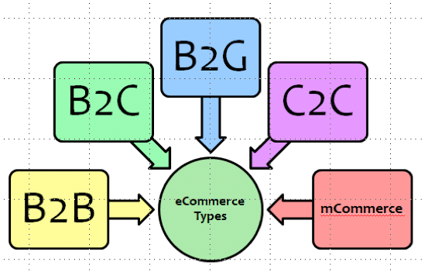
Figure 5.5: Types of E-commerce
5.6 BROWSERS & SEARCH TOOLS
5.6.1 Meaning and List of web browsers

A web browser is a client program that request services from a web server. Web sites are hosted on dedicated computers known as ‘web servers’. Web browsers display web pages delivered from a web server. Browsers access the Web, allowing you to surf or explore. Some related terms are:
• URLs: locations or addresses to Web resources; two parts are protocol and domain name;

top-level domain (TLD) identifies type of organization.
• HTML: commands to display Web pages; hyperlinks (links) are connections.
• JavaScript: a scripting language that adds basic interactivity and form checking to Web pages. AJAX allows rapid response time.
• Applets: special programs linked to Web pages; typically written in Java.
• Mobile browsers: run on portable devices; display on very small screens; provide special navigational tools.

A popular and mostly used web browser include internet explorer, others are listed below.

Opera
Opera also provides a mobile web browser, Opera Mini.

Firefox iCab

Mozilla Firefox  iCab Mobile is also available for iPhone, iPod Touch and iPad.

Safari Konqueror


Google Chrome Epiphany


SeaMonkey


K-Meleon


OmniWeb


5.6.2 Search Tools
Search allows you to search content created by tools within a worksite or course. It achieves this by creating an index of all content that other tools make available to the search tool. This index is updated automatically, so as content is added to the worksite or course, it will be indexed.
Search indexes have many different types of content, including messages, web pages in Hyper Text Markup Language (HTTML) format, documents in DOC, PDF, or RTF format, spreadsheets in XLS format, and Wiki pages.
There are three basic types of search tools that most people use to find what they are looking for on the Web.
- Search Engines
- Subject Directories
- MetaSearch Tools
A. Definition and List of Search Engines
A search engine is a computer program that is used to look for information on the internet. A search engine searches documents for specified keywords and return a list of marching documents. Search engines are large, spider created databases of web pages that help searchers find specific information on any given subject. You type in a keyword or phrase and the search engine retrieves pages that correspond to your search query.
Search results gathered from these search engines are not always relevant to the keywords entered, since these engines are not intuitive and cannot infer dynamically what it is you might be searching for (although results are getting better all the time).

1.  Google 2. Infospace

3.  Bing 4. Info

5.  Yahoo! Search 6.  DuckDuckGo
7.  Ask 8.  Blekko

9. Aol Search 10.  Contenko

11.  Wow 12.  Dogpile
13.  WebCrawler 14. Alhea
15. MyWebSearch

B. Subject Directories
Subject directories in general are smaller and selective than search engines. They use categories to focus your search, and their sites are arranged by categories, not just by keywords. Subject directories are handy for broad searches, as well as finding specific web sites. Most subject directories' main purpose is to be informational, rather than commercial.
A good example of a search directory is Yahoo, a combination search engine/search directory/search portal, or one of the original search directories, Open Directory or DMOZ for short.

C. Definition and list of Metasearch Engines

A metasearch engine (or aggregator) is a search tool that uses another search engine's data to produce their own results from the Internet. Metasearch engines take input from a user and simultaneously send out queries to third party search engines for results.

Examples of Meta-search Engines include Blingo , Yippy (formerly Clusty) , DeeperWeb ,Dogpile, Excite , HotBot , Info.com , Ixquick (StartPage), Kayak and SideStep, Mamma ,Metacrawler , Mobissimo , Otalo , PCH Search, and Win, and Skyscanner WebCrawler.
5.7 WEB UTILITIES
Web utilities are specialized utility programs that make using the Internet and the Web easier and safer.
There are two categories of web utilities:
(a) Plug-ins
  - Programs that automatically load and operate as part of your browser.
  - Many web sites require plug-ins for users to fully experience web page contents.
  - Some plug-ins are included in many of today’s browsers; others must be installed.
  - Some widely used plug-ins are:
    - Shockwave
    - Quicktime
(b) Helper Applications (add-ons)
  - Independent programs that can be executed or launched from your browser.
  - Four types of helper applications are:
    - Off-line browsers
      - Automatically connects you to selected web sites.
      - Downloads HTML documents.
      - Saves them to your hard disk.
      - Documents can be read later without connecting to the Internet.
      - Example:
        - FlashSite
    - Information pushers
      - Automatically gathers information on topics areas (channels).
      - Sends them to your hard disk.
      - Information can be read later without being connected to the Internet.
      - Examples:
        - PointCast
        - Backweb
    - Off-line search utilities
      - Automatically submits your search request to several search engines.
      - receives the results, sorts them, and eliminates duplicates
      - Examples:
        - Metacrawler
        - Dogpile
    - Filters
      - Programs that can allow parents or organizations to block out selected sites.
      - Can monitor usage and generate reports detailing time spent on activities.
      - Examples:
        - Cyber Patrol
        - Cybersitter
        - Net Nanny

5.8 FILE TRANSFER UTILITIES
File transfer utilities copy files to (downloading) and from (uploading) your computer. Three types are
- File Transfer Protocol (FTP) and Secure File Transfer Protocol (SFTP) allow you to efficiently copy files across the Internet.
- Web-based file transfer services make use of a Web browser to upload and download files.
- BitTorrent distributes file transfers across many different computers.
5.9 INTRANET AND EXTRANET
5.9.1 Intranet
An intranet is a computer network that uses Internet Protocol technology to share information, operational systems, or computing services within an organization. This term is used in contrast to extranet, a network between organizations, and instead refers to a network within an organization.
An intranet is also basically a network that is local to a company. In other words, users from within this company can find all of their resources without having to go outside of the company. An intranet can include Local Area Networks (LANs), private Wide Area Networks (WANs) and Metropolitan Area Networks (MANs).

5.9.2 Extranet
An extranet is a private network that uses Internet technology and the public telecommunication system to securely share part of a business's information or operations with suppliers, vendors, partners, customers, or other businesses.
An extranet is also an extended intranet, where certain internal services are made available to known external users or external business partners at remote locations.
5.10. FIREWALL
A firewall is a network security system that monitors and controls the incoming and outgoing network traffic based on predetermined security rules. A firewall typically establishes a barrier between a trusted, secure internal network and another outside network, such as the Internet, that is assumed to not be secure or trusted. It is a part of a computer system or network that is designed to block unauthorized access while permitting outward communication. It is also a device or set of devices configured to permit, deny, encrypt, decrypt, or proxy all computer traffic between different security domains based upon a set of rules and other criteria.
Firewalls can be implemented in both hardware and software, or a combination of both. Firewalls are frequently used to prevent unauthorized Internet users from accessing private networks connected to the Internet.
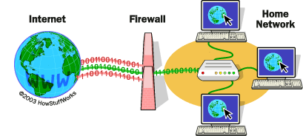

REFRENCES
1. Teach ICT- GCSE ICT- The internet and the WWW. Available at:.http://www.teach-ict.com/gcse_news/internet/internet_www/miniweb/pg5.htm . Retrieved 25 May, 2015
2. Teach ICT- GCSE ICT- The internet and the WWW. Available at: http://www.teach-ict.com/gcse_news/internet/internet_www/miniweb/pg4.htm. Retrieved 25 May, 2015
3. Top 15 Most Popular Search Engines | February 2015 http://www.ebizmba.com/articles/search-engines. Retrieved 25 May, 2015
4. http://searchwindevelopment.techtarget.com/definition/Internet
5. https://www.reference.com/technology/different-parts-email-address-2b83fd5ca98b21cc. Retrieved 31 August, 2016
6. http://www.studentprojectideas.com/wp-content/uploads/2014/06/Intranet-Mailing-System.jpg. Retrieved 31 August, 2016
7 https://encrypted-tbn1.gstatic.com/images?q=tbn:ANd9GcSbi53Znyvwd1z-KhDU9WuZDk-lh3mCULGf2onMzfOIM2raKtH6uQ. Retrieved 31 August, 2016
8. Sameer S Paradkar(2014)” eCommerce in the Customer Empowerment Era” Available at: http://www.bptrends.com/bpt/wp-content/uploads/03-04-2014-ARTeCommerce-in-the-Customer-Empowerment-Era-Paradkar.pdf. Retrieved 25 January, 2016.

9. Jeff Tyson, “How Firewalls Work” Available at: http://computer.howstuffworks.com/firewall.htm. Retrieved 25 May, 2015
10. http://s.hswstatic.com/gif/firewall.gif Retrieved 25 May, 2015

COMPUTER SECURITY AND PRIVACY
R. G. JIMOH, O. C. ABIKOYE, & A. O. BALOGUN
Department of Computer Science
Faculty of Communication and Information Sciences
University of Ilorin
Corresponding Author E-mail: jimoh_rasheed@yahoo.co; jimoh_rasheed@unilorin.edu.ng

6.1 CONCEPTS AND TERMINOLOGIES OF COMPUTER SECURITY
Generally, security means "freedom from risk or danger." In the context of computer science, security is the prevention of, or protection against:
- access to information by unauthorized recipients, and
- intentional but unauthorized destruction or alteration of that information.
This can be re-stated: "Security is the ability of a system to protect information and system resources with respect to confidentiality and integrity." Note that the scope of this second definition includes system resources, which include CPUs, disks, and programs, in addition to information.
The term computer security has evolved in recent years. Before the problem of data security became widely known and publicized, most people’s idea of computer security is focused on the physical machine, the computer system in this case.
Traditionally, computer facilities need to be protected for the following three reasons:
- To prevent unauthorized access or damage to the computer hardware.
- To prevent unauthorized access or damage to the information on the computer system.
- To prevent disruption or break up of service by the computer system.
Consequently, trying to give a suitable definition to "computer security" is quite a problem. The problem lies in developing a definition that is broad enough to be valid regardless of the system being described, yet specific enough to describe what security really is.
Computer security is the application of protective mechanisms to computing devices such as computers and smartphones, as well as computer networks such as private and public networks, including the whole Internet. It encompasses all the processes and mechanisms by which digital devices, information and services are protected from unauthorized access, distortion or destruction, and are of growing importance in line with the increasing reliance on computer systems in all spheres of life. It also includes physical security to prevent theft of digital devices, and information security to protect the data on that device. It is also referred to as "cyber security" or "IT security", though these terms generally do not refer to physical security.
Computer security is frequently associated with three core areas, which can be conveniently summarized by the acronym "CIA":
a. Confidentiality – This ensures that computer related assets are accessed only by authorized persons only. That is, only those who should have access to the computer system are actually accessing it. It is sometimes called “Privacy” or “Secrecy”.
b. Integrity – This is about maintaining the consistency, accuracy and trustworthiness of data or information on a computer system. That is, only authorized persons in an authorized way can perform modification on the computer system.
Integrity can be examined from three perspectives:
- Unauthorized subjects should be prevented from making modifications.
- Authorized subjects should be prevented from making unauthorized modifications
- Objects should be internally and externally consistent so that their data is a correct and true reflection of the real world and any relationship with any child, peer, or parent object is valid, consistent, and verifiable.
c. Availability -- In this case, data or information should be available only to authorized persons only at appropriate time(s).
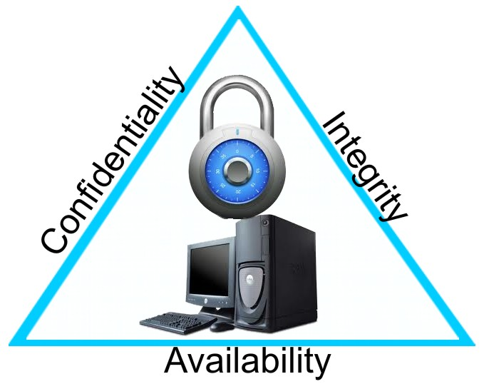
Figure 6.1: Computer Security CIA Triad
(Source: http://k-rodriguez.blogspot.com.ng/2012/04/security-goals-cia-triad.html )
Security management concepts and principles are inherent elements in a security policy and solution deployment. They define the basic parameters needed for a secure environment. They also define the goals and objectives that both policy designers and system implementers must achieve to create a secure solution. The primary goals and objectives of security are contained within the CIA Triad. One of the challenges in building a secured system is finding the right balance among the goals which often conflicts. These goals can be independent and sometimes overlap just to create a secured system.
Security controls must address one or more of these three principles. Security controls are typically evaluated on whether or not they address all three of these core information security tenets. Vulnerabilities and risks are also evaluated based on the threat they pose against one or more of the CIA Triad principles. Thus, it is a good idea to be familiar with these principles and use them as guidelines and measuring sticks against which to judge all things related to security.
These three principles are considered the most important within the realm of security. However, how important each is to a specific organization depends upon the organization’s security goals and requirements and on the extent to which its security might be threatened.
6.2 Other Security Concepts
In addition to the CIA Triad, there are host of other security-related concepts, principles, and tenets which include privacy, identification, authentication, authorization, accountability, non-repudiation, and auditing.
6.2.1 Privacy
The term privacy is used in numerous contexts differently. Here are some possible partial definitions of privacy:
- Prevention of unauthorized access.
- Freedom from unauthorized access to information deemed personal or confidential.
- Freedom from being observed, monitored, or examined without consent or knowledge.

6.2.2 Identification
Identification is about claiming to be somebody. In computer security, identification is the process by which a subject professes an identity and accountability is initiated. A subject must provide an identity to a system to start the process of authentication, authorization, and accountability. Providing an identity can be typing in a username; swiping a smart card; waving a token device; speaking a phrase; or positioning your face, hand, or finger for a camera or scanning device. Proving a process ID number also represents the identification process. Without an identity, a system has no way to correlate an authentication factor with the subject. Once a subject has been identified (i.e., once the subject’s identity has been recognized and verified), the identity is accountable for any further actions by that subject. IT systems track activity by identities, not by the subjects themselves. A computer doesn’t know one human from another, but it does know that your user account is different from all other user accounts. A subject’s identity is typically labeled as or considered to be public information.
6.2.3 Authentication
The process of verifying or testing that the claimed identity is valid is authentication. Authentication requires from the subject additional information that must exactly correspond to the identity indicated. The most common form of authentication is using a password. Authentication verifies the identity of the subject by comparing one or more factors against the database of valid identities (i.e., user accounts). The authentication factor used to verify identity is typically labeled as or considered to be private information. The capability of the subject and system to maintain the secrecy of the authentication factors for identities directly reflects the level of security of that system. Identification and authentication are always used together as a single two-step process. Providing an identity is step one and providing the authentication factor(s) is step two. Without both, a subject cannot gain access to a system—neither element alone is useful.
There are several types of authentication information a subject can provide (e.g., something you know, something you have). Each authentication technique or factor has its unique benefits and drawbacks. Thus, it is important to evaluate each mechanism in light of the environment in which it will be deployed to determine viability.
6.2.4 Authorization
Once a subject is authenticated, access must be authorized. The process of authorization ensures that the requested activity or access to an object is possible given the rights and privileges assigned to the authenticated identity. In most cases, the system evaluates an access control matrix that compares the subject, the object, and the intended activity. If the specific action is allowed, the subject is authorized. If the specific action is not allowed, the subject is not authorized. Keep in mind that just because a subject has been identified and authenticated does not automatically mean they have been authorized. It is possible for a subject to be logged onto a network (i.e., identified and authenticated) but be blocked from accessing a file or printing to a printer (i.e., by not being authorized to perform that activity). Most network users are authorized to perform only a limited number of activities on a specific collection of resources. Identification and authentication are all-or-nothing aspects of access control. Authorization has a wide range of variations between all or nothing for each individual object within the environment. A user may be able to read a file but not delete it, print a document but not alter the print queue, or log on to a system but not access any resources.
6.2.5 Auditing
Auditing, or monitoring, is the programmatic means by which subjects are held accountable for their actions while authenticated on a system. Auditing is also the process by which unauthorized or abnormal activities are detected on a system. Auditing is recording activities of a subject and objects as well as recording the activities of core system functions that maintain the operating environment and the security mechanisms. The audit trails created by recording system events to logs can be used to evaluate the health and performance of a system. System crashes may indicate faulty programs, corrupt drivers, or intrusion attempts. The event logs leading up to a crash can often be used to discover the reason a system failed. Log files provide an audit trail for re-creating the history of an event, intrusion, or system failure. Auditing is needed to detect malicious actions by subjects, attempted intrusions, and system failures, and to reconstruct events, provide evidence for prosecution, and produce problem reports and analysis. Auditing is usually a native feature of an operating system and most applications and services. Thus, configuring the system to record information about specific types of events is fairly straightforward.
6.2.6 Accountability
An organization’s security policy can be properly enforced only if accountability is maintained. In other words, security can be maintained only if subjects are held accountable for their actions. Effective accountability relies upon the capability to prove a subject’s identity and track their activities. Accountability is established by linking a human to the activities of an online identity through the security services and mechanisms of auditing, authorization, authentication, and identification.
6.2.7 Non-repudiation
Non-repudiation ensures that the subject of an activity or event cannot deny that the event occurred. Non-repudiation prevents a subject from claiming not to have sent a message, not to have performed an action, or not to have been the cause of an event. It is made possible through identity, authentication, authorization, accountability, and auditing. Nonrepudiation can be established using digital certificates, session identifiers, transaction logs, and numerous other transactional and access control mechanisms.
6.3 Protection Mechanisms
Another aspect of security solution concepts and principles is the element of protection mechanisms. These are common characteristics of security controls. Not all security controls must have them, but many controls offer their protection for confidentiality, integrity, and availability through the use of these mechanisms.
6.3.1 Layering
Layering, also known as defense in depth, is simply the use of multiple controls in a series. No one specific control can protect against all possible threats. The use of a multilayered solution allows for numerous different and specific controls to be brought to bear against whatever threats come to pass. When security solutions are designed in layers, most threats are eliminated, mitigated, or thwarted. Using layers in a series rather than in parallel is an important concept. Performing security restrictions in a series means to perform one after the other in a linear fashion. Only through a series configuration will each attack be scanned, evaluated, or mitigated by every security control.
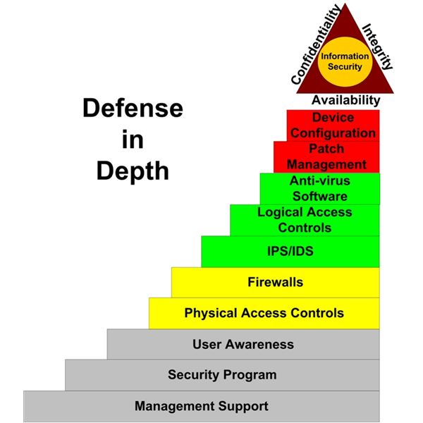
Figure 6.2: Defense in Depth
(Source: http://www.brighthub.com/computing/smb-security/articles/2217.aspx)
A single failure of a security control does not render the entire solution ineffective. If security controls were implemented in parallel, a threat could pass through a single check point that did not address its particular malicious activity. Serial configurations are very narrow but very deep, whereas parallel configurations are very wide but very shallow. Parallel systems are useful in distributed computing applications, but parallelism is not a useful concept in the realm of security. Think of physical entrances to buildings. A parallel configuration is used for shopping malls. There are many doors in many locations around the entire perimeter of the mall. A series of configuration would most likely be used in a bank or an airport. A single entrance is provided and that entrance actually has several gateways or checkpoints that must be passed in sequential order to gain entry into active areas of the building. Layering also includes the concept that networks comprise numerous separate entities, each with its own unique security controls and vulnerabilities. In an effective security solution, there is a synergy between all networked systems that creates a single security front. The use of separate security systems creates a layered security solution.

6.3.2 Abstraction
Abstraction is used for efficiency. Similar elements are put into groups, classes, or roles that are assigned security controls, restrictions, or permissions as a collective. Thus, the concept of abstraction is used when classifying objects or assigning roles to subjects. The concept of abstraction also includes the definition of object and subject types or of objects themselves (i.e., a data structure used to define a template for a class of entities). Abstraction is used to define what types of data an object can contain, what types of functions can be performed on or by that object, and what capabilities that object has. Abstraction simplifies security by enabling you to assign security controls to a group of objects collected by type or function.
6.3.3 Data Hiding
Data hiding is exactly what it sounds like: preventing data from being discovered or accessed by a subject. Keeping a database from being accessed by unauthorized visitors is a form of data hiding, as is restricting a subject at a lower classification level from accessing data at a higher classification level. Preventing an application from accessing hardware directly is also a form of data hiding. Data hiding is often a key element in security controls as well as in programming.
6.3.4 Encryption
Encryption is the art and science of hiding the meaning or intent of a communication from unintended recipients. Encryption can take many forms and be applied to every type of electronic communication, including text, audio, and video files, as well as applications themselves. Encryption is a very important element in security controls, especially in regard to the transmission of data between systems. There are various strengths of encryption, each of which is designed and/or appropriate for a specific use or purpose. Figures 2.1 and 2.2 describe aspects of computer security.
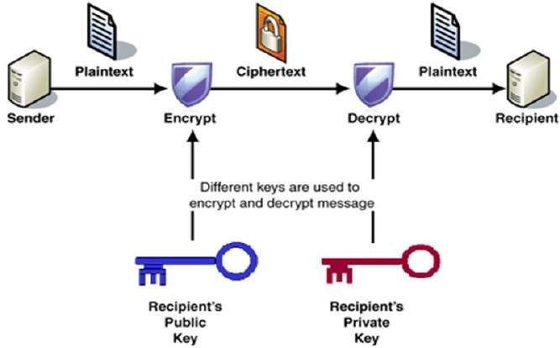
Figure 6.3: An Aspect of Encryption process
(Source:https://www.tutorialspoint.com/cryptography/images/public_key_cryptography.jpg)
6.4 THREATS AND VULNERABILITIES
A computer system assets can be divided into three parts; Hardware, Software and the Data on the system itself. Each of which offers value to different members of the community affected by the system. Based on this, methods can be highlighted that the system or its data can experience some kind of loss or damage. For example, we can identify data whose content format or content should be protected in some way. We want our security system to make sure that no data are disclosed to unauthorized users. Neither do we want the data modified in illegitimate ways. At the same time we want to ensure that legitimate users have access to the data. In this way, we can identify weaknesses in the system either in design or implementation that might be exploited to cause loss or damage. Such type of weaknesses in the security system is known as vulnerability. Vulnerability is a weakness which allows an attacker to reduce a system’s information assurance. Threat on the other hand is a set of circumstances that has the potential to cause loss or harm. Exploiting the vulnerabilities of a system leads to threat. A threat can therefore be blocked with the control of vulnerability of a system. Threat can be viewed as one of the following kinds: Interception, Interruption, Modification and Fabrication. With each exploiting vulnerabilities of assets in computing system.
Computer security threat is therefore a possible danger that might exploit a vulnerability of a computer in order to breach the security and thereafter causing possible harm to the computer or its assets. The threat in this case could be Hardware or Software Threat. The Hardware threat is the accidental or deliberate damage of the hardware component of the computer system. While the Software threat deals with deletion, alteration or damage of the software component of a computer system. Damage(s) caused by the aforementioned will definitely have a devastating effect on the computer which could ultimately destroy the computer system.
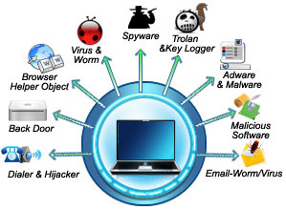
Figure 6.4: Computer Threats
(Source: http://computertrriks.blogspot.com.ng/2011/05/types-of-computer-threats.html)
However, malicious entities are focused on violating the security perimeter of a system to obtain access to data, alter or destroy data, and inhibit valid access to data and resources. The actual means by which attacks are perpetrated vary greatly. Some are extremely complex and require detailed knowledge of the victimized systems and programming techniques, whereas others are extremely simple to execute and require little more than an IP address and the ability to manipulate a few tools or scripts. But even though there are many different kinds of attacks, they can be generally grouped into a handful of classifications or categories.
These are the common or well-known classes of attacks or attack methodologies:
6.4.1 Brute force and dictionary attacks
Brute force and dictionary attacks are often discussed together because they are waged against the same entity: passwords. Either type of attack can be waged against a password database file or against an active logon prompt. A brute force attack is an attempt to discover passwords for user accounts by systematically attempting every possible combination of letters, numbers, and symbols. With the speed of modern computers and the ability to employ distributed computing, brute force attacks are becoming successful even against strong passwords. With enough time, all passwords can be discovered using a brute force attack method. The longer and more intricate a password is, the longer it will take a computer to try all of the possible combinations.
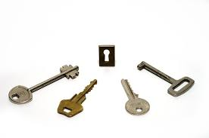
Figure 6.5: Brute Force Attack
(Source: http://www.pcadvisor.co.uk/download/backup-recovery/free-word-excel-password-recovery-wizard-2115-3328430/)
A dictionary attack takes place when an attacker utilizes a dictionary in an attempt to crack a password. Essentially, words from the dictionary are inputted into the password field to try to guess the password. Programs and tools exist that allow hackers to easily try various combinations of words in the dictionary against a user's password. Because of the dictionary attack, it is recommended to use passwords that do not contain simple words that can be found in a dictionary. The primary defense against brute force and dictionary attack is the deployment and enforcement of a strong password policy. Passwords should be required to contain at least seven characters, with mixed upper- and lower-case letters, numbers, and punctuation. Also, consider implementing an incrementing response delay routine in your application in place of an automatic account lockout.
6.4.2. Denial of service
Denial of service (DoS) attacks are attacks that prevent the system from processing or responding to legitimate traffic or requests for resources and objects. The most common form of denial of service attacks is transmitting so many data packets to a server that it cannot process them all. Other forms of denial of service attacks focus on the exploitation of a known fault or vulnerability in an operating system, service, or application. Exploiting the fault often results in system crash or 100 percent CPU utilization. No matter what the actual attack consists of, any attack that renders the victim unable to perform normal activities can be considered a denial of service attack. Denial of service attacks can result in system crashes, system reboots, data corruption, blockage of services, and more.
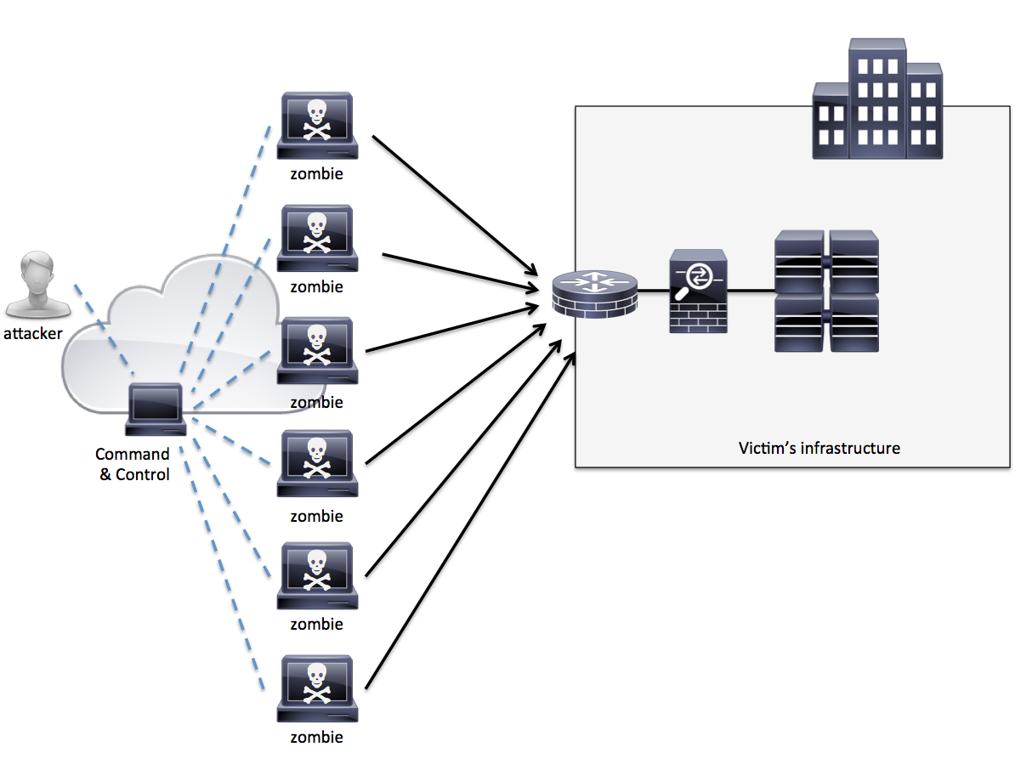
Figure 6.6: Denial of Service Attack
(Source: http://www.cisco.com/c/en/us/about/security-center/guide-ddos-defense.html)
There are several types of DoS flood attacks. The first, or original, type of attack employed a single attacking system flooding a single victim with a steady stream of packets. Those packets could be valid requests that were never completed or malformed or fragmented packets that consume the attention of the victimized system. A more complicated form is called the distributed denial of service (DDoS) where denial of service occurs when the attacker compromises several systems and uses them as launching platforms against one or more victims. The compromised systems used in the attack are often called slaves or zombies. A DDoS attack results in the victims being flooded with data from numerous sources. DDoS attacks can be stopped by blocking packets from the compromised systems. But this can also result in blocking legitimate traffic because the sources of the flood packets are victims themselves and not the original perpetrator of the attack.
6.4.3 Spoofing Attacks
Spoofing is the art of pretending to be something other than what you are. Spoofing attacks consist of replacing the valid source and/or destination IP address and node numbers with false ones. Spoofing is employed when an intruder uses a stolen username and password to gain entry, when an attacker changes the source address of a malicious packet, or when an attacker assumes the identity of a client to fool a server into transmitting controlled data. Two specific types of spoofing attacks are impersonation and masquerading. Ultimately, these attacks are the same: someone is able to gain access to a secured system by pretending to be someone else. These attacks often result in an unauthorized person gaining access to a system through a valid user’s account that has been compromised. Impersonation is considered a more active attack because it requires the capture of authentication traffic and the replay of that traffic in such a way as to gain access to the system. Masquerading is considered a more passive attack because the attacker uses previously stolen account credentials to log on to a secured system.
Countermeasures to spoofing attacks include the following:
i. Patching the OS and software,
ii. Enabling source/destination verification on routers, and
iii. Employing IDS to detect and block attacks.
As a general rule of thumb, whenever your system detects spoofed information, it should record relevant data elements into a log file; then the system should drop or delete the spoof itself.
6.4.4 Man-in-the-Middle Attacks
A man-in-the-middle attack occurs when a malicious user is able to gain a position between the two endpoints of a communications link. There are two types of man-in-the-middle attacks. One involves copying or sniffing the traffic between two parties; this is basically a sniffer attack (see the next section). The other involves attackers positioning themselves in the line of communication where they act as a store-and-forward or proxy mechanism. The attacker functions as the receiver for data transmitted by the client and the transmitter for data sent to the server. The attacker is invisible to both ends of the communication link and is able to alter the content or flow of traffic. Through this type of attack, the attacker can collect logon credentials or sensitive data as well as change the content of the messages exchanged between the two endpoints. An offshoot of a man-in-the-middle attack is known as a session hijack attack. In this type of attack, a malicious user is positioned between a client and server and then interrupts the session and takes it over. Often, the malicious user impersonates the client to extract data from the server. Another type of attack in this category is the replay attack (also known as a playback attack), it is similar to session hijacking. A malicious user records the traffic between a client and server; then the packets sent from the client to the server are played back or retransmitted to the server with slight variations of the time stamp and source IP address (i.e., spoofing). In some cases, this allows the malicious user to restart an old communication link with a server. Once the communication session is reopened, the malicious user can attempt to obtain data or additional access. The captured traffic is often authentication traffic (i.e., that which includes logon credentials, such as username and password), but it could also be service access traffic or message control traffic. Replay attacks can be prevented by employing complex sequencing rules and time stamps to prevent retransmitted packets from being accepted as valid.
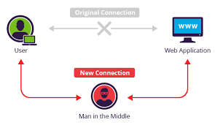
Figure 6.7: Man in the Middle Attack
(Source: https://www.incapsula.com/web-application-security/man-in-the-middle-mitm.html)
Countermeasures to these types of attacks require improvement in the session establishment, identification, and authentication processes. Some man-in-the-middle attacks are thwarted through patching the OS and software. IDS cannot usually detect a man-in-the-middle or session hijack attack, but it can often detect the abnormal activities occurring via “secured” communication links. Operating systems and many IDSs can often detect and block replay attacks.
6.4.5 Sniffer Attacks
A sniffer attack (also known as a snooping attack) is any activity that results in a malicious user obtaining information about a network or the traffic over that network. A sniffer is often a packet capturing program that duplicates the contents of packets traveling over the network medium into a file. Sniffer attacks often focus on the initial connections between clients and servers to obtain logon credentials (e.g., usernames and passwords), secret keys, and so on. When performed properly, sniffing attacks are invisible to all other entities on the network and often precede spoofing or hijack attacks. A replay attack is a type of sniffer attack.
Countermeasures to prevent or stop sniffing attacks require improvement in physical access control, active monitoring for sniffing signatures (such as looking for packet delay, additional routing hops, or lost packets, which can be performed by some IDSs), and using encrypted traffic over internal and external network connections.
6.4.6 Computer Hackers
A computer hacker is someone who develops changes or attempts to circumvent computer security hardware or software. This can either happen for negative (criminal) or positive reasons. Criminal hackers develop computer malware or spyware to gain access to confidential information. Criminal hackers are malicious users with the intent of waging an attack against a person or system. They may be motivated by greed, power, or recognition. Their actions can result in stolen property (data, ideas, etc.), disabled systems, compromised security, negative public opinion, loss of market share, reduced profitability, and lost productivity.

Figure 6.8: Computer Hacker
(Source: https://www.123rf.com/photo_32010767_hacker-on-a-computer.html)
Thwarting a hacker’s attempts to breach your security requires vigilant effort to keep systems patched and properly configured. IDSs and honey pot systems often offer means to detect and gather evidence to prosecute hackers once they have breached your controlled perimeter. Since it is not easy to apprehend criminal hackers strict measures must be enforced to ensure safety. Using strong password, installing original softwares, deploying good internet ethics of not sharing personal information with strangers and not downloading attachments except it is from a known person.
6.4.7 Malicious Code
Malicious code is the general name for unanticipated or undesired effects in programs or parts of a program, caused by an agent with the intent to harm the computer system. This definition eliminates unintentional errors, although they can also have a serious negative effect. It also eliminates coincidence in which two benign programs combine for a negative effect. The agent is the writer of the program or the person who causes its distribution.
Malicious code objects include a broad range of programmed computer security threats that exploit various network, operating system, software, and physical security vulnerabilities to spread malicious payloads to computer systems. Some malicious code objects, such as computer viruses and Trojan horses, depend upon irresponsible computer use by human beings to spread from system to system with any success. Other objects, such as worms, spread rapidly among vulnerable systems under their own power. All computer security practitioners must be familiar with the risks posed by the various types of malicious code objects so they can develop adequate countermeasures to protect the systems under their care as well as implement appropriate responses if their systems are compromised.
6.4.7.1 Viruses
The computer virus is perhaps the earliest form of malicious code to plague security administrators. Indeed, viruses are so prevalent nowadays that major outbreaks receive attention from the mass media and provoke mild hysteria among average computer users. Hundreds of thousands of variations of these viruses strike unsuspecting computer users each day. Many carry malicious payloads that cause damage ranging in scope from displaying a profane message on the screen all the way to causing complete destruction of all data stored on the local hard drive.
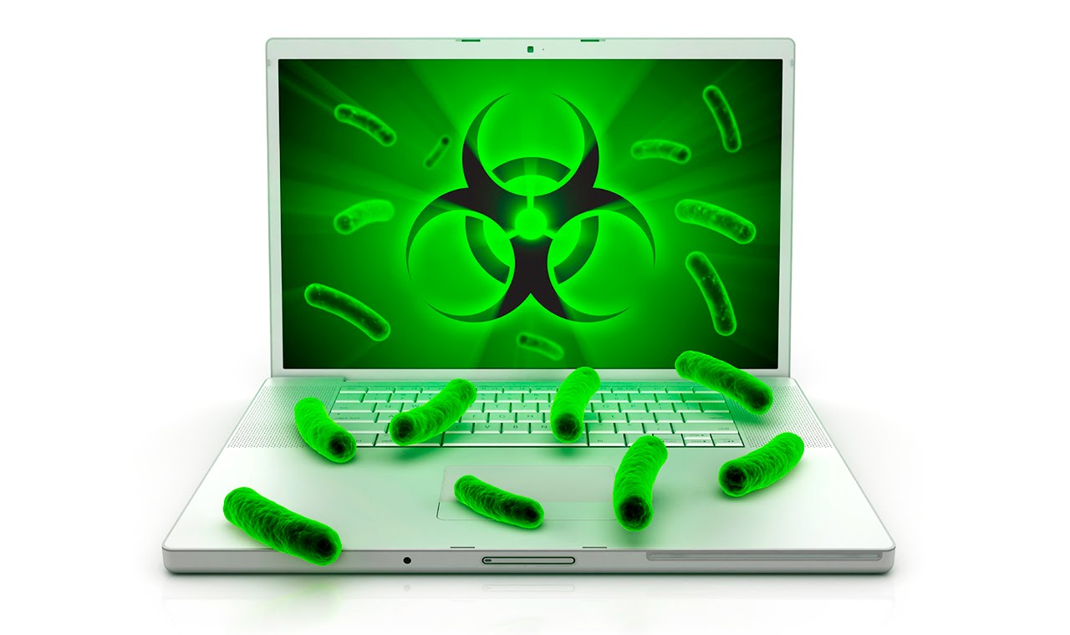
Figure 6.9: Computer Virus
(Source:https://www.asus.com/zentalk/forum.php?mod=viewthread&action=printable&tid=70444)
As with biological viruses, computer viruses have two main functions—propagation and destruction. Miscreants who create viruses carefully design code to implement these functions in new and innovative methods that they escape detection and bypass increasingly sophisticated antivirus technology. The propagation function defines how the virus will spread from system to system, infecting each machine it leaves in its wake. A virus’s payload delivers the destructive power by implementing whatever malicious activity the virus writer had in mind. It infects other healthy subjects by attaching itself to the program and either destroying it or coexisting with it. Due to their insidious nature, we cannot assume that a clean program yesterday is still clean today. Moreover, a good program can be modified to include a copy of the virus program, so the infected good program itself begins to act as a virus, infecting other programs. The infection usually spreads at a geometric rate, eventually overtaking an entire computing system and spreading to all other connected systems.
6.4.7.2 Logic Bombs
Logic bombs are malicious code objects that infect a system and lie dormant until they are triggered by the occurrence of one or more conditions such as time, program launch, website logon, and so on. The vast majority of logic bombs are programmed into custom-built applications by software developers seeking to ensure that their work is destroyed if they unexpectedly leave the company. However, it’s important to remember that, like any malicious code object, logic bombs come in many shapes and sizes. Indeed, many viruses and Trojan horses contain a logic bomb component.
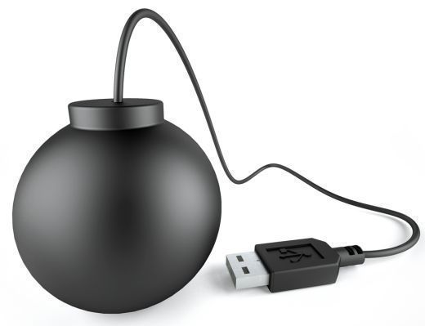
Figure 6.10: Logic Bomb
(Source: http://www.tech-faq.com/logic-bomb.html)
The famous Michelangelo virus caused a media frenzy when it was discovered in 1991 due to the logic bomb trigger it contained. The virus infects a system’s Master Boot Record through the sharing of infected floppy disks and then hides itself until March 6—the birthday of the famous Italian artist Michelangelo Buonarroti. On that date, it springs into action, reformatting the hard drives of infected systems and destroying all of the data they contain.

6.4.7.3 Trojan Horses
System administrators constantly warn computer users not to download and install software from the Internet unless they are absolutely sure it comes from a trusted source. In fact, many companies strictly prohibit the installation of any software not prescreened by the IT department. These policies serve to minimize the risk that an organization’s network will be compromised by a Trojan horse—a software program that appears benevolent but carries a malicious, behind-the-scenes payload that has the potential to wreak havoc on a system or network. Trojans differ very widely in functionality. Some will destroy all of the data stored on a system in an attempt to cause a large amount of damage in as short a time frame as possible. Some are fairly innocuous. Unlike viruses, Trojan horses do not replicate but they are harmful.
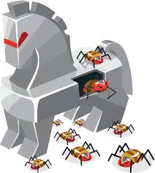
Figure 6.11: Trojan Horse (Source:https://informationstrategyrsm.wordpress.com/2015/10/11/what-is-a-trojan-horse-and-how-can-protect-ourselves-from-it/)
For example, a series of Trojans appeared on the Internet in mid-2002 that claimed to provide PC users with the ability to run games designed for the Microsoft Xbox gaming system on their computers. When users ran the program, it simply didn’t work. However, it also inserted a value into the Windows Registry that caused a specific web page to open each time the computer booted. The Trojan creators hoped to cash in on the advertising revenue generated by the large number of page views their website received from the Xbox Trojan horses. Unfortunately for them, antivirus experts quickly discovered their true intentions and the website was shut down.
Back Orifice is a well-known Trojan horse that affects various versions of the Windows operating system. To install Back Orifice on the systems of unsuspecting users, malicious individuals place it within the installation package for legitimate software. When a victim installs the legitimate software, they unknowingly install Back Orifice at the same time. The package then runs in the background and gives the miscreant the ability to remotely access the target computer and gain administrative access.
6.4.7.4 Worms
Worms pose an unparalleled risk to network security. They contain the same destructive potential as other malicious code objects with an added twist—they propagate themselves without requiring any human intervention. A worm is a program that spreads copies of itself through a network. The primary difference between a worm and a virus is that a worm operates through networks, and a virus can spread through any medium (but usually uses copied program or data files). Additionally, the worm spreads copies of itself as a stand-alone program, whereas the virus spreads copies of itself as a program that attaches to or embeds in other programs.
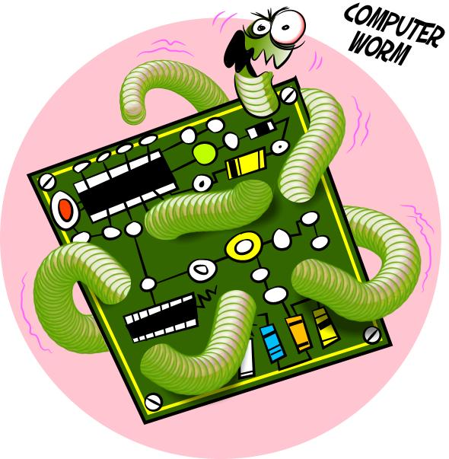
Figure 6.12: Computer Worms
(Source: https://uk.pinterest.com/explore/computer-worm/)
The Internet Worm was the first major computer security incident to occur on the Internet. Since that time, hundreds of new worms (with thousands of variant strains) have unleashed their destructive power on the Internet.
The Code Red worm received a good deal of media attention in the summer of 2001 when it rapidly spread among web servers running unpatched versions of Microsoft’s Internet Information Server (IIS). Code Red performed three malicious actions on the systems it penetrated: It randomly selected hundreds of IP addresses and then probed those hosts to see if they were running a vulnerable version of IIS. Any systems it found were quickly compromised. This greatly magnified Code Red’s reach as each host it infected sought many new targets.

6.5 COMPUTER SECURITY COUNTERMEASURES
The solution to computer security threats can be grouped into two parts, the Active Protection and the Preventive Measures. The active protection mechanism includes using original and updated Anti-Virus and Anti-Spyware softwares, performing regular system updates, enabling firewall, frequent full system scanning etc. The preventive measures are the necessary conditions and practices that computer users must always keep to and it chiefly relies on applying caution when using the computer system and any of its assets over the internet.
The cornerstone of any security program is education. Computer security personnel should continually remind users of the importance of choosing a secure password and keeping it secret. Users should receive training when they first enter an organization, and they should receive periodic refresher training, even if it’s just an e-mail from the administrator reminding them of the threats. Provide users with the knowledge they need to create secure passwords. Tell them about the techniques hackers use when guessing passwords and give them advice on how to create a strong password. One of the most effective password techniques is to use a mnemonic device such as thinking of an easy-to-remember sentence and creating a password out of the first letter of each word.
The primary means of defense against malicious code is the use of antivirus filtering software. These packages are primarily signature-based systems, designed to detect known viruses running on a system. It’s wise to consider implementing antivirus filters in at least three key areas:
a. Client systems: Every workstation on a network should have an updated antivirus software searching the local file system for malicious code.
b. Server systems: Servers should have similar protections. This is even more critical than protecting client systems because a single virus on a common server could quickly spread throughout an entire network.
c. Content filters: The majority of viruses today are exchanged over the Internet. It’s a wise move to implement on your network content filtering that scans inbound and outbound electronic mail and web traffic for signs of malicious code.

6.6 CYBERCRIME
Cybercrime is defined as crimes committed on the internet using the computer as either a tool or a targeted victim. It is very difficult to classify crimes in general into distinct groups as many crimes evolve on a daily basis. Even in the real world, crimes like rape, murder or theft need not necessarily be separated. However, all cybercrimes involve both the computer and the person behind it as victims; it just depends on which of the two is the main target. Hence, the computer will be looked at as either a target or tool for simplicity’s sake. For example, hacking involves attacking the computer’s information and other resources. It is important to take note that overlapping occurs in many cases and it is impossible to have a perfect classification system.


Figure 6.13: Cybercrime
(Source: http://www.littlegatepublishing.com/2015/10/new-cybercriminal-trends-to-beware-of/)

A generalized definition of cybercrime may be “unlawful acts wherein the computer is either a tool or target or both” The computer may be used as a tool in the following kinds of activity- financial crimes, sale of illegal articles, pornography, online gambling, intellectual property crime, email spoofing, forgery, cyber defamation, cyber stalking. The computer may however be target for unlawful acts in the following cases- unauthorized access to computer/ computer system/ computer networks, theft of information contained in the electronic form, e-mail bombing, data didling, salami attacks, logic bombs, Trojan attacks, internet time thefts, web jacking, theft of computer system, physically damaging the computer system.

6.6.1 Cyber Criminals
A cybercriminal is an individual who commits cybercrimes, where he/she makes use of the computer either as a tool or as a target or as both. They are of various groups/category. This division may be justified on the basis of the object/intent for such practice. The following are the category of cyber criminals:

a. Children and adolescents between the age group of 6 – 18years
The simple reason for this type of delinquent behavior pattern in children is seen mostly due to the inquisitiveness to know and explore the things. Other cognate reason maybe to prove themselves to be outstanding amongst other children in their group. Further the reasons may be psychological even.

b. Organized hackers
These kinds of hackers are mostly organized together to fulfill certain objective. The reason may be to fulfill their political bias, fundamentalism, etc. The Pakistanis are said to be one of the best quality hackers in the world. They mainly target the Indian government sites with the purpose to fulfill their political objectives. Further, the NASA as well as the Microsoft sites is always under attack by the hackers.

c. Professional hackers / crackers
Their work is motivated by the colour of money. These kinds of hackers are mostly employed to hack the site of the rivals and get credible, reliable and valuable information. Further they are then employed to crack the system of the employer basically as a measure to make it safer by detecting the loopholes.

d. Discontented employees
This group includes those people who have been either sacked by their employer or are dissatisfied with their employer. To avenge they normally hack the system of their employee.

6.6.2 Prevention of Cyber Crime
Prevention is always better than cure. It is always better to take certain precaution while operating the net. Everyone should make them part of cyber life. Sailesh kumar Zarkar, a technical Advisor and network security Consultant to the Mumbai Police Cybercrime Cell, advocates the 5P’s mantra for online security: Precaution, Prevention, Protection, Preservation and Perseverance. Every computer and internet user should keep in mind the following things:

- To prevent cyber stalking by avoiding disclosure of any information pertaining to one self. This is as good as disclosing your identity to strangers in public places.
- Always avoid sending any photograph online particularly to strangers and chat friends as there have been incidents of misuse of the photographs.
- Always use latest and updated antivirus software to guard against virus attacks.
- Always keep back up volumes so that one may not suffer data loss in case of virus contamination.
- Never send your credit card number to any site that is not secured, to guard against frauds.
- Always keep a watch on the sites that your children are accessing to prevent any kind of harassment or depravation in children.
- It is better to use a security programme that gives control over the cookies and send information back to the site as leaving the cookies unguarded might prove fatal.
- Web site owners should watch traffic and check any irregularity on the site. Putting host-based intrusion detection devices on servers may do this.
- Use of firewalls and other malware protective mechanisms may be beneficial.
- Web servers running public sites must be physically separated and protected from internal corporate network.
REFERENCES
Bosworth, S., Kabay, M. E., & Whyne, E.(2014).“Computer Security Handbook ” Sixth Edition, Volume 1. Published by John Wiley & Sons, Inc., Hoboken, New Jersey, U.S.A.
Charles, P.Pfleeger, Shari Lawrence Pfleeger. Security in Computing – (3rd Edition). PHI.
Isaac, D. S., & Isaac, M. J. (2003).“The SSCP Prep Guide: Mastering The Seven Key Areas of System Security ”. Published by Wiley publishing, Inc., Indianapolis, Indiana, U.S.A.
Nestler, V., White, G., & Arthur Conklin, WM.(2011). “Principles of Computer Security: Comptia Security+ and beyond” Lab Manual, Second Edition. Published by McGraw Hill Companies.
Stewart, J. M., Tittel, E., & Chapple, M.(2005).“Certified Information System Security Professionals: CISSP” Study Guide, Third Edition. Published by Sybex Inc., 1151 Marina Village Parkview, Alameda, CA 94501.

