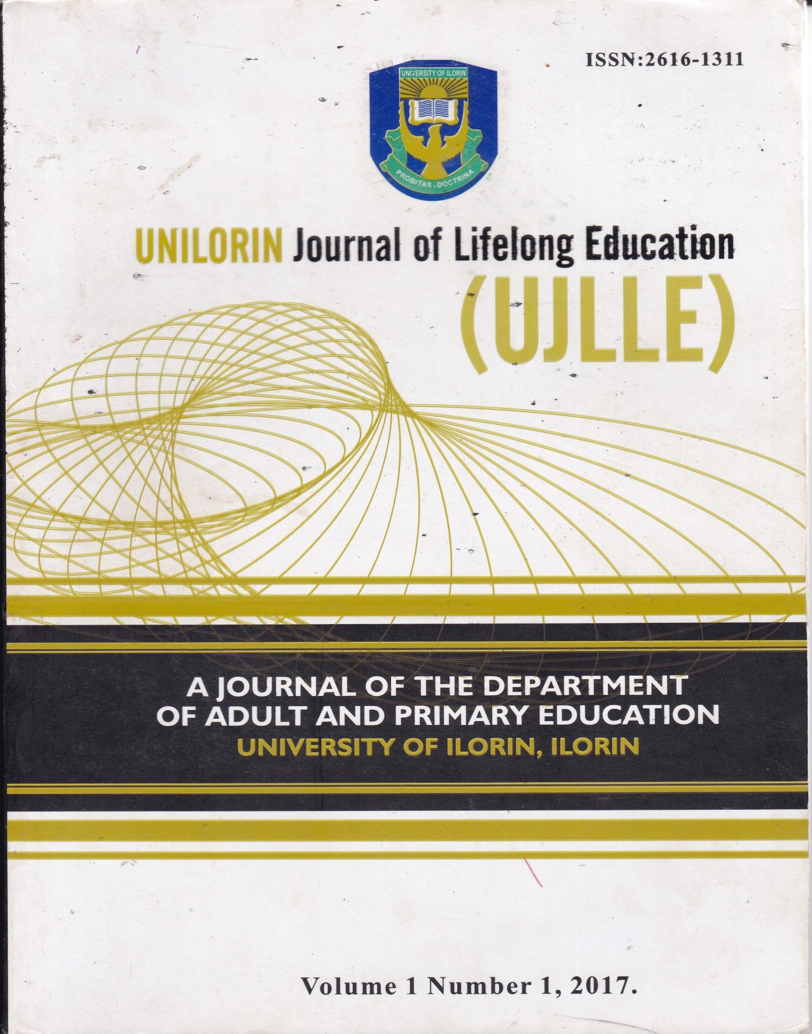
UNILORIN JOURNAL OF
LIFELONG EDUCATION
ISBN: 2616-1311
VOL.1 NO 1, 2017

A PUBLICATION OF DEPARTMENT OF ADULT AND PRIMARY
EDUCATION, UNIVERSITY OF ILORIN, NIGERIA

ALL RIGHTS RESERVED

EDITORIAL BOARD
Editor-in-Chief
Prof. Henry O. Owolabi
Department of Adult and primary Education,
University of Ilorin, Nigeria

Managing Editor
Prof. Ayodele Fajonyomi

Editorial Board Members
Dr. M. O. Ogunjimi
Dr. Mrs. Olabisi Adedigba
Dr. Mrs. E.K. Ola-Alani
Dr. Mrs. T. T. Ambali

Associate Editors
Dr. Mrs. M. O. Esere
Dr. S. B. Olajide
Dr. Mrs. B.O. Olawuyi
Dr. R. W. Okunloye
Dr. Mrs. L. Dominic

Consulting Editors
Prof. Rotimi Ogidan
African Centre for Distance Education

Prof. Mrs. F. A. O. Olasehinde-Williams
Department of Social Sciences
University of Ilorin, Ilorin

Prof. A. O. U. Onuka
Institute of Education
University of lbadan

Pereto, Lenin, Freud and Engel (N.D). Religion and Art: The Theory and Reality in Rasheed, A.M. (l999), Advocating Religious Tolerance through Theatre Practice in Nigeria: Department of Performing Arts, University of Ilorin, Ilorin Nigeria. A Journal of intellectual Scientific and Cultural interest University of Ilorin, Ilorin Nigeria. 9 (1)
Rasheed, A.M. (1999). Advocating Religious Tolerance through Theatre Practice in Nigeria: Department of Performing Arts, University of Ilorin, Ilorin, Nigeria. A Journal of Intellectual Scientific and Cultural Interest. University of Ilorin, Ilorin, Nigeria. 9 (l) Sjalfbaerniverkefniejtustu
The Oxford English dictionary, (201 6) London, Oxford University Press, 20 I 6
Tylor E.B. (N.D). Religion and Art: The Theory and Reality in Rasheed A.M. (1999) Advocating Religious Tolerance through Theatre Practice in Nigeria: Department of Performing Arts, University of Ilorin, Ilorin Nigeria: A Journal of Intellectual scientific and Cultural Interest. University of Ilorin, Ilorin, Nigeria. 9 (1)
Qur'an 2: V 198
Qur'an 2: V 275
Qur'an 2: V 282
Qur'an 4: V29
Qur'an 5:V90
Qur'an 62: V 10 11

PROMOTING PEACE EDUCATION FOR NATIONAL SECURITY:
IMPLICATIONS FOR EXTENSION EDUCATION

Ramat Mope Opobiyi MOHAMMED
Dept. of Adult &Primary Education
University of Ilorin, Nigeria
mopeodun@gmail.com

Abstract
Over the years, peaceful coexistence exists among the people in the country until recently when series of crises and conflicts have emerged and are emerging. This paper highlights the role of peace in building national security and by extension in ensuring sustainable development: It further examined the impact of peace towards the development of any given society. It glimpsed at the various roles of individuals in promoting peaceful coexistence among themselves irrespective of their personality, religion and the culture they represent. However, some agents of promoting peace were also explored in the likes of family, faith based organizations, community development associations, and national orientation agency among others. The study concluded that, peace education should be a continuous process in human endeavour throughout of school education programmes in the likes of extension education to promote harmonious relationship among the people without conflicts. The paper suggested that peace education should be made available at all level of our educational system in order to assists in transmitting knowledge of peace from one generation to another It focused on the concept, content and objectives of peace education.
Keywords: Peace education, National security, Sustainable development, Extension education

Introduction
Nigeria has been in existence as far back as 19" century. Different groups of individuals with different socio-cultural groups lived peacefully in the cosmopolitan and autonomous village with a well-defined socio-economic and political system. Recently, titre country has recorded series of violent, crises and disasters which include communal conflicts, armed robbery on the high ways, Niger-Delta militants, ethnic crises, Boko Haram, avengers, ritual killings, drug-abuse, among others that have resulted in national insecurity, loss of lives and properties (News report by NEMAI2rH APRIL, 2014). However, emergence of these crises and social vices constituting social menace has set the country backward and does calling for immediate remediation. In doing this, the role of extension education comes in as it covers different categories of people in the educational process. Extension in this regards is an act of extending or a state of being extended thus, extension education according to Leagans (1961), is an applied science consisting of content derived from research, accumulated field experiences and relevant principles drawn from the behavioural science synthesized with useful technology into a body of philosophy, principles, content and methods focused on the problems of out of school education for adults and youth. To start with peace, as a concept motivates imagination and connotes more than no violence. Galtung (2006 P.12); describes peace in terms of the conditions that hold when a peaceful state is maintained and promoted, I {e explained further by saying that, peace consists of positive thoughts, pure feelings, and good wishes and to stay peaceful requires strength and compassion. Therefore, for peace to rein in any given and existing society it requires some strategies of which education be it in any form, either inside or put side the for trial education system is found to be one. However, education is generally process of transmitting societal lore, values and desirable attitudes from one generation to another It is a process of developing individuals so as to equip them with desired mode of behaviour that is inconformity

