IMPACT OF THE MODERNIZATION OF ARABIC AND ISLAMIC EDUCATION IN ILORIN EMIRATE, 1943-2015
- ADESHINA, Lukman
Department of History and International Studies
Faculty of Arts,
University of Ilorin,
Ilorin, Nigeria.
adeshina.l@unilorin.edu.ng
08039404799
- ABDULRAHMAN, Adebayo Suleiman (PhD)
Department of History and International Studies
Faculty of Arts,
University of Ilorin,
Ilorin, Nigeria.
Abdulrahman.as@unilorin.edu.ng
08034808108

Abstract
The much emphasis, which Islam laid on knowledge as a criterion for effective worship of Allah (God) necessitated the need for people of Ilorin Emirate to establish various traditional Islamic schools. The presence of Islamic knowledge in Ilorin following the formation of a theocratic government by the way of an Emirate in 1823 attracted a large number of Muslims from inside and outside the Oyo empire who were in search of Islamic learning, this therefore, called for the establishment of more advanced Arabic and Islamic educational institutions in Ilorin. This emphasis of Islam on knowledge acquisition as well as the contemporary educational challenges therefore gave birth to the changing of phases of Arabic and Islamic learning in Ilorin Emirate from 1940s till the present time whose effect has been the modernization of Arabic and Islamic learning in Ilorin with its attendant impacts. Using oral sources and secondary sources, the paper examines the transformation of Arabic and Islamic school system in Ilorin Emirate from traditional to advanced form as well as the impacts of the modernization/westernization on the Arabic and Islamic learning in Ilorin Emirate and beyond.
Keywords: Arabic, Ilorin Emirate, Islam, Modernization, Quranic

Introduction
Ilorin Emirate is a historic hub of Islamic learning in Nigeria which has witnessed significant transformation in its Arabic and Islamic education system in recent decades. The modernization of the traditional mode of teaching Arabic and Islamic education was aimed at harmonizing Islamic values with modern pedagogical approaches in their entirety upon the realization of the importance of western type of education, especially in the age of industrialization, scientific and technological advancement.
The modernization of Arabic and Islamic education which was a route through which western education was introduced to the majority of Muslim parents in Ilorin Emirate in 1947 has shown the compatibility of Islamic and Western education. The modernization of Arabic and Islamic schools in Ilorin Emirate have resulted to the production of thousands of students who were not only native of Ilorin but indigenes of various towns across Nigeria who have become notable and reputable scholars, eloquent preachers, University dons, judges, proprietors of schools, and chief Imam amongst others. This paper using both primary and secondary sources examines the transformation of Arabic and Islamic school system in Ilorin Emirate from traditional to advanced form from 1943 up till 2015 and the various impacts of the modernization in Ilorin Emirate and beyond.
This paper is divided into six sections apart from introduction and conclusion. The first section examined Arabic and Islamic education in Ilorin before 1900 while section two analyzed the organization/nature of traditional Islamic education in Ilorin Emirate. The next section discussed modern developments in the Quranic school system in Ilorin Emirate. The fourth section listed numerous modernized Arabic and Islamic schools within Ilorin Emirate. The fifth section discussed the problems encountered in the modernization of Islamic learning in Ilorin while the last section examined impacts of the modernization of the Arabic and Islamic education in Ilorin Emirate.
Arabic and Islamic Education in Ilorin Emirate before 1900
In Ilorin, the first stage of Islamic education before 1900 was traditional Quranic School which is called by several names depending on the local language of the recipient, for instance, Makaranta Allo in Hausa, Ile-Kewu Wala’a in Yoruba and Tablet school in English languge². Muslim children were expected to start this first stage of Quranic education as early as the third years of life. The pupils at the stage learnt through repetition and whatever pleasure they derived from the system lied solely in the choral recitations which often took a sing song pattern³.
The tablet school which we may call the primary level of the system is the one where the pupils were expected to memorize some of the 114 chapters of the Quran, often beginning with the short ones after which he then moved to the next stage at which he learnt the alphabet of the Arabic language which is composed of some 26 letters, all of which are consonant sound⁴. At this stage, the child could read any portion of the Quran although he might not know the meaning but he could recognize and pronounce any word written in Arabic language. This however ended the stage of learning reading skill⁵.
The next stage to the learning reading skills is learning the writing skills though not applicable to all the Tablet schools in Ilorin. The teaching of writing skills started at different times in different schools. It was generally a very slow, painstaking and rather tedious process during which the teacher wrote the model of a verse on the slate and the pupil copied this out several times over below the teacher’s model⁶. The child at this stage would have memorized some chapters of the Quran and then able to read any word written in Arabic⁷.
The secondary level of local Quranic or Islamic system of education could be called the middle or Advance Quranic school⁸. It has much broader and deeper curriculum compared with that of the Table schools. The pupil began by learning the meanings of the chapters he had committed to memory as well as introducing him to other writings such as the Hadith (the tradition of the Prophet)⁹. The course of study at this advanced school level included as saif (grammatical inflexions); annahw (syntax); al-mantiq (logic); fiqh (jurisprudence); at-tafsir (commentaries on the Quran) etc. This different branches of learning explained why the student at this stage received instructions from many Mallams i.e teachers¹⁰.
The secondary level of education ended at the stage when the pupil or student decided his area of specialization after which he then proceeded to university (usually one of the celebrated universities of Fez, Sankore, Timbuctoo or Al-Azhar) or continued at home learning from local specialists and at the end of his studies, he received a “license” which empowered him to practice either as a teacher, an Imam, an Alkali (al-Qadi) Judge etc depending on his area of specialization¹¹.
The Organization/Nature of the Traditional Islamic Education in Ilorin Emirate
A typical traditional Islamic education or Quranic school was organized and looked somewhat like this: there were no rigidly codified rules and regulations, the students were obliged to conform to; yet there was a few conventionalized ways of behaviour which guided the pupils and the teachers¹². The teacher saw himself as a custodian of the pupils, whose primary duty was to train them to be good citizens i.e. good Muslims and this perhaps explained the reason why the teachers did not hesitate to lash the pupils as a corrective measure when necessary in a fatherly manner¹³.
The school week started on Saturday and ended on Wednesday. The teacher himself can unilaterally declare a holiday or close earlier for the day if he had some religious obligations to attend. The gifted ones among the students were assigned at times by the teacher to help him in teaching other students at the lower level when the cases mentioned above arose¹⁴. There was no bell to summon the pupils to school; nor was there a fixed uniform. The fees at the Quranic school were paid in cash and kind. There was no fixed amount because this varied from teacher to teacher. The teacher collected the “fees” from pupils for writing their new lessons on their wooden boards at the end of the school week¹⁵. Other fees that the teacher collected include the one to mark the end of the school vacation most especially during the Ramadan (owo Itashi)¹⁶. On the completion of the level designated as the primary level above, the “Wolimat” can take place. Wolimat is an elaborated feast organized for the pupil for achieving so much¹⁷. In Ilorin, the feast of completion of the learning of how to recite the Quran is often merged with wedding ceremony for which the word “Wolimat is more often appropriately used¹⁸.
There were many Islamic scholars/teachers in Ilorin who had imparted knowledge through the traditional mode discussed above even ever before the arrival of Sheikh Alimi. They included Mallam Abdullahi Tahir, nick-named Solagberu and other scholars at Okesuna whose descendants are also scholars and presently located in different parts of Ilorin¹⁹. Jimoh. L.A.K’s “Ilorin: The journey So Far” listed numerous past Islamic scholars in Ilorin²⁰. Figure 1 shows picture of pupils in a Quranic school at Popo-Giwa, Ilorin.
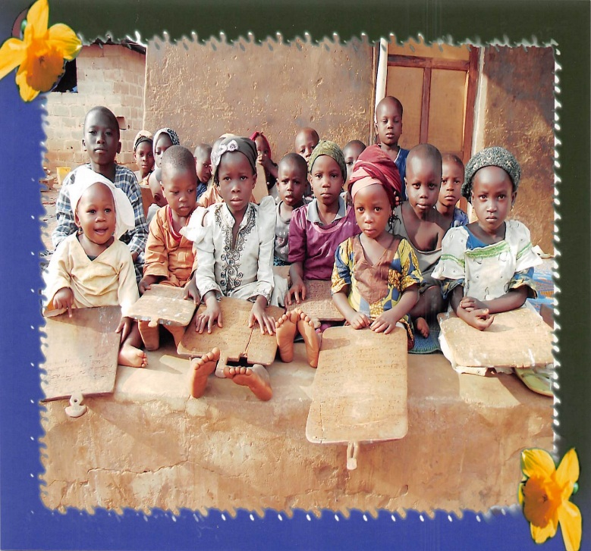
Fig. 1

Modern Developments in the Quranic School System in Ilorin Emirate
The modernization of Islamic education started in Ilorin around 1943 after the return of Sheikh Muhammed Kamaldeen from pilgrimage to Mecca in 1937/8²¹. After his return from Mecca, he began to re-organize his own schools along the lines with the system of education in Arabian countries and this explains why his new school in Lagos was perhaps the first formal Arabic school founded in Nigeria by an indigenous Nigerian-scholar. The school in Ilorin followed the suit around 1943²².
The modernization of Islamic learning being referred to here has to do with the modern ways of teaching in its entirety which include but not limited to the following:
- School Curricula
The curricula of modern Arabic and Islamic schools are wider in scope than that of the traditional Quranic school and they have four stages of acquisition of Islamic education, namely²³.
- Rahodatul Quraniyyah (Pre-nursery) where Arabic Alphabets are being taught.
- Ibtidaiyyah Primary School) which lasts about three years. Subjects taught are Quranic texts, Hadith, Islamic History, Jurisprudence, and Arabic Grammar.
- Idadiyyah (Junior Secondary School) which has three years duration. The subjects mentioned above are studied in addition to basic logic, geography, arithmetic, social studies, rhetoric and science, all in Arabic.
- Thanawiyyah (Senior Secondary), it deals with more intensive study of the subjects named above. It is called Tawjjihiyyah in some schools²⁴.
Any student who graduated from this stage will have opportunity to further his learning in any field he likes abroad so far he has good results. The foreign universities like al Azhar University, Cairo, Medina University as well as Kuwait and Iraq Universities are among the higher institutions where the graduates of those schools used to go for further studies²⁵.

- Instructional Materials
The use of modern instructional materials such as printed text, pens, and chalkboard, amongst others are also notable development to Quranic learning in Ilorin Emirate. The use of Al-Qua’ida Al-Baghdadiyyah (a book containing about thirty chapters of the Quran to facilitate learning is as a result of modernization and the use of the text is now a common feature of most Islamic schools in Ilorin as most of the traditional Quranic schools are no longer using slate for learning²⁶.
- Formal Class System
As part of the modernization of Islamic learning system of education, students now sit in the classroom in rows of two or more facing the chalkboard²⁷. Most traditional schools have adopted a formal class system as this was observed by Sheikh Adam Abdullahi to have helped to facilitate learning because it categorizes students into divisions that take care of their respective intelligence quotients²⁸.
The modernization has also extended to the sitting arrangement. By this, students at the Islamic schools are no longer sitting on mats or cow skin as the use of benches and lockers or sets of chairs is the order of the day²⁹. Some schools use both mats and benches because of small children in their schools who feel more comfortable squatting or sitting on mat than sitting on the bench³⁰.
- School Uniform
The use school uniform is another notable difference between modern Islamic schools and the traditional Quranic schools. In traditional Quranic schools, there was no uniform for the pupils but the case is otherwise in modern Quranic schools. There are some schools with the same school uniform yet distinction between them can be made through the school badge. Figure 2 and 3 show pictures of junior students of Shamsudeen College of Arabic and Islamic Studies, Ilorin and student of Baraje Centre for Arabic and Islamic Studies, Ilorin receiving lecture in a class room.
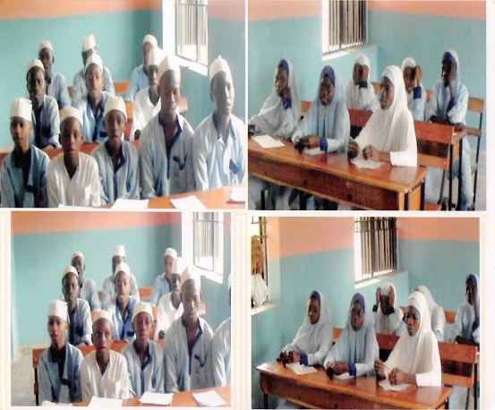
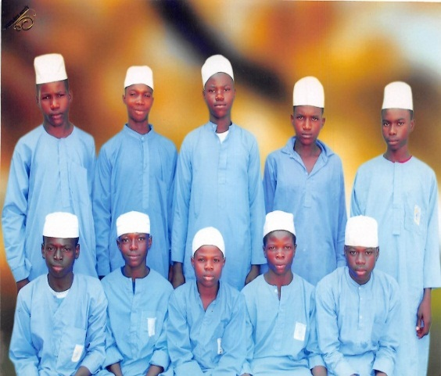
Fig.2 Fig.3

- The Teaching of Western Oriented Subjects in Arabic and Islamic Oriented Schools.
Another major area of the modernization of Arabic and Islamic learning is the westernization of the education by the way of teaching of western oriented subjects in Arabic and Islamic oriented schools.
Sheikh Muhammed Kamaldeen, his followers and supporters realized the importance of western type of education, especially in the age of industrialization, scientific and technological advancement. Therefore, they saw the necessity to add “western” subjects to their Islamic teaching and their Arabic school in Ilorin was transformed into a fully-fledged primary school combining “western” and Arabic subjects³¹. In 1947, the Adabiyya Muslim Society changed its name to Ansarul-Islam Society whose school was recognized by the government in 1956 and it became more and more engaged in the “western” type of education. The western subjecst that were taught at the school included; writing, reading, arithmetic, history, English language and geography³². A certain Mr. Kazeem and Mr. S.L. Afolabi who was national president of Ansarul-Islam Society of Nigeria were among the teachers who were invited from Lagos to teach these western subjects at Ansarul Islam Primary School, Okekere, Ilorin³³. The modernization of Arabic and Islamic education in Ilorin Emirate witnessed a land mark as the standard of Islamic education offered at the Ansarul-Islam established primary school was recognized as generally advanced by contemporary standard. The first set of twenty-three (23) pupils who obtained government certificates from Ansarul-Islam Primary School, Okekere, Ilorin passed out in 1957 and among the famous sons of Ilorin who benefited from this cooption of western and Islamic learning include Justice Abdulmutalib Ambali, Professor Shuaib Oba Abdul-Raheem and late Professor Musa Ali Ajetunmobi³⁴.
The Modernized Arabic and Islamic Schools within Ilorin Emirate
There are hundreds of modernized Arabic and Islamic schools in Ilorin Emirate. Some that registered with the National Board of Arabic and Islamic studies include³⁵.
- Omohiyah Zainu – Salihn College of Arabic and Islamic Studies, Ojagboro, Ilorin
- Darul-Kitab Wassuna, Ga’a Akanbi, Ilorin
- Kamal School of Arabic and Islamic studies, Ilorin.
- Shamsudeen College of Arabic and Islamic Studies, Akalanbi, Ilorin
- Muhyideen College of Arabic and Islamic Studies, Kulende, Ilorin
- Imam Shaban College of Arabic and Islamic Studies, Idi-Orombo, Compound, Ilorin.
- Jebba Government Arabic College, Jebba (Ilorin Emirate)
- Baraje Centre for Arabic and Islamic Studies, Gerewu, Ilorin
- Arabic and Islamic Training Centre, Agodi, Ilorin
- Taofiqullahi Islamic Academy, Ilorin
- El-Markazul Islamic El-Khairy College, Idiape, Ilorin
- Sheikh Ibrahim Niyas College of Islamic and Model Education, Abayawo, Ilorin
- Lateef College, Fate, Ilorin
- Darul-Ulum CAIS, Isalekoto, Ilorin
- Sadiyyah Solihiyyah School for Arabic and Islamic Studies, Koro, Ilorin
A part from the schools mentioned above, other major notable Arabic and Islamic school within Ilorin Emirate that are founded on the pattern of modernization include the following³⁶.
- Al-Zumratul Adabiyyah School of Arabic Studies founded by sheikh (Dr.) Kamaldeen Al-adaby in 1930
- Al-Jawahirul Islamiyyah School, Agbaji, Ilorin. It was founded in 1960 by Sheikh Abdullahi Gali.
- Al Ma’had al –Dini al-Azhri, Ogidi, Ilorin. It was founded by Sheikh Kamaldeen al-Adaby in 1963.
- Madrasat Darul-Ulum, Isale Koto, Ilorin, founded in 1963 by leading Arabic and Islamic scholars in Ilorin.
- Marikaz al-Talim al-Arabi Wal-Islami, Oke-Agodi, founded in 1965 by Sheikh Yahya Muritala.
- Al-Madrasutul Adabiyyal as-sa’a-diyyal, founded in 1970 by Sheikh Muhammed Baba Olomigbona.
- Al-Adabiyyah al-Kamaliyyah Institute of Arabic and Islamic Studies, Abata Sunkere, Ilorin, it was founded in 1971 by Sheikh Abdulraheem Aminulahi (Oniwasi Agbaye)
- Madrasatu I-Ummatil – Islamiyyah al-Adabiyyah, Ilorin central mosque, founded in 1973 by Sheikh Imam Yakub Ali Agan.
- Markaz al-Islam al-Khaeri, old central mosque, Ilorin. It was founded by Alhaji Fazazi Ahmad Imam in 1973.
- Markaz Ihya’a al-Islam, Abayawo, llorin. It was founded in 1976 by Sheikh Abubakar Yusuf Abayawo
- Markaz Jihadiddin al-Islam, Shao, Moro LGA. It was founded in 1979 by Jihaduddin Society.
- Arabic and Islamic Training Centre, Ajegunle Jimba, Ilorin, founded in 1980 by Alhaji Ibrahim Mustapha.
It should be added here that close to a hundred number of modernized Arabic and Islamic schools in Ilorin Emirate participated in the 2010/2011 Hijra celebration at the Kwara State Stadium, Complex, Ilorin. For details on the names of the schools, see Adesihna Lukman “The changing phases of Islamic learning in Ilorin Emirate up to the 20th century”. M.A. thesis, Department of History and International Studies, University of Ilorin, 2014 appendix (ix)
Problems Encountered in the Modernization of Islamic Learning
The initial innovations to Quranic learning in the name of modernization in Ilorin by Sheikh Kamaldeen provoked very stiff opposition and condemnation from conservative Mallams in Ilorin. This was due to the notion that the conservative Mallams had against anything from western world as being Christian oriented, especially at that time when western education tended to mean Christian antique, Christian moral, instruction and literature³⁷. The above problem could be termed resistance to change and there are still few Mallams most especially among the Zumura Muslim group (Makondoro) who disdain modernization or westernization of Islamic learning in Ilorin. For example, a popular Zumura Mallam by name Alfa Okutagidi, now late, was noted to have publicly denounced in strong terms the modern approaches to the Quranic learning³⁸.
Financial problem is also cited as one of the greatest problems in the modernization of Islamic learning in Ilorin as many of the remaining Quranic schools desired to modernize but hampered by limited resources. The government at the same time does not give subvention to uplift the standard of Quranic schools as it gives to public or western oriented schools; this is equally identified as one of the major factors militating against the effective modernization of Islamic learning in Ilorin³⁹.

Impacts of the Modernization of Arabic and Islamic Learning in Ilorin Emirate
Academic Impact
The modernization has positive impact in the area of academic pursuit. The introduction of modern categorization of students into level/arms such as Idadiyyah and Thanawiyyah with appropriate certificates has helped students with such certificates to further their education in higher institutions like College of Arabic and Islamic Legal Studies, Ilorin. This has gone a long way in responding to the contemporary educational challenges facing the products and students of various Quranic schools in Kwara State⁴⁰. The College academic programmes such as Shariah and common Law, Arabic and Islamic Studies has given the successful students with university requirements the opportunity to continue their studies in various Nigerian universities through Direct Entry and some went outside Nigeria⁴¹.
More importantly, the modernization (westernization) of Islamic education in Ilorin as exemplified by Sheikh Muhammed Kamaldeen as discussed above had led to the popularity of western education in Ilorin Emirate among the Muslim parents. The Muslim parents in Ilorin rejected western education for fear of converting their children to Christianity and they therefore preferred the existing Islamic education for their children⁴². But the modernization of Islamic education is seen as a route through which western education was introduced to the majority of Muslim parents in Ilorin Emirate because the introduction of combined western and Islamic education curricula by the Ansarul-Islam Society of Nigeria under the leadership of Sheikh Kamaldeen eventually received the approval of the generality of people of Ilorin after the initial stiff opposition from the conservative Mallams and this marked the beginning of the acceptance of western education by the people of Ilorin⁴³. The above position was further buttressed by the popular reference to the westernized Islamic School as Akewu-kewe, meaning that the school where both western and Islamic education are taught⁴⁴.
Social Impact
The modernization of Islamic education has changed or improved the social status of Islamic scholars. The students or graduates of modernized Arabic and Islamic schools are no longer seen as second class citizen. With the certificate they obtained, they can pursue their chosen field of study up to the Ph.D. level and by this, they can raise up their heads anywhere either to contribute their quotas towards the development of the society or in any discussion that has to do with their area of discipline⁴⁵.
Besides, the introduction of modern teaching aids to the system of teaching in Islamic schools as well as school uniform amongst others had given the students sense of belonging and to be seen and identified as students of a certain school.
In addition, the Islamic scholars nowadays due to the modernization put on suit and tie as against their initial attitude in those days when Quranic teachers forbade themselves wearing western cloths and affluent lives⁴⁶.
Economic Impact
One of the major impacts of the modernization of Arabic and Islamic learning in Ilorin Emirate and Kwara State in general is in the area of economic development. Due to the modernization or westernization, the graduates of madrassa are able to gain admission into higher institutions to further their studies. Upon graduation, the certificates issued can be used to secure white-collar job in Nigeria there by reducing the rate of unemployment among Islamic and Arabic scholars in Kwara State and Nigeria in general.
Besides, the proliferation of government approved Arabic and Islamic Nursery and Primary schools in Ilorin Emirate has tremendously contributed to the economic development of Kwara State as the proprietors or management of these private schools pay revenue to the government and at the same to employ the services of both Arabic and Islamic teachers as well as western oriented subject teachers. All these are nothing more than the economic impact of the modernization of Arabic and Islamic learning⁴⁷.

Conclusion
This paper examined the impact of the modernization of Arabic and Islamic education in Ilorin Emirate, 1943-2015. It has been proved that the modernization (westernization) of Islamic education in Ilorin as exemplified by Sheikh Muhammed Kamaldeen had led to the popularity of western education in Ilorin Emirate among the Muslim parents because the introduction of combined western and Islamic education curricula by the Ansarul-Islam Society of Nigeria eventually received the approval of the generality of people of Ilorin after the initial stiff opposition from the conservative Mallams and this marked the beginning of the acceptance of western education by the people of Ilorin.
The modernization has recorded a tremendous positive impact in Ilorin and beyond. For example, the introduction of modern categorization of students into level/arms such as Idadiyyah and Thanawiyyah with appropriate certificates has helped students with such certificates to further their education in higher institutions like College of Arabic and Islamic Legal Studies, Ilorin. This has gone a long way in responding to the contemporary educational challenges facing the products and students of various Quranic schools in Kwara State. The education has changed or improved the social status of Islamic scholars. The students or graduates of modernized Arabic and Islamic schools are no longer seen as second class citizen. With the certificate they obtained, they can pursue their chosen field of study up to the Ph.D. level and by this, they could raise up their heads anywhere either to contribute their quotas towards the development of the society or in any discussion that has to do with their area of discipline. Upon graduation, the certificates issued could be used to secure white-collar job in Nigeria there by reducing the rate of unemployment among Islamic and Arabic scholars in Kwara State and Nigeria in general.
This paper will get the readers acquainted with the operation and nature of typical Quranic schools in Ilorin Emirate before 1900 and the introduction of innovations to Islamic learning in the Emirate from 1943 to 2015. Lastly, the examination of the teaching of western education in Arabic and Islamic oriented schools and vice versa in this work will enhance our knowledge on the compatibility of Islamic and Western education.

Notes and References
- Omoiya, S.Y. (2006), “Diplomacy as Veritable Instrument of War”: A study of Ilorin Wars of Survival as an Emirate”. Ilorin Journal of History, Department of History, University of Ilorin. Ilorin, Vol.1 No. 2, P.75 and Hamid, K.R. “The Reality and Challenges of Arabic in Nigeria Schools and Colleges with Emphasis on Yorubaland”. Unpublished Ph.D. Thesis, Department of Arabic, University of Ilorin, 2009, PP. 179-180.
- Taiwo, B.M. (2003), “An Introduction to History of Education”. Ilorin: Nathadex Publishers, P.51.
- Jimoh, S.A. (1971-1972), “Critical Appraisal of Islamic Education with Particular Reference to Relevant Happenings on the Nigerian Scene”. Nigerian Journal of Islam, University of Ife, Ile-Ife, Nigeria. Vol.2, No, P.38.
- Jimoh, S.A. (1971-1972), “Critical Appraisal of Islamic Education with Particular Reference to Relevant Happenings on the Nigerian Scene”…P.39.
- Jimoh, S.A. (1971-1972), “Critical Appraisal of Islamic Education with Particular Reference to Relevant Happenings on the Nigerian Scene”…P.39.
- Jimoh, S.A. (1971-1972), “Critical Appraisal of Islamic Education with Particular Reference to Relevant Happenings on the Nigerian Scene”…P.39.
- Taiwo, B.M. (2003) “An Introduction to History of Education”…P.52.
- Taiwo, B.M. (2003) “An Introduction to History of Education”… P.52.
- Jimoh, S.A. (1971-1972) “Critical Appraisal of Islamic Education with Particular Reference to Relevant Happenings on the Nigerian Scene”… P.40.
- Jimoh, S.A. (1971-1972) “Critical Appraisal of Islamic Education with Particular Reference to Relevant Happenings on the Nigerian Scene”… P.40.
- Jimoh, S.A. (1971-1972) “Critical Appraisal of Islamic Education with Particular Reference to Relevant Happenings on the Nigerian Scene”… P.40.
- Jimoh, S.A. (1971-1972) “Critical Appraisal of Islamic Education with Particular Reference to Relevant Happenings on the Nigerian Scene”… P.40.
- Jimoh, S.A. (1971-1972) “Critical Appraisal of Islamic Education with Particular Reference to Relevant Happenings on the Nigerian Scene”…P.4.
- Is’haq, I, “The Development of Quranic School in Ilorin”. N.C.E. Unpublished Project, Department of Islamic Studies, Kwara State College of Education, Ilorin, June, 1989, PP.24-25.
- Jimoh, S.A. (1971-1972) “Critical Appraisal of Islamic Education with Particular Reference to Relevant Happenings on the Nigerian Scene”….P.41.
- Interview with Alhaji Abdulraheem Oreku, 72 years, a Quranic teacher (Alfa Ile-kewu), Onagun Compound Quranic School, Onagun Compound, Ilorin, 10/11/2013.
- Oseni, Z.I. (2006), “Arabic and Islamic Scholarship in Ilorin”, in: S.A. Jimoh (eds.), Ilorin: Centre of Learning, Ilorin: Jimson Publishers, PP.48-49.
- Oseni, Z.I. (2006), “Arabic and Islamic Scholarship in Ilorin”, in: S.A. Jimoh (eds.), Ilorin: Centre of Learning…P.49.
- Jimoh, L.A.K. (1994), “Ilorin: The Journey So Far”. Ilorin: Atoto Press Ltd., PP.420-421.
- Jimoh, L.A.K. (1994), “Ilorin: The Journey So Far”. Ilorin...P.420-442.
- Jimoh, L.A.K. (1994), “Ilorin: The Journey So Far”. Ilorin...P.419.
- Interview with Sheikh Issa Bur’anudeen, 94 years, Imam Ita-Egba Mosque, Olokonla Compound, Ita-Egba, Ilorin, 13/04/2014.
- Is’haq, I. “The Development of Quranic School in Ilorin”…P.22.
- Is’haq, I. “The Development of Quranic School in Ilorin”…P.22.
- Is’haq, I. “The Development of Quranic School in Ilorin”…P.22.
- Muhammed-Bello, M. “Modern Approach to Quranic Learning in Ilorin East Local Government”, Unpublished B.A. Project, Department of Religions, University of Ilorin, 2003, P.25.
- Is’haq, I. “The Development of Quranic School in Ilorin”… P.41.
- Muhammed-Bello, M. “Modern Approach to Quranic Learning in Ilorin East Local Government”…P.27.
- Muhammed-Bello, M. “Modern Approach to Quranic Learning in Ilorin East Local Government”...P.27.
- Muhammed-Bello, M. “Modern Approach to Quranic Learning in Ilorin East Local Government”...P.28.
- Stefan R. (1993), “Islamic Learning and Its Interaction with Western Education in Ilorin, Nigeria” in: Brenner, L. (eds.), Muslim Identity and Social” Change in Sub-Sharan Africa. London: C. Hurst & Co. Ltd., P.185.
- Gambari, S.F. “Influence of Western Education on Islamic Education in Ilorin West Local Government Area of Kwara State”. N.C.E. Project, Department of Islamic Studies, Kwara State College of Education, Ilorin, July, 2009, P.39.
- Interview with Alhaji A.B. Salah, 81 years, Former teacher at Ansarul-Islam Primary School, Okekere, Ilorin, (Islamic scholar), Okekere Area, Ilorin, 20/08/2014.
- Gambari, S.F. “Influence of Western Education on Islamic Education in Ilorin West Local Government Area of Kwara State”…P.40.
- Interview with Alhaji Imam Abdulkadir Sheu, 52 yers, State Coordinator, National Board of Arabic and Islamic Studies, Kwara State Ministry of Education, Ilorin, Examination Unit, Kwara State Ministry of Education, Ilorin, 16/04/2014.
- Oseni, Z.I. (2006), “Arabic and Islamic Scholarship in Ilorin”, in: S.A. Jimoh (eds.), Ilorin: Centre of Learning...PP.50-52.
- Gambari, S.F. “Influence of Western Education on Islamic Education in Ilorin West Local Government Area of Kwara State”…P.23.
- Muhammed-Bello, M. “Modern Approach to Quranic Learning in Ilorin East Local Government”…P.37.
- Abdul Salam, O.A. “The Origin of Arabic and Islamic Institutions in Ilorin Emirate: A Case Study of Markas Tahlim L-Arobiya, Oke Agodi, 1965-2005”, Unpublished B.A Project, Department of History, University of Ilorin, September, 2006, P.62.
- Issa, A. and Abdullahi, K.A. (2006), “Kwara CAILS: The Journey So Far”. Kwara State College of Arabic and Islamic Legal Studies, Ilorin, PP.133-134.
- Issa, A. and Abdullahi, K.A. (2006), “Kwara CAILS: The Journey So Far”. Kwara State College of Arabic and Islamic Legal Studies, Ilorin…PP.175-176.
- Gambari, S.F. “Influence of Western Education on Islamic Education in Ilorin West Local Government Area of Kwara State”… PP.35-36.
- Gambari, S.F. “Influence of Western Education on Islamic Education in Ilorin West Local Government Area of Kwara State”…P.34.
- Interview with Dr. Abdur-Razaq M.B. Solagberu, 57 years, Chief Imam of College of Arabic and Islamic Legal Studies, Ilorin, CAILS, Ilorin, 02/05/2014.
- Interview with Dr. Abdulganiy Akorede Abdulhameed Agbarigidoma, 50+ years, Senior Lecturer, Department of Languages, Al-Hikmah University, Ilorin, Al-Hikmah University, Ilorin, 03/05/2014.
- Interview with Dr. Abdulganiy Akorede Abdulhameed Agbarigidoma, as previously cited.
- Interview with Dr. Abdulganiy Akorede Abdulhameed Agbarigidoma, as previously cited.

