Plasmid Profiles of Multi-Drug Resistant E.coli Isolates from Stools of Diarrhoeic Children Below Five Years in Zaria, Nigeria.
David M.S *¹, Ehinmidu J.O², Olayinka B.O², Olayinka A.T³, David O.S⁴
- Department of Pharmaceutical Microbiology and Biotechnology, Faculty of Pharmaceutical Sciences, University of Ilorin, Ilorin., Nigeria
- Department of Pharmaceutics and Pharmaceutical Microbiology, Faculty of Pharmaceutical Sciences, Ahmadu Bello University, Zaria
- Department of Medical Microbiology, Ahmadu Bello University Teaching Hospital, Shika, Zaria, Nigeria
- Department of Internal Medicine, Bingham University Teaching Hospital, Jos.

Correspondence; Email: susanmosebolatan@gmail.com. GSM: +2347039137090
__________________________________________________________________________________

ABSTRACT
E. coli is one of the main causes of both nosocomial and community acquired infections in humans and is therefore an organism of clinical importance in the lives of children. Antibiotic resistance poses a serious public health problem. Antibiotic susceptibility testing was carried on seventy (70) isolates of Escherichia coli from stool samples of diarrhoeic children below five (5) years of age with suspected gastrointestinal infections attending two hospitals and a primary health care centre in Zaria by Kirby Bauer agar diffusion method. Curing experiments of the transconjugants and resistant Escherichia coli isolates was carried out using acridine orange dye to determine if the resistant determinants were plasmid mediated. Isolates were subjected to plasmid DNA isolation following the protocol of Gene Jet TM plasmid miniprep kit.1% agarose gel was used to resolve the plasmid fragment after loading and electrophoresis carried out. Polymerase chain reaction (PCR) amplification of target genes from isolated plasmid DNA was carried out. Gene specific primers were used in PCR to amplify specific fragments from genes coding for resistance to quinolones and bla _{CTX-M} ESBL as described by the manufacturer (Iquaba Biotec). Plasmid DNA analysis on thirty-five resistant isolates showed 11 plasmid band sizes with molecular weights ranging from 2800 bp to > 5000 bp. Three isolates were found to harbour the IncK epidemiologic plasmid encoding gene for the bla _{CTX-M} of the ESBLs and nineteen resistant isolates were also found to harbour the gyrB gene. The plasmid profiles observed in this study indicates a notable correlation between antibiotic resistance and plasmid presence. Plasmid borne resistant genes among the Escherichia coli isolates were more from the stools of children obtained from the General Hospital, Kofan-Gaya, Zaria-city, Nigeria.
__________________________________________________________________________________

INTRODUCTION
Diarrhoea is defined as the passage of three or more loose or liquid stools per day or more frequent passage than is normal for the individual (WHO, 2009). Diarrhoeal disease has been reported to be a leading cause of morbidity and mortality in children and there are about two billion cases of diarrhoeal disease worldwide (WHO, 2009). Diarrheal diseases has also been documented to account for 1 in 9 child deaths worldwide, making diarrhoea the second leading cause of death among children under the age of five (CDC, 2013). Diarrhoea is a symptom of an infection in the intestinal tract, which can be caused by a variety of bacteria, viral and parasitic organisms. Infection is spread through contaminated food or drinking water, or from person to person as a result of poor hygiene (WHO, 2013).
Antimicrobial resistance threatens the effective prevention and treatment of an everincreasing range of infections caused by bacteria, parasites, viruses and fungi. It is an increasingly serious threat to global public health that requires action across all government sectors and society. New resistance mechanisms emerge and spread globally. (WHO , 2015). E. coli is one of the main causes of both nosocomial and community acquired infections in humans and is therefore an organism of clinical importance in the lives of children. E. coli strains are termed commensals and part of the normal intestinal microflora of human and warmblooded animals, they may cause diseases under certain circumstances (Kaper et al., 2004).
E. coli and other members of the family Enterobacteriaceae are well known to develop or acquire resistance to a variety of antibiotics by different mechanisms. However, production of β-lactamases is the most common and clinically significant mechanism of resistance among this bacterial group (Suarez et al., 2005; Torres et al., 2007; Woodford et al., 2007). Accordingly, the intestinal E. coli microflora may provide an important reservoir for antibiotic-resistant bacteria, and resistance genes, which may be transmitted further to potentially pathogenic bacteria (Pallecchi et al., 2007). Thus, the ecological impact of different antimicrobial agents, as well as the development of antimicrobial resistance before it appears in pathogenic strains and in clinical infections, could be studied in the intestinal E. coli flora

MATERIALS AND METHODS
Sample collection, isolation and identification. The stool samples were collected into sterile specimen containers and transported to the laboratory at ambient temperature (15°C to 30°C). The stool samples were inoculated into sterile nutrient broth and incubated at 37°C overnight. Overnight nutrient broth stool cultures were then sub-cultured on MacConkey agar and Eosin Methylene Blue Agar plates. The plates were incubated at 37⁰C for 18 hours for primary isolation.
Lactose fermenting colonies from MacConkey and Eosin-Methylene Blue agar were subjected to microscopic examination to determine cell morphology and Gram stain reactions. Cultural characteristics, colonial morphology of the isolates and Gram staining reactions were determined as described Cheesbrough (2006).
Gram negative bacilli were biochemically identified and confirmed as Escherichia coli using non-citrate utilization, indole formation, methyl red production, Voges Proskauer test and fermentation of sugars.

ANTIBIOTIC SUSCEPTIBILITY TESTING , CONJUGATION STUDIES AND CURING TRANSCONJUGANTS
The susceptibility of seventy Escherichia coli isolates to nine (9) commonly prescribed antibiotics was determined according to Wolf, (1975) as modified by CLSI (1995) using the Kirby Bauer disc diffusion method. The transfer of resistance traits by the resistant isolates of Escherichia coli to ciprofloxacin sensitive Proteus mirabilis was investigated using the methods described by Onaolapo (1986) with some modifications. The minimum inhibitory concentrations (MIC) of selected test antibiotics against the sensitive Proteus mirabilis were determined using the standard method. Thereafter, resistant isolates of E. coli and the ciprofloxacin sensitive Proteus mirabilis were each grown in sterile nutrient broth (5ml) each at 37°C for 18 hours. The overnight cultures of the potential donor (R⁺) E. coli resistant isolates and the recipients (R⁻) i.e. sensitive Proteus mirabilis was grown in a ratio of 10:1 respectively in 5ml volume of sterile nutrient broth and incubated in a static incubator at 37°C for 18 hours. One loopful of recombinants (transconjugants) from the admixtures (E. coli and Proteus mirabilis) bottles were subcultured in triplicate on MacConkey agar plates incorporated with the antibiotic of MIC strength (4 µg/ml of ciprofloxacin in double strength MacConkey agar) against sensitive Proteus mirabilis and incubated at 37°C for 24 hours. The plates were examined for the presence or absence of cultural characteristics of Proteus mirabilis and lactose fermenting properties. Original culture of Proteus miralibis and E. coli separately was diluted in1:100 ratio and a drop was spread on MacConkey agar containing ciprofloxacin 4µg/ml for positive control. The colonies of Proteus mirabilis observed were aseptically picked and transferred into nutrient agar slant and subcultured, after which the MICs of transconjugants were determined as described by Lennette et al. (1990). The curing of transconjugants Proteus mirabilis (Rf plasmid) was carried out by treating the Proteus mirabilis transconjugants with acridine orange dye as described by Onaolapo (1986).

ISOLATION OF PLASMID DNA
Isolation of DNA plasmid and its analysis was carried out at the centre for Biotechnology research and training institute of the University. The transconjugant strains and resistant isolates were subjected to plasmid DNA isolation following the protocol of Gene JetTM Plasmid Miniprep kit.

Agarose Gel Electrophoresis
A 1% agarose gel was used to resolve the plasmid fragment. The agarose gel was prepared by combining lg of agarose in ten times concentration of Tris acetate ethylene diamine tetra acetate (10ml 10x TAE) buffer and 90 ml distilled water in a 250ml beaker flask and heating in a microwave for 2 minutes until the agarose was dissolved. Two and half milliliter (2.5ml) ethidium bromide (5.0

Gene | Primers | Sequence,5’→3’ | Target | Product size bp | References
blaCTX-M-14 | pCT(008)F | CATTGTATCTATCTTGTGGG | pCTpCT 008-pCT009 region | 428 | Cottel et al., 2011
 | pCT(009)R | GCATTCCAGAAGATGACGTT | pCTpCT 008-pCT009 region | 428
gyrB | Primer 1 F | GCGCGTGAGATGACCCGCCGT | QRDR region of 995 to 1442 | 448 | Gomez et al., 2004

Table 3.1: Primers used in the study
mg/ml) was added to the dissolved agarose solution with swirling to mix. The gel was then poured onto a mini horizontal gel electrophoresis tank and the casting combs were inserted. It was then allowed to set for 30 minutes. The casting combs were then carefully removed after the gel had completely solidified, one time concentration (1X) TAE electrophoresis buffer was then added to the reservoir until the buffer just covered the agarose gel.

Loading Plasmid DNA Samples
Five microlitres (5µl) of gel tracking dye (bromophenol blue) was added to 15µl of each plasmid DNA isolates with gentle mixing. 20µl of the mixture was then loaded onto the wells of the gel, the mini horizontal electrophoresis gel set up was then covered and the electrodes connected. Electrophoresis was carried out at 100mV for 45 minutes. At the completion of the electrophoresis, the gel was removed from the buffer and the gel was viewed under a long wave UV light box i.e. Transilluminator (302 nm). The band pattern of the DNA fragments were then photographed with a Polaroid camera and documented using an electrophoresis gel documentation system.

POLYMERASE CHAIN REACTION AMPLIFICATION OF TARGET GENES Polymerase chain reaction (PCR) amplification of target genes from isolated plasmid DNA was carried out. Gene specific primers were used in PCR to amplify specific fragments from genes coding for resistance of fluoroquinolones and bla_{CTX-M} ESBL as described by the manufacturer (Iquaba Biotec). Protocol for the Dream TaqTM PCR master mix (2x) was followed.

Primer 1 R CTGGCGGTAGAAGAAGGTCAG QRDR region of 995 to 1442 448
Gene bank accession number D87842
*Agarose Gel Electrophoresis of PCR Products resistance factor of the donor bacterium had been incorporated. (Table 4.2).
RESULTS AND DISCUSSION
CONJUGATION STUDIES  Conjugation studies was carried out to determine the existence of transferable antibiotic resistance determinants using ciprofloxacin resistant E. coli isolates as donor. The studies showed that out of the twenty (20) donor E. coli isolates with ciprofloxacin resistant factor, only twelve (12) were observed to transfer their resistance factor. The increase in the minimum inhibitory concentration of the recipient Proteus mirabilis (0.375μg/ML) to that of ciprofloxacin ( 6-100μg/ml) after conjugation showed that the phenotypic | PLASMID CURING  Curing of the transconjugants with acridine orange showed changes in the antibiotic sensitivity pattern of all the tested transconjugants. The MIC values of ciprofloxacin against the tested cured transconjugants decreased significantly when compared to the values obtained before curing. (Table 4.3).  Out of the seventy E.coli isolates, twenty- seven were observed to be resistant to ciprofloxacin. Twelve out of the twenty donor E.coli isolates used were found to transfer plasmids to the recipient Proteus mirabilis.(Table 4.2 & 4.3).

Table 4. 1: Minimum inhibitory concentration of ciprofloxacin before and after conjugation.
S/N Isolates code MIC of ciprofloxacin Recipient Proteus MIC of ciprofloxacin
 | before (µg/ml) | conjugation | mirabilis characteristics | after (µg/ml) | conjugation
1 S36 | 50.0 |  | + | 100
2 S 30 | 50.0 |  | + | 50
3 K 57 | 100.0 |  | + | 12
4 K53 | 100.0 |  | + | 100
5 K10a¹ | 3.0 |  | _ | _
6 K52 | 12.0 |  | _ | _
7 S18 | 12.0 |  | _ | _
8 S29 | 12.0 |  | + | 20
9 K37 | 50.0 |  | + | 100
10 K1 | 100.0 |  | _ | _
11 K49 | 100.0 |  | + | 100
12 K48 | 3.0 |  | _ | _
13 K56 | 100.0 |  | _ | _
14 K6b | 50.0 |  | + | 50
15 K47 | 6.0 |  | + | 6
16 K59 | 20.0 |  | + | 20
17 S27 | 50.0 |  | + | 50
18 S16 | 100.0 |  | _ | _
19 K58 | 20.0 |  | + | 20
20 S21 | 3.0 |  | _ | _
MIC Range 3-100 µg/ml. MIC of recipient Proteus mirabilis before conjugation = 0.375µg/ml
+ =isolates which showed Proteus mirabilis characteristics.
_ = isolates which showed no characteristics for Proteus mirabilis.

Table 4. 2: Transconjugants Proteus mirabillis MIC and phenotypic resistant pattern at transfer temperature of 37ºC.
Donor isolates lab no | Transconjugants MIC (µg/ml) | Donor phenotypic resistance profile
S36 | 100 | Aml, Caz, Cn, Sxt, Te, Amp.
S30 | 50 | Aml. Caz,Cxm,Sxt,Te,Amp.
K57 | 12 | Aml,Cro,Caz,Cxm,Sxt,Te,Amp.
K53 | 100 | Aml,Cro,Caz,Cxm,Sxt,Cip,Te,Amp.
S29 | 20 | Aml, Cro,Caz, Cxm,Sxt,Te,Amp.
K37 | 100 | Aml,Caz,Cxm,Sxt,Te,Amp
K49 | 100 | Aml, Cro, Caz, Cxm, Sxt, Cip, Te, Amp.
K6b | 50 | Aml, Cro, Caz, Cn, Cxm,Sxt,Cip,Te,Amp.
K59 | 20 | Aml,Cro,Caz,Cn,Cxm,Sxt,Cip,Te,Amp.
S27 | 50 | Aml, Cro,CAz,Cxm,Sxt,Cip,Te,Amp.
K58  K47 | 20  6 | Aml,Cro,Caz, Cxm, Sxt, Te,Amp.  Aml, Cro, Caz, Cxm, Sxt, Te, Amp.
Aml=Amoxicillin Cro = Ceftriaxone Sxt = Sulfamethoxazole/Trimethoprim
Caz = Ceftazidine Cxm = Cefuroxime Te = Tetracycline
Cn = Gentamicin Cip = Ciprofloxacin Amp = Ampicillin

Table 4. 3: Minimum inhibitory of ciprofloxacin against the cured transconjugants (Proteus mirabilis).
S/No | Isolates No. | MIC before curing | MIC after curing
1 | S₃₆ | 100 | 0.375
2 | S₃₀ | 50 | 0.375
3 | K₅₇ | 12 | 0.75
4 | K₅₃ | 100 | 0.375
5 | S₂₉ | 20 | 0.75
6 | K37 | 100 | 6
7 | K49 | 100 | 6
8 | K6b | 50 | 0.75
9 | K47 | 6 | 1.5
10 | K59 | 20 | 0.375
11 | S27 | 50 | 1.5
12 | K58 | 20 | 0.375

PLASMID DNA ANALYSIS
Plates 4.1-4.3 shows the plasmid DNAs obtained from the multiple antibiotic resistant E. coli isolates on agarose gel electrophoresis. Plasmid analysis of E. coli isolates yielded five different plasmid profiles (2800, 3100, 3200, >4000 and >5000bp) (Table 4.4). From the agarose gel electrophoresis of the plasmid DNAs isolated, eleven plasmid bands were observed in this study. Plate 4.1 shows six resistant isolates harbouring nine plasmids, plate 4.2 shows an isolate harbouring one plasmid band and plate 4.3 also shows an isolate harbouring one plasmid band. Plates 4.4-4.8 shows polymerase chain reaction products of gene-specific primers 1 and 2. Primer 1 codes for part of IncK plasmid of the bla_{CTX-M} of ESBLs while primer 2 codes for gyrB gene of QRDR for fluoroquinolone resistance. Three resistant isolates were found to carry the bla_{CTX-M} of the ESBL genes ( lane 12 in plate 4.4 and lanes 13 and 15 in plate 4.6), while nineteen resistant isolates were observed to carry the gyrB genes ( lanes 2,4,6,8,10,12 and 14 in plate 4.6 ,lanes 2 and 5 in plate 4.7 and lanes 3,4,5,7,9,10,11,13,14,15 in plate 4.8). Seven isolates out of the resistant E.coli donor cells for conjugation studies which showed no plasmid transfer were observed to harbour plasmid band and they showed the presence of resistant genes on PCR. It was also observed that the transconjugant Proteus mirabilis displayed one or two plasmid bands in them and they were also observed to carry resistant genes on PCR.

The order of occurrence of these plasmid base (2), 3200bp (1)=3100bp (1) (Table4.4). pairs was >5000bp (4), 2800bp (3), >4000bp
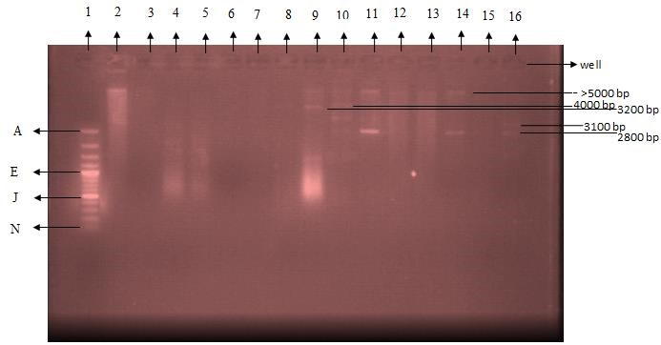
Plate 4. 1: 1% Agarose gel electrophoresis (100V, 45 min) of plasmid DNAs from multiple antibiotics resistant E. coli and transconjugant isolates in Zaria, Nigeria.
Lane 1: 100bp plus DNA ladder showing plasmid sizes of 3000(A), 2000, 1500, 1200, 1000 (E), 900, 800, 700, 600, 500 (J), 400, 300, 200, 100 (N). Lane 2- 6: Resistant E. coli isolates (R_{16-R20)} Lane 7-16: Transconjugant (T_{1-T10}).
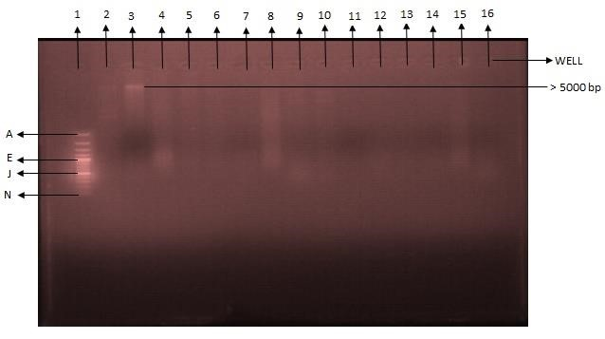
Plate 4. 2: 1% Agarose Gel Electrophoresis (100V, 45 min) of plasmid DNAs from multiple antibiotics resistant E. coli isolates in Zaria, Nigeria.
Lane 1: 100bp plus DNA ladder showing plasmid sizes of 3000(A), 2000, 1500, 1200, 1000 (E), 900, 800, 700, 600, 500 (J), 400, 300, 200, 100 (N).
Lane 2-16: Resistant E. coli isolate (R₁-R₁₅)

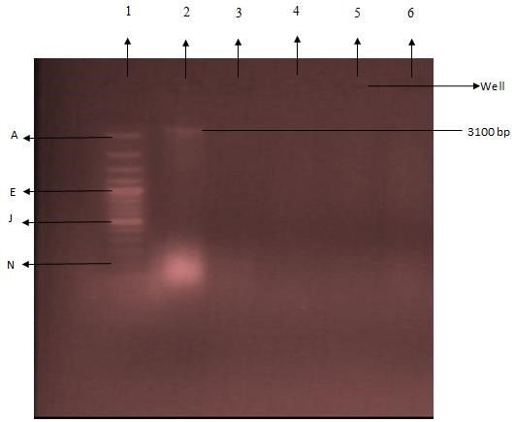
Plate 4. 3: 1% Agarose Gel Electrophoresis (100V, 45 mins) of Plasmid DNAs isolate from Transconjugants, Cured and recipient isolates in Zaria, Nigeria.
Lane 1: 100bp plus DNA ladder showing plasmid sizes of 3000(A), 2000, 150 0, 1200, 1000 (E), 900, 800, 700, 600, 500 (J), 400, 300, 200, 100 (N).
Lane 2-3: transconjugant (T_{11-T12}) ; Lane 4-5: Cured transconjugant (T_{6-T7}) Lane 6: Conjugation recipeint (Proteus mirabilis)

Table 4.4 : Profile of resistant isolates and transconjugants harbouring plasmids
Isolate no. | E. coli isolate | No. of plasmids | Estimated molecular sizes of plasmids (bp)
S18 | R₂ | 1 | Higher than (>) 5000
K53 | R16 | 1 | Higher than (>) 5000
S36 | T3 | 1 | Higher than (>) 4000
K6b | T4 | 2 | >4000 and 3200
S27 | T5 | 2 | > 5000, 2800
K49 | T8 | 2 | > 5000, 2800
K57 | T10 | 1 | 2800
K58 | T11 | 1 | 3,100
Total | 8 | 11

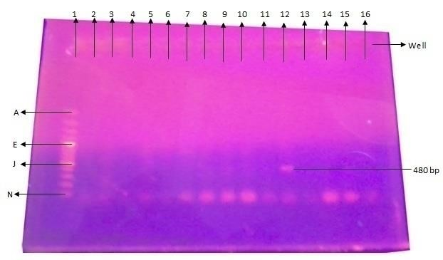
Plate 4. 4: Polymerase chain reaction products with primer 2 on 1% agarose gel electrophoresis (100v, 45 min) of plasmid DNAs from multiple antibiotic resistant and tranconjugant isolates in Zaria, Nigeria.
Lane 1: 100bp plus DNA ladder showing plasmid sizes of 3000(A), 2000, 1500, 1200, 1000 (E), 900, 800, 700, 600, 500 (J), 400, 300, 200, 100 (N).
Lane 2 to 4: Transconjugants (T₁ – T₃) with primer 2 respectively. Lane 5 to 16: Resistant E. coli isolates (R₁ to R12) with primer 2.

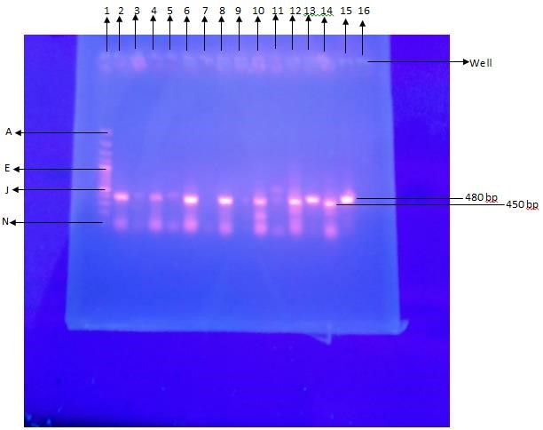
Plate 4.5: Polymerase chain reaction products with primer 1 and 2 in alternate positions on 1% agarose gel electrophoresis (100v, 45 min) of plasmid DNAs from multiple antibiotic resistant E. coli and transconjugant isolates in Zaria.
Lane 1: 100bp plus DNA ladder showing plasmid sizes of 3000(A), 2000, 1500, 1200, 1000 (E), 900, 800, 700, 600, 500 (J), 400, 300, 200, 100 (N).
Lane 2 and 3: Resistant E. coli (R₁₇) with primer 1 and 2 respectively.
Lane 4 and 5: Transconjugant (T₉) with primer 1 and 2 respectively.
Lane 6 and 7: Transconjugant (T₁₀) with primer 1 and 2 respectively.
Lane 8 and 9: Transconjugant (T₁₁) with primer 1 and 2 respectively.
Lane 10 and 11:Resistant E. coli isolate (R₁₄) with primer 1 and 2 respectively
Lane 12 and 13:Resistant E. coli isolate (R₁₅) with primer 1 and 2 respectively
Lane 14 and 15:Resistant E. coli isolate (R₁₆) with primer 1 and 2 respectively
Lane 16: Empty
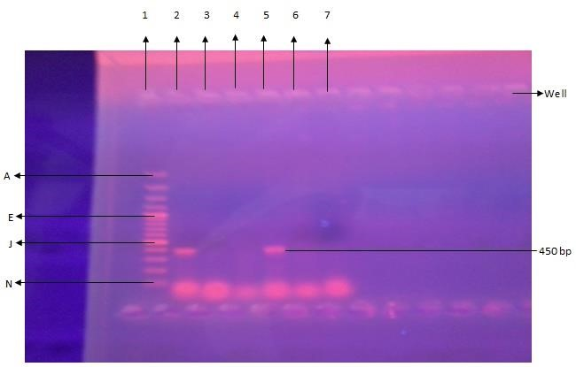
Plate 4.6: Polymerase chain reaction products with primer 1 on 1% agarose gel electrophoresis (100v, 45 min) of plasmid DNAs from multiple antibiotic resistant E. coli and transconjugant isolates in Zaria, Nigeria.
Lane 1: 100bp plus DNA ladder showing plasmid sizes of 3000(A), 2000, 1500, 1200, 1000 (E), 900, 800, 700, 600, 500 (J), 400, 300, 200, 100 (N).
Lane 2: Transconjugant (T₈) with primer 1; Lane 3: Transconjugant (T₇) with primer 1. Lane 4-7 : Resistant E. coli isolate (R13,R18,R19 and R20 respectively) with primer 1

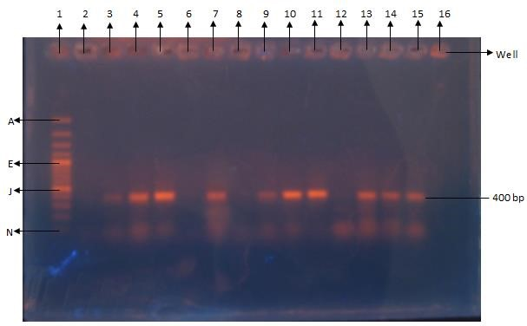
Plate 4.7: Polymerase chain reaction products with primer 1 on 1% agarose gel electrophoresis (100v, 45 min) of plasmid DNAs from multiple antibiotic resistant E. coli and transconjugant isolates in Zaria, Nigeria.

Lane 1: 100bp plus DNA ladder showing plasmid sizes of 3000(A), 2000, 1500, 1200, 1000 (E), 900, 800, 700, 600, 500 (J), 400, 300, 200, 100 (N).
Lane 2: Resistant E. coli isolate (R₁) with primer 1.
Lane 3 -11: Resistant E. coli isolates (R2,R3,R4,R5,R8,R9,R10,R11 and R12 respectively ) with primer 1.

Lane 12-16: Transconjugant (T_{1-T5}) with primer 1.

-1000
0
1000
2000
3000
4000
5000
0
1
2
3
4
5
6
Molecular weight sizes of plasmids (bp)

Distance moved

Series1
Log. (Series1)

Figure 4. 1: Logarithmic graph of the molecular weight sizes of marker against the distance travelled in centimetres by the plasmid DNA.(Agarose)

RESISTANT PLASMID INVESTIGATION
Twenty resistant isolates from the antibiotic susceptibility testing results were used for conjugation studies, of which thirteen were from Kofan-Gaya and seven from the Primary health care centre,Samaru . The result of the conjugation studies showed that some of the antibiotic resistance genes were likely plasmid-encoded and transmissible. The MIC of ciprofloxacin was done before and after conjugation in other to ascertain if there was plasmid transfer between the donor and recipient organisms. The increase in the MIC value of ciprofloxacin after conjugation shows that the recipient had taken the characteristics of the donor resistant E. coli donor isolates.
The curing of transconjugants showed a reduced MIC value for ciprofloxacin against the same transconjugants. The MIC of ciprofloxacin against the cured transconjugant decreased as compared to the values obtained before the curing. This shows that the curing of the plasmid from the transconjugants with the acridine orange dye has affected the change in MIC values observed (Table 4.1).
Plasmid analysis on agarose gel electrophoresis of 35 isolates revealed a total of 11 plasmid bands on agarose gel electrophoresis (Plates 4.1-4.3) and 22 plasmid genes on PCR with primers 1 and 2 (Plates 4.4 to 4.7). The bands in this study did not occur randomly, this observation disagrees with a previous work carried out by Faruque et al.(1993) who analyzed 69 clinical isolates of E. coli and found 29 different plasmid bands. In the work documented, he observed that none of the plasmids were found to be common in all the strains indicating that none of these plasmids carried information for characteristics essential for the bacteria to survive in the environment and within the host. This was in agreement with the assumptions that plasmids usually carry accessory characteristics (Hardy, 1986). In contrast to this report, in this study, some of the plasmid bands were found to be common in other resistant isolates (Plates 4.1,4.2 and 4.3) . The plasmid analysis of E. coli isolates yielded five different plasmid profiles with estimated molecular weights of 2800bp, 3100bp, 3200bp ,>4000bp and >5000bp. The highest molecular base pair plasmid profile which corresponds to >5000bp was shared by four resistant isolates. From this study, it was observed that all the isolates which carried this plasmid band showed phenotypic resistance to amoxicillin, ceftazidime, cefuroxime, ampicillin and tetracycline. So we can say that this plasmid possibly codes for resistance to the beta-lactam antibiotics, cephalosporins and tetracycline. Two resistant isolates shared the plasmid profile of >4000bp with phenotypic resistant pattern to amoxicillin, ceftazidime, cefuroxime, ampicillin, tetracycline, sulphamethoxazole/trimethoprim and gentimicin. Three isolates shared the plasmid profile of 2800bp which showed phenotypic resistance to amoxicillin, ceftazidime, cefuroxime, ampicillin, tetracycline, sulphadoxine/trimethoprim, ceftriazone and ciprofloxacin. One isolate each shared plasmid profile of 3200bp and 3100bp which showed phenotypic resistance to amoxicillin, ceftazidime, cefuroxime, ampicillin, tetracycline, sulphadoxine/trimethoprim, ceftriazone, ciprofloxacin and gentamicin for 3200bp, then amoxicillin, ceftazidime, cefuroxime, ampicillin, tetracycline, sulphadoxine/trimethoprim and ceftriazone for 3100bp.
The plasmid profiles observed in this study indicates a notable correlation between antibiotic resistance and plasmid presence. It was observed that all the eight isolates which were found to have plasmid bands showed close antibiotic resistant patterns to about four antibiotics, and five out of the eight isolates carried one plasmid band in them while the remainig three isolates carried two plasmid bands each making a total of eleven plasmid bands. This report is similar to what was observed by Smith et al., (2003) who reported plasmid range sizes from 0.564kb to >23kb in Lagos, Nigeria. It was also observed from this study that 5 resistant isolates out of eight were found to come from the General Hospital Kofan- Gayan, Zaria, Nigeria giving a percentage of 16.1% (5/31) of isolates harbouring plasmids, while three resistant isolates (3/32), 9.4% were found to harbour plasmids from the Primary Health Care Centre, Samaru.
PRESENCE OF bla_{CTX-M} ESBL GENES The designed primer (pCT008-009) adapted from Cottell et al., (2011), was used on the plasmid DNAs of 29 resistant E. coli isolates for the detection of IncK epidemiologic plasmid of bla_{CTX-M} of ESBL encoding gene for amplification. PCR detection using this gene specific primers showed that three resistant E. coli isolates harboured the bla_{CTX-M} genes with molecular weight sizes of about 480bp. The finding of bla_{CTX-M} plasmid in this study is also consistent with the work done by Cottel et al., (2011). This suggests that the resistant genes found are plasmid borne. Also the three resistant E.coli isolates which were observed to harbour these genes were from the General Hospital, Kofan-Gayan. According to
Bonnet, 2004; Perez et al ., 2007 and Yohei, 2009, the CTX-M type of beta –lactamases which have become important, originated from beta-lactamases found in environmental species of the genus kluyvera, and this enzyme has been reported to hydrolyse cefotaxime and ceftriazone but is weakly active against ceftazidime . In this study, the resistant isolates which harboured plasmids coding for this resistance were found to be resistant to ceftriazone and ceftazidime. This study therefore agrees with the report of the other workers. (Bonnet, 2004; Perez et al., 2007 and Yohei, 2009).
In addition, according to Livermor et al., 2007, Yohei, 2009, and Cottell et al., 2011 the bla_{CTX-M} gene is considered the most prevalent ESBL-encoding gene worldwide and is replacing TEM and SHV types as the predominant ESBL in many European countries . The finding in this study may soon become wide spread in the locality studied if the pattern of resistance persist. The finding of this study also agrees with documented reports that the emergerce of Escherichia coli and Klebsiella pneumonia resistant to ceftazidime and other cephalosporins seriously compromise the efficacy of these life saving antibiotics.( Perez et al., 2007).

PRESENCE OF gyrB RESISTANT GENE OF THE QRDR
Fluoroquinolone resistant genes were detected by PCR using gene specific primer pairs (gene accession number D87842). This established primer (Primer 2) was used on the plasmid DNA of 28 resistant E. coli isolates for the amplification of a 448bp fragment of the QRDR of gyrB. gyrB genes were detected in 19 isolates with estimated molecular weight sizes of about 450bp. This also suggests that the genes for this resistance are plasmid borne and is consistent with the reports of other workers (Park et al., 1998; Gomez et al., 2004; Cattoir, 2009). These genes are known to be among the four genes responsible for quinolone resistance. The presence of this gene in nineteen E. coli isolates, indicates prevalence of the quinolone resistant plasmid genes in this study. This probably explains the reason for the observed increase in the prevalence of resistance to ciprofloxacin in this study. Also, thirteen out of the nineteen isolates found to harbour these resistant genes observed in this study are from the General Hospital, Kofan- Gaya and six from Primary Health Care Centre, Samaru.

CONCLUSION

Findings from this study showed that most of the antibiotic resistant E. coli isolates from children under five years in the three study health institutions harboured plasmids. This could be the reason for the multi-drug resistant pattern observed. This is also an indicator of a public health hazard in the study environment. There is therefore a need for constant antimicrobial susceptibility surveillance, as this will help clinicians in providing safe and effective empiric therapies.
REFERENCES
- Bonnet, R (2004). Growing group of ESBLs: The CTX-M enzymes.
Antimicrobial agents chemotherapy. 48(1):1-14.
- Cattoir, V., Nordmann, P. (2009). Plasmid-mediated quinolone resistance in Gram-negative bacterial species: an update. Current Medicinal Chemistry 16:1028-46.
- Cheesebrough, M. (2006). District laboratory practise in tropical countries (part II). Cambridge, University press. pp.105-115.
- Cottell, L., Webber, M. A., Coldham,
N. G., Taylor, D. L., Cerdeno-Tarraga, A. M., Hauser, H., Thomson, N. R., Woodward, M. J and Piddock, J. V. (2011). Complete sequence and Molecular Epidermiology of IncK
Epidermic Plasmid Encoding bla_{ctx-m} .Emerging Infectious Diseases.
17(4):645-652.
- Faruque, S. M., Haider, R., Rahman, M. M., Alim, ARMA., Baqui, A.H., Abmad, Q.S., Hossain, K.M.B.,
Albert, M. J. (1992). Evaluation of a
DNA probe to identify critcroaggregative E.coli from children with diarrhoea in Bangladesh. Journal of Diarrhoea Diseases Researh. 10: 314.
- Hardy, K. (1986). Bacterial Plasmids, 2nd edn. American Society of
Microbiology, Washington D. C. 8387.
- Kaper, J. B., Nataro, J.P. and
Mobley, H.L. (2004). Pathogenic Escherichia coli. National Revision of Microbiology. 2:123-140.
- Lennette, E. H., Balones, P., Hausa, W. J., Shadonmu, H. J. (1990). Manual of clinical microbiology, Washington DC. pp.10-20.
- Livermore, D. M., Canton, R., Gniadkowski, M., Nordmann, P., Rossolini,G. M., Arlet, G., Ayala, J., Coque, T. M., Kern-Zdanowicz, I., Luzzaro, F., Poirel, L and Woodford. N. ( 2007). CTX-M: changing the face of ESBLs in Europe. Journal of Antimicrobial Chemotherapy. 59:165174.
- National Committee for Clinical and Laboratory Standards (NCCLS) (1995). Performance standards for antimicrobial susceptibility tests. 6th Informational Supplement, December
1995. M₁₀₀-S₆: M₂-A₅.
- Onaolapo, J. A. and Klemperer, R. M. M. (1986). Effect of R-plasmid RP1 on surface hydrophobicity of Proteus mirabilis. Journal of General Microbiology. 132:3303-3307.
- Pallecchi, L., Bartoloni, A., Fiorelli, C., Mantella, A., Di Maggio, T., Gamboa, H., Gotuzzo, E., Kronvall, G., Paradisi, F. and Rossolini, G. M. (2007). Rapid dissemination and diversity of CTX-M extendedspectrum beta-lactamase genes in commensal Escherichia coli isolates from healthy children from lowresource settings in Latin America. Antimicrob ial Agents Chemotherapy 51: 2720-2725.
- Park, Y. H., Yoo, J. H., Huh, D. H., Cho,Y. K.,Choi, J. H and Shin, W. S. (1998). Molecular analysis of fluoroquinolone-resistance in Escherichia coli on the aspect of gyrase and multiple antibiotic resistance (mar) genes. Yonsei Medical Journal. 39(6): 534-540
- Perez, F., Endimiani, A., Hujer, K. M and Bonomo, R. A. (2007). The continuing challenge of ESBLs. National Institute of Health. Current opinion on pharmacology. 7(5): 459469.
- Smith, S. I., Aboaba, O. O., Odeigha, P., Shodipo, K., Adeyeye, J. A., Ibrahim, A., Adebiyi, T., Onibokun, H and Odunukwe, N. .N. (2003). Plasmid profile of E.coli 0157:H7 from apparently healthy animals. African Journal of Biotechnology. 2(9) : 322-324.
- Suarez, C. J., Lolans, K., Villegas, M.
  - and Quinn, J. P. (2005).
Mechanisms of resistance to betalactams in some common Gramnegative bacteria causing nosocomial infections. Expert Revision on Anti Infective Therapy 3, 915-922.
- Torres, J. A., Villegas, M. V. and Quinn, J. P. (2007). Current concepts in antibiotic-resistant gram-negative bacteria. Expert Revision on Anti Infective Therapy. 833-843.
- WHO (2009). Diarrhoeal disease.
  - H.O; Geneva. Switzerland, 2009.
- Wolf, P. L. (1975). Practical clinical microbiology and mycology:
Tecniques and Interpretations. John Wiley and Sons.Inc,New York. pp186 -188.
- Woodford, N., Kaufmann, M. E., Karisik, E. and Hartley, J. W. (2007).
Molecular epidemiology of multiresistant Escherichia coli isolates from community-onset urinary tract infections in Cornwall, England. The Journal of antimicrobial chemotherapy 59: 106-109.

- Yohei, D., Nordman, P. (2009). ESBL producing E. coli in the community. An emerging public health problem. In: Solutions to manage the antimicrobial resistance threat. International Newsletter, 1-4.

