http//www.unilorin.edu.ng/centrepoint
Volume 22, No.2, pages 92-102 ©2016 University of Ilorin

Centrepoint Journal (Science Edition) 2141-3819/2016 $5.00 + 0.00

CPJ 2016018/22208

Close-to-Community Health Care Providers: The Operation and Performance of Patent Medicine Vendors in Management of Malaria in Kwara State, Nigeria

M.J. Saka^{*1} T.S. Adisa¹ A.O. Saka² I.S. Abdulraheem²
¹Department of Epidemiology & Community Health, University of Ilorin, Ilorin. Nigeria.
²Department of Pediatrics and Child Health, University of Ilorin, Ilorin. Nigeria.
E-mail: sakamj@unilorin.edu.ng, sakamj1@yahoo.com
Tel:08030686345

Abstract
The operation and performance of Close to Community Patent Medicine Vendors (CTC-PMVs) in the provision of malaria treatment and services were determined. A descriptive cross-sectional study was conducted among CTC-PMVs who were selected through multi stage sampling techniques. Interviewer administered questionnaires was used to collect data, EPI-INFO software statistical package was used to analyse data collected. Two hundred and six respondents were interviewed with mean age was 34.45±11.22, more females 116(56.3 %) than males 90(43.7%). Majority of the CTC-PMVs 115(55.8%) had secondary education. Most 174(84.5%) of the respondents learnt the job through apprenticeship from shop owners. Correct knowledge on the cause of malaria 183 (88.8%), on predisposing factors to malaria infestation 148(71.8%) and on sign and symptoms 189(97.1%) of malaria infection. Finally, performance factors on years of practice and type of training undergone by PMV was found to be associated with their readiness to sell drugs to customers. pv <0.05, P= 0.0040). The study showed that operation and performance of CTC-PMV is predicated on level of education, type of training and years of practices as PMV. Continuous medical education is recommended to maintain and improve the quality of malaria service by CTC-PMV.

Keywords: Close- to-Community, Patent Medicine Vendors, Malaria, Treatment.

Introduction
Many low- and middle-income countries are striving to achieve elimination of malaria burden among children and attain universal health coverage (1), and are increasingly implemented by close-to-community (CTC) (2-3) health care providers. CTC like Patent Medicines Vendors (PMV) (4-6) health service providers are the front-line health workers with informal education, and are mostly embedded within the community (7). They deliver a wide range of health services in rural and urban slum areas in Nigeria (8). These CTC-PMVs health service providers are engaged in roles such as education, counselling, treatment, follow-up and even data collection (9). Even with these roles, there still remain some issues in terms of the availability of evidence based operation, quality of care and performance, which, if strengthened, can meet the health needs of individuals and households, making it more appropriate to link the health sector and beyond.

Unfortunately, public health services in Nigeria are struggling to serve poor and vulnerable communities that bear the brunt of the global burden of disease especially malaria (10). Malaria is a devastating but treatable disease. In sub-Saharan Africa, which accounts for over 90% of malaria cases worldwide, the disease mortality is particularly high among the young population.

Malaria affects 3.3 billion people, or half of the world’s population, in 106 countries and territories. WHO estimates 216 million cases of malaria occurred in 2010, 81% in the African region. WHO estimates there were 655,000 malaria deaths in 2010, 91% in the African Region, and 86% were children under 5 years of age (11). Malaria is the 3rd leading cause of death for children under five years worldwide, after pneumonia and diarrheal disease. Thirty countries in Sub-Saharan Africa account for 90% of global malaria deaths (12). Nigeria, Democratic Republic of Congo (DRC), Ethiopia, and Uganda account for nearly 50% of the global malaria deaths. Malaria is the second leading cause of death from infectious diseases in Africa, after HIV/AIDS. Almost 1 out of 5 deaths of children under 5 in Africa is due to malaria (13). Malaria is a major public health problem in Nigeria where it accounts for more cases and deaths than any other country in the world. Malaria is a risk for 97% of Nigeria’s population. The remaining 3% of the population live in the malaria free highlands. There are an estimated 100 million malaria cases with over 300,000 deaths per year in Nigeria. This compares with 215,000 deaths per year in Nigeria from HIV/AIDS. Malaria contributes to an estimated 11% of maternal mortality (14). There is great need to embark on this study on the appropriateness of PMVs in the management of malaria to understand the context, conditions of practices and factors that affect performance in which CTC- PMVs group operate in order to strengthen and support their critical services so as to realise their potential.

Materials and Methods
This study was carried out in Ilorin East Local Government which was created in 1991, with her headquarters in Oke-Oyi, about 18km from Ilorin, the Kwara State capital in Nigeria. The LGA is bounded in the north by Moro LGA; in the south by Ilorin West LGA; and in the east by Ilorin South LGA. It is located in the central zone between northern and southern parts of Kwara State. The local government is made up of twelve (12) political wards, 28 public health facilities, 22 private health facilities and one tertiary hospital (University of Ilorin Teaching Hospital) in Ilorin East Local Government Area.
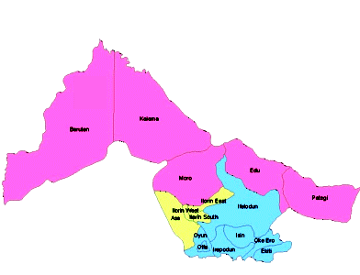
Map of the Study Site Locating Ilorin East Local Government. Source Kwara State Ministry of Health

The study was cross sectional and consisted of a structured questionnaire with close ended questions used to collect the data. A total of 206 CTC-PMVs participated in the study. The multi stage sampling technique was used to select participants. Simple random sampling was used to select six wards out of the twelve wards of National Association of Patent Medicine Vendors (NAPMED) in the LGA. Proportional allocation to the size of the sample was used to determine the number of respondent to be chosen in each of the selected sampled wards. Simple random sampling using table of random numbers was used to determine the starting point at each ward. Systematic sampling technique was then used to select the respondents until the desired sample was achieved in each of the selected wards. This instrument was administered by trained research assistants. The questions were interpreted as appropriate, for some of the respondents when the need arose. Informed consent was obtained from all the participants of the study. The pre-testing of the questionnaire was carried out at Gaa Akanbi community in Ilorin South Local Government Area of Kwara State, which has similar characteristics with Ilorin East LGA with a view to validating the research tool at Cronbach Alpha 0.09004 and making appropriate corrections. Data collected from the questionnaire were sorted, collated, and analysed using EPI INFO software package. Statistical analysis was then carried out at p<0.05 level of significance.

Results

One hundred and sixteen of the respondents (56.3 %) were females, while ninety (43.7%) were males. Eleven (5.3%) did not have formal education, twenty-three 23(11.2%) had primary education, one hundred and fifteen (55.8%) had secondary school education, with fifty-seven having (27.7%) had tertiary education. Twenty-two (10.7%) of the respondents had spent less than one year. Eighty-four (40.8%) of the respondents had spent 1 to 4 years practicing as patent medicine vendor (PMVs) while about half had spent five years and above on the job. Only 41(19.9%) of the respondent had between 5-8 years of practices, while 15(17.2%) of the respondents had more that twelve years of practices. A vast majority of 174 (84.5%) of the respondent learnt the job through apprenticeship from shop owners with 28(13.6%) of the respondents learned in a formal school while only 1.9% had no formal training. (Table 1). While the majority (88.8%) agreed that bite of mosquitoes are the main causes of malaria infection, twenty (9.7%) and three (1.5%) agreed that flies and germs respectively cause malaria infection. Fig1.

Majority of the respondents 148(71.8%) and 126(61.2%) attributed predisposing factor to malaria infection to living in a dirty environment and stagnant water respectively. Only 3(1.3%) attributed it to old age. (Table 2).

One hundred and ninety-eight (96%) asked for the patient’s age, one hundred and ninety-two (93.2%) sought to know when an illness started from their patients while fourteen (6.8%) do not bother to enquire about the time the illness started. One hundred and eighty-nine (91.7%) ask for other symptoms that might accompany the illness but seventeen (8.3%) do not bother to ask for other accompanying symptoms. Only twelve (5.8%) do not give correct dose to patients, as one hundred and eighty three (88.8%) explained the dose given to patients for complete treatment. Twenty five (12.1%) of the CTC do not advise patients on referral services. While only thirty two (15.5%) do not enquire about patient’s previous medication. (Table 3).

Gender difference among CTC –PMVs was found not to be statistically significant in relation to their readiness to sell customer request always (i.e. 0.05< P=0.1256). Their level of education was statistically found to be associated with their readiness to sell customer request always (i.e. 0.05> P=0.0001). Years in practice was statistically found to be associated with their readiness to sell customer request always (i.e. 0.05>P= 0.0040). And the type of training undergone by respondents was found to be statistically associated with their readiness to sell customer request always (i.e. 0.05> P=0.0060). (Table 4).

Discussion

This study found out that majority of the respondents were educated up to tertiary level, several other studies (15-17) have placed minimum education attainment of the PMVs group to primary levels. This observed increase in education level of CTC-PMVs is a reflection of the dwindling employment situation in Nigeria such that many graduates from the university are picking up medicine vendor employment with the ease of obtaining CTC-PMV license, which have attracted highly educated people to the employment.(15)

Operation of CTC-PMV in the present study was evidence based probably because of their understanding of the causes of malaria, these findings differed from other studies. (15) However, despite the fact that majority the respondents underwent informal trainings, few of the respondents still attributed causes of malaria to flies and germs. It is not surprising as some CTC-PMV had no formal education and do not participate in apprenticeship training. Most of the CTC- PMVs in this study had their training through apprenticeship, this finding corroborates the findings in other studies (14-18) conducted at Enugu State which showed that predominant method of joining PMVs is by apprenticeship under an existing License holder.

In Nigeria malaria is endemic, conditions of high population density and poor sanitation exacerbate the spread of disease and other kinds of vulnerability (19).

Some of the respondents attributed age disparity with young and old age groups as predisposing factors to malaria infection as it was reported in other studies (20). This might due to the fact that malaria is endemic in Nigeria, the high population density and poor sanitation exacerbate the spread of the disease making different age groups vulnerable to it. Other studies (18) reported high poor perception of PMVs to the causes of diseases including malaria. However, the low perception found in this study might be due to the fact that more of the CTC-PMVs reported had higher level of formal education.

The assumption has been that the gap in the providers' performance was attributed to inadequate knowledge and skills, however training is often-times not the only solution required to influence performance (21) as one of the findings in this study was that factors influencing CTC-PMVs optimal performance was predicated on education level, type of training and years of practice.

The other important finding of the study is the statistical significant relationships between performance and the performance factors, on the one-to-one relationships. The performance factors seem to have more weight on performance than critical background conditions such as age and gender of the CTC-PMVs providers. Additionally, it is clear that for malaria management, the years of practices, type of training and educational levels of CTC-PMVs providers are key to the performance of the CTC-PMVS in offering quality care to clients.

Conclusion

This study showed CTC-PMVs operated as informal health care providers in the management of malaria in Kwara State, many of them are females, and they get licensed to operate after successfully learning from a shop owner as apprentices. Their operation is evidenced on the predisposing factors to malaria infection. In performance of patent medicine vendors in management of malaria, many of them asked for the age of patients, onset of the illness, and other symptoms. They sell correct doses of drugs, explain doses for complete treatment and make appropriate referral. However, critical performance factors include gender, years of practices, type of training and educational level. Training and mandatory continual medical education as a pre-requisite for renew of license are recommended for better performance. Besides, these will also serve as a supportive means of orientation, awareness and sensitization of the PMVs towards the appropriate management of malaria.

Acknowledgements

The authors appreciate the study participants, management and staff of Epidemiology and Community Health and Ilorin East Local Government for their supports and cooperation during the study.

References

Saka AO., Saka, M.J., Mokolu, A.O. Malaria parasitaemia in children with protein energy malnutrition in north central Nigeria. Journal of IOSRJPBS 1(3): 49-53. 2012 Available online at http;// www.iosrjournals.org

Bhutta, Z.A., Lassi, Z.S., Pariyo, G. Global experience of community health workers for delivery of health-related millennium development goals: Global fund. 50-57. 2010.

Showkat, M., Gani, M., Sarker, B. Close-to Community Health Care Service Providers in Bangladesh. School of Public Health. BRAC Institute of Global Health, BRAC University press.1-30. 2014

Oladepo, O., Salami, K.K., Adeoye, B.W., Oshiname, F. Malaria treatment and policy in three regions in Nigeria: The role of patent medicine vendors. The Future 21-37. 2007. Cited 16/09/2015 from http:// www.futurehealthsystems.org.

Goodman, C., Brieger, W., Unwin, A. Medicine sellers and malaria treatment in Sub-Saharan Africa: What do they do and how can their practice be improved? ncbi, 4-7. 2007 Cited http:// www.ncbi.n/m.nih.gov/pmc/articles/PM.

Theodora, A.O., Benjamin, S.C., Henrietta, U.O. An in dept study of patent medicine seller’s perspectives on malaria in a rural Nigerian community. Malaria journal. 20-37. 2006. Cited 30/09/2015 from http:// www.malariajournal.com/content/5/1/97 . 2006

Aniebue, P.N., Aguwa, E.N., Obi, E.I. Awareness and practice of patent medicine vendors in Enugu Metropolis South East Nigeria. Niger Med J. 51:30-4. 2010

Tavrow, P., Shabahang, J., Makawa, S. Vendor-to-vendor education to improve malaria treatment by private drug outlets in Bungoma District, Kenya. Malar J. 2;1-10. 2003

Oladimeji, O., Salami, K., Babatunde, W.A., Oshiname, F., Ofi, B., Oladepo, M, Ogungbemi O. The role of patent medicine vendors in dispensing anti-malarial drugs in Nigeria. Journal of community health. 1(2) 20-27. 2009.

Federal Ministry of Health. A Road Map for Malaria Control in Nigeria Abridged Version: National Malaria Control Programme Strategic Plan. 1-30. 2013

UN Millennium Project. Coming to Grips with Malaria in the New Millennium. Task Force on HIV/AIDS, Malaria, TB, and Access to Essential Medicines, Working Group on Malaria. 30-37. 2005.

UNICEF Committing to Child Survival. 2014. A Promise Renewed Progress Report http://www.unicef.org/lac/Committing to_Child_Survival_APR_9_Sept_2013.pdf, 47-50.

UNICEF and the Global Fund to Fight AIDS, Tuberculosis, and Malaria. “Joint Statement on a Coordinated Approach to Support Integrated Community Case Management” UNICEF 30-48.2014.

UNICEF and USAID. “Integrating Community Health Annual Program Statement”. 1-15. 2015.

Virginia, W., Obinna, O., Benjamin, U., Nkem, D., Nkoli. A cost-effectiveness analysis of provider and community interventions to improve the treatment of uncomplicated malaria in Nigeria: study protocol for a randomized controlled trial. Trials (1)3;81-91. 2012. http://www.trialsjournal.com/content/13/1/81

Malaria Control in Nigeria. A Strategy for Behaviour Change Communication; National Malaria Control Program, Federal Ministry of Health, Abuja. 1-28. 2010

Berendes, A., Adeyemi, O., Oladele, E.A., Oresanya, O.B., Okoh, F. Are patent medicine vendors’ effective agents in malaria control? Using Lot Quantity Assurance Sampling to assess Quantity of Practice in Jigawa, Nigeria. PLOS ONE.7 (9); 44-47. 2012.

Luoma, M., Voltero, L. Performance Improvement, Stages, Steps and Tools Chapel Hill, NC: Intrah; 2002. Cited on 13/07 2015 at http://www.jhpiego.org/global/ pi.htm

de la Peza, L. Lessons from the field: Strengthening supervision using a performance improvement approach. Management Sciences for Health. Presentation at session 6021.2, Performance Improvement – a Common Model Focusing on Health Results, 129th Annual Meeting and Exposition, APHA Atlanta, GA, USA. 21– 25. 2001.

Mielke, E., Beattie, K., Kaniauskene, A., Adrience, D. Using COPE® and performance improvement for community involvement. EngenderHealth, presentation at session 6021.2, Performance Improvement – a Common Model Focusing on Health Results, 129th Annual Meeting and Exposition, APHA Atlanta, GA, USA. October 21–25. 2001.

Lande, R. Performance improvement. Population Reports, J: 52, Baltimore, the Johns Hopkins Bloomberg School of Public Health, Population Information Program, Spring. 2002.

Tables and Figures
Table 1: Socio Demographic Data of CTC-PMVS Group

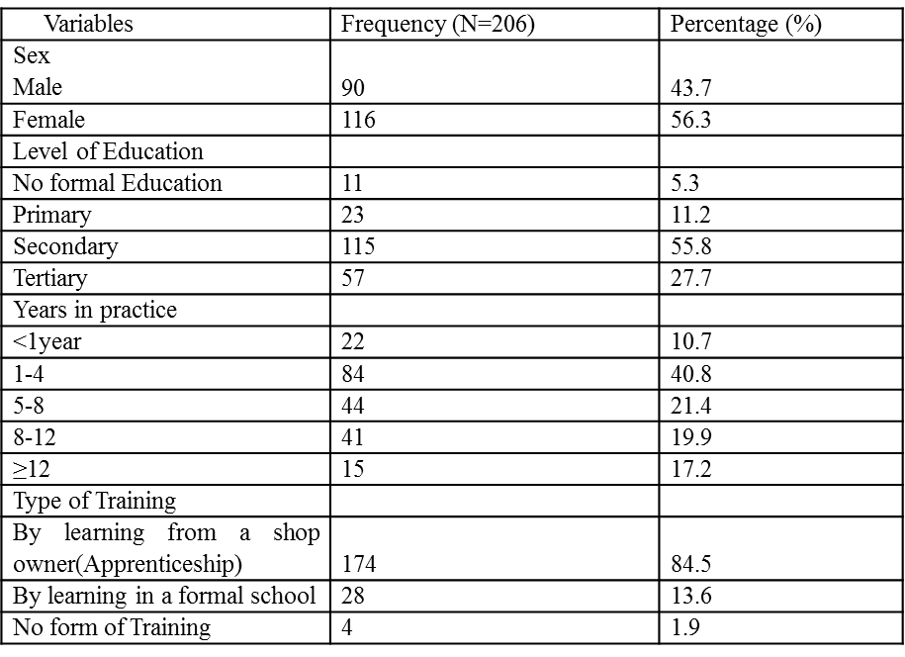

Figure 1: CTC-PMVs Evidence -knowledge base on the causes of malaria

Table 2: Ctc-Pmvs Operation Evidence on the Predisposing Factors to Malaria Infection
Predisposing factors | Freq. (n=206) | Perce (%)
Living in a dirty environment | 148 | 71.8
Living around stagnant water | 126 | 61.2
Pregnant women | 26 | 12.6
Lack of use of bed net ITN | 23 | 11.2
Young age | 15 | 7.3
Old age | 3 | 1.5

