https://doi.org/10.1007/s00210-025-03873-x


RESEARCH

The neurotoxic effects of lead acetate and the abrogating actions of 6‑gingerol‑rich extract of ginger via modulation of antioxidant defence system, pro‑inflammatory markers, and apoptotic cascade
Maryam Tayo Ayinla¹ · Abraham Olufemi Asuku^{1,2}

Received: 30 August 2024 / Accepted: 1 February 2025
© The Author(s), under exclusive licence to Springer-Verlag GmbH Germany, part of Springer Nature 2025

Abstract
Lead exposure is a public health concern and it has been linked to cognitive deficit, memory impairment, and neurotoxicity. This study was designed to investigate the effect of 6-gingerol-rich extract of ginger (6-GREG) on oxidative stress, inflam- mation, and apoptosis in lead acetate (PbAc)-induced neurotoxicity in male Wistar rats. Twenty-five (25) male Wistar rats in total were divided into five groups at random (n = 5). The control group received 0.5 ml of normal saline, the PbAc-treated group received 7.5 mg/kg of PbAc, the vitamin C, 6-GREG (100), and 6-GREG (200) groups received 7.5 mg/kg of PbAc followed by administration of vitamin C (100 mg/kg), 6-GREG (100 mg/kg), and 6-GREG (200 mg/kg) respectively for 2 weeks. Following behavioral tests, the rats were euthanized, and their brain tissues were homogenized for biochemical analysis. When compared to the control group, the administration of PbAc caused behavioral alterations as well as a signifi- cant (p < 0.05) decrease in the activities of catalase, glutathione peroxidase, as well as reduced glutathione and Bcl-2 levels in the PbAc-treated group. Furthermore, the PbAc-treated group showed a statistically significant rise (p < 0.05) in brain acetylcholinesterase, malondialdehyde, nitric oxide, interleukin-1-beta, tumor necrosis factor-α, and caspase-9 levels in com- parison to the control. Administration of both 100 mg/kg and 200 mg/kg of 6-GREG effectively reversed these behavioral and biochemical changes in 6-GREG (100)- and 6-GREG (200)-treated groups respectively compared to the PbAc-treated group. Consequently, the study reveals the role of 6-GREG in attenuating PbAc-induced neurotoxicity and brain damage via antioxidative, anti-inflammatory, and anti-apoptotic mechanisms.
Keywords Lead acetate · Antioxidant · Ginger · 6-Gingerol-rich extract of ginger · Neurotoxicity

Abbreviations
PbAc Lead acetate
6-GREG 6-Gingerol-rich extract of ginger CNS Central nervous system
Pb-NMDA Lead–N-methyl–D-aspartate NMDA N-methyl-D-aspartate
ChAT Choline acetyl-transferase TLC Thin-layer chromatography
HPLC High-performance liquid chromatography DAD Diode array detector

 Abraham Olufemi Asuku asufem2017@gmail.com

¹ Department of Physiology, Faculty of Basic Medical Sciences, College of Health Sciences, University of Ilorin, Ilorin, Ilorin, Nigeria
² Bioresources Development Centre, National Biotechnology Research and Development Agency (NBRDA), Ogbomoso, Nigeria
Vit.C Vitamin C
MWMT Morris water maze test LDBT Light and dark box test NORT Novel object recognition test BWBT Beam walking balance test FGST Forelimb grip strength test RR Recognition ratio
BWA Beam walking apparatus
PBS Phosphate buffer solution
MDA Malondialdehyde
GSH Reduced glutathione
AchE Acetylcholinesterase enzyme GPx Glutathione peroxidase
ELISA Enzyme-linked immunosorbent assay ROS Reactive oxygen species
BDNF Brain-derived neurotrophic factor IL-1β Interleukin 1-beta
TNF-α Tumor necrosis factor-alpha SEM Standard error of mean

ANOVA Analysis of variance SAR Same arm return
SAP Spontaneous alternation performance NO Nitric oxide
IQ Intelligent quotient
HgCl₂ Mercury chloride
LTP Long-term potentiation
LPO Lipid peroxidation

Introduction
Neurotoxicity occurs as a result of exposure to either natu- rally or artificially produced harmful compounds that affect the nervous system’s ability to operate normally (Bilge 2022). Millions of lives are at risk due to environmental poisoning by heavy metals, which is a major global public health risk (Yousuf et al. 2023). Neurotoxicity can cause mild, temporary changes or severe, irreversible damage that can result in a variety of neurological illnesses as well as cognitive, sensory, or motor deficits. Despite efforts to reduce its prevalence through laws, lead exposure is still a major global public health concern. Lead is one of the most ubiquitous heavy metals. Currently, the Centre for Disease Control and Prevention has established greater than or equal to 5 ug/dL as blood reference value; however, there are no measurable blood levels of lead found to be safe since even low levels of lead produce toxic effects (Ortega et al. 2021). The result of the analysis of samples of drinking of water, taking from different sources in the Southeastern Nigeria, revealed that the concentrations of lead in all the water sources tested were far beyond the recommended standard of the US Environmental Protection Agency (0.015 mg/L) (Ignatius et al. 2012). Kaufman et al. (2016) reported an out- break of acute lead poisoning from the gold ore processing in the Northern part of Nigeria which killed more than 400 children less than 5 years of age in the year 2010, and left more than 2000 people with permanent disabilities. Cogni- tive deficits are linked to even low levels of lead exposure, especially in youngsters who are more susceptible to the neurotoxic effects of lead. Lead exposure can cause cog- nitive deficits such as lower intelligent quotient (IQ), con- centration issues, and memory impairments. These deficits might have long-term effects on social behavior and educa- tional success (Lanphear et al. 2018). There is compelling evidence that environmental factors increase the vulnerabil- ity to lead exposure and that lead exposures during infancy can cause neurodegeneration in later life, as well as impair- ing the central nervous system (CNS) (Asuku et al. 2024a). Lead comes in a variety of metallic and chemical forms. Lead is utilized in paint pigment, building materials, batter- ies, radiation shielding, glassblowing, ceramics, lead-acid batteries, matches, and explosives manufacturing.
The chemical substance, lead acetate, has the formula Pb(C₂H₃O₂)₂. It is utilized in several industries for various purposes, such as hair coloring and as a sweetener in some conventional winemaking techniques. Lead acetate (PbAc) is extremely hazardous, especially because of its effects on the nervous system. Lead poisoning can result from consum- ing or absorbing it via the skin, which damages the central nervous system. Encephalopathy, behavioral abnormali- ties, and cognitive deficiencies are examples of neurotoxic consequences. According to the World Health Organization (2024), prolonged exposure can cause serious neurological damage, developmental issues in children, and other sys- temic health problems. According to Flora et al. (2012), exposure to lead acetate can cause inflammation and oxida- tive damage in the brain, which may accelerate the onset of neurodegenerative processes. Lead has the ability to pro- duce lead–N-methyl–D-aspartate (Pb-NMDA) complexes, which can change the postsynaptic neuron’s intracellular Ca²⁺ levels. Long-term potentiation dysfunction is a result of kynurenic acid production in astrocytes and its elevation by PbAc. According to Ramirez et al. (2021), PbAc has an effect on the redox state, thereby encouraging an oxidant environment and cell death.
Neurotransmitters essential for learning and memory pro-
cesses, such as glutamate and acetylcholine, are disrupted by PbAc (Bihaqi et al. 2022). It also impairs the activity of N-methyl-D-aspartate (NMDA) receptors, which are involved in synaptic plasticity and memory formation (Kumawat et al. 2021). Cholinergic dysfunction is caused by a decrease in the expression and activity of choline acetyl- transferase (ChAT), the enzyme responsible for the synthe- sis of acetylcholine (Abreu-Villaca et al. 2020). Exposure to lead acetate causes oxidative stress and the production of reactive oxygen species (ROS), which can harm brain structures and compromise cellular function (Chibowska et al. 2022), causing additional cognitive losses by induc- ing neuro-inflammatory reactions, which are marked by the production of pro-inflammatory cytokines and the activa- tion of microglia (Cui et al. 2022). The development and maintenance of memory depend on synaptic dysfunction, disruption of neuronal signaling, and defective neurogenesis, all of which can be brought on by oxidative stress and neuro- inflammation (Zeng et al. 2022). It weakens the blood-brain barrier, which permits more metal to enter the brain and potentially intensify its neurotoxic effects (Cui et al. 2022). Exposure to PbAc has the potential to disrupt neurogenesis processes, especially in the hippocampus, which is crucial for the creation of new memories (Kobayashi et al. 2021).
Thus, it is still essential to discover practical methods to
lessen the harmful consequences of lead exposure on the brain. Developing natural molecules with anti-inflammatory and antioxidant capabilities is a promising approach for the creation of such therapies. Famous for its healing qualities,

ginger (Zingiber officinale) is a common spice and medicinal plant. It has long been used to treat conditions like inflam- mation, discomfort, and nausea. 6-gingerol, a phenolic mol- ecule that gives ginger its unique, pungent flavor, is one of the main bioactive substances in ginger. Antioxidant, anti- inflammatory, and anticancer properties are just a few of the pharmacological activities that 6-gingerol demonstrates (Saenghong et al. 2020; Asuku et al. 2024b). Its neuropro- tective properties are of particular interest in the context of neurotoxicity caused by neurotoxins like lead acetate. There is dearth of literature on the effect of 6-gingerol on neu- rotoxicity caused by lead acetate; hence, the present study aims to investigate the effect of 6-gingerol-rich extract of ginger (6-GREG) on lead acetate-induced neurotoxicity in male Wistar rats.

Materials and methods

Plant material

Fresh ginger rhizomes were purchased from Ipata market in Ilorin East Local Government Authority, Kwara State, Nigeria. The rhizomes were identified and verified at the Department of Plant Biology, Faculty of Life Sciences, Uni- versity of Ilorin and UILH/001/1168/2022 was given as the voucher number.

Drugs, chemicals, and reagents

Lead acetate (Sigma-Aldrich, Steinheim, Germany) and ketamine (Parkie-Davies, Freiburg, Germany) were got- ten from Mich-Mikedenson laboratory, Taiwo road, Ilorin, Nigeria, and vitamin C (Chemo-pharma Laboratories Ltd. Lagos, Nigeria) was purchased from Mamrota Pharmacy, Ilorin, Nigeria.

Animals

Twenty-five (25) male Wistar rats weighing 150–200 g were purchased from the animal house of Biochemistry Depart- ment, Faculty of Life Sciences, University of Ilorin, Ilorin, Nigeria. Before the study commenced, the rats were accli- matized to the environment for a period of 14 days. The Wistar rats were fed ad-libitum. All the procedures for the experiment received approval from the Ethical Review Com- mittee of the University of Ilorin, UERC/ASN/2023/2451 was given as the approval number, and the research was conducted in accordance with ARRIVE (Animal Research: Reporting of In vivo Experiments) guiding principles.

Preparation and isolation of 6‑gingerol‑rich extract of ginger (6‑GREG)

After being rinsed with clean water, chopping and slic- ing into pieces, air-drying, and grinding of the ginger rhizomes were carried out. Also, extraction was done for 3 days using 95% ethanol at 25 °C and at a reduced pres- sure (Asuku et al. 2024b). Separation of the extract was done with a sieve. After that, a Whatman filter paper-grade 1 was used to filter it, and a rotary evaporator concen- trated it at 45 °C while under vacuum. The procedure of Almada da Silva et al. (2012) was used for the column chromatography. Ten fractions were obtained by dissolv- ing approximately 50 g of the concentrated extract in a solution of ethyl acetate, absorbing it with 70–230 mesh of silica gel (stationary phase), defatting it with n-hexane solution, and eluting it with a 1:1 combination of ethyl acetate and n-hexane solvents as the mobile phase.

Thin layer chromatography

The resulting fractions were subjected to thin-layer chro- matography (TLC). A horizontal line was formed at the top of the TLC paper, marked with the various fractions that were produced at the bottom, and submerged in an ethyl acetate–filled tank. The ethyl acetate was shown to rise from the lower immersion level. Once it approached the line, it was taken out and the movement of the different fractions marked on the paper was seen using an ultraviolet light source. Samples with comparable retention factors were mixed together.

High‑performance liquid chromatography

High-performance liquid chromatography (HPLC) was used on the samples to achieve the separation, identification, and quantification of the individual components. The Ubonda- pak C-18 column (ID: 4.6 mm, length: 100 mm, thickness: 7 μm) in an HPLC system (Shimadzu Company, Nexara, MX) was used to determine the chemical compositions of 6-GREG. The 6-GREG samples were diluted with acetoni- trile and water before being collected for HPLC analysis into a 25-ml standard flask. The stationary phase was Ubondapak (C-18 column). The mobile phase consisted of acetonitrile and water, with a flow rate of 1 ml per minute. Pumps A and B, respectively, transported acetonitrile and water. The sample was injected using a 10-μl-loop rheodyne injector.
At room temperature, the separation into several con- stituents was carried out. After column separation, the samples were exposed to a diode array detector (DAD; 254 nm), which made it possible to identify and measure

each individual component. 6-GREG was analyzed in a typical HPLC setup and then quantitatively identified using a DAD.
The 14 bioactive substances that made up the 6-gin- gerol-rich fraction (6-GREG) are displayed in Fig. 1, with 6-gingerol being the most abundant (51.05%).

Experimental design

The study was carried out in the Bioresearch Hub labora- tory limited, Ilorin, Nigeria. The male Wistar rats were randomly divided into five (5) groups (n = 5) for the study. All the drugs were administered orally for a period of 14 days. Table 1 shows the groupings of the rats and the administered dosages of drugs.

Behavioral assessment

On days 13 and 14, the Morris water maze test (MWMT), light and dark box test (LDBT), Y-maze test, novel object recognition test (NORT), beam walking balance test (BWBT), and forelimb grip strength test (FGST) were carried out.

Fig. 1 HPLC Components of 6-GREG and its quantification

Table 1 Groupings of the rats and the administered dosages of drugs

Morris water maze test

The Morris water maze test was utilized to test for spatial memory. The maze consists of an open circular pool that roughly has a diameter of 200 cm, depth of about 70 cm, and water-filled to around 60 cm of the pool. A concealed plat- form, submerged beneath the surface of the water at a depth of approximately 1.5 cm, had a top surface of approximately 15 cm and was kept in the same location for the duration of the experiment. In order to make the water unclear, less vis- ible and the platform almost undetectable, milk was added to the background to produce a camouflage effect. The use of Morris water maze consisted of two trials:

- The training trials which was conducted before admin- istration (four acquisition trials for 5 days) to teach the animals about the understanding of the rules of the task (that is, to “escape” in which the animal must find a hidden platform, and stay on it in order to be “res- cued”). During training, the rats were trained to locate the hidden escape platform where by any rat that could not locate the hidden platform in sixty (60) seconds was gently guided to the escape platform. After this, the rats were allowed to remain on the platform for about ten
(10) seconds after locating the platform, before being removed from the tank to rest for thirty (30) minutes. The rats were then placed again at the same starting point, maintaining same quadrant in the tank. Observa- tion of the animals revealed that with subsequent expo- sure during training, the animals became more familiar with the task and they quickly learned to swim to the correct location with decreasing escape latencies, that is, they were able to find the platform more quickly (Nunez 2008).
- The memory test trial was done on the last day of administration during which the rats after been admin- istered PbAc, Vit.C, and 6-GREG per group were re- exposed to the task to determine the escape latency, to assess the acquisition and retention of the spatial memory in order to evaluate the effect of the drugs administered. To quantify the steadily decreasing

 | Group (n = 5) | Treatments
1 | Control | Rats received orally administered normal saline (0.5 ml)
2 | PbAc-only | Rats were given PbAc by oral gavage (7.5 mg/kg/day; Singh et al. 2017)
3 | PbAc + Vit.C | Rats were given PbAc and Vit.C by oral gavage (100 mg/kg/day; Ayinla et al. 2020)
4 | PbAc + 6-GREG (100) | Rats were given PbAc and 6-GREG by oral gavage (100 mg/kg/day; Asuku et al. 2024b)
5 | PbAc + 6-GREG (200) | Rats were given PbAc and 6-GREG by oral gavage (200 mg/kg/day; Asuku et al. 2024b)
PbAc lead acetate, Vit.C vitamin C, 6-GREG (100) 6-gingerol-rich extract of ginger (100 mg/kg body weight), 6-GREG (200) 6-gingerol-rich extract of ginger (200 mg/kg body weight)

escape latency over trials, a webcam was positioned on the top of the pool’s center to record video of the swim- ming rats (Morris 2008). The experimental procedures were recorded, and the scores for latency to escape to the platform were computed (Nunez 2008).

Light and dark box test

Ayinla et al. (2020) modified the light and dark box, a device often used to measure anxiety, to examine spatial memory. The light and dark sections are the two compartments that make up the tool. The dimensions of the light and dark box were 50 cm × 30 cm × 100 cm, and an 8-cm² opening con- nected the two halves. The rats were trained for 3 days con- secutively, three trials a day, for 5 min each, prior to admin- istration. Only the animals that had learned to memorize the path that led from the light to the dark compartments at the end of training were included in the study. Black plank was used to obstruct the opening route from the dark com- partment in order to test the establishment of memory in rats. Animals were then reintroduced and allowed to move freely, increased probing of the blocked exit showed memory formation. On day 15, an hour after the final treatments, the rats were placed back into the modified light and dark box and allowed to spend 5 min exploring the maze. A blinded investigator performed an analysis on the footage that was captured using an overhead camera (Logtech Webcam, 5MP). The index for intact or increased spatial memory was found to be the frequency with which each rat examined the blocked aperture.

Y‑maze

Utilizing the Y-maze device, which consists of a smooth ply- wood structure with three arms measuring 25 × 10 × 70 cm and alternations at 120° among one another, the animals’ short-term working memory was assessed. Each rat was put in the middle of the maze on the day of the experiment and given precisely 6 min to investigate the three arms. The pattern of arms entries—at first identified as A, B, and C, respectively—was noted by a blind observer. Rats should typically visit a relatively new arm and not go back to the arm they were just in or the arm they had visited lately. Accordingly, a rat with a greater spontaneous alternation point (SAP)—that is, a visit sequence of arms A, B, and C that occurs consecutively and without repetition—has supe- rior short-term memory function. When all four of the rat’s limbs were inside the designated arm, entry was presumed. Before using the maze for the next rodent, it was cleaned using cotton wool soaked in a 20% ethanol solution and let to fully dry.

Novel object recognition test

Cognitive memory was assessed using the novel object rec- ognition test which was adapted by Brown et al. (1999). The NORT measures what is known as recognition memory—the rat’s capacity to identify a known object over a range of times. There are three phases to NORT: habituation, famil- iarization, and test.
The rat explored the open field for 5 min during habitua- tion. An animal was given two identical objects (objects A) in the familiarisation phase and allowed to examine them in order to build initial familiarity. They were positioned along the diagonal.
After this phase, the test components which consisted of presenting an item A and a novel item B in the identical set-up was subsequently administered to the animal. It was assumed that the rat has “recognized” item A if it orients itself preferentially toward item B, demonstrating a sensi- tive ability to differentiate old item from newly introduced item. Contrarily, it is considered that the rat does not have sufficient memory ability to recognize and discriminate if it orients toward and investigates both objects equally (Kin- navanne et al. 2015). The testing continued for 5 min. The recognition ratio (RR) was used to measure the performance of the NORT. RR represents the amount of time spent by the rat exploring the new item in comparison to the old item as a proportion of the total exploration time of the animal. The video was recorded using a webcam.

Beam walking balance test

The rats’ ability to cross a narrow beam and arrive at an enclosed safety platform was employ to investigate their postural balance and motor coordination (Fan et al. 2008). The beam walking apparatus (BWA) that Puurunen (2001) and Carter et al. (2001) described was modified and utilised for this investigation.
Method: The beam walking apparatus was comprised of a raised platform joined by a 3-cm-wide, 100-cm-long wood beam. The beam was positioned horizontally, 50 cm above the floor, with one end fixed to a goal box (20 × 20 × 20 cm) and the other end put on a small support that was connected to the start platform (10 × 10 cm) (Rodrigues-Alves et al. 2009).
A strong light source was positioned at the beginning to encourage the rats to cross the beam. The rats at the base were protected from the fall by a box filled with sawdust. A video recording of the performance was made. Rats were acclimated to the BWA every day for 3 days before treat- ment. Training was repeated three times daily. As stated by Abou-Donia et al. (2008), the duration of time it takes for the nose of the rat to enter the box (up to 60 s) was documented as beam walking latency. Those rats that failed to enter the

goal box or fell off the beam were given 60-s latency. Peri- odically, methylated spirit was used to clean the beam. On the fourteenth day after treatment, rats were tested. For every trial, the beam walking latency and the foot slip scores; the quantity of times the hind feet slipped off each beam were noted. Recordings were made with a webcam.

Forelimb grip strength test

A modified forelimb grip strength test outlined by Olopade et al. (2012) was used to evaluate sensory motor function.
Method: The rat’s forelimbs were placed on a metal wire that was suspended horizontally, having length and diameter of 1 m and 2.5 mm respectively. The wire was positioned 1 m above a landing space that was covered with tender bedding. Every rat was allowed a maximum of 2 min to suspend on the wire before it fell off, and the fell off time was documented for every rat. They were acclimated to the set-up daily for 2 days before treatment. On the fourteenth day of treatment, rats were tested.

Biochemical analysis

The rats were anaesthetised by intraperitoneal injection of ketamine (75 mg/kg; Otong et al. 2022) following the com- pletion of 14 days of treatment. Brain tissues were removed on ice; they were immediately washed in 0.1 mol of phos- phate buffer solution (PBS) and preserved in 0.1 mol of PBS. Homogenization of brain samples was done in 5 ml of ice- cold PBS (Haq and Almaro 2018). There was collection of supernatants after centrifugation was carried out for 10 min at 3000 revolution/min, and this was used for biochemical analysis. The malondialdehyde (MDA) activity was deter- mined using the Ohkawa et al. (1979) technique. The amount of nitric oxide was determined by measuring the interac- tion between the nitrite content and Griess reagent, which produced a colored molecule that absorbs light at 540 nm (Green et al. 1982). Catalase activity was determined by measuring the rate of hydrogen peroxide clearance at pH 7.0, 25 °C, and 240-nm wavelengths using the Clairbone method (Clairborne 1985). The reduced glutathione (GSH) level in the brain was determined using Elman's reagent (5, 5′-dithiobis [2-nitrobenzoic acid]) (Beutler et al. 1963). The activity of glutathione peroxidase (GPx) was measured indi- rectly using a coupled reaction with glutathione reductase (Paglia and Valentine 1967).
The activity of the cholinergic marker acetylcholinest-
erase enzyme (AchE) in the brain was measured using an AchE activity assay kit. The test kit includes an enhanced version of Ellman’s technique (Ellman et al. 1961). Follow- ing a 5-min incubation period of 0.4 ml of brain homogen- ate with 2.6 ml of phosphate buffer, the combination was prepared once more with the absorbance set to zero. About
0.1 ml of Ellman’s reagent (5, 5-dithiobis 2-nitrobenzic acid) was added. Subsequently, 0.02 ml of cholinergic iodide solu- tion was added, and the absorbance was again adjusted at 412 nm.
Using a commercially available enzyme-linked immuno- sorbent assay (ELISA) kit (Elabscience Biotechnology Inc., Texas), the following were measured: brain-derived neuro- trophic factor (BDNF), casase-9, interleukin-1beta (IL-1β), tumor necrosis factor-alpha (TNF-α), Bcl-2, and caspase-9 levels.

Statistical analysis

All data were presented as mean ± SEM, and analysis was carried out using GraphPad Prism 9.0 version, data were subjected to one way ANOVA, and Newman-Keul’s post hoc test. Values are statistically significant at p < 0.05.

Results
In Fig. 2, a PbAc-treated group showed a significant increase in escape latency compared with the control group which indicates cognitive impairment (as this group of rats took a longer time to identify the escape platform). Administration of either 100 mg/kg body weight or 200 mg/kg body weight of 6-GREG caused a significant decrease in the EL when compared with the PbAc group (p < 0.05). However, there is no significant difference in the EL of the rats treated with Vit.C and the 6-GREG.
Administration of PbAc causes cognitive deficits as shown by the significantly (p < 0.05) decreased frequency of the PbAc-only group when compared with the control group, however, administration of 6-GREG reverses the cog- nitive deficit as demonstrated by the significantly (p < 0.05)

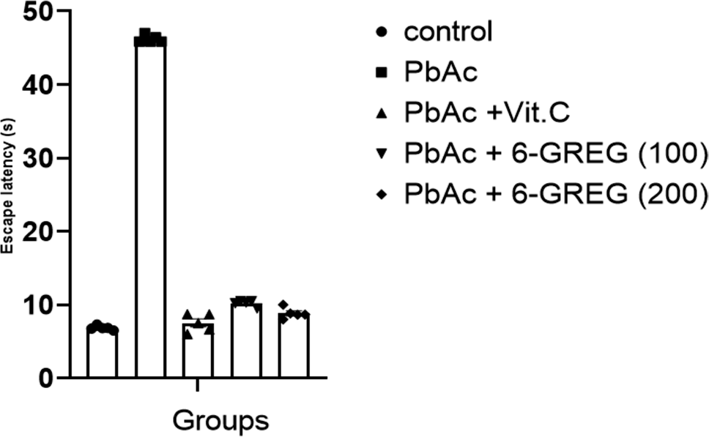

Fig. 2 Effect of 6-GREG on cognitive deficit. Data are presented as mean ± SEM, n = 5. PbAc, lead acetate; 6-GREG (100), 6-gingerol- rich fraction (100 mg/kg body weight); 6-GREG (200), 6-gingerol- rich fraction (200 mg/kg body weight); Vit.C, vitamin C

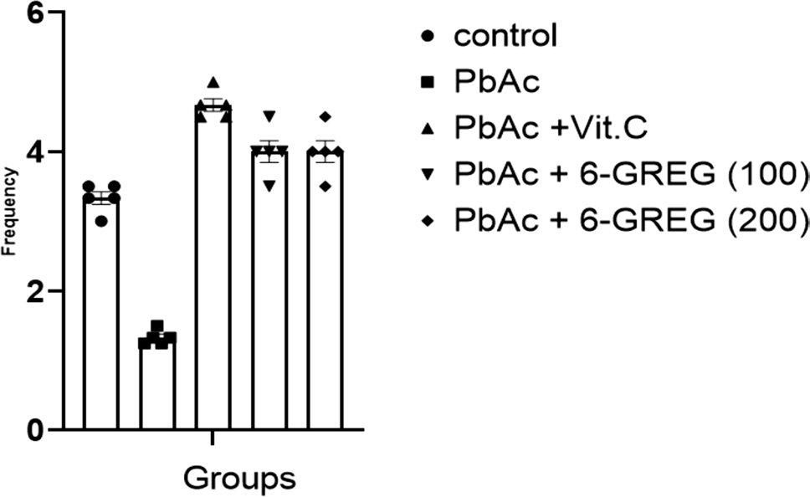

Fig. 3 Effect of 6-GREG on cognitive deficit. Data are presented as mean ± SEM, n = 5. PbAc, lead acetate; 6-GREG (100), 6-gingerol- rich fraction (100 mg/kg body weight); 6-GREG (200), 6-gingerol- rich fraction (200 mg/kg body weight); Vit.C, vitamin C

increased frequency of the groups administered 100 and 200 mg/kg of 6-GREG respectively when compared with the group administered PbAc-only, and this result is consist- ent with that of the Vit.C-treated group (Fig. 3).
In Table 2, administration of PbAc causes memory impairment as shown by the significantly (p < 0.05) decreased spontaneous alternation performance (SAP) of the PbAc-only group when compared with the control group; however, administration of 6-GREG reverses the memory impairment as demonstrated by the significantly (p < 0.05) increased SAP of the groups administered 100 and 200 mg/ kg of 6-GREG respectively when compared with the group administered PbAc-only, and this result is consistent with that of the Vit.C-treated group.
In Fig. 4, administration of PbAc causes memory impair- ment as shown by the significantly (p < 0.05) decreased rec- ognition ratio (RR) of the PbAc-only group when compared with the control group; however, administration of 6-GREG reverses the memory impairment as demonstrated by the sig- nificantly (p < 0.05) increased RR of the groups administered 100 and 200 mg/kg of 6-GREG respectively when compared with the group administered PbAc-only, and this result is consistent with that of the Vit.C-treated group.

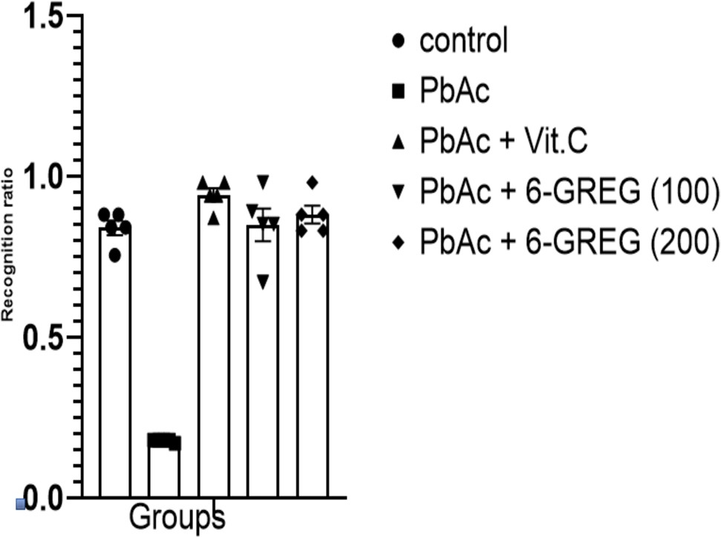
Fig. 4 Effect of 6-GREG on cognitive deficit. Data are presented as mean ± SEM, n = 5. PbAc, lead acetate; 6-GREG (100), 6-gingerol- rich fraction (100 mg/kg body weight); 6-GREG (200), 6-gingerol- rich fraction (200 mg/kg body weight); Vit.C, vitamin C

In Fig. 5, administration of PbAc causes dysfunction in motor coordination and balance as shown by the signifi- cantly (p < 0.05) increased beam walking latency (BWL) of the PbAc-only group when compared with the control group; however, administration of 6-GREG reverses the dysfunction as demonstrated by the significantly (p < 0.05) decreased BWL of the groups administered 100 and 200 mg/kg of 6-GREG respectively when compared with the group administered PbAc-only. There is a significant difference in the BWL of the 6-GREG (200)-treated group when compared with the Vit.C-treated group and 6-GREG (100)-treated group.
In Fig. 6, administration of PbAc causes sensory dys- function as shown by the significantly (p < 0.05) decreased drop-off time (DOT) of the PbAc-only group when com- pared with the control group; however, administration of 6-GREG reverses the sensory dysfunction as demonstrated by the significantly (p < 0.05) increased DOT of the groups administered 100 and 200 mg/kg of 6-GREG respectively when compared with the group administered PbAc-only.

Table 2 Effect of 6-GREG on spatial memory

 | Control | PbAc-only | PbAc + Vit.C | PbAc + 6-GREG (100) | PbAc + 6-GREG (200)
SAR | 1.00 ± 0.58 | 2.67 ± 0.33ª | 0.67 ± 0.33^{b} | 1.33 ± 0.33^{c} | 1.33 ± 0.67^{c}
SAP | 5.50 ± 0.96 | 1.50 ± 0.50ª | 3.25 ± 0.75^{b} | 4.25 ± 0.95^{b} | 5.25 ± 1.25^{b}
Data are presented as mean ± SEM, n = 5
ªp < 0.05 vs. control
^{b,} ^{c}p < 0.05 vs. PbAc
PbAc lead acetate, 6-GREG (100) 6-gingerol-rich fraction (100 mg/kg body weight), 6-GREG (200) 6-gin- gerol-rich fraction (200 mg/kg body weight), Vit.C vitamin C, SAR same arm return, SAP spontaneous alternation performance

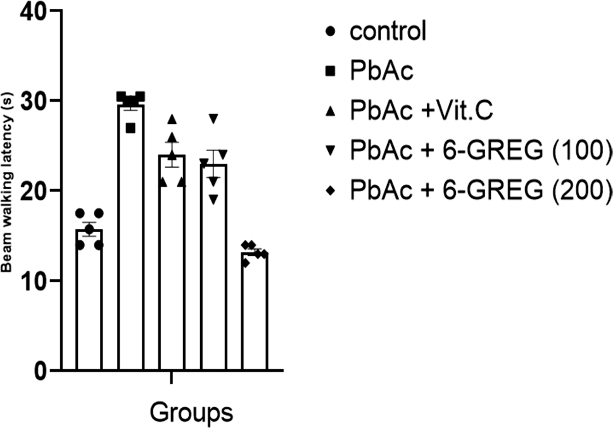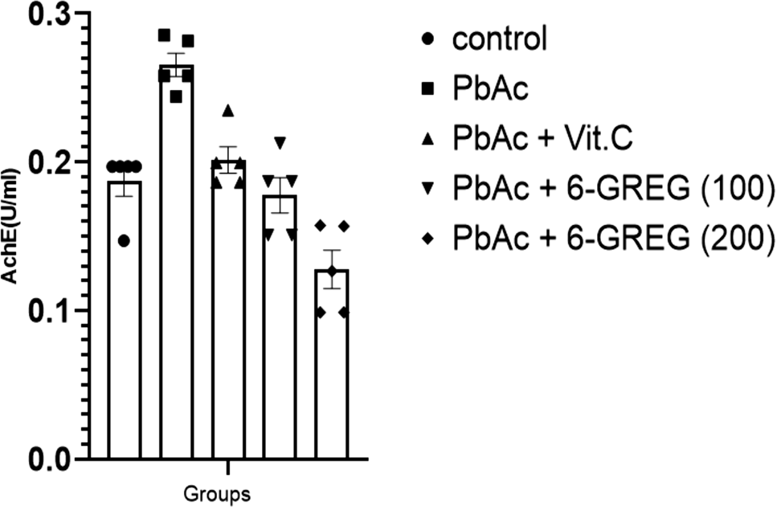

Fig. 5 Effect of 6-GREG on motor co-ordination and balance. Data are presented as mean ± SEM, n = 5. PbAc, lead acetate; 6-GREG (100), 6-gingerol-rich fraction (100 mg/kg body weight); 6-GREG (200), 6-gingerol-rich fraction (200 mg/kg body weight); Vit.C, vita- min C
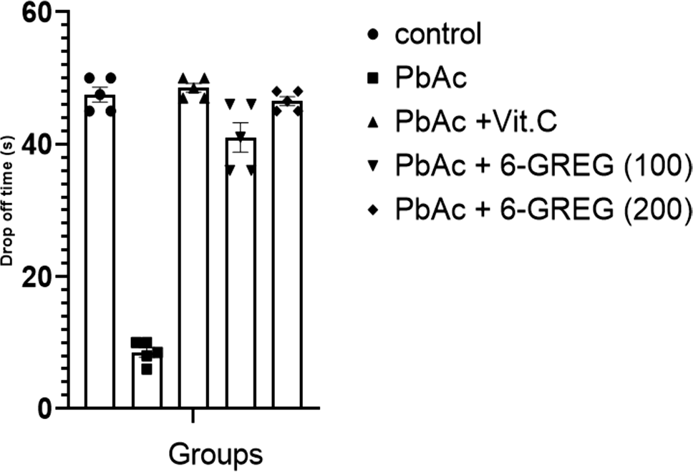

Fig. 6 Effect of 6-GREG on sensory function. Data are presented as mean ± SEM, n = 5. PbAc, lead acetate; 6-GREG (100), 6-gingerol- rich fraction (100 mg/kg body weight); 6-GREG (200), 6-gingerol- rich fraction (200 mg/kg body weight); Vit.C, vitamin C

This result compares favourably with the standard group (Vit.C-treated group).
In Fig. 7, administration of PbAc causes cholinergic deficit as shown by the significantly (p < 0.05) increased acetylcholinesterase enzyme (AchE) activity of the PbAc- only group when compared with the control group; however, administration of 6-GREG attenuates the deficit as demon- strated by the significantly (p < 0.05) decreased AchE of the groups administered 100 and 200 mg/kg of 6-GREG respec- tively when compared with the group administered PbAc- only. There is a significant difference among the three inter- vention groups with 6-GREG (200) being the most potent.
In Fig. 8, administration of PbAc causes lipid peroxi- dation as shown by the significantly (p < 0.05) increased
Fig. 7 Effect of 6-GREG on acetylcholinesterase (AchE) activ- ity. Data are presented as mean ± SEM, n = 5. PbAc, lead acetate; 6-GREG (100), 6-gingerol-rich fraction (100 mg/kg body weight); 6-GREG (200), 6-gingerol-rich fraction (200 mg/kg body weight); Vit.C, vitamin C

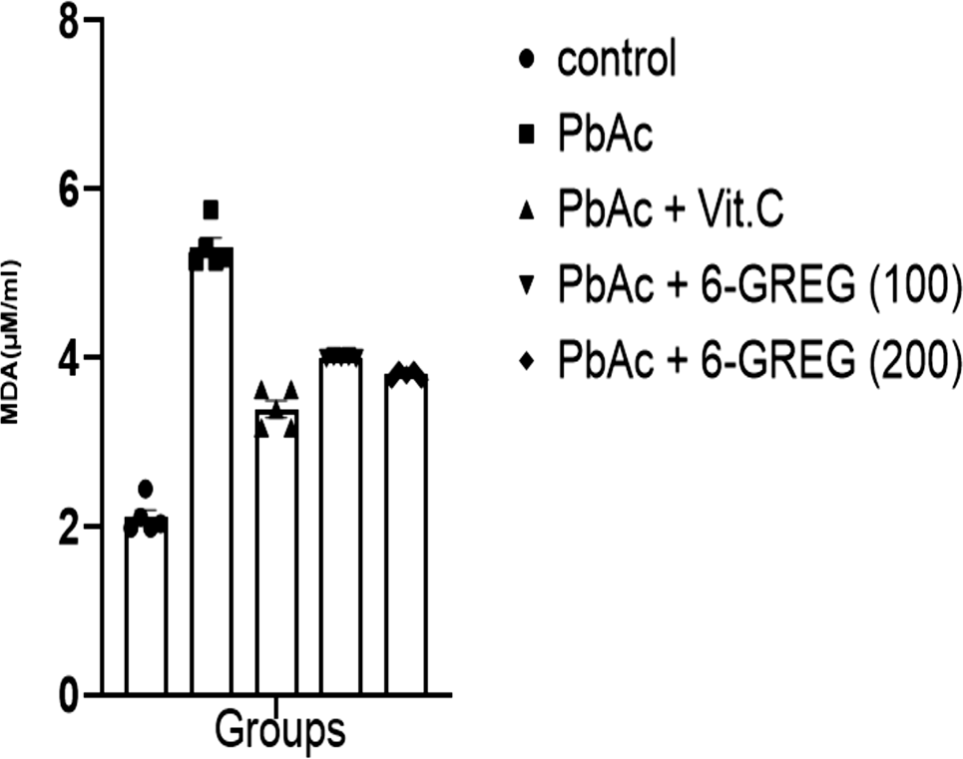

Fig. 8 Effect of 6-GREG on malondialdehyde (MDA) level. Data are presented as mean ± SEM, n = 5. PbAc, lead acetate; 6-GREG (100), 6-gingerol-rich fraction (100 mg/kg body weight); 6-GREG (200), 6-gingerol-rich fraction (200 mg/kg body weight); Vit.C, vitamin C

malondialdehyde (MDA) level of the PbAc-only group when compared with the control group; however, administration of 6-GREG reverses the lipid peroxidation as demonstrated by the significantly (p < 0.05) decreased MDA levels of the groups administered 100 and 200 mg/kg of 6-GREG respec- tively when compared with the group administered PbAc- only. This result compares favourably with the Vit.C-treated group.
In Fig. 9, administration of PbAc causes a significant decrease (p < 0.05) in the reduced glutathione (GSH) level of the PbAc-only group when compared with the control group; however, administration of 100 and 200 mg/kg of 6-GREG

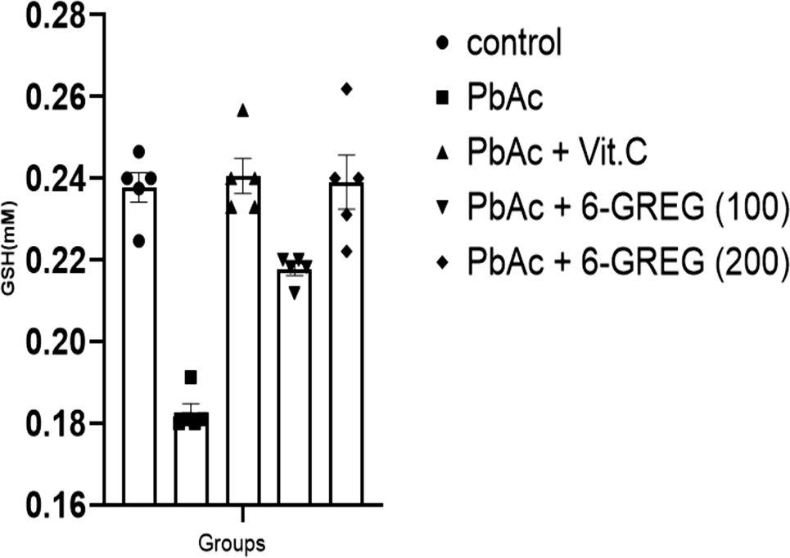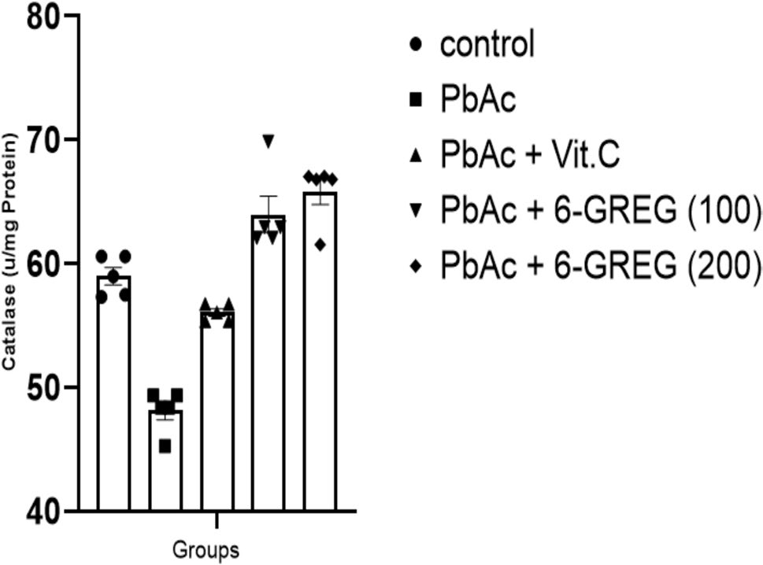

Fig. 9 Effect of 6-GREG on glutathione (GSH) level. Data are pre- sented as mean ± SEM, n = 5. PbAc, lead acetate; 6-GREG (100), 6-gingerol-rich fraction (100 mg/kg body weight); 6-GREG (200), 6-gingerol-rich fraction (200 mg/kg body weight); Vit.C, vitamin C

Fig. 11 Effect of 6-GREG on catalase activity. Data are presented as mean ± SEM, n = 5. PbAc, lead acetate; 6-GREG (100), 6-gingerol- rich fraction (100 mg/kg body weight); 6-GREG (200), 6-gingerol- rich fraction (200 mg/kg body weight); Vit.C, vitamin C

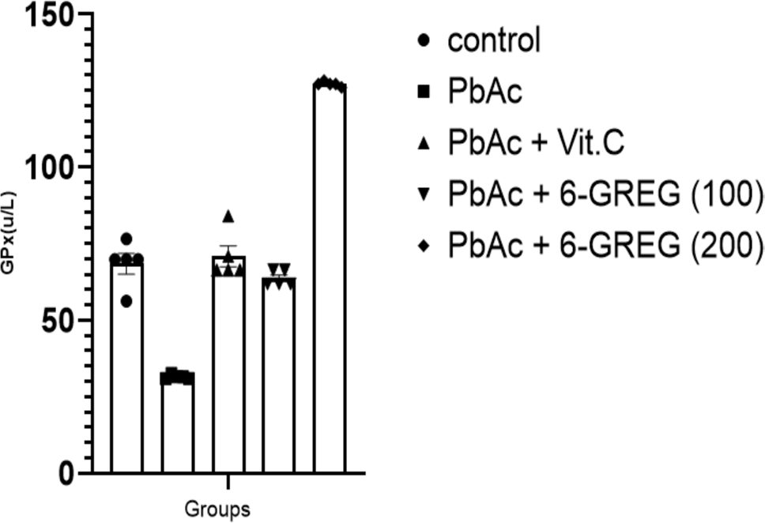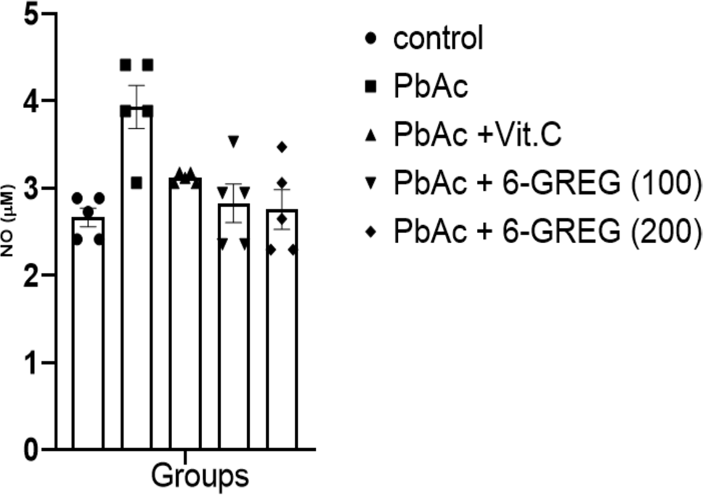

Fig. 10 Effect of 6-GREG on glutathione peroxidase (GPx) activ- ity. Data are presented as mean ± SEM, n = 5. PbAc, lead acetate; 6-GREG (100), 6-gingerol-rich fraction (100 mg/kg body weight); 6-GREG (200), 6-gingerol-rich fraction (200 mg/kg body weight); Vit.C, vitamin C

Fig. 12 Effect of 6-GREG on nitric oxide (NO) level. Data are pre- sented as mean ± SEM, n = 5. PbAc, lead acetate; 6-GREG (100), 6-gingerol-rich fraction (100 mg/kg body weight); 6-GREG (200), 6-gingerol-rich fraction (200 mg/kg body weight); Vit.C, vitamin C

reverses the trend. There is a significant decrease in GSH level of the 6-GREG (100)-treated group when compared with the Vit.C-treated group and 6-GREG (200)-treated group.
In Fig. 10, administration of PbAc causes a significant decrease (p < 0.05) in the glutathione peroxidase (GPx) activity of the PbAc-only group when compared with the control group; however, administration of 100 and 200 mg/ kg of 6-GREG reverses the trend. Among the three interven- tion groups, 6-GREG (200) is the most potent.
In Fig. 11, administration of PbAc causes a signifi- cant decrease (p < 0.05) in the catalase activity of the PbAc-only group when compared with the control group,
however, administration of 100 and 200 mg/kg of 6-GREG reverses the trend. There is a significant decrease in the catalase activity of the Vit.C-treated group when com- pared to both groups of 6-GREG.
In Fig. 12, administration of PbAc causes a significant increase (p < 0.05) in the nitric oxide (NO) level of the PbAc-only group when compared with the control group; however, administration of 100 and 200 mg/kg of 6-GREG causes a significant decrease (p < 0.05) in the NO level of both 6-GREG (100) and 6-GREG (200)-treated groups when compared to the PbAc-only group. This result is in line with the Vit.C-treated group.

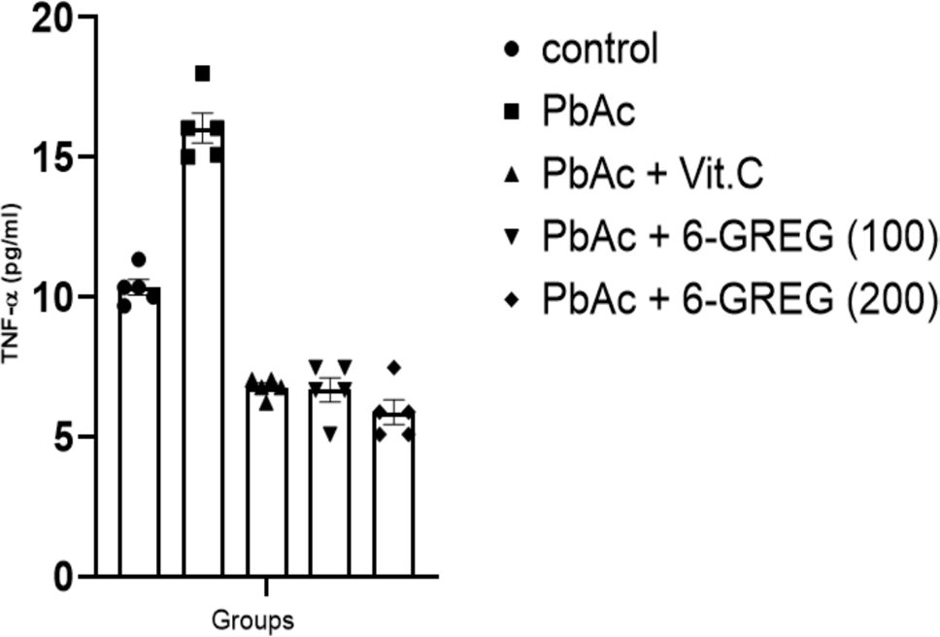

Fig. 13 Effect of 6-GREG on tumor necrosis factor alpha (TNF- α). Data are presented as mean ± SEM, n = 5. PbAc, lead acetate; 6-GREG (100), 6-gingerol-rich fraction (100 mg/kg body weight); 6-GREG (200), 6-gingerol-rich fraction (200 mg/kg body weight); Vit.C, vitamin C

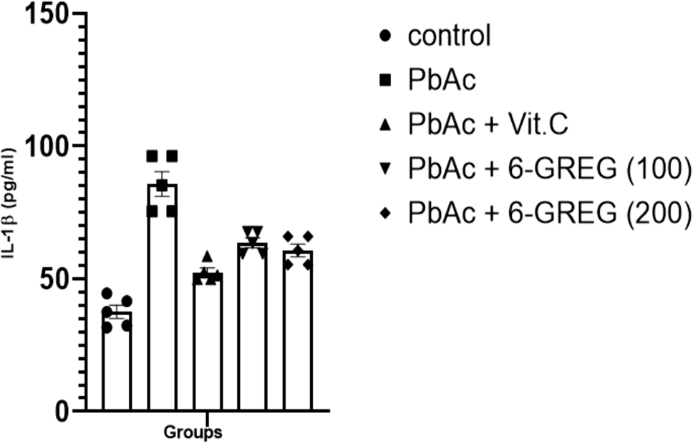

Fig. 14 Effect of 6-GREG on interleukin-1β (IL-1β). Data are pre- sented as mean ± SEM, n = 5. PbAc, lead acetate; 6-GREG (100), 6-gingerol-rich fraction (100 mg/kg body weight); 6-GREG (200), 6-gingerol-rich fraction (200 mg/kg body weight); Vit.C, vitamin C

In Fig. 13, administration of PbAc causes a significant increase (p < 0.05) in the tumor necrosis factor-alpha (TNF- α) level of the PbAc-only group when compared with the control group; however, administration of 100 and 200 mg/ kg of 6-GREG causes a significant decrease (p < 0.05) in the TNF-α level of both 6-GREG (100) and 6-GREG (200)-treated groups when compared to the PbAc-only group. This result is in line with the Vit.C-treated group.
In Fig. 14, administration of PbAc causes a significant increase (p < 0.05) in the interleukin-1beta (IL-1β) level of the PbAc-only group when compared with the control group; however, administration of 100 and 200 mg/kg of 6-GREG causes a significant decrease (p < 0.05) in the IL-1β level of both 6-GREG (100) and 6-GREG (200)-treated groups when compared to the PbAc-only group. There is a significant

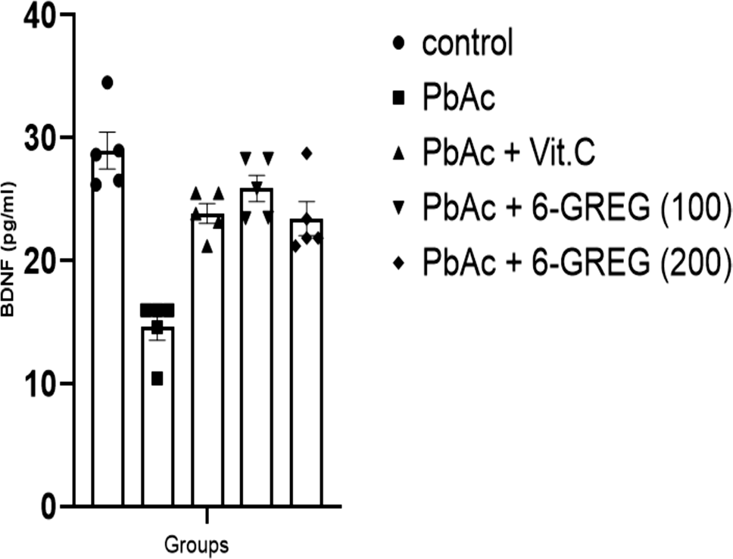
Fig. 15 Effect of 6-GREG on brain-derived neurotrophic fac- tor (BDNF). Data are presented as mean ± SEM, n = 5. PbAc, lead acetate; 6-GREG (100), 6-gingerol-rich fraction (100 mg/kg body weight); 6-GREG (200), 6-gingerol-rich fraction (200 mg/kg body weight); Vit.C, vitamin C
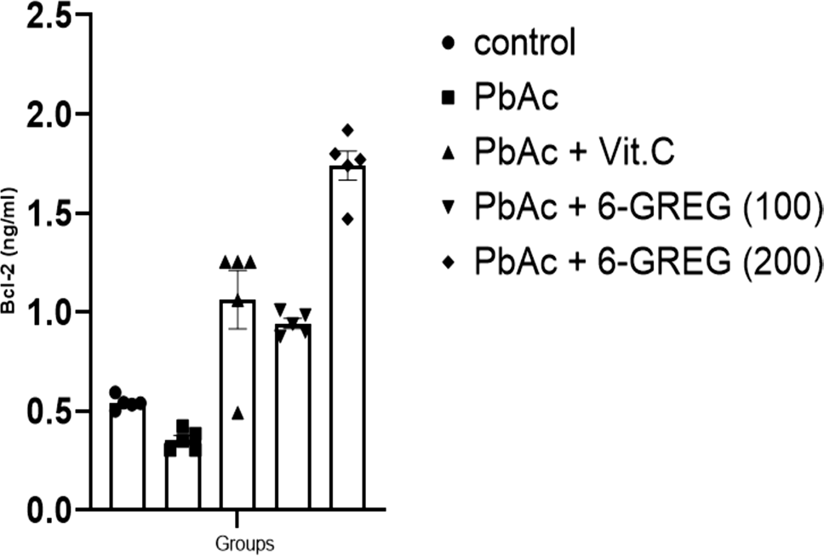

Fig. 16 Effect of 6-GREG on Bcl-2 level. Data are presented as mean ± SEM, n = 5. PbAc, lead acetate; 6-GREG (100), 6-gingerol- rich fraction (100 mg/kg body weight); 6-GREG (200), 6-gingerol- rich fraction (200 mg/kg body weight); Vit.C, vitamin C

decrease in the IL-1β of the Vit.C-treated group when com- pared to both groups of 6-GREG.
In Fig. 15, administration of PbAc causes a significant decrease (p < 0.05) in the brain-derived neurotrophic fac- tor (BDNF) level of the PbAc-only group when compared with the control group; however, administration of 100 and 200 mg/kg of 6-GREG causes a significant increase (p < 0.05) in the BDNF level of both 6-GREG (100) and 6-GREG (200)-treated groups when compared to the PbAc- only group. This result compares favorably with the standard group.
In Fig. 16, administration of PbAc causes a significant decrease (p < 0.05) in the Bcl-2 level of the PbAc-only group

when compared with the control group; however, adminis- tration of 100 and 200 mg/kg of 6-GREG causes a signifi- cant increase (p < 0.05) in the Bcl-2 level of both 6-GREG
(100) and 6-GREG (200)-treated groups when compared to the PbAc-only group. There is a significant decrease in the Bcl-2 of the Vit.C-treated group and 6-GREG (100)-treated group when compared to the 6-GREG (200)-treated group. In Fig. 17, administration of PbAc causes a significant increase (p < 0.05) in the caspase-9 level of the PbAc-only group when compared with the control group; however, administration of 100 and 200 mg/kg of 6-GREG causes a significant decrease (p < 0.05) in the caspase-9 level of both 6-GREG (100) and 6-GREG (200)-treated groups when compared to the PbAc-only group. There is a significant decrease in the caspase-9 level of the Vit.C-treated group when compared to the 6-GREG (100)-treated group and
6-GREG (200)-treated group.

Discussion
Currently, there is dearth of information on the effect of 6-gingerol-rich extract of ginger (6-GREG) on lead acetate (PbAc)-induced neurotoxicity; hence, this study examined the potential mechanism of action and ameliorative effects of oral administration of 6-GREG on neurotoxicity caused by PbAc in male Wistar rats. The examination of spatial learn- ing and memory was conducted through neurobehavioral studies such as the Morris water maze test (MWMT), light and dark box test (LDBT), Y-maze test, and novel object rec- ognition test (NORT). Similarly, the examination of sensory motor function and motor coordination and balance were conducted through the forelimb grip strength test (FGST)

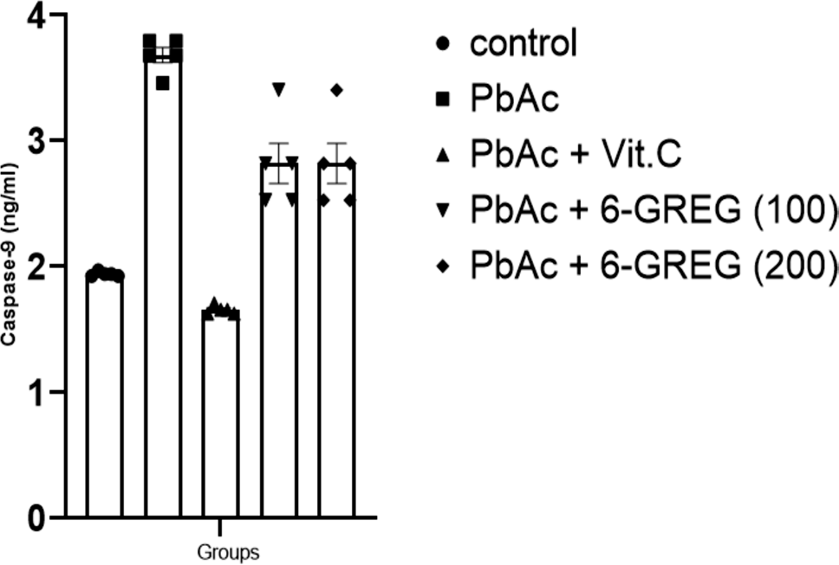

Fig. 17 Effect of 6-GREG on caspase-9 level. Data are presented as mean ± SEM, n = 5. PbAc, lead acetate; 6-GREG (100), 6-gingerol- rich fraction (100 mg/kg body weight); 6-GREG (200), 6-gingerol- rich fraction (200 mg/kg body weight); Vit.C, vitamin C
and the beam walking balance test (BWBT) respectively. Studies on the biochemical parameters were also conducted. The current study’s findings demonstrate that rats exposed to PbAc experience cognitive decline. According to Morris water maze, light and dark box test, Y-maze, and novel object recognition tests, animals are predicted to locate the escape platform faster, probe the closed aperture, alter- nate the arms spontaneously, and explore novel items in the arena more thoroughly, respectively. However, rats exposed to PbAc for 14 days in the current study spent more time to locate the escape platform, have lower probing frequency, lower spontaneous alternation performance, and less time exploring new objects in MWMT, LDBT, Y-maze test, and NORT respectively, when compared with the control rats. This indicates that the recognition memory is damaged (Benkermiche et al. 2021). This could be due to PbAc neu-
rotoxic effects.
Similar findings regarding the neurotoxicity of PbAc have been reported by Lanphear et al. (2018), PbAc exposure cog- nitive deficits that include reduced IQ, attention problems, and memory impairments, which can have long-lasting impacts on educational attainment and social behavior. The cognitive impairment might be as a result of oxidative stress (Asuku et al. 2023).
Cognitive impairments resulting from PbAc exposure have been well reported (Abreu-Villaca et al. 2020; Bihaqi et al. 2022). According to this study, one of the most com- mon cognitive deficits linked to PbAc exposure is memory deficit. The hippocampus, a part of the brain essential for learning and memory functions, is frequently implicated in these deficits (Sui et al. 2019).
Nevertheless, this study’s findings indicated that 6-GREG had ameliorative effects against PbAc-induced cognitive deficits by reversing the increase in the escape latency time, decreased in probing frequency and spontaneous alternation performance, as well as the reduction in recognition ratio caused by PbAc. This could be because 6-GREG has anti- oxidant properties, as Flora et al. (2012) found that elevated oxidative stress caused by PbAc leads to cognitive impair- ments. This suggests that the 6-GREG protects formation of memory in PbAc-exposed rats, thus corroborates previ- ous findings reporting the strong and powerful memory- enhancing actions of 6-gingerol (Shen et al. 2019; Asuku et al. 2024b) which is abundant in 6-GREG.
Exposure to PbAc may also have an effect on the cerebel- lum, which is important in balance and motor coordination. The cerebellar cortex plays a crucial role in the learning of movements (e.g., in learning to write), and the cerebellum maintains the body’s equilibrium thanks to its connections with the spinal and vestibular systems (Singh 2014). Ani- mals used in this study have their motor abilities assessed using the beam walking tests. A deficit in motor function is shown by the longer length of time it takes the experimental

animal to traverse the beam in the beam walking test (Sweis et al. 2016).
The beam walking test provides greater insight into bal- ance, motor coordination, and motor refinement. This motor test makes it possible to assess motor deficits in detail since the animal is presented with difficulty when crossing a nar- row beam. The poor performance of the PbAc-exposed rats on the beam in the current study indicates that higher levels of PbAc accumulation in the motor cortex were related with impairment in work demanding higher motor improvement. The PbAc-exposed rats’ increased beam walking latency indicates impaired motor coordination and balance, as well as cerebellar injury and neuronal degeneration that may be due to oxidative process. However, the amelioration of motor coordination and balance dysfunctions observed in the 6-GREG-treated groups in this study demonstrated its anti-oxidative role as reported by Asuku et al. (2024b).
The forelimb grip strength test is used to measure and assess the muscular strength as well as balance. According to this study, rats treated with PbAc showed lower muscle strength and a shorter drop-off time than the rats treated with 6-GREG. This may be as a result of the marked reduction in the cerebellar neurons due to oxidative stress as confirmed by the result of the oxidative stress marker observed in this study. The increase in muscular strength and longer drop-off time in the 6-GREG-treated groups observed in this study may be due to its antioxidant property and this corroborates the work of Ayinla et al. (2024) and Asuku et al. (2024b).
Changes in oxidative state due to increased oxidant pro- duction may be among the primary impacts of PbAc intoxi- cation in animals (Singh et al. 2017). Lipids are highly susceptible to reactive oxygen species (ROS), and lipid per- oxidation (LPO) is brought on by free radicals generated by PbAc (Singh et al. 2017). LPO induces modifications in the permeability and structure of the high-lipid cell membrane. The results of this investigation into MDA, an indicator of LPO in brain tissue, showed that the MDA concentration was higher in the PbAc rats that were not given any treat- ment. This result agrees with earlier research that reported MDA increase after oral dose of mercury chloride (HgCl₂) (Singh et al. 2017). Reactive oxygen species are significant LPO generators. Through a number of changes in antioxi- dant function, they cause oxidative stress (Ragy 2015; Akin- toye et al. 2021).
However, as seen by the study’s notable reduction in brain MDA concentrations, an oral 6-GREG treatment reversed oxidative stress and LPO in the rats. The ability of 6-GREG to reverse the aggravated lipid peroxidation may be due to its potent anti-oxidant property as reported by Kongsui and Jittiwat (2023).
Over the course of the year, scientific data supporting antioxidant supplementation in a number of pathologi- cal conditions have been reinforced (Carrasco et al. 2018;
Kongsui and Jittiwat 2023; Asuku et al. 2023). Results from this study demonstrated that PbAc dramatically lowered the levels of the antioxidant molecule GSH as well as the enzymes catalase and GPx. Interestingly, the altered anti- oxidant molecule and enzymes were restored by treatment with 6-GREG. This was indicated by elevated GSH levels, catalase, and GPx activity. It has been revealed that 6-GREG possesses antioxidant properties (Chuljerm et al. 2023). It contains mostly 6-gingerol, as well as p-coumaric acid, sinapinic acid, and zingerone that may act via preserving or improving the antioxidant enzymes activities or directly against ROS as observed in this study. By directly interact- ing with ROS and enhancing the antioxidant status of the rat brain, 6-GREG was able to reverse the decline in antioxidant enzymes and molecules comparable to vitamin C, indicating that they have similar antioxidant characteristics.
The cholinergic system is essential for neurotransmission, memory, and learning. The primary enzyme responsible for degrading acetylcholine in the synapse and neuromus- cular junction, which ends nerve impulse transmission, is called acetylcholinesterase enzyme (AchE). According to Akinyemi et al. (2015), interactions between toxic metals and neurotransmitters can alter the cholinergic system. Lead acetate was found to raise AchE activity in the brain tissue in this investigation. This could be because it interacts with AchE and/or AchE receptors, causing AchE to hydrolyze acetylcholine more actively. The outcomes of the present study are in line with another study showing that exposure to lead and cadmium increases AchE activity in the brain (Akinyemi et al. 2015). Also, Ishola et al. (2017) reported that the increase in the activity of AchE as a result of HgCl₂ administration to rats could lead to deficits in cognition and cholinergic transmission. The potential mechanism underly- ing the 6-GREG ameliorative actions against cognitive loss caused by administration of PbAc in this study may be due to its capacity to prevent PbAc from elevating AchE activity. Inflammation of the neurons is essential for protection as well as the repair of the neurons after brain injury (Konishi and Kiyama 2018); however, when it is not regulated, it can impair neural circuit function or lead to death of neurons, which contributes to the onset, continuation, and/or wors- ening of neurodegenerative disorders (Shi and Holtzman 2018). Brain damage–related stimuli can activate inflam- matory cells, including adipocytes and macrophages, and cause the production of inflammatory enzymes and proteins as well as inflammatory cytokines, including NO, TNF-α, and IL-1β (Ayinla et al. 2024). These molecules could be utilized as biomarkers in the diagnosis, prognosis, as well as
selection of suitable treatment options (Gupta et al. 2012).
Lead acetate exposure can trigger neuro-inflammatory responses, characterized by the activation of microglia and the release of pro-inflammatory cytokines, further contrib- uting to cognitive deficits (Cui et al. 2022). In the current

investigation, PbAc increased the levels of inflammatory markers NO, TNF-α, and IL-1β in the rats’ brains. This could point to yet another toxicity-related mechanism. This is due to the fact that the pathophysiology of neurodegenera- tive disorders has been linked to these inflammatory indi- cators (Shi and Holtzman 2018). In contrast, observations made from this study demonstrated that 6-GREG signifi- cantly reduced the inflammatory markers mentioned above, ameliorating the brain damage caused by PbAc-induced inflammation in rats. This may be due to its anti-inflamma- tory as reported by Asuku et al. (2024b).
Research has demonstrated that lead exposure disrupts synaptic plasticity, inhibits long-term potentiation (LTP), and reduces the expression of brain-derived neurotrophic factor (BDNF), all of which are crucial for memory forma- tion and consolidation (Liu et al. 2020). This is consistent with the finding of this study, as there was reduction in the BDNF level of the PbAc-treated rats. However, the noticea- ble increase in the BDNF level of the 6-GREG-administered group might be as a result of 6-GREG memory-enhancing ability which is corroborated by the results of behavioral studies discussed earlier.
Moreover, it has been reported that oxidative stress cir- cumstances may act as a trigger to start the apoptotic process (El Asar et al. 2019). Furthermore, it has been demonstrated
that the apoptotic process can be started by an increase in ROS through the induction of oxidative processes and oxida- tive damage to DNA (Tang et al. 2019).
This study assessed the levels of caspase-9 as well as anti-apoptotic Bcl-2 in the rats’ brain tissues to confirm if the PbAc-induced oxidative stress is accompanied by apoptosis. The brain tissues of rats administered only PbAc showed a substantial rise in the levels of caspase-9 and corresponding decrease in the level of Bcl-2, indicating the development of a neurotoxic effect through apoptosis. The rise in the oxidative stress marker of the PbAc-treated rats in this finding indicates that ROS could be the cause for the observed increase in pro-apoptotic marker and decrease in anti-apoptotic marker. According to El Asar et al. (2019), ROS is involved in altering the potential of the mitochondrial membrane, opening the mitochondrial permeability transition pore, and releasing apoptogenic factors like cytochrome c, which triggers the caspase cas- cade, which accounts for the ROS-mediated apoptosis in neurotoxicity caused by PbAc. However, 6-GREG’s ability to reduce oxidative stress-mediated apoptosis caused by PbAc was demonstrated by a marked rise in antioxidant enzymes activities, which was accompanied by a down- regulation of caspase-dependent apoptosis and increase in antiapoptotic Bcl-2. The abundance of 6-gingerol in

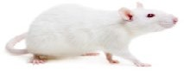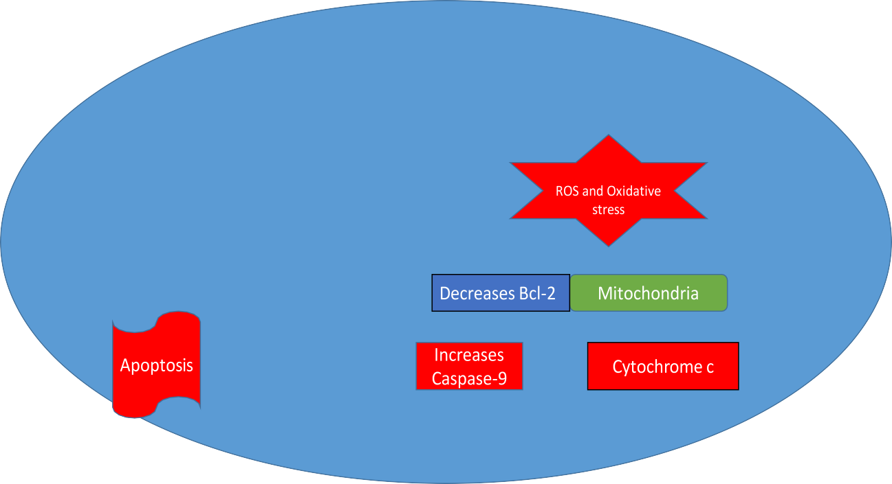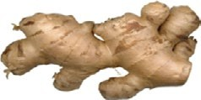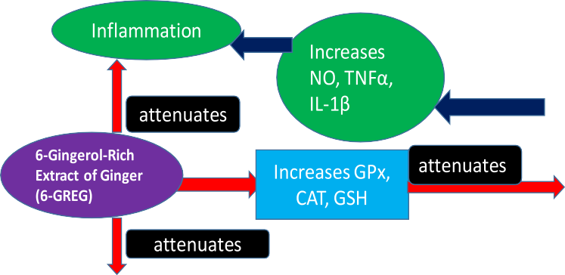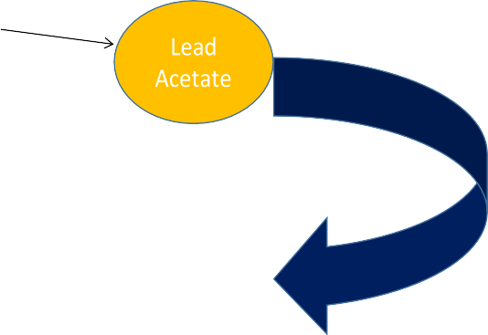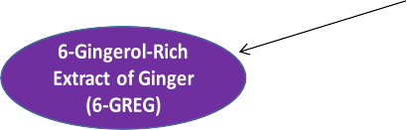

Fig. 18 The mechanism of PbAc-induced brain damage and the ameliorative effect of 6-GREG in Wistar rats

6-GREG, which has been reported to have anti-apoptotic property, may be the reason for this (Rezazadeh-Shojaee et al. 2022). This is in line with the study that documented that 6-gingerol dramatically lowered Bax and caspase-3 levels in a rat model of diabetes mellitus caused by strep- tozotocin’s administration (Yu et al. 2017).
The anti-apoptotic activity of 6-GREG observed in this study might be due to inhibition of oxidants generation, mitochondrial membrane collapse, cytochrome c release, cytosolic calcium release, and calcium entry through the channels because it has earlier been reported that PbAc causes apoptosis through these processes (Thangarajan et al. 2018). However, contrary to our work, Chakraborty et al. (2012) reported a downregulation in the Bcl-2 gene, and an enhancement in Bax and cytochrome c levels by 6-gingerol in cancer cell lines, thereby inducing a caspase- 3-dependent apoptosis and autophagy. Also, 6-gingerol has been reported to induce caspase-dependent apoptosis in colon cancer cell lines by inhibiting MAPK/AP-1 signal- ing (Radhakrishnan et al. 2014). Moreover, Chiaramonte et al. (2021) reported that 6-gingerol had a dose-dependent toxic effect on Paracentrotus lividus, and suggested that its use in the food and pharmaceutical industry should be con- trolled as it might have negative effect at high doses. The disparity between these reports and ours may be attrib- uted to differences in the 6-GREG dose and the method of studies.

Conclusion
The present study shows that the exposure of rats to PbAc caused behavioral deficit, altered antioxidant defence sys- tem, increased inflammation, and increased apoptosis, resulting in neurotoxicity. It reveals the role of 6-GREG in reversing PbAc-induced neurotoxicity and brain damage via antioxidative, anti-inflammatory, and anti-apoptotic mecha- nisms as shown in Fig. 18. We therefore recommended that 6-GREG, which is a naturally occurring active substance, may be used for treating lead-induced neurodegenerative dis- orders. Further studies are needed to investigate the effects of 6-GREG on mechanistic pathways and neurotransmitter like glutamate in PbAc-induced neurotoxicity.
Supplementary Information The online version contains supplemen- tary material available at https://doi.org/10.1007/s00210-025-03873-x.
Author contributions All authors contributed to the study conception and design. Material preparation, data collection and analysis were performed by A.O.A and M.T.A. The first draft of the manuscript was written by A.O.A, and all authors commented on previous versions of the manuscript. All authors read and approved the final manu- script. The authors declare that all data were generated in-house and that no paper mill was used.
Funding The authors declare that no funds, grants, or other support were received during the preparation of this manuscript.
Data availability All source data for this work (or generated in this study) are available upon reasonable request.

Declarations
Competing interests The authors declare no competing interests.

References
Abreu-Villaca Y, Levin ED, Seidler FJ (2020) The effects of devel- opmental lead exposure on cholinergic systems. Neurotoxicol Teratol 80:106897
Abou-Donial MB, Goldstein LB, Bullman S, Tu T, Khan WA, Dechk- ovskaia AM, Abdel-Rahman AA (2008) Imidacloprid induces neurobehavioral deficits and increases expression of glial fibril- lary acidic protein in the motor cortex and hippocampus in off- spring rats following in utero Exposure. J Toxicol Environ Health 71:119–130
Akintoye OO, Ajibare AJ, Fabunmi OA, Asuku AO, Tajudeen RA (2021) Effect of honey on oxidative stress in brain tissue of sleep deprived rats. Nig J Basic Appl Sci 29(1):83–89. https://doi.org/ 10.4314/njbas.v29i1.10
Akinyemi AJ, Oboh G, Ademiluyi AO (2015) Local salt substitutes “Obu-otoyo” activate acetylcholinesterase and butyrylcholinest- erase and induce lipid peroxidation inrat brain. Interdiscip Toxicol 8:139–145
Almada da Silva J, Becceneri AB, Sanches Mutti H, Moreno Martin AC, Fernandes da Silva MF, Fernandes JB, Vieira PC, Cominetti M (2012) Purification and differential biological effects of ginger- derived substances on normal and tumor cell lines. J Chromatogr 903:157–162
Asuku AO, Ayinla MT, Olajide TS, Yakub Z, Owoyele BV (2023) Cola acuminata mitigates cognitive deficit and oxidative stress in mercury chloride-induced neurotoxicity in male Wistar rats. Nig J Neurosci 14(2):33–40.2023. https://doi.org/10.47081/ njn2023.14.2/001
Asuku AO, Ayinla MT, Ajibare AJ, Adeyemo MB, Adeyemo RO (2024a) Heavy metals and emerging contaminants in food and food products associated with neurotoxicity. In: Aransiola SA, Akinsola RO, Abioye OP, Maddela NR (eds) Emerging con- taminants in food and food products. CRC Press, Taylor and Francis group, Boca Raton, Florida, USA, 114:236–250
Asuku AO, Ayinla MT, Ajibare AJ, Olajide TS (2024b) Mercury chloride causes cognitive impairment, oxidative stress and neuroinflammation in male Wistar rats: the potential protec- tive effect of 6-gingerol-rich fraction of Zingiber officinale via regulation of antioxidant defense system and reversal of pro- inflammatory markers increase. Brain Res 148741: 1826, ISSN 0006-8993. https://doi.org/10.1016/j.brainres.2023.148741
Ayinla MT, Asuku AO, Bayo-Olugbami A, Ayeni AO, Abiola AA, Owoyele BV (2020) Melatonin and vitamin C modulate cholin- ergic neurotransmission and oxidative stress in scopolamine– induced rat model of memory impairment. J Afr Assoc Physiol Sci 8(1):20
Ayinla MT, Yakub ZM, Asuku AO, Muzzamil SS (2024) Ameliora- tive effect of aqueous leaf extract of aqueous leaf extract of Cola acuminata on mercury chloride-induced neurotoxicity in male Wistar rat. Bulletin of Faculty of Pharmacy, Cairo University, 62:11,18. https://doi.org/10.54634/2090-9101.1049

Benkermiche S, Djemli S, Haloui M, Boussensa M (2021) The ben- eficial effects of ginger and Nigella sativa in Wistar rats against the inorganic mercury memory impairment and neurobehav- ioural troubles. Uttar Pradesh J Zool 42(24):947–957
Beutler E, Duron O, Kelly BM (1963) Improved method for the determination of blood glutathione. J Lab Clin Med 61:882–888 Bilge S (2022) Neurotoxicity, types, clinical manifestations, diagno- sis and treatment. Neurotoxicity - New Advances. IntechOpen.
https://doi.org/10.5772/intechopen.101737
Bihaqi SW, Huang H, Zawia NH (2022) Lead exposure impairs long- term potentiation and synaptic plasticity in the hippocampus. Toxicol Appl Pharmacol 441:115946
Brown RE, Corey SC, Moore AK (1999) Differences in measures of exploration and fear in MHC-congenic C57BL/6J and B6-H-2K mice. Behav Genet 26:263–271
Carrasco C, Naziroglu M, Rodriguez AB, Pariente JA (2018) Neu- ropathic pain: delving into the oxidative origin and the pos- sible implication of transient receptorpotential channels. Front Physiol 14(9):95
Carter RJ, Morton JA, Dunnett SB (2001) Motor coordination and balance in rodents. Curr Protoc Neurosci 8(12):1–8
Chakraborty D, Bishayee K, Ghosh S, Biswas R, Mandal SK, Anisur Rahman Khuda-Bukhsh AR (2012) [6]-Gingerol induces cas- pase 3 dependent apoptosis and autophagy in cancer cells: drug–DNA interaction and expression of certain signal genes in HeLa cells. Eur J Pharmacol 694:1–3
Chiaramonte M, Bonaventura R, Costa C, Zito F, Russo R (2021) [6]-Gingerol dose-dependent toxicity, its role against lipopoly- saccharide insult in sea urchin (Paracentrotus lividus Lamarck), and antimicrobial activity. Food Biosci 39(100833):2212–4292
Chibowska K, Gutowska I, Baranowska-Bosiacka I, Chlubek D (2022) The role of oxidative stress in the neurotoxicity of lead. Antioxidants 11(6):1146
Chuljerm H, Paradee N, Katekaew D, Nantachai P, Settakorn K, Srichairatanakool S, Koonyosying P (2023) Iron chelation prop- erty, antioxidant activity, and hepatoprotective effect of 6-gin- gerol-rich ginger (Zingiber officinale) extract in iron-loaded Huh7 cells. Plants 12:2936
Clairborne A (1985) Catalase activity. In: Greenwald RA (ed) CRC handbook of methods for oxygen radical research. CRC Press, Boca Raton, pp 283–284
Cui C, Li Y, Zhang S, Zhang W, Feng Y (2022) Lead exposure dis- rupts the integrity of the blood-brain barrier and exacerbates neuroinflammation. Environ Pollut 300:118998
El Asar HM, Mohammed EA, Aboulhoda BE, Emama HY, Imama AA (2019) Selenium protection against mercury neurotoxicity: modulation of apoptosis and autophagy in the anterior pituitary. Life Sci 231(2019):116578
Ellman GL, Courtney KD, Andres V Jr (1961) Feather-stone RM (1961) A new and rapid colorimetric determination of acetyl- cholinesterase activity. Biochem Pharmacol 7:88–95
Fan LW, Mirchell HJ, Tien LT, Zheng B, Pang Y, Rhodes PG, Cai Z (2008) Alpha-phenyl-n-tert-butyl-nitrone reduces lipopolysac- charide-induced white matter injury in the neonatal rat brain. Dev Neurobiol 68:365–378
Flora G, Gupta D, Tiwari A (2012) Toxicity of lead: a review with recent updates. Interdiscip Toxicol 5(2):47–58
Green LC, Wagner DA, Glogowski J, Skipper PL, Wishnok JS, Tan- nenbaum SR (1982) Analysis of nitrate, nitrite, and [15N]nitrate in biological fluids. Anal Biochem 126(1):131–138
Gupta J, Mitra N, Kanetsky PA, Devaney J, Wing MR, Reilly M, Shah VO, Balakrishnan VS, Guzman NJ, Girndt M (2012) Asso- ciation between albuminuria, kidney function, and inflammatory biomarkers profile in CKD in CRIC. Clin J Am Soc Nephrol Cjasn 7:1938–1946
Haq SH, AlAmro AA (2018) Neuroprotective effect of quercetin in murine cortical brain tissue cultures. Clin Nutr Exp 23:89–96
Ignatius CM, Emeka EN, Ebele JI, Otuu IO, Silas AU, Edwin AO (2012) Lead in potable water sources in Abakaliki metropolis, South-East, Nigeria. Bull Environ Contam Toxicol 88:793–796
Ishola IO, Adamson FM, Adeyemi OO (2017) Ameliorative effect of kolaviron, a biflavonoid complex from Garcinia kola seeds against scopolamine-induced memory impairment in rats: role of antioxi- dant defense system. Metab Brain Dis 32:235–245
Kaufman JA, Brown MJ, Umar-Tsafe NT, Adbullahi MB, Getso KI, Kaita IM, Sule BB, Baába A, Davis L, Nguku PM (2016) Preva- lence and risk factors of elevated blood lead in children in gold ore processing communities, Zamfara, Nigeria, 2012. J Health Pollut 6:2–8
Kinnavane L, Albasser MM, Aggleton JP (2015) Advances in the behavioural testing and network imaging of rodent recognition memory. Behav Brain Res 285:67–78
Kobayashi K, Okada T, Kobayashi M, Kishino A, Ishihara R, Ishii K (2021) Lead exposure impairs neurogenesis and synaptic plasticity in the dentate gyrus. Neurotoxicology 87:53–62
Kongsui R, Jittiwat J (2023) Ameliorative effects of 6-gingerol in cer- ebral ischemia are mediated via the activation of antioxidant and anti-inflammatory pathways. Biomed Rep 18: 26
Konishi H, Kiyama H (2018) Microglial TREM2/DAP12 signaling: a double-edged sword in neural diseases. Front Cell Neurosci 6(12):206
Kumawat KL, Kaushik DK, Goswami P, Basu A (2021) Acute lead exposure induces neuroinflammation and synaptic plasticity impairment in the hippocampus of young mice. Toxicology 453:152749
Lanphear BP, Rauch S, Auinger P, Allen RW, Hornung RW (2018) Low-level lead exposure and mortality in US adults: a population- based cohort study. Lancet Public Health 3(4):e184
Liu C, Zhou X, Li Y, Liu W, Wang H, Wang C, Wang Z (2020) Lead- induced cognitive impairment in rats is alleviated by magnesium administration. Biol Trace Elem Res 194(2):507–517
Morris RGM (2008) Morris water maze. Scholarpedia. https://doi.org/ 10.4249/.6315
Nunez J (2008) Morris water maze experiment. J vis Exp. https://doi. org/10.3791/897PMCID:PMC2872979
Ohkawa H, Ohishi N, Yagi K (1979) Assay for lipid peroxides in animal tissues by thiobarbituric acid reaction. Anal Biochem 2:351–358 Olopade FE, Shokunbi MT, Siren A (2012) The relationship between the ventricular dilatation, neuropathological and neurobehavioural
changes in hydrocephalic rats. Fluids Barriers CNS 9:19
Ortega DR, Esquivel DFG, Ayala TB, Pineda B, Manzo SG, Quino JM, Mora PC, de la Cruz VP (2021) Cognitive impairment induced by lead exposure during lifespan: mechanisms of lead neurotoxicity. Toxics 9(2):23
Otong ES, Makena W, Solomon AY, Bazabang SA, Aminu A, Henry R (2022) Andrographis paniculata protects against brain hip- pocampus and cerebellum from mercury chloride induced dam- age by attenuating oxidative stress. Environ Anal Health Toxicol 37(4):2671–9525
Paglia DE, Valentine WN (1967) Studies on the quantitative and quali- tative characterization of erythrocyte glutathione peroxidase. J Lab Clin Med 70(1):158–169
Puurunen K (2001) The effects of pharmacotherapy and training on functional recovery after global and focal cerebral ischemia in rats. Series of Reports, Department of Neuroscience and Neurol- ogy, University of Kuopio, 58, 40
Radhakrishnan E, Bava SV, Narayanan SS, Nath LR, Thulasidasan AKT, Soniya EV (2014) [6]-Gingerol induces caspase-depend- ent apoptosis and prevents PMA-induced proliferation in colon cancer cells by inhibiting MAPK/AP-1 signaling. PLoS One 9(8):e104401. https://doi.org/10.1371/journal.pone.0104401

Ragy MM (2015) Effect of exposure and withdrawal of 900 MHz- electromagnetic waves on brain, kidney, and liver oxidative stress and some biochemical parameters in male rats. Electromagn Biol Med 34(4):279–284
Ramírez Ortega D, González Esquivel DF, Blanco Ayala T, Pineda B, Gómez Manzo S, Marcial Quino J, Carrillo Mora P, Pérez de la Cruz V (2021) Cognitive impairment induced by lead expo- sure during lifespan: mechanisms of lead neurotoxicity. Toxics 28: 9(2):23
Rezazadeh-Shojaee FS, Ramazani E, Kasaian J (2022) Tayarani- Najaran Z (2022) Protective effects of 6-gingerol on 6-hydroxy- dopamine-induced apoptosis in PC12 cells through modulation of SAPK/JNK and survivin activation. J Biochem Mol Toxicol 36:e22956
Saenghong N, Wattanathorn J, Tong-Un T, Muchimapura S, Wannanon P (2020) Anti-aging properties of Zingiber officinale Roscoe and its active compound, 6-gingerol in mice. Evid-Based Complement Alternat Med 2020:5740563
Shen Y, Sun Q, Gao Y, Ding F, Wang M, Wang L (2019) Protec- tive effects of gingerol against chronic cerebral hypoperfusion- induced learning and memory deficits in mice. NeuroReport 30(6):425–432
Shi Y, Holtzmann DM (2018) Interplay between innate immunity and Alzheimer’s disease: APOE and TREM2 in the spotlight. Nat Rev Immunol 18(12):759–772
Singh I (2014) Gross anatomy of cerebellum. Textbook of human neu- roanatomy, 9th edn. Jaypee Brothers Medical Publishers (P) Ltd, Delhi, pp 62–66. https://doi.org/10.5005/jp/books/12211
Singh PK, Singh MK, Yadav RJ, Dixit RK, Mehrotra A, Nath R (2017) Attenuation of lead-induced neurotoxicity by omega-3 fatty acid in rats. Ann Neurosci 24:221–232
Sui L, Han Z, Chu W, Kang W, Ren Y (2019) Early postnatal mercu- ric chloride exposure induces pathological changes and cogni- tive deficits in the hippocampus of adult mice. Neurochem Res 44(3):769–780
Sweis BM, Bachour SP, Brekke JA, Gewirtz JC, Sadeghi-Bazargani H, Hevesi M (2016) A modified beam-walking apparatus for the
assessment of anxiety in a rodent model of blast traumatic brain injury. Behav Brain Res 296:149–156
Tang JY, Ou-Yang F, Hou MF, Huang HW, Wang HR, Li KT (2019) Oxidative stress-modulating drugs have preferential anticancer effects - involving the regulation of apoptosis, DNA damage, endoplasmic reticulum stress, autophagy, metabolism, and migra- tion. Semin Cancer Biol 58:109–117
Thangarajan S, Vedagiri A, Somasundaram S, Sakthimanogaran R, Murugesan M (2018) Neuroprotective effect of morin on lead ace- tate-induced apoptosis by preventing cytochrome c translocation via regulation of Bax/Bcl-2 ratio. Neurotoxicol Teratol 66:35–45
World Health Organization (2024) Lead poisoning and health. Retrieved from https://www.who.int/news-room/fact-sheets/detail/ lead-poisoning-and-health
Yousuf R, Verma PK, Sharma P, Sood S, Bhatti MA, Bhat ZF (2023) Neuroprotective effect of quercetin and Zingiber officinale on sodium arsenate-induced neurotoxicity in rats. Food Sci Nutr 11(6):2964–2973
Yu LY, Shi WL, Guo XG (2017) Cardio-protective role of gingerol along with prominent anti-diabetic cardiomyopathy action in a streptozotocin-induced diabetes mellitus rat model. Cell J 19:469–475
Zeng Y, Xu W, Feng J, Cui H, Xu S, Luo Q (2022) Lead exposure induces epigenetic modifications and cognitive impairments. Environ Pollut 292:118285
Publisher's Note Springer Nature remains neutral with regard to jurisdictional claims in published maps and institutional affiliations.

Springer Nature or its licensor (e.g. a society or other partner) holds exclusive rights to this article under a publishing agreement with the author(s) or other rightsholder(s); author self-archiving of the accepted manuscript version of this article is solely governed by the terms of such publishing agreement and applicable law.

