GROWTH AND CHALLENGES OF URBAN SPRAWL IN SULEJA, NIGER STATE
By
*Idowu, O. O., **Bako, A. I. **Raheem W. A., **Abdulraheem, M. O. *** A.O Abdulyekeen
*Department of Urban and Regional Planning
Federal University of Technology Minna, Niger State
**Department of Urban and Regional Planning
***Department of Surveying and Geoinformatics
University of Ilorin, Kwara State.

Absract
This paper aimed at examining the growth and challenges of urban sprawl in four selected peri-urban neighbourhoods of Suleja: Maje, Paulossa, Chassa and Gwazunnu. The objectives are to: examine the pattern of development; determine the factors responsible for spread; and analyze the challenges of urban sprawl development. The data employed were sourced from primary and secondary sources. The primary data were sourced from questionnaire administration. A systematic random sampling method was used in the selection of 320 respondents in these four neighbourhoods. The questionnaire was analyzed using descriptive method The Google earth image maps of the neighbourhoods were downloaded and geo-referenced. The Google earth image map was digitized using GIS techniques. The study revealed that the peri-urban areas exhibited different characteristics of urban sprawl; the proximity of the town to Abuja (64.3%), ethnicity and religion (56.5%), displacement (91.6%) strongly influenced the pattern of peri-urban development; the challenges of peri-urban areas are insecurity of tenure (87%), accessibility to community facilities (98.4%), lack of infrastructure (98.4%), and poor physical planning. Thus, the suburbs of Suleja are increasingly spreading, therefore, participatory planning approach, and refurbishment of facilities and development of comprehensive land use planning are required for effective monitoring of development.

Keywords: urbanization, urban sprawl, urban growth, planning, development

1.0 Introduction
The world’s urban areas are now home to nearly half of humankind. Kofi Annan, the former General Secretary of the United Nation in 2001 emphasized that, the world has entered into the realm of urban millennium, a period with a remarkable difference in innovations, for an irresistible urban growth (UN-Habitat, 2001; Idowu, 2015). The industrial revolution of the 18th century began the current phase of urban growth, which the world is facing in the recent time (UN-Habitat, 2001). The growth of the world population since the turn of the 19th century and particularly after the World War II has been unparalleled in the history of the world. With the increased population, the phases of urban settlements are changing rapidly, with the semi-urban areas and medium-sized towns turning into full urban town (Obateru, 2005; Idowu and Olaniyan, 2009; Idowu, 2015).
UN-Habitat (2001), presented the global report on the collective implications of the growing population of the world during the two hundred years (19th and 20th centuries) of global economic expansions. It was published that the cities which grew at less than 30 million in that century, now recorded more than 3 billion at the beginning of the 21st century, with over 500 cities harbouring thousands of people. This implies that, the planet earth hosts a range of population of people across the world. Other studies also established that, the process of urban growth will, however, continue as this century advances. The prediction is that, there will be an increasing urban agglomeration in all regions of the world by 2050 (UN-Habitat, 2008; 2011; 2013; United Nations, Department of Economic and Social Affairs, Population Division - UNDESA, 2014; 2015).
Consequently, growth is a natural phenomenon in life, therefore it is expected that cities and towns should grow (Popoola, 2014). Meanwhile, the growth of cities and towns increasingly subjected the urban environment into dramatic problems which ranges social to physical and environmental problems. The negative implications of urbanization and urban growth are widely linked to several problems such as urban sprawl development (Durieux, Lagabrille, and Nelson, 2008).
Urban sprawl has been used to describe a wide variety of the undesirable aspects of urban growth; it is consciously referred to as, unplanned and uncontrolled development resulting in poor and much unplanned urban fringe. There is growing concern and awareness about urban sprawl and its consequences across the world, as urban system are evolving and emerging in surprising ways (Downs, 1999; Torrens, 2006. Feng, 2009). It is agreed as one of the problems affecting the course of development, both in the developed and the developing countries.
The idea and early studies on urban sprawl is unanimously agreed to start from the United States of America (Hamidi and Ewing, 2014). As rightly observed by Franz et al. (2006) the discussions and researches on urban sprawl were anchored predominately in the context of the urban morphology and land use pattern in the US for a long time, but, it later spilled over to Europe and other regions of the world. Alabi (2009) and several other scholars, however, observed the variations in the degree of urban sprawl between the developed and developing countries, he accepted that there are differences in the challenges of urban sprawl all over the world. The components of urban sprawl, however, have been highly debated by several scholars in the field of urban studies; it means different things to different people. Concomitantly, it remains a hot topic attracting a considerable attention from geographers, planners and social scientists across the world (Downs, 1999; Paul and Tonts, 2005; Frenkel and Ashkenazi, 2008).
On the perspectives of urban sprawl Torrens (2008), Liu and Jiang (2011) and Idowu (2015), however, maintained that, the term ‘urban sprawl’ is characterized to be popular, complex and as well surrounded by controversy. Several reports on sprawl begin with the admission that, sprawl has no definite definition, it is a value loaded term and a reference point in many planning literature (Frank, et al., 2000; Adaku, 2014).Other contentions areas in the study extend to the bottleneck associated with the characterization, measurement, causes and consequences (Torrens 2008; Hamidi and Ewing 2014). Several authors have made several attempts to describe how urban sprawl looks like, without a clear cut accepted features to describe it (Ewing, 1997; 2002; Burchell et al., 1998; Glaster et al., 2001). Franz et al. (2006) on the contrary, however, argued that these features describing urban sprawl are ambiguous; it’s jointly reflecting the causes and consequences in the same manner it’s presenting what characterized by urban sprawl, while, the existing methods for measuring urban sprawl have been contested worldwide. The entire areas still remain unresolved based on the divergent views of the scholars.
The causes of urban sprawl in the world are universal, but vary in character, impact and challenges (Oueslati et al., 2015).Urban sprawl has not only generated a series of studies and discussions in the developed countries, but also in the developing countries. For instance, in Nigeria, Mabogunje (1968), Olorunfemi (1979), Okewole (2002), Barredo, et al., (2004), Fabiyi (2006), Olujimi (2009) Alabi (2009), Aguda and Adegboyega (2013) among other several scholars have reported the sprawling nature of several urban centres in Nigeria. Barredo, et al., (2004), Olujimi (2009) and Aguda and Adegboyega, (2013), have attributed the rapid increasing urban agglomeration in Nigeria to the prevailing inadequate institutional framework, economic growth and population increase. The unprecedented demographic changes have seriously laid huge challenges on the peri-urban space, mostly in the development of residential accommodations (Olujimi, 2009, Wapwera et al., 2015).
The growth and expansion of Suleja have reflected in both the human population and the spatial coverage over time. The proximity of the town to the Federal Capital of Nigeria, place it at advantage for numbers of people to reside and as well works in the Federal Capital Territory, Abuja. However, the expansion of Suleja is not only reflecting the common urban challenges like, transportation and traffic problems, waste generation and lots more, but, has witnessed the uncoordinated development at the fringe area of the town. This study examines the factors responsible for the pattern and the problems facing the peri-urban residents.
2.0 Study Area
Suleja, lies on latitude 7˚ 31′N and longitude 7˚58′E. The town was formerly referred to as Abuja prior to the time of the establishment of the Federal Capital Territory. The town is situated on the Iku River, a minor tributary of the River Niger at the Abuchi Hills and lies at the intersection of several roads. The Local Government reform of 1976 facilitated the creation of the Suleja Local Government Council from the defunct Abuja Native Authority. The Local Government Council shared boundary with Gurara and Tafa Local Government Councils in Niger State and Gwagalada in FCT. The Local Government land expanses for about 153.4 sq.km land coverage (Fig. 1). This study is centred on four peri-urban neighbourhoods in Suleja. This consists of Maje in the Northern part of the Local Government, Chassa and Paulossa in the Southwest region of the town and Gwazunuin the Eastern part of the town (Fig. 2)
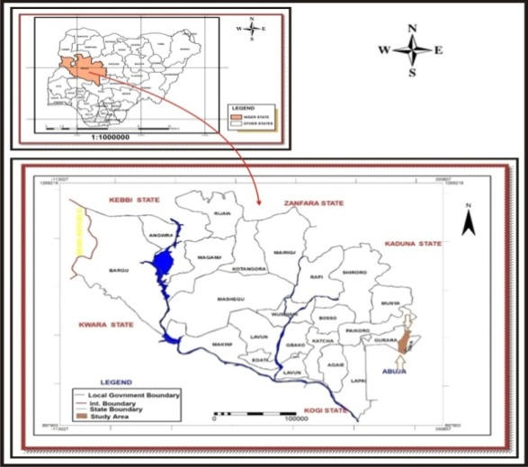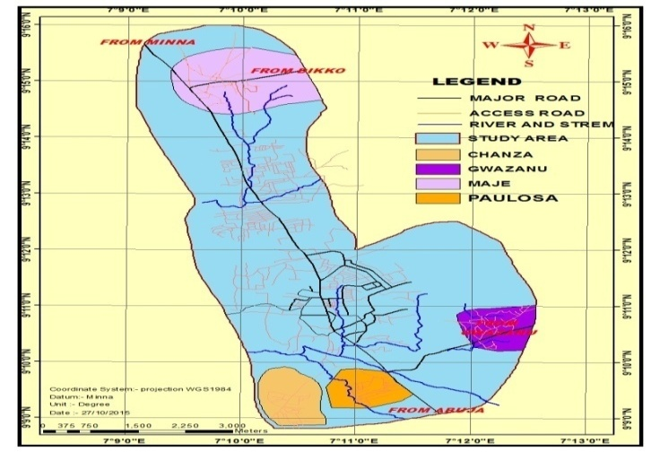
Figure 1: Map of Niger State Figure 2: Selected Neighbourhoods for the study.

3.0 Methodology
This study employed both primary and secondary sources of data collection. The secondary data comprise of the Google Earth image data of the four neighbourhoods were downloaded via internet and were geo-referenced. The existing buildings and other features such as roads and rivers were digitized using ArcGIS 10.2 software. The primary data was sourced from questionnaire administration. In all, 320 copies of questionnaire were administered on the peri-urban residents across the four neighbourhoods (Maje, Paulossa, Chassa and Gwazunnu). Based on the fact that population of the neighbourhoods were not available, house count system was adopted in order to estimate the population of the neighbourhoods. Using an average of household size of 6 per family, a total of 3,200 households were estimated for the four neighbourhoods. For this purpose, 10% was adopted as the sample size. The systematic sampling method was used in the questionnaire administration, because the streets and lanes that can be accessed. The first building in each lane/street was selected randomly, while subsequent samples were selected at an interval of eight buildings. The data were analyzed using descriptive method of data analysis.

4.0 Results and Discussions
4.1 Patterns of Development in the Peri-urban area of Suleja
The digitization of the google earth image of the selected four neighbourhoods revealed the development pattern of the study area. For instance, Maje, covers 567,246.01m², the area exhibited a continuous pattern of developemnt it shows an intense development of unused land and forming unbroken fashion of development. The settlement is, however, supported by major access linking Kaduna – Abuja road and bounded by the Minna – Suleja regional road (Figure 3), it developed outward spread of low density in ribbon low pattern along major suburban highways.
Paulossa covers 548,017.88m²in the area coverage and exhibited clustered pattern of development. The development pattern in the area has been affected by the nature of the landscape of the area, reflecting a series of environmental challenges affecting the community. Due to the natural feature (river and mountain) the settlement is bounded westward by river and eastward by the Suleja –Abuja road. These features bunched the growth and development of the neighbourhood tightly, minimizing the amount of land for development of residential or nonresidential units (Fig. 4).
Chaza neighbourhood covers about 49,361.87m² area. This peri-uban neighbourhood is a low density area surrounded by open spaces (Fig. 5). It exhibits a continuous pattern of leap frog development and it has the potential to extend toward any direction. Gwazunu, the fourth neighbourhood has the total coverage of 638,277.60m². The settlement is characterized as clustered pattern settlement, bounded by roads and rivers
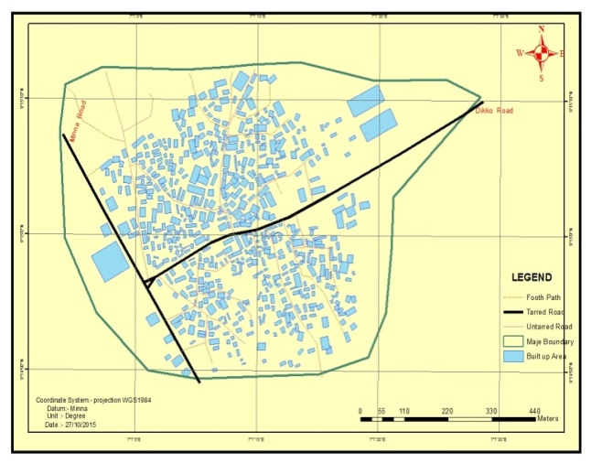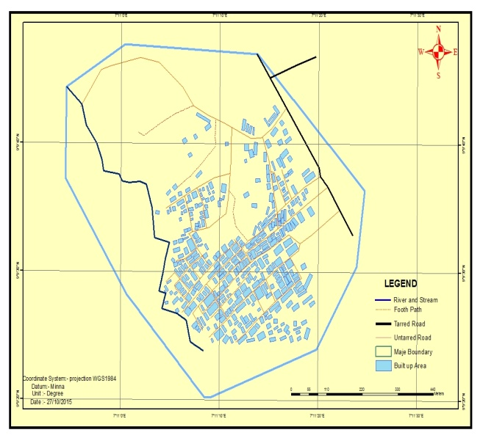Figure 3: Development Pattern of Maje Fig. 4: Development Pattern of Paulossa
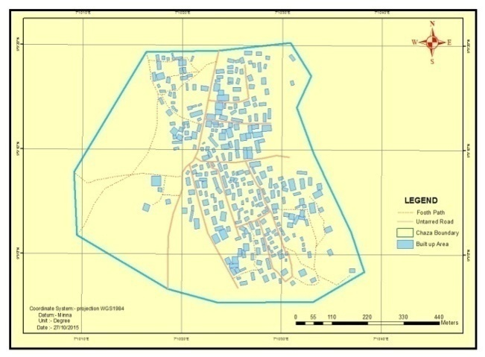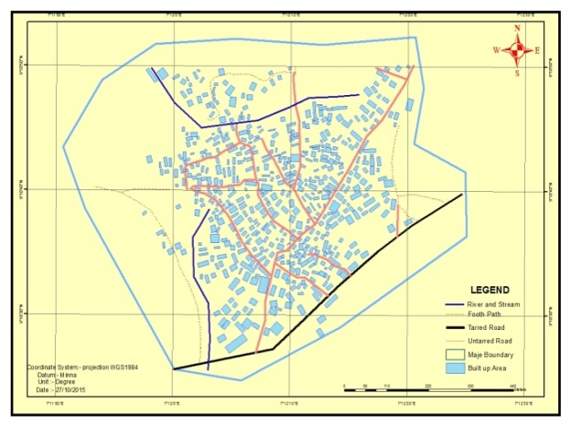Figure 5: Development Pattern of Chassa Figure 6: Development Pattern of Gwazunu

This analysis implies that, the pattern of development exhibited in the peri-urban area of Suleja are sprawled like in nature: clustered; leap frog; unplanned; and continuous growth. These were influenced by the landscape of the area. As observed, these areas are relatively undulating landform.
4.2 Factors Influencing Peri-urban Sprawl in Suleja
The factors examines are the proximity of the location to the Federal Capital Territory, Abuja, the price of land, the rate of growth of the selected neighbourhoods, ethnicity and religion and the displacement of the residents from their previous areas due of conflict. Table 1 reveals that, the location of the neighbourhoods and their proximity to the FCT captured the absolute response of the respondents (100%). In comparison on the price of land in the selected peri-urban area, with the other areas of the town (preferably at the city centre), the analysis indicates that, 100% of the respondents attested to the low and cheaper price of land, at the fringe area of the town.
Table 1: Factors Contributing to Urban Sprawl Development in Suleja
S/No. | Factors | Degree of Influence
S/No. | Factors | SA | A | U | D | SD
1 | Proximity to Abuja | 198(64.3%) | 110(35.7%) | - | - | -
2 | Cheap land for building | 219(71.1%) | 89(28.9%) |  | - | -
3 | Natural population growth |  | 174(56.5%) | 20(6.5%) |  | 114(37.0%)
4 | Ethnicity/Religion | 174(56.5%) | 128(41.6%) | 6(1.9%)
5 | Displacement due to conflict | 119(38.6%) | 163(52.8%) | 13(4.2%) | - | 13(4.2%)
6 | Availability of infrastructure | - | - | 12(3.9%) | 223(72.4%) | 739(23.7%)
7 | Proximity to place of work | - | 11(3.6%) | 1(0.3%) | 156(50.6%) | 140(45.5%)
8 | High rent of housing accommodation at the city centre | 145(47.1%) | 161(52.3%) | 2(0.6%) | - | -
Note: SA= Strongly Agree; A=Agree; U= Undecided; D= Disagree; SD= Strongly Disagree
Source: Author, 2015

The effects of the increase in the population of people in Suleja were acknowledged as 56.5% of the respondents admitted that, this factor naturally influences the growth of the peri-urban settlements and villages surrounding Suleja. Meanwhile, ethnicity and religion recorded 98.1% of the respondents, who agreed that this factor contributed to the growth of the peri-urban area. Likewise, 90% of the respondents supported the view that the growth of peri-urban was as a result of displacement of some people from the FCT and the occurrence of civic conflict and disturbance in the core area of the town. In addition, 96.1% of the respondents disagree that infrastructures within the selected neighbourhoods are inadequate and that the neighbourhoods of their residents, were not closer to their places of work. Above ninety percent of the respondents maintained that, high rent of housing accommodation contributed to the spread of the town in an outward direction.

4.3 Challenges of Peri-urban Sprawl Development in Suleja
The challenges peri-urban sprawl development in Suleja are; problem of tenure on landed property, insecurity accessibility to public facilities, lack of infrastructure and poor physical planning strategy. Table 2, revealed that, about 87% of the respondents agreed that insecurity of tenure on the land acquired by the residents’ poses a serious challenge for the people living in the sprawled area. Similarly, 56.2% of the respondent agreed that, insecurity of life and property within the core area influences the development of the peri-urban area. In addition, 98.4% of the respondents attested that access to community facilities remains a common challenge affecting the residents of the area. Similarly, 98.4% of the respondents agreed that lack of public infrastructure was a major challenge affecting the peri-urban areas and their residents. Poor physical development of the area was acknowledged by all the respondents of the peri-urban area.
Table 2: The Challenges of Urban Sprawl Development in Suleja
S/No. | Challenges | Degree of Significant
S/No. | Challenges | SA | A | U | D | SD
1 | Insecurity of tenure | 14(4.5%) | 254(82.5%) | 10(3.2%) | 2(0.6%) | 28(9.1%)
2 | Insecurity of life and property | 136(44.2%) | 37(12.0%) | 5(1.6%) | 50(16.2%) | 80(26.0%)
3 | Accessibility to community facility | 197(64.0%) | 106(34.4%) | 5(1.6%) | - | -
4 | Lack of infrastructure | 138(44.8%) | 165(53.6%) | 5(1.6%) | - | -
5 | Poor physical development | 114(37.0%) | 194(63%.) | - | - | -
Note: SA= Strongly Agree; A=Agree; U= Undecided; D= Disagree; SD= Strongly Disagree
Source: Author, 2015

4.4 The Physical Characteristics of the Neighbourhoods
The physical characteristics of the selected peri-urban neighbourhoods (Maje, Paulossa, Chassa and Gwazunnu) are revealed in Table 3. The physical features investigated include; the layout plan of the respective neighbourhoods, which are virtually unplanned, the types of building, which ranges from traditional to modern and owners’ occupiers. The building conditions in the peri-urban neighbourhoods are of different categories and are inadequate, similarly, the condition of accessibility connecting most of the houses in the peri-urban areas are untarred, poor and inadequate. Based on the infrastructure such as water and power supply, the finding shows that the residents of the areas relies more on the water vendors and the well water, while the electricity supply to the neighbourhoods are irregular in supply.

Table 3: Physical Characteristics of the selected Peri-urban Neighbourhood
Features | Maje | Paulossa | Chassa | Gwazanu
Neighbourhood Layout | Unplanned residential landscape, presence of other complimentary land use like commercial area and industrial areas. | Unplanned residential area and presence of other complimentary land use. | Unplanned residential area and presence of other complimentary land use. | Unplanned residential area and presence of other complimentary land use.
Building Type | The buildings presence ranges from traditional houses to modern ‘. There are mixed use of buildings especially for the buildings along the major highways. | The buildings in this area are predominantly modern, and are mostly owners occupiers houses, with just few of them as tenement | The buildings in this area are predominantly traditional; it’s mostly owners’ occupiers’ houses. | The buildings in this area are predominantly modern, and are mostly owners occupiers houses, with just few of them as tenement
Building Condition | The buildings in this area are of different categories, mostly, the houses are inadequate. | Buildings in this area are of different categories, reflecting the status of the residents of the area. | Buildings in this area are of different categories, reflecting the status of the residents of the area. | Buildings in this area are of different categories, reflecting the status of the residents of the area.
Condition of Access | Apart from the major access road, all other roads connecting houses were untarred and are in poor condition | The access roads are fair within the neighbourhood | The access roads are poor within the neighbourhood | The access roads are fair within the neighbourhood
Water Supply | Water supply to this neighbourhood is inadequate, as quite number of the population relies on water vendors and well | The neighbourhood was not connected to water mains. | The neighbourhood was not connected to water mains. | The neighbourhood was not connected to water mains.
Electricity Supply | Not regular | Not regular | Not regular | Not regular
Source: Author 2015.

4.5 Functionality and Satisfaction of Existing Facilities
In the survey conducted, the existing facilities (both community services and utility) include; health, education, water supply, electricity supply, organized waste dump sites and community centre. Based on the study on the functionality of the facilities (Table 4); 100% of the respondents attested that, both the health care facilities and the educational facilities were functional. Over quarter of the respondents agreed to the fairly performance of the water supply and educational facilities, while 73.7% and 72.7% supported that water supply and transformers available are not functional. Also, 97% and 100% of the respondents admitted that, the refuse disposal and community centre were not functional.

Table 4: Functionality of the Existing Facilities
Facility | Level of Functionality
Facility | Highly Functional | Fairly Functional | Not Functional
Health facility | 113(36.7%) | 195(63.3%) | -
Primary school | 140(45.5%) | 168(54.5%) | -
Secondary school | 114(37%) | 195(63%) | -
Public water supply | - | 81(26.3%) | 227(73.7%)
Transformer | - | 84(27.3%) | 224(72.7%)
Disposal of refuse dumped | - | 9(2.9%) | 299(97%)
Community centre | - | - | 308(100%)
Source: Author, 2015.

Table 5 shows that all the respondents 100% were not satisfied with public water supply and the nature of the community centre. However, 76.3% of the respondents claimed that they were not satisfied with the power supply and distribution in their area. On the health facility and community market; 19.8% and 18.2% of the respondents were not satisfied with the services and 57.8% and 43.5% were fairly satisfied. For the educational facility, 61.7% and 66.5% of the respondents were satisfied with the condition of the primary and secondary education facilities, while 38.3% and 33.4% of the respondents were not satisfied the primary and secondary school, respectively.
Table 5: Level of Satisfaction with the available Facilities
Facility | Level of Satisfaction
Facility | Highly Satisfied | Satisfied | Fairly Satisfied | Not Satisfied
Health care facility |  | 69(22.4%) | 178(57.8%) | 61(19.8%)
Primary school | 39(12.7%) | 151(49.0%) | 118(38.3%)
Secondary school | 46(14.9%) | 159(51.6%) | 103(33.4%)
Water supply |  |  |  | 308(100%)
Public power supply (Transformer) |  |  | 73(23.7%) | 235(76.3%)
Community centre |  |  |  | 308(100%)
Source: Author, 2015.

This analysis implies that, the basic infrastructure such as, water supply, electricity were grossly inadequate, similarly, sanitation of the peri-urban environment remains a major concern with reference to waste deposition and management. In addition, the peri-urban neighbourhoods in Suleja lack adequate water for domestic use and for other purposes. In addition, power supply to these areas have been irregular and affecting the socio-economic activity of the area.

4.6 Impact of the Challenges of Urban Sprawl Development on Suleja Environ.
The Challenges of urban sprawl development in the peri-urban of Suleja basically affects the certain areas, such as; transportation, economic and environment.
- Transportation: the effects of the challenges on transportation are enormous, as it affects the use and travelling pattern of the people using automobiles. Studies by Gordan and Richardson (1997) Glaster et.al (2001) firmly asserted this, with respect to the volume of traffic and distance travel by the residents from the selected neighbourhoods. This has increase the rate of pollution been released into the atmosphere with the use of automobile.
- Economy: the effects of market forces are more prominent in the spread of sprawl settlements. The influence of low rental value in these suburbs areas and the cheap cost of land are considered high in this study to promote the development of urban sprawl in Suleja. However, this directly affects the provision of infrastructure facility and services by the government. Based on the household economy; the cost of travelling affects the income of the family or the individual and it invariably causes an increase in the price of commodities in the area.
- Environment: the effects of this factor are seemingly numerous. This includes the development in the ecological unstable area, reduction of regional open space, indiscriminate disposal of wastes, increase pollution and higher energy consumption, increase runoff of storm water and risk of flooding, removal native vegetation and ecosystem fragmentation.

5.0 Recommendations
The Findings from this study has shown that there are factors encouraging the spatial growth of peri-urban neighbourhoods in Suleja. However, the spatial expansion is observed to have a serious negative impact on the planning and land administration, malfunction of infrastructure facilities and natural vegetation depletion. The study therefore recommends thus;
- The collaboration of the government and the neighbourhoods in the development of participatory planning approach system. The land or property title owned by the individual who reside in the peri-urban areas be regularized. The government to engage in the development of service plots, which will ensure and control haphazard development within the peri-urban areas.
- Intervention of the government in refurbishing the existing dilapidated facilities and in the provision of new facilities to the peri-urban area. The refurbishment and provision of infrastructure will help supporting the development at the peri-urban area and at the same time, it will enhance the quality of the environment.
- The rate of waste deposition into the peri-urban environment should be discouraged by the government. In respect to this, sustainable waste management approach should be se in place to monitor the environment. To do this, synergy between the community and the government be formed, as this will help to maintain clean and healthy environment across the neighbourhoods in the peri-urban areas.
- In view of the patterns of development exhibited across the selected neighbourhoods (Maje, Paulossa, Chassa and Gwazunnu) in Suleja, there is need for a comprehensive land use planning and development control strategy, with a view to limiting the uncoordinated outward spread of the neighbourhoods. The comprehensive development plan envisages, to incorporate both the sustainable development agenda and the climate change framework, so as to reducing the adverse effects of urban expansion.

6.0 Conclusion
The suburbs of Suleja are increasingly spreading with the evidence of unplanned growing peri-urban neighbourhoods. The proximity of Suleja to the Federal Capital of Nigeria, the relatively low price of land, ethnicity and religion and high rental value in the city centre are responsible as the factors encouraging the growth of the town. The challenges such as, insecurity in term tenure acquired on lands and the rate of disturbance and insecurity in the core area, inadequate infrastructural provision and poor physical planning are prominent among the challenges affecting the peri-urban residents. The impact of the growth in the peri-urban does not only affect the physical environment in term of the waste generation, but has an impact on the household economy and on the government expenditure and on the cost of transportation and travelling distance of the residents. Although, some facilities were seems available in the areas, the response of the residents on the level of their satisfaction and the functionality of these facilities remain as a big problem. Participatory planning approach, refurbishment and provision of facilities, sustainable waste management strategy and development of comprehensive land use planning and development control strategy are required for effective coordination of the development in the peri-urban area of Suleja.

References

Adaku, E. (2014). Urban Sprawl: A view from Developing and Developed Countries. African Journal of Geography and Regional Planning, 1 (6): 193 – 207. Accessed from www.internationalscholarsjournals.org.

Aguda, A. S. and Adegboyega, S. A. (2013). Evaluation of Spatio-Temporal Dynamics of Urban Sprawl in Osogbo, Nigeria Using Satellite Imagery and GIS Techniques. International Journal of Multidisciplinary and Current Research. Sept/Oct 2013 issue. Accessed online at http://ijmcr.com.
Alabi, M. O. (2009). Urban Sprawl, Pattern and Measurement in Lokoja, Nigeria. Theoretical and Empirical Researches in Urban Management, 4 (13): 158 – 164.
Barredo, J. I., Demichelli, L., Lavalle, C., Kasanko, M. and McCormick, N. (2004). Modelling Future Urban Scenario in Developing Countries: An Application Case Study in Lagos, Nigeria. Journal of Environment and Planning B: Planning and Design, 32: 65 - 84.
Burchell, R. W., Shad, N. A., Listokin, D., Phillips, H., Seskin, S., Davis, J. S., Moore, T., Helton D. and Gall, M. (1998). The Cost of Sprawl. Revisited Transportation Research Board Report 39. National Academy Press, Washington, DC.
Downs, A. (1999). Some Realities about Sprawl and Urban Decline, Journal of Housing Policy Debate, 10: 955 – 974.
Durieux, L., Lagabrille, E. and Nelson, A. (2008). A Method for Monitoring Building Existing GIS Data. International Journal of Photogrammetry and Remote Sensing ISPRS. Accessed from www.sciencedirect.com.
Ewing, R. H. (1997). Is Los Angeles – Style Sprawl Desirable? Journal of American Planning Association, 63(1): 107 – 126.

Ewing, R. H., Pendall, R. and Chen, D. (2002). Measuring Sprawl and its Impact. S.G.American, Assessed from http://www.smartgrowthamerica.org/sprawlindex/MeasuringsprawlPDF

Fabiyi, O. O. (2006). Urban Land Use Change Analysis of a Traditional City from Remote Sensing Data: The Case of Ibadan Metropolitan Area, Nigeria. Humanity and Social Sciences Journal. 1(1): 42 – 64.
Feng, L. (2009). Applying Remote Sensing and GIS on Monitoring and Measuring Urban Sprawl: A Case Study of China. Institute for Regional Development Planning, University of Stuttgart.
Frank, N., White, S., Peng, Z., Harris, K. and Sanders, W. (2000). Exploring Sprawl: Findings of a Comprehensive Review of the Literature Related to Sprawl or What do we really know?.Being a paper presented at the Association of Collegiate Schools of Planning, Atlanta, Georgia, 2nd - 5th November,2000.
Franz, G., Maier, G. and Schrock, P. (2006). Urban Sprawl: How useful is this Concept? In ERSA conference papers from European Regional Science Association. Accessed from www-sre.wu-wien.ac.at/ersa/ersaconfs/ersa06/papers/105.pdf.
Frenkel, A. and Ashkenazi M. (2008). The integrated Sprawl Index: Measuring the Urban Landscape in Israel. Annals of Regional Science, 42: 99 -121.
Galster, G., Hanson, R., Wolman, H., Coleman, S., and Freihage, J. (2001). Wrestling Sprawl to the Ground: Defining and Measurement an Exclusive Concept. Housing Policy Debate, 12: 681 – 717.
Gordon, P., and Richardson, H. W. (1997a). Are Compact Cities a Desirable Planning Goal? Journal of the American Planning Association, 63(1), 95–106.
Hamidi, S. and Ewing, R. (2014). A Longitudinal Study of Changes in Urban Sprawl Between 2000 and 2010 in United State. Journal of Landscape and Urban Planning, Assessed from Science Direct Site, www.elsvier.com/locate/landurbplan.
Idowu, O. O. and Olaniyan, O. A. (2009). An Assessment of the Changing Phases of Minna City-Centre. International Journal of Architecture and Environment (ARCHISEARCH), 1 (2): 34 – 41.s
Idowu, O. O. (2015). Perspectives of Urban Sprawl. Being a PhD Area Paper, Presented at the Staff/Post Graduate Students Seminars, Department of Geography and Environmental Management, University of Ilorin.
Idowu, O. O., Shaibu, S. I., Adeleye, B. M., Medayese S. O. and Abd’razack, N.T.A. (2016). The Challenges of Urban Sprawl Development in Suleja, Niger State. Paper Presented at the International Conference, 21st -24th March, 2016, at The Federal University of Technology, Akure, Nigeria.
Liu X and Jiang, B. (2011). A Novel Approach to the Identification of Urban Sprawl Patches to Based on the Scaling of Geographic Space. International Journal of Geomatics and Geosciences, 2 (2): 415 – 429.
Mabogunje, A. L. (1968). Urbanization in Nigeria. University of London Press.

Obateru, I. O. (2005). Basic Elements of Planning. Penthouse Publications Limited Ibadan, Nigeria.
Okewole, E. A. (2002). Controlling Urban Sprawl in Developing Countries through Effective Urban Governance. A Seminar Paper at the Department of Urban and Regional Planning , Obafemi Awolowo University, Ile-Ife.
Olorunfemi, J. F. (1979). Inter-censal Population Estimation and Urban Land use Changes in Nigeria. Being a PhD. Thesis Submitted to the Department of Geography, University of Bristol, United Kingdom.
Olujimi, J. (2009). Evolving Strategy for Mapping Urban Sprawl in Nigeria Human Ecology, 25 (3): 201 – 208.
Oueslati, W., Alvanides. S. And Garrod, G. (2015). Determinants of Urban Sprawl in European Cities. Urban Studies. 52(9): 1594 – 1614.
Popoola, N. I. (2014). The Impact of Peri-Urban Residential Development on Real Property Value in Minna, Niger State, Nigeria, Unpublished PhD Proposal, Urban and Regional Planning Department, Federal University of Technology Minna.
Sabo, J. (2015). Assessment of Urban Sprawl Development and Infrastructure Deficit in Peri- Urban Areas of Suleja, Niger State, Nigeria. Department of Urban and Regional Planning, FUT Minna.
Torrens, P. M. (2006). Simulating Sprawl. Annals of the Association of American Geographers. 96(2): 248 - 275 Blackwell Publishing, United Kingdom.
Torrens, P. M. (2008). A Toolkit for Measuring Sprawl. Journal on Applications of Spatial Analysis, 1: 5 - 36.
UN-Habitat (2001). The State of the World’s Cities 2001: A World of Cities. UN-Habitat Publications Unit, Nairobi Kenya.
UN-Habitat (2008). The State of the World’s Cities 2008/2009: Harmonious Cities. Earthscan. London.
UN-Habitat (2011). The State of the World’s Cities 2010/2011: Bridging the Urban Divide. Earthscan. Routledge, Taylor and Francis Group.
UN-Habitat (2013a). The State of the World’s Cities 2012/2013: Prosperity of Cities. Earthscan. Routledge, Taylor and Francis Group.
United Nations, Department of Economic and Social Affairs, (UNDESA) (2014). World Urbanization Prospects: The 2014 Revision, Highlights. Population Division (ST/ESA/SER.A/352).
United Nations, Department of Economic and Social Affairs, Population Division (UNDESA) (2015). World Population Prospects: The 2015 Revision, Key Findings and Advance Tables. Working Paper No. ESA/P/WP.241.
Wapwera, S. D., Mallo, M. D., Jiriko, K. D. and Charles, E. O. (2015). An Analysis of Suburban Developments in Jos Metropolis, Nigeria. Journal of the Nigerian Institute of Town Planners. 23(2): 15 -32.

